Project 2
Wanjing Ding
2025-11-15

Github link: https://github.com/WanjingDing/Project-2
## # A tibble: 6 × 8
## Date co_max8hr co_unit pm_mean pm_unit o3_max8hr o3_unit year
## <date> <dbl> <chr> <dbl> <chr> <dbl> <chr> <dbl>
## 1 2018-01-01 0.2 ppm 7.5 ug/m3 LC 0.037 ppm 2018
## 2 2018-01-02 0.7 ppm 8.95 ug/m3 LC 0.034 ppm 2018
## 3 2018-01-03 0.9 ppm 15.2 ug/m3 LC 0.032 ppm 2018
## 4 2018-01-04 0.2 ppm 9.7 ug/m3 LC 0.035 ppm 2018
## 5 2018-01-05 0.2 ppm 7.75 ug/m3 LC 0.036 ppm 2018
## 6 2018-01-06 0.2 ppm 7.6 ug/m3 LC 0.036 ppm 2018
## # A tibble: 6 × 8
## Date co_max8hr co_unit pm_mean pm_unit o3_max8hr o3_unit year
## <date> <dbl> <chr> <dbl> <chr> <dbl> <chr> <dbl>
## 1 2019-01-01 0.2 ppm 8.5 ug/m3 LC 0.033 ppm 2019
## 2 2019-01-02 0.3 ppm 9.2 ug/m3 LC 0.027 ppm 2019
## 3 2019-01-03 0.6 ppm 7.9 ug/m3 LC 0.015 ppm 2019
## 4 2019-01-04 0.7 ppm 8.9 ug/m3 LC 0.026 ppm 2019
## 5 2019-01-05 0.2 ppm 6 ug/m3 LC 0.039 ppm 2019
## 6 2019-01-06 0.6 ppm 6.75 ug/m3 LC 0.034 ppm 2019
## # A tibble: 6 × 8
## Date co_max8hr co_unit pm_mean pm_unit o3_max8hr o3_unit year
## <date> <dbl> <chr> <dbl> <chr> <dbl> <chr> <dbl>
## 1 2020-01-01 0.5 ppm 3.7 ug/m3 LC 0.036 ppm 2020
## 2 2020-01-02 0.8 ppm 8.2 ug/m3 LC 0.03 ppm 2020
## 3 2020-01-03 0.4 ppm 8.5 ug/m3 LC 0.01 ppm 2020
## 4 2020-01-04 0.4 ppm 1.93 ug/m3 LC 0.033 ppm 2020
## 5 2020-01-05 0.4 ppm 2.7 ug/m3 LC 0.032 ppm 2020
## 6 2020-01-06 0.7 ppm 4.7 ug/m3 LC 0.033 ppm 2020
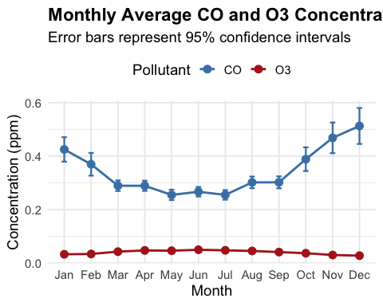

Alternative plot (in case the ozone error bars are too small to observe)
