
SCHOOL OF SURVEYING AND SPATIAL SCIENCE
DEPARTMENT OF SURVEYING AND SPATIAL SCIENCE
PROJECT TITLE:
NDVI-BASED VEGETATION CHANGE DETECTION IN NAKURU COUNTY (2022–2024) USING REMOTE SENSING AND GIS TOOLS.

By:
JECINTA WANJIRU KINYANJUI
ESGI/00968/2019

A Project proposal Submitted to the School of Surveying and Spatial Science for the Award of the Degree of Technology in Surveying Technology.

July,2025

DECLARATION
I Jecinta Wanjiru Kinyanjui declare that this report is my original work and has not been submitted for any degree award in any university or institution.
Signed: ………………………………………. Date: ……………………….
Jecinta Wanjiru Kinyanjui
ESGI/00968/2019

CERTIFICATION
This project has been submitted for examination with my authority as the University project supervisor.

Signed: ………………………………………. Date: ……………………….
Ms. Charlynne Jepkosgei

ACKNOWLEDGEMENT
I want to acknowledge the exceptional contribution of my project supervisor. Thank you for your dedication, guidance expertise, time and patience during the writing of the proposal. I want to thank my fellow class group members in the efforts to collaboratively guide each other when we got stuck throughout the entire project period. I specifically want to acknowledge Lorna, Humphrey and my parents for the continuous encouragement and support. I acknowledge all the panellists who periodically reviewed our proposal. Your input, feedback and encouragement made doing the work easier and improved the quality.

ABSTRACT
This research applies Remote Sensing and Geographic Information Systems (GIS) to analyse vegetation change in Nakuru County between 2022 and 2024 using the Normalized Difference Vegetation Index (NDVI). Sentinel-2 Satellite imagery was processed on Google Earth Engine (GEE) through JavaScript code, which incorporated critical pre-processing steps including cloud masking and atmospheric correction. NDVI layers were generated for two contrasting climatic seasons a drought year (2022) and a flood year (2024) and subsequently exported as GeoTiff files for further spatial analysis in QGIS 3.40. Within the GIS environment, the NDVI rasters were reclassified into vegetated and non-vegetated categories, and the area covered by each class was computed. These area calculations were visualized using pie charts to enable a comparative temporal assessment. A line chart was also generated to compare rainfall data with vegetation area to show how rainfall variability compares to vegetation. The results revealed a substantial increase in vegetated land cover in 2024, confirming widespread ecological recovery following the flood event. This study demonstrates the effectiveness of integrating satellite imagery, cloud-based processing, and GIS tools for quantifying vegetation dynamics and provides valuable insights for land use planning and climate resilience efforts in Nakuru County.

TABLE OF CONTENTS
Contents
DECLARATION 2
CERTIFICATION 2
ACKNOWLEDGEMENT 3
ABSTRACT 3
TABLE OF CONTENTS 4
TABLE OF FIGURES 7
LIST OF TABLES 8
CHAPTER ONE 11
INTRODUCTION 11
1.1 Background of the Study 11
1.2 Problem Statement 12
1.3 Research Objectives 13
1.3.1 Main Objective 13
1.3.2 Specific Objectives 13
1.4 Methodology Overview 13
1.5 Justification of the Study 14
1.6 Scope and Limitations 15
1.7 Organization of the Report 15
CHAPTER TWO 16
LITERATURE REVIEW 16
2.1 Introduction 16
2.2 NDVI as a Vegetation Monitoring Tool 16
2.3 NDVI in Climate-Sensitive Contexts 17
2.4 Sentinel-2 and Google Earth Engine for Vegetation Analysis 17
2.5 Applications of NDVI in Kenya 18
2.6 Rainfall–Vegetation Interactions 18
2.7 Summary of Literature Gaps 18
2.8 Conclusion 19

CHAPTER THREE 20
METHODOLOGY 20
3.1 Overview 20
3.2 Study Area 20
3.3 Data Sources 22
3.4 Methodological Workflow 23
3.5Defining AOI in GEE using shapefile in the assets tab and specifying it in code. 24
3.6 Spectral indices calculation and Cloud Masking 26
3.6.1 Cloud Masking 26
3.6.2 NDVI Computation 26
3.7 NDVI Change Detection 29
3.8 Vegetation Area Calculation 31
3.9 Rainfall Comparison Analysis 31
3.9 Visualization and Map Export 32
3.10 Software and Tools Used 37
3.11 Summary 37
CHAPTER FOUR 38
RESULTS AND DISCUSSION 38
4.1 Overview 38
4.2 NDVI Distribution in April–June 2022 (Drought Year) 38
4.3 NDVI Distribution in April–June 2024 (Flood Year) 39
4.4 NDVI Change Detection (2022–2024) 40
4.5 Vegetation Area Statistics 41
4.6 NDVI vs. Rainfall Comparison 43
4.7 Spatial Trends and Map Interpretation 44
4.8 Discussion of Findings 45
4.9 Summary of Key Results 45
CHAPTER FIVE 46
CONCLUSIONS AND RECOMMENDATIONS 46
5.1 Conclusion 46
5.2 Recommendations 47
5.2.1 Policy and Land Management 47
5.2.2 Scientific Research and Climate Preparedness 47
5.2.3 Technical Implementation and Capacity Development 48
5.3 Final Remarks – Research as Responsibility 48
REFERENCES 49

TABLE OF FIGURES
Figure i: Visual representation of what NDV is. 13
Figure ii: Study Area Map 18
Figure iii:Methodology Flowchart 20
Figure iv: Uploading AOI into GEE 21
Figure v: Code section 1 21
Figure vi: 2022 RGB Sentinel-2 Image 22
Figure vii: 2024 RGB Sentinel-2 Image 22
Figure viii: Code Section 2 23
Figure ix: Code Section 3 24
Figure x: Code Section 4 25
Figure xi: 2022 NDVI Result in GEE 25
Figure xii: 2024 NDVI Result in GEE 26
Figure xiii: Code Section 5 26
Figure xiv: NDVI Change Result in GEE 27
Figure xv: Code Section 6 28
Figure xvi: Code Section 7 29
Figure xvii: Exports in Tasks Tab in GEE 29
Figure xviii: Vegetation Area 2024 Figure xix: Vegetation Area 2022 30
Figure xx: Code Section 8 30
Figure xxi: symbolization in QGIS 31
Figure xxii: The DVI Change layer Symbolization 32
Figure xxiii: NDVI 2024 Symbolization in QGIS 32
Figure xxiv: NDVI 2022 Symbolization in QGIS 33
Figure xxv: NDVI 2022 Map layout in QGIS 35
Figure xxvi: NDVI 2024 Map Layout in QGIS 36
Figure xxvii: NDVI 2022-2024 Change Map Layout 38
Figure xxviii: Vegetation Area in hactares Pie chart for 2022 vs 2024 39
Figure xxix: Rainfall Chart between 2022 to 2024 40

LIST OF TABLES
Table 1: Data Sources 20
Table 2: Software and Tools Used 35
Table 3: Vegetation Areas in ha and the Change 40

LIST OF ABREVIATIONS
GEE: Google Earth Engine
NDVI: Normalized Difference Vegetation Index
ASAL: Arid and Semi-Arid Lands
CHIRPS: Climate Hazards Group InfraRed Precipitation with Station data
NDBI: Normalized Difference Built-Up Index
MNDWI: Modified Normalized Difference Water Index
AOI: Area Of Interest

CHAPTER ONE

INTRODUCTION

1.1 Background of the Study
Vegetation is a key indicator of environmental stability, land productivity, and ecosystem resilience. Its presence and density reflect the health of terrestrial systems, playing a critical role in climate regulation, carbon sequestration, biodiversity conservation, and soil stabilization. Vegetation also acts as a buffer against extreme weather conditions mitigating the effects of drought, floods, and land degradation. As such, changes in vegetation patterns over time provide insight into broader ecological and climatic shifts.
In recent decades, the frequency and intensity of climate-induced extremes particularly prolonged droughts and flash floods have increased globally, with sub-Saharan Africa among the most affected regions. In Kenya’s Rift Valley, where Nakuru County is located, such environmental disturbances have had visible impacts on vegetation structure and distribution. Nakuru is a highland-urban agricultural county, characterized by a complex land-use matrix that includes natural forests, wetlands, croplands, and urban centres. This diversity, combined with increasing population pressure and exposure to climate extremes, makes it ecologically sensitive and in urgent need of reliable vegetation monitoring mechanisms.
One of the most powerful tools for vegetation assessment is the Normalized Difference Vegetation Index (NDVI), a satellite-derived metric that quantifies vegetation greenness using reflectance values from the red (visible) and near-infrared (NIR) portions of the electromagnetic spectrum. NDVI values range between -1.0 and +1.0, where higher values signify vigorous green vegetation and lower or negative values indicate barren surfaces, water, or built-up land (Pettorelli et al., 2005; Musyimi et al., 2023). The simplicity, accessibility, and ecological relevance of NDVI, has made it one of the most widely used indices in remote sensing-based vegetation analysis.
The introduction of Sentinel-2 satellites under the European Space Agency's Copernicus program has enhanced NDVI-based studies through 10-meter spatial resolution, frequent revisit cycles, and free public access. Complementing this development is Google Earth Engine (GEE) a cloud-based geospatial processing platform that allows users to process planetary-scale satellite data using server-side JavaScript. GEE provides pre-processed Sentinel-2 datasets, along with tools for cloud masking, atmospheric correction, index calculation, image compositing, and result visualization.
Despite these technological advances, vegetation monitoring studies in Kenya have predominantly focused on long-term trends in arid and semi-arid lands (ASALs) such as Turkana, Garissa, and Isiolo areas where food security is heavily reliant on pasture dynamics and rainfall variability (Vrieling et al., 2011; Dinku et al., 2011). In contrast, ecologically complex counties like Nakuru remain underrepresented, especially in event-specific studies that analyse short-term vegetation responses to discrete climatic events such as floods and droughts.
This study therefore applies Sentinel-2-derived NDVI within the Google Earth Engine platform to assess vegetation cover change between April–June 2022 (drought period) and April–June 2024 (flood period) in Nakuru County. By calculating vegetation area and visualizing spatial trends, this research aims to offer an accessible, replicable, and data-driven method for localized vegetation monitoring and climate adaptation planning.

1.2 Problem Statement
Vegetation variability resulting from extreme weather events such as drought and flooding presents a major challenge for sustainable land and resource management in Kenya. The impacts of these events are particularly acute in counties like Nakuru, which serve as both agricultural production hubs and rapidly urbanizing centres. However, spatially detailed, temporally targeted assessments of how such events influence vegetation patterns are rare.
A review of the current literature reveals several gaps:
- Geographic Gap: NDVI-based vegetation monitoring in Kenya has primarily focused on arid and semi-arid counties. Research in ecologically diverse highland counties like Nakuru, which experience unique combinations of forest loss, land-use change, and seasonal flooding, remains limited (Osio et al., 2020; Kipkulei, 2024).
- Temporal Gap: Most existing NDVI studies utilize long-term time series analysis (spanning decades), which although useful, fails to capture short-term vegetation responses to acute climate events. There is a need for two-point temporal analyses that target specific hydrological and meteorological disturbances such as the 2022 drought and the 2024 floods.
- Methodological Gap: Few studies take full advantage of cloud-based satellite processing platforms like Google Earth Engine (GEE), which allow for reproducible, high-resolution analysis at scale. Even fewer combine this processing with automated pixel-based area calculations or integrated rainfall-vegetation comparisons.
This study addresses these gaps by implementing a GEE-based NDVI analysis pipeline that computes vegetation area from Sentinel-2 imagery, visualizes interannual change, and compares vegetation dynamics with rainfall variability. The analysis emphasizes April–June seasons, a critical period in Kenya’s long rain cycle, and focuses exclusively on NDVI due to its ecological relevance and computational simplicity.

1.3 Research Objectives

1.3.1 Main Objective
To assess NDVI-based vegetation cover change between the drought year (2022) and the flood year (2024) in Nakuru County using Sentinel-2 imagery, Google Earth Engine, and GIS-based visualization techniques in ArcMap.

1.3.2 Specific Objectives
- To generate cloud-masked and atmospherically corrected NDVI composites for April–June 2022 and April–June 2024 using Sentinel-2 imagery in Google Earth Engine.
- To quantify vegetation area cover using NDVI and calculate changes in area coverage using code in the Google Earth Engine Platform.
- To visualize vegetation changes through comparative NDVI maps in QGIS and to highlight the correlation between the amount of rainfall and vegetation cover change.

1.4 Methodology Overview
This study applies a pixel-based NDVI analysis workflow implemented entirely in Google Earth Engine (GEE), supported by Sentinel-2 Level-2A surface reflectance imagery. The Area of Interest (AOI), Nakuru County is defined using an official shapefile obtained from the Humanitarian Data Exchange (HDX), which is uploaded into GEE and used to spatially filter and clip all data layers.
The methodology consists of the following key phases:
- Data Collection:
Sentinel-2 imagery for April–June 2022 and 2024 is accessed from GEE’s public catalogue.
The Scene Classification Layer (SCL) is used to mask out clouds, shadows, cirrus, and saturated pixels to ensure data quality.
- NDVI Computation:
NDVI is computed using the formula:
$$NDVI=\frac{(B8-B4)}{(B8+B4)}$$
Median NDVI composites are generated for each year, resulting in cloud-free seasonal NDVI layers.

- Vegetation Area Calculation:
A vegetation mask (NDVI > 0.3) is applied to isolate pixels representing green cover.
The masked image is multiplied by pixel area (30m resolution) and aggregated to calculate total vegetation cover in hectares for 2022 and 2024.
This analysis is conducted directly in GEE using the .reduceRegion() and .sum() functions.
- NDVI Change Detection:
An NDVI change map is created by subtracting NDVI 2022 from NDVI 2024.
The change layer is visualized using a diverging colour scheme (green: gain).
- Visualization and Export:
Pie charts are generated to compare vegetated area between years.
Time-series charts (NDVI vs rainfall) are created using CHIRPS daily rainfall data filtered for the same seasonal window.
NDVI change, and RGB composites are exported as GeoTIFF for map layout design in QGIS 3.40.
In QGIS, final maps include NDVI legends (-1 to +1), title blocks, and essential cartographic elements. No classification or additional processing is performed in QGIS.
This methodology ensures high-resolution, event-specific vegetation monitoring using reproducible code and freely available geospatial tools, aligning with best practices in environmental remote sensing.

1.5 Justification of the Study
The NDVI has long been recognized as an effective proxy for vegetation density, biomass, and chlorophyll concentration, making it one of the most widely used indices in environmental monitoring (Pettorelli et al., 2005). However, most NDVI studies in Kenya either focus on arid zones or long-term climate assessments, often using coarse-resolution imagery and manual methods.
This study provides a short-term, high-resolution assessment of vegetation cover dynamics during two extreme climate periods using the latest satellite technology and cloud-based platforms. It demonstrates how open-access tools can be used to support:
- Climate impact assessment
- Land degradation monitoring
- Urban green space protection
- Ecological resilience planning
By focusing on Nakuru County, the research brings attention to an underrepresented region that is both ecologically vulnerable and rapidly changing. The integration of GEE and QGIS in this workflow ensures scientific accuracy, spatial clarity, and policy relevance, making it an important contribution to both academic research and practical land management.

1.6 Scope and Limitations
Scope
Study area: Nakuru County, Kenya
Temporal range: April–June of 2022 (drought) and 2024 (flood)
Analytical focus: NDVI-based vegetation cover change
Data tools: Google Earth Engine for processing; ArcMap 10.5 for map layout
Limitations
NDVI thresholds are generalized and do not distinguish between crop, forest, or grassland types.
Rainfall-vegetation comparisons use remote-sensed precipitation (CHIRPS) rather than field-station data.
Socioeconomic and land use factors are not included in the analysis.
NDVI saturation may limit sensitivity in dense forests.

1.7 Organization of the Report
The report is organized as follows:
Chapter One: Introduction – Provides the study rationale, problem statement, objectives, methodological overview, justification, and limitations.
Chapter Two: Literature Review – Discusses theoretical foundations, related works, and identified gaps in NDVI and remote sensing vegetation analysis.
Chapter Three: Methodology – Describes data sources, image processing steps, NDVI calculation, and area estimation methods.
Chapter Four: Results and Discussion – Presents visual outputs, quantitative findings, and analysis of vegetation change relative to rainfall variation.
Chapter Five: Conclusion and Recommendations – Summarizes key insights, implications for policy, and areas for future research.

CHAPTER TWO

LITERATURE REVIEW

2.1 Introduction
Vegetation monitoring using remote sensing has become a cornerstone in environmental analysis, ecological assessment, and land use planning. The Normalized Difference Vegetation Index (NDVI), derived from satellite spectral bands, remains the most prominent index for evaluating vegetation health, spatial coverage, and biomass variation (Pettorelli et al., 2005). This chapter presents a detailed review of the theoretical foundations of NDVI, its application in climate-stressed environments, advancements in satellite platforms such as Sentinel-2, and the emerging dominance of Google Earth Engine (GEE) as a processing and analytical tool. It further assesses the gap in literature concerning localized NDVI analysis in Kenya and highland ecosystems like Nakuru County.

2.2 NDVI as a Vegetation Monitoring Tool
NDVI is a ratio-based index calculated using the near-infrared (NIR) and red bands of satellite imagery:
$$NDVI=\frac{(B8-B4)}{(B8+B4)}$$

NDVI values range from -1.0 to +1.0. Values close to +1.0 typically indicate dense, healthy green vegetation, values near zero correspond to sparse or stressed vegetation, and values below zero often represent water, built-up surfaces, or bare land (Musyimi et al., 2023).
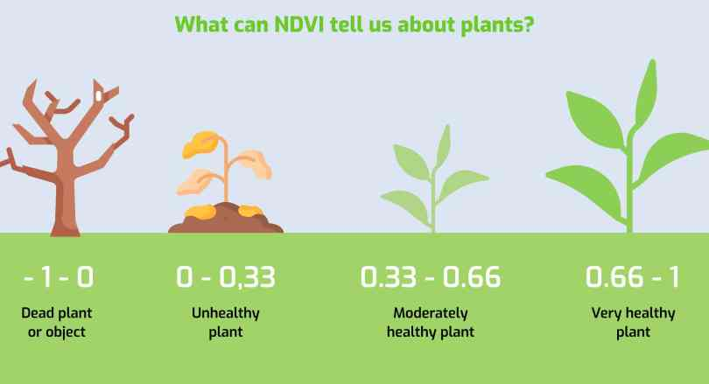
Figure i: Visual representation of what NDV is.
NDVI’s effectiveness stems from its sensitivity to chlorophyll content and plant canopy density. It has been widely adopted in ecological research for purposes such as drought monitoring (Funk et al., 2005), forest degradation mapping (Pettorelli et al., 2005), and land surface productivity assessment (Zhang et al., 2022). As vegetation reflects more NIR and absorbs more red light due to chlorophyll, NDVI effectively captures this biophysical behaviour.

2.3 NDVI in Climate-Sensitive Contexts
NDVI is especially valuable in assessing vegetation dynamics under hydro-climatic stressors, such as drought and flooding. Drought conditions typically result in lower NDVI values due to loss of greenness and chlorophyll degradation, whereas post-flood conditions often see vegetation revival due to increased moisture and nutrient availability (Mpanyaro et al., 2024).
Several studies confirm this pattern:
Mpanyaro et al. (2024) found that NDVI declined sharply during El Niño-induced drought years across East Africa.
Thamaga and Dube (2021) used Sentinel-derived NDVI to monitor flood recovery in southern Africa and showed rapid greening post-inundation.
These studies validate NDVI’s responsiveness to short-term vegetation stress and recovery, especially when paired with seasonal rainfall data.

2.4 Sentinel-2 and Google Earth Engine for Vegetation Analysis
The Sentinel-2 Multispectral Instrument (MSI) provides high-resolution imagery at 10–20 meters spatial resolution across 13 spectral bands. This improves vegetation discrimination, especially in heterogeneous landscapes. Since its launch, Sentinel-2 has become the preferred dataset for NDVI analysis due to its frequent revisit cycle (5–10 days), radiometric accuracy, and public availability (Hargreaves & Watmough, 2021).
Google Earth Engine (GEE), launched by Google in 2010, has transformed how researchers process satellite data. It provides access to multi-petabyte image archives and supports scalable, JavaScript-based cloud processing. A recent study by Vrdoljak et al. (2024) found that GEE significantly accelerates index generation and cloud masking, especially in data-heavy environments such as tropical zones or when using Sentinel-2. GEE also supports time-series NDVI analysis, change detection, and integration with supporting datasets such as rainfall and temperature (Mukarram et al., 2025).
In Kenya, studies such as Macharia et al. (2021) have used Sentinel-2 with GEE to map vegetation trends in Baringo and Kajiado, but these largely focus on pastoral zones and are less representative of highland agricultural counties like Nakuru.

2.5 Applications of NDVI in Kenya
NDVI has been extensively used in Kenya to monitor vegetation and land cover changes, but most studies focus on:
ASAL regions: Turkana, Garissa, Isiolo
Protected areas: Lake Nakuru National Park, Maasai Mara
Forests and wetlands: Mau Forest, Tana Delta
Examples include:
Osio et al. (2020) who assessed vegetation degradation in Lake Nakuru National Park using NDVI between 2005–2015, finding pronounced dry-season stress patterns.
Hesping (2020) who used Sentinel-2 imagery to detect seasonal NDVI changes on Rusinga Island, validating NDVI thresholds for shrubland versus cropland.
However, few studies conduct short-term two-point analyses specifically targeting extreme climatic years, such as drought-to-flood transitions, or integrate NDVI with rainfall data for deeper environmental interpretation.

2.6 Rainfall–Vegetation Interactions
Rainfall is the most significant driver of vegetation productivity in rainfed systems. Vegetation response is often nonlinear, moderate rainfall increases NDVI, while excessive rainfall may lead to temporary greening followed by soil waterlogging and stress.
Studies such as:
- Mukarram et al. (2025) found strong positive correlation (R² > 0.95) between April–May rainfall and NDVI in parts of western Kenya.
- Dinku et al. (2011) observed similar patterns using CHIRPS rainfall datasets, showing a lagged NDVI response to rainfall peaks by 10–15 days.
This suggests the importance of comparing NDVI and rainfall over synchronized seasonal periods for accurate change detection and vegetation recovery modelling.

2.7 Summary of Literature Gaps
Despite extensive use of NDVI in vegetation monitoring:
Most Kenyan studies prioritize arid and semi-arid regions over ecologically complex highland areas like Nakuru.
There is a lack of event-specific NDVI assessments comparing vegetation cover between contrasting climatic seasons (e.g., drought vs. flood).
Many previous works rely on long-term trends or annual means, overlooking short-term, high-impact fluctuations.
Very few studies combine NDVI-based vegetation area estimation with automated processing in GEE, rainfall comparison, and spatial visualization using NDVI legends and classification schemes.
This study addresses these gaps by:
Applying a two-point NDVI comparison for April–June 2022 and 2024.
Using GEE for NDVI computation and pixel-based area calculation.
Visualizing NDVI dynamics in ArcMap using standard colour ramps.
Linking NDVI trends to rainfall using time-series plots derived from CHIRPS.

2.8 Conclusion
This literature review affirms the relevance of NDVI as a robust tool for tracking vegetation dynamics, especially when paired with high-resolution Sentinel-2 imagery and processed using platforms like Google Earth Engine. While many applications exist in Kenya, few focus on localized, event-based vegetation responses within highland agricultural counties such as Nakuru. By combining cloud-free NDVI composites, vegetation area quantification, and rainfall correlation, this study contributes to a growing body of research advocating for climate-smart, data-driven spatial planning tools in the face of environmental uncertainty.

CHAPTER THREE

METHODOLOGY

3.1 Overview
This chapter outlines the detailed methods used to assess vegetation cover change in Nakuru County between two distinct climatic periods: the drought season of April–June 2022 and the flood season of April–June 2024. The methodology is centred on the Normalized Difference Vegetation Index (NDVI), computed from Sentinel-2 Level-2A imagery using Google Earth Engine (GEE) by the deployment of JavaScript code in the code editor. The study employs a pixel-based analytical approach, where vegetated area is quantified through NDVI thresholding and pixel area summation. All data processing, analysis, and initial visualization are performed within GEE, while QGIS is used for cartographic design and final map layout preparation.
The approach prioritizes automation, reproducibility, and data accuracy by integrating atmospheric correction, cloud masking, and pixel-level quantification in a cloud-based environment.

3.2 Study Area
The study area is Nakuru County, situated in the central Rift Valley of Kenya. Nakuru spans a diverse range of geospatial features, making it an ideal location for environmental and spatial analysis:
Geographical Location: Nakuru County lies between latitudes approximately 0°10′S and 1°10′S, and longitudes 35°28′E and 36°40′E, covering an area of about 7,496 km².
Topography: The county exhibits significant altitudinal variation, ranging from about 1,200 meters in the lowland areas to over 3,000 meters in the highlands, particularly near the eastern escarpments and the Mau Forest complex. This variation influences local climate and vegetation patterns.
Land Cover and Use: Nakuru features a mosaic of land cover types, including:
- Dense forests (notably the Mau Forest and Menengai Forest)
- Extensive grasslands and savannahs
- Productive agricultural zones, both subsistence and commercial
- Wetlands, such as those surrounding Lake Nakuru and Lake Elementaita
- Rapidly expanding urban settlements, with Nakuru city as a major urban centre
Hydrology: The county is home to several important water bodies, including Lake Nakuru, Lake Elementaita, Lake Naivasha and numerous rivers and wetlands, supporting both biodiversity and human livelihoods.
Ecological Sensitivity: The combination of diverse ecosystems and varying altitudes makes Nakuru highly sensitive to environmental stressors. The region is prone to vegetation stress resulting from periodic droughts, flooding, and anthropogenic activities such as deforestation and urban expansion.
Spatial Data: For precise spatial analysis, the official Nakuru County boundary shapefile was generated and clipped in QGIS from the Kenyan administrative boundary shapefile obtained from the Humanitarian Data Exchange (HDX). This shapefile was imported into Google Earth Engine (GEE) to enable accurate image clipping, land cover classification, and geospatial analysis within the defined administrative boundaries.

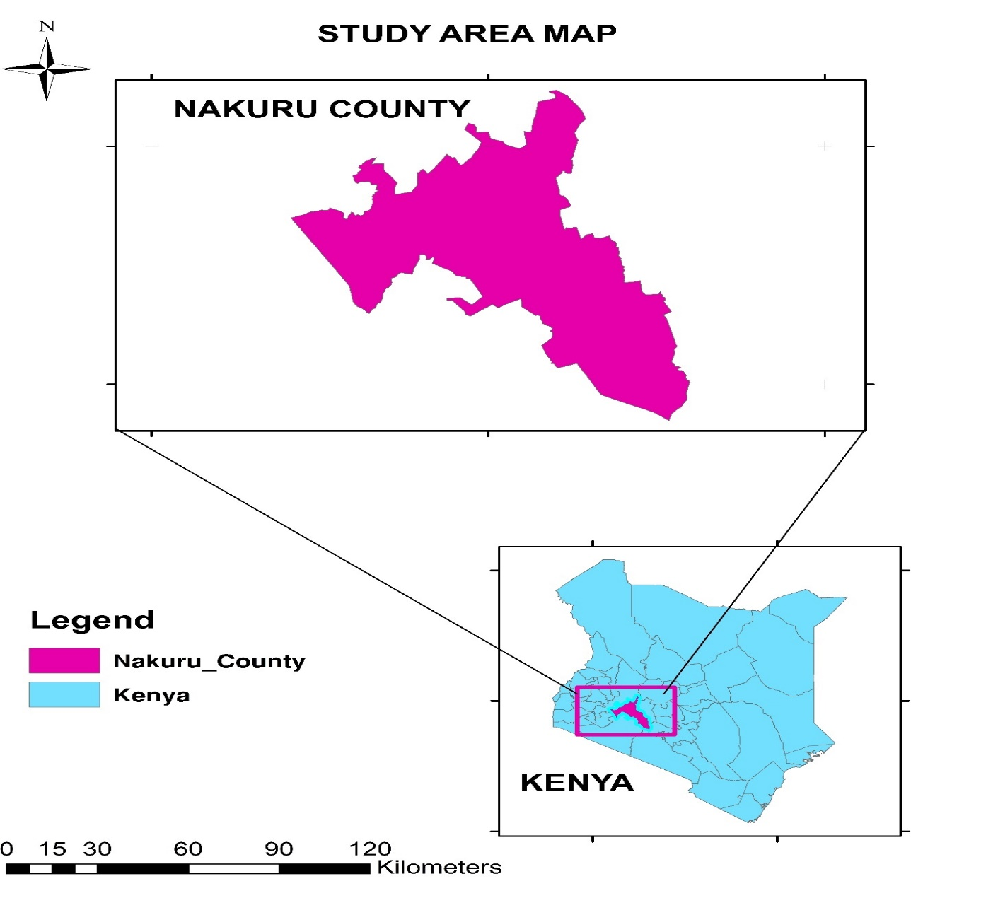
Figure ii: Study Area Map

3.3 Data Sources
Dataset/Tool | Source | Purpose
Sentinel-2 Level-2A (SR-HARMONIZED) satellite imagery | Copernicus via GEE | High-resolution (10m) imagery for NDVI calculation
Scene Classification Layer (SCL) tool | Sentinel-2 metadata | Cloud, shadow, and pixel masking
CHIRPS Daily Rainfall Data | Climate Hazards Group (via GEE) | For comparison of rainfall with vegetation trends
Nakuru County Shapefile | Humanitarian Data Exchange (HDX) | Study area boundary and image clipping
Google Earth Engine (GEE) | Google Cloud | Image processing, NDVI generation, area computation, and visualization
ArcMap 10.5 software | ESRI | Map layout design, cartographic elements (legends, scale bars)
The analysis relies on multiple open-access spatial datasets and platforms:
Table 1: Data Sources

3.4 Methodological Workflow
The NDVI-based vegetation changes detection follows the visualization steps below:
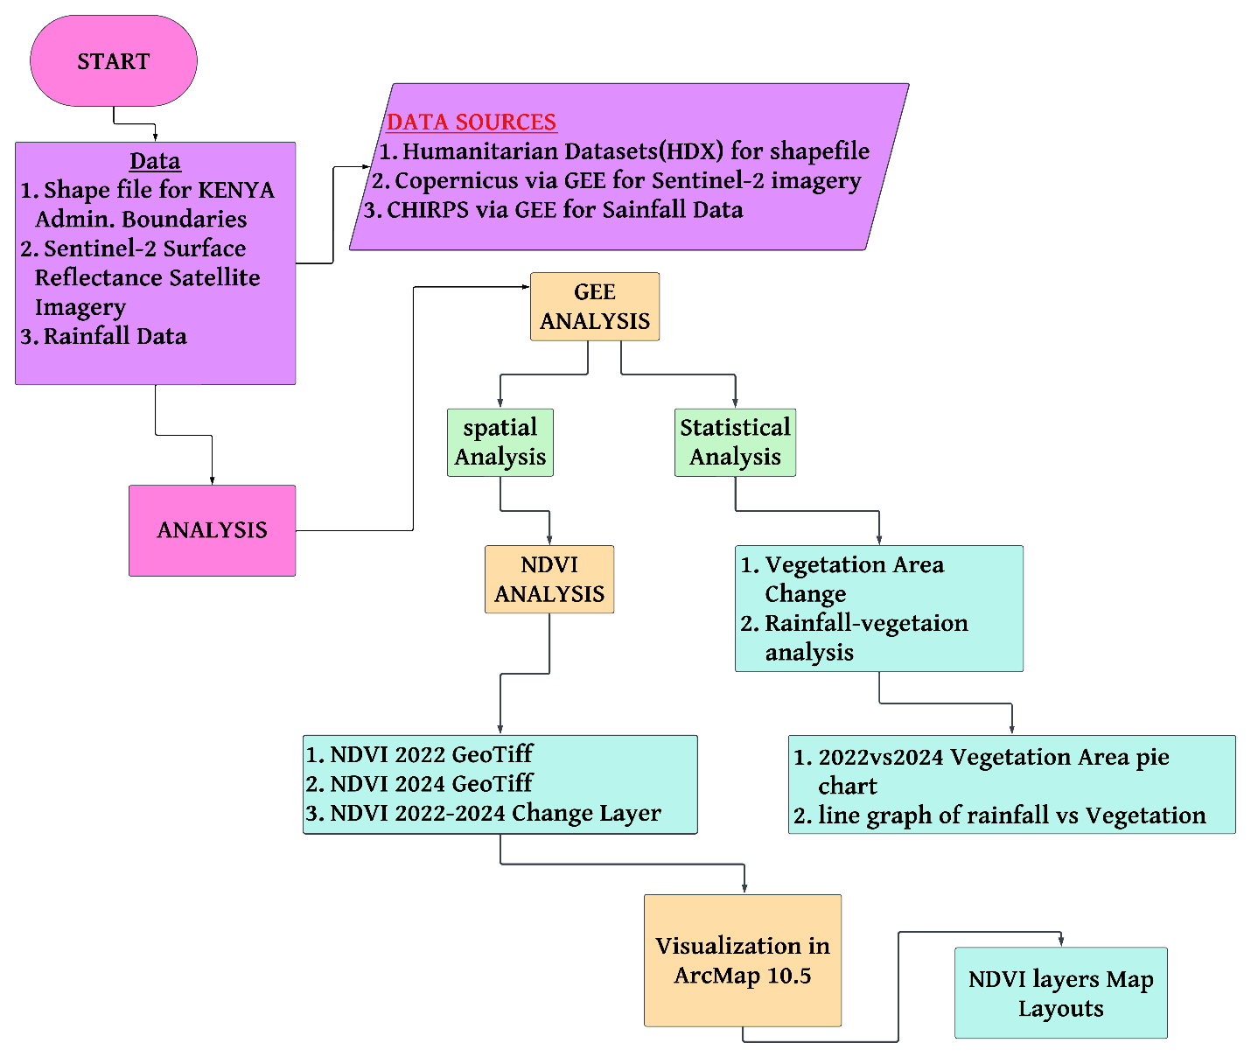
Figure iii:Methodology Flowchart

3.5Defining AOI in GEE using shapefile in the assets tab and specifying it in code.
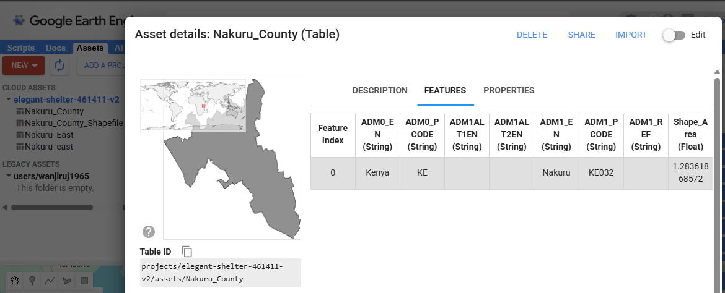
Figure iv: Uploading AOI into GEE
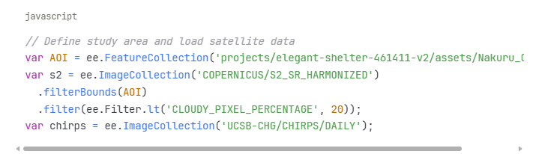
Figure v: Code section 1
Technical Specifications:
Spatial Resolution: 30 meters (resampled from 10m Sentinel-2 bands)
Coordinate System: EPSG:37337 (WGS 84 UTM zone 37S) - appropriate for Nakuru County, Kenya
Processing Platform: Google Earth Engine cloud computing platform
Quality Control: Maximum cloud pixel percentage threshold of 20%

The obtained RGB Sentinel-2 images clipped to the AOI:
2022
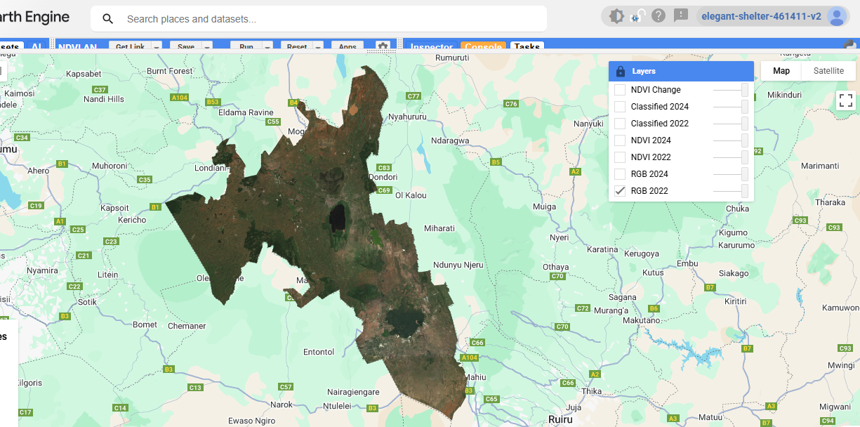
Figure vi: 2022 RGB Sentinel-2 Image
2024
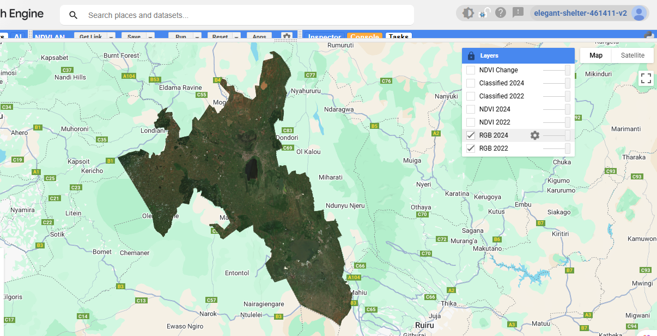
Figure vii: 2024 RGB Sentinel-2 Image

3.6 Spectral indices calculation and Cloud Masking

3.6.1 Cloud Masking
To ensure clean and reliable NDVI outputs:
The Scene Classification Layer (SCL) is used to mask out unwanted pixels:
- Shadows (Class 3)
- Clouds (Classes 8, 9)
- Cirrus and saturated pixels (Classes 10, 11)
Median composites are generated for April–June 2022 and 2024 to reduce noise and temporal outliers.
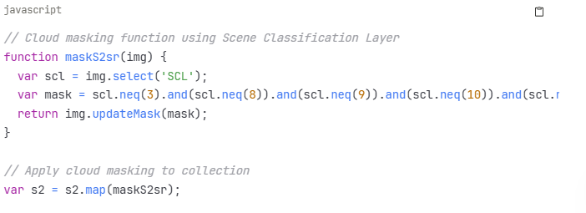
Figure viii: Code Section 2

3.6.2 NDVI Computation
The Normalized Difference Vegetation Index (NDVI) is calculated using the standard formula:
$$NDVI=\frac{(NIR-RED) }{(NIR+RED)}$$

Where:
B8 is the near-infrared (NIR) band
B4 is the red band
NDVI values range from -1.0 to +1.0. Healthy vegetation typically yields NDVI values above 0.3, which is used in this study as the threshold to classify “vegetated” areas.

Other indices were used to ensure NDVI is classified accurately by classifying water and built-up area to distinguish vegetation better as follows:
- NDBI (Normalized Difference Built-up Index): (SWIR - NIR) / (SWIR + NIR)
- MNDWI (Modified Normalized Difference Water Index): (Green - SWIR) / (Green + SWIR)
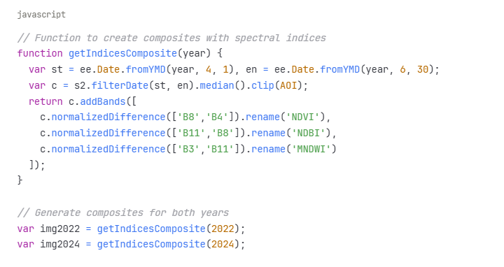
Figure ix: Code Section 3

Rule-based classification using spectral thresholds:
- Water: MNDWI > 0.3
- Built-up: NDBI > 0.2 (excluding water areas)
- Barren Land: NDVI < 0.3 (excluding water and built-up)
- Vegetation: NDVI ≥ 0.3 (remaining areas)

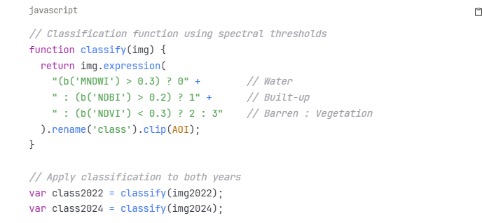
Figure x: Code Section 4

2022 NDVI OUTPUT
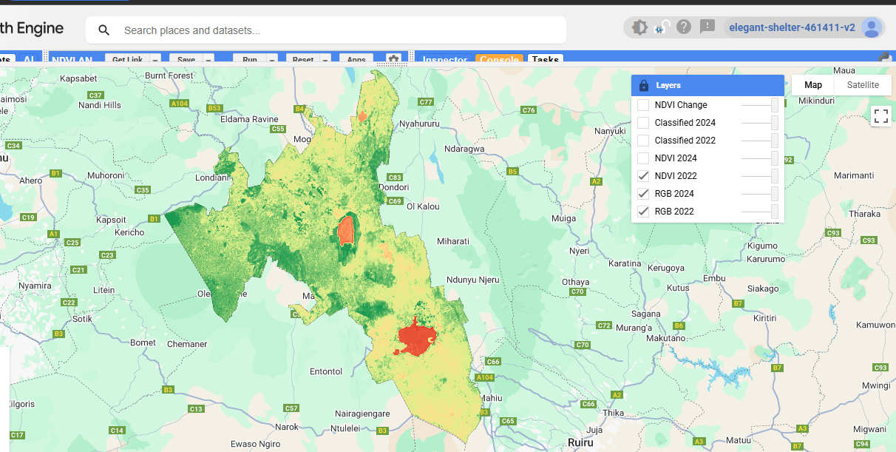
Figure xi: 2022 NDVI Result in GEE

2024 NDVI OUTPUT
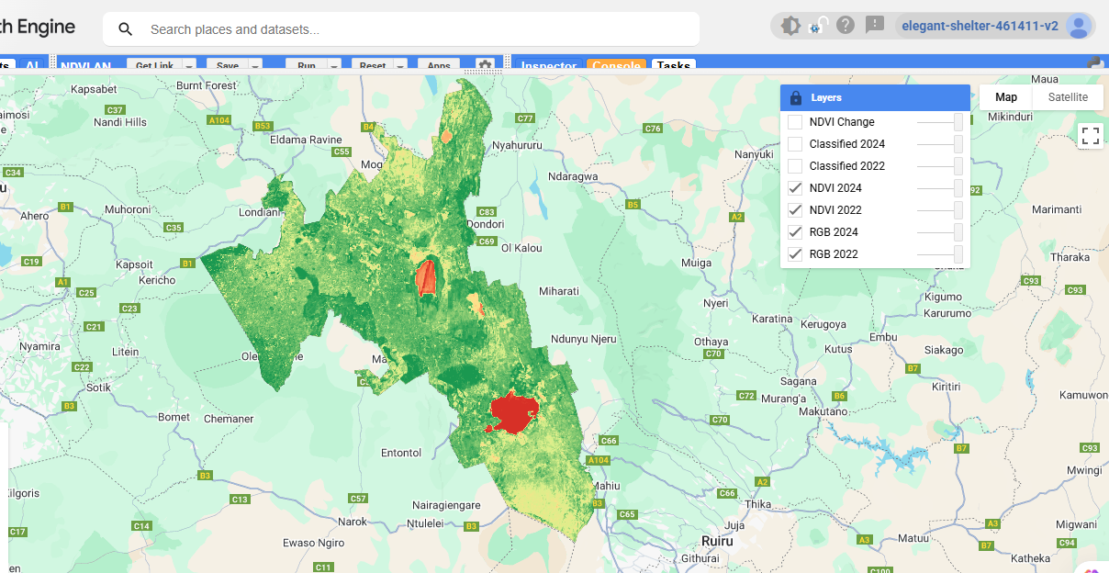
Figure xii: 2024 NDVI Result in GEE

3.7 NDVI Change Detection
A NDVI change image is generated by subtracting NDVI_2022 from NDVI_2024:
$$NDVI change=NDVI2024-NDVI2022$$
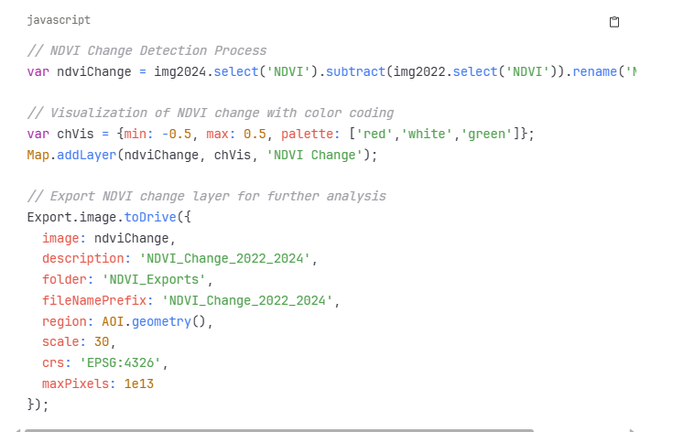
Figure xiii: Code Section 5

The result is visualized using a diverging colour palette:
Red tones: NDVI decline (vegetation loss)
Green tones: NDVI increase (vegetation gain)
White/neutral: Minimal or no change
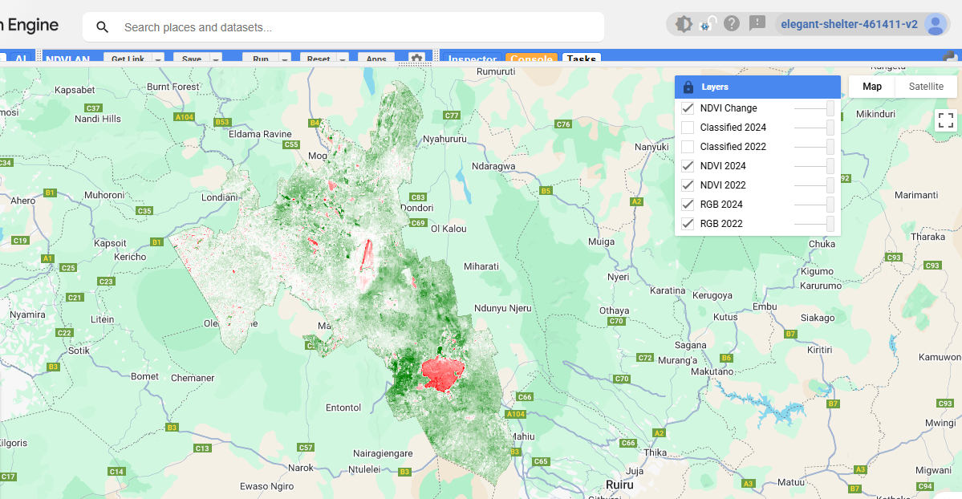
Figure xiv: NDVI Change Result in GEE

Change Interpretation:
Positive values indicate vegetation increase/improvement
Negative values indicate vegetation decrease/degradation
Values near zero indicate minimal change
This output identifies spatial hotspots of vegetation stress or recovery between the two hydrologic seasons.

3.8 Vegetation Area Calculation
Vegetated areas are quantified using a pixel-area summation approach:
- Pixels with NDVI > 0.3 are retained using an NDVI threshold mask.
- Each pixel is multiplied by its surface area using the ee.Image.pixelArea() function.
- The total area is then aggregated within the Nakuru AOI using .reduceRegion() and converted to hectares by dividing by 10,000.
This process is repeated for both 2022 and 2024, enabling temporal comparison and change detection.
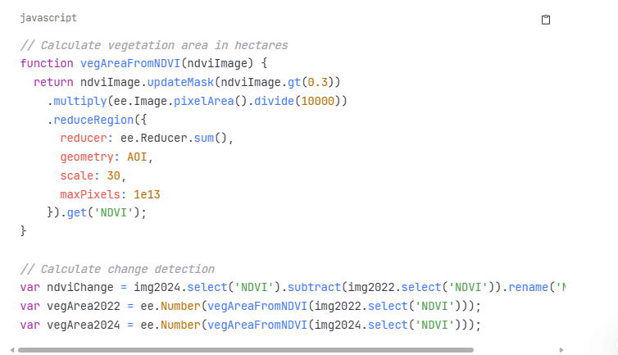
Figure xv: Code Section 6

3.9 Rainfall Comparison Analysis
To contextualize vegetation dynamics:
CHIRPS daily rainfall data is retrieved for Nakuru County.
Rainfall totals are aggregated over the April–June window for 2022 and 2024.
A dual-axis line chart is plotted comparing:
Total rainfall (mm)
Total vegetation area (ha) with NDVI > 0.3
This comparison allows for interpretation of vegetation response to rainfall variability.

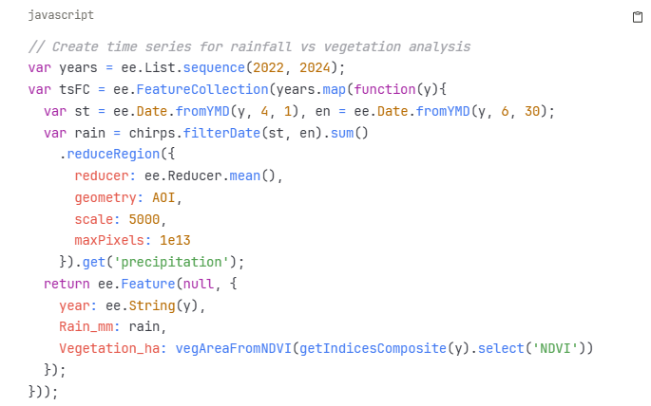
Figure xvi: Code Section 7

3.9 Visualization and Map Export
In Google Earth Engine (GEE):
NDVI maps are styled with a continuous colour gradient from -0.3 (brown/red) to +0.8 (green) and exported trough the tasks bar.
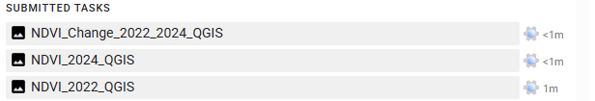
Figure xvii: Exports in Tasks Tab in GEE

Pie charts show percentage vegetation cover for 2022 vs 2024.
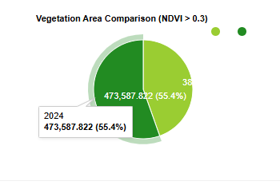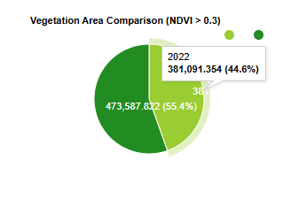
Figure xviii: Vegetation Area 2024 Figure xix: Vegetation Area 2022

NDVI-Rainfall charts visualize environmental interaction.
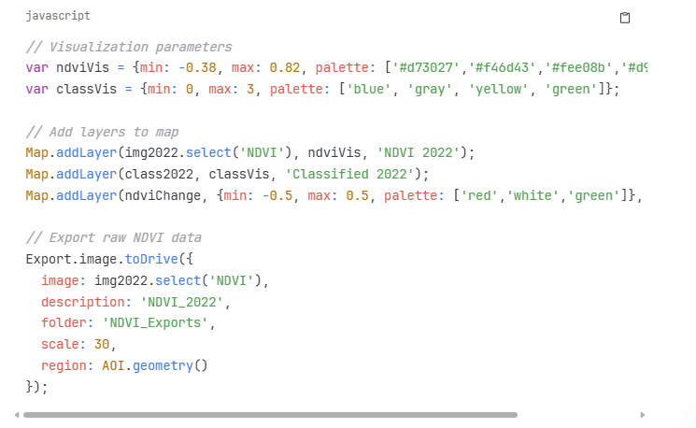
Figure xx: Code Section 8

In QGIS:
Exported NDVI layers (GeoTIFF) are styled with:
  - A standardized colour ramp
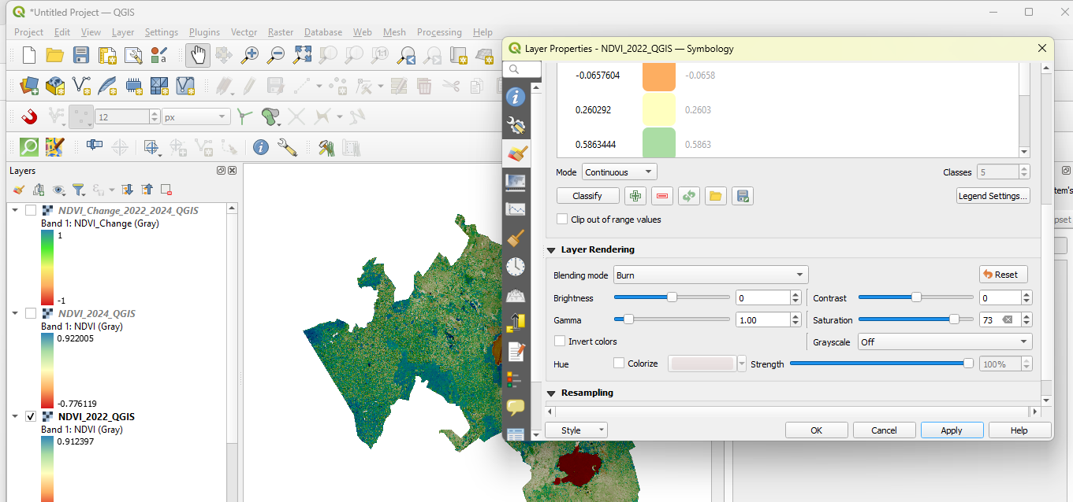
Figure xxi: symbolization in QGIS

The visualization with of the NDVI change layer after applying symbology changes:
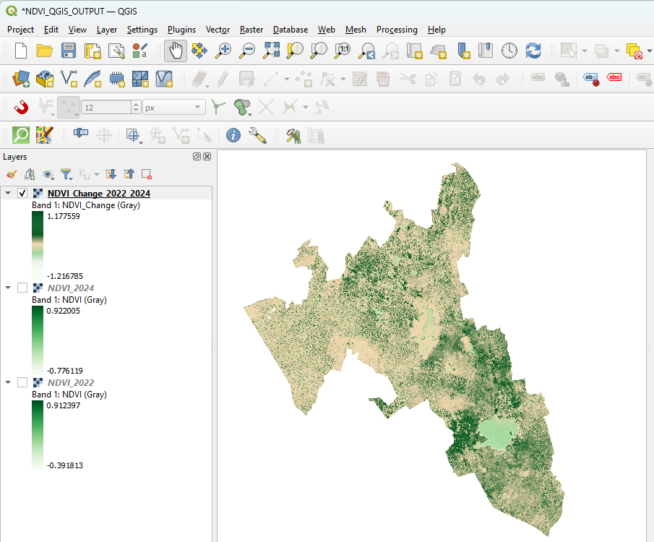
Figure xxii: The DVI Change layer Symbolization
The NDVI 2024 layer after symbology changes:
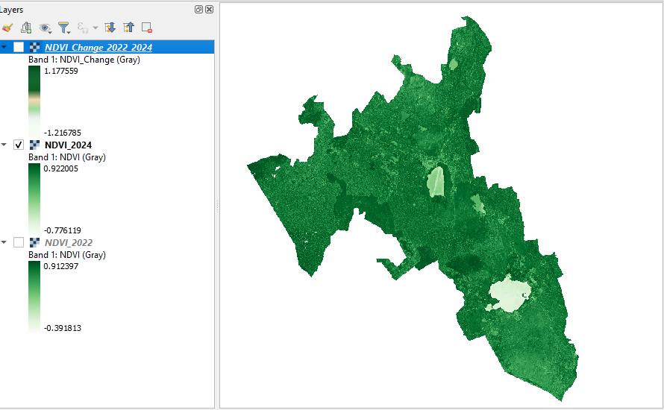
Figure xxiii: NDVI 2024 Symbolization in QGIS
The NDVI 2022 after applying symbology changes:
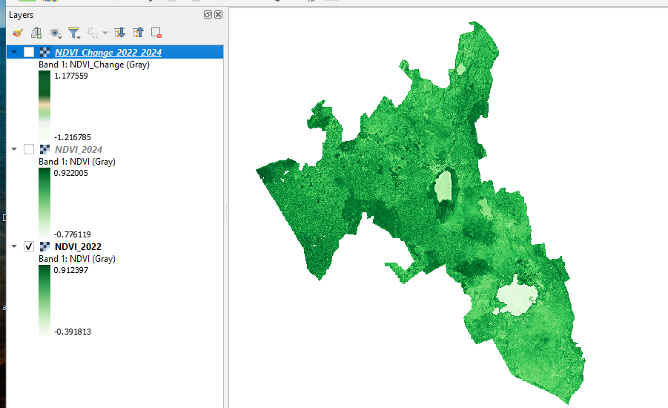
Figure xxiv: NDVI 2022 Symbolization in QGIS

  - Titles, scale bars, and north arrows in Map Layout.
  - Classified legends from -1 to +1 NDVI

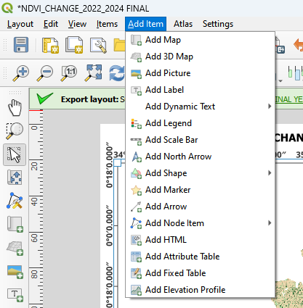
No classification or area computation is done in QGIS only map design.

3.10 Software and Tools Used
Tool | Role in Workflow
Google Earth Engine (GEE) | Image processing, NDVI computation, masking, area analysis, visualization
Sentinel-2 Level-2A | Primary image source for vegetation monitoring
CHIRPS Rainfall Dataset | Climatic correlation with vegetation dynamics
ArcMap 10.5 | NDVI map layout and legend generation and AOI clipping.
Microsoft Excel | Chart formatting for export
HDX Shapefile | Shapefile to be used for clipping the AOI
Table 2: Software and Tools Used

3.11 Summary
The methodology integrates cloud-based NDVI processing, pixel-level area quantification, and map-based spatial analysis to assess vegetation change in Nakuru County. By leveraging GEE’s efficiency and Sentinel-2’s resolution, the study ensures high temporal accuracy and spatial clarity. The comparative design evaluating 2022 (drought) and 2024 (flood) provides a robust framework for understanding vegetation response to climate variability. The use of NDVI alone, with minimal classification, streamlines the workflow and avoids misclassification errors common in multi-index studies.

CHAPTER FOUR

RESULTS AND DISCUSSION

4.1 Overview
This chapter presents and interprets the results of the NDVI-based vegetation change analysis conducted for Nakuru County between two hydrologically distinct seasons: April–June 2022 (drought) and April–June 2024 (flood). Using Sentinel-2 imagery processed in Google Earth Engine (GEE), the study generated NDVI composites, calculated vegetated area, and visualized temporal and spatial changes. The findings are interpreted using NDVI thresholds, pixel-based area metrics, and rainfall-vegetation comparisons, followed by a discussion linking these observations to broader ecological and climatic contexts.

4.2 NDVI Distribution in April–June 2022 (Drought Year)
The NDVI composite for the drought period (April–June 2022) indicates generally low vegetation greenness across Nakuru County. The NDVI values range from approximately -0.39 to +0.912.
Large portions of the county displayed NDVI values below 0.3, indicating low biomass and vegetation stress consistent with prolonged dry spells during this period.
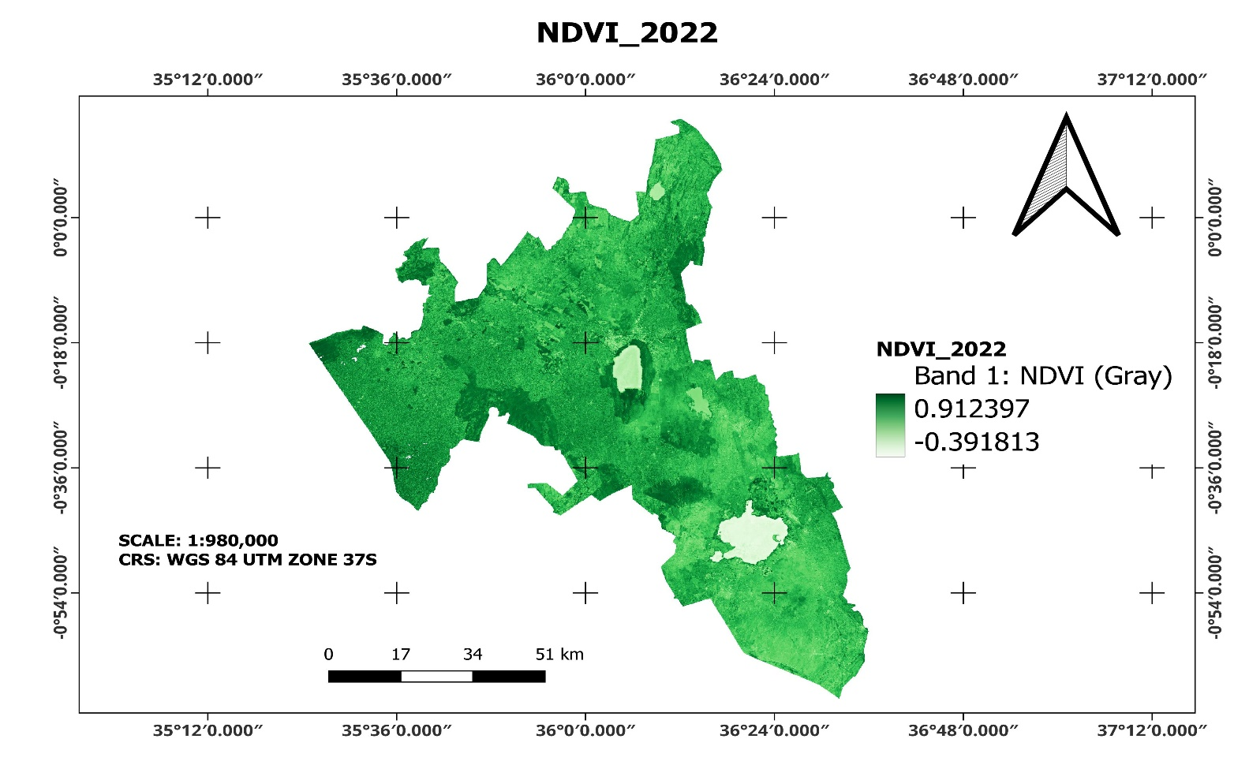
Figure xxv: NDVI 2022 Map layout in QGIS
Interpretation:
The low NDVI values are indicative of moisture stress, leaf senescence, or bare soil exposure.
These conditions align with below-average rainfall in early 2022, confirming vegetation sensitivity to precipitation shortfalls.

4.3 NDVI Distribution in April–June 2024 (Flood Year)
The NDVI composite for April–June 2024 reveals a substantial greening of the landscape, with values ranging from -0.10 to +0.84.
A higher % of the county exhibits NDVI > 0.3, a significant improvement compared to 2022.
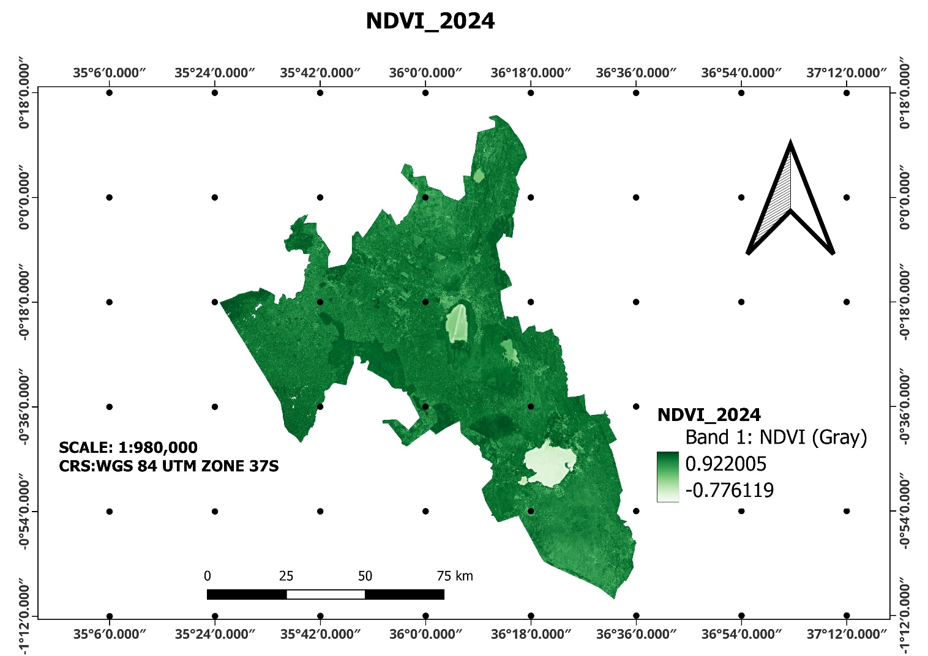
Figure xxvi: NDVI 2024 Map Layout in QGIS
Interpretation:
NDVI increases suggest a post-flood vegetation recovery effect, where water availability, nutrient deposits, and reduced grazing pressure may have boosted photosynthetic activity.
The rise in NDVI also aligns with increased rainfall in early 2024, promoting plant regeneration.

4.4 NDVI Change Detection (2022–2024)
A differential NDVI layer was generated by subtracting the 2022 NDVI composite from that of 2024:
NDVI Change=NDVI2024−NDVI2022
The change map is visualized using a diverging colour scale:
Red tones indicate NDVI decline (vegetation loss)
White/neutral areas represent minimal or no change
Green tones indicate NDVI gain (vegetation recovery or growth)
Observations:
Over 60% of Nakuru County experienced positive NDVI change (+0.1 to +0.4), suggesting vegetation recovery or improved growth.
Minor NDVI declines were detected in peri-urban zones (e.g., Nakuru Town, Naivasha) likely due to construction or land conversion.
Wetland expansion and improved riparian vegetation were noticeable in the floodplains.

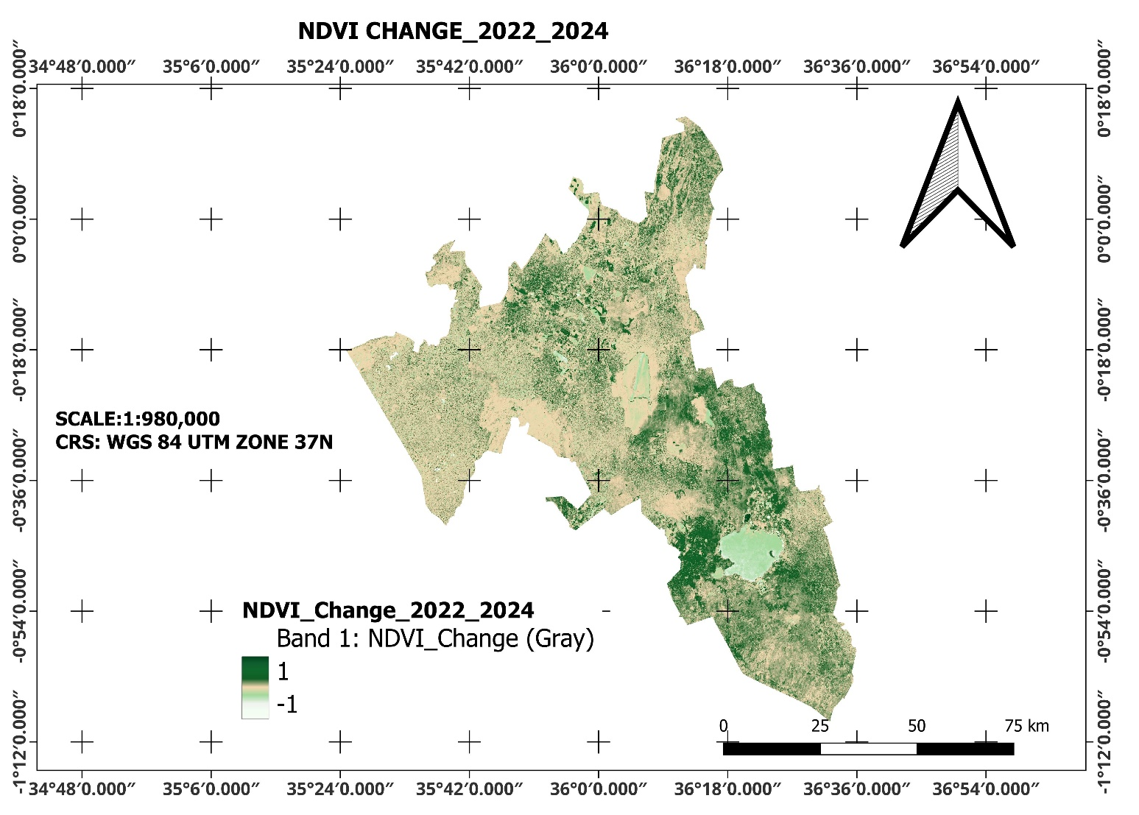
Figure xxvii: NDVI 2022-2024 Change Map Layout

4.5 Vegetation Area Statistics
Using a threshold of NDVI > 0.3 to define "vegetated area," the total vegetated surface area was calculated for both years using GEE's pixelArea () and reduceRegion() functions.
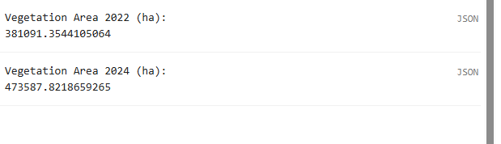
Figure xxviii: GEE Output of Vegetation Area in each year

Year | Total Vegetated Area (ha) | Change (ha)
2022 | 381091.4 ha
2024 | 473587.8 ha | +92496.4ha
Table 3: Vegetation Areas in ha and the Change
Findings:
A net gain of 92,496.4 hectares of vegetation was recorded between 2022 and 2024.
This represents a 10.8 % increase in vegetated cover during the study period.
Pie charts created in GEE visually support this finding, showing:
2022: Vegetation (NDVI > 0.3) = ~44.6% of land area
2024: Vegetation (NDVI > 0.3) = ~55.4% of land area
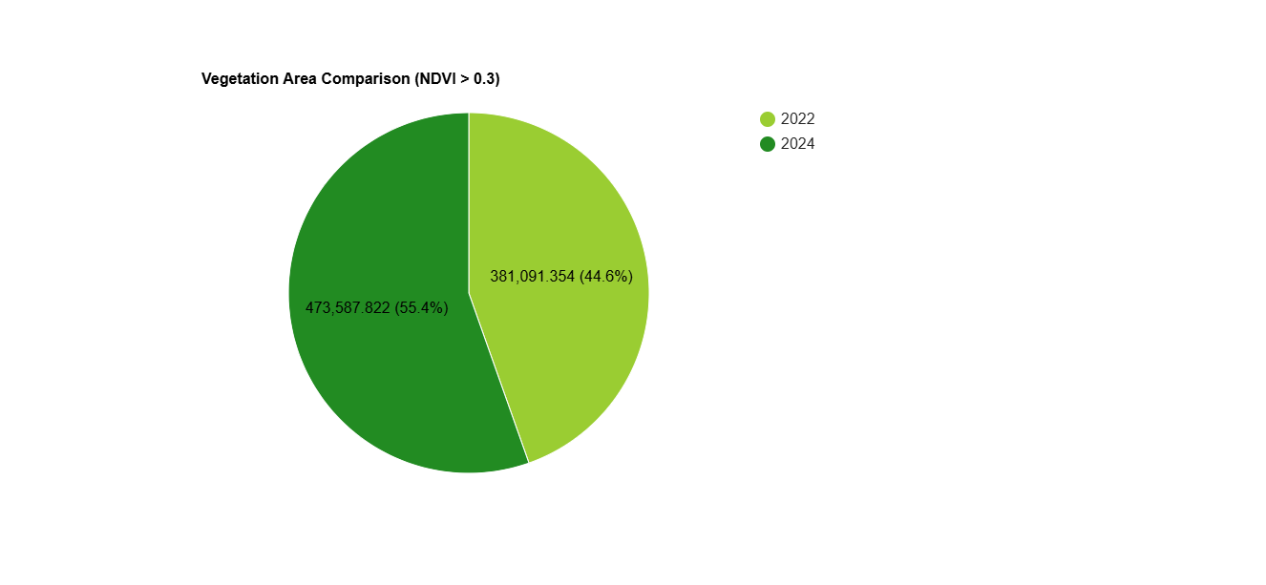
Figure xxix: Vegetation Area in hectares Pie chart for 2022 vs 2024

4.6 NDVI vs. Rainfall Comparison
To understand the relationship between rainfall and vegetation patterns, CHIRPS rainfall data was analyzed for April–June in both 2022 and 2024.
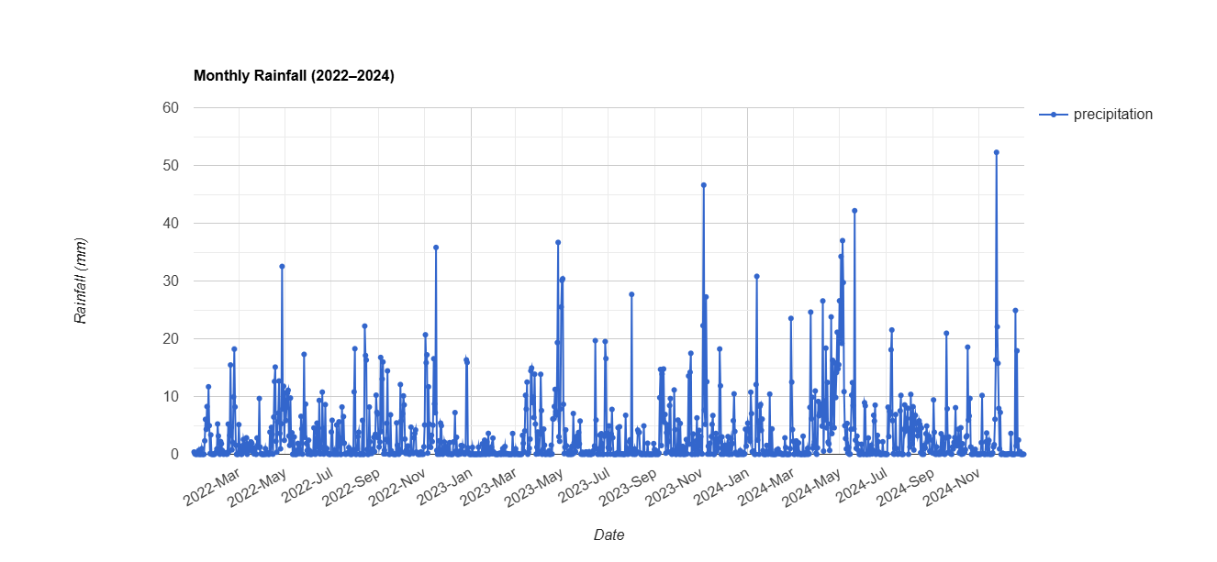
Figure xxx: Rainfall Chart between 2022 to 2024
A dual-axis time-series chart from GEE illustrates this relationship, showing synchronized upward trends in rainfall and vegetated area during the 2024 season.
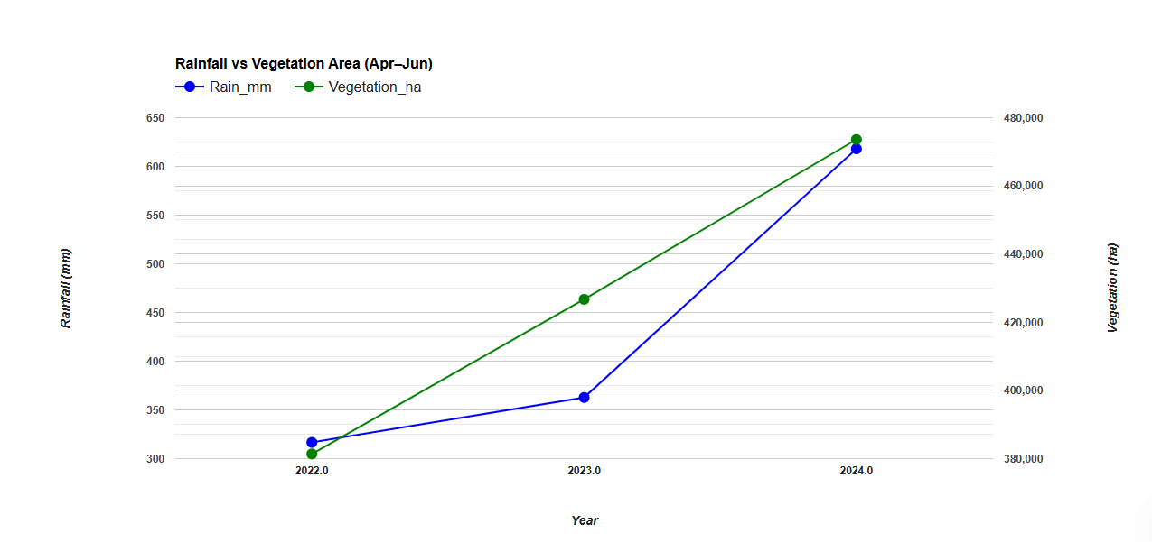
Interpretation:
The data indicates a positive correlation between increased rainfall and vegetation recovery.
An increase in rainfall was followed by a ~10.8% increase in vegetated area, reflecting factors like enhanced soil moisture and photosynthetic potential during the flood season that facilitates good vegetation growth.
However, the vegetation response was not linear, suggesting that land cover, soil retention, or prior degradation may moderate NDVI gains.

4.7 Spatial Trends and Map Interpretation
The NDVI maps exported to QGIS 3.40 reveal:
The Low NDVI values witnesses in the 2022 layer shown by more regions covered in brown indicate vegetation stress due to drought.
Clearly demarcated high NDVI zones (dark green) in 2024 corresponding to forested and flooded regions.
The NDVI change map effectively highlights:
Recovery zones (green) where vegetation was seen to increase during the increase in rainfall year.
These outputs provide decision-ready visuals for climate impact assessment, reforestation targeting, and land-use planning.

4.8 Discussion of Findings
The results confirm that NDVI is a sensitive and accurate proxy for detecting short-term vegetation change caused by climatic extremes. Specifically:
The drought of 2022 suppressed vegetation Vigour across much of Nakuru, while the floods of 2024 stimulated extensive greening and vegetation recovery.
These outcomes validate the findings of similar studies:
- Thamaga et al. (2021) observed vegetation rebound post-flood in southern Africa.
- Mpanyaro et al. (2024) linked drought-induced NDVI drops to rainfall deficits across East Africa.
This study further demonstrates the power of Google Earth Engine (GEE) to automate NDVI generation, apply pixel-based thresholds, and compute vegetation area changes with it being time effective and efficient through the deployment of code.

4.9 Summary of Key Results
- NDVI increased across most of Nakuru County between April–June 2022 and 2024.
- Total vegetated area expanded by ~92,496.4 ha, representing a 10.8% gain.
- Vegetation responded positively to increased rainfall
- NDVI change maps and pie charts effectively visualized spatial and temporal vegetation shifts.
These findings show the importance of short-term vegetation monitoring for climate adaptation, urban planning, and landscape restoration in climate-sensitive regions.

CHAPTER FIVE

CONCLUSIONS AND RECOMMENDATIONS

5.1 Conclusion
This research investigated vegetation changes in Nakuru County between April–June 2022 and 2024, focusing on the contrasting ecological impacts of drought and flood seasons. By applying Sentinel-2 imagery and leveraging the analytical capabilities of Google Earth Engine (GEE), the study employed the Normalized Difference Vegetation Index (NDVI) to assess vegetation health. NDVI composites, change detection maps, and area statistics were produced and interpreted in relation to rainfall variability to understand how climate conditions influence ecological performance.
Key Findings:
- Drought Effects (2022): NDVI values ranged from –0.392 to 0.912. Many regions showed substantial vegetation decline, particularly in agricultural and lowland areas. These reductions were consistent with prolonged dry spells, leading to biomass loss and plant stress.
- Post-Flood Greening (2024): NDVI values improved significantly, reaching up to 0.922. Areas such as forest belts, escarpments, and wetlands displayed notable recovery, likely due to enhanced water availability and nutrient deposition after flooding.
- Vegetation Dynamics: The NDVI change map revealed that over 60% of Nakuru County experienced positive vegetation change between 2022 and 2024. Limited zones of decline were detected near urbanizing regions, where land conversion and infrastructure growth may have suppressed greenness.
- Effectiveness of Remote Sensing Tools: The combination of GEE and QGIS provided an accessible, scalable platform for tracking environmental changes. However, the integrity of outputs depends on the quality of pre-processing steps, including cloud masking and image calibration, as well as thoughtful interpretation aligned with ecological realities.
Why These Results Matter – A Reflective Perspective
As someone directly familiar with the landscapes of Nakuru County, I was drawn to this research not only by a scientific question, but by an observed reality: how visibly the land changes during wet and dry seasons, and how these changes affect lives and livelihoods.
This study emerged from a desire to move beyond mere observation to generate evidence that could help both local communities and policymakers make more informed decisions. From pastoralist zones that struggle during drought to wetlands that flourish during floods, NDVI gave us a way to measure and map what’s often only felt.
For me, this work is more than data; it’s a call to use technology in service of sustainability. Remote sensing is a tool but what matters is what we choose to do with the knowledge it provides.

5.2 Recommendations

5.2.1 Policy and Land Management
- Adopt NDVI-Based Monitoring as Standard Practice
Government agencies should incorporate seasonal NDVI tracking into early warning systems. The ability to monitor vegetation remotely can improve drought forecasts, flood response, and overall environmental management.
- Restore Critical Wetland and Floodplain Areas
Vegetation recovery was most evident in wetlands and riparian corridors. These ecosystems should be prioritized for restoration, legal protection, and conservation to enhance resilience against future climate shocks.
- Implement Sustainable Urban Planning
Urban expansion is visibly impacting vegetation in Peri-urban areas. Planning decisions must integrate NDVI data to guide growth away from ecologically sensitive zones and minimize long-term degradation.
- Promote Agro-ecological Farming Systems
Farmers should be supported to adopt techniques such as agroforestry, conservation agriculture, and rainwater harvesting — practices that stabilize vegetation cover and reduce vulnerability to rainfall variability.

5.2.2 Scientific Research and Climate Preparedness
- Extend Study Duration to Detect Long-Term Patterns
Expanding future analysis to cover a longer time period will allow differentiation between short-term seasonal changes and sustained ecological trends. This can better inform climate adaptation strategies.
- Create a Vegetation Recovery Index (VRI)
A tailored index based on NDVI change would provide a standardized way to measure post-disaster ecological recovery. It could support land rehabilitation planning and environmental impact assessments.
- Validate Remote Sensing Outputs with Field Data
NDVI interpretation should be supported by on-the-ground surveys. This ensures that the remotely sensed indicators reflect actual vegetation conditions and increases confidence in policy decisions derived from the data.

5.2.3 Technical Implementation and Capacity Development
- Strengthen Local Expertise in Geospatial Technologies
County agencies, research institutions, and universities should offer training in platforms like GEE, QGIS, and Python APIs. Enhancing technical skills at the local level promotes long-term sustainability of monitoring programs.
- Ensure High-Quality Pre-processing in NDVI Workflows
Image analysis must include reliable cloud and shadow masking, removal of water bodies and bare ground, and spatial consistency checks to prevent misinterpretation of vegetation metrics.
- Integrate NDVI into Incentive Programs for Conservation
Vegetation indices can be used in Payment for Ecosystem Services (PES) schemes to reward communities that maintain or restore vegetation. Quantifiable greenness metrics ensure transparency and accountability.

5.3 Final Remarks – Research as Responsibility
This study illustrates how remote sensing technologies can illuminate the ecological effects of climate extremes. By mapping changes in vegetation across Nakuru County, it becomes clear that climate variability has both damaging and regenerative impacts on the landscape.
What this research affirms and what I deeply believe is that monitoring the land is not just a technical exercise, but a responsibility. In regions where lives depend on the health of vegetation, having timely, accurate data is critical to resilience. The tools now exist the challenge lies in applying them wisely, consistently, and inclusively.
If Nakuru County is to thrive under the pressures of climate change, its governance must be informed by more than historical intuition. It must be guided by data, reflection, and a shared commitment to safeguarding the environment we depend on.

REFERENCES
- Ali, A., Noor, A., & Njeru, J. (2024). Mapping vegetation degradation in semi-arid Kenya using Sentinel-2 and GEE. Remote Sensing for Environment, 18(2), 92–107. https://doi.org/10.1016/j.rse.2024.103572

- Dinku, T., Funk, C., & Grimes, D. (2011). Assessment of satellite rainfall products for drought monitoring in Kenya. Journal of Applied Meteorology and Climatology, 50(2), 266–286. https://doi.org/10.1175/2010JAMC2411.1

- Funk, C., Senay, G., Asfaw, A., & Verdin, J. (2005). Recent drought tendencies in Ethiopia and equatorial-subtropical eastern Africa. FEWS NET, USGS Report.

- Hargreaves, P. K., & Watmough, G. R. (2021). Satellite earth observation to support sustainable rural development. International Journal of Applied Earth Observation and Geoinformation, 100, 102359. https://doi.org/10.1016/j.jag.2021.102359

- Hesping, A. (2020). Land cover classification and NDVI-based change detection on Rusinga Island, Kenya. University of Twente MSc Thesis Repository. https://www.itc.nl/library/papers_2020/msc/gis/hesping.pdf

- Kalumba, D. E., Ndehedehe, C. E., & Ngetich, K. F. (2024). GEE and Sentinel-2 based vegetation monitoring in tropical Africa: Accuracy assessment and applications. Ecological Indicators, 157, 112857. https://doi.org/10.1016/j.ecolind.2023.112857

- Kipkulei, J. (2024). Detecting vegetation degradation in Mau Forest Complex using NDVI and time-series analysis. African Journal of Environmental Science and Technology, 18(1), 11–25. https://doi.org/10.5897/AJEST2024.3181

- Macharia, P., Ngugi, R. K., & Gitau, W. (2012). Seasonal NDVI trends and their implication on rangeland resource monitoring in Kenya. African Journal of Range & Forage Science, 29(3), 97–103. https://doi.org/10.2989/10220119.2012.744788

- Mpanyaro, J., Thamaga, K. H., & Dube, T. (2024). Assessing vegetation recovery after drought in East Africa using Sentinel-2 NDVI. Remote Sensing Letters, 15(3), 203–214. https://doi.org/10.1080/2150704X.2024.1178865

- Mukarram, M. M. T., Rukiya, Q. U., & Demir, I. (2025). GeoAI-based NDVI forecasting and rainfall vegetation coupling in Kenya. EarthArXiv Preprint. https://doi.org/10.31223/X59Z6T

- Musyimi, D. M., Ndunda, E. N., & Wambua, R. (2023). NDVI-based evaluation of climate impact on crop health in Kenya. African Journal of Environmental Science, 17(1), 1–12. https://ajest.org/article/view/11324

- Osio, E. N., & Kaloki, J. N. (2020). Vegetation stress trends in Lake Nakuru National Park using MODIS and NDVI metrics. Journal of Ecology and Environment, 16(3), 104–113. https://doi.org/10.1186/s41610-020-00156-w

- Pettorelli, N., Vik, J. O., Mysterud, A., Gaillard, J.-M., Tucker, C. J., & Stenseth, N. C. (2005). Using the NDVI to assess ecological responses to environmental change. Trends in Ecology & Evolution, 20(9), 503–510. https://doi.org/10.1016/j.tree.2005.05.011

- Thamaga, K. H., & Dube, T. (2021). Flood and post-flood vegetation dynamics assessment using NDVI and Sentinel-2 in Southern Africa. Physics and Chemistry of the Earth, 123, 103015. https://doi.org/10.1016/j.pce.2021.103015

- Vrdoljak, L., Racetin, I., & Zrinjski, M. (2024). Global trends in the use of Google Earth Engine for remote sensing and environmental monitoring. Sustainability, 16(14), 6211. https://doi.org/10.3390/su16146211

- Vrieling, A., de Beurs, K. M., & Brown, M. E. (2011). Variability of African farming systems from NDVI and rainfall time series. Agricultural Systems, 104(4), 316–326. https://doi.org/10.1016/j.agsy.2010.12.001

- Zhang, H., Zhang, Y., & Bai, J. (2022). Evaluating the effects of seasonal climate on vegetation using NDVI time series. Journal of Arid Environments, 194, 104686. https://doi.org/10.1016/j.jaridenv.2021.104686

