

Functional Safety Concept Lane Assistance

**Document Version: [Version]**

**Template Version 1.0, Released on 2017-06-21**



# Document history

|  |  |  |  |
| --- | --- | --- | --- |
| Date | Version | Editor | Description |
| 2018.10.29 |  | Wanlin Yang | gandue |
|  |  |  |  |
|  |  |  |  |
|  |  |  |  |
|  |  |  |  |

# Table of Contents

Document history

Table of Contents

Purpose of the Functional Safety Concept

Inputs to the Functional Safety Analysis

Safety goals from the Hazard Analysis and Risk Assessment

Preliminary Architecture

Description of architecture elements

Functional Safety Concept

Functional Safety Analysis

Functional Safety Requirements

Refinement of the System Architecture

Allocation of Functional Safety Requirements to Architecture Elements

Warning and Degradation Concept

# Purpose of the Functional Safety Concept

The functional safety concept provides a high level overview of the system. Based on the hazard analysis and risk assessment, the requirements of the system will be figured out in this section. The safety goals are refined into safety requirements. These safety requirements are then allocated to the appropriate parts of the item’s architecture.

# Inputs to the Functional Safety Concept

## Safety goals from the Hazard Analysis and Risk Assessment

|  |  |
| --- | --- |
| **ID** | **Safety Goal** |
| Safety_Goal_01 | The oscillating torque to the steering wheel from the lane departure function shall be limited. |
| Safety_Goal_02 | The LKA function shall be time limited and the additional steering torque shall end after a given time interval so that the driver cannot misuse the system for autonomous driving. |

## Preliminary Architecture

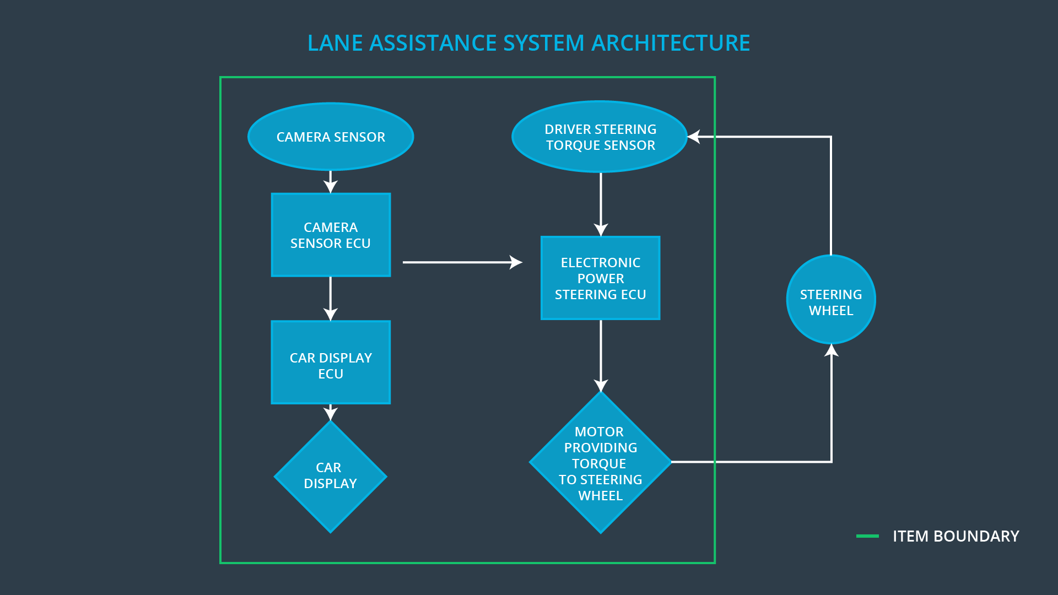

### Description of architecture elements

|  |  |
| --- | --- |
| **Element** | **Description** |
| Camera Sensor | The Camera Sensor reads in images from the road. |
| Camera Sensor ECU | The Camera Sensor ECU identifies when the vehicle has accidentally departed its lane, and sends the appropriate messages to the Car Display ECU and the Electronic Power Steering ECU. |
| Car Display | The Car Display is the user interface that displays warning and suggestion on dashboard. |
| Car Display ECU | The Car Display ECU receives signal from the Camera Sensor ECU, processes image information, and sends output to the Car Display. |
| Driver Steering Torque Sensor | The Driver Steering Torque Sensor measures how much the driver is turning, and sends data to the Electronic Power Steering ECU. |
| Electronic Power Steering ECU | The Electronic Power Steering ECU computes how hard the steering wheel should turn and vibrate based on car’s departure information, and sends messages to the Motor. |
| Motor | Motor is the actuator that vibrates and turns the steering wheel. |

# Functional Safety Concept

The functional safety concept consists of:

* Functional safety analysis
* Functional safety requirements
* Functional safety architecture
* Warning and degradation concept

## Functional Safety Analysis

|  |  |  |  |
| --- | --- | --- | --- |
| **Malfunction ID** | **Main Function of the Item Related to Safety Goal Violations** | **Guidewords (NO, WRONG, EARLY, LATE, MORE, LESS)** | **Resulting Malfunction** |
| Malfunction_01 | Lane Departure Warning (LDW) function shall apply an oscillating steering torque to provide the driver a haptic feedback | MORE | The lane departure warning function applies an oscillating torque with very high torque amplitude (above limit) |
| Malfunction_02 | Lane Departure Warning (LDW) function shall apply an oscillating steering torque to provide the driver a haptic feedback | MORE | The lane departure warning function applies an oscillating torque with very high torque frequency (above limit) |
| Malfunction_03 | Lane Keeping Assistance (LKA) function shall apply the steering torque when active in order to stay in ego lane | NO | The lane keeping assistance function is not limited in time duration which leads to misuse as an autonomous driving function. |

## Functional Safety Requirements

Lane Departure Warning (LDW) Requirements:

|  |  |  |  |  |
| --- | --- | --- | --- | --- |
| **ID** | **Functional Safety Requirement** | **ASIL** | **Fault Tolerant Time Interval** | **Safe State** |
| Functional  Safety  Requirement  01-01 | The electronic power steering ECU shall ensure that the oscillating torque amplitude is below Max_Torque_Amplitude. | C | 50 ms | LDW will set the oscillating torque amplitude to 0. |
| Functional  Safety  Requirement  01-02 | The electronic power steering ECU shall ensure that the oscillating torque frequency is below Max_Torque_Frequency. | C | 50 ms | LDW will set the oscillating torque frequency to 0. |

Lane Departure Warning (LDW) Verification and Validation Acceptance Criteria:

|  |  |  |
| --- | --- | --- |
| **ID** | **Validation Acceptance**  **Criteria and Method** | **Verification Acceptance**  **Criteria and Method** |
| Functional  Safety  Requirement  01-01 | Test how drivers react to different torque amplitudes to prove that the value is appropriate. | When the torque amplitude crosses the limit, the lane assistance output is set to zero within the fault tolerant time interval. |
| Functional  Safety  Requirement  01-02 | Test how drivers react to different torque frequencies to prove that the value is appropriate. | When the torque frequency crosses the limit, the lane assistance output is set to zero within the fault tolerant time interval. |

Lane Keeping Assistance (LKA) Requirements:

|  |  |  |  |  |
| --- | --- | --- | --- | --- |
| **ID** | **Functional Safety Requirement** | **ASIL** | **Fault Tolerant Time Interval** | **Safe State** |
| Functional  Safety  Requirement  02-01 | The electronic power steering ECU shall ensure that the lane keeping assistance torque is applied for only Max_Duration. | B | 50 ms | The LKA will turn off the assistance system. |

Lane Keeping Assistance (LKA) Verification and Validation Acceptance Criteria:

|  |  |  |
| --- | --- | --- |
| **ID** | **Validation Acceptance**  **Criteria and Method** | **Verification Acceptance**  **Criteria and Method** |
| Functional  Safety  Requirement  02-01 | The Max_Duration really did dissuade drivers from taking their hands off the wheel. | The system really does turn off if the lane keeping assistance while exceeding Max_Duration. |

## Refinement of the System Architecture

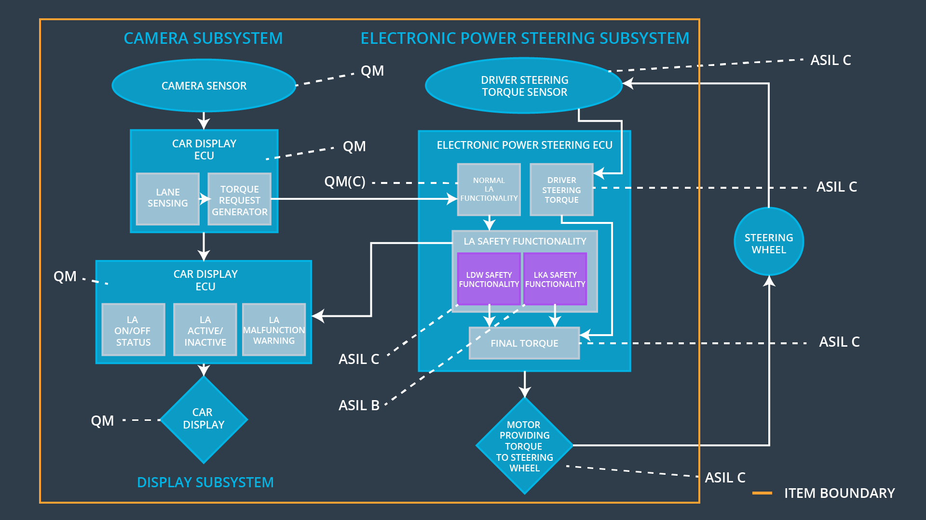

## Allocation of Functional Safety Requirements to Architecture Elements

|  |  |  |  |  |
| --- | --- | --- | --- | --- |
| **ID** | **Functional Safety Requirement** | **Electronic Power Steering ECU** | **Camera ECU** | **Car Display ECU** |
| Functional  Safety  Requirement  01-01 | The electronic power steering ECU shall ensure that the oscillating torque amplitude is below Max_Torque_Amplitude. | X |  |  |
| Functional  Safety  Requirement  01-02 | The electronic power steering ECU shall ensure that the oscillating torque frequency is below Max_Torque_Frequency. | X |  |  |
| Functional  Safety  Requirement  02-01 | The electronic power steering ECU shall ensure that the lane keeping assistance torque is applied for only Max_Duration. | X |  |  |

## Warning and Degradation Concept

**[Instructions: Fill in the warning and degradation concept.]**

|  |  |  |  |  |
| --- | --- | --- | --- | --- |
| **ID** | **Degradation Mode** | **Trigger for Degradation Mode** | **Safe State invoked?** | **Driver Warning** |
| WDC-01 | Turn off the functionality. | Malfunction_01,Malfunction_02,Malfunction_04. | Yes | The warning is shown on the Car Display system. |
| WDC-02 | Turn off the functionality. | Malfunction_03,Malfunction_05 | Yes | The warning is shown on the Car Display system. |