**CHAPTER 2**

**LITERATURE REVIEW**

* 1. **. Traffic Light System**

A traffic light system is an electronic device that assigns right of way at an intersection or crossing or street crossing by means of displaying the standard red, yellow and green coloured indications. An addition, it also works in conjunction with pedestrian displays to assign pedestrian crossing right of way. A traffic light, also known as traffic signal, stop light, stop-and-go lights, is a signalling device positioned at a road intersection, pedestrian crossing, or other location in order to indicate when it is safe to drive, ride, or walk using a universal colour code (and a precise sequence, for that are colours blind).

A red light meant traffic in all directions had to stop. A yellow light meant cross-town traffic would have to slow and a green light would to go or proceed. The difficulty in understanding this confusing colour sequence was compounded by neighbouring towns using another system. The development of an intelligent control structure ensures an optimal solution for all participants in the transportation and road traffics system.

There are different ways controlling road intersections. In the simplest cases the right-hand rule or, if the traffic is higher, a roundabout or the signal of a policeman can help steer the traffic. However, especially in big cities, in the complicated cases when the roads in the intersection have several lanes, the use of traffic lights cannot be avoided. An additional issue arises when in the intersection not only roads but also railroad tracks take part, what often occurs in suburban traffic situations. The most common way to handle this type of intersection is the conventional cyclic lights control.

In more enhanced control, the traffic in different directions is monitored by sensors and the signals thus obtained control the traffic lights. In this method the control is adapting to the traffic.

The general problem is the huge number of variables and the need for large computing efforts. To simplify this problem a possible way is the use of fuzzy techniques. In the last couple of years a lot of simulations were done and also practical control systems were built based on simple fuzzy rules. However in the most complicated cases where the numbers of lanes are large and maybe not only one but more road intersections and railroad take part, it does make sense to use fuzzy methods containing hierarchy and apply interpolation to decrease the complexity.

**2.2. Traffic Engineering**

Traffic engineering is that the phase of engineering which deals with the improvement of traffic performance on road networks and terminals.[] Traffic engineering includes the analysis of traffic characteristics, planning of regulatory measures, geometric design and functional planning of routes, design and application of control devices. The basic function of most arterial streets and highways is to move traffic safely and efficiently with minimum delay. The main source of delay and congestion along most arterial streets and highways are traffic control devices such as traffic signals. If traffic control devices are effectively used by the public, they minimize the chances of accidents and decrease the operational cost of the vehicles. Engineers are desired to plan the devices in such a way that accidents do not occur and for, this well designed traffic control systems are discussed, planned and implemented. To get good knowledge in the traffic system, traffic characteristics and traffic flow theories are necessary to be studied. This chapter deals with traffic studies and various traffic control devices.

**2.3. Traditional Traffic Light Control System**

Traditional Traffic light controllers used a fixed predetermined schedule for traffic inflow for each direction in the junction. The controller was an electro mechanical controller which consists of mechanical systems operated electrically. It consists of three major parts- a dial timer, a solenoid and a cam assembly. A motor and a gear assembly operates the dial timer which in turn are responsible to energize or de energize a solenoid which in turn operates a cam assembly which are responsible to provide current to each signal indications. The dial timer is used to provide repetition of fixed duration intervals. Traditional traffic arrangements help in solving the huge loss of traffic, reducing transport problems, reducing the amount of traffic and reducing waiting time, reducing overall travel time, optimizing cars safety and efficiency, health, there is a need to upgrade to expand profits in the economic and environmental sectors.

However the whole idea of a fixed time traffic light controller is not convenient for cities where traffic flow is variable. For this reason a dynamic traffic control system is needed, which controls the traffic signals according to the density of traffic.

**2.4. Adaptive Traffic Control System**

Adaptive traffic control system is a traffic management strategy in which traffic signals timing changes, or adapts, based on actual traffic demand. These systems work completely opposite to fixed-time planning, where a series of signal timing plans are scheduled by day of week and time of day. In fixed-time the time relationship between signals is pre-calculated; based on previously surveyed traffic conditions.

2.4.1. Sydney Coordinated Adaptive Traffic System [ ]

The Sydney Coordinated Adaptive Traffic System, abbreviated SCATS, is an intelligent transportation system and innovative computerized traffic management system which primary developed in Sydney, Australia by former constituents of the Roads and Maritime Services in the 1970s. It has been used in Melbourne since 1982 and Western Australia since 1983 (Acott, Kent, 2011).

This system uses sensors at each traffic signal to detect vehicle presence in each lane and pedestrians waiting to cross at the local site. The vehicle sensors are generally inductive loops1 installed within the road pavement. The pedestrian sensors are usually push buttons. Various other types of sensors can be used for vehicle presence detection, provided that a similar and consistent output is achieved. Information collected from the vehicle sensors allows SCATS to calculate and adapt the timing of traffic signals in the network.

SCATS gathers data on traffic flows in real-time at each intersection. Data is fed via the traffic controller to a central computer. The computer makes incremental adjustments to traffic signal timings based on minute by minute changes in traffic flow at each intersection. This adaptive traffic control system help to Minimize Stops ( light traffic), delay (heavy traffic) and travel time By selecting the most appropriate; Cycle Length, Splits (that is the phase, or green, splits), and Links (or Offsets).

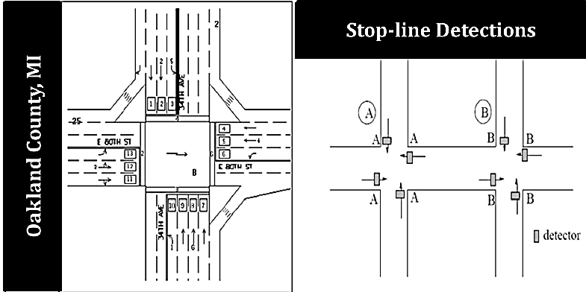

Fig 3. Loop detectors at the stop lines

2.4.2 Split, Cycle and Offset Optimization Technique

The second reputable adaptive traffic control system is “SCOOT”. The traffic adaptive urban traffic control (UTC) system SCOOT, which is the acronym of Split, Cycle and Offset Optimization Technique, has been developed by TRL10 to help authorities manage and control traffic on their networks. SCOOT is continually being improved through research by TRL funded by the Department for Transport (DfT) and the SCOOT suppliers.

Modern traffic management and control systems must account for all methods of transport in the urban areas and SCOOT provides effective priority for public transport without disadvantaging the normal traffic, allowing public transport vehicles to adhere to their schedule and hence provide a credible alternative mode of travel.

SCOOT has been demonstrated in over 200 towns and cities in over 14 countries around the world given proven benefits in reduced congestion and delay. These have been demonstrated several times with detailed studies highlighting the effectives of SCOOT urban traffic control as a tool for management of traffic and congestion.

The Kernel software at the heart of a SCOOT system is standard to all installations. The additional software (the “knitting” or UTC software) which links the SCOOT Kernel to on-street equipment and which provides the user interface is specific to the supplier. The user interface includes the data input to store information on the detector locations, physical layout of the road network and how the traffic signals control the individual traffic streams in the SCOOT database (Gordon, 2003).

Any adaptive traffic control system relies upon good detection of the current conditions in real-time to allow a quick and effective response to any changes in the current traffic situation. Detectors are normally required on every link. Their location is important. To good information in advance of the vehicles’ arrival at the stop line SCOOT detectors are usually positioned at the upstream end of the approach link. Inductive loops are normally used.

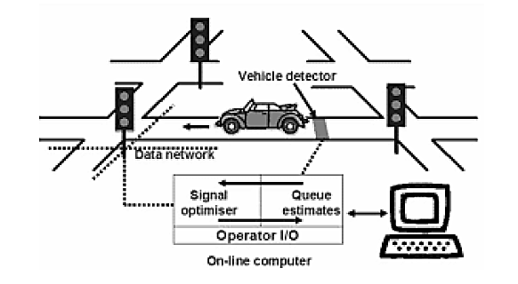

Fig 4. Graphical illustration of how SCOOT works

2.4.3. InSync adaptive traffic control system

The InSync adaptive traffic control system is an intelligent transportation system that enables traffic signals to adapt to actual traffic demand. As of March 2012, traffic agencies in 18 U.S. states have selected InSync for use at more than 650 intersections. This system was developed by Rhythm Engineering at first. Rhythm Engineering is a reputable company which works in field of transportation and mostly in United State of America.

InSync is a plug-and-play system that works with existing traffic control cabinets and controllers. Its two main hardware components are IP video cameras and a processor, sometimes referred to as "the eyes" and "the brain" of the system, respectively. Mounted video cameras determine the number of vehicles present and how long the vehicles have been waiting (delay). The processor, a state machine, is located in the traffic controller cabinet at the intersection. The system calls up the traffic signal state that best serves actual demand while coordinating its decision with other intersections.

Local Optimization InSync uses integrated digital sensors to know the exact number of cars demanding service at an intersection and how long they’ve been waiting. Approaches are given phasing priority based on this queue and delay data. InSync’s dynamic phasing and dynamic green splits enable the traffic signals to use green time efficiently.

Global Optimization InSync creates progression along an entire corridor by using “green tunnels.” Platoons of vehicles gather and are then released through the corridor. By communicating with each other, the signals anticipate the green tunnel’s arrival so vehicles pass through without slowing down or stopping. The green tunnels’ duration and frequency can vary to best support traffic conditions. Between green tunnels, the local optimization serves the side streets and left turns.

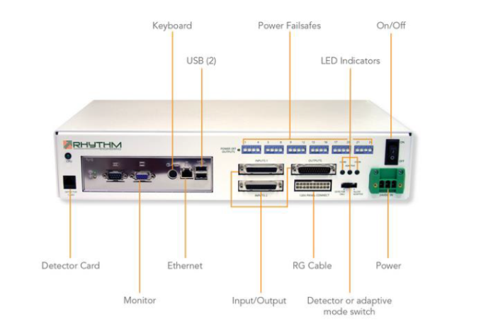

Fig 4. InSync Processor

**2.5 Webster’s Method**

This method is used to compute the required data for determining suitable signal timing as it is suitable for timing of a pre-timed signal.

2.5.1. Signal Phases

The number of phases varies with the number of intersection’s approaches, the general intersection’s layout, the composition and the direction of traffic flows. Phasing can be used to minimize hazard risks by separation of movements. A large number of phases may be required if all conflicts are eliminated. Increasing the number of phases promotes safety but hinders efficiency because it results in increasing delays. The first issue is to decide how many phases are required. It is possible to have two, three, four or even more number of phases.

2.5.1.1. Four phase signals

There are at least three possible phasing options. Figure 2.3 shows the most simple and trivial phase plan. Where, flow from each approach is put into a single phase avoiding all conflicts. This type of phase plan is ideally suited in urban areas where the turning movements are comparable with through movements and when through traffic and turning traffic need to share the same lane. This phase plan could be very inefficient when turning movements are relatively low. Figure 2.4 shows a second possible phase plan option where opposing through traffic are put into the same phase. This type of phasing is very efficient when the intersection geometry permits to have at least one lane for each movement, and the through traffic volume is significantly high. Figure 2.5 shows yet another phase plan. However, this is rarely used in practice. There are five phase signals and six phase signals. They are normally provided if the intersection control is adaptive, that is, the signal phases and timing adapt to the real time traffic conditions.

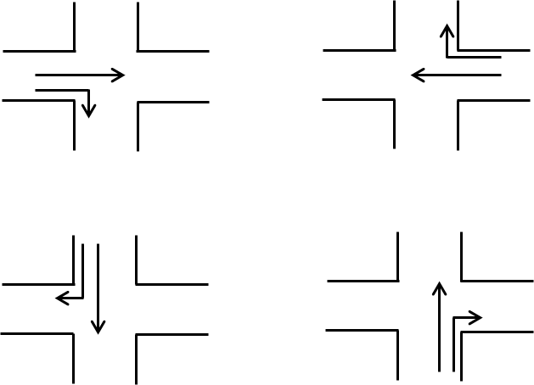

Phase 3

Phase 4

Phase 2

Phase 1

Figure 2.3. Movements in Four Phase Signal System: Option 1

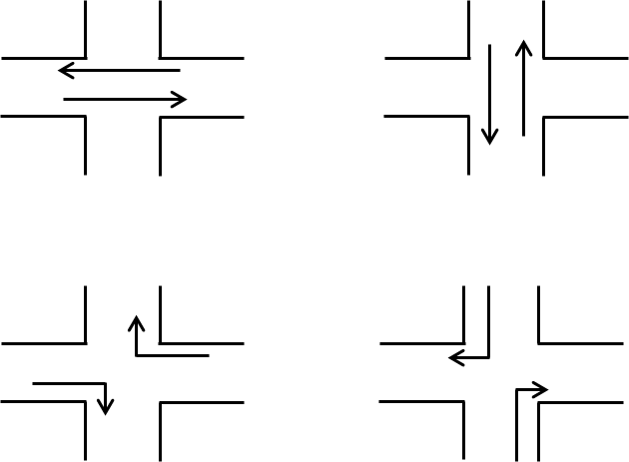

Phase 2

Phase 1

Phase 3

Phase 4

Figure 2.4. Movements in Four Phase Signal system: Option 2

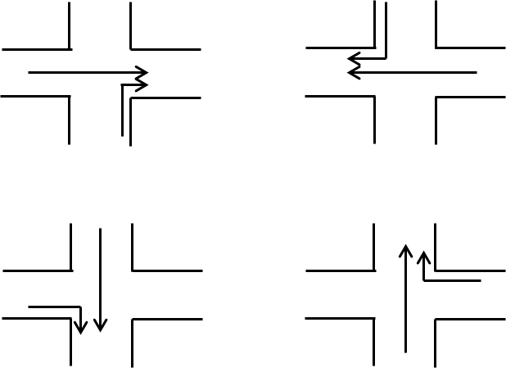

Phase 3

Phase 4

Phase 2

Phase 1

Figure 2.5. Movements in Four Phase Signal System

2.5.1.2. Passenger car unit (PCU)

This unit is used for all traffic engineering design such as intersections, roadway, bridges, parking and traffic signals. The traffic volume and capacity are generally expressed as PCU per hour or PCU per hour or PUC/lane/hours and traffic density as PCU per kilometer length of lane.

On common roadway, different classes of vehicles such as cars, vans, buses, trucks, auto risk shaw, motor cycles, bicycles, bullock carts are found. Therefore, the mixed traffic flow characteristics are very complex. It is the method of expressing various types of vehicles having different characteristics that are very complex and common equipment unit. One car is considered as one unit. Traffic such as cycle, pedal cycle cause less inconvenience to other traffic than a car and hence it is considered as equipment to half car unit. A bus causes a lot of inconvenience to other traffic. It is estimated that a single bus causes inconvenience equivalent to three cars and hence it has three car units. Different vehicles having different vehicular and operational characteristics are also expressed in terms of standard unit called passenger car unit. The PCU for straight rural road and urban road are described in Table 2.1.

Table 2.1. Suggested Values of PCU for Urban Roads [1]

|  |  |  |  |  |
| --- | --- | --- | --- | --- |
| Sr  No. | PCU Values of Vehicles Class | | | |
| Vehicle Class | Urban Roads Mid-block Section | Signalized Intersection | Curb Parking (Parallel and Angle) |
| 1 | Car | 1.0 | 1.0 | 1.0 |
| 2 | Bus and truck | 2.2 | 2.8 | 3.4 |
| 3 | Auto risk shaw | 0.5 | 0.4 | 0.4 |
| 4 | Two wheeler automobiles | 0.4 | 0.3 | 0.2 |
| 5 | Pedal cycles | 0.7 | 0.4 | 0.1 |
| 6 | Bullock cart | 4.6 | 3.2 | 1.2 |
| 7 | Hand cart | 4.6 | 3.2 | 0.3 |

2.5.2. Vehicle Clearance Interval

The objective of the amber signal indication following each green interval is to warn moving traffic facing the signals to come to a stop. It should provide enough time for vehicles to clear the intersections before cross traffic starts to move. If it is too short, it may constitute a hazard and increases rear-end collisions. The safe stopping distance can be calculated by the following formula.

 (2.1)

where, Y = clearance interval, in second

t = perception reaction time, in second, suggest value = 1

v = approach speed of clearing vehicle, feet per second

a = deceleration rate of clearing vehicle, in feet per second square, suggested value 15

W = intersection width (curb to curb), in feet

L = length of vehicle, in feet, suggest value = 20

2.5.3. Minimum Cycle Length

The minimum cycle time may be calculated by Webster’s Method for three and four phases signal cycle. In calculating minimum cycle length, the largest number of vehicles in a single lane entering the intersection must be considered during peak and off-peak hour. And then, approximate average headway between vehicles entering the intersection is also considered. The cycle lengths between 45 seconds and 180 seconds are used in the field [6].

 (2.2)

where, N = the number of phases

tl = lost time per phase in seconds

Xc = critical  ratio where v is the volume and c is the capacity

 = the ratio of critical volume to saturation flow

2.5.4. Green Splitting

Green splitting or apportioning of green time is the proportioning of effective green time in each of the signal phase. The green splitting is given by

 (2.3)

where, Vi = the critical lane volume for phase i

Vc = the critical lane volume

gi = the effective green time

C = the cycle time in seconds

L = total loss time

Actual green time can be now found out as,

 (2.4)

where, Gi = actual green time

gi = the effective green time

Yi = the yellow time

** = the lost time for phase i

Actual cycle length can be now found out as,

Actual cycle length, Cact = Gi + Yi + Ri (2.5)

**2.6 Image Processing Methods**

Image processing is a method to perform some operations on an image, in order to get an enhanced image or to extract some useful information from it. It is a type of signal processing in which input is an image and output may be image or characteristics or features associated with that image. Nowadays, image processing is among rapidly growing technologies. It forms core research area within engineering and computer science disciplines too.

Image processing basically includes the following three steps:

1. Importing the image via image acquisition tools;
2. Analysing and manipulating the image;
3. Output in which result can be altered image or report that is based on image analysis.

There are two types of methods used for image processing namely, analogue and digital image processing. Analogue image processing can be used for the hard copies like printouts and photographs. Image analysts use various fundamentals of interpretation while using these visual techniques. Digital image processing techniques help in manipulation of the digital images by using computers. The three general phases that all types of data have to undergo while using digital technique are pre-processing, enhancement, and display, information extraction.

2.6.1 Analogue Image Processing

Analog image processing is done on analog signals. It includes processing on two dimensional analog signals. In this type of processing, the images are manipulated by electrical means by varying the electrical signal. The common example include is the television image.

2.6.2 Digital Image Processing

A digital image processing is applied to digital images (a matrix of small pixels and elements). For manipulating the images, there is a number of software and algorithms that are applied to perform changes. Digital image processing is one of the fastest growing industrial which affects everyone's life. Examples of digital images are color processing, image recognition, video processing, etc.

There are following differences between Analog Images Processing and Digital Image Processing.

|  |  |
| --- | --- |
| **Analogue Image Processing** | **Digital Image Processing** |
| The analogue image processing is applied on analogue signals and it processes only two-dimensional signals. | The digital image processing is applied to digital signals that work on analyzing and manipulating the images. |
| Analogue signal is time-varying signals so the images formed under analog image processing get varied. | It improves the digital quality of the image and intensity distribution is perfect in it. |
| Analogue image processing is a slower and costlier process. | Digital image processing is a cheaper and fast image storage and retrieval process. |
| Analogue signal is a real-world but not good quality of images. | It uses good image compression techniques that reduce the amount of data required and produce good quality of images |
| It is generally continuous and not broken into tiny components. | It uses an image segmentation technique which is used to detect discontinuity which occurs due to a broken connection path. |

Table 2.1 Differences between Analog Images Processing and Digital Image Processing

**2.7. Types of Images**

There are three types of images. They are as following.

2.7.1 Binary Images

It is the simplest type of image. It takes only two values i.e, Black and White or 0 and 1. The binary image consists of a 1-bit image and it takes only 1 binary digit to represent a pixel. Binary images are mostly used for general shape or outline. For Example: Optical Character Recognition (OCR).

Binary images are generated using threshold operation. When a pixel is above the threshold value, then it is turned white('1') and which are below the threshold value then they are turned black('0').

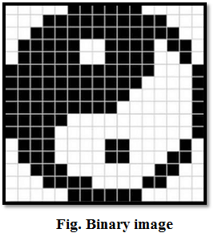

Fig 2.4 Binary Image

2.7.2 Grayscale Images

Grayscale images are monochrome images, Means they have only one color. Grayscale images do not contain any information about color. Each pixel determines available different grey levels. A normal grayscale image contains 8 bits/pixel data, which has 256 different grey levels. In medical images and astronomy, 12 or 16 bits/pixel images are used.

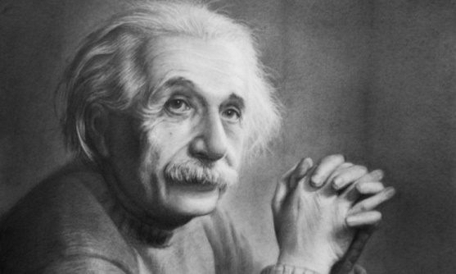

Fig 2.7 Grayscale Image

2.7.3 Colour Images

Colour images are three band monochrome images in which, each band contains a different color and the actual information is stored in the digital image. The color images contain gray level information in each spectral band. The images are represented as red, green and blue (RGB images). And each color image has 24 bits/pixel means 8 bits for each of the three colour band (RGB).



Fig 2.10 Colour Image

**2.8. Python Programming Language**

Python is an interpreted, object-oriented, high-level programming language with dynamic semantics. Its high-level built in data structures, combined with dynamic typing and dynamic binding, make it very attractive for Rapid Application Development, as well as for use as a scripting or glue language to connect existing components together. Python's simple, easy to learn syntax emphasizes readability and therefore reduces the cost of program maintenance. Python supports modules and packages, which encourages program modularity and code reuse. The Python interpreter and the extensive standard library are available in source or binary form without charge for all major platforms, and can be freely distributed.

Debugging Python programs is easy a bug or bad input will never cause a segmentation fault. Instead, when the interpreter discovers an error, it raises an exception. When the program doesn't catch the exception, the interpreter prints a stack trace. A source level debugger allows inspection of local and global variables, evaluation of arbitrary expressions, setting breakpoints, stepping through the code a line at a time, and so on.

**2.9. OpenCV Library**

OpenCV (Open Source Computer Vision Library) is an open source computer vision and machine learning software library. OpenCV was built to provide a common infrastructure for computer vision applications and to accelerate the use of machine perception in the commercial products. Being a BSD-licensed product, OpenCV makes it easy for businesses to utilize and modify the code.

The library has more than 2500 optimized algorithms, which includes a comprehensive set of both classic and state-of-the-art computer vision and machine learning algorithms. These algorithms can be used to detect and recognize faces, identify objects, classify human actions in videos, track camera movements, track moving objects, extract 3D models of objects, produce 3D point clouds from stereo cameras, stitch images together to produce a high resolution image of an entire scene, find similar images from an image database, remove red eyes from images taken using flash, follow eye movements, recognize scenery and establish markers to overlay it with augmented reality, etc.

Along with well-established companies like Google, Yahoo, Microsoft, Intel, IBM, Sony, Honda, Toyota that employ the library, there are many startups such as Applied Minds, VideoSurf, and Zeitera, that make extensive use of OpenCV. OpenCV’s deployed uses span the range from stitching streetview images together, detecting intrusions in surveillance video in Israel, monitoring mine equipment in China, helping robots navigate and pick up objects at Willow Garage, detection of swimming pool drowning accidents in Europe, running interactive art in Spain and New York, checking runways for debris in Turkey, inspecting labels on products in factories around the world on to rapid face detection in Japan.

**2.10. Threading**

2.10.1. Thread

In computing, a process is an instance of a computer program that is being executed. Any process has three basic components:

1. An executable program.
2. The associated data needed by the program (variables, work space, buffers, etc.)
3. The execution context of the program (State of process)

A thread is an entity within a process that can be scheduled for execution. Also, it is the smallest unit of processing that can be performed in an OS (Operating System).

In simple words, a thread is a sequence of such instructions within a program that can be executed independently of other code. For simplicity, you can assume that a thread is simply a subset of a process.

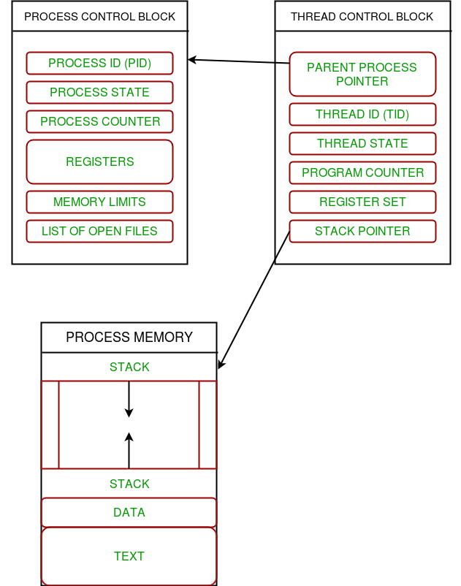

Fig 2.11 The relation between process and its thread

2.10.2. **Thread Control Block**

A thread contains all this information in a Thread Control Block (TCB).

1. Thread Identifier: Unique id (TID) is assigned to every new thread
2. Stack pointer: Points to thread’s stack in the process. Stack contains the local variables under thread’s scope.
3. Program counter: a register which stores the address of the instruction currently being executed by thread.
4. Thread state: can be running, ready, waiting, start or done.
5. Thread’s register set: registers assigned to thread for computations.
6. Parent process Pointer: A pointer to the Process control block (PCB) of the process that the thread lives on.

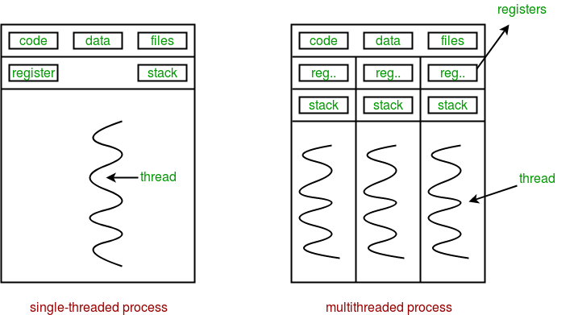

Fig 2.12 multiple threads exist in memory

2.10.3. **Multithreading**

Multiple threads can exist within one process.

1. Each thread contains its own register set and local variables (stored in stack).
2. All thread of a process share global variables (stored in heap) and the program code.

Multithreading is defined as the ability of a processor to execute multiple threads concurrently. single-core CPU, it is achieved using frequent switching between threads. This is termed as context switching. In context switching, the state of a thread is saved and state of another thread is loaded whenever any interrupt (due to I/O or manually set) takes place. Context switching takes place so frequently that all the threads appear to be running parallel (this is termed as multitasking).

**2.11. Real-Time Object Detection with YOLOv3**

2.11.1. Darknet

Darknet is a Neural Network framework written in C and CUDA and with it you can build, train and run neural networks []. It supports computation with both CPU and GPU. The project is open source and available on GitHub. It is compatible with Linux and MacOS.

2.11.2. YOLOv3

YOLO is an extremely fast real time multi object detection algorithm. YOLO stands for “You Only Look Once”. The algorithm applies a neural network to an entire image. The network divides the image into an S x S grid and comes up with bounding boxes, which are boxes drawn around images and predicted probabilities for each of these regions. The method used to come up with these probabilities is logistic regression. The bounding boxes are weighted by the associated probabilities. For class prediction, independent logistic classifiers are used.

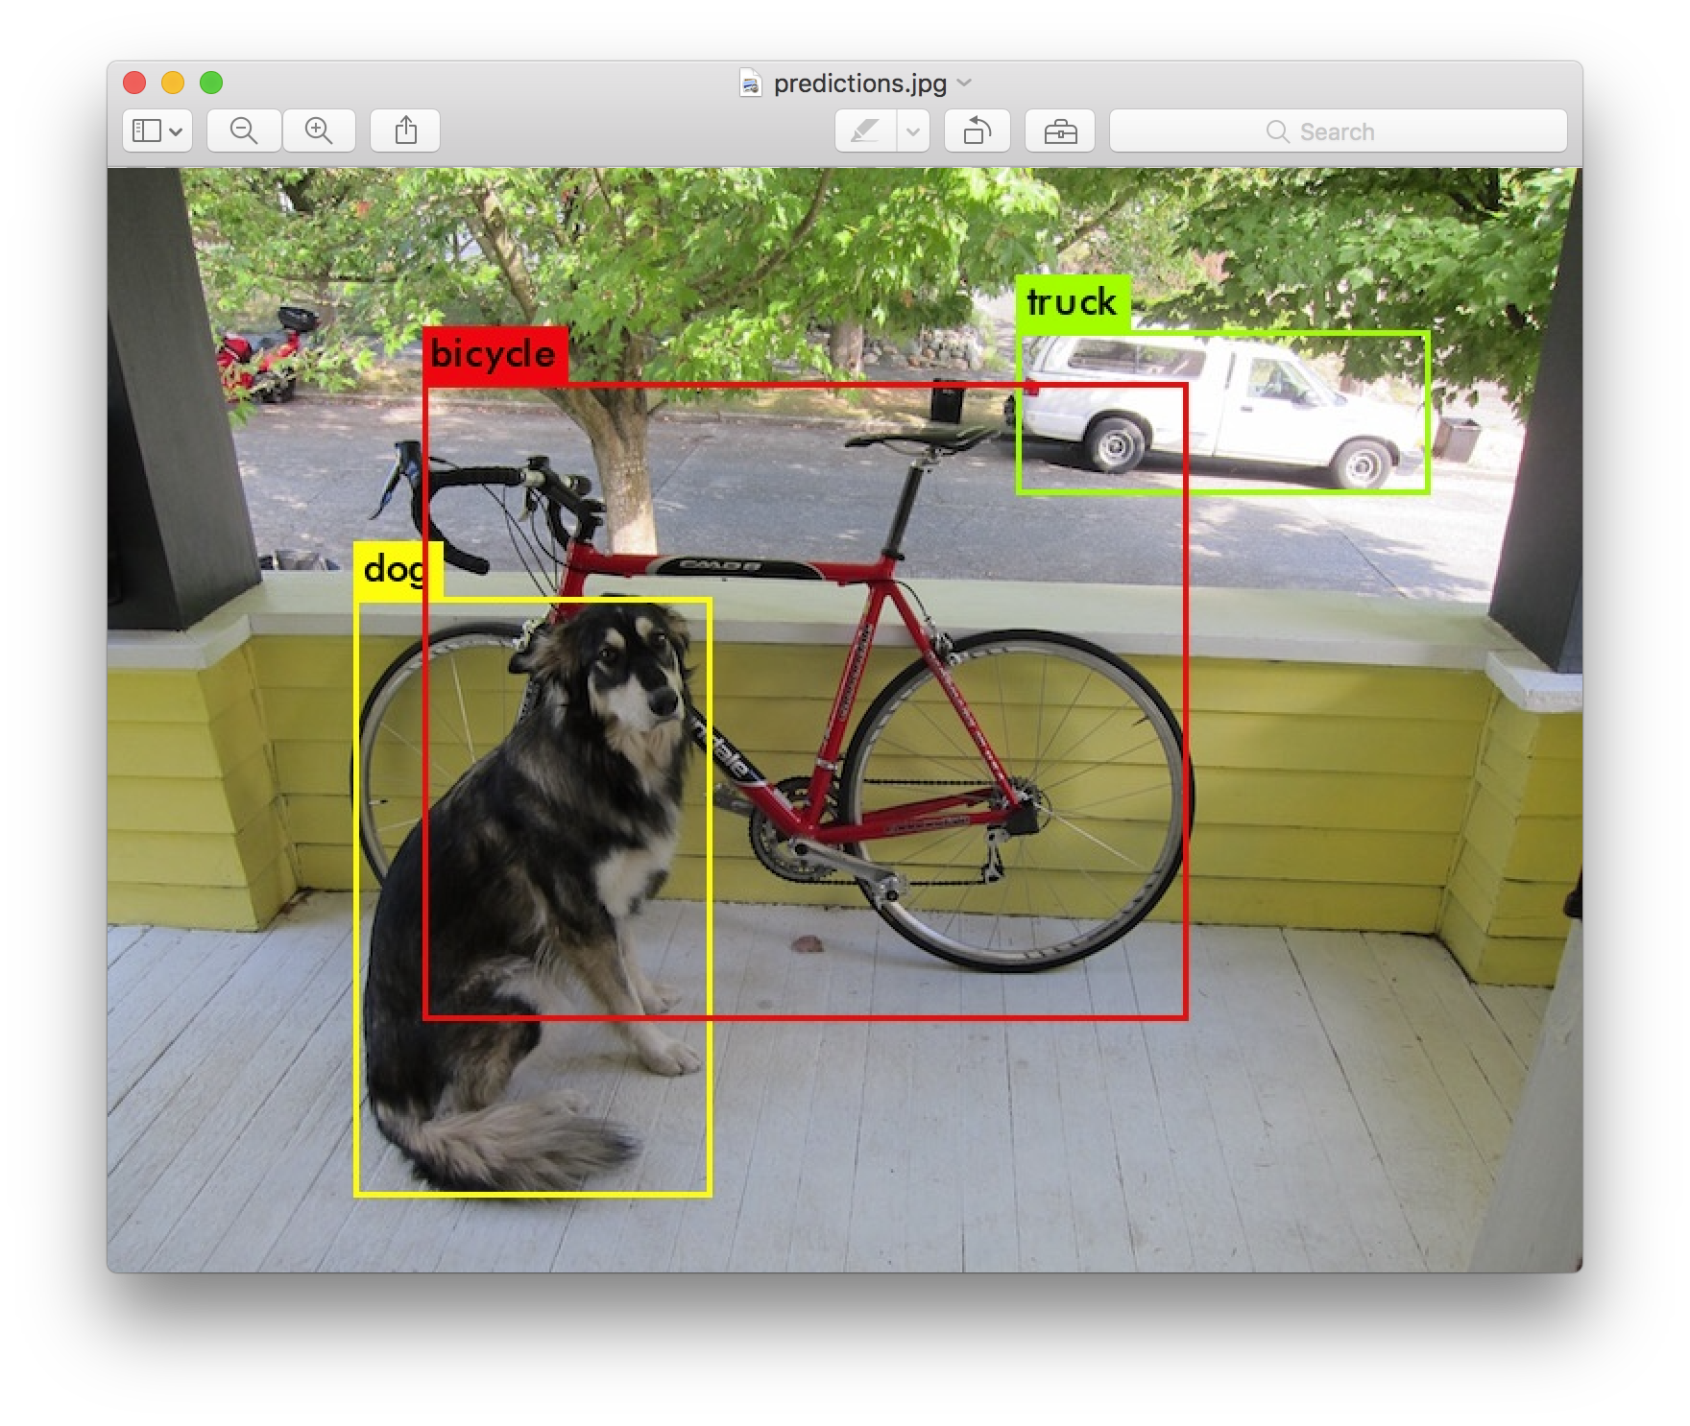

Fig 2.13 Object Detection with YOLOv3 and Python