**CHAPTER 2**

**LITERATURE REVIEW**

* 1. **Traffic Light System**

A traffic light system is an electronic device that assigns right of way at an intersection or crossing or street crossing by means of displaying the standard red, yellow and green coloured indications. An addition, it also works in conjunction with pedestrian displays to assign pedestrian crossing right of way. A traffic light, also known as traffic signal, stop light, stop-and-go lights, is a signalling device positioned at a road intersection, pedestrian crossing, or other location in order to indicate when it is safe to drive, ride, or walk using a universal colour code (and a precise sequence, for that are colours blind).

A red light meant traffic in all directions had to stop. A yellow light meant cross-town traffic would have to slow and a green light would to go or proceed. The difficulty in understanding this confusing colour sequence was compounded by neighbouring towns using another system. The development of an intelligent control structure ensures an optimal solution for all participants in the transportation and road traffics system.

There are different ways controlling road intersections. In the simplest cases the right-hand rule or, if the traffic is higher, a roundabout or the signal of a policeman can help steer the traffic. However, especially in big cities, in the complicated cases when the roads in the intersection have several lanes, the use of traffic lights cannot be avoided. An additional issue arises when in the intersection not only roads but also railroad tracks take part, what often occurs in suburban traffic situations. The most common way to handle this type of intersection is the conventional cyclic lights control.

In more enhanced control, the traffic in different directions is monitored by sensors and the signals thus obtained control the traffic lights. In this method the control is adapting to the traffic.

The general problem is the huge number of variables and the need for large computing efforts. To simplify this problem a possible way is the use of fuzzy techniques. In the last couple of years a lot of simulations were done and also practical control systems were built based on simple fuzzy rules. However in the most complicated cases where the numbers of lanes are large and maybe not only one but more road intersections and railroad take part, it does make sense to use fuzzy methods containing hierarchy and apply interpolation to decrease the complexity.

2.2. **Traffic Engineering**

Traffic engineering is that the phase of engineering which deals with the improvement of traffic performance on road networks and terminals.[] Traffic engineering includes the analysis of traffic characteristics, planning of regulatory measures, geometric design and functional planning of routes, design and application of control devices. The basic function of most arterial streets and highways is to move traffic safely and efficiently with minimum delay. The main source of delay and congestion along most arterial streets and highways are traffic control devices such as traffic signals. If traffic control devices are effectively used by the public, they minimize the chances of accidents and decrease the operational cost of the vehicles. Engineers are desired to plan the devices in such a way that accidents do not occur and for, this well designed traffic control systems are discussed, planned and implemented. To get good knowledge in the traffic system, traffic characteristics and traffic flow theories are necessary to be studied. This chapter deals with traffic studies and various traffic control devices.

2.3. **Traditional Traffic Light Control System**

Traditional Traffic light controllers used a fixed predetermined schedule for traffic inflow for each direction in the junction. The controller was an electro mechanical controller which consists of mechanical systems operated electrically. It consists of three major parts- a dial timer, a solenoid and a cam assembly. A motor and a gear assembly operates the dial timer which in turn are responsible to energize or de energize a solenoid which in turn operates a cam assembly which are responsible to provide current to each signal indications. The dial timer is used to provide repetition of fixed duration intervals. Traditional traffic arrangements help in solving the huge loss of traffic, reducing transport problems, reducing the amount of traffic and reducing waiting time, reducing overall travel time, optimizing cars safety and efficiency, health, there is a need to upgrade to expand profits in the economic and environmental sectors.

However the whole idea of a fixed time traffic light controller is not convenient for cities where traffic flow is variable. For this reason a dynamic traffic control system is needed, which controls the traffic signals according to the density of traffic.

2.4. **Adaptive Traffic Control System**

Adaptive traffic control system is a traffic management strategy in which traffic signals timing changes, or adapts, based on actual traffic demand. These systems work completely opposite to fixed-time planning, where a series of signal timing plans are scheduled by day of week and time of day. In fixed-time the time relationship between signals is pre-calculated; based on previously surveyed traffic conditions.

2.4.1. **InSync Adaptive Traffic Control System**

The InSync adaptive traffic control system is an intelligent transportation system that enables traffic signals to adapt to actual traffic demand. As of March 2012, traffic agencies in 18 U.S. states have selected InSync for use at more than 650 intersections. This system was developed by Rhythm Engineering at first. Rhythm Engineering is a reputable company which works in field of transportation and mostly in United State of America.

InSync is a plug-and-play system that works with existing traffic control cabinets and controllers. Its two main hardware components are IP video cameras and a processor, sometimes referred to as "the eyes" and "the brain" of the system, respectively. Mounted video cameras determine the number of vehicles present and how long the vehicles have been waiting (delay). The processor, a state machine, is located in the traffic controller cabinet at the intersection. The system calls up the traffic signal state that best serves actual demand while coordinating its decision with other intersections.

Local Optimization InSync uses integrated digital sensors to know the exact number of cars demanding service at an intersection and how long they’ve been waiting. Approaches are given phasing priority based on this queue and delay data. InSync’s dynamic phasing and dynamic green splits enable the traffic signals to use green time efficiently.

Global Optimization InSync creates progression along an entire corridor by using “green tunnels.” Platoons of vehicles gather and are then released through the corridor. By communicating with each other, the signals anticipate the green tunnel’s arrival so vehicles pass through without slowing down or stopping. The green tunnels’ duration and frequency can vary to best support traffic conditions. Between green tunnels, the local optimization serves the side streets and left turns.

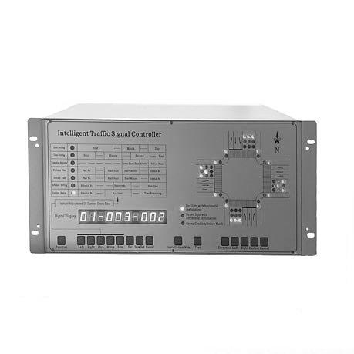

Figure 2.1. InSync Processor

2.5. **Webster’s Method**

This method is used to compute the required data for determining suitable signal timing as it is suitable for timing of a pre-timed signal.

2.6.  **Image Processing Methods**

Image processing is a method to perform some operations on an image, in order to get an enhanced image or to extract some useful information from it. It is a type of signal processing in which input is an image and output may be image or characteristics or features associated with that image. Nowadays, image processing is among rapidly growing technologies. It forms core research area within engineering and computer science disciplines too.

Image processing basically includes the following three steps:

1. Importing the image via image acquisition tools.
2. Analysing and manipulating the image.
3. Output in which result can be altered image or report that is based on image analysis.

There are two types of methods used for image processing namely, analogue and digital image processing. Analogue image processing can be used for the hard copies like printouts and photographs. Image analysts use various fundamentals of interpretation while using these visual techniques. Digital image processing techniques help in manipulation of the digital images by using computers. The three general phases that all types of data have to undergo while using digital technique are pre-processing, enhancement, and display, information extraction.

2.6.1.  **Analogue Image Processing**

Analog image processing is done on analog signals. It includes processing on two dimensional analog signals. In this type of processing, the images are manipulated by electrical means by varying the electrical signal. The common example include is the television image.

2.6.2. **Digital Image Processing**

A digital image processing is applied to digital images (a matrix of small pixels and elements). For manipulating the images, there is a number of software and algorithms that are applied to perform changes. Digital image processing is one of the fastest growing industrial which affects everyone's life. Examples of digital images are color processing, image recognition, video processing, etc.

There are following differences between Analog Images Processing and Digital Image Processing.

Table 2.1. Differences between Analog and Digital Image Processing

|  |  |
| --- | --- |
| **Analogue Image Processing** | **Digital Image Processing** |
| The analogue image processing is applied on analogue signals and it processes only two-dimensional signals. | The digital image processing is applied to digital signals that work on analyzing and manipulating the images. |
| Analogue signal is time-varying signals so the images formed under analog image processing get varied. | It improves the digital quality of the image and intensity distribution is perfect in it. |
| Analogue image processing is a slower and costlier process. | Digital image processing is a cheaper and fast image storage and retrieval process. |
| Analogue signal is a real-world but not good quality of images. | It uses good image compression techniques that reduce the amount of data required and produce good quality of images |
| It is generally continuous and not broken into tiny components. | It uses an image segmentation technique which is used to detect discontinuity which occurs due to a broken connection path. |

2.7. **Types of Images**

There are three types of images. They are as following.

2.7.1. **Binary Images**

It is the simplest type of image. It takes only two values i.e, Black and White or 0 and 1. The binary image consists of a 1-bit image and it takes only 1 binary digit to represent a pixel. Binary images are mostly used for general shape or outline. For Example: Optical Character Recognition (OCR).

Binary images are generated using threshold operation. When a pixel is above the threshold value, then it is turned white('1') and which are below the threshold value then they are turned black('0').

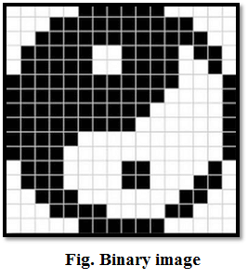

Figure 2.2. Binary Image

2.7.2. **Grayscale Images**

Grayscale images are monochrome images, Means they have only one color. Grayscale images do not contain any information about color. Each pixel determines available different grey levels. A normal grayscale image contains 8 bits/pixel data, which has 256 different grey levels. In medical images and astronomy, 12 or 16 bits/pixel images are used.

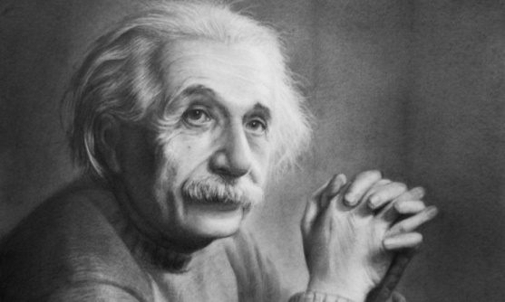

Figure 2.3. Grayscale Image

2.7.3. **Colour Images**

Colour images are three band monochrome images in which, each band contains a different color and the actual information is stored in the digital image. The color images contain gray level information in each spectral band. The images are represented as red, green and blue (RGB images). And each color image has 24 bits/pixel means 8 bits for each of the three colour band (RGB).



Figure 2.4. Colour Image

2.8. **Python Programming Language**

Python is an interpreted, object-oriented, high-level programming language with dynamic semantics. Its high-level built in data structures, combined with dynamic typing and dynamic binding, make it very attractive for Rapid Application Development, as well as for use as a scripting or glue language to connect existing components together. Python's simple, easy to learn syntax emphasizes readability and therefore reduces the cost of program maintenance. Python supports modules and packages, which encourages program modularity and code reuse. The Python interpreter and the extensive standard library are available in source or binary form without charge for all major platforms, and can be freely distributed.

Debugging Python programs is easy a bug or bad input will never cause a segmentation fault. Instead, when the interpreter discovers an error, it raises an exception. When the program doesn't catch the exception, the interpreter prints a stack trace. A source level debugger allows inspection of local and global variables, evaluation of arbitrary expressions, setting breakpoints, stepping through the code a line at a time, and so on.

2.9. **OpenCV Library**

OpenCV (Open Source Computer Vision Library) is an open source computer vision and machine learning software library. OpenCV was built to provide a common infrastructure for computer vision applications and to accelerate the use of machine perception in the commercial products. Being a BSD-licensed product, OpenCV makes it easy for businesses to utilize and modify the code.

The library has more than 2500 optimized algorithms, which includes a comprehensive set of both classic and state-of-the-art computer vision and machine learning algorithms. These algorithms can be used to detect and recognize faces, identify objects, classify human actions in videos, track camera movements, track moving objects, extract 3D models of objects, produce 3D point clouds from stereo cameras, stitch images together to produce a high resolution image of an entire scene, find similar images from an image database, remove red eyes from images taken using flash, follow eye movements, recognize scenery and establish markers to overlay it with augmented reality, etc.

Along with well-established companies like Google, Yahoo, Microsoft, Intel, IBM, Sony, Honda, Toyota that employ the library, there are many startups such as Applied Minds, VideoSurf, and Zeitera, that make extensive use of OpenCV. OpenCV’s deployed uses span the range from stitching street view images together, detecting intrusions in surveillance video in Israel, monitoring mine equipment in China, helping robots navigate and pick up objects at Willow Garage, detection of swimming pool drowning accidents in Europe, running interactive art in Spain and New York, checking runways for debris in Turkey, inspecting labels on products in factories around the world on to rapid face detection in Japan.

2.10. **Threading**

It is a lightweight process which is the execution of code sequence along with all the data supporting structures such as opened resources, memory map, stack, etc. In case we want to run the code in parallel making programming easy. It takes benefit from the architectures of multi-CPU. It can also run multiple processes or multiple threads within one process.

2.10.1. **Thread**

In computing, a process is an instance of a computer program that is being executed. Any process has three basic components:

1. An executable program.
2. The associated data needed by the program. (variables, work space, buffers, etc.)
3. The execution context of the program (State of process).

A thread is an entity within a process that can be scheduled for execution. Also, it is the smallest unit of processing that can be performed in an OS (Operating System).

In simple words, a thread is a sequence of such instructions within a program that can be executed independently of other code. For simplicity, you can assume that a thread is simply a subset of a process.

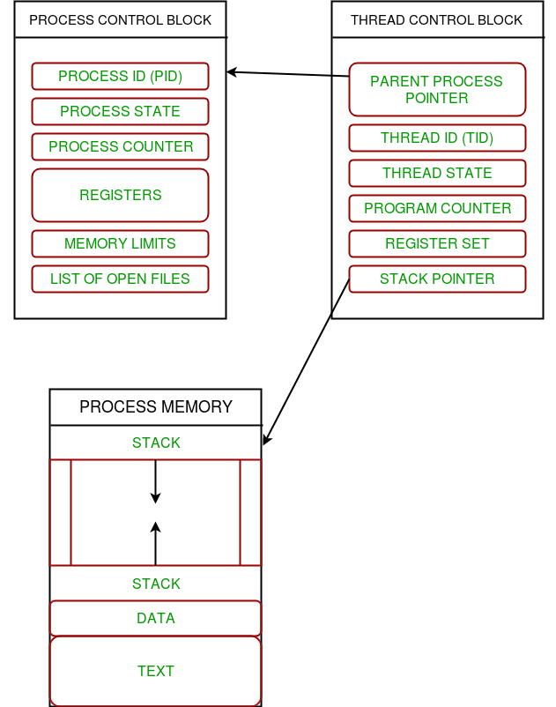

Figure 2.5. The relation between process and its thread

2.10.2. **Thread Control Block**

A thread contains all this information in a Thread Control Block (TCB).

1. Thread Identifier: Unique id (TID) is assigned to every new thread.
2. Stack pointer: Points to thread’s stack in the process. Stack contains the local variables under thread’s scope.
3. Program counter: a register which stores the address of the instruction currently being executed by thread.
4. Thread state: can be running, ready, waiting, start or done.
5. Thread’s register set: registers assigned to thread for computations.
6. Parent process Pointer: A pointer to the Process control block (PCB) of the process that the thread lives on.

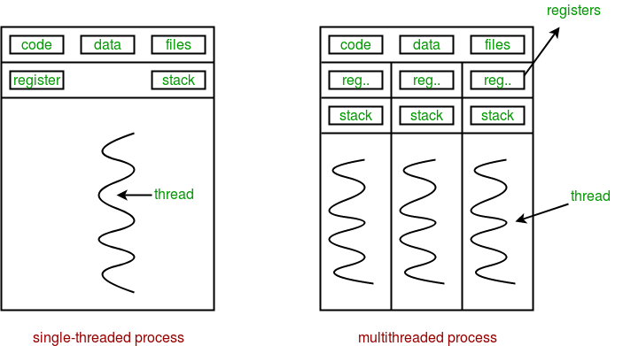

Figure 2.6. Multiple threads exist in memory

2.10.3. **Multithreading**

Multiple threads can exist within one process.

1. Each thread contains its own register set and local variables (stored in stack).
2. All thread of a process share global variables (stored in heap) and the program code.

Multithreading is defined as the ability of a processor to execute multiple threads concurrently. single-core CPU, it is achieved using frequent switching between threads. This is termed as context switching. In context switching, the state of a thread is saved and state of another thread is loaded whenever any interrupt (due to I/O or manually set) takes place. Context switching takes place so frequently that all the threads appear to be running parallel (this is termed as multitasking).

2.11. **Real-Time Object Detection with YOLOv3**

Object detection is applied in numerous views, for example, mechanized vehicle frameworks, movement acknowledgment, a person on foot recognition, apply autonomy, robotized CCTV, object checking, etc. As of late, object recognition in light of profound learning has grown significantly. Basic target location techniques are separated into 2 species. They are recognition methodologies good with the locale proposition and single-step indicator. YOLOv3 has a place with a solitary advance identifier. It is a quick and well-identified article location innovation.

2.11.1. **Darknet**

Darknet is a Neural Network framework written in C and CUDA and with it you can build, train and run neural networks. It supports computation with both CPU and GPU. The project is open source and available on GitHub. It is compatible with Linux and MacOS.

2.11.2. **YOLOv3**

YOLO is an extremely fast real time multi object detection algorithm. YOLO stands for “You Only Look Once”. The algorithm applies a neural network to an entire image. The network divides the image into an S x S grid and comes up with bounding boxes, which are boxes drawn around images and predicted probabilities for each of these regions. The method used to come up with these probabilities is logistic regression. The bounding boxes are weighted by the associated probabilities. For class prediction, independent logistic classifiers are used.

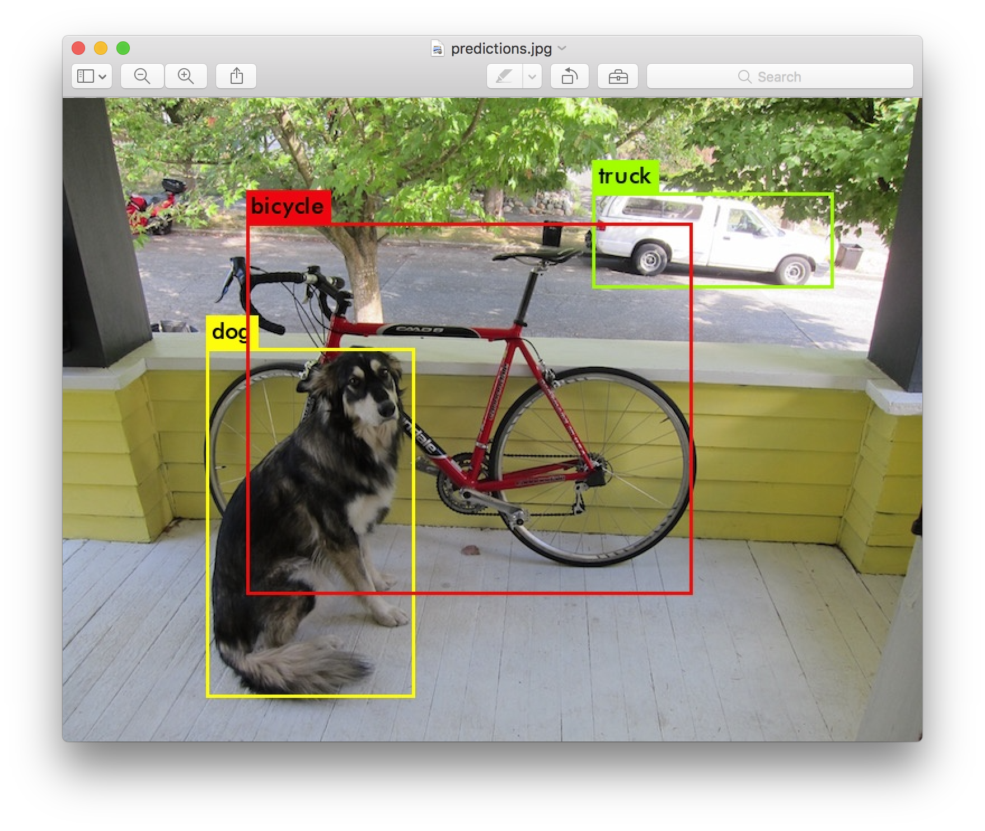

Figure 2.7. Object Detection with YOLOv3 and Python

2.12. **Arduino**

Arduino is an open-source electronics platform based on easy-to-use hardware and software. [Arduino boards](https://www.arduino.cc/en/Main/Products) are able to read inputs - light on a sensor, a finger on a button, or a Twitter message - and turn it into an output - activating a motor, turning on an LED, publishing something online. Arduino board designs use a variety of [microprocessors](https://en.wikipedia.org/wiki/Microprocessor) and controllers. The boards are equipped with sets of digital and analogue [input/output](https://en.wikipedia.org/wiki/Input/output) (I/O) pins that may be interfaced to various expansion boards ('shields') or [breadboards](https://en.wikipedia.org/wiki/Breadboards) and other circuits. The boards feature serial communications interfaces, including [Universal Serial Bus](https://en.wikipedia.org/wiki/Universal_Serial_Bus) (USB) on some models, which are also used for loading programs from personal computers. The microcontrollers can be programmed using [C](https://en.wikipedia.org/wiki/C_(programming_language)) and [C++](https://en.wikipedia.org/wiki/C%2B%2B) [programming languages](https://en.wikipedia.org/wiki/Programming_language). In addition to using traditional [compiler](https://en.wikipedia.org/wiki/Compiler) [toolchains](https://en.wikipedia.org/wiki/Toolchains), the Arduino project provides an [integrated development environment](https://en.wikipedia.org/wiki/Integrated_development_environment) (IDE) based on the [Processing](https://en.wikipedia.org/wiki/Processing_(programming_language)) language project.

Most Arduino boards consist of an [Atmel](https://en.wikipedia.org/wiki/Atmel) 8-bit [AVR microcontroller](https://en.wikipedia.org/wiki/AVR_microcontroller) (ATmega8, ATmega168, [ATmega328](https://en.wikipedia.org/wiki/ATmega328), ATmega1280, ATmega2560) with varying amounts of flash memory, pins, and features. The 32-bit [Arduino Due](https://en.wikipedia.org/wiki/Arduino_Due), based on the Atmel [SAM3X8E](https://en.wikipedia.org/wiki/Atmel_ARM-based_processors#SAM_3) was introduced in 2012. The boards use single or double-row pins or female headers that facilitate connections for programming and incorporation into other circuits. These may connect with add-on modules termed shields. Multiple and possibly stacked shields may be individually addressable via an [I²C](https://en.wikipedia.org/wiki/I%C2%B2C) [serial bus](https://en.wikipedia.org/wiki/Serial_bus). Most boards include a 5 V [linear regulator](https://en.wikipedia.org/wiki/Linear_regulator) and a 16 MHz [crystal oscillator](https://en.wikipedia.org/wiki/Crystal_oscillator) or [ceramic resonator](https://en.wikipedia.org/wiki/Ceramic_resonator). Some designs, such as the LilyPad, run at 8 MHz and dispense with the on board voltage regulator due to specific form-factor restrictions.

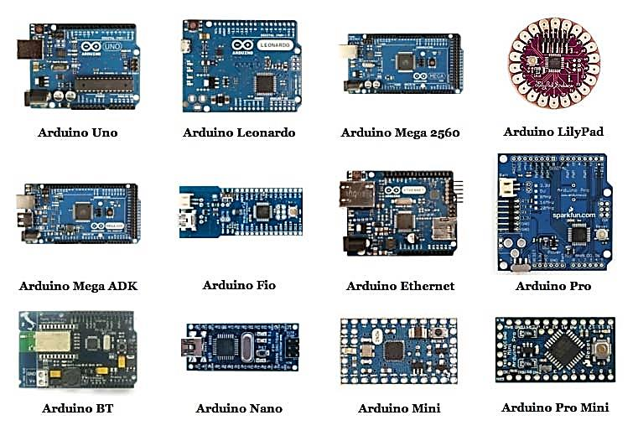

Figure 2.8. Different types of Arduino microcontroller boards

Arduino microcontrollers are pre-programmed with a [boot loader](https://en.wikipedia.org/wiki/Boot_loader) that simplifies uploading of programs to the on-chip [flash memory](https://en.wikipedia.org/wiki/Flash_memory). Boards are loaded with program code via a serial connection to another computer.

### 2.13. ENC28J60 Ethernet Module

### ENC28J60 is a 10BASE-T standalone Ethernet unit with on board MAC and PHY, 8 Kbytes of Buffer RAM and an SPI serial interface for 3.3V and 5V logics. With a small size the Nano Ethernet Shield minimizes complexity, board space and cost. ENC28J60 Ethernet chip which provide a network (IP) stack capable of both TCP and UDP. Target applications include VoIP, Industrial Automation, Building Automation, Smart Home Control, Security and Instrumentation. Shield use power 5V from Nano board and convert to 3.3V (on shield have 3.3V LDO). The data-rate of ENC28J60 is limited to 10 Mbps. Ethernet Shield connects with Arduino to the internet in mere minutes. Just plug this module onto Arduino board, connect it to network with an RJ45 cable and follow a few simple instructions to start controlling through the internet or network. It supports up to four simultaneous socket connections.

### 

Figure 2.9. ENC28J60 Ethernet module for Arduino Nano

2.14. **Categories of Network**

Computer Networks fall into three classes regarding the size, distance and the structure namely: LAN (Local Area Network), MAN (Metropolitan Area Network), WAN (Wide Area Network). Before discussing about type of network we can discuss about what is a network.

2.14.1. **Local Area Network (LAN)**

A local area network (LAN) is usually privately owned and links the devices in a single office, building, or campus. A LAN can be as simple as two PCs and a printer in someone’s home office; or it can extend throughout a company and include audio and video peripherals. Currently, LAN size is limited to a few kilometres. LANs are designed to allow resources to be shared between personal computers or workstations. The resources to be shared can include hardware, software or data.

2.14.2. **Wide Area Network (WAN)**

A wide area network (WAN) provides long-distance transmission of data, image, audio, and video information over large geographic areas that may comprise a country, a continent or even the whole world. A WAN can be as complex as the backbones that connect the Internet or as simple as a dial-up that connects a home computer to the internet. The point to point WAN is normally a line leased from a telephone or cable TV provider that connects a home computer or a small LAN to an Internet Service Provider (ISP). This type of WAN is often used to provide Internet access.

2.14.3. **Metropolitan Area Network (MAN)**

A metropolitan area network (MAN) is a network with a sixe between a LAN and a WAN. It normally covers the area inside a town or a city. It is designed for customers who need a high-speed connectivity, normally to the internet, and have endpoints spread over a city or part of city. A good example of a MAN is the part of the telephone company network that can provide a high-speed DSL line to the customer. Another example is the cable TV network that originally was designed for cable TV, but today can also be used for high-speed data connection to the internet.

2.15. **Network Protocols**

Simply, a protocol is a set of rules. A network protocol is a set of rules followed by the network. Network protocols are formal standards and policies made up of rules, procedures and formats that define communication between two or more devices over a network. Network protocols conducts the action, policies, and affairs of the end-to-end process of timely, secured and managed data or network communication. They define rules and conventions for communication. They incorporate the entire processes requirement and constraints of initiating and accomplishing communication between computers, routers, servers and other network enabled devices. Network protocols must be confirmed and installed by the sender and receiver to ensure network/data communication. It also applies software and hardware nodes that communicate on a network. There are several types of network protocols.

2.15.1. **Transmission Control Protocol (TCP)**

The Transmission Control Protocol is the core protocol of the internet protocol suite. It originated in the network implementation in which it complemented the Internet Protocol. Therefore the entire suite is commonly referred to as TCP/IP. TCP provides reliable delivery of a stream of octets over an IP network. Ordering and error-checking are main characteristics of the TCP. All major Internet applications such as World Wide Web, email and file transfer rely on TCP.

# 2.15.2. User Datagram Protocol (UDP)

User Datagram Protocol (UDP) is a Transport Layer protocol. UDP is a part of Internet Protocol suite, referred as UDP/IP suite. Unlike TCP, it is unreliable and connectionless protocol. So, there is no need to establish connection prior to data transfer.

Though Transmission Control Protocol (TCP) is the dominant transport layer protocol used with most of Internet services and provides assured delivery, reliability and much more but all these services cost us with additional overhead and latency. UDP comes into picture. For the real time services like computer gaming, voice or video communication, live conferences, UDP is needed. Since high performance is needed, UDP permits packets to be dropped instead of processing delayed packets. There is no error checking in UDP, so it also saves bandwidth.

UDP header is 8-bytes fixed and simple header, while for TCP it may vary from 20 bytes to 60 bytes. First 8 Bytes contains all necessary header information and remaining part consists of data. UDP port number fields are each 16 bits long, therefore range for port numbers defined from 0 to 65535, port number 0 is reserved.

UDP is mostly common used for real time applications which cannot tolerate uneven delays between sections of a received message, some routing update protocols like RIP (Routing Information Protocol) and Used for simple request response communication when size of data is less and hence there is lesser concern about flow and error control. It is suitable protocol for multicasting as UDP supports packet switching.

# 2.16. Internet Protocol Camera

# An Internet Protocol Camera, commonly referred to as an IP camera, is a digital video camera much like a webcam, which transmits and receives data over a network or the internet. Unlike an ordinary webcam it is a standalone unit with its own IP address that requires nothing more than a network connection in order to transfer images. The IP camera connects to a network in exactly the same way as any other standard network device such as a laptop, tablet or printer. IP cameras capture images in much the same way as a digital camera, and compress the files to transmit over the network. IP cameras may be used with a wired network connected via ethernet cable to a broadband modem or router, or wirelessly via a WiFi router.

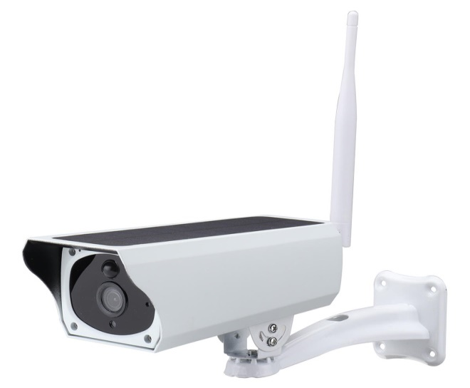

Figure 2.10. Internet Protocol Camera

2.17. **MySQL Database**

MySQL is an Oracle-backed open source relational database management system ([RDBMS](https://searchdatamanagement.techtarget.com/definition/RDBMS-relational-database-management-system)) based on Structured Query Language ([SQL](https://searchsqlserver.techtarget.com/definition/SQL)). MySQL runs on virtually all platforms, including [Linux](https://searchdatacenter.techtarget.com/definition/Linux-operating-system), [UNIX](https://searchdatacenter.techtarget.com/definition/Unix) and [Windows](https://searchwindowsserver.techtarget.com/definition/Windows). Although it can be used in a wide range of applications, MySQL is most often associated with web applications and online publishing.

MySQL is based on a [client-server](https://searchnetworking.techtarget.com/definition/client-server) model. The core of MySQL is MySQL server, which handles all of the database instructions (or commands). MySQL server is available as a separate program for use in a client-server networked environment and as a library that can be embedded (or linked) into separates applications. MySQL operates along with several utility programs which support the administration of MySQL databases. Commands are sent to MySQL Server via the MySQL client, which is installed on a computer. MySQL was originally developed to handle large databases quickly. Although MySQL is typically installed on only one machine, it is able to send the database to multiple locations, as users are able to access it via different MySQL client interfaces. These interfaces send SQL statements to the server and then display the results.