Wanner HernandezR

CMSC405 Project 4

Professor Jarc Duane

May 11, 2021

**Project 4  
WebGL 3D Project**

In this project you will create a unique 3D animated scene composed of WebGL graphic components. The scene should include animation, lighting, textures, frame buffers and multiple objects.

**Requirements:**

WebGL create a unique 3D animated scene. The scene has the following specifications:

1. Includes at least 10 different objects.
2. Uses multiple lighting effects on different materials
3. Uses multiple textures
4. Includes radio buttons, slider bars or other widgets to turn on or off certain components

of the animation.

1. Uses frame buffers to organize the memory resources that are needed to render the

scene.

1. Use WebGL
2. All JavaScript source code should be written using Google JavaScript style guide.(

http://google.github.io/styleguide/jsguide.html)

1. Prepare, conduct and document a test plan verifying your application is working as expected.

This plan should include a test matrix listing each method you tested, how you tested it, and the

results of testing.

**Source Code:**

* Animation.js
* Basic-object-models-IFS.js
* Colors.js
* Extended-object-models.js
* Gl-matrix.js
* Teapot-nodel-IFS.js
* Trackball-rotator.js
* Project4.html/Project4.txt

**Directions:**

* To make a figure to stop moving Slide the control bottom to the left, to speed it up slide it to the right.
* To change the speed of each individual object just mess around with slide bar,
* By playing around with the slide you can make different type of convinations.

**Test Cases/plan:**

|  |  |  |  |  |
| --- | --- | --- | --- | --- |
| **Shape** | **Animation?** | **Lighting?** | **Responds to Mouse Rotation?** | **Responds to Slider Bar?** |
| Cube | Yes | Yes | Yes | Yes |
| Sphere | Yes | Yes | Yes | Yes |
| Cylinder | Yes | Yes | Yes | Yes |
| Ring | Yes | Yes | Yes | Yes |
| Torus | Yes | Yes | Yes | Yes |
| Cone | Yes | Yes | Yes | Yes |
| Triangle | Yes | Yes | Yes | Yes |
| Pyramid | Yes | Yes | Yes | Yes |
| Cross | Yes | Yes | Yes | Yes |
| Teapot | Yes | Yes | Yes | Yes |

**Compile Test:**

**Compile Success:**

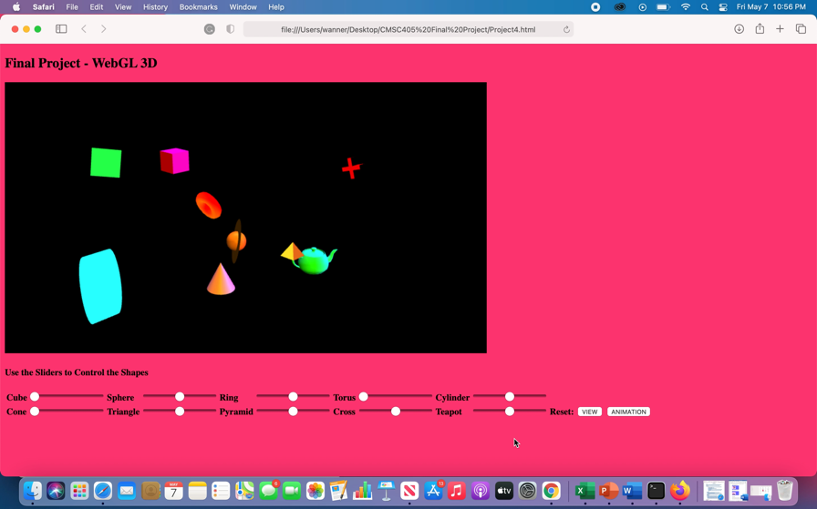**Test case 1:** for this test case I stop the cube,cone and torus (double Click image to play)

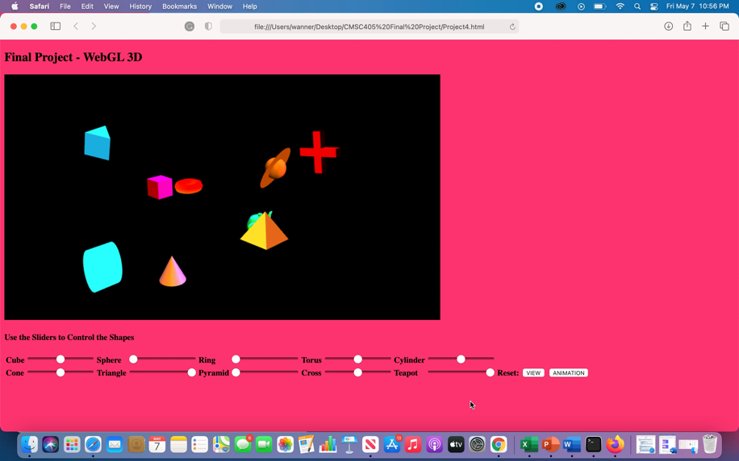**Test case 2:** This test case stop Sphere,Ring,Pyramid and speed up Triangle,Teapot

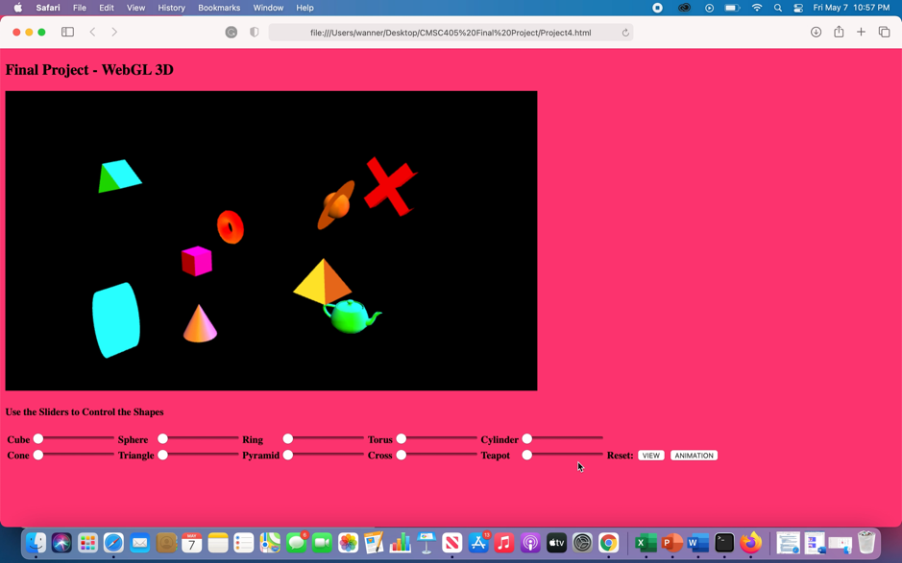**Test case 3:** This test case stop all the shapes

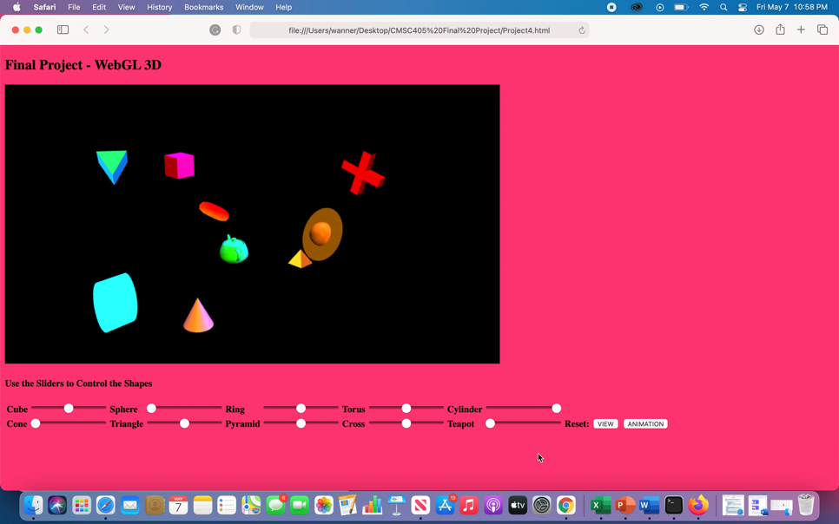**Test case 4:** This test case stop Sphere,Cone,Teapot and speed up Cylinder

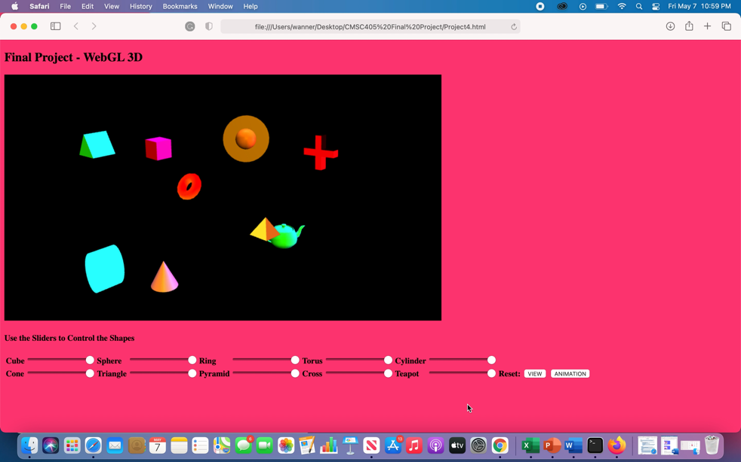**Test case 5:** This case speed all shapes

**Summary/Explanation:**

This week Project 4 was really fun and an experimental experience to be honest I completed this project base on experimenting and making up shapes step by step. The fact that we had to create a unique 3D animated scene composed of WebGL graphic components and got to experiment with different type of project animation in order to create my project. It was fun going through this final project because it build us as programmers to look at different perspective and enforcing our skills. I am looking forward on learning more about what I have throughout this class and enhance my skill to the max because computer science is a vast of never-ending leaning skills.

**References**

N.podbielski. (n.d.). Line in WebGL and Why You Are Going to do this on your Own. Retrieved May 7, 2021, from [https://www.codeproject.com/Articles/594222/LineplusinplusWebGLplusandpluswhyplusyouplu sgonnap](https://www.codeproject.com/Articles/594222/LineplusinplusWebGLplusandpluswhyplusyouplusgonnap)

WebGL 3D Perspective. (n.d.). Retrieved May 7, 2021, from <https://webglfundamentals.org/webgl/lessons/webgl-3d-perspective.html>

WebGL Fundamentals. (n.d.). Retrieved May 7, 2021, from <https://webglfundamentals.org/webgl/lessons/webgl-fundamentals.html>