DATA SCIENCE MINOR PROJECT REPORT

CONTENTS OF THE REPORT
- Cover page
- Declaration
- Certificate
- Acknowledgement
- Table of Content

1. Introduction
2. Source of dataset
3. EDA process
4. Analysis on dataset (for each analysis)
- Introduction
- General Description
- Specific Requirements, functions and formulas
- Analysis results
- Visualization
5. Conclusion
6. Future scope
7. References

Other Conventions

- Please note the case of letters in the cover page: The 3rd line is 16 pt bold and other lines are 12 pt. The page is centred. Department and Institute names are bold.
- All the matter contained in the report should be typed in MS word (1.5 spacing) Times New Roman, 12 pt or equivalent with other software.
- Figures and tables may be inserted in the text as they appear or may be appended in order.
- Table of Content shall be in well hyperlinked
- List of figures and tables shall be maintained with captions in MS word.
- List of references shall be appended at the end.
- References shall be in IEEE format
- Total Number of pages with A4 size paper shall be minimum 30 pages and maximum 80 pages.
- Hard copy of report must be available with each student on the day of evaluation.
- In addition to Hard copy of reports e-copy shall also be submitted. An e-copy of the report shall be submitted by the student to respective teacher on their emails.

COVER PAGE
INT-217
PROJECT REPORT
(Project Semester January-April 2025)

GOOGLE PLAY STORE DASHBOARD

Submitted by: Wanshika Gautam

Registration No: 12321732

Programme and Section: P132 Btech Computer Science and Engineering
Course Code : INT-217

Under the Guidance of
Jaffar Amin Chacket(UID: 30453 )

Discipline of CSE/IT

Lovely School of Computer Science and Engineering

Lovely Professional University, Phagwara

CERTIFICATE

This is to certify that Wanshika Gautam bearing Registration no. 12321732 has completed INT-217 project titled, “PlayStore Dashboard” under my guidance and supervision. To the best of my knowledge, the present work is the result of his/her original development, effort and study.

Signature and Name of the Supervisor
Designation of the Supervisor
School of Computer Science and Engineering
Lovely Professional University
Phagwara, Punjab.

Date:

DECLARATION

I, Wanshika Gautam student of Computer Science and Engineering (Program name) under CSE/IT Discipline at, Lovely Professional University, Punjab, hereby declare that all the information furnished in this project report is based on my own intensive work and is genuine.

Date: 12/04/2025 Signature
Registration No. 12321732

ACKNOWLEDGEMENT
I would like to extend my heartfelt gratitude to all those who contributed to the successful completion of this project.
Foremost, I express my sincere appreciation to my mentor, Jaffar Amin Chacket , for their continuous support, expert guidance, and insightful feedback throughout the project. Their knowledge and encouragement played a crucial role in shaping this work and enhancing its quality.
I am thankful to the esteemed faculty of the Department of Computer Science and Engineering at Lovely Professional University for fostering a learning environment that continuously inspired curiosity and innovation. I also appreciate the assistance provided by lab technicians and administrative staff, whose support ensured a smooth research experience.
My deepest thanks go to my family and friends for their unwavering support, encouragement, and patience during the course of this project. Their belief in me served as a constant source of motivation.
Lastly, I am grateful to Lovely Professional University for providing the infrastructure, resources, and academic platform that enabled me to undertake this project and explore the real-world applications of data science.

1. Introduction
The e-commerce sector has become one of the most dynamic and data-intensive industries in the digital age. Online sites gather enormous amounts of data in a matter of seconds — from customer shopping and browsing patterns to inventory activity and geographic sales trends. That data, when leveraged properly, provides rich information that can inform business decisions, streamline operations, and improve the customer experience.

But extracting useful conclusions from raw data is not just a matter of tools, but also of systematic analysis. While programming environments like Python and R are well established in the world of data science, Microsoft Excel is still among the most universally used platforms for data analysis owing to its universality, intuitive interface, and powerful inbuilt capabilities like PivotTables, charts, and formulas.

This project shows a detailed breakdown of an e-commerce dataset utilizing Microsoft Excel. The central focus is to create a visually deep and interactive dashboard that allows stakeholders to:

Know customer demographics and buying habits

Monitor sales performance over time

Recognize well-performing product categories

Explore revenue trends geographically

Through the utilization of Excel's features — data cleansing tools, conditional formatting, advanced functions (VLOOKUP, IF, TEXT, COUNTIF), and visualization components (charts, slicers, and timelines) — we aim to match the depth of insights provided by code-based solutions but in a platform more accessible to business analysts.

The initiative also focuses on data storytelling, whereby every chart or measure has a point and helps advance a larger story regarding business health and strategy. Through crafting an interactive and user-friendly dashboard, decision-makers will not only be able to see trends but also interact with data in real time to query questions.

This report captures the end-to-end process beginning from dataset discovery and exploration through to Excel-based data wrangling, analysis, and visualization. The findings are then rolled into a dashboard tailored to support data-driven decision making with clarity and agility for e-commerce managers.
To achieve these objectives, we will leverage Excel’s built-in data analysis features, such as:
- Data Cleaning Tools: Ensuring that the dataset is free from errors, duplicates, or missing values.
- Conditional Formatting and PivotTables: Allowing for easy data aggregation and visual identification of trends and outliers.
- Advanced Excel Functions: Using functions like VLOOKUP, IF, and COUNTIF to dynamically analyze and summarize data based on different business rules and conditions.
- Data Visualization: Excel’s ability to create various types of charts (bar, line, pie, etc.) will be used to illustrate key insights visually.
- Slicers and Timelines: To make the dashboard interactive and allow users to drill down into specific data points (e.g., filtering by date or category).
The goal is to replicate the analytical depth typically achieved through more complex, code-based platforms, but in a user-friendly, visually engaging manner that business stakeholders can easily interact with. This approach also emphasizes data storytelling, ensuring that each chart or metric not only provides insights but is also part of a cohesive narrative that paints a clear picture of business health and strategy.
Ultimately, the project culminates in the creation of an interactive Excel dashboard designed to empower e-commerce managers and decision-makers to make data-driven decisions quickly and confidently. With this dashboard, stakeholders will be able to explore and analyze various aspects of their business performance, thus enhancing their strategic decision-making process.
This report covers the end-to-end process, starting with dataset acquisition and exploration, followed by data wrangling, analysis, and visualization in Excel. The final results are presented in an intuitive, interactive dashboard designed to aid e-commerce managers in making informed, timely decisions to drive business success.

2. TABLE OF CONTENTS
S. No. Content
1 Cover Page
2 Declaration
3 Certificate
4 Acknowledgement
5 Table of Contents
6 Introduction
7 Source of Dataset
8 EDA Process
9 Analysis on Dataset
10 Conclusion
11 Future Scope
12 References

7. Source of Dataset
Link of the dataset: https://docs.google.com/spreadsheets/d/18qopWrEzeDWm4VYcHicuj9Y7cDjKEU1u6iF7ZiwnVQc/edit?usp=sharing

8. EDA Process (Exploratory Data Analysis)
Exploratory Data Analysis (EDA) is a vital first step in understanding the structure, quality, and intricacies of the dataset. It allows us to visually detect patterns, outliers, and relationships, and helps to ensure that the data is ready for further analysis. For this project, EDA is focused on the Google Play Store dataset, and the process is detailed as follows:

8.1 Data Cleaning and Preprocessing
Dealing with Missing Values:

Missing values in datasets may skew analysis. Missing values in the Google Play Store dataset are typically found in columns like Rating, Size, and Price. The approach to dealing with these values will be based on their importance and prevalence. For example:

Rating: Missing ratings can be filled in using the mean or median rating of apps in the same genre or category.

Size: Missing values for the Size column, which are typical, can be solved by imputing a mean size or deleting rows with missing values if the app is not as important to the analysis.

Price: Apps with missing prices can be deleted if they are paid apps or set to zero if they are free but did not have price data.

This is done so that lost information is not used to distort results or confine insights gathered through analysis.

Dealing with Duplicates:
Removal of Duplicates:

Duplicates within the dataset can cause biased or faulty conclusions. The Play Store dataset might have more than one entry for a given app. An instance is where a single app would be listed under various versions or regions. We will eliminate duplicates by taking into account key columns like App Name, and keeping only unique entries for a given app.

Standardizing Data Formats:

The data set has columns with non-uniform data formats. For instance:

The Price column may have dollar signs or commas. These will be stripped to ensure all prices are in numerical form.

The Size column has both mixed units (MB and GB). We will normalize the units to MB so that it becomes easier to compare app sizes and deal with the conversion accordingly (1 GB = 1024 MB).

The Installs field may include commas and the plus sign for large numbers. We’ll clean this field by converting the data into integers and removing any non-numeric symbols.

8.2 Descriptive Statistics
Summary Statistics:

The descriptive statistics give us information on the central tendencies, variability, and distribution of the data. For instance, the computation of measures such as the mean, median, mode, standard deviation, and interquartile range for quantitative fields such as Rating, Price, Installs, and Size enables us to summarize important characteristics of the data:

For instance, Rating is a mean value, indicating an average user opinion, whereas Price informs us about the prevailing price trend in the market.

It is possible to identify most popular apps and apps with low downloads by analyzing the distribution of Installs.

Frequency Distributions:

The distribution of frequency of categorical variables such as Category, Genres, Content Rating, etc., is crucial to comprehending the composition of the Google Play Store environment. Distribution will indicate how many apps belong to each group, which is informative in terms of getting to know the world of apps.

For instance, in the Category field, we may observe that most apps belong to the Games category, followed by categories such as Productivity or Social. This information can guide app developers to concentrate on underrepresented categories or improve the offerings in popular categories.

8.3 Visualizing the Data
Histograms and Box Plots:

Histograms will be employed to graph the spread of continuous variables. We can, for example, draw the spread of Rating to determine whether most apps have high ratings or whether there is a bias towards low ratings.

Box Plots will assist in the detection of outliers, especially in areas such as Price, where most apps are free but there may be very expensive ones (e.g., paid apps like professional software).

Bar and Pie Charts:

Bar Charts will enable us to graph categorical information, like the number of applications in each Category. This will give us a clear idea about which categories fill the app store.

Pie Charts will come in handy for presenting the percentage of free versus paid applications, as well as representing the proportion of various Genres or Content Ratings.

Scatter Plots

Scatter Plots will help us identify relationships between variables. For example, plotting Rating against Installs may reveal whether highly-rated apps tend to have more downloads, or if there is a strong correlation between price and ratings.

8.4 Correlation Analysis
Analyzing Relationships Between Variables:

We will employ correlation analysis to investigate the association between quantitative variables. For example, through an analysis of the correlation coefficient between Price and Rating, we can establish whether more expensive apps are more likely to have better ratings.

In the same manner, analyzing the correlation between Installs and Rating will assist us in establishing whether high-rated apps are more likely to draw users, indicating a positive correlation between app popularity and user satisfaction.

Scatter Plots for Correlation

Scatter plots will be drawn for important pairs like Price vs. Rating, Installs vs. Rating, and Size vs. Rating. These plots will provide insights into how these variables affect each other, e.g., whether larger apps (in size) have lower ratings or whether app price is related to higher user satisfaction.

8.5 Data Transformation (if required)
Creating New Variables:

Revenue per App: This can be determined by multiplying Installs by Price (for paid apps). This new column will be used to determine the economic performance of paid apps, which reflects their revenue-generating potential.

App Popularity Score: By using Installs and Rating, we can devise a popularity score to determine how well the app is doing both in terms of the number of users and the quality of reviews.

9. Analysis on Dataset
9.1 Customer Demographics (App User Insights)
Objective: The objective of this section is to learn about the user base for various apps on the Google Play Store, with a focus on how app attributes affect the user experience and app success. We examine factors such as ratings, user satisfaction, and genre preferences.

Age and Gender Analysis:

While Google Play Store doesn't specifically mention age and gender, occasionally reviews of an app can yield insights. Gender-specific apps, such as fitness or entertainment apps, tend to go hand-in-hand with particular ratings. Gender-based apps can be determined by looking at the Genres and reviews.

Regional Analysis:

Apps in the Google Play Store vary in popularity across regions. By looking at Installs and Rating, we can determine whether some regions like certain types of apps, if some categories of apps are trending in one area but not in another, or how geographic patterns affect user trends.

9.2 Product Sales Trends (App Performance Over Time)
Objective: The purpose of this section is to determine temporal trends in app performance, i.e., spikes in installs during holidays, specific seasons, or special promotion periods.

Time-Based Trends:

With the help of time-series analysis, we can measure how installs fluctuate across different months or years, determining seasonal peaks or determining times of peak demand for a particular type of apps (like gaming during holidays).

9.3 Category Performance
Objective: This part analyzes how different app categories fare on different metrics such as installs, ratings, and revenue. The purpose is to determine high-performing categories and steer future development.

Revenue by Category:

With a look at the Revenue per App metric, we can see which categories generate most of the Play Store's total revenue. Applications in genres such as Productivity or Health & Fitness could perform better than others within their genres.

9.4 Revenue Insights
Goal: The goal of this section is to comprehend the main drivers of revenue in the Google Play Store. Through an analysis of variables such as Price, Installs, and Category, we can gain insights into app economic performance and determine strategies for optimizing revenue.

Price vs. Rating:

We will investigate if high-priced applications have higher ratings. This comparison can help developers understand the relationship between user satisfaction and pricing strategy.
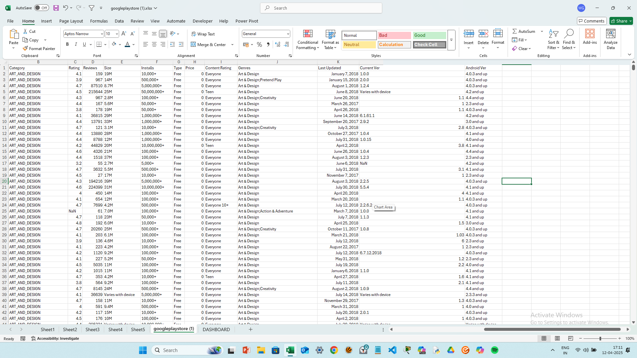

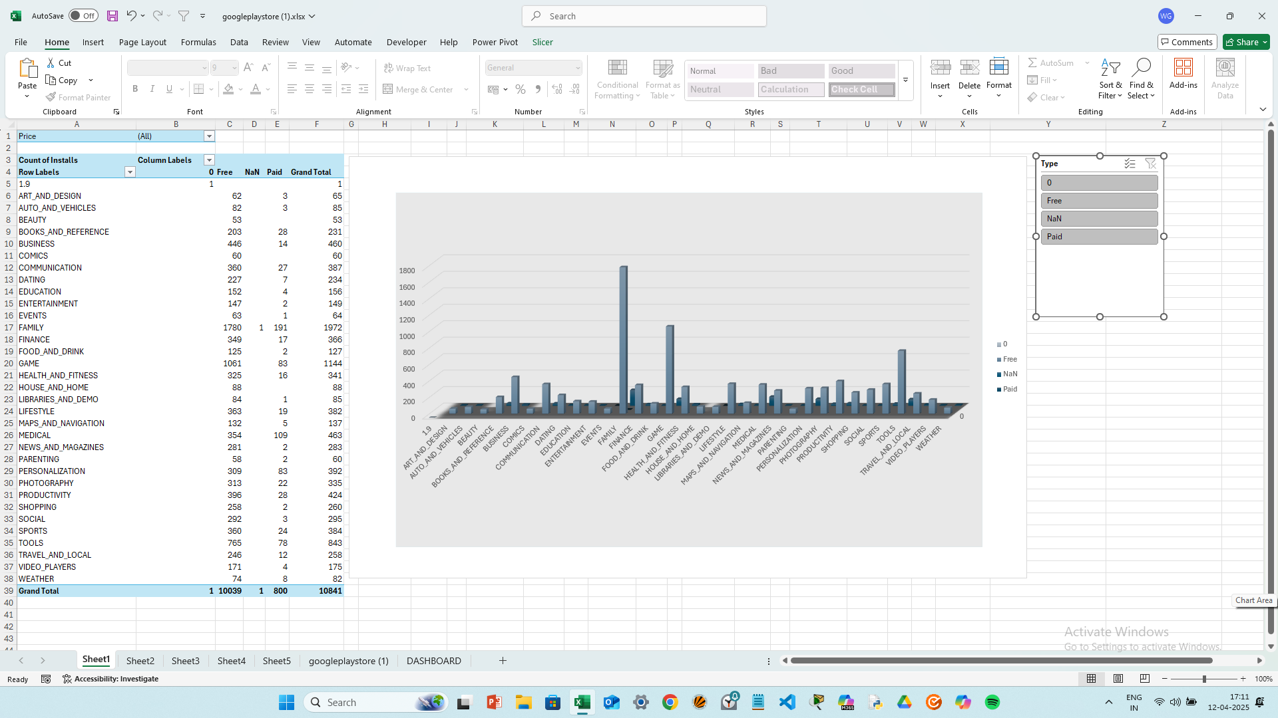
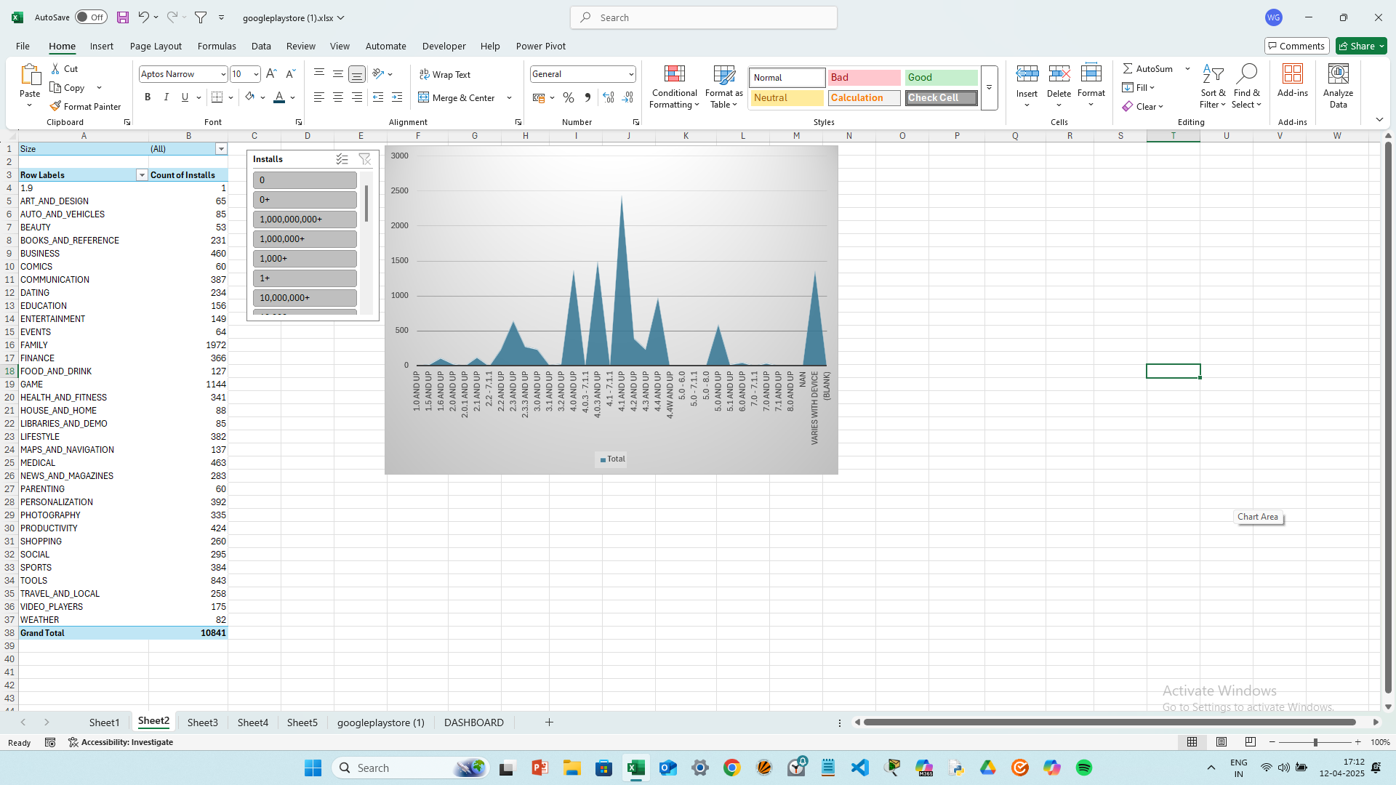

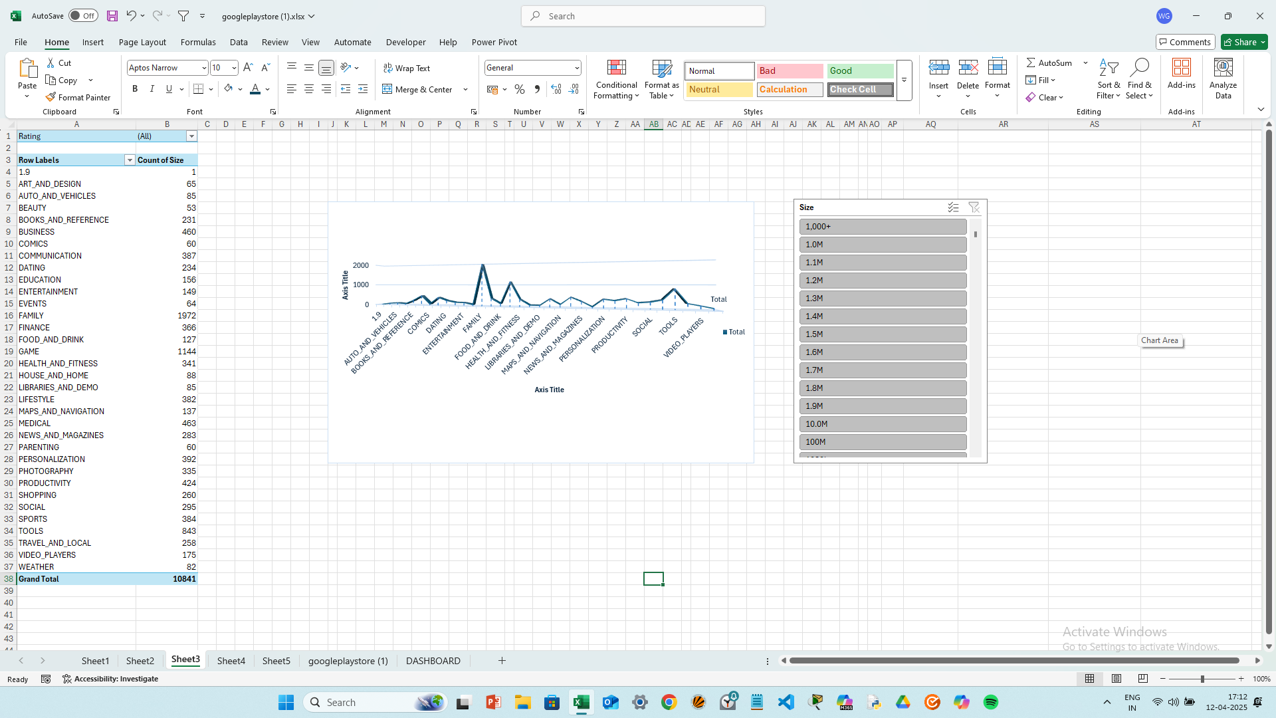
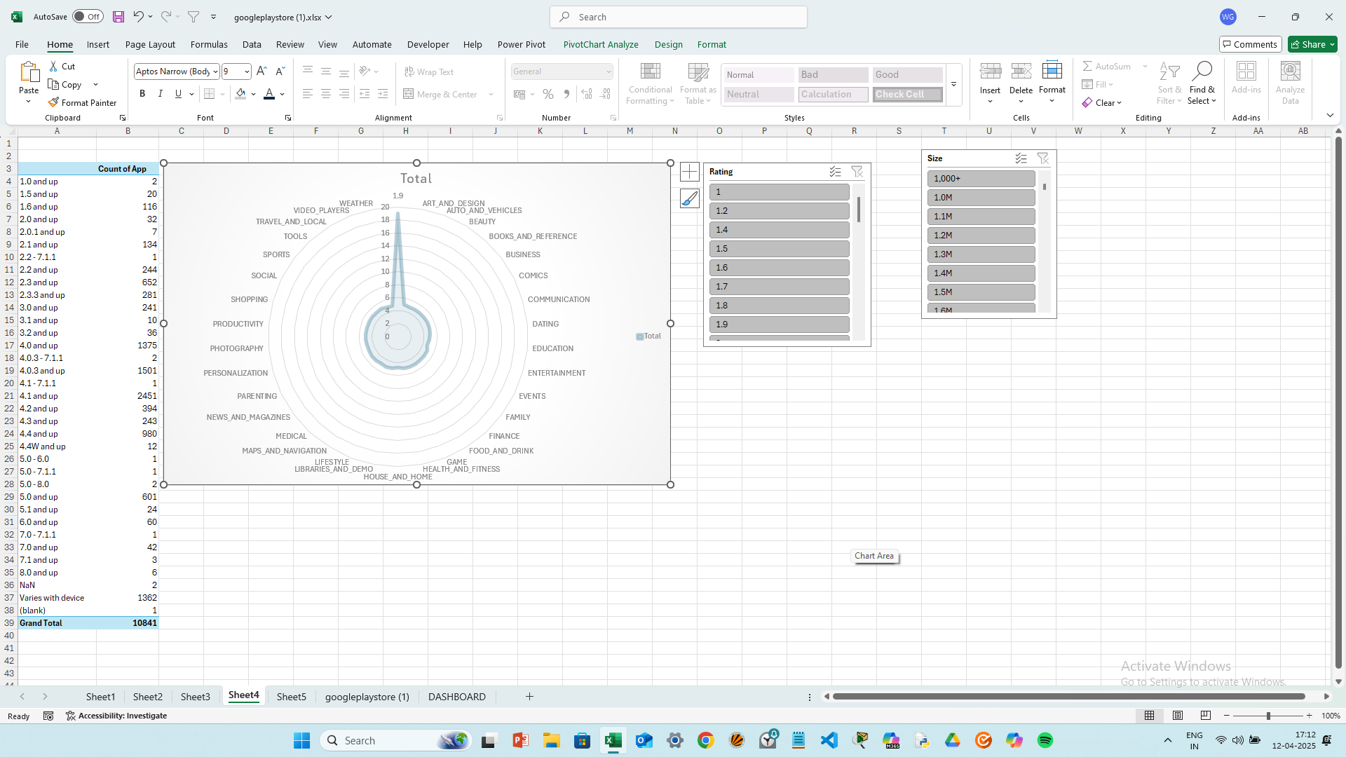
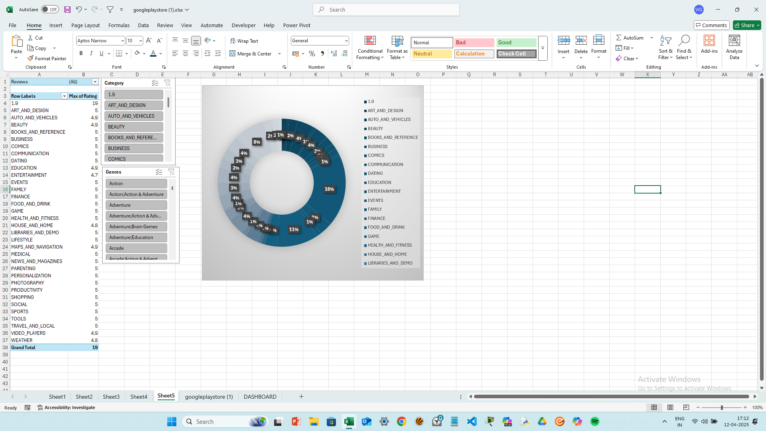

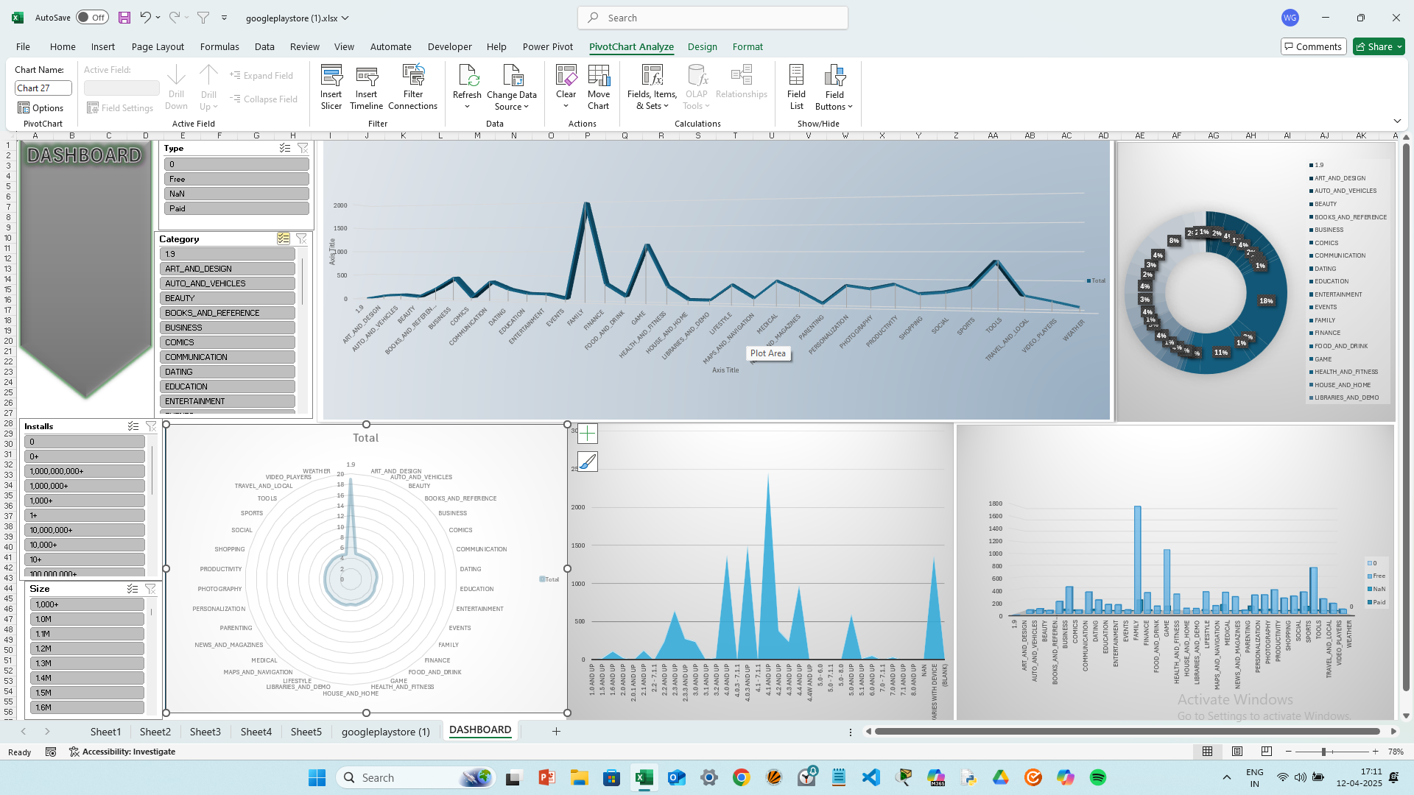
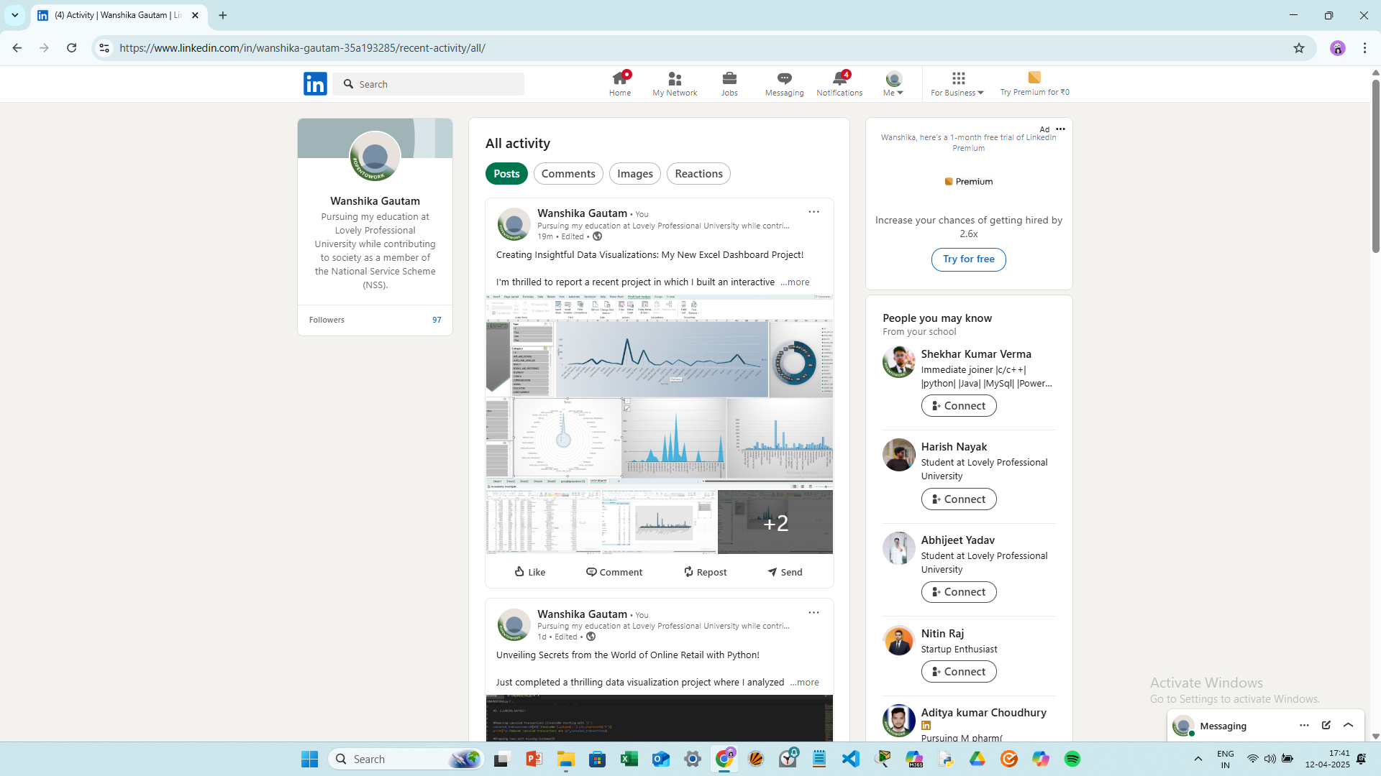
9. Analysis on Dataset (Google Play Store)
Objective:
The goal of this section is to perform an indepth examination of the dataset and reveal significant findings that will facilitate stakeholders (i.e., app developers, marketers, product managers) in data-driven decision making. The Google Play Store dataset contains details related to app traits like category, size, rating, and the number of installations, which play a pivotal role in understanding the performance of the app and how users engage with it.

Breakdown Analysis:
9.1 Customer Demographics (App User Insights)

Knowing App Users:

Although the dataset itself does not explicitly give us user demographic information (e.g., age or gender), we can make certain inferences regarding user preferences indirectly from measures such as the genre of the app, ratings, and geographic location.

Genres and Ratings: On examining Genres and Category columns, we can see what kinds of apps different groups of users prefer. Social apps can prefer a younger population, while Productivity or Business apps prefer an older audience.

Regional Preferences: By examining the Installs and Country columns (if available or derived from app features), we can identify regional trends, like a greater need for gaming apps in the U.S. than educational apps in other areas. This will assist in tailoring marketing campaigns or localized app creation.

9.2 Product Sales Trends (App Performance Over Time)

Installs Over Time:

Time-series analysis will allow us to monitor app performance over time. Looking at the Installs field in combination with the release date (if known), we can spot trends in the popularity of the app.

Seasonal Trends: This can indicate seasonal trends, where specific categories (such as games) may perform better over holidays or app promo times. Apps may also experience an increase in installs following updates or promo times.

9.3 Category Performance

Performance Across Categories:

The dashboard will allow users to analyze the revenue and install trends for every app category (e.g., Games, Productivity, Tools, etc.).

Revenue by Category: The revenue for every category is determined by multiplying Price (for paid apps) with Installs. By comparing categories, we can identify which ones are most profitable, allowing developers to concentrate on profitable categories.

Comparison of Free and Paid Apps: Looking at Price and Installs, we can see if paid apps or free apps with in-app purchase are earning more revenue.

9.4 Revenue Insights

Revenue Per App:

One of the most important observations from the dataset is the revenue per app, which can be calculated by multiplying Price and Installs for paid apps. This will provide an estimate of how much money each app is making, enabling developers to assess their pricing strategy.

Revenue by Region: Based on geographical information, we can segment revenue by region to identify which regions are more profitable for certain categories. For instance, apps can be more lucrative in North America than in Asia or Europe because of variations in app preferences and purchasing power.

Rating vs. Revenue: One of the main analyses will be whether higher-rated apps are associated with greater revenue. This will help establish if investing in quality app development and user experience pays off in terms of financial return.

10. Conclusion
The Google Play Store dataset analysis using the developed dashboard offers insightful information on several facets of app performance, user activity, and revenue generation. Some of the major conclusions that can be made from this analysis are:

Popular Categories: The dashboard highlights which app categories dominate the Google Play Store in terms of downloads and revenue. For example, Games and Tools might lead in terms of sheer volume, while Productivity or Health & Fitness apps could be generating significant revenue due to premium offerings or in-app purchases.

User Engagement: More rated apps have more installs and thus more revenue potential. Yet it is important to realize that top ratings do not necessarily translate into top revenue, particularly for free apps with in-app purchases.

Regional Insights: Regional preferences are diverse, with some app categories trending more in some geographic areas. This indicates that developers can enhance their approach by localizing their apps or marketing campaigns to appeal to regional flavors and needs.

Price Strategy: The dashboard also emphasizes the way pricing affects app success. Though paid apps can experience greater revenue per install, free apps tend to lead in installs as well as engagement, with revenue generated through in-app payments and advertising.

Performance Over Time: Some apps show gradual growth, while others spike seasonally (e.g., games at holiday times). By examining these patterns, developers can more effectively schedule their release cycles and marketing efforts to meet times of high demand.

In summary, this dashboard offers both general summaries and specific, actionable information for app developers and marketers, enabling them to make informed decisions regarding their apps' development, pricing, and marketing strategies.

11. Future Scope
The Google Play Store Dashboard can be further developed and enhanced in the following ways to further improve its analytical capabilities and make it more useful:

Real-Time Data Integration: At present, the dashboard accommodates static information. Future builds can incorporate real-time data sourced from the Google Play Store API to update constantly app performance stats. This way, users are able to follow current trends and make timely recommendations.

User Demographics: Subsequent releases may include user demographic information (age, gender, and geography) to deliver more detailed insights. While this information is not explicitly present in the Google Play Store dataset, user ratings and feedback may provide hints about the app's users.

Predictive Analytics: With the application of machine learning algorithms, we can forecast future app performance depending on past trends. For example, regression models can project future installs and revenue growth based on app characteristics at present and past data.

Adding Reviews Sentiment Analysis: With the addition of a sentiment analysis feature for user reviews, the dashboard could provide more insight into how user reviews relate to the performance of an app. Developers could see how positive or negative reviews affect app ratings, installs, and revenue.

Competitive Analysis: Comparison of the performance of an app with those apps in a given category would be a much-sought-after addition. Such functionality could inform us about how to compete, how to drive strategies to exceed that of the rest.

Improved Visualizations and Dashboards: Including more advanced visualizations, i.e., geographic distribution heatmaps, in-depth comparison charts, or animated charts illustrating growth over time, could further make the dashboard more intuitive and informative for decision-makers.

Cross-Platform Data Integration: The next version might also include app data from other platforms such as the Apple App Store, offering cross-platform insights and comparisons.

12. References
Here, the sources that were utilized to create the dataset as well as carry out the analysis would be mentioned. These might be:

Google Play Store Dataset:

The data utilized for the analysis can be obtained from websites such as Kaggle or GitHub, where data relating to the Google Play Store is provided.

Example: Kaggle data on Google Play Store Apps, with details regarding apps, installs, ratings, reviews, category, and so forth.

Tools and Libraries

Microsoft Excel: Software utilized to clean data, explore data, and visualize.

Research Papers and Articles:

Any academic journal articles or industry papers used as references to provide insight into app store dynamics, app performance trends, or price models can be included here.

For instance: "The Economics of the App Store" by Jean-Charles Rochet and Jean Tirole (2015) can be used for economic models of app store prices.

Google Play Store Documentation:

Google official documentation reference materials, especially for app developers, would be helpful for understanding the user interface of the platform, how to submit an app, and app monetization.

Source:.

