1、1000000内所有素数

#include<iostream>

using namespace std;

int main() {

cout << 2 << " ";

for (int i = 3; i <= 1000000; i++) {

int k = 2;

while (k != i) {

if (i % k == 0) { break; }

else { k++; }

}

if (k == i) { cout << i << " "; }

}

}

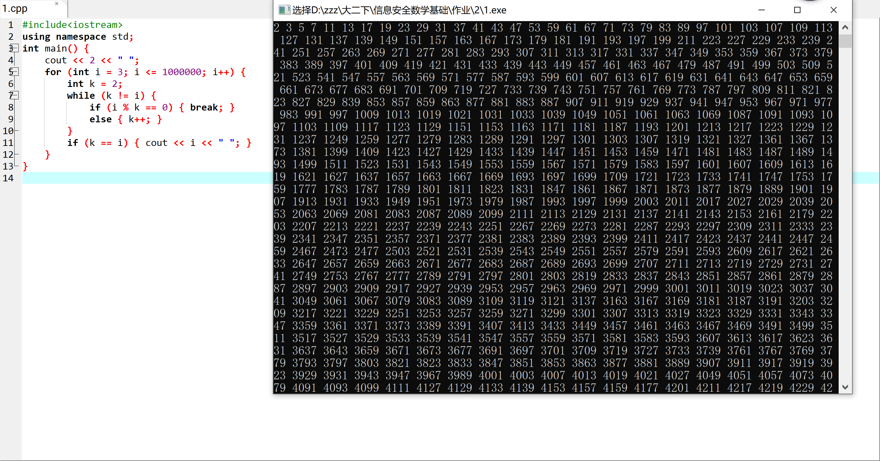

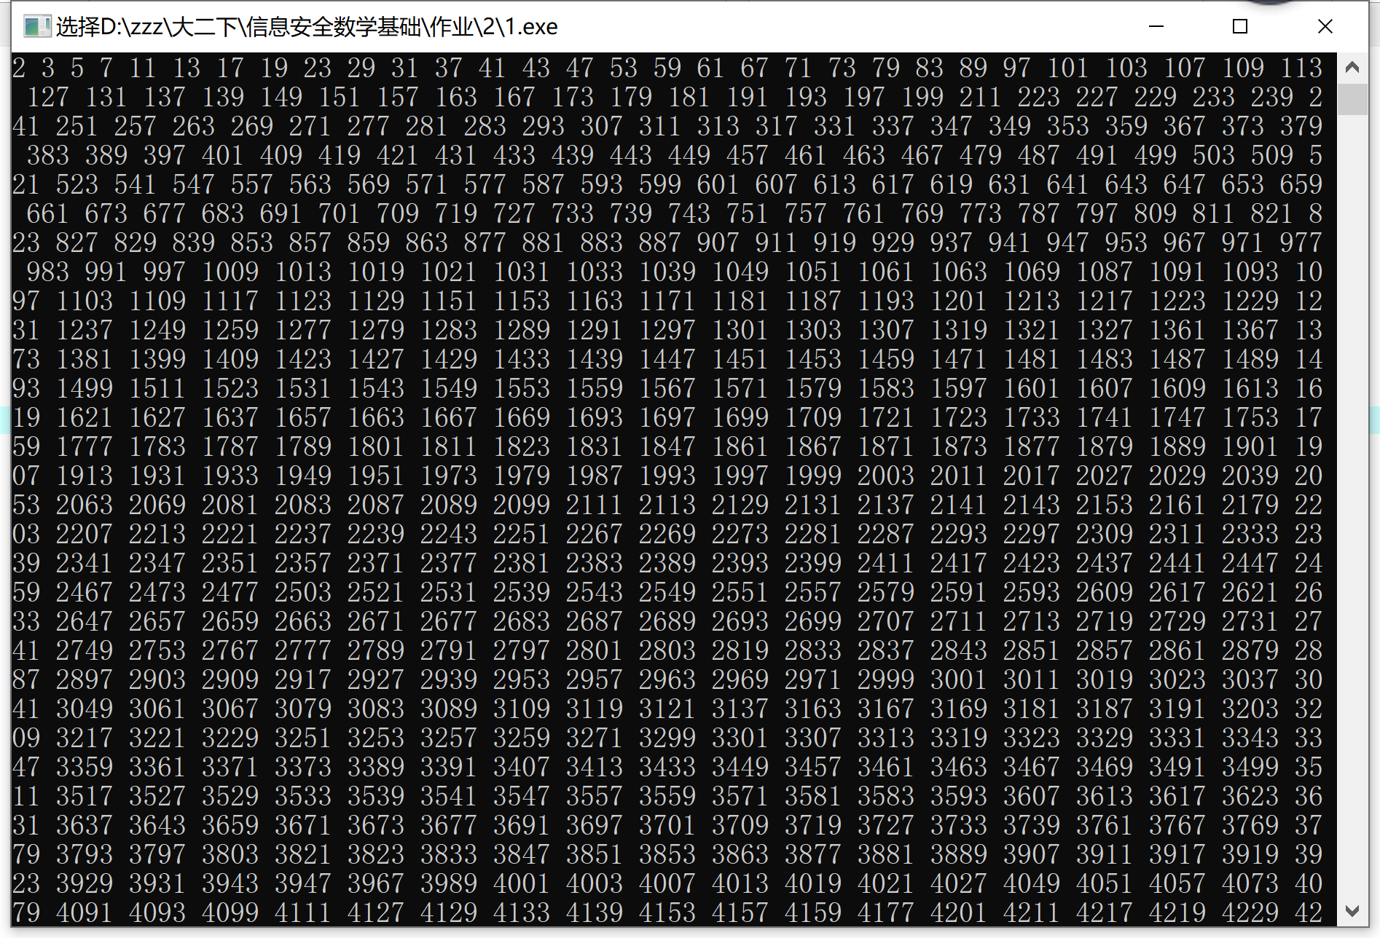

2、计算a、b的最大公因子

#include<iostream>

using namespace std;

int main() {

int a, b, c;

cin >> a >> b;

if (a < b) { c = b; b = a; a = c; }

int r = a % b;

while (r != 0) {

a = b;

b = r;

r = a % b;

}

cout << b;

}

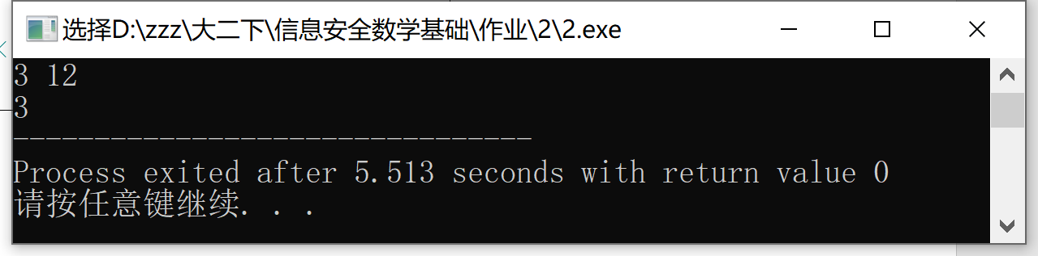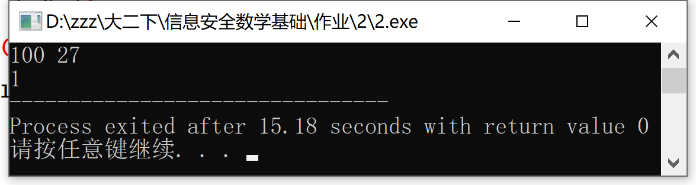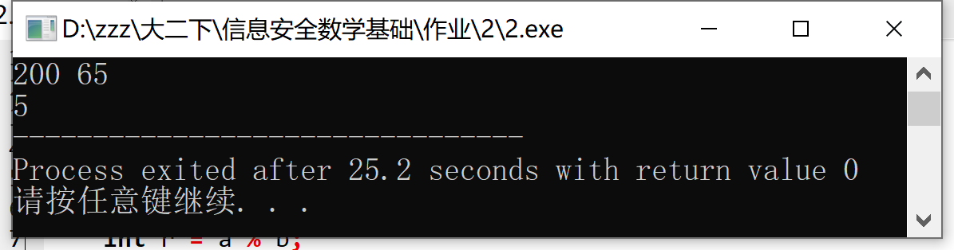

3、正整数n的素因子分解

#include<iostream>

using namespace std;

bool sushu(int m) {

if (m == 2) { return 1; }

int k = 2;

while (k != m) {

if (m % k == 0) { return 0; }

else { k++; }

}

if (m == k) { return 1; }

}

int main() {

int n;

cin >> n;

int m = n;

int s=1;

for (int i = 2;; i++) {

if (sushu(i) == 1) {

int r = m % i;

while (1) {

if (r == 0)

{

cout << i <<" ";

s \*= i;

m /= i;

r = m % i;

if (r != 0) { break; }

}

else { break; }

}

}

if (s == n) { return 0; }

}

}

