Contents
1.Introduction 1
1.1 Problem Background 1
1.2 Previous Research 2
1.3 Our Work 3
2. General Assumptions 4
3.Notations 4
4.Analysis of Tesla 5
5. The Model of Charging Network 7
5.1The Design of the Model 7
5.2 Sub Models 8
5.2.1Quantitative model 8
5.2.2Location model 10
6.Results of the Model 12
6.1Results of the America 12
6.1.1Results of the quantitive model 12
6.1.2Results of the Location model 12
6.2Results of the South Korea 14
6.2.1Results of the quantitive model 14
6.2.2Results of the location model 15
7. Analysis of the evolution of electric vehicles 16
7.1Quantitative analysis 16
7.2Comprehensive analysis 17
8.The model of the classification system. 18
8.1 The design of the model 19
8.2Comparison and analysis of Korea and Saudi Arabia 19
9.Analysis of the technology 20
9. Sensitivity Analysis 21
10. Strengths and Weaknesses 22
10.1Strengths 22
10.2 Weaknesses 22
10.3Future work 23
Factors Affecting the Development of Electric Vehicles 24

1.Introduction

1.1 Problem Background
Electric vehicles (EV) refer to a kind of vehicle, which is driven by the electromotor, taking the rechargeable battery as power source, and can satisfy every request by rules of road traffic safety. Electric vehicles are characterized by zero emission or ultra-low emission, low noise and low heat radiation. Meanwhile, the sources of electric energy are more and more diversified and clean.
According to the survey, the vehicle's harmful exhaust emissions have become the main source of air pollution in the world.The data showed that, at present, the pollution of the 60% of the CO, 50% of the nitrogen oxides,30% of the hydrocarbon in the city came from exhaust emissions of the vehicles, meanwhile, traffic vehicles also brought 80% of the noise pollution in the city^{[1]}. Therefore, electric vehicles that reduce the environmental pollution and carbon emissions, which is characterized by "energy saving" and "environmental protection", are considered to be ideal substitutes for fuel vehicles in the society under the dual constraints of resources and environment.
To further accelerate the switch to electric vehicles, some countries, including China, have announced that they will ban gasoline and diesel cars in the coming years. With the EV technology's improvement and the government's support, the EV market grows constantly. However, the popularity of electric vehicles can not be realized only through new technology, we must replace the fuel vehicle system with the electric vehicle system, and establish a perfect and efficient charging station network to support the promotion and use of electric vehicles. Compared with traditional fuel vehicles, electric vehicles have two obvious disadvantages: short travel range and long charging time, So how to decide the location and sizing of the charging station is very important.
At present, both the completed charging facilities and the facilities under construction are charging demonstration stations. Most of the charging facilities in use are dedicated electric vehicle charging stations, which neither really achieve large-scale commercial operation, nor consider the service of private electric vehicles^{[1]}. The main reason is the unreasonable layout of the charging facilities. Therefore, how to fully consider the regional differences and the development time of vehicle type conversion to establish a comprehensive charging network is very important.

1.2 Previous Research
The construction of electric vehicle charging station network is a concerned problem all over the world. In view of this problem, many scholars have made a study.
For example, MORROW K and others analyzed the demand for charging facilities in 3 different areas, and evaluated and compared the construction cost of different charging facilities^{[2]}. Schneider K and others are aiming at the power system in Vermont to analyze the size of the electric vehicle that the system can accommodate when different charging strategies are used. The conclusion is that when disorderly charging is applied, it can accommodate 50 thousand electric vehicles. When adopting the delayed charging strategy, it can accommodate 100 thousand electric vehicles;When using an intelligent charging strategy,200 thousand electric vehicles can be accommodated^{[3]}.REVELLE C S and others summarized the problem of facility location, and a series of classical location models, and various expanded models by adding different constraints^{[4],[5]}. Andy Ip and others proposed two-stage model of charging station planning for electric vehicles. The first stage uses cluster analysis to transform the road condition information into the charging demand cluster, the second stage uses the optimization algorithm to optimize the location of electric vehicle charging station under the consideration of certain constraints and capital factors^{[6]}.

1.3 Our Work
We are asked to build a realistic, sensible, and useful model to explore the current growing network of Tesla charging stations in the United States. Then choose South Korea, Ireland or Uruguay to determine the optimal number, placement, and distribution of charging stations. Our model needs to consider the number of stations, where they will be located, the number of chargers at the stations, the differences in the needs of rural areas, suburban areas, and urban areas, new technologies and other key factors we consider necessary.
Then we set out from the model and the data to analyze the key factors that shaped the development of the plan of electric vehicles. According to the growth plan, imagine the timeline for the full evolution to electric vehicles; present a proposal for evolving the charging network from zero chargers to a full electric-vehicle system; consider countries with very different geographies, population density distributions, and wealth distributions, and explore weather the proposed plan for growing and evolving the network of chargers still applies to each of these countries; consider the key factors that trigger the selection of different approaches to growing the network and discuss the feasibility of creating a classification system that would help a nation determine the general growth model they should follow.
To begin with, we searched a large number of papers that discuss the charging network to help us deepen the understanding of the problem. LuFang et al. provided a large amount of background information and their work^{[1]} served as an important introduction. We found that a few of the papers did modeling analysis of the location and optimization of charging stations^{[7]}.We integrated Markov chain, Simulated annealing algorithm and Voronoi Diagram to develop a model to simulate the charging network when the occupancy of electric vehicles is 100%.
Next, we build up a model to test the rationality of charging station distribution of Tesla. Then we build up the model SHXW to simulate the number and distribution of charging stations. And consider the factors which impact the architecture of the charging network in South Korea without transition time.Put the data of South Korea into SHXW to get the number and distribution of charging stations.
Then make a plan which includes the proposal of evolving the charging network and the timeline for full evolution to electric vehicles.And do qualitative analysis to the factors of the proposal and growth plan.
Finally, we build up a model of the classification system to consider whether the plan we made is applied to different countries.

General Assumptions
●The total mileage of an electric vehicle is the same as that of a gasoline car.
●The population of a small scale focus on the center of population distribution in the scale.
●The impact of household charging equipment is not considered.
●The proportion of destination charging stations and supercharging stations is the same as the current ratio of Tesla
●Assume that each charging station has the same load capacity.
●Each charging station has 5 chargers.
●The quantity of supercharging stations/the quantity of destination charging stations is 1:5.

3.Notations
Symbol | Description
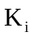 | State GDP
 | The population of each state
 | The proportion of charging stations in each state
 | Daily travel distance
 | The region that all charging stations should be placed in
 | A possible site selection of all charging stations
 | Quantity of supercharging stations/Quantity of destination charging stations
 | Mathematical Expectation
 | Standard deviation
 | The exact state of the car
 | The probability of this state appears
 | American total car ownership
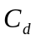 | Max output mileage of a destination charging station daily
 | Max output mileage of a supercharging station daily
 | Predicted quantity of supercharging stations
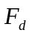 | Predicted quantity of destination charging stations
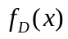 | Probability distributions of car travel distance in America
 | The minimum summation of all possible distance between stations and users
 | EV sales volume per year
 | The year when EV substitute for traditional vehicle absolutely
 | the general car ownership of a country
 | the universal ratio relative to the previous year

4.Analysis of Tesla
Tesla is known as the largest company of electric vehicles which have put up charging stations over 200 in America.The distribution of charging Stations is as follows: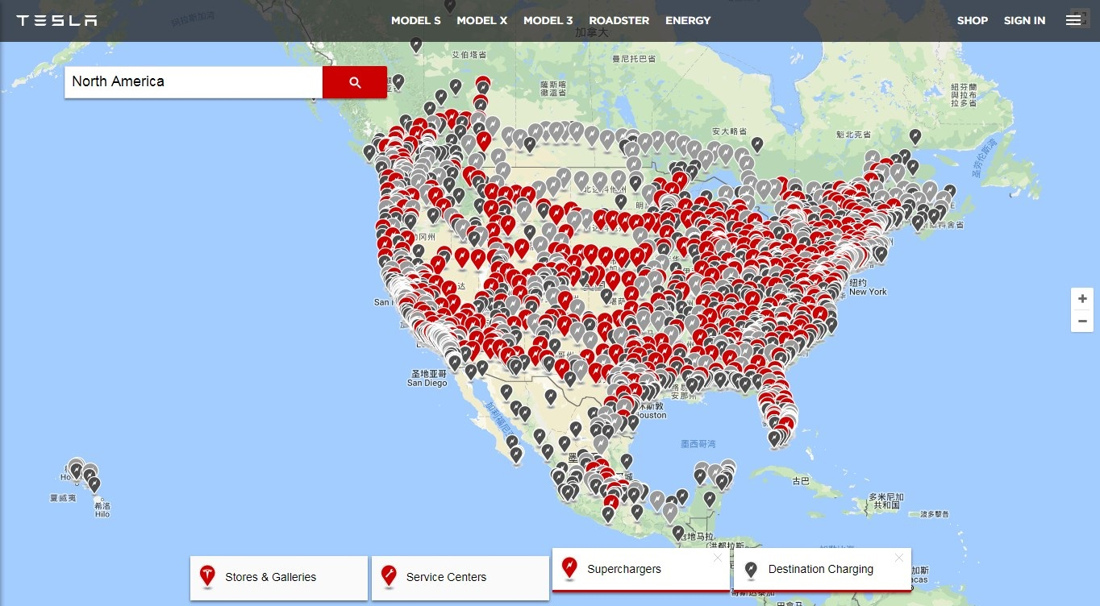
Figure 1.Charging station layout of Tesla in America
https://www.tesla.com/findus#/bounds/

To test the rationality of distribution,we design a model to estimate the proportion of charging stations in different states.
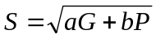 (4,1)
where:
is the proportion of charging stations in each state,
is the State GDP,
is the population of each state,
is the proportion of G,
is the proportion of P.
We analyzed State GDP and the population of each state to speculate the coefficient that a=3,b=25.The result is as follows:
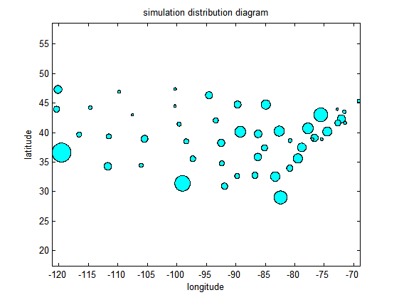
Figure 2.Simulation distribution diagram

By comparing the actual data of Tesla and the calculated data from the model,we got the conclusion that Tesla is on his track.

The Model of Charging Network
In this section, we develop the basic model to simulate the charging network when the occupancy of electric vehicles is 100%.The basic model includes the number of stations, where they will be located, the number of chargers at the stations, and the differences in the needs of rural areas, suburban areas, and urban areas. Then we discover that the GDP,the population and the coordinates are key factors to influence the model.

5.1The Design of the Model

In order to demonstrate our basic model clearly, we divide it into the two following sub models.
• Quantitative model:The number of charging stations is discussed in this model.
• Location model: This model is designed to simulate the location of the charging stations.

5.2 Sub Models

5.2.1Quantitative model
The quantitative model simulates the number of the charging stations.It is influenced by the daily driving distance of each car and the probability of charging the vehicle outside.
Firstly, we used data from National Transportation Statistics to calculate the daily driving distance of each car and get American daily driving distance distribution.
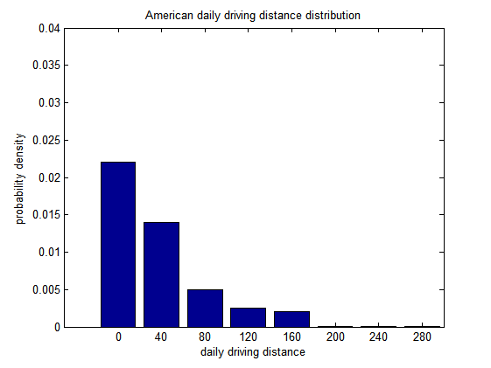
Figure 3.American daily driving distance distribution

Then we fit the data according to the principle of exponential distribution, and obtained following formula to calculate the expectation of distribution law, namely the daily driving distance.
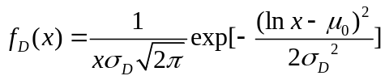 (5,1)
is car travel distance,
is probability distributions of car travel distance in America,
is standard deviation,
is Mathematical Expectation.
Secondly, we used Markov Chain to calculate the probability of charging the vehicle outside. Markov Chain is a stochastic model describing a sequence of possible events in which the probability of each event depends only on the state attained in the previous event.
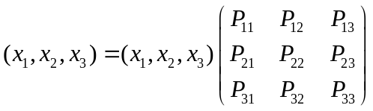 (5,2)
 is driving status of vehicles,
 is charging status of vehicles,
 is neither driving nor charging status of vehicles,
 is fromto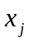.
Finally, calculate the total formula (5,3) from (5,1) and (5,2). We use data of American total car ownership from Bureau of Transportation Statistics to calculate the number of charging stations.
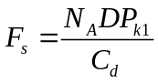
(5,3)

is predicted quantity of supercharging stations,
is American total car ownership,
is daily travel distance,
is the probability of this state appears,
is max output mileage of a destination charging station daily,
is quantity of supercharging stations/Quantity of destination charging stations,
is predicted quantity of destination charging stations.

5.2.2Location model
The location model simulates the location of the charging stations.To estimate the location of charging stations,we used Simulated annealing algorithm, which is a probabilistic technique for approximating the global optimum of a given function. It’s invented by S. Kirkpatrick, C. D. Gelatt and M. P. Vecchi in 1983. V. Černý also invented it independently in 1985.

Select Solution space
Objective function 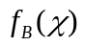
Select Initial answer 
Select Initial temperature 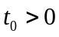,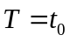
Select threshold value 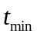
Select temperature reduction function

Repeat
Repeat
Randomly select 

if 
then 
else
generate a random number 
if 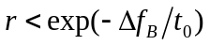
then
Until iteration-count = max. iteration
Set 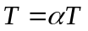
Until stopping condition = TRUE
is the best solution

stopping condition: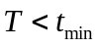

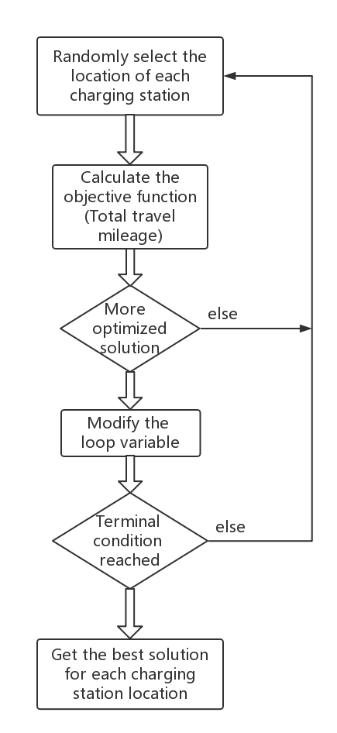

is the region that all charging stations should be placed in,
is a possible site selection of all charging stations,
is the minimum summation of all possible distance between stations and users.

6.Results of the Model

6.1Results of the America

6.1.1Results of the quantitive model
By analyzing the operation data of the traditional American automobile, the distribution law of the daily driving distance of the car is fitted, as shown in the figure 3. According to (5,1), we got the =28.4; According to (5,2), we obtained the =0.42; According to (5,3), we get the =42267, =213338.
To sum up, according to the quantitative model, the number of supercharging stations is 177500, the number of destination charging stations is 335000 in America.

6.1.2Results of the Location model
Because the overall data of the United States is too large, we selected a representative city, Tulare, to test the model. Because Tulare is small,the impact of GDP can be ignored. The data needed for the estimation can be obtained from the City-Data[17] and the Google Maps[18], which includes the data of population distribution and coordinates.We used (4,1) to get the population distribution diagram of Tulare.

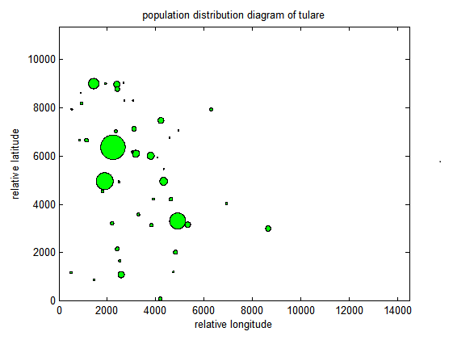
Figure 4.Population distribution diagram of Tulare
Put the population distribution data of Tulare into simulated annealing algorithm to get the location of the charging station; and then put the location information into Voronoi diagram to get the charging station division ; Finally,combine the charging station location and division to get Figure 5.

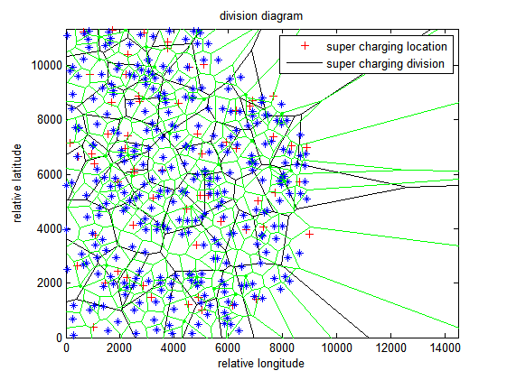
Figure 5.Division diagram in Tulare
＋: The location of supercharging station
: The division of supercharging station
: The location of destination charging station
: The division of destination charging station
By comparing Figure 4 and Figure 5,we can believe that the model is appropriate for the question.

6.2Results of the South Korea

6.2.1Results of the quantitive model
Regardless of the transitional time assumes that the proportion of electric vehicles is 100%, which fits the model SHXW. Consumers can only buy electric vehicles. At this point, the key factors that affect the development of electric vehicles are the population and GDP. The increase of population makes the demand of electric vehicles grow and the increase of GDP strengthens the purchasing power of consumers. Both will increase the ownership of electric vehicles and promote the popularization of electric vehicles.
Put the data (Korean Statistical Information Service)of South Korea into 5.2.1 and we got =416, =2080.
To sum up, according to the quantitative model, the number of supercharging stations is 416, the number of destination charging stations is 2080 in South Korea.

6.2.2Results of the location model
Put the data (Korean Statistical Information Service)of South Korea into 5.2.2 to get the location of charging stations in South Korea.
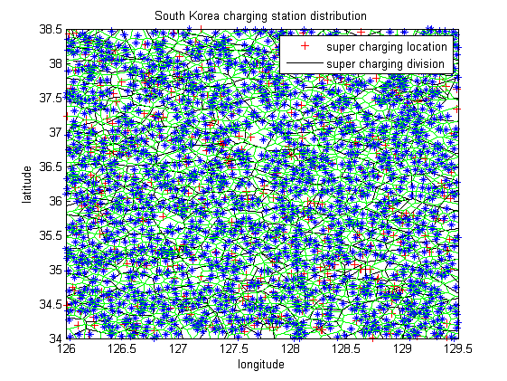
Figure 6. Division diagram in Korea

＋: The location of supercharging station
: The division of supercharging station
: The location of destination charging station
: The division of destination charging station

Analysis of the evolution of electric vehicles

7.1Quantitative analysis
We assume that the disuse of cars is not considered. The main issue at the present stage of the development of electric vehicles is the sell and popularization of electric vehicles. And the popularization of electric vehicles influences the evolution of charging network.We use the data from Electric Drive Transportation Association and the data of car ownership from Bureau of Transportation Statistics to analyze and predict future data, then summarize the following three points through the analysis:
• The current car ownership is 280 million;
• At the moment of the full penetration of fuel vehicles, the change in annual purchase amount is small , with an average of 21 million;
• The maximum annual growth rate of electric cars is 38%.
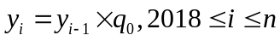
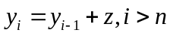 (7,1)
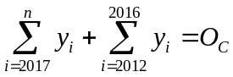 (7,2)
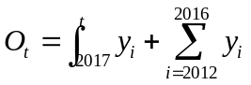 (7,3)
is EV sales volume per year,
is the year when EV substitute for traditional vehicle absolutely,
is the general car ownership of a country,
is the universal ratio relative to the previous year.
The result is as follows:
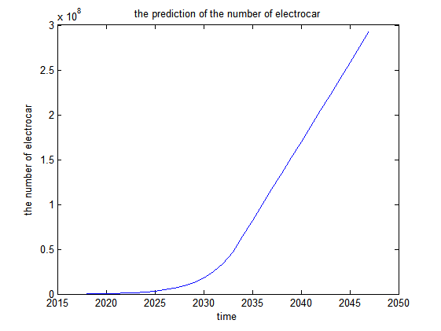
Figure 7. The prediction of the electric vehicle ownership
The Figure 7 shows the changes in the ownership of electric vehicles,It is estimated that the purchase volume of electric vehicles will increase by 38% annually from 2015 to 2033. After 2033, the total number of electric vehicles will reach the total number of current fuel vehicles, that is, the share of electric vehicles nears 100%. There is no significant change in its annual growth rate of the purchase, the increment of car ownership is 21 million per year.

7.2Comprehensive analysis
From (7,1),(7,2),(7,3) to speculate on the EV variation with time, the evolution of charging stations should on the basis of the growing trend of electric vehicles . 7.1 has assumed that growth rate of the purchase of electric vehicles is at the maximum, then the construction of charging stations need to meet the demand shown in the figure 7 for electric vehicle ownership.At the same time, establishing charging stations quickly in the initial stage is totally necessary, when the mount of stations reaches a level, turn to meet the electric car ownership.
The main factors to sell are performance and price of electric vehicles, as well as consumer’s income, respectively accounting for the proportion of 0.5101 and 0.2028; The percent of the impact of infrastructure constructions is only 0.1032, and the impact of charging stations only accounts for 0.079 on this basis^{[8]}. It shows that the impact of the construction of charging stations on the sell of electric vehicles is not obvious; At the same time, the construction and depreciation of charging stations also cost high. In summary, we think that should build chargers in response to car purchases.
As for the distribution of charging stations in urban and rural areas, it influences the purchasing power and demand of electric vehicles based on the urban-rural GDP and population density gap. In general, cities have higher demand and purchasing power for electric vehicles than rural areas. Therefore, the investment and construction of charging stations should start from the city, but it is unrealistic to consider the rural area after establishing the city charging station completely. The Figure 7 shows that as the number of electric vehicles are increasing, the demand for charging stations will also arise in rural areas. So it should be a mix of both, and the speed of construction in rural areas is slower than that in cities, the number of charging stations in rural areas is less.
According to my plan, Figure 7 shows the change of electric vehicle ownership and the timeline for full evolution to electric vehicles. By 2030, the share will reach 10% and it will account for 30% by 2034. The share will reach 50% by 2038 and reach 100% until 2044. The timeline is based on the current maximum growth rate of electric vehicles, but due to the uncertainties of various factors, it is impossible to confirm the change of the growth rate of electric vehicles. It may not be able to reach a growth rate of 38% or may exceed.
When considering the development of electric vehicles,we divided it into two parts.
• the factors of consumers
• the factors of enterprises
When thinking about consumers,the key factor is electric vehicle itself.For example,the price,security,convenience, output and others.The income,acceptance of electric vehicles,green awareness and knowledge level of consumers also influence the purchase of electric cars.Besides,the after-sale service can influence as well.
When thinking about enterprises,the key factor are the costs and profits which impact production quantity and the scale of the charging station directly,then influence the development of electric vehicles.
In order to maintain the rapid growth of electric vehicles, electric vehicle manufacturers are required to improve the price / performance ratio and build a convenient network of charging stations. Enterprises should accelerate the research and development process to reduce costs of production, rationalize the number and location of charging stations. Besides, the government should give some subsidies to costumers, and provide supporting policies as well as funding on electric vehicle-related businesses.

8.The model of the classification system.

8.1 The design of the model
The applicability of the development plan we have made is based on Korea as a basis for comparisons. The original plan was based on the rapid growth of the sales volume of electric vehicles as well as the simultaneous development in cities and rural areas, with differences in the scale and pace of development.
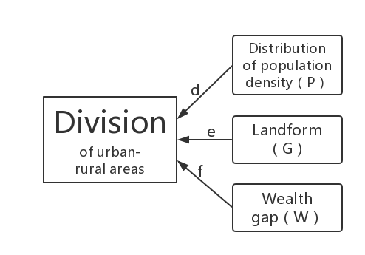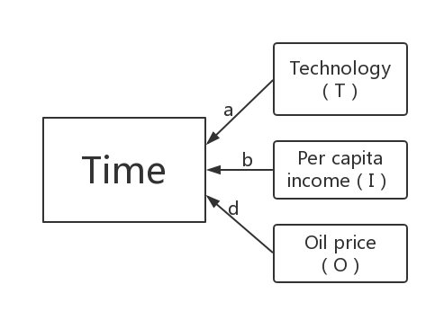  (8,1)
 (8,2)

We analyze from the perspective of geographical environment, population density distribution and wealth distribution, and use the time of promoting electric vehicles completely as well as the distribution of charging stations in urban and rural areas as the basis for evaluating whether the development plan is applicable to other countries, and determine the plans that fit different countries.
Among them, the time of promoting electric vehicles completely is affected mainly by the technical level, per capita income, oil and gas resources and other factors. The distribution of charging stations in urban and rural areas is mainly affected by factors such as population density distribution, landform and wealth distribution. According to the analysis, we choose = 0.5, = 0.4, = 0.1, = 0.3, = 0.1, = 0.6 for each factor to give the corresponding weight and quantify the degree of application of the model to different countries.

8.2Comparison and analysis of Korea and Saudi Arabia
First of all, we obtain data from A to get Korean technical index = 1036.56, per capita income index = 28,524 US dollars, oil and gas resources index = 11.06, population density distribution index = 31.3, geographical environment index = 74% , the difference index of richness = 31.6% .Through the standardization process, the evaluation index of development time in Korea was obtained as = 2.76, and the evaluation index of urban-rural distribution = 0.36.
Take Saudi Arabia as an example for inclusion in the classification system. From the above data sources, we get Saudi Arabian technical index = 97.24, per capita income index =20092 US dollars, oil and gas resources index = 1.69, population density distribution index = 57.9, geographical environment index =57.9% , the difference index of richness = 43.3%. Through the standardization process, the evaluation index of development time in Saudi Arabia was obtained as = 1.46, and the evaluation index of urban-rural distribution = 0.44.
As a result, Saudi Arabia has a smaller evaluation index of the development time. Therefore, it should extend the development planning period of its electric vehicles. The urban-rural distribution index is larger, so the urban-rural distribution of electric vehicle charging stations should be more concentrated in urban areas.

9.Analysis of the technology
As we all know, the world is developing at an unpredictable speed, new technologies are constantly growing, and the popularization of new forms of transport is foreseeable. China and other countries have already proposed to ban buying fuel vehicles by 2030, and then electric vehicles will become the main means of transport. At the same time,car-sharing and ride-sharing services, self-driving cars, rapid battery-swap stations for electric cars, and even flying cars and a Hyperloop are all going fast. They will promote each other and develop at a rapid pace.
A self-driving car (also known as a driverless car,autonomous car, robotic car[1] and unmanned ground vehicle is a vehicle that is capable of sensing its environment and navigating without human input.[2]
Self-driving cars use a variety of techniques to detect their surroundings, such as radar, laser light, GPS, odometry and computer vision. Advanced control systems interpret sensory information to identify appropriate navigation paths, as well as obstacles and relevant signage.[3][4] Self-driving cars must have control systems that are capable of analyzing sensory data to distinguish between different cars on the road.[5]
Self-driving vehicles require controllability. The controllability of electric vehicle motors is much higher than that of internal combustion engines.Motor torque and the response speed of rotational speed reaches millisecond level through electric power technology and motor drive technology. With the help of the upper processor,the car's attitude control can reach the height that any traditional car can not match.As the basis for the self-driving vehicles,the use of electric vehicles will naturally increase with the development of self-driving vehicles. The two complement each other. At the same time, large data shows that self-driving vehicles can promote car-sharing, ride-sharing, and then dramatically reduce the use of cars. These self-driving vehicles can reduce energy consumption, increase the capacity of major roads, save time, increase travel efficiency and increase satisfaction of residents. The increase of public acceptance can promote the development of self-driving vehicles and indirectly increase the use of electric vehicles.
The development of rapid battery-swap stations for electric cars makes up for the lack of existing electric vehicle charging mode largely. For example, the long charging time can not meet the demand for rapid charging of transportation vehicles such as buses and taxis, thereby reducing the convenience of using electric vehicles in related fields. Although rapid battery-swap stations cost high at the early stage of construction, the stable demand can still create profits in a short payback period, which perfects the use of EVs while meeting the feasible development of rapid battery-swap stations, and increase the use of electric vehicles.
A flying car is a type of personal air vehicle that provides door-to-door transportation by both ground and air. Many prototypes have been built since the first years of the twentieth century, but no flying car has yet reached production status.Some existing flying vehicles are required to save fuel during the R & D process. With the elimination of fuel vehicles, the future of flying cars is bound to the development of electric vehicles. The realization and promotion of this new technology will increase the use of electric vehicles.
A Hyperloop is a proposed mode of passenger and/or freight transportation, first used to describe an open-source vactrain design released by a joint team from Tesla and SpaceX^{[6]}. It has such characteristics as ultra-high speed, low energy consumption, no noise and zero pollution. The Hyperloop is a solar-powered and super-high-speed urban transport system that does not consume electricity resources, thus reducing the burden on the power grid and indirectly providing protection for the operation of electric vehicles, increasing the use of electric vehicles.

Sensitivity Analysis
In our quantitative model, the Markov chain varies from different car usage t. We test the
sensitivity of Markov chain by using different car usage.The state transition matrix is following.
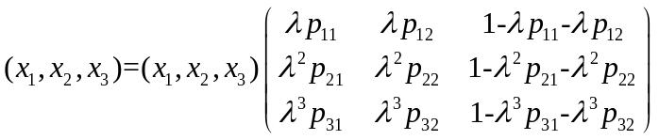
is car usage.
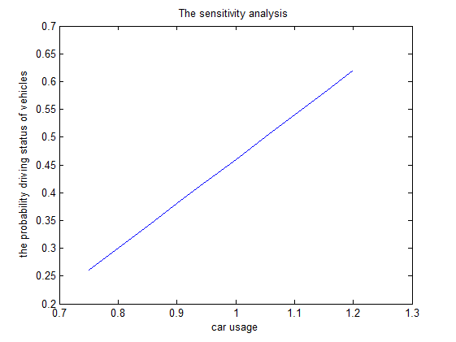
Figure 8.The sensitivity analysis
From the diagram,it is obvious that our conclusion isn’t sensitive to the usage.

Strengths and Weaknesses

10.1Strengths
• The model SHXW will get the charging station distribution to make the distance from users to station shortest.
• The model SHXW obtains the charging station distribution by considering the population distribution, so most of people will get enough charging station.

10.2 Weaknesses
• To analyze the evolution of electric vehicles,we do quantitative analysis by predicting the number of EV sales but the prediction is simple which will lead to the inaccurate quantity.
• Because of the data from the US is too large, we choose a small town as a representative example to put into our model but the small town is not able to support our analysis sufficiently.

10.3Future work
• we will plan to take more factors to the location model of the model SHXW, not only the population distribution and wealth distribution .
• The world has another way to charging the car which is exchanging battery, we also should take the way into consideration.
• In this paper ,we ignore the commercial vehicles including heavy trucks and buses to reduce workload.After the competition ,we will rebuild the model including the commercial vehicles.Because time costs are very important to commercial vehicles, the proportion of supercharging stations and determination stations should be changed.

Factors Affecting the Development of Electric Vehicles
With the continuous development of industrial society, the shortage of non-renewable resources and environmental problems have become increasingly prominent. For global sustainable development, the replacement of traditional fuel vehicles by electric vehicles is an inevitable trend of development.
- Factors that affect the development of electric vehicles
1.1 EV
price security convenience
output endurance mileage
1.2 Consumer
income green awareness knowledge level
1.3 Policy
registration”green channel” financial support
1.4 Infrastructure
charging stations parking lot
smooth traffic
1.5 Manufacturer
creditworthiness after-sale service
1.6 Social environment
security of society political stability market sentiment

II.Government policy recommendations
● Government improves policy support
Electric vehicle is a new industry, which needs strong support. First, we should expand the scope of subsidies so that car buyers all over the country can enjoy the subsidy policy. Second,the subsidy should be raised to make consumers feel that the actual cost of buying an electric car and purchasing a traditional fuel car is almost the same. Thirdly, Give priority to electric vehicles, and finally, the government should give support to related businesses.
● Promote the R & D of the electric vehicle battery
At present, the battery cost is too high, the service life is short, and the performance is poor. The investment in battery research and development should be increased to developing a new generation of high-performance batteries.
● speed up the construction of ancillary facilities
The government should participate in contacting enterprises that manufacture electric vehicles, and formulate standards with departments of the local government, rationally plan and improve the program to build a network of electric vehicle charging stations.
● strengthen environmental publicity
Both government and EV manufacturers are obliged to publicize the benefits of using EVs to raise people's environmental awareness and promote their purchase of electric vehicles.

REFERENCES
[1]Lu Fang.The location-sizing problem of electric vehicle charging station deployment based on queuing-theory[D].Beijing:Beijing Jiaotong University,2015.
[2]MORROW K, KARNER D, FRANCFORT J. Plug-in hybrid electric vehicle charging Infrastructure review[R] Idaho Falls：Idaho National Laboratory, 2008.
[3]Schneider K, Gerkensmeyer C, Kintner-Meyer M, et al. Impact assessment of plug-in hybrid vehicles on pacific northwest distribution systems. IEEE Power and Energy Society General Meeting. Pittsburgh: IEEE, 2008:1-6.
[4]REVELLE C S, EISELT H A. Location analysis：a synthesis and survey[J]. European Journal of Operational Research, 2005, 165(1):l-19.
[5]OWEN S H, DASKIN M S. Strategic facility Location：a review[J].European Journal of Operational Research, 1998, 111(3)：423-447.
[6]Andy Ip, Simon Fong, Elaine Liu. Optimization for Allocating BEV Recharging Stations in Urban Areas by Using Hierarchical Clustering．The 2nd International Conference on Data Mining and Intelligent Information Technology Applications (ICMIA 2010), Seoul, Korea, 2010.
[7]Hao Jianfei.Research on problem of electric vehicle charing station[D].Dalian:Dalian Maritime University,2015.
[8]Shen Hongchao. Analysis of the influence factors of electric vehicle demand in China based on ahp.[J]. Journal of Jilin business college, 2013.

[17]City-Data,California,
http://www.city-data.com/city/California.html
[18]Google Maps,Tulare,
https://www.google.com/maps/place/Tulare

