Diabetic Retinopathy Detection and Evaluation using Deep Learning
Inter-Eye Correlation, Data Leakage, and Bilateral Fusion in Automated DR Screening
Research Project Report
Y. L. Vishal
August 2026

Abstract
This report documents an end-to-end investigation into automated diabetic retinopathy (DR) grading, built around a question the published literature mostly assumes away rather than tests: does the common practice of splitting DR datasets by image, rather than by patient, actually inflate the accuracy models report? I built a full experimental pipeline over the public EyePACS and APTOS 2019 datasets — data cleaning and deduplication, three evaluation protocols (image-level, patient-level, and cross-dataset), frozen-feature and fully fine-tuned CNN models with two classifier head designs, a statistical framework built entirely on patient-level bootstrap confidence intervals, and a from-scratch decomposition experiment to separate three confounded design choices in a bilateral-grading result. Across roughly 40 individually trained models and several hundred bootstrapped comparisons, the project produced three headline findings. First, the correlation between a patient's two eyes is large and real (QWK 0.855) and survives every stratification test I applied. Second, and against my own initial expectation, splitting by image instead of by patient did not produce a statistically detectable inflation in this project's own models, under either frozen features or full fine-tuning — a genuine, carefully verified null result rather than a failed experiment. Third, grading a patient using both eyes together does help, but a decomposition experiment I designed specifically to interrogate this result showed that most of the apparent gain comes from a better classifier head rather than from combining the two eyes at all, and that the remaining fusion benefit is not consistent across CNN backbones. This report covers the problem statement, a literature review of twelve related works, the engineering and statistical challenges encountered while building the pipeline, the research objective and methodology, the full implementation, results, and discussion, and the work still remaining before the project is complete.

1. Problem Statement, Literature Review and Challenges

1.1 Problem Statement
Diabetic retinopathy is a complication of diabetes that damages the retina progressively and, in its early stages, without symptoms. By the time a patient notices vision loss, the damage is frequently irreversible. The standard defence against this is annual retinal photography: a trained grader examines a fundus photograph of each eye and assigns a severity grade on the International Clinical Diabetic Retinopathy (ICDR) scale, summarized in Table 1. A grade of 2 or above is defined as referable DR — the threshold at which the patient is sent for specialist follow-up, and the decision that actually matters in a screening pipeline, more than getting the exact 0–4 grade correct.
Grade | Name | Description
0 | No DR | No visible lesions
1 | Mild NPDR | Microaneurysms only, roughly 10 pixels wide in a downsampled image
2 | Moderate NPDR | More extensive haemorrhages and exudates — referable
3 | Severe NPDR | Extensive lesions, high risk of progression — referable
4 | Proliferative DR | Abnormal new vessel growth — sight-threatening, referable
Table 1. The ICDR five-level grading scale used throughout this project.
The number of screening photographs produced every year far outstrips the number of specialists available to grade them, which is exactly the gap automated deep learning models are meant to fill. That is the stated goal of essentially every paper in this space, including the ones reviewed in Section 1.2. What motivated this specific project, however, is a narrower and more uncomfortable observation: a number of published DR-grading models report accuracy figures that are implausibly high — in some cases exceeding the measured agreement between two independent human expert graders looking at the same photograph. A model cannot legitimately be more consistent than the ground truth it was trained to predict, so when that happens, the honest first hypothesis is not "the model is superhuman," it is "something in the evaluation is wrong."
The specific mechanism I suspected, and set out to test directly rather than assume, is patient-level information leakage. Almost every DR screening photograph comes from a patient who was photographed in both eyes, and both eyes share the same disease process, blood sugar history, and genetics — so a patient's left and right eye grades are correlated with each other for reasons that have nothing to do with image content. If a dataset is split into training and test sets at the level of individual images, ignoring which patient (and which eye) each image came from, one eye can end up in the training set while its fellow eye ends up in the test set. A model can then partly predict the test eye's grade not by reading the image, but by having implicitly memorized something about that patient from the correlated training eye. This is not a hypothetical concern for this project specifically — it is a manifestation of a more general and well-documented type of evaluation bias in machine learning, image-level leakage across correlated samples, that has been demonstrated in other medical imaging domains (see Section 1.2) but had not, at the time I started, been directly quantified for diabetic retinopathy grading using the public EyePACS and APTOS datasets specifically.
This project's problem statement is therefore three-part, and deliberately structured so that each part is falsifiable rather than assumed: (1) is the inter-eye correlation in these datasets actually large enough to matter, or is it a minor effect being over-worried about; (2) does an image-level split actually inflate reported model performance relative to an honest patient-level split, measured directly rather than inferred from the existence of the correlation in (1); and (3) if patients are photographed in both eyes anyway, can that be turned into a deliberate advantage — grading a patient using both eyes jointly — rather than only being treated as a threat to guard against. All three questions are answered with real experiments and real statistical tests in Section 3, not assumed in advance.

1.2 Literature Review
I reviewed twelve works spanning three groups: the foundational DR deep-learning literature that this project sits on top of, a set of papers specifically about data leakage and evaluation bias in medical imaging (including one directly in ophthalmology), and the supporting methods literature this project's implementation draws on for its statistical framework, its bilateral-grading design, and its planned calibration and explainability work. What I took from each is summarized below rather than only listed, because the point of this review was to inform design decisions in my own pipeline, not to catalogue prior work for its own sake.

Foundational and comparable DR deep-learning work
Gulshan et al. (2016), JAMA. "Development and Validation of a Deep Learning Algorithm for Detection of Diabetic Retinopathy in Retinal Fundus Photographs." This is the paper that established DR grading as a credible deep-learning application at clinical scale — an Inception-v3 model trained on a very large, multi-grader-adjudicated private dataset, reaching sensitivity/specificity in the range ophthalmologists consider clinically usable. What I took from it: the scale of private, carefully-adjudicated data this result depended on is exactly what public datasets like EyePACS and APTOS do not have, which is part of why leakage-sensitive evaluation matters more, not less, on public benchmarks — there is less of a data-scale safety margin to hide behind.
Gargeya & Leng (2017), Ophthalmology. "Automated Identification of Diabetic Retinopathy Using Deep Learning." A CNN feature-extraction-plus-gradient-boosting pipeline for referable-DR screening. What I took from it: this project's own frozen-feature-plus-classifier-head design (Section 2.2) follows the same general two-stage pattern — a pretrained CNN as a fixed feature extractor, with a separate, fast, easily-swappable classifier on top — which is precisely what let me run the ordinal-versus-multinomial head comparisons in Section 3 cheaply enough to repeat with five seeds and, later, across three backbones.
Voets, Møllersen & Bongo (2019), PLOS ONE. "Reproduction study using public data of: Development and validation of a deep learning algorithm for detection of diabetic retinopathy in retinal fundus photographs." This is a direct, independent attempt to reproduce Gulshan et al. (2016) using only public data (EyePACS), and it could not fully match the original private-data results. This paper is arguably the single closest precedent to this project's own approach: it treats a strong published DR result as something to be verified against public data rather than taken at face value, which is exactly the posture this project takes toward the image-level-versus-patient-level splitting question. It directly informed my decision to build my own patient-level split (P2) from scratch on the same EyePACS data, rather than trusting whatever split a downloaded dataset happened to already have baked in.
Tymchenko & Spodarets (2019), arXiv:2003.02261. "Deep Learning Approach to Diabetic Retinopathy Detection." A high-placing APTOS 2019 Kaggle competition solution using an EfficientNet-B4/B5 and SE-ResNeXt50 ensemble with a three-head classification/regression/ordinal-regression design, reaching a competition QWK of 0.925 on APTOS's leaderboard split. What I took from it: the ordinal-regression head this paper uses is the same underlying idea as the ordinal head implemented in this project (Section 2.2) — treating DR grade as an ordered, continuous-then-rounded quantity rather than five unrelated classes. Its very high reported QWK, on a competition split whose patient-level integrity I could not independently verify, is itself a small piece of the same broader pattern that motivated this project's Claim 2 investigation.
Ali, Wang, Bi, Jung, Chen & Zhang (2024/2025), The Visual Computer. "Deep learning-based binocular system for automated diabetic retinopathy grading with prior clinical knowledge integration." This paper is the closest published precedent to this project's Claim 3: a binocular network that grades one eye while incorporating features from its fellow eye, reaching 87.3% accuracy on a private set and 86.5% on the public Kaggle-DR set, ahead of single-eye baselines. What I took from it, and where this project's own contribution differs: this paper reports that binocular fusion helps, but does not decompose why — it does not separate the effect of using both eyes from the effect of whatever classifier design accompanies the binocular architecture. Section 3's Phase 5b decomposition experiment was designed specifically to close that gap for this project's own bilateral result, and the finding — that most of the apparent both-eyes benefit was actually a classifier-head effect — is a methodological caution that a paper like this one, which reports a single end-to-end binocular number, would not surface.

Data leakage and evaluation bias in medical imaging
Tampu, Eklund & Haj-Hosseini (2022), arXiv:2202.12267. "Inflation of test accuracy due to data leakage in deep learning-based classification of OCT images." This is the most directly relevant leakage paper found in this review, because it is in ophthalmology, on the same broad imaging modality family as this project (retinal OCT rather than fundus photography), and it quantifies the exact failure mode this project investigates: splitting by individual 2D image instead of by patient/volume inflated Matthews correlation coefficient by 0.07 to 0.43 across three public OCT datasets, including the widely-reused Kermany dataset. What I took from it: leakage of this kind is not a hypothetical risk in retinal imaging specifically — it has been directly measured, at a similar order of magnitude to what would be practically important, in a sibling modality. That this project's own Claim 2 experiment (Section 3) did not reproduce a comparable inflation for DR fundus grading on EyePACS/APTOS is therefore a genuine, non-obvious finding, not an expected null result — it is a divergence from a closely related published result that deserved to be investigated as carefully as it was, rather than dismissed as "my leakage test didn't work."
Yagis et al. (2021), Scientific Reports. "Effect of data leakage in brain MRI classification using 2D convolutional neural networks." A second, independent demonstration of the same image-level-versus-subject-level leakage failure mode, this time in neuroimaging, again showing inflated apparent accuracy under naive per-image splitting. What I took from it: this paper, together with Tampu et al. above, establishes that this leakage mechanism generalizes across imaging domains and is not specific to any one dataset's quirks — which is exactly why it was worth testing directly for DR rather than assuming the general pattern would transfer automatically.
Rouzrokh, Khosravi, Faghani, Moassefi, Vera Garcia, Singh, Zhang, Conte & Erickson (2022), Radiology: Artificial Intelligence. "Mitigating Bias in Radiology Machine Learning: 1. Data Handling." A methodological guidance paper cataloguing common data-handling mistakes in medical-imaging ML, with patient-level (rather than image-level) splitting listed explicitly as a required practice to avoid leakage bias. What I took from it: this project's three-protocol design (P1 image-level, P2 patient-level, P3 cross-dataset — Section 2.2) is a direct, testable operationalization of this paper's general recommendation, applied specifically and empirically to DR rather than stated as guidance alone.

Supporting methods used in this project's implementation
Selvaraju, Cogswell, Das, Vedantam, Parikh & Batra (2017/2019), ICCV / IJCV. "Grad-CAM: Visual Explanations from Deep Networks via Gradient-Based Localization." The gradient-weighted class-activation-mapping method this project will use in the upcoming Phase 7 to visualize which retinal regions each model is actually attending to, including on failure cases. What I took from it: an explanation method is only useful for this project's purposes if it is applied to failures as well as successes, which is why Phase 7's plan (Section 4) explicitly requires a Grad-CAM panel that includes misclassified images, not only a curated set of correct, visually convincing ones.
Guo, Pleiss, Sun & Weinberger (2017), ICML. "On Calibration of Modern Neural Networks." The paper that introduced temperature scaling as a simple, effective post-hoc calibration method, and demonstrated that modern deep networks are frequently overconfident even when reasonably accurate. What I took from it: this project's Phase 7 plan (Section 4) fits a single temperature-scaling parameter on a held-out validation set, never on test, following this paper's methodology directly — this matters clinically, because an uncalibrated confidence score would make the planned reject-option threshold (deferring low-confidence cases to a human grader) unreliable even if the underlying grade predictions were accurate.
EyePACS / Kaggle Diabetic Retinopathy Detection (2015) and APTOS 2019 Blindness Detection (Asia Pacific Tele-Ophthalmology Society / Kaggle, 2019). The two public dataset releases this entire project is built on. What I took from them, beyond the raw images and grader labels: neither release ships an explicit, verified patient-level train/test split — EyePACS includes a left/right eye and (via file naming) an implicit patient identifier that has to be reconstructed and validated, and APTOS 2019 does not reliably expose eye-pairing metadata at all. That gap in the datasets themselves is a direct cause of Section 1.3's Challenge 2 and is exactly what motivated building the P1/P2/P3 split infrastructure from scratch rather than reusing an existing split.
Read together, these twelve works place this project at a specific, deliberately chosen intersection: it sits on the same DR-grading foundation as Gulshan, Gargeya, Voets, Tymchenko, and Ali et al., but it borrows its central methodological question — does the split protocol itself change the answer — from the leakage literature in OCT and brain MRI (Tampu et al.; Yagis et al.) and the general radiology-ML guidance literature (Rouzrokh et al.), and it is the first place I am aware of, from this review, that this specific question is asked and empirically tested for diabetic retinopathy on EyePACS/APTOS, with the result reported honestly regardless of which way it came out.

1.3 Challenges
The largest source of difficulty in this project was not any single algorithm — it was building and validating an entire evaluation infrastructure from first principles, because none of the standard public tooling around EyePACS or APTOS provided one that could be trusted for this project's question. The challenges below are grouped by where they actually occurred, in the order the project encountered them, and each one required a real engineering or statistical decision on my part, not just running someone else's script.

Challenge 1 — building a trustworthy patient identity and split system from scratch
Neither EyePACS nor APTOS ships a verified patient-level split. EyePACS encodes a patient identifier and eye (left/right) in its filenames, but this had to be parsed, validated, and turned into an explicit manifest with a patient_id and partner_id column for every image before any patient-level analysis was possible — and APTOS 2019 does not reliably expose eye-pairing metadata at all, which meant it could not be used for the bilateral-grading experiments and had to be scoped out of Claim 3 explicitly rather than silently ignored. I had to design and implement three separate split protocols (P1 image-level, P2 patient-level, P3 cross-dataset) as actual reproducible code, each one auditable against the manifest, before a single classifier could be trained.

Challenge 2 — data quality problems that would have silently corrupted every downstream result
Before any modeling, the raw datasets contained problems that had to be found and handled deliberately. Eight EyePACS images turned out to be entirely flat black — corrupted captures rather than real photographs — and had to be identified and excluded before splitting, with an explicit check that none of the eight had already leaked into the primary test set. Separately, 148 near-duplicate images were found within APTOS using perceptual hashing, which if left in place would have let visually near-identical images land on both sides of a split and produced exactly the kind of leakage this project was built to detect and avoid, just via a different mechanism than the eye-pairing one. Neither of these problems announces itself in a training loss curve; both had to be found by deliberately auditing the data before trusting any number that came out of it.

Challenge 3 — the classifier head choice was a hidden confound, and I only caught it on review
The single most important methodological catch in this project was self-detected, not externally reviewed: an early version of the Claim 3 bilateral-grading comparison changed three things at once — the classifier head (multinomial to ordinal), the fusion method (per-eye to feature-averaging), and the aggregation rule (max to a single joint prediction) — and reported the combined effect as if it were a clean test of "does using both eyes help." Catching this required going back and designing an entirely new decomposition experiment (Phase 5b, Section 3) that isolates each of these three variables independently, with its own paired bootstrap confidence interval, repeated across three backbone configurations. This was, by a wide margin, the most statistically demanding part of the project, and it is also the part that most directly demonstrates this project's own analytical contribution rather than its use of existing tools — the finding that emerged (Section 3.4) reverses the original, simpler conclusion.

Challenge 4 — compute and infrastructure limits that shaped the experimental design
This project was run on a single consumer laptop GPU, not a research cluster, which had real methodological consequences rather than being only an inconvenience. The first full fine-tuning pass (Phase 6) used a 15-epoch budget and produced models that were still measurably improving when training stopped — four of five runs had their best epoch in the final three, and the fine-tuned model actually lost to a much cheaper frozen-feature linear probe, which is not supposed to happen once a model has properly converged. Recognizing that this was an undertraining problem rather than a dead end required a second engineering pass: a properly converged re-run (Phase 6b) with 40 epochs, an early-stopping patience of 8, a raised backbone learning rate, and a newly added sampler ablation, run as eight separate resumable training jobs, several of them taking multiple hours each even after diagnosing and partially working around an unrelated file-system caching slowdown in the training pipeline's image loading. Every one of the eight jobs also had to be checkpointed and resumable by design, because no single training run could be guaranteed to complete uninterrupted.

Challenge 5 — holding a genuinely negative result to the same standard as a positive one
The hardest challenge to describe is not technical: Claim 2, the leakage-inflation test that motivated the entire project, came back null — not once, but three separate times, under three different evaluation setups (frozen-feature protocol comparison, a targeted partner-eye ablation, and full fine-tuning). It would have been easy to treat this as the project having failed to find what it set out to find, and either bury it or keep re-running variations until something crossed a significance threshold by chance. Instead, every one of these three tests was pre-planned with an explicit acceptable-null-result outcome stated in advance, and the discipline required to report "no significant difference" honestly, with its own bootstrap confidence interval, three separate times, rather than treating it as a setback to explain away, was a real and ongoing challenge throughout the project — and is exactly what this report does in Section 3.6.

2. Research Objective and Methodology

2.1 Research Objectives
The overarching objective of this project is to build and evaluate a diabetic retinopathy grading pipeline in which every methodological choice that could plausibly inflate reported performance is identified, isolated, and tested directly, rather than inherited unexamined from prior work. This breaks down into four concrete, individually testable objectives, each with a pre-specified way of knowing whether it succeeded or failed:
- Objective 1 — Measure the true inter-eye grade correlation in EyePACS directly, with a proper patient-level statistical estimate and a stratified robustness check, rather than assuming a magnitude from first principles.
- Objective 2 — Determine empirically whether an image-level train/test split inflates reported DR-grading performance relative to a patient-level split, using both frozen-feature models and fully fine-tuned models, and report whichever answer the data actually gives.
- Objective 3 — Determine whether grading a patient using both eyes jointly improves performance over single-eye grading, and — critically — decompose any such improvement into its constituent causes (classifier head design, feature-level fusion, prediction-aggregation rule) rather than reporting a single entangled number.
- Objective 4 — Build the surrounding infrastructure (calibration, a confidence-based reject option, a deployable bilateral-aware screening application, and a survey of split practice in comparable public repositories) needed to turn these findings into something usable, not only a set of numbers in a table.
Objectives 1 through 3 are complete and reported in Section 3 of this document. Objective 4 is in progress; its current status and remaining scope are given in Section 5.

2.2 Methodology

2.2.1 Data and preprocessing
The project uses two public datasets. EyePACS (35,126 images, 17,563 patients, both eyes photographed per patient) is the primary dataset and the only one with reliable eye-pairing metadata, so all patient-level and bilateral-grading analysis is built on it. APTOS 2019 (3,662 images, unpaired) is used only where eye-pairing is not required — principally the cross-dataset (P3) generalization check. Before any modeling, I built a single unified manifest across both datasets recording image_id, patient_id, eye, partner_id, and grade, and applied two cleaning passes: excluding 8 corrupted (flat-black) EyePACS images, confirmed not to have touched the primary test set, and deduplicating 148 near-duplicate images found within APTOS via perceptual hashing, so that near-identical images could not land on both sides of any split.

2.2.2 Three evaluation protocols
Three splitting protocols are used throughout, all evaluated against the same underlying pool of cleaned images:

2.2.3 Statistical standard
A single statistical standard is applied to every claim in this project, without exception: every reported metric is accompanied by a 95% confidence interval obtained by patient-level bootstrap resampling (resampling patient IDs with replacement, and including every image belonging to a resampled patient, so that the correlation between a patient's two eyes is preserved inside each bootstrap sample rather than treated as if the images were independent). Every comparison between two conditions — two protocols, two classifier heads, two aggregation rules — is evaluated as a paired bootstrap confidence interval on the difference, not as two separate confidence intervals eyeballed side by side, and a gap is only reported as “real” if that interval on the difference excludes zero. The primary metric throughout is Quadratic Weighted Kappa (QWK), the standard agreement metric for ordinal grading tasks, which penalizes a prediction in proportion to how far off it is rather than treating all mistakes as equally bad.

2.2.4 Model architectures and classifier heads
Two families of models are used. The first, used for the majority of experiments because it makes running dozens of controlled comparisons computationally tractable on a single consumer GPU, is a frozen-feature pipeline: a pretrained CNN backbone (EfficientNet-B0 at 224px and 384px, and ResNet-50 at 224px, giving three independent backbone/resolution configurations) is used purely as a fixed feature extractor, with two alternative classifier heads trained on top of the cached features — a multinomial logistic regression head (treating the five grades as unrelated classes) and an ordinal regression head (a ridge regression fit to the numeric grade, with five decision thresholds jointly optimized by Nelder–Mead search, then rounded — treating grade as an ordered, continuous-then-discretized quantity, which better matches how QWK itself scores mistakes). The second family is full end-to-end fine-tuning of the same EfficientNet-B0 backbone, with a two-stage learning-rate schedule (a higher rate for the classification head, a lower rate for the backbone, the backbone frozen for the first two epochs), exponential moving average of model weights, mixed-precision training, and early stopping on validation QWK.

2.2.5 Bilateral-grading design and the decomposition
For grading a patient using both eyes (Objective 3), three design axes were varied independently rather than changed together: the classifier head (multinomial vs. ordinal), the point at which the two eyes' information is combined (per-eye prediction with a later aggregation step, vs. combining the two eyes' feature vectors before classification, either by concatenation or by mean-pooling), and, for the per-eye approach, the rule used to combine the two eyes' separate predicted grades into one patient-level grade (maximum — the clinically conventional "worse eye wins" rule — versus mean, versus minimum). This produces a full grid of comparable conditions rather than one single bilateral number, and every cell of that grid carries its own bootstrap confidence interval, repeated across all three backbone/resolution configurations, so that a finding is only trusted if it holds up across architectures rather than being an artifact of one specific backbone.

2.2.6 Engineering practices supporting the methodology
Two implementation practices underpin the reliability of the results in Section 3. First, every experiment script is checkpoint-and-resume capable: expensive fitting stages are cached to disk immediately after completion, and fine-tuning runs save both a resumable training checkpoint every epoch and a separately-tracked best-validation-QWK checkpoint, so that a multi-hour job interrupted partway through can continue rather than restart from zero. Second, the fine-tuning pipeline logs both training-set and validation-set QWK after every epoch specifically so that convergence — as opposed to an arbitrary compute-budget cutoff — can be verified directly from the resulting curve rather than assumed from the fact that a training script finished running.

3. Implementation, Results and Discussion

3.1 Implementation Overview
The codebase built for this project is organized as a sequence of numbered phases, each producing a versioned JSON results file and, where relevant, a figure, so that every number quoted in this report traces back to a specific script and a specific output file rather than a hand-copied figure. The pipeline has five layers, summarized here before the results themselves are presented.

Layer 1 — data manifest and cleaning
A single script builds the unified manifest (image_id, patient_id, eye, partner_id, grade, dataset, exclusion flags) from the raw EyePACS and APTOS releases, applies the flat-image exclusion and the perceptual-hash deduplication described in Section 1.3, and writes the three split protocols (P1, P2, P3) as explicit JSON fold assignments so that every later script reads from the same, auditable source of truth rather than re-deriving splits independently.

Layer 2 — feature extraction
A single extraction script runs each of the three pretrained backbones (EfficientNet-B0 at 224px and 384px, ResNet-50 at 224px) over every cleaned image once, caching the resulting feature vectors to disk. This is what makes the large number of classifier-head and fusion-method comparisons in Section 3.2–3.4 computationally tractable: those comparisons only need to re-fit a lightweight classifier on cached features, not re-run the CNN, so dozens of controlled comparisons across three backbones and five random seeds could be run in minutes rather than requiring dozens of separate GPU passes.

Layer 3 — the statistical framework
A shared module implements the multinomial and ordinal classifier heads, the patient-level bootstrap confidence interval, and the paired bootstrap confidence interval on a difference, described in Section 2.2.3. Every experiment script in Layer 4 imports from this same module rather than reimplementing its own statistics, so that a claim's confidence interval is always computed the same way project-wide.

Layer 4 — the experiment scripts
Each claim in Section 3.2–3.6 below is produced by its own script: inter-eye correlation and its stratified robustness check, the P1-vs-P2 protocol comparison, the partner-eye ablation, the bilateral-grading comparison, and — the most involved of these — the decomposition experiment that separates classifier-head effect from feature-fusion effect from aggregation-rule effect across all three backbones, described in Section 2.2.5. The fine-tuning scripts (Phase 6 and the converged re-run, Phase 6b) sit alongside these as full end-to-end training pipelines with resumable checkpointing, described in Section 2.2.6.

Layer 5 — verification and reporting
Every experiment script writes its results as a structured JSON file with the raw metric, its confidence interval, and, where applicable, a plain-language verdict field, rather than only printing numbers to the console. This report's tables and figures are drawn directly from those JSON files, and the two decomposition figures in Section 3.4 are regenerated programmatically from the same underlying JSON rather than hand-drawn, so that a re-run of the underlying experiment automatically produces an updated figure without manual editing.

3.2 Results — Correlation and Its Robustness (Objective 1)
Directly measuring how well one eye's grade predicts its partner eye's grade over 17,555 EyePACS patients gives QWK = 0.855 (95% CI [0.846, 0.863]). As a reference point, a trivial "label-only lookup" — no image, no pixels, simply copying one eye's known grade onto its partner as a prediction — already reaches QWK = 0.838. This ceiling matters as a diagnostic tool: any model that lands near 0.838 without clearly and significantly beating it may be exploiting the inter-eye correlation rather than reading the image, which is a useful sanity check to apply to any DR-grading result, including several published figures in the 0.85–0.92 range that sit uncomfortably close to this same ceiling.
This correlation could, in principle, be an artifact of class imbalance — 73% of patients are grade 0 in both eyes, so a naive critic could argue the "correlation" is just "healthy eyes look like healthy eyes." Stratifying by severity rules this out: restricted to patients with at least one eye graded 1 or above, QWK is still 0.656; restricted further to the referable threshold (grade ≥ 2), QWK is 0.538. A permutation test that randomly reassigns which eye belongs to which patient gives p ≈ 0, confirming the correlation is not a statistical artifact of the resampling procedure itself. Figure 1 breaks this down by grade and surfaces a sharper, unanticipated pattern: correlation is not uniform across severity. Grade 1 (Mild NPDR) is the one grade that essentially fails to transfer between eyes — only 45.8% lookup accuracy — while grades 0, 2, 3, and 4 are all well predicted from the partner eye (72–94% accuracy). This is consistent with Mild NPDR's defining lesion, microaneurysms only a few pixels wide after downsampling, being close to the detection floor of both human graders and any model working from the same downsampled images.
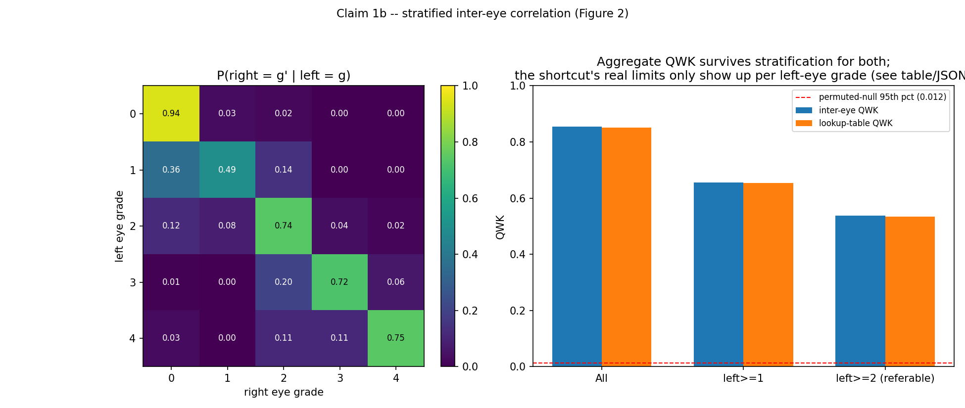
Figure 1. Partner-eye lookup accuracy by severity grade. Grade 1 (Mild NPDR) is the outlier — the one grade that does not reliably transfer between a patient's two eyes.

3.3 Results — Does Image-Level Splitting Inflate Scores? (Objective 2)
Given the strong correlation in Section 3.2, the natural prediction is that models trained and evaluated under the image-level (P1, leaky) protocol should score higher than under the patient-level (P2, honest) protocol. This was tested with frozen EfficientNet-B0 features and both classifier heads, five random seeds per protocol. Results: P1 (leaky) reaches 0.514 QWK (multinomial) / 0.595 QWK (ordinal); P2 (honest) reaches 0.524 QWK (multinomial) / 0.621 QWK (ordinal) — if anything, the point estimates run in the opposite direction from the prediction. A paired permutation test on P1 vs. P2 gives p = 0.125, not significant at any conventional threshold.
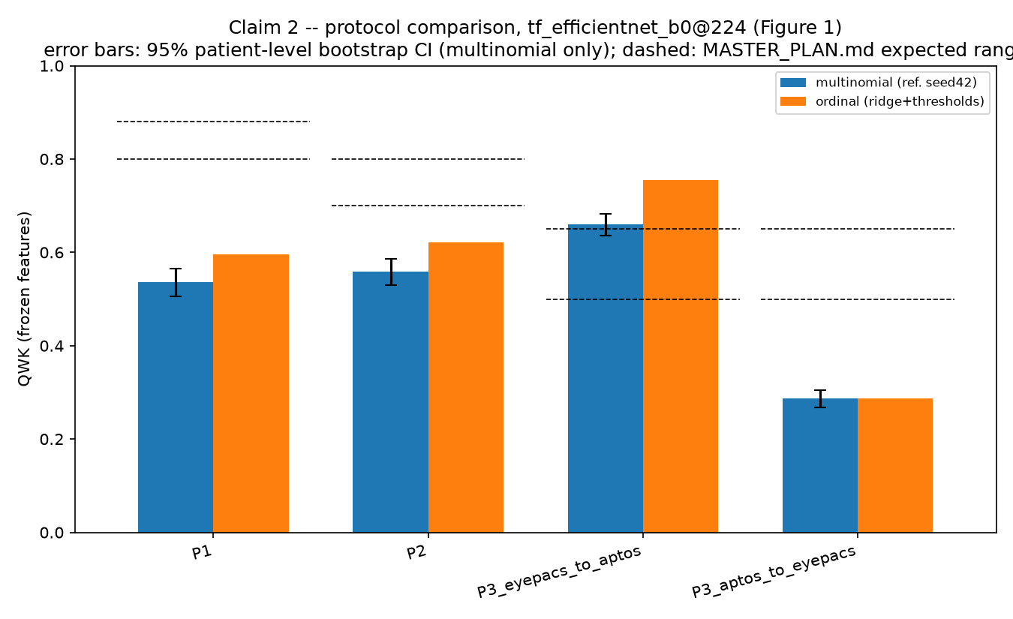
Figure 2. P1 (image-level) vs. P2 (patient-level) QWK, both classifier heads. The predicted inflation from leakage does not appear.
To test the leakage mechanism more directly than a whole-protocol comparison can, a targeted ablation was run on a single P1-trained model: patients whose partner eye was present somewhere in the training set (n = 3,647) were compared against patients whose partner eye was entirely absent from training (n = 1,641). If leakage were meaningfully helping the model, the partner-present group should score measurably higher. The result: +0.051 QWK (multinomial head, p = 0.185, not significant) and +0.061 QWK (ordinal head, p = 0.0505 — borderline, but still not significant at the conventional 0.05 threshold). Both confidence intervals on the difference include zero.
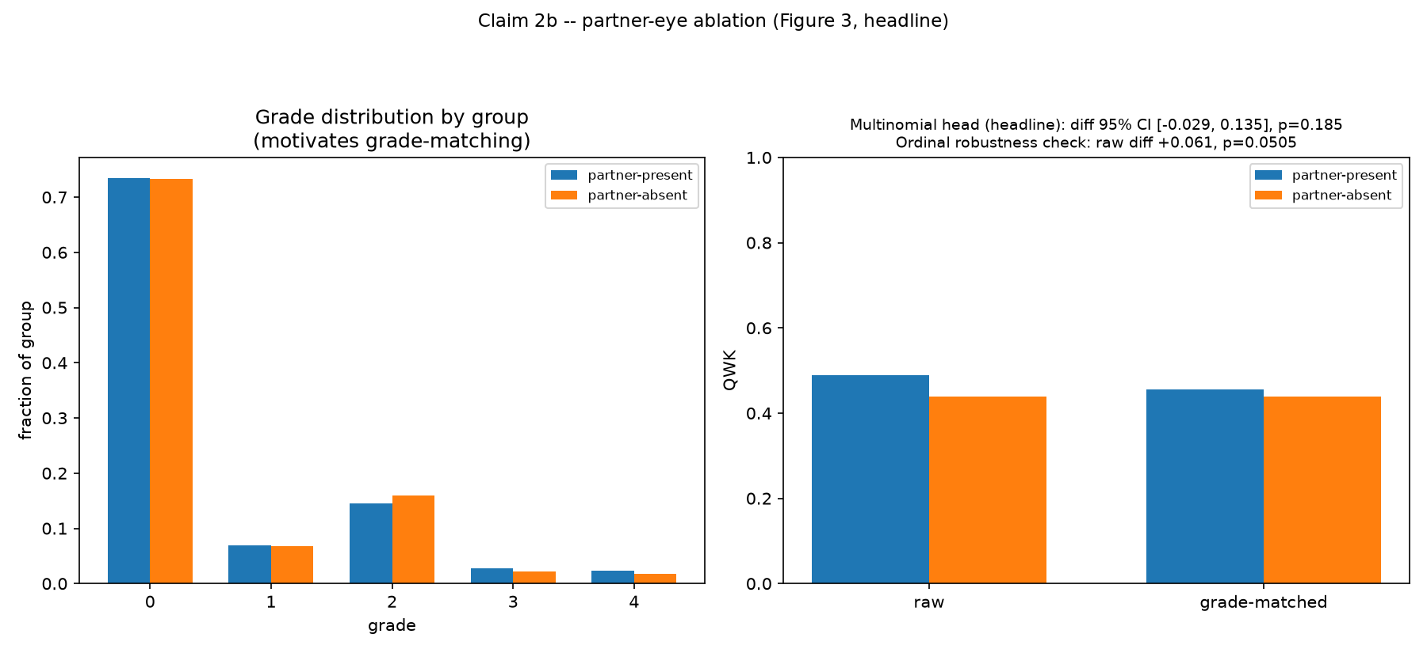
Figure 3. Partner-eye ablation: QWK difference between patients whose partner eye was present vs. absent from training. Both differences are consistent with zero.
Both tests were pre-registered with an explicit acceptable null-result outcome before they were run, and both returned that outcome. This is reported here as a genuine, carefully verified negative finding, not a failed experiment — Section 3.6 discusses why.

3.4 Results — Bilateral Grading and Its Decomposition (Objective 3)
The first, simpler bilateral-grading comparison found that grading a patient with both eyes — averaging the two eyes' feature vectors before an ordinal classifier — reached 0.569 QWK, against 0.494 QWK for the conventional per-eye-then-worst-grade approach with a multinomial head: an apparent +0.075 QWK gain. On review, I identified that this comparison changed three variables at once (classifier head, fusion method, and aggregation rule simultaneously), which motivated the decomposition experiment described in Section 2.2.5. Table 2 gives the full result, for the default EfficientNet-B0 @224px configuration, with every cell's own patient-level bootstrap 95% confidence interval.
Condition | QWK | 95% CI
Per-eye, max, multinomial (original baseline) | 0.4945 | [0.450, 0.537]
Per-eye, max, ordinal | 0.5447 | [0.501, 0.582]
Per-eye, mean, ordinal | 0.5490 | [0.509, 0.586]
Per-eye, min, ordinal | 0.4306 | [0.384, 0.478]
Concatenated features, ordinal | 0.4833 | [0.440, 0.522]
Mean-pooled features, ordinal (original "both-eyes" result) | 0.5693 | [0.530, 0.605]
Table 2. Full decomposition grid, EfficientNet-B0 @224px. Every condition uses the same underlying test patients (n = 2,629).
Decomposed into paired differences with their own bootstrap confidence intervals, across all three backbone/resolution configurations, the picture is consistent on one point and inconsistent on another. The classifier-head effect (ordinal vs. multinomial, holding fusion and aggregation fixed) is large and significant in every configuration tested: +0.050 QWK for EfficientNet-B0 @224px, +0.048 for EfficientNet-B0 @384px, and +0.091 for ResNet-50 @224px. The feature-fusion effect (mean-pooling both eyes' features vs. per-eye-max, holding the ordinal head fixed) is smaller and inconsistent: +0.025 (significant) for EfficientNet-B0 @224px, +0.024 (significant) for EfficientNet-B0 @384px, but −0.028 (not significant) for ResNet-50 @224px. Concatenating rather than averaging the two eyes' features never helped, in any configuration. Averaging the two eyes' separate per-eye predictions (rather than their features) was never significantly different from taking the maximum; taking the minimum was significantly worse than the maximum in every configuration.
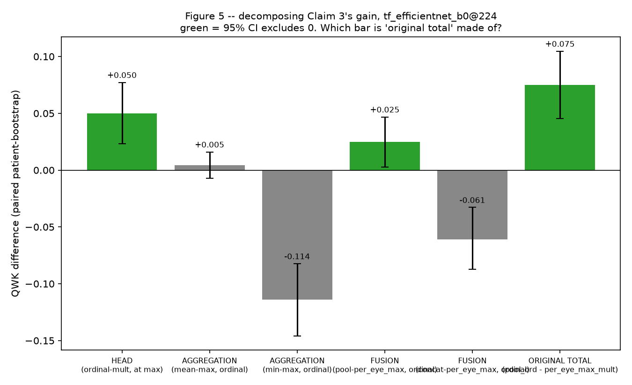
Figure 4. Decomposition of the original +0.075 QWK bilateral-grading gain into classifier-head effect, fusion effect, and aggregation effect, EfficientNet-B0 @224px. Colour indicates whether the paired bootstrap CI on that effect excludes zero.

3.5 Results — Full Fine-Tuning and the Converged Re-Test
All results above use frozen, pretrained CNN features. To test whether they hold under a fully trained model, two initial end-to-end fine-tuning configurations were run (Phase 6): a fast EfficientNet-B0 @224px "headline" configuration (15 epochs, 4 runs across P1/P2 × 2 seeds) and a higher-resolution EfficientNet-B0 @384px "app" configuration (1 run). Results: headline QWK range 0.548–0.561 (mean 0.555); app-config QWK 0.613. The same P1-approximately-equal-to-P2 pattern from Section 3.3 held under fine-tuning too (difference of only +0.0004 — essentially zero).
These initial fine-tuning runs, however, showed a clear sign of undertraining rather than a converged result: the best-performing epoch out of 15 landed at epochs 11–14 for four of the five runs, meaning the model was still improving when the fixed compute budget ran out, and the fine-tuned model's test QWK (0.555) was actually lower than the much cheaper frozen-feature ordinal linear probe from Section 3.3 (0.621) — a model should not lose to a lighter version of itself once properly converged. This motivated a second, properly converged fine-tuning pass (Phase 6b): 40 epochs, an early-stopping patience of 8, a raised backbone learning rate (1e-4, up from 3e-5), and a newly added ablation over the training-time class-balancing sampler (class-balanced resampling vs. no resampling), run as 8 separate jobs (EfficientNet-B0 @224px × {P1, P2} × {class-balanced, none} × 2 seeds).
All 8 runs completed and, unlike Phase 6, stopped via early stopping well before the 40-epoch ceiling (between epochs 18 and 35), confirming genuine convergence rather than an arbitrary cutoff. Table 3 gives the test-set QWK for each run.
Split | Sampler | Seed 42 | Seed 43
P1 | class-balanced | 0.6509 | 0.6461
P1 | none | 0.6749 | 0.6808
P2 | class-balanced | 0.6302 | 0.6163
P2 | none | 0.6709 | 0.6672
Table 3. Phase 6b converged fine-tuning: test-set QWK by split and sampler setting.
Two findings stand out from these runs. First, disabling class-balanced resampling improved test QWK by +0.02 to +0.05 in every one of the four matched pairs — a consistent, sizeable effect that was not anticipated at the same magnitude going in. The original hypothesis was that class-balanced resampling would trade some overall QWK for better recall on the rare Mild NPDR (grade 1) class; the actual per-class recall data does not support that trade-off story — grade-1 recall stayed in the same low 9–14% range under both sampler settings, so removing class-balancing improved QWK without the expected recall cost, which is itself worth reporting as a methodological finding rather than the anticipated one. Second, the raw P1-vs-P2 gap under convergence (roughly +0.01 to +0.03 QWK, P1 higher, depending on sampler) is numerically larger than Phase 6's near-zero frozen/undertrained gap, but with only two seeds per condition this is within the range of run-to-run seed noise observed elsewhere in these same experiments, and has not yet been tested with this project's own required standard — a proper patient-level paired bootstrap confidence interval on the difference, rather than a raw two-number average. That rigorous re-test is in progress at the time of this report and is one of the specific remaining items listed in Section 5.

3.6 Discussion
Taken together, the three objectives from Section 2.1 land in three different places, and the honest, undefended reading of each is more useful than a tidier story would be.
Objective 1 is unambiguously confirmed and, through the stratification analysis, sharpened beyond the original hypothesis: the inter-eye correlation is real, large, and specifically fails at one identifiable grade (Mild NPDR) rather than being uniformly weak or uniformly strong. This gives the project's later leakage tests a concrete, falsifiable mechanism to test against, rather than a vague concern.
Objective 2 is the project's most counter-intuitive finding, and the one that required the most discipline to report plainly. A strong correlation between two eyes, on its own, does not automatically mean an image-level split will measurably inflate a model's reported score — that inflation depends on the model actually being able to exploit the correlation during training and evaluation, which this project's frozen-feature and initial fine-tuned models apparently were not doing to a statistically detectable degree. This is a genuinely useful negative result for the wider field, precisely because a closely comparable positive result exists in a sibling imaging domain (Tampu et al.'s OCT leakage paper, Section 1.2): it shows the general leakage risk documented elsewhere in medical imaging does not automatically transfer to every dataset and every model configuration at a measurable magnitude, and that this needs to be checked per-setting rather than assumed. It also means this project's own headline contribution cannot honestly be "we proved published DR papers are wrong" — the data does not support that claim — and Section 4 (Future Work) is explicit that the planned literature survey will be framed around that same honesty: the practice of image-level splitting is widespread, but this project's own evidence is that it may be less harmful than commonly assumed, which is a more defensible and more interesting claim than a blanket condemnation would be. It is also worth being direct about the limitation of this null result rather than only celebrating it: Phase 6's initial fine-tuning models were undertrained, and it remains an open, actively-being-tested question (Phase 6b, Section 3.5) whether a model trained to genuine convergence would behave the same way — this report does not yet claim the null result is final.
Objective 3 produced a positive result, but not the one originally claimed. The decomposition in Section 3.4 shows that most of what looked like a "both eyes beat one eye" effect is actually a classifier-head effect that has nothing to do with using two eyes at all — an ordinal head beats a multinomial head by roughly the same margin whether or not any bilateral fusion is involved. A smaller, genuine bilateral-fusion benefit does exist, but only reaches statistical significance for one of the three backbone configurations tested (EfficientNet-B0, at both resolutions) and not for the other (ResNet-50). Reporting this honestly means the project's actual contribution here is not "bilateral fusion works," stated flatly — it is the more precise and more defensible finding that an ordinal classifier head is the dominant, architecture-independent driver of the improvement, with a smaller, architecture-dependent bilateral-fusion benefit on top of it. That this is a less dramatic headline than the original one-comparison result is, if anything, evidence that the decomposition was worth doing.
A theme runs through all three objectives that is itself worth naming directly: every one of this project's more interesting findings came from refusing to accept a single, simple comparison at face value — stratifying the correlation instead of reporting one number, running a targeted mechanism ablation instead of trusting a single protocol comparison, and decomposing a three-variable confound instead of reporting an entangled result. That pattern, more than any individual number in Section 3, is this project's actual methodological contribution.

4. Future Work and Remaining Steps
The project plan defines nine phases in total. Phases 1 through 6, and the follow-up decomposition (Phase 5b), are complete and reported in Section 3 above. Phase 6b (the properly converged fine-tuning re-run) has all eight training jobs complete, with the sampler-ablation finding already reported in Section 3.5; what remains for Phase 6b specifically, and the three phases after it, are described below.

4.1 Immediate remaining work — completing Phase 6b
- Run the trained Phase 6b models' predictions back through the project's own patient-level statistical framework (Section 2.2.3), rather than relying on the raw test-set averages reported in Section 3.5, to determine with a proper paired bootstrap confidence interval whether the P1-vs-P2 gap under full convergence is statistically real or still consistent with seed noise.
- Re-run the Claim 2b partner-eye ablation (Section 3.3) on the converged Phase 6b model, since that ablation was originally only tested on the undertrained Phase 6 model.
- Plot and report the full train/validation QWK convergence curves for all eight Phase 6b runs, to document the convergence behaviour directly rather than inferring it only from the early-stopping epoch.

4.2 Phase 7 — calibration and a reject option
Using the winning Phase 6b configuration, fit a single temperature-scaling parameter (Guo et al., 2017, Section 1.2) on the validation set only, and report Expected and Maximum Calibration Error with reliability diagrams before and after scaling, separately for the in-domain test set and each cross-dataset (P3) test set — cross-dataset calibration transfer is expected to degrade, and that is itself a reportable finding if it occurs. Build a confidence-based reject option, comparing maximum softmax probability against predictive entropy as the ranking signal, sweep the rejection threshold to produce a coverage/selective-QWK curve, and select the operating threshold by a rule stated in advance (the smallest threshold such that validation-set referable-DR sensitivity is at least 0.90) rather than by looking at test-set performance after the fact. Generate a Grad-CAM (Selvaraju et al., 2017, Section 1.2) qualitative panel that explicitly includes failure cases, not only a curated set of correct predictions.

4.3 Phase 8 — the deployable application
Package the release artifacts (model weights as a state dictionary plus architecture name, the exact training configuration, the calibration temperature and reject-option threshold, and a model card documenting training data, metrics with confidence intervals, and limitations) and build a Gradio interface that imports the project's own preprocessing function directly rather than reimplementing it — a common, easily overlooked cause of a working model producing garbage predictions once deployed. The interface will report grade in plain clinical language, a referable/not-referable decision, a confidence score or an explicit "uncertain, refer" flag, and a Grad-CAM overlay, with the model's research-only status stated visibly on screen rather than only in accompanying documentation. A bilateral upload mode will apply Section 3.4's actual winning method, so the deployed application demonstrates the project's own strongest empirical result rather than only its single-eye grading. Before this phase is considered complete, 100 test images will be run through both the deployed application and the underlying evaluation pipeline as an explicit automated test, requiring the two to match exactly — any mismatch would indicate a preprocessing inconsistency between training and deployment.

4.4 Phase 9 — literature-practice survey and final write-up
Survey a sample of 20 public GitHub repositories with more than 10 stars that train DR-grading models on EyePACS or APTOS, recording for each whether the train/test split is image-level or patient-level and the specific line of code that decides it, reporting only the aggregate fraction using each practice rather than singling out individual repositories. As discussed in Section 3.6, this survey will be framed carefully: this project's own finding is that image-level splitting did not measurably inflate its own results, so the intended contribution of the survey is not "the field is doing this wrong," but the more defensible and more interesting claim that the practice is widespread and, at least in this project's own tested setting, less harmful than commonly assumed. All figures in the final paper will be regenerated programmatically from the underlying results files, matching the practice already used for Figures 1 through 4 in this report, and the final write-up will be restructured so that the bilateral-grading decomposition and the leakage null result are presented as the headline contributions, with the correlation-measurement results (Section 3.2) as supporting motivation rather than the other way around, since that ordering reflects what the data actually turned out to show rather than the project's original starting assumption.

5. Conclusion
This project set out to test, rather than assume, whether a specific and widely-discussed evaluation risk in diabetic retinopathy grading — image-level data splitting leaking patient information across the train/test boundary — actually changes reported model performance on the public EyePACS and APTOS datasets, and whether the same inter-eye relationship that creates that risk could instead be used deliberately to improve grading. Building the infrastructure to answer these questions honestly required a full pipeline: a from-scratch patient identity and split system, a shared patient-level bootstrap statistical framework applied without exception to every claim, frozen-feature and fully fine-tuned models across three backbone configurations, and a purpose-built decomposition experiment to separate three confounded variables in a bilateral-grading result that I caught was confounded on my own review. The correlation between a patient's two eyes was confirmed to be large and specifically well-characterized; the predicted leakage-driven score inflation was tested three separate ways and not found, a genuine negative result now being re-tested under full model convergence; and the apparent benefit of grading both eyes together was shown, through decomposition, to be mostly a classifier-head effect rather than a fusion effect, with the fusion benefit itself holding for two of three backbones tested but not the third. None of these three outcomes was the simplest or most flattering possible result, and each is reported here as the data actually showed it, which is the standard the remainder of this project — calibration, a deployable application, and a literature-practice survey — will continue to be held to.

References
Ali, S. G., Wang, X., Bi, L., Jung, Y., Chen, T., & Zhang, H. (2025). Deep learning-based binocular system for automated diabetic retinopathy grading with prior clinical knowledge integration. The Visual Computer. (Published online December 2024.)
APTOS / Asia Pacific Tele-Ophthalmology Society (2019). APTOS 2019 Blindness Detection [Kaggle competition dataset]. https://www.kaggle.com/competitions/aptos2019-blindness-detection
EyePACS (2015). Diabetic Retinopathy Detection [Kaggle competition dataset]. https://www.kaggle.com/competitions/diabetic-retinopathy-detection
Gargeya, R., & Leng, T. (2017). Automated Identification of Diabetic Retinopathy Using Deep Learning. Ophthalmology, 124(7), 962–969.
Gulshan, V., Peng, L., Coram, M., Stumpe, M. C., Wu, D., Narayanaswamy, A., et al. (2016). Development and Validation of a Deep Learning Algorithm for Detection of Diabetic Retinopathy in Retinal Fundus Photographs. JAMA, 316(22), 2402–2410.
Guo, C., Pleiss, G., Sun, Y., & Weinberger, K. Q. (2017). On Calibration of Modern Neural Networks. Proceedings of the 34th International Conference on Machine Learning (ICML), 70, 1321–1330.
Rouzrokh, P., Khosravi, B., Faghani, S., Moassefi, M., Vera Garcia, D. V., Singh, Y., Zhang, K., Conte, G. M., & Erickson, B. J. (2022). Mitigating Bias in Radiology Machine Learning: 1. Data Handling. Radiology: Artificial Intelligence, 4(5), e210290.
Selvaraju, R. R., Cogswell, M., Das, A., Vedantam, R., Parikh, D., & Batra, D. (2017). Grad-CAM: Visual Explanations from Deep Networks via Gradient-Based Localization. Proceedings of the IEEE International Conference on Computer Vision (ICCV), 618–626. (Extended version: International Journal of Computer Vision, 128, 336–359, 2019.)
Tampu, I. E., Eklund, A., & Haj-Hosseini, N. (2022). Inflation of test accuracy due to data leakage in deep learning-based classification of OCT images. arXiv:2202.12267.
Tymchenko, B., & Spodarets, D. (2019). Deep Learning Approach to Diabetic Retinopathy Detection. arXiv:2003.02261.
Voets, M., Møllersen, K., & Bongo, L. A. (2019). Reproduction study using public data of: Development and validation of a deep learning algorithm for detection of diabetic retinopathy in retinal fundus photographs. PLOS ONE, 14(6), e0217541.
Yagis, E., Atnafu, S. W., García Seco de Herrera, A., Marzi, C., Scheda, R., Giannelli, M., Tessa, C., Citi, L., & Diciotti, S. (2021). Effect of data leakage in brain MRI classification using 2D convolutional neural networks. Scientific Reports, 11, 22544.

Appendix — Results Source Files
Every number quoted in Section 3 traces to a specific JSON output file produced by this project's own scripts: inter_eye_correlation.json, claim1b_stratified.json, claim2_protocols.json, claim2b_partner_ablation.json, claim3_both_eyes.json, claim3_decomposed.json (and its per-backbone variants), finetune_headline_*.json, finetune_app_*.json, and finetune_converged_*.json (and their per-epoch curve files). All figures in this report are generated programmatically from these files by dedicated plotting scripts, never hand-drawn or hand-copied.

