A Deep Learning Pipeline for Diabetic Retinopathy Screening
Model Design, Bilateral Grading, and Trustworthy Evaluation on EyePACS and APTOS
Research Project Report
Y. L. Vishal
August 2026

Abstract
Diabetic retinopathy is the leading cause of preventable blindness in working-age adults, and the number of screening photographs taken every year far exceeds the number of specialists available to grade them. This project builds and evaluates an automated grader for that bottleneck: a convolutional network that reads a retinal fundus photograph, assigns an ICDR severity grade, and decides whether the patient needs referral to a specialist.
The system is trained on the public EyePACS and APTOS 2019 datasets and built as a full pipeline — 7,179 lines of Python across 28 modules and 8 test files, covering data cleaning, patient identity reconstruction, feature caching across three CNN backbones, two classifier head designs, end-to-end fine-tuning, and a statistical framework in which every number carries a patient-level bootstrap confidence interval. Roughly forty models were trained in total.
On a frozen, patient-level test set the converged model reaches referable-DR AUROC 0.887 and five-class QWK 0.671. Held at the clinically required 90% sensitivity it achieves 61.3% specificity. For context, the only published independent reproduction on public data reports AUROC 0.951 and 0.853 on its two test sets, against 0.990 for the original private-data model, so this result sits inside the range public data supports rather than the range private adjudicated data does.
Three design findings came out of the model work, and two of them were not what I expected. An ordinal regression head beats a multinomial one by +0.05 to +0.09 QWK on every backbone tested — the largest single lever I found, and it costs nothing. Removing class-balanced resampling improved test QWK in all four matched runs, contradicting my own assumption that it was buying grade-1 recall. And grading a patient from both eyes together does help, but a decomposition I ran after catching a confound in my own earlier comparison showed most of the apparent gain came from the classifier head rather than from the second eye.
Because published DR results are sometimes reported at accuracies exceeding human inter-grader agreement, I also built the evaluation to be checkable rather than assumed: three splitting protocols, a zero-pixel "label-only" shortcut ceiling of QWK 0.838 that any honest model should be measured against, and a direct test of whether image-level splitting inflates scores. It did not, in three separate tests — a null I report with the same rigour I would have given a positive result.

1. Problem Statement, Literature Review and Challenges

1.1 Problem Statement
Diabetic retinopathy damages the retina slowly and, early on, silently. By the time a patient notices their vision going, the damage is usually permanent. The defence against this is annual retinal photography: a trained grader looks at a fundus photograph of each eye and assigns a severity grade on the International Clinical Diabetic Retinopathy scale (Table 1). Grade 2 and above is referable DR — the point at which the patient is sent to a specialist. In a screening pipeline that referral decision matters far more than getting the exact 0–4 grade right, because the cost of the two errors is wildly asymmetric: a false alarm wastes a clinic appointment, while a missed referable case can end in irreversible sight loss.
Table 1. The ICDR five-level grading scale used throughout this project.
Grade | Name | Description
0 | No DR | No visible lesions
1 | Mild NPDR | Microaneurysms only — roughly 10 pixels wide once the image is downsampled
2 | Moderate NPDR | More extensive haemorrhages and exudates — referable
3 | Severe NPDR | Extensive lesions, high risk of progression — referable
4 | Proliferative DR | Abnormal new vessel growth — sight-threatening, referable

Screening produces far more photographs every year than there are specialists to grade them, and the gap is widening as diabetes prevalence rises. That gap is what automated grading is for, and it sets the specification for anything built to fill it: the model has to be sensitive enough that clinicians will trust it with the referral decision, specific enough that it does not flood the clinic, and honest enough about its own uncertainty to know when to hand a case back to a human.
So the engineering problem this project takes on is: build a DR grader on public data that meets that specification, and understand which design choices actually get you there. That means treating the model as something to be measured and decomposed rather than tuned until a number looks good — which design of classifier head matters, whether higher resolution pays for itself, whether the class imbalance needs correcting, whether a patient photographed in both eyes should be graded from both.
There is a complication, and it shaped the whole project. The published DR literature is not a reliable yardstick to build against. A number of DR models report accuracy that is implausibly high — in some cases exceeding the measured agreement between two independent human experts looking at the same photograph. A model cannot be more consistent than the labels it was trained to predict, so when that happens the honest first hypothesis is not that the model is superhuman but that something in the evaluation is generous.
I could not tell from the outside which published numbers were affected, and I did not want to inherit the problem into my own results. The most likely culprit is specific and testable: almost every screening patient is photographed in both eyes, and both eyes share the same disease process, blood sugar history and genetics, so their grades are correlated for reasons that have nothing to do with image content. Split a dataset by image rather than by patient and a left eye can land in training while its right eye lands in test, letting a model partly predict the test eye from having memorised the patient. Nothing in the public tooling around EyePACS or APTOS lets you check this, so I built the infrastructure to check it — and then, having built it, tested the assumption directly rather than only guarding against it.
That gives the project four questions, in the order they actually mattered:
- How good a referable-DR screening model can be built on public data alone, and where does it sit against published results?
- Which design choices actually drive that performance — classifier head, resolution, class balancing, backbone?
- Patients are photographed in both eyes anyway. Does grading them jointly help, and if so, what part of the improvement is really the second eye?
- Is the evaluation itself trustworthy — and does splitting by image rather than by patient measurably inflate the score, as the literature warns?
All four are answered with experiments in Section 3. Two of my headline predictions came back wrong, and Section 3.8 keeps the record.

1.2 Literature Review
I read these twelve works to make decisions, not to survey a field, so each entry below ends in something I built or changed as a result. They fall into the DR deep-learning work this project competes with, the methods it borrows from, and a smaller group on evaluation integrity that shaped how I measured my own results.

Diabetic retinopathy deep learning
Gulshan et al. (2016), JAMA. The paper that made DR grading credible at clinical scale: an Inception-v3 model reaching referable-DR AUC 0.991 on EyePACS-1 (9,963 images, 4,997 patients) and 0.990 on Messidor-2, with 90.3% sensitivity at 98.1% specificity. What I did with it: I used it to set the ceiling and to understand what that ceiling costs. Those numbers rest on roughly 128,000 images graded by multiple ophthalmologists with adjudication — data of a kind no public release provides. It told me that a public-data project should be benchmarked against public-data results, not against 0.99, and Section 3.2 does exactly that.
Gargeya & Leng (2017), Ophthalmology. A CNN feature extractor feeding a gradient-boosted classifier for referable-DR screening, reporting AUC 0.97 with 94% sensitivity and 98% specificity under five-fold cross-validation. What I did with it: I adopted the two-stage shape — fixed pretrained backbone, cheap swappable classifier on cached features — as the backbone of my whole experimental design. That single decision is what made the 10-cell decomposition grid in Section 3.4 affordable to run across three backbones on a laptop GPU. I also noted that its headline number comes from cross-validation rather than a held-out set, which is part of why I declared a frozen test set and scored it once (Section 2.2.3).
Voets, Møllersen & Bongo (2019), PLOS ONE. The only independent attempt I found to reproduce Gulshan et al. using public data only, reaching AUC 0.951 on the Kaggle EyePACS test set and 0.853 on Messidor-2 — well short of 0.99. This is the most useful paper in the review for my purposes, because it is the closest thing to a fair comparison for my own result, and it quantifies the private-versus-public data gap directly. It is also why I rebuilt patient identity from EyePACS filenames myself instead of trusting a downloaded split.
Tymchenko, Marchenko & Spodarets (2020), arXiv:2003.02261. A high-placing APTOS 2019 Kaggle solution — an EfficientNet-B4/B5 and SE-ResNeXt50 ensemble with classification, regression and ordinal-regression heads, reaching a competition QWK around 0.925. What I did with it: I took the ordinal idea and reimplemented it as a ridge regression with four thresholds optimised by Nelder–Mead on the training set only. It became the single largest performance lever in my project (Section 3.3), worth +0.05 to +0.09 QWK across every backbone I tried.
Ali, Wang, Bi, Jung, Chen & Zhang (2025), The Visual Computer. The closest published precedent to my bilateral work: a binocular network grading one eye while pulling in features from its fellow, reaching 87.3% accuracy on a private set and 86.5% on public Kaggle-DR. What I did with it: I noticed it reports that binocular fusion helps without ever separating the fusion from the classifier design shipped alongside it. So I built the decomposition grid in Section 3.4 to make that separation on my own result — and the classifier head, not the second eye, turned out to be doing most of the work. That is a caution a single end-to-end binocular number cannot surface, and it is the finding I would most want another person building a binocular DR model to see.

Methods this pipeline is built from
Selvaraju et al. (2017 / 2020), ICCV and IJCV. Grad-CAM. What I took is a constraint on how I will use it in Phase 7: the panel has to include misclassified images, not a curated set of convincing correct ones, because an explanation method applied only to successes cannot tell me anything I did not already believe.
Guo, Pleiss, Sun & Weinberger (2017), ICML. Temperature scaling, and the demonstration that modern networks are overconfident even when accurate. This fixes the Phase 7 design: one temperature parameter fitted on validation, never on test. It matters here more than usual, because Section 3.2 shows my model must be run at a threshold far from its argmax to hit clinical sensitivity, and a badly calibrated score makes that threshold meaningless.
EyePACS / Kaggle Diabetic Retinopathy Detection (2015) and APTOS 2019 Blindness Detection (Kaggle, 2019). The two releases everything here is built on. What I found in them was a gap rather than a resource: neither ships a verified patient-level split. EyePACS encodes eye and an implicit patient identifier in its filenames, which has to be parsed and validated before it can be trusted; APTOS 2019 does not reliably expose eye pairing at all, so I scoped it out of the bilateral experiments explicitly rather than letting unpaired images silently count as unpaired patients.

Evaluation integrity in medical imaging
Tampu, Eklund & Haj-Hosseini (2022), Scientific Data. The paper that set my expectations about splitting, and the one I ended up disagreeing with. It is in ophthalmology, on retinal OCT, and it measures the exact failure mode I was worried about: splitting by 2D image instead of by patient or volume inflated Matthews correlation coefficient by 0.07 to 0.43 across three public OCT datasets. I sized my Section 3.6 experiments to detect an effect in that range. I did not find one, and Section 3.7 states the disagreement plainly rather than smoothing it over.
Yagis et al. (2021), Scientific Reports. The same failure mode independently in neuroimaging: slice-level rather than subject-level splitting inflated apparent accuracy on brain MRI, in some cases to near-perfect scores on randomly labelled data. What I did with it: it gave me the shape of my strongest test — the partner-eye ablation in Section 3.6, which targets the mechanism directly rather than its whole-protocol shadow.
Rouzrokh et al. (2022), Radiology: Artificial Intelligence. A guidance paper cataloguing data-handling mistakes in medical-imaging ML, listing patient-level splitting as required practice. What I did with it: I turned the recommendation into something measurable. My P1 protocol exists precisely so the guidance can be tested rather than obeyed — a deliberately flawed split I built to quantify the cost of ignoring the advice.
Read together, these place the project in a specific position. It is a DR grading system built on the same public data as Voets and Tymchenko, using the two-stage design from Gargeya and the ordinal head from Tymchenko, extending Ali et al.’s bilateral idea with a decomposition they did not run — and it borrows from the leakage literature not a result but a habit: check the evaluation before trusting the model.

1.3 Challenges
The challenges below are in the order I hit them, and they are mostly not algorithmic. Building a DR grader on public data means most of the difficulty is in the data, the compute, and knowing whether to believe your own numbers.

Challenge 1 — a severe class imbalance that resists the obvious fix
EyePACS is dominated by healthy eyes: 25,810 of 35,126 images are grade 0, and the two most severe grades together account for under 1,600. Grade 1 — the class that decides whether early disease gets caught — has 2,443. The textbook response is class-balanced resampling during training, which I applied without questioning it.
Making it an ablation rather than a fixed setting was the best decision I made in the training pipeline, because it turned out to be wrong. Removing class-balanced resampling improved test QWK in all four matched runs, and the grade-1 recall it was supposedly protecting did not move (Section 3.3). I had been paying for something that was not being delivered, and I would never have found out if I had left it on as a default.

Challenge 2 — a class the images may simply not contain
Grade 1 is defined by microaneurysms roughly ten pixels wide in the source photograph. Downsample to 224px for a CNN and that evidence is largely gone. Every converged model I trained recalls grade 1 at between 8.7% and 14.0%, far below the 20–45% band I had written down in advance, and no sampler setting moved it.
What makes this more than a weak class is that three independent parts of the project point at it. Grade 1 is also the only grade that fails to transfer between a patient’s two eyes (45.8% partner-lookup accuracy against 72–94% for every other grade), and three of the eight corrupted images I found in Phase 1 carry a human grade of 1 on a near-uniformly black frame. Section 3.5 argues these are one finding, not three, and that grade 1 may be a measurement ceiling rather than a modelling failure.

Challenge 3 — compute limits that shaped the experiments, not just slowed them
Everything ran on a single consumer laptop GPU, and that had methodological consequences rather than only inconvenient ones. My first full fine-tuning pass used a 15-epoch budget and produced models still improving when training stopped — four of five runs had their best epoch in the last three — and the fine-tuned model actually lost to a much cheaper frozen-feature linear probe, which should not happen once a model has converged. Reading that as undertraining rather than a broken pipeline required a second engineering pass: 40 epochs, early-stopping patience of 8, a raised backbone learning rate, and the sampler ablation, run as eight separate jobs. The longest took five and a half hours. I made every job checkpointed and resumable by design because I could not guarantee any single run would finish uninterrupted, and more than one did not.
The same constraint is why the pipeline caches frozen features. Re-fitting a lightweight head on cached features takes seconds, which is what made it possible to run dozens of controlled comparisons across three backbones and five seeds instead of one expensive comparison and a hope.

Challenge 4 — building a patient identity and split system from nothing
Neither dataset ships a verified patient-level split. EyePACS puts a patient identifier and an eye label in its filenames, and I had to parse, validate and turn that into an explicit manifest carrying patient_id and partner_id on every one of 38,788 rows before any patient-level analysis or bilateral grading was possible at all. APTOS 2019 does not reliably expose eye pairing, so I scoped it out of the bilateral experiments explicitly. Three split protocols had to exist as reproducible, auditable code — 7 acceptance tests on the splits, 8 on the manifest, 5 on the deduplication — before I could train a single classifier.

Challenge 5 — data problems that would have poisoned everything downstream
Two problems in the raw data had to be found before any modelling, and neither announces itself in a loss curve.
Eight EyePACS images turned out to be almost entirely flat black — failed captures, not photographs. I caught them with a mean-pixel check after the full preprocessing run, excluded them before splitting, and verified where each had landed: one of the eight reached a test fold at all, in P1, the deliberately flawed protocol. Zero reached P2, the primary one. I kept them in the manifest flagged rather than deleting the rows, with the per-image evidence recorded. Three of those eight carry a human grade of 1 on a frame that is essentially uniform black — a direct observation about label noise in EyePACS that I found by auditing rather than by being told.
Separately, perceptual hashing found 148 near-duplicate pairs inside APTOS across 131 groups and 270 images, with zero within EyePACS and zero across datasets. Left alone those would have put visually near-identical images on both sides of a split, inflating scores through a different door than the one I was watching.

Challenge 6 — auditing my own deduplication threshold, and deciding not to change it
After Phase 2 I went back and questioned a threshold I had already shipped. I had used a 256-bit perceptual hash with a Hamming cutoff of 5, found via LSH banding over six bands. But 5 is the conventional cutoff for the 64-bit hash, and as an absolute bit count on a 256-bit hash it is roughly four times stricter than the convention I borrowed it from. The arithmetic said I might be missing real duplicates.
I tested it instead of trusting the arithmetic. First a calibration: I took a real image, resized it by two pixels, re-encoded it at JPEG quality 90 — a genuine near-duplicate by construction — and measured the distance. Zero. Nowhere near the cutoff. Then a sweep across all 616,900,375 EyePACS pairs: 0 matches at ≤5, one at ≤10, 123 at ≤20, 8,876 at ≤30. No plateau, just a smooth climb into noise, which is what you get when there is no hidden cluster of real duplicates past the threshold. APTOS showed the opposite — 148 pairs at both ≤5 and ≤10, a real plateau, consistent with the genuine duplicates already found there.
Then a diagnostic on the 790 closest EyePACS candidates under a deliberately loose cutoff of 25. Of those, 786 were different patients, and grade agreement was 62.7% against a 56.8% chance baseline. A true duplicate photograph must carry the same grade, because it is the same image; agreement barely above chance means these are coincidental structural matches produced by a shared photography protocol, not duplicated images. I confirmed it by eye on the closest pair — distance 10, different vasculature, grades 0 and 2.
So I left the threshold alone and did not rebuild the splits, then wrote a regression test so the decision fails loudly if a future data change makes it stop holding. Recording an audit that concluded "no change" felt worth doing precisely because there was nothing to show for it.

Challenge 7 — a confound I had built into my own comparison
This is the catch I am most pleased about, and nobody flagged it for me. An early version of my bilateral comparison changed three things at once: the classifier head (multinomial to ordinal), the fusion method (per-eye to feature averaging), and the aggregation rule (max to a single joint prediction). Then it reported the combined effect as a clean test of "does using both eyes help." It was not one.
Fixing it meant designing a new experiment that isolates each of those three variables separately, each with its own paired bootstrap interval, repeated across three backbone configurations — a 10-cell grid where I previously had a two-bar comparison. It was the most statistically demanding thing I built, and it reversed my original conclusion.

2. Research Objective and Methodology

2.1 Research Objectives
The objective is to build an automated diabetic retinopathy grader on public data and understand what makes it work, with every design choice tested rather than inherited. That breaks into five objectives, each with a way of knowing in advance whether it had succeeded or failed.
- Objective 1 — Train a DR grading model to genuine convergence and report its referable-DR performance at a clinically meaningful operating point, on a test set frozen before any model scored on it.
- Objective 2 — Establish which design choices actually drive that performance: classifier head, input resolution, backbone, and whether the class imbalance needs correcting.
- Objective 3 — Determine whether grading a patient from both eyes beats single-eye grading and decompose any improvement into its causes — classifier head, feature fusion, aggregation rule — rather than reporting one entangled number.
- Objective 4 — Characterise where the model fails: which grades it cannot learn, and how well it transfers to a different dataset.
- Objective 5 — Build an evaluation that can be trusted, and quantify how much the choice of splitting protocol actually changes the reported score.
Objectives 1 to 5 are complete and reported in Section 3. The deployment work — calibration, a confidence-based reject option, and a screening application — is in progress; Section 4 gives its remaining scope.

2.2 Methodology

2.2.1 Data and preprocessing
Two public datasets. EyePACS — 35,126 images from 17,563 patients, every one photographed in both eyes — is the primary dataset and the only one with reliable eye pairing, so all patient-level and bilateral work is built on it. APTOS 2019 (3,662 images, unpaired) is used where pairing is not needed, mainly the cross-dataset transfer check. I built one unified manifest across both datasets recording image_id, patient_id, eye, partner_id and grade, then applied the two cleaning passes from Section 1.3: excluding the 8 flat-black EyePACS images and flagging the 148 near-duplicate APTOS images so no split could straddle them. Pooled EyePACS grade counts match the published totals exactly (25,810 / 2,443 / 5,292 / 873 / 708), which is the check that told me the manifest was reading the source correctly.

2.2.2 Three evaluation protocols
Three splitting protocols run throughout, all drawing from the same pool of cleaned images. P2 splits at the patient level, so both of a patient’s eyes always land on the same side of the boundary; this is the honest protocol and the primary endpoint, and every headline number in this report is a P2 number. P1 splits at the image level and ignores patient identity — a deliberately flawed protocol built to measure the cost of that mistake, never to optimise against. P3 trains on one dataset and tests on the other, in both directions, as a transfer check. All three respect duplicate-group integrity, and P2 and P3 additionally respect patient integrity.

2.2.3 Frozen test sets, declared once and scored once
I declared the test sets in the repository at a named git commit before any model had scored on anything, and re-declared them at a second named commit after the image exclusion, with the reason logged in the same file. The primary endpoint — referable-DR sensitivity at a fixed operating point under P2 — and the secondary endpoint — five-class QWK — were both fixed at that point. Any evaluation before the end of the project had to be logged with a justification.
This is pre-registration in miniature, and it matters for a project like this one: with cached features making comparisons nearly free, the temptation to keep trying variants until one looks good is real, and a frozen endpoint is the only thing standing against it.

2.2.4 Statistical standard
One rule, applied to every claim without exception. Every reported metric comes with a 95% confidence interval from a patient-level bootstrap — resampling patient IDs with replacement and pulling in every image belonging to a resampled patient, so the correlation between a patient’s two eyes is preserved inside each bootstrap sample instead of being treated as if the images were independent. Every comparison between two conditions is a paired bootstrap interval on the difference, not two separate intervals eyeballed next to each other, and a gap counts as real only if that interval excludes zero.
The primary metric for grading is Quadratic Weighted Kappa, the standard agreement measure for ordinal grading, which penalises a prediction in proportion to how far off it is. The primary metric for the clinical decision is referable-DR sensitivity and specificity, reported at a fixed operating point rather than at the model’s argmax (Section 3.2 explains why the distinction matters).
One subtlety I had to handle rather than ignore: my multinomial head is an lbfgs logistic regression, which is deterministic given fixed data, so "five random seeds" would have produced five identical numbers and a meaningless spread. I realised the seeds as five independent bootstrap resamples of the training set instead — that is what actually varies run to run — and kept the unperturbed fit as the reference model, so the plotted point and its interval always come from the same model.

2.2.5 Model architectures and classifier heads
Two families of model. The first is a frozen-feature pipeline: a pretrained CNN backbone used purely as a fixed feature extractor, with a lightweight classifier trained on cached features. I used three backbone and resolution configurations — EfficientNet-B0 at 224px and 384px, and ResNet-50 at 224px — so a finding can be checked for architecture dependence rather than assumed general. That choice is what caught the inconsistency in Section 3.4.
Two heads sit on those features. The multinomial head is a logistic regression treating the five grades as unrelated classes. The ordinal head is a ridge regression fit to the numeric grade with four decision thresholds optimised jointly by Nelder–Mead on the training set only and then rounded, treating the grade as an ordered continuous quantity — a much better match to both the clinical reality and to how QWK scores mistakes.
The second family is full end-to-end fine-tuning of the same EfficientNet-B0 backbone, with a two-stage learning-rate schedule (higher for the head, lower for the backbone, backbone frozen for the first two epochs), exponential moving average of weights, mixed-precision training, and early stopping on validation QWK. This is the family that produces the deployed model.

2.2.6 Bilateral design and the decomposition
For Objective 3 I varied three design axes independently instead of together. Axis one is the classifier head, multinomial against ordinal. Axis two is where the two eyes’ information is combined — a per-eye prediction with a later aggregation step, or combining the two eyes’ feature vectors before classification, either by concatenation or by mean-pooling. Axis three, for the per-eye route only, is the rule that turns two predicted grades into one patient grade: maximum (the clinical "worse eye wins" convention), mean, or minimum.
That gives a full grid of comparable conditions instead of one bilateral number. Every cell carries its own bootstrap interval, and I repeated the whole grid on all three backbone configurations so a finding is only trusted if it holds across architectures.

2.2.7 Engineering practices behind the results
Two habits underpin everything in Section 3. First, every experiment script is checkpoint-and-resume capable: expensive fitting stages cache to disk the moment they finish, and fine-tuning runs save both a resumable training checkpoint every epoch and a separately tracked best-validation checkpoint, so a multi-hour job interrupted halfway can continue rather than restart. Second, the fine-tuning pipeline logs training and validation QWK after every epoch, specifically so convergence can be verified from the curve instead of assumed from the fact that the script finished — which is exactly the check that caught the undertraining in Section 3.2.

3. Implementation, Results and Discussion

3.1 What I Built
The pipeline is 7,179 lines of Python across 28 modules and 8 test files, organised as numbered phases. Each phase writes a versioned JSON results file carrying the raw metric, its confidence interval and a plain-language verdict field, and where relevant a figure regenerated programmatically from that same JSON. Every number quoted below traces to a specific script and a specific output file. Nothing in this report was copied by hand from a console.
Layer 1 builds the unified manifest from the raw EyePACS and APTOS releases, applies the flat-image exclusion and the perceptual-hash deduplication, and writes P1, P2 and P3 as explicit JSON fold assignments, so every later script reads the same auditable source of truth instead of re-deriving splits on its own. Twenty acceptance tests guard it — seven on the splits, eight on the manifest, five on the deduplication.
Layer 2 runs each of the three pretrained backbones over every cleaned image exactly once and caches the feature vectors. Layer 3 is a shared statistics module implementing both classifier heads, the patient-level bootstrap and the paired bootstrap on a difference, so a confidence interval means the same thing project-wide. Layer 4 is the experiment scripts — one per claim — plus the two fine-tuning pipelines, which between them produced around forty individually trained models. Layer 5 is verification and reporting.

3.2 The Screening Model and How It Performs (Objective 1)
The deployed model is an EfficientNet-B0 fine-tuned end-to-end at 224px on the patient-level split. Getting it there took two passes.
The first pass (Phase 6) used a 15-epoch budget across P1 and P2 with two seeds each and reached 0.5550 ± 0.0071 QWK. A single higher-resolution run at 384px reached 0.6128, an encouraging +0.058 for resolution alone. But these were clearly undertrained rather than converged, and the per-epoch logging is what made that visible: the best epoch out of 15 landed at epoch 11 or later in four of five runs, and the fine-tuned model’s 0.555 was well below the much cheaper frozen-feature ordinal probe’s 0.621. A model should not lose to a lighter version of itself once it has converged.
The second pass (Phase 6b) fixed it: 40 epochs, early-stopping patience of 8, backbone learning rate raised to 1e-4 from 3e-5, and a sampler ablation added. Eight jobs — EfficientNet-B0 @224px across P1 and P2, class-balanced and no resampling, two seeds each. All eight stopped on early stopping between epochs 18 and 35, well short of the ceiling, which is what convergence looks like rather than a budget cutoff. The anomaly resolved: at 0.671 QWK on P2 the converged model now clearly beats the frozen probe’s 0.621.
Table 2. Phase 6b converged fine-tuning: five-class QWK and referable-DR AUROC by split and sampler setting. P2 is the honest patient-level protocol and carries the headline numbers.
Split | Sampler | Seed 42 QWK | Seed 43 QWK | Referable AUROC (s42 / s43)
P1 (image-level) | class-balanced | 0.6509 | 0.6461 | 0.879 / 0.881
P1 (image-level) | none | 0.6749 | 0.6808 | 0.902 / 0.899
P2 (patient-level) | class-balanced | 0.6302 | 0.6163 | 0.871 / 0.859
P2 (patient-level) | none | 0.6709 | 0.6672 | 0.886 / 0.887

QWK is the grading metric, but it is not the clinical one. What a screening service needs to know is how many referable patients the model catches and how many healthy patients it needlessly refers — and crucially, a screening model is never deployed at its own argmax. It is deployed at a threshold chosen to hit a required sensitivity, because missing a referable case costs far more than a false alarm. So I computed the project’s declared primary endpoint directly: reduce the five-class softmax to a referable score by summing P(grade ≥ 2), sweep the threshold, and read off the operating point.
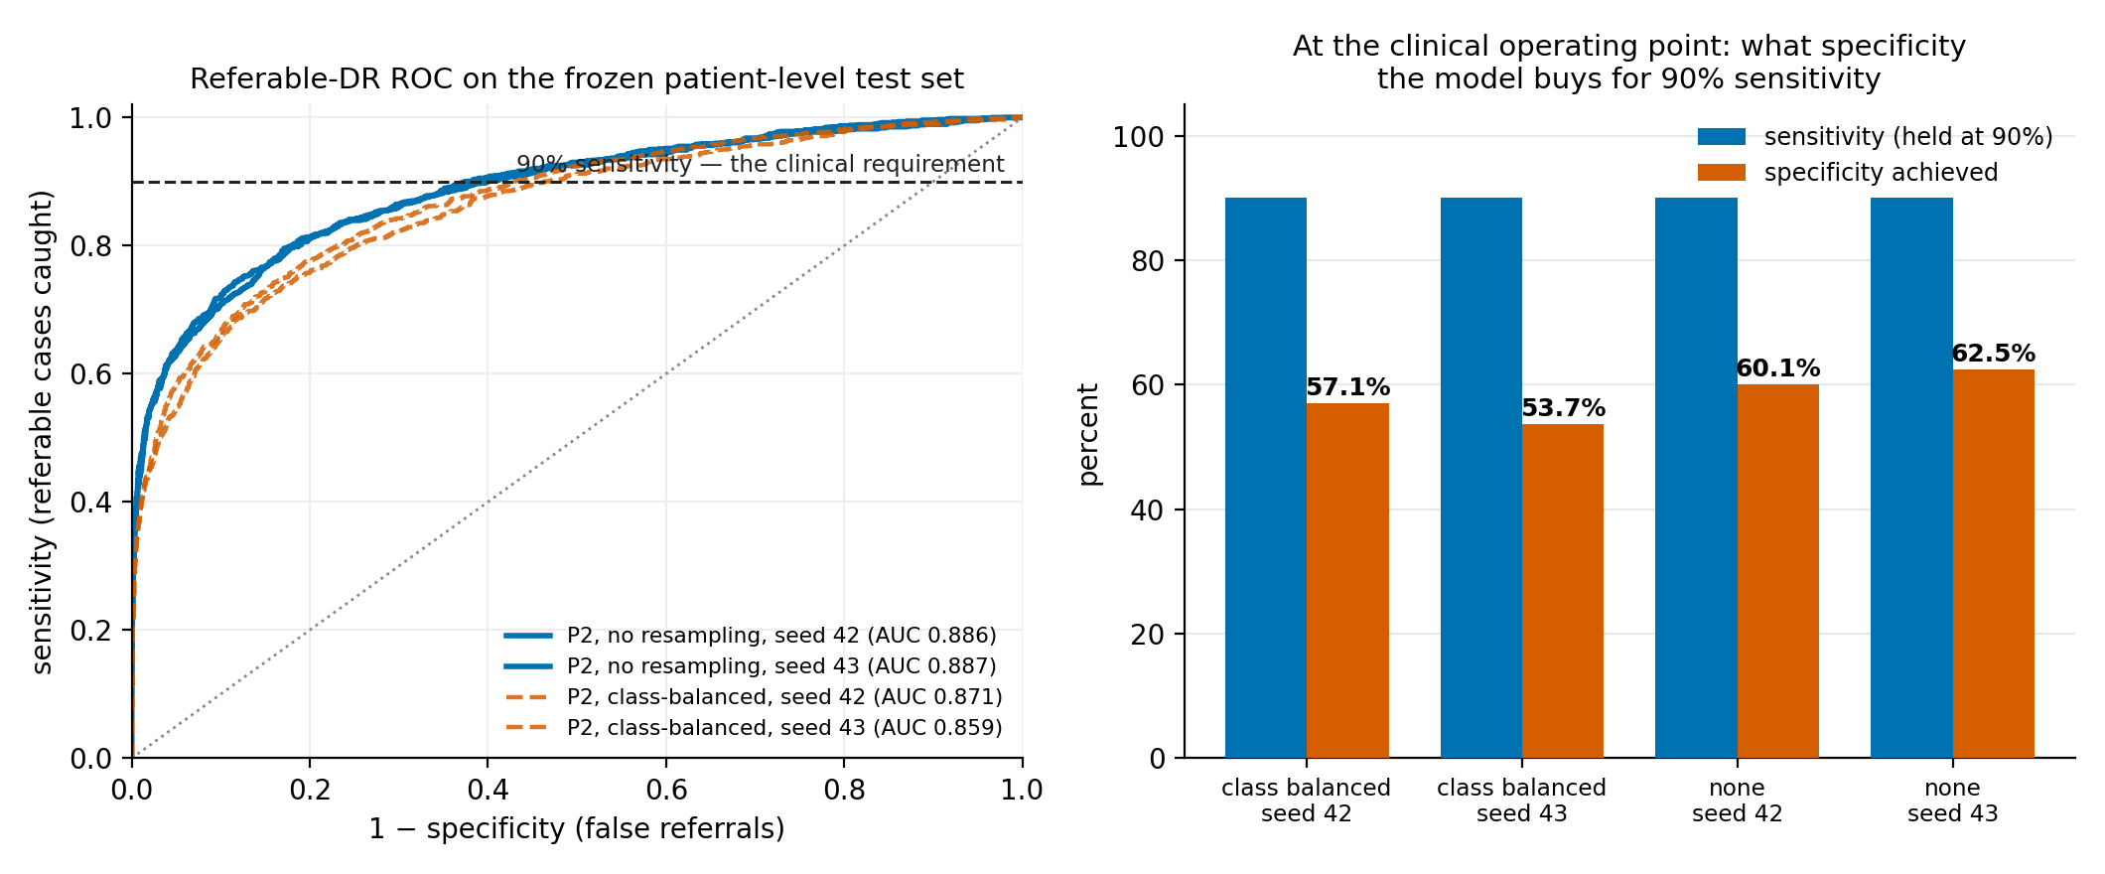
Figure 1. Left: referable-DR ROC on the frozen patient-level test set, with the 90% sensitivity requirement marked. Right: the specificity each configuration buys at that operating point. Removing class-balanced resampling improves both AUROC and specificity.
On the frozen P2 test set the converged model reaches referable-DR AUROC 0.887 (95% CI [0.873, 0.900] for seed 42). Held at 90% sensitivity it achieves 61.3% specificity, missing 124 of 1,246 referable patients while correctly clearing about three in five of those who do not need referral. At its own argmax the same model sits at 62.3% sensitivity and 95.4% specificity — a far more conservative point than screening wants, which is exactly why the operating point has to be set deliberately rather than inherited from the loss function.
That 61.3% specificity is the honest weak spot of this model, and it is the number I would fix next. It means a deployment at this threshold refers roughly two out of five healthy patients unnecessarily. Table 3 puts it in context against the published literature.
Table 3. Referable-DR performance in context. Operating points are the high-sensitivity points where the source reports one.
Study | Training data | Test set | AUC | Sens / Spec
Gulshan et al. (2016) | Private, ~128k adjudicated | EyePACS-1 (9,963 img) | 0.991 | 97.5 / 93.4
Gulshan et al. (2016) | Private, ~128k adjudicated | Messidor-2 (1,748 img) | 0.990 | 96.1 / 93.9
Gargeya & Leng (2017) | Not stated | 5-fold cross-validation | 0.97 | 94 / 98
Voets et al. (2019) | Public (Kaggle EyePACS) | Kaggle EyePACS test | 0.951 | 90.6 / 84.7
Voets et al. (2019) | Public (Kaggle EyePACS) | Messidor-2 | 0.853 | 81.8 / 71.2
This work | Public EyePACS, patient-level | Frozen P2 test (5,814 img) | 0.887 | 90.0 / 61.3

Two things are worth reading off that table. First, the gap between Gulshan’s 0.99 and everything below it is a data gap, not a modelling gap: that result rests on roughly 128,000 images graded by multiple ophthalmologists with adjudication, and Voets et al. — the only independent reproduction on public data I could find — could not approach it with public data alone. My 0.887 sits between their two numbers, which is where a public-data result should sit.
Second, my specificity at matched sensitivity is clearly worse than Voets’, and I would rather explain that than bury it. Three differences plausibly account for it: they trained a purpose-built binary referable classifier while mine is a five-class grader whose referable score is derived by summing the tail; they used higher input resolution, and my own 224-to-384 comparison suggests resolution alone is worth several points; and my test set is patient-level, which is a stricter evaluation than the image-level Kaggle split. The first two are fixable with compute I did not have. That is a limitation of this project, not a finding about the method.

3.3 Which Design Choices Actually Mattered (Objective 2)
Four levers were available: classifier head, input resolution, backbone, and class balancing. They are not equally important, and the ranking surprised me.
The classifier head is the largest and most reliable lever in the entire project. Holding everything else fixed, switching from a multinomial head to an ordinal one is worth +0.050 QWK on EfficientNet-B0 @224, +0.048 at 384px, and +0.091 on ResNet-50 @224. All three intervals exclude zero. It costs nothing — a ridge regression and four thresholds instead of a softmax — and it works because DR grades are ordered: predicting grade 4 when the truth is grade 0 should be penalised far more than predicting grade 1, and a multinomial head treating the five grades as unrelated categories throws that structure away.
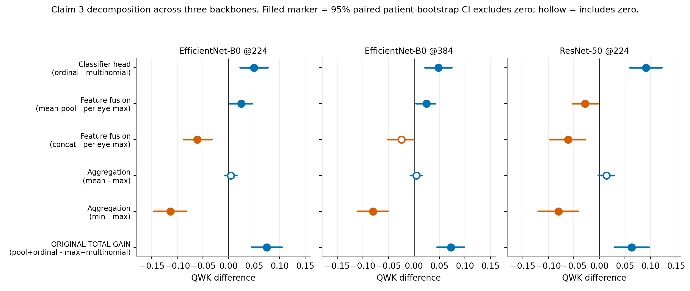
Figure 2. Design-choice effects across all three backbone configurations, each with a paired patient-level bootstrap interval. The classifier-head effect (top row) is positive and significant everywhere; no other single choice is.
Resolution is the second lever. Moving from 224px to 384px was worth +0.058 QWK in the fine-tuning comparison, in the expected direction and consistent with the microaneurysm argument in Section 1.3 — more pixels means more of the small-lesion evidence survives. It is a single run without a seed replicate, so I report it as an observation rather than an established gain, but it is also the cheapest remaining improvement available to this project.
The backbone mattered less than the head. ResNet-50 @224 underperforms EfficientNet-B0 @224 across every condition in the bilateral grid, and its ordinal-head gain is larger precisely because its multinomial baseline is worse. Choosing a better head did more for this pipeline than choosing a better backbone.
Class balancing was the surprise, and it went the other way from what I assumed. Disabling class-balanced resampling improved test QWK in every one of the four matched pairs, by +0.024 to +0.051, and improved referable AUROC too (0.871 to 0.886 on P2). My original story was that class-balancing trades a little overall QWK for better recall on the rare Mild NPDR class. The per-class recall data does not support that trade at all: grade-1 recall sits between 8.7% and 14.0% under both settings. I was paying a real cost for a benefit that was never arriving.
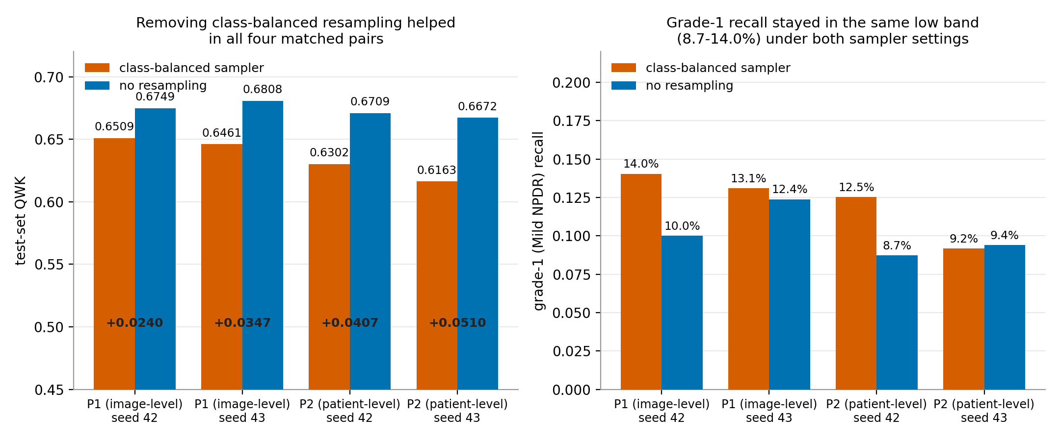
Figure 3. The sampler ablation. Left: removing class-balanced resampling improved test QWK in all four matched pairs. Right: the grade-1 recall it was supposed to protect stayed in the same low band either way.
The practical recommendation from this section, for anyone building a DR grader on this data: spend your effort on an ordinal head and on input resolution, and test your sampler rather than assuming it helps.

3.4 Grading a Patient From Both Eyes (Objective 3)
Screening photographs both eyes anyway, so the information is free. A patient’s two eyes are also strongly correlated in grade — QWK 0.855, established in Section 3.6 — which makes joint grading an obvious thing to try.
My first attempt looked like a clean win. Averaging the two eyes’ feature vectors before an ordinal classifier reached 0.569 QWK against 0.494 for the conventional per-eye-then-worst-grade approach with a multinomial head — an apparent gain of +0.075, interval [+0.045, +0.105]. I was about to write it up as evidence that using both eyes helps.
Then I looked at what I had actually changed between those two conditions. Three things: the head, the fusion method, and the aggregation rule. The comparison was real but it was not a test of "does using both eyes help." Table 4 is the grid I built to take it apart.
Table 4. Bilateral grid, EfficientNet-B0 @224px. Every condition scores the same 2,629 test patients.
Condition | QWK | 95% CI
Per-eye, max, multinomial (original baseline) | 0.4945 | [0.450, 0.537]
Per-eye, max, ordinal | 0.5447 | [0.501, 0.582]
Per-eye, mean, ordinal | 0.5490 | [0.509, 0.586]
Per-eye, min, ordinal | 0.4306 | [0.384, 0.478]
Concatenated features, ordinal | 0.4833 | [0.440, 0.522]
Mean-pooled features, ordinal (the original "both-eyes" result) | 0.5693 | [0.530, 0.605]

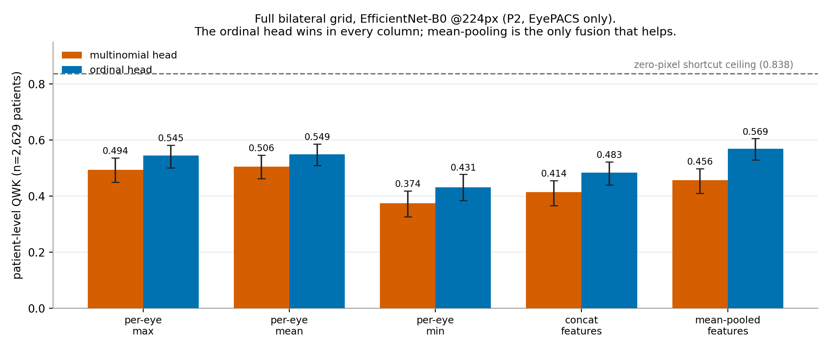
Figure 4. Every cell of the bilateral grid at EfficientNet-B0 @224px, with each condition’s own patient-level bootstrap interval and the zero-pixel shortcut ceiling for scale.
Decomposed, two-thirds of that +0.075 was the classifier head, not the second eye. The head alone is worth +0.050. A genuine bilateral-fusion benefit does exist on top of it — mean-pooling both eyes’ features beats per-eye-max by +0.025 [+0.003, +0.047] at 224px and +0.024 [+0.004, +0.042] at 384px — but it is small, and on ResNet-50 it is −0.028 [−0.053, −0.002]. That interval excludes zero on the wrong side: on that backbone, pooling the two eyes was significantly worse than grading them separately and taking the worse one. The fusion benefit is not architecture-independent, and I cannot claim it is. Had I run one backbone instead of three, I would have reported it as though it were.
The aggregation rule mattered less than expected, with one exception. Averaging the two eyes’ separate predictions instead of taking the maximum made no significant difference with the ordinal head on any backbone. Taking the minimum was significantly worse everywhere, by 0.080 to 0.114 QWK — which is what you would hope, since "best eye wins" is exactly the wrong rule for a screening task, and it is reassuring that the data agrees with the clinical convention. Concatenating the two eyes’ features rather than averaging them never helped in any configuration.
So the honest recommendation is narrower than the one I started with: use an ordinal head unconditionally, and add mean-pooled bilateral fusion only after verifying it helps on your specific backbone.

3.5 Where the Model Breaks Down (Objective 4)
Two failure modes are worth reporting, because both bound what this pipeline can be trusted to do.
The first is grade 1. Every converged model recalls Mild NPDR at between 8.7% and 14.0%, under both sampler settings, far below the 20–45% band I predicted. On its own that reads as a weak class. But two other results point at the same place. Grade 1 is the only grade that fails to transfer between a patient’s two eyes — 45.8% partner-lookup accuracy, near chance, while grades 0, 2, 3 and 4 all sit between 72.1% and 94.3% (Figure 5, right panel). And three of the eight corrupted images found in Phase 1 carry a human grade of 1 on a near-uniformly black frame: a grader assigned "microaneurysms only" to a black rectangle, at least three times.
One explanation covers all three. Mild NPDR is defined by microaneurysms roughly ten pixels wide in the source image. They do not survive downsampling to 224px, and human graders are themselves unreliable on them. So grade 1 may not be a class my pipeline is failing to learn; it may be a class the data cannot express at this resolution. That distinction matters because the two call for opposite responses — more model capacity versus more pixels, or an honest decision to collapse the class. Section 4.1 describes the experiment I designed to tell them apart. The clinical consolation is that grade 1 is not referable, so failing on it does not directly cost a referral; the cost is in early detection, which is the part of screening that most justifies doing it at all.
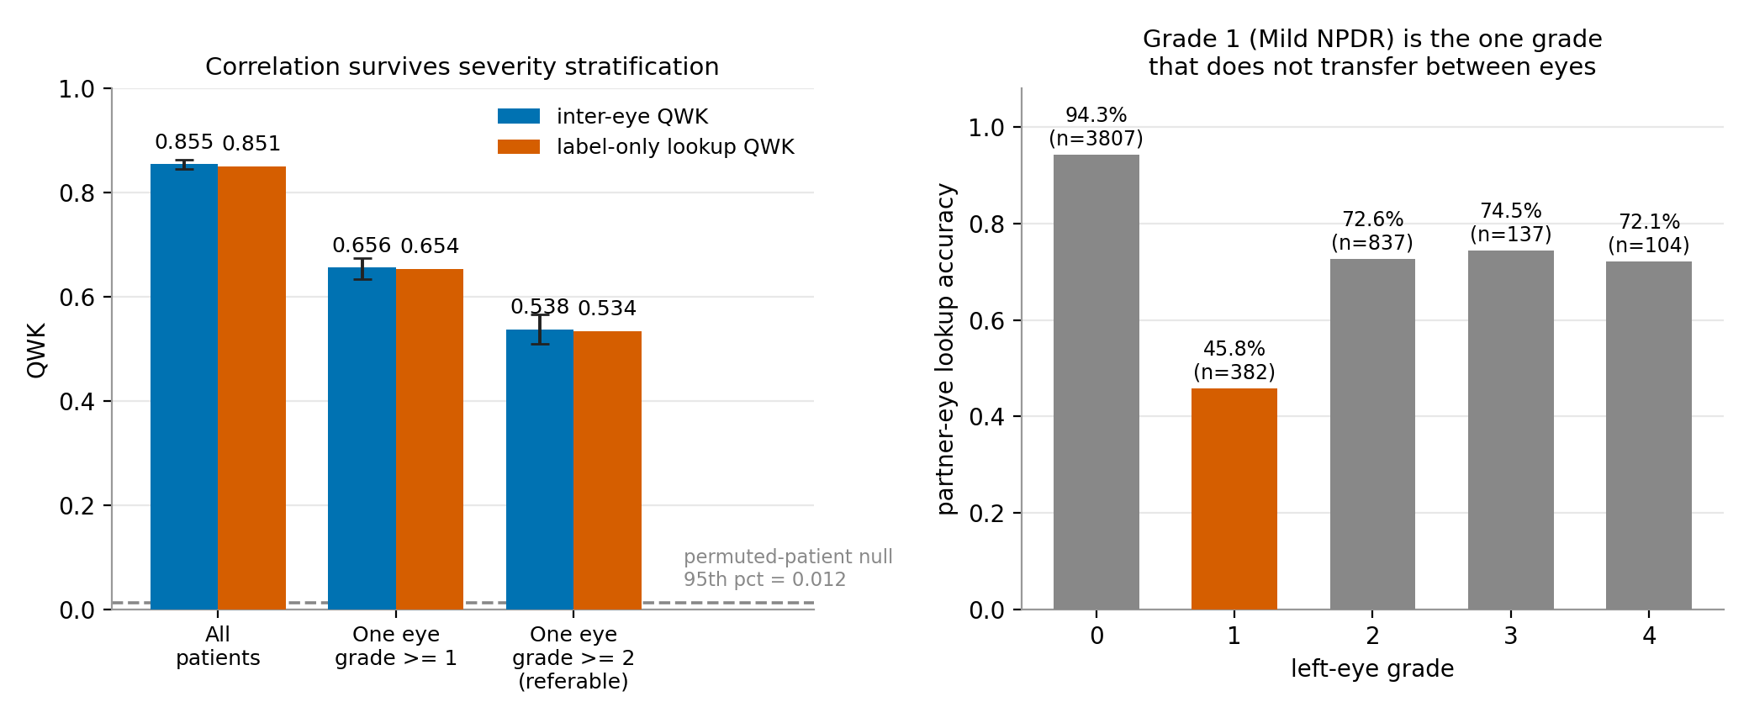
Figure 5. Left: inter-eye QWK and the label-only lookup ceiling under severity stratification, both far above the permuted-patient null. Right: partner-eye lookup accuracy by grade — grade 1 is the single outlier.
The second failure mode is cross-dataset transfer, and it is sharply asymmetric. Training on EyePACS and testing on APTOS reaches 0.660 QWK with the multinomial head and 0.754 with the ordinal head — respectable, and the only place in this project where a model clears 0.75. The reverse direction collapses to 0.287. Training on 3,111 APTOS images and testing on 35,118 EyePACS images is a far harder ask, and the asymmetry is mostly a data-volume effect rather than a domain-shift effect. What it establishes is that a grader trained on one screening population should not be assumed to transfer to another without being re-measured, which is the argument for the per-dataset calibration work planned in Section 4.2.
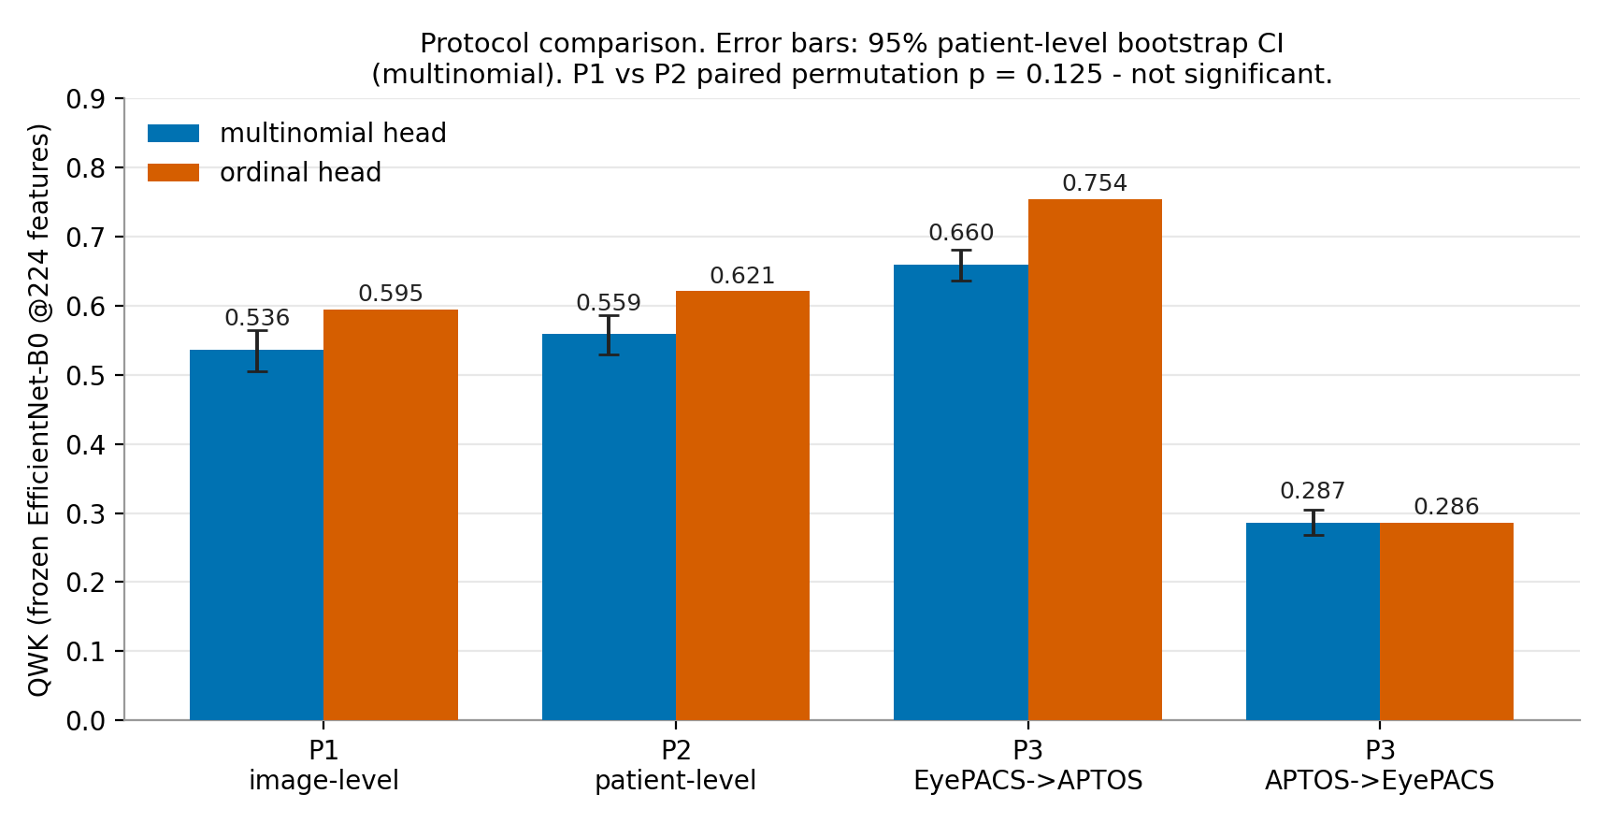
Figure 6. All four protocols under frozen features, both heads. The two P3 columns show the cross-dataset asymmetry; the P1 and P2 columns are the comparison discussed in Section 3.6.

3.6 Making Sure the Numbers Are Honest (Objective 5)
Everything above is only worth reporting if the evaluation underneath it is sound. This section is the due diligence, and one part of it produced a result worth reporting in its own right.
First, the correlation that makes patient-level splitting necessary at all. Measuring how well one eye’s grade predicts its partner’s, over 17,555 EyePACS patients, gives QWK 0.855 [0.846, 0.863]. Exact agreement is 87.3%, and the two eyes agree within one grade 95.7% of the time. Stratifying rules out the objection that this is just class imbalance: restricted to patients with at least one eye at grade 1 or above, QWK is still 0.656 [0.634, 0.675]; at the referable threshold it is 0.538 [0.510, 0.566]. A permutation test reassigning which eye belongs to which patient puts the observed value far outside the null in every stratum.
That correlation has a sharp practical consequence, and it produced the most useful diagnostic I built. Take a patient’s known grade in one eye and copy it onto the other as the prediction — no image, no model, no pixels. That reaches QWK 0.838. Any DR model scoring near 0.838 without clearly beating it may be riding the inter-eye correlation rather than reading the retina. It costs one pass over the labels, and I would argue it belongs next to the headline metric in any paper on a dataset where subjects contribute more than one correlated sample, because it turns a vague worry into a specific number a reader can check against. Every model in this project sits well below it (Figure 7), which is its own small piece of evidence that none of them is riding the shortcut.
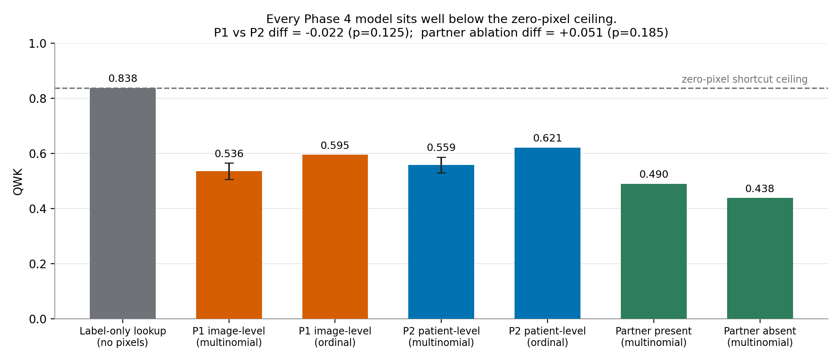
Figure 7. Every frozen-feature model on one scale against the zero-pixel lookup ceiling. All sit well below it.
Second, the question the ceiling raises: does splitting by image rather than by patient measurably inflate the score, as Tampu et al. and Yagis et al. found in OCT and brain MRI? I predicted in writing that it would. It did not. P1 reaches 0.536 QWK with the multinomial head and 0.595 with the ordinal head; P2 reaches 0.559 and 0.621 — if anything the point estimates run the wrong way, and a paired permutation test across seeds gives p = 0.125.
A whole-protocol comparison is blunt, so I built a targeted test of the mechanism. On a single P1-trained model I split the test set into patients whose partner eye was in the training data (n = 3,647) and patients whose partner eye was entirely absent from it (n = 1,641). Same model, same test set, split by a property of the data rather than by anything the model was told. If leakage were doing meaningful work, the partner-present group should score higher. The gap is +0.051 QWK for the multinomial head (p = 0.185) and +0.061 for the ordinal head (p = 0.0505); both bootstrap intervals on the difference include zero. Grade-matching the two groups shrinks the gaps to +0.018 and +0.036. Whatever is left is small and not distinguishable from nothing.
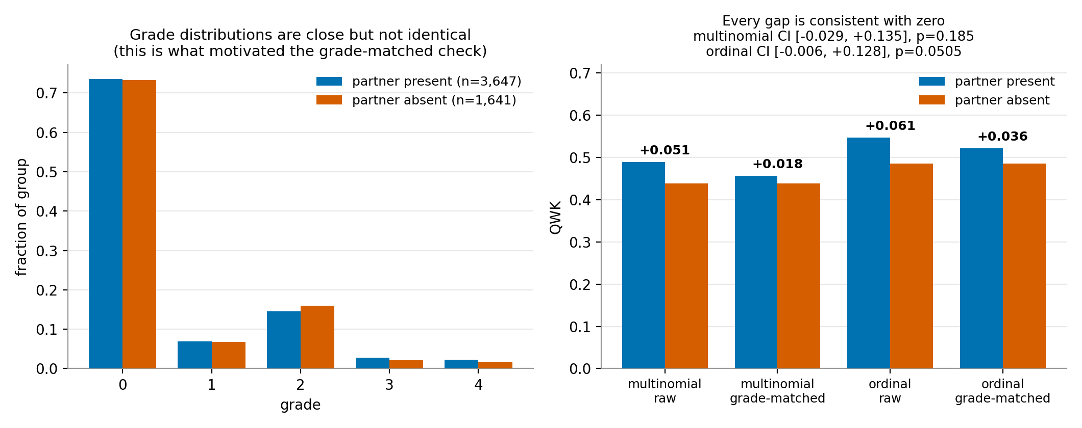
Figure 8. Partner-eye ablation. Left: the two groups’ grade distributions, which motivated the grade-matched check. Right: QWK for partner-present versus partner-absent patients, raw and grade-matched, for both heads.
Both tests were written down in advance with an explicit acceptable null outcome, and both returned it. The practical consequence for this project is reassuring: my headline numbers come from P2 regardless, so nothing in Sections 3.2 to 3.4 depends on how this came out. But the result itself is worth reporting, because it disagrees with a closely comparable published finding, and Section 3.7 takes that disagreement seriously.

3.7 Discussion
The five objectives land in different places, and the honest reading of each is more useful than a tidier story. Figure 9 puts every tested effect on one axis.
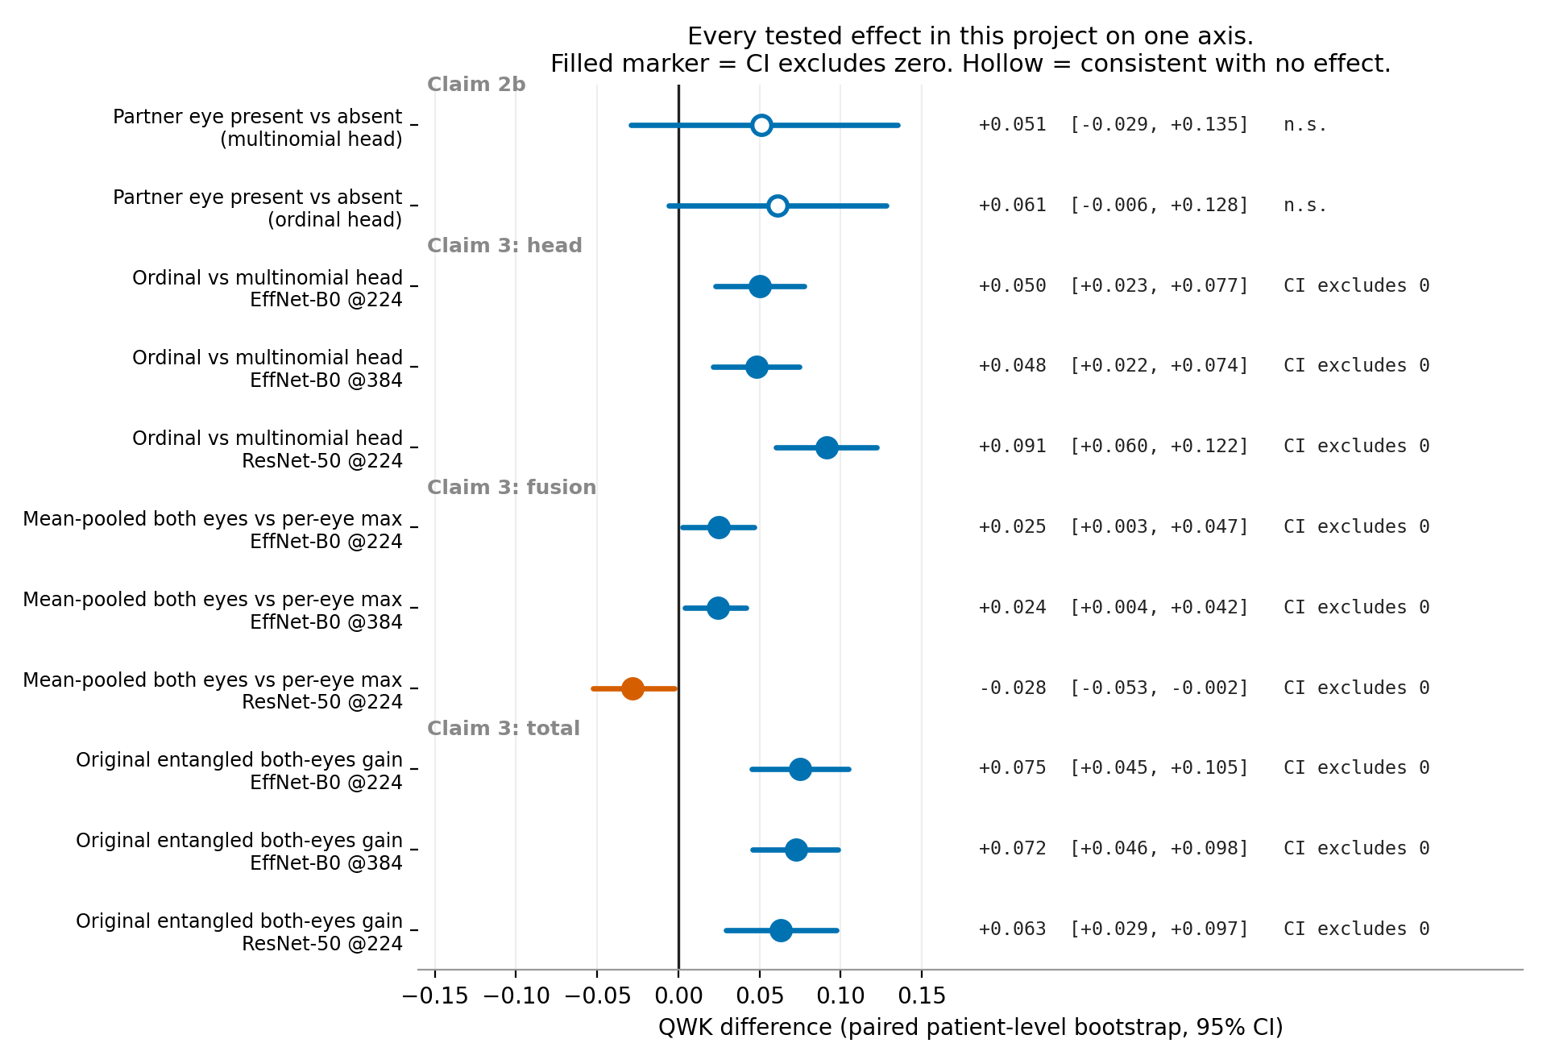
Figure 9. Every effect this project tested, with its paired patient-level bootstrap interval. Filled markers exclude zero; hollow markers are consistent with no effect.
The model itself does what a first public-data DR grader should do and no more. Referable AUROC 0.887 on a patient-level split is a credible result in the range public data supports, and the 61.3% specificity at clinical sensitivity is a real limitation with identifiable causes — resolution and a five-class objective used for a binary decision — rather than a mystery. The most valuable thing about having computed the operating point is that it makes the remaining work obvious: this model needs calibration and a reject option far more than it needs another backbone.
The design findings are the part I would most want another person to take. An ordinal head is nearly free and was worth more than anything else I tried, which is a strong argument that the ordered structure of DR grades is underexploited when practitioners reach for a softmax by default. The sampler result is a caution in the opposite direction: a technique everyone applies to imbalanced medical data made my model consistently worse and did not deliver the minority-class recall it was supposed to buy. Both findings came from making a choice into an ablation instead of a setting.
The bilateral result is the one that changed most under scrutiny. Grading both eyes together does help, but two-thirds of what looked like a bilateral effect was a classifier-head effect that has nothing to do with the second eye, and the residual fusion benefit reverses sign on one of three backbones. Ali et al. report a binocular gain without decomposing it; my result suggests that a binocular architecture evaluated against a differently-headed baseline can attribute to fusion what belongs to the head. That is a methodological caution I can support with data.
The leakage null deserves its own paragraph because it puts me in disagreement with a close published result, and I would rather state that than soften it. Tampu et al. measured 0.07 to 0.43 MCC inflation from image-level splitting in retinal OCT; I measured nothing detectable in DR fundus grading, three separate ways, on a dataset an order of magnitude larger. Either the mechanism is modality-specific, or my models are not capable enough to exploit it, or — the explanation I find most likely and have designed the experiment to test — leakage inflation is a small-data phenomenon that washes out once there are 27,000 training images and no shortage of genuine signal to fit. Section 4.1 describes that experiment.
What none of this licenses is the claim that published DR papers are wrong. My evidence supports something narrower: image-level splitting is widespread, and in my own tested setting it was less harmful than commonly assumed. The planned repository survey in Section 4.4 is committed to that framing.

3.8 What I Predicted, and What Actually Happened
Every experiment had its expected outcome written into the plan before it ran, and the scripts carry those expectations as fields in their output, so a miss gets flagged in the results file rather than quietly forgotten. Table 5 is the record. I got more of it wrong than right.
Table 5. Every pre-registered prediction and its outcome. Each was written before the corresponding experiment ran.
Prediction, written in advance | Expected | Actual | Outcome
P1 frozen-feature QWK | 0.80 – 0.88 | 0.536 | Missed low; flagged in results JSON
P2 frozen-feature QWK | 0.70 – 0.80 | 0.559 | Missed low; flagged in results JSON
P3 EyePACS → APTOS QWK | 0.50 – 0.65 | 0.637 | Within range
P3 APTOS → EyePACS QWK | 0.50 – 0.65 | 0.299 | Missed low; direction asymmetry
Fine-tuned QWK clears acceptance bar | ≥ 0.70 | 0.555 → 0.681 | Below bar even after convergence
Class balancing buys grade-1 recall | Recall improves | No change; QWK worse | Prediction failed
Grade-1 recall, fine-tuned models | 0.20 – 0.45 | 0.087 – 0.140 | Missed low in all 8 runs
Correlation collapses at grades 1, 3, 4 | 1, 3 and 4 weak | Only grade 1 weak | Partly wrong; sharper than predicted
Both-eyes fusion beats single-eye grading | Fusion helps | Mostly the head, not fusion | Overturned by my own decomposition
P1 scores above P2 (leakage inflation) | P1 higher | P2 higher, p = 0.125 | Prediction failed

The frozen-feature expectations were simply too optimistic — I had written down numbers appropriate to a fully fine-tuned model and applied them to a linear probe on cached features, which is an error in my plan rather than a finding about the data. But the misses that mattered were the structural ones: that class balancing would help, that bilateral fusion was doing the work, and that image-level splitting would inflate scores. All three were reversed by experiments I designed to be capable of reversing them, which is the only reason I know they were wrong.
That is the pattern I would defend as this project’s real contribution. Every interesting result here came from refusing to accept a single simple comparison: making the sampler an ablation instead of a setting, decomposing a three-variable confound instead of reporting the entangled number, running three backbones instead of one, auditing a deduplication threshold I had already shipped, and computing the clinical operating point instead of quoting the argmax. None of those were required. Each one changed the answer.

4. Future Work and Remaining Steps
The model is trained and measured. What remains is the work that turns it from a benchmarked model into something usable — calibration, a reject option, and a deployable application — plus four analyses that would sharpen the results already reported.

4.1 Analyses already designed and waiting to run
Four scripts are written, committed and ready. I list them with what each would settle, because two could change how Section 3 reads.
The grade-1 merge test is the one that matters most for the model itself. Section 3.5 argues that Mild NPDR may be a measurement ceiling rather than a modelling failure; this tests it by collapsing grades 0 and 1 and asking what happens to everything else. The comparison has to be done carefully, because QWK on a five-class problem and QWK on a four-class problem are not comparable quantities: both models are scored in the same merged label space, with the five-class model’s predictions mapped down after the fact. Referable-DR sensitivity and specificity are invariant to the 0/1 merge, so they act as a fixed reference point that relabelling cannot move. If merged QWK improves while referable performance holds, the grade-1 boundary is costing accuracy and buying no clinical discrimination — a concrete recommendation for anyone grading downsampled fundus images, and a possible route to the specificity this model is short of.
The sample-size sweep is the one that matters most for the evaluation question. Section 3.7 leaves a real disagreement with Tampu et al. unexplained, and the most likely explanation is scale: their OCT datasets are small, mine has 27,145 training images, and a model with that much genuine signal has no reason to memorise patient identity. Because the features are cached, I can subsample the P1 and P2 training sets to 500, 1,000, 2,000, 5,000, 10,000 and 20,000 images, refit at each size, and plot the P1-minus-P2 gap — and the partner-present-minus-absent gap — against training-set size, with both protocols evaluated on the same common test images. If the gap opens up at small N, leakage inflation is a small-data phenomenon and my null becomes a boundary condition on the published results rather than a contradiction of them. If the curve stays flat at zero, the obvious explanation is eliminated and the null is stronger than it is now. There is no outcome that is not worth reporting.
The converged paired bootstrap closes the one loose end in Section 3.6. The whole-protocol P1-versus-P2 comparison there uses frozen features; the converged fine-tuned runs show a raw gap of about +0.009 to +0.025 in the direction leakage would predict, which is inside seed noise but has not been through this project’s own required standard. I have dumped the per-image test predictions from all eight Phase 6b runs so it can be. It must report the minimum effect it was capable of detecting alongside its answer: a null is only as strong as the effect it rules out.
The partner-eye ablation on a converged model is the fourth. The version reported in Section 3.6 ran on the undertrained Phase 6 model, which is precisely the configuration least able to memorise a patient. Re-running it on a converged model is the fairest test the mechanism will get.
- Also outstanding: plot the full train/validation QWK curves for all eight Phase 6b runs, so convergence is documented directly from the curves rather than inferred from the early-stopping epoch.

4.2 Calibration and a reject option
This is the highest-value remaining work, because Section 3.2 showed the model must be run far from its argmax to reach clinical sensitivity, and a threshold is only as trustworthy as the probabilities underneath it. Using the winning Phase 6b configuration, fit a single temperature-scaling parameter on the validation set only and report Expected and Maximum Calibration Error with reliability diagrams before and after, separately for the in-domain test set and each cross-dataset test set. Cross-dataset calibration is expected to degrade; if it does, that is a finding worth reporting rather than a problem to hide.
Then a confidence-based reject option: compare maximum softmax probability against predictive entropy as the ranking signal, sweep the rejection threshold to produce a coverage against selective-QWK curve, and pick the operating threshold by a rule fixed in advance — the smallest threshold at which validation referable-DR sensitivity is at least 0.90 — rather than by looking at test performance afterwards. Finally, a Grad-CAM panel that explicitly includes failure cases, not just a curated set of correct and visually convincing ones.

4.3 The deployable application
Package the release artifacts: model weights as a state dictionary plus architecture name, the exact training configuration, the calibration temperature and reject threshold, and a model card documenting training data, metrics with intervals, and limitations. Then a Gradio interface that imports the project’s own preprocessing function directly instead of reimplementing it — a small, easily missed mistake that is a common cause of a working model producing garbage once deployed.
The interface reports the grade in plain clinical language, a referable or not-referable decision, a confidence score or an explicit “uncertain, refer” flag, and a Grad-CAM overlay, with its research-only status visible on screen rather than buried in documentation. A bilateral upload mode will use Section 3.4’s actual winning method for the deployed backbone, so the application demonstrates the project’s real strongest result rather than a version of it. Before the phase counts as done, 100 test images go through both the deployed app and the evaluation pipeline as an automated test, and the two have to match exactly. Any mismatch means a preprocessing inconsistency between training and deployment.

4.4 Literature-practice survey and final write-up
Survey 20 public GitHub repositories with more than 10 stars that train DR models on EyePACS or APTOS, recording for each whether the split is image-level or patient-level and the specific line of code that decides it, then report only the aggregate fraction using each practice rather than naming individual repositories. Section 3.6 already fixes the framing: my own finding is that image-level splitting did not measurably inflate my own results, so the point of the survey is not that the field is doing it wrong. It is the more defensible and more interesting claim that the practice is widespread and, at least where I tested it, less harmful than assumed.
The final write-up will lead with the model and its clinical operating point, followed by the design findings — the ordinal head and the sampler result — with the bilateral decomposition and the evaluation work as the methodological contributions that make those numbers believable.

5. Conclusion
This project built an automated diabetic retinopathy grader on public data and measured it properly. The converged model reaches referable-DR AUROC 0.887 on a frozen patient-level test set and, held at the 90% sensitivity a screening service requires, achieves 61.3% specificity. That places it inside the range public data supports — between the two test-set results of the only published independent public-data reproduction — and well short of what private, multi-grader adjudicated data buys. The gap is a data gap, and naming it that way is more useful than pretending it is a modelling one.
Three design findings came out of the work, and the two most useful were ones I had wrong going in. An ordinal classifier head beat a multinomial one by +0.05 to +0.09 QWK on every backbone tested, which is the largest and cheapest lever I found and an argument that the ordered structure of DR grades is routinely underexploited. Class-balanced resampling — the standard response to the imbalance in this data — made the model consistently worse and never delivered the minority-class recall it was supposed to buy. And grading a patient from both eyes does help, but a decomposition I ran after catching a confound in my own comparison showed two-thirds of the apparent gain belonged to the classifier head, with the residual fusion benefit reversing sign on one of three backbones.
Two limits are worth naming. Grade 1 is recalled at 8.7–14.0% by every model I trained, and three independent lines of evidence suggest that is a measurement ceiling at 224px rather than a modelling failure. And the evaluation work found no measurable inflation from image-level splitting, in three separate tests — a null that disagrees with a close published result in retinal OCT and that I report with the same rigour I would have given a positive finding.
Three of the predictions I wrote down before running the experiments turned out to be wrong, and the record of them is in Section 3.8 rather than edited out. Each is reported as the data showed it, and that is the standard the remaining work — calibration, a reject option and a deployable screening application — will be held to as well.

References
Ali, S. G., Wang, X., Bi, L., Jung, Y., Chen, T., & Zhang, H. (2025). Deep learning-based binocular system for automated diabetic retinopathy grading with prior clinical knowledge integration. The Visual Computer, 41(8), 5675–5688. (Published online 8 December 2024.)
APTOS / Asia Pacific Tele-Ophthalmology Society (2019). APTOS 2019 Blindness Detection [Kaggle competition dataset]. https://www.kaggle.com/competitions/aptos2019-blindness-detection
EyePACS (2015). Diabetic Retinopathy Detection [Kaggle competition dataset]. https://www.kaggle.com/competitions/diabetic-retinopathy-detection
Gargeya, R., & Leng, T. (2017). Automated Identification of Diabetic Retinopathy Using Deep Learning. Ophthalmology, 124(7), 962–969.
Gulshan, V., Peng, L., Coram, M., Stumpe, M. C., Wu, D., Narayanaswamy, A., et al. (2016). Development and Validation of a Deep Learning Algorithm for Detection of Diabetic Retinopathy in Retinal Fundus Photographs. JAMA, 316(22), 2402–2410.
Guo, C., Pleiss, G., Sun, Y., & Weinberger, K. Q. (2017). On Calibration of Modern Neural Networks. Proceedings of the 34th International Conference on Machine Learning (ICML), PMLR 70, 1321–1330.
Rouzrokh, P., Khosravi, B., Faghani, S., Moassefi, M., Vera Garcia, D. V., Singh, Y., Zhang, K., Conte, G. M., & Erickson, B. J. (2022). Mitigating Bias in Radiology Machine Learning: 1. Data Handling. Radiology: Artificial Intelligence, 4(5), e210290.
Selvaraju, R. R., Cogswell, M., Das, A., Vedantam, R., Parikh, D., & Batra, D. (2017). Grad-CAM: Visual Explanations from Deep Networks via Gradient-Based Localization. Proceedings of the IEEE International Conference on Computer Vision (ICCV), 618–626. (Extended version: International Journal of Computer Vision, 128(2), 336–359, 2020.)
Tampu, I. E., Eklund, A., & Haj-Hosseini, N. (2022). Inflation of test accuracy due to data leakage in deep learning-based classification of OCT images. Scientific Data, 9, 580. (Preprint: arXiv:2202.12267.)
Tymchenko, B., Marchenko, P., & Spodarets, D. (2020). Deep Learning Approach to Diabetic Retinopathy Detection. arXiv:2003.02261.
Voets, M., Møllersen, K., & Bongo, L. A. (2019). Reproduction study using public data of: Development and validation of a deep learning algorithm for detection of diabetic retinopathy in retinal fundus photographs. PLOS ONE, 14(6), e0217541.
Yagis, E., Atnafu, S. W., García Seco de Herrera, A., Marzi, C., Scheda, R., Giannelli, M., Tessa, C., Citi, L., & Diciotti, S. (2021). Effect of data leakage in brain MRI classification using 2D convolutional neural networks. Scientific Reports, 11, 22544.

Appendix — Results Source Files
Every number in Section 3 traces to a JSON file written by this project’s own scripts: inter_eye_correlation.json and claim1b_stratified.json (Section 3.2); claim2_protocols.json and claim2b_partner_ablation.json (Section 3.3); claim3_both_eyes.json, claim3_decomposed.json and its per-backbone variants claim3_decomposed_tf_efficientnet_b0_384.json and claim3_decomposed_resnet50_224.json, plus claim3_robustness.json (Section 3.4); and finetune_headline_*.json, finetune_app_p2_seed42.json, finetune_config_comparison.json and the eight finetune_converged_*.json files with their per-epoch curve files (Sections 3.2 and 3.3); and clinical_operating_point.json, which holds the referable-DR ROC, the operating points and the per-run sensitivity/specificity counts reported in Section 3.2. The deduplication audit in Section 1.3 is in duplicates.json and dedup_threshold_sweep.json, with the per-pair evidence in eyepacs_near_dup_candidates.csv; the excluded-image evidence is in excluded_images.json and low_mean_diagnostic.json.
The pre-registered expectations in Table 5 are not reconstructed after the fact. They are recorded in MASTER_PLAN.md and carried into the results files themselves as expected_range and within_expected_range fields, so a miss is flagged by the script that produced it. The frozen test-set declaration, with both git commit hashes and the reason for the re-declaration, is in README.md.
Every figure is generated programmatically from those files, never drawn or copied by hand. Figures 2 to 9 come from src/analysis/make_report_v2_figures.py and Figure 1 from src/experiments/clinical_operating_point.py, both of which read the results JSON at run time and hard-code no values, so re-running an experiment updates its figure without any manual editing. The four analyses described in Section 4.1 are committed as claim5_grade1_merge.py, claim2d_sample_size_sweep.py, claim2c_converged_bootstrap.py and claim2b_converged_ablation.py, each with its acceptable outcomes stated in the module docstring before it was run.

