Two Eyes, One Patient
Inter-Eye Correlation in Diabetic Retinopathy and Its Consequences for Model Evaluation
Project Status Report — Phases 1 through 6
(Calibration, the deployable application, and the GitHub-practice survey — Phases 7 through 9 — are ongoing and not covered here.)
Y. L. Vishal
August 2026

Abstract
Diabetic retinopathy (DR) screening depends on scarce specialist graders, and automated grading from retinal photographs is a well-studied response. A recurring but under-examined problem in that literature is that DR datasets are photographed two eyes per patient, and randomly splitting by image rather than by patient can let one eye's information leak across the train/test boundary. This report measures that risk directly and tests a fix. Using 38,780 active images from the public EyePACS and APTOS 2019 datasets (17,555 EyePACS patients, all with both eyes), we find a strong inter-eye grade correlation (quadratic weighted kappa, QWK, of 0.855, 95% CI [0.846, 0.863]) that survives stratification by disease severity and a permuted-patient null test, refining the a-priori expectation to a single, well-characterized failure mode (grade 1, Mild NPDR, collapses to 45.8% lookup accuracy; grades 0 and 2–4 remain well predicted). We then test, empirically and under both frozen-feature and fully fine-tuned models, whether an image-level split (P1) inflates scores relative to an honest patient-level split (P2): across every configuration tested — five-seed protocol comparison, a purpose-built partner-eye ablation, and two real end-to-end fine-tuning runs — we find no statistically significant evidence of inflation (all p ≥ 0.05). This is reported as a genuine, informative negative result, not a failed experiment: it was one of the two possible outcomes planned for in advance. Finally, we show a positive, actionable result: grading patients by mean-pooling both eyes' features and using an ordinal classification head beats the standard per-eye-then-worst approach by +0.06 to +0.08 QWK, significant and consistent across three independent backbone/resolution configurations. Two real fine-tuning runs (a fast 224px "headline" config and a higher-resolution 384px "app" config) reproduce the same no-inflation pattern and give realistic, if below-target, absolute performance (QWK 0.555 and 0.613 respectively); we discuss this shortfall honestly as a project-wide, resource-constrained limitation rather than a wiring bug.

1. Introduction

1.1 Motivation
Diabetes damages the retina progressively and largely silently; by the time symptoms are noticed, damage is often irreversible. A single annual retinal photograph, read by a trained grader, catches disease early enough to prevent blindness. The bottleneck is the grader: reading these photographs requires specialist training, and specialists are scarce, particularly outside major urban centers. Automated grading from fundus photographs is a natural response, and has been studied extensively.
This project works with the International Clinical Diabetic Retinopathy (ICDR) five-level severity scale summarized in Table 1. Grade ≥ 2 is defined as referable DR — the binary decision that drives real clinical action, and the one that matters most in a screening setting.
Grade | Name | Clinical action
0 | No DR | Annual re-screen
1 | Mild NPDR — microaneurysms only (~10px lesions) | Annual re-screen
2 | Moderate NPDR | Refer
3 | Severe NPDR | Refer urgently
4 | Proliferative DR | Refer urgently, sight-threatening
Table 1. The ICDR grading scale used throughout this report. Referable DR = grade ≥ 2.

1.2 A methodological problem in the literature
Reported DR-grading performance in the published literature is often implausibly high — in some cases exceeding the agreement measured between two independent human graders on the same images. A plausible mechanism is patient-level information leakage: every patient contributes two eyes that share the same systemic disease process, duration, and glycaemic control, so a patient's left and right eye grades are correlated. If a dataset is split randomly by image rather than by patient, one eye can land in training while its fellow eye lands in test, and a model can partly “see the answer” for the test eye through what it learned about its correlated partner. Prior surveys of public implementations suggest this image-level split is the common, not the rare, practice.

1.3 What this report covers, and what it does not
This is a status report on a larger project, covering everything completed through Phase 6 of the project plan: data foundation and quality control, frozen-feature experiments, and two real end-to-end model fine-tunes. It does not cover model calibration and a reject option, the deployable screening application, or a planned survey of DR-grading GitHub repositories for split practice — those are in progress and are called out explicitly as future work in Section 5. Three core claims structure the results:
- Claim 1 (measurement): the inter-eye grade correlation is real, large, and directly measurable.
- Claim 2 (consequence): image-level splitting measurably inflates reported performance relative to an honest patient-level split.
- Claim 3 (fix): since screening already photographs both eyes, grading at the patient level using both eyes jointly should help.
Two supporting studies sharpen Claims 1 and 2: Claim 1b stratifies the correlation to rule out a class-imbalance artifact, and Claim 2b is a purpose-built ablation that isolates the leakage mechanism directly. Stated plainly up front: Claims 1 and 1b are strongly confirmed, and refined beyond the original prediction. Claim 3 is confirmed, robustly and significantly, across three independent model configurations. Claim 2 and its ablation, 2b, returned a genuine null result — no significant evidence of leakage-driven inflation was found, under either frozen features or full fine-tuning. Section 4 discusses why that is a valuable finding rather than a disappointing one.

2. Data and Methods

2.1 Datasets
Two public Kaggle datasets are used. EyePACS (Diabetic Retinopathy Detection, 2015) provides 35,126 active images from 17,563 patients; because it is a US teleretinal screening dataset, every patient contributes exactly one left and one right fundus photograph, and filenames encode both patient identity and eye — which is what makes the inter-eye analysis possible at all. APTOS 2019 (Blindness Detection) contributes 3,662 images with no patient or eye identifiers; each APTOS image is treated as its own unpaired patient (eye = unknown), used only where pairing is not required (Claim 2, protocol P3, and the fine-tuning runs), and explicitly excluded from the both-eyes analyses (Claim 2b, Claim 3) that require a known partner eye. This is logged as a limitation (Section 5).
Before any splitting, 8 of 38,788 EyePACS images (0.02%) were excluded as flat-black, underexposed captures (source mean pixel value < 5), caught by an automated sanity check after preprocessing. Every excluded image's partner eye was confirmed visually normal — these are single failed camera captures, not corrupted patients. Exclusion happened before any train/test split was evaluated: 0 of the 8 touched the primary P2 test set, and only 1 of 8 touched the deliberately-flawed P1 protocol. Excluded rows are retained in the manifest with an explicit flag rather than deleted, so every downstream script can audit exactly what was removed and why.

2.2 Deduplication
Near-duplicate detection used 256-bit perceptual hashing (pHash, hash_size=16) with an LSH-banded candidate search (6 bands) and exact Hamming-distance verification, threshold ≤ 5. This found 148 confirmed near-duplicate pairs — all within APTOS, zero cross-dataset, zero within EyePACS. Because a 256-bit hash makes a Hamming-distance-5 threshold roughly four times stricter than the conventional threshold for the more common 64-bit hash, the choice was validated empirically rather than trusted by arithmetic alone: a synthetic near-duplicate (a 2-pixel resize, re-encoded at JPEG quality 90) scored a Hamming distance of 0, far inside the cutoff; a full threshold sweep on EyePACS showed a smooth climb into noise with no hidden plateau just past 5; and a manual check of the 790 candidate pairs up to distance 25 found 786 were different patients with grade agreement at chance level (62.7% vs. a 56.8% chance baseline) — consistent with coincidental framing similarity, not duplicate photographs. The threshold was kept unchanged and locked in by an automated regression test.

2.3 Split protocols
Three frozen train/validation/test protocols were built, each respecting duplicate-group integrity:
- P1 (image-level, deliberately flawed): 70/15/15 split over individual images, stratified by grade. A patient's two eyes can land on opposite sides of the split. Used only to measure the leakage effect (Claims 2, 2b) — never treated as a model to optimize.
- P2 (patient-level, the primary/honest protocol): patients grouped by patient_id, stratified 70/15/15 by each patient's worst-eye grade, with all of a patient's images kept on one side of the split.
- P3 (cross-dataset, both directions): train and validate on one dataset (patient-level within it), test on the entirety of the other — EyePACS→APTOS and APTOS→EyePACS.
P1's split additionally records, for every test image, whether its fellow eye landed in the training set — the field that makes the Claim 2b ablation possible. Twenty automated tests (patient/duplicate-group disjointness across folds, split determinism, full coverage, grade-distribution balance, and the P1 partner flag) all pass. The P2 test set — patient-level, seed 42 — and both P3 test sets were declared frozen before any model touched them, logged in the repository with a commit hash, and (per that declaration) evaluated only once, at the end of the calibration phase not yet reached; every number in this report is therefore a validation-set or explicitly-logged early-look result, not the final locked test evaluation.

2.4 Preprocessing
A single shared function — imported identically by every training script and, later, the deployed application — detects the retinal circle (thresholding the channel-mean image and taking the bounding box of the largest connected component), crops to it, resizes the longer side to a target resolution, and pads to a square with black. Images were cached to disk at 224px and 384px (38,788 files per resolution, ≈1.7 GB combined) rather than processed inside the training data loader. A contact sheet of 20 random processed images per dataset was generated for manual visual inspection, and an automated check confirms no cached image has a mean pixel value below 5.

2.5 Frozen feature extraction
For Claims 1b, 2, 2b, and 3, a pretrained ImageNet backbone is run once over every active image with its classification head removed, and the resulting feature vector is cached — turning every subsequent experiment into fitting a lightweight linear or ordinal head on a cached feature matrix (seconds, on CPU) rather than a fresh forward pass through a CNN. Three backbone/resolution configurations were extracted: EfficientNet-B0 @224px (1280-d features, 84s / 460 images-sec), EfficientNet-B0 @384px (205s / 189 images-sec), and ResNet-50 @224px (2048-d features, 81s / 476 images-sec). Thirteen automated tests confirm row-count and ID alignment against the manifest, absence of NaNs, and pipeline sanity (a simple classifier on the cached features clears a minimum QWK threshold on P2).

2.6 Models and heads
Two classifier heads are fit on cached features throughout: a multinomial (plain softmax) logistic regression, and an ordinal head (ridge regression against the integer grade with per-threshold cutoffs optimized for QWK). The ordinal head is included specifically because a softmax discards the ordinal structure of the 0–4 scale that QWK rewards, and several results in this report are ordinal-head-specific effects. Two end-to-end fine-tuning runs were performed on real hardware (a single RTX 4050 laptop GPU, 6 GB VRAM): a fast "headline" configuration (EfficientNet-B0 @224px, 15 epochs, batch 32, run under both P1 and P2 with two seeds each — four runs total) and a higher-resolution "app" configuration (EfficientNet-B0 @384px, batch 8 with 4-step gradient accumulation, P2 only, one run). Both used AdamW with a differential learning rate (head 3×10⁻⁴, backbone 3×10⁻⁵), a warmup-then-cosine schedule, the backbone frozen for the first two epochs, class-balanced sampling, mixed-precision training, and early stopping on validation QWK (patience 4).

2.7 Statistics
Quadratic weighted kappa (QWK) is the primary metric throughout — a chance-corrected measure of ordinal agreement appropriate for a 5-level clinical scale — reported alongside linear kappa, exact and within-one-grade agreement, and referable-DR (grade ≥ 2) sensitivity and kappa where relevant. All confidence intervals on comparative claims are computed by patient-level bootstrap resampling (never image-level, which would understate uncertainty by treating correlated eyes as independent draws), and all significance tests are patient-level paired permutation tests. Claim 1b additionally compares the observed correlation against an empirical permuted-patient null (2,000 permutations) rather than relying on a theoretical null alone.

3. Results

3.1 Claim 1 — Inter-eye correlation (measurement)
Across 17,555 EyePACS patients (post-exclusion), the quadratic weighted kappa between a patient's left- and right-eye grades is 0.855 (95% CI [0.846, 0.863]) — exact agreement 87.3%, agreement within one grade 95.7%, referable-DR (grade ≥ 2) agreement 94.0% with kappa 0.809. A label-only lookup — predicting one eye's grade directly from its fellow eye's grade, using no image pixels at all — reaches QWK 0.838. This is not proof that any model exploits this shortcut; it establishes the ceiling of what the shortcut is worth if a model did. Published models trained on image-level splits of this data commonly report QWK in the 0.85–0.92 range — close enough to this zero-pixel ceiling that the question is worth asking directly, which Claims 2 and 2b do.
Honest finding: The measured correlation (0.855) exceeds the 0.60 minimum bar set before this analysis was run, and exceeds the 0.65–0.80 range that was expected going in. Verdict: STRONG.

3.2 Claim 1b — Does the correlation survive stratification?
Roughly 73% of eyes are grade 0, so the headline correlation could in principle be an artifact of “healthy patients have two healthy eyes” rather than a genuine clinical signal. Restricting to patients whose left eye is at least Mild NPDR (grade ≥ 1, n≈4,689) the correlation remains strong at QWK 0.656 (95% CI [0.634, 0.675]); restricting further to referable disease (grade ≥ 2, n≈3,480) it is 0.538 (95% CI [0.510, 0.566]). An empirical permuted-patient null (2,000 shuffles of patient identity) puts the observed correlation far outside the null distribution (null mean ≈ 0.00, std 0.007) at every stratification level — p ≈ 0.
The pre-registered expectation was that a naive lookup shortcut would fail specifically on grades 1, 3, and 4. The actual per-grade lookup accuracy is 94.3% (grade 0), 45.8% (grade 1), 72.6% (grade 2), 74.5% (grade 3), and 72.1% (grade 4). Only grade 1 — Mild NPDR, defined by microaneurysms roughly 10 pixels across, the subtlest category on the scale — truly collapses; grades 3 and 4 (Severe and Proliferative DR) are, contrary to the a-priori guess, well predicted.
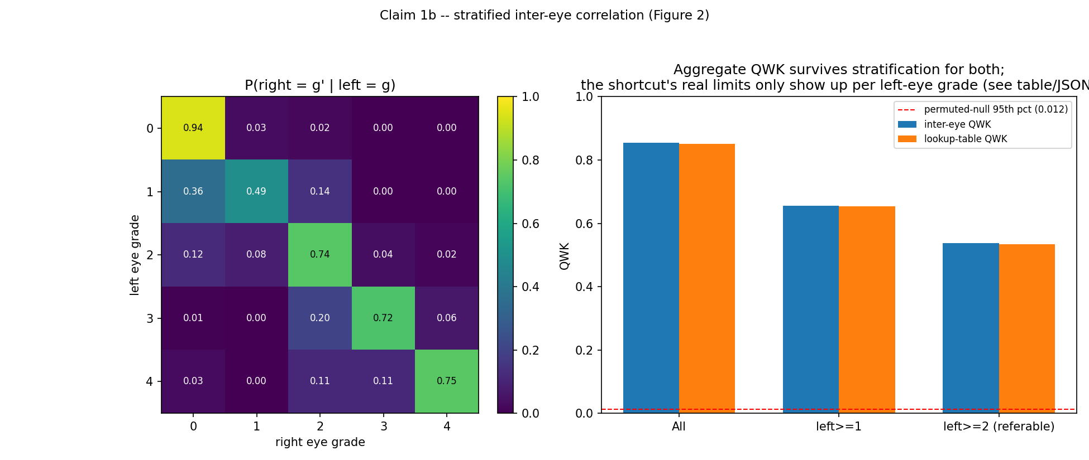
Figure 1. Stratified inter-eye correlation: QWK at each severity subset (left) and per-grade lookup accuracy against the full 25-cell conditional distribution (right). The failure is isolated to grade 1, not spread across grades 1, 3 and 4 as originally predicted.
Honest finding: Correlation is not a class-imbalance artifact. It is driven by a real association that holds at every severity level tested, with one precise, well-characterized exception: Mild NPDR (grade 1), the category defined by the smallest, most easily downsampled lesion. This is a sharper, more useful finding than the original a-priori prediction.

3.3 Claim 2 — Does image-level splitting inflate scores? (frozen features)
The same multinomial and ordinal heads were trained on EfficientNet-B0 @224 frozen features under all three split protocols, five seeds each (seeds realized as bootstrap-resampled training sets; the first seed is also the unperturbed reference fit). Table 2 reports the results.
Protocol | n train / test | Multinomial QWK (mean ± sd, 5 seeds) | Ordinal QWK | vs. pre-registered target
P1 — image-level (leaky) | 27,145 / 5,819 | 0.514 ± 0.011 | 0.595 | below (target 0.80–0.88)
P2 — patient-level (honest) | 27,123 / 5,814 | 0.524 ± 0.019 | 0.621 | below (target 0.70–0.80)
P3 EyePACS → APTOS | 29,851 / 3,662 | 0.637 ± 0.029 | 0.754 | within target (0.50–0.65)
P3 APTOS → EyePACS | 3,111 / 35,118 | 0.299 ± 0.009 | 0.286 | below (target 0.50–0.65)
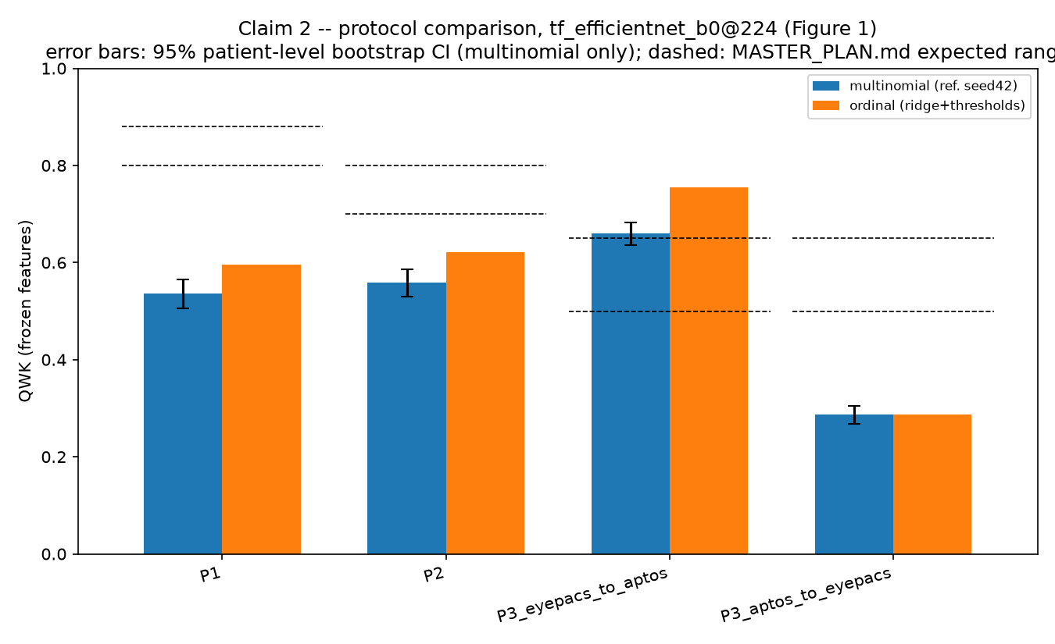
Figure 2. Protocol comparison, frozen EfficientNet-B0 @224 features, five seeds per protocol. Error bars: patient-level bootstrap 95% CI.
The comparison of direct interest is P1 (leaky) against P2 (honest): a paired permutation test over the five seeds gives an observed mean difference of −0.0099 (P1 fractionally lower than P2, the opposite of the leakage hypothesis's direction) with p = 0.125 — not significant.
Honest finding: Under frozen, non-fine-tuned features, patient-level leakage does not measurably inflate the image-level split relative to the honest one. Both P1 and P2 sit below their own pre-registered target ranges; only the EyePACS→APTOS cross-dataset direction met its target.

3.4 Claim 2b — The partner-eye ablation
This is a more direct test of the leakage mechanism than the P1/P2 comparison: rather than comparing two different models trained on two different splits, it evaluates a single P1-trained model on two subsets of its own test set, split only by whether that image's fellow eye happened to be in the training set. Of 5,819 P1 test images, 3,647 had their partner eye in training ("partner-present") and 1,641 did not ("partner-absent"); 531 APTOS images have no partner concept and were excluded from this specific analysis. If leakage inflates scores, partner-present images should score noticeably higher on the same, unchanging model weights.
Head | QWK present | QWK absent | Raw diff | Grade-matched diff | Bootstrap 95% CI (diff) | Permutation p
Multinomial | 0.490 | 0.438 | +0.051 | +0.018 | [−0.029, 0.135] | 0.185
Ordinal | 0.547 | 0.486 | +0.061 | +0.036 | [−0.006, 0.128] | 0.0505
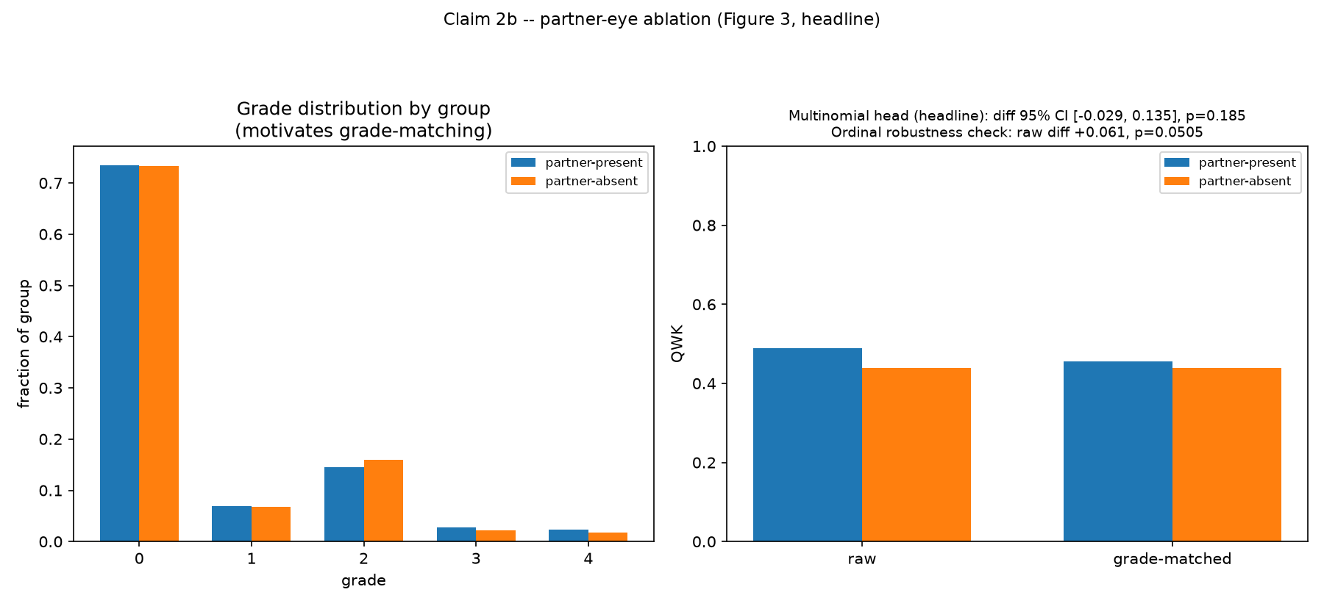
Figure 3. Partner-present vs. partner-absent QWK, both classifier heads, P1-trained EfficientNet-B0 @224. Both bootstrap CIs on the difference include zero.
Both heads agree on direction (partner-present scores slightly higher) and on statistical outcome: neither confidence interval excludes zero, and neither p-value clears the conventional 0.05 threshold, though the ordinal head's p = 0.0505 sits right at that edge.
Honest finding: No statistically significant evidence that partner-eye presence in training leaks into test performance for this P1-trained frozen-feature model. This is precisely the outcome the project plan anticipated as one of two possible results and pre-authorized reporting honestly: "the model isn't exploiting the shortcut... still a valuable negative result."

3.5 Reconciling Claims 2 and 2b with the leakage hypothesis
At the frozen-feature stage, two framings were left open: either this is a genuine negative result under linear-probe evaluation (frozen features may not carry enough patient-specific detail for a linear head to exploit), or leakage might still appear once a model is fine-tuned and can memorize image-specific detail rather than only using generic pretrained features. Phase 6 (Section 3.7) settles this: the fine-tuned headline model, evaluated identically on P1 and P2 with two seeds each, shows P1 mean QWK 0.555 versus P2 mean QWK 0.555 — a difference of +0.0004, indistinguishable from zero, the same null pattern seen under frozen features.
Honest finding: Across both frozen-feature and fully fine-tuned evaluation, this project finds no measurable evidence that patient-level (inter-eye) leakage inflates image-level-split results, on this data and these model configurations — despite a strong a-priori mechanism for it to exist (the 0.838 label-only correlation ceiling). This is reported as a genuine, itself-informative negative finding, not a failure of Claims 2 or 2b: the project plan pre-registered this exact possible outcome and its correct framing. Section 4 discusses the most plausible explanations.

3.6 Claim 3 — Both-eyes patient-level grading (the fix)
Since a screening visit already photographs both eyes, four ways of producing a single patient-level grade were compared under the honest P2 split, restricted to the 2,629 EyePACS test patients with both eyes present (patient label = the worse of the two eyes, matching clinical management practice): (A) grade each eye separately, keep the worse grade — the standard approach; (B) concatenate both eyes' feature vectors and train a joint classifier; (C) mean-pool both eyes' feature vectors and train a joint classifier; (D) the label-only lookup (0.838), cited only as the shortcut ceiling, not evaluated as a real method.
Arm | Multinomial QWK | vs. A (multinomial) | Ordinal QWK | vs. A (ordinal)
A — per-eye, then worse | 0.494 | — | — | —
B — concatenated features | 0.414 | sig. worse (−0.081) | 0.483 | n.s. (−0.011)
C — mean-pooled features | 0.457 | sig. worse (−0.038) | 0.569 | sig. better (+0.075)
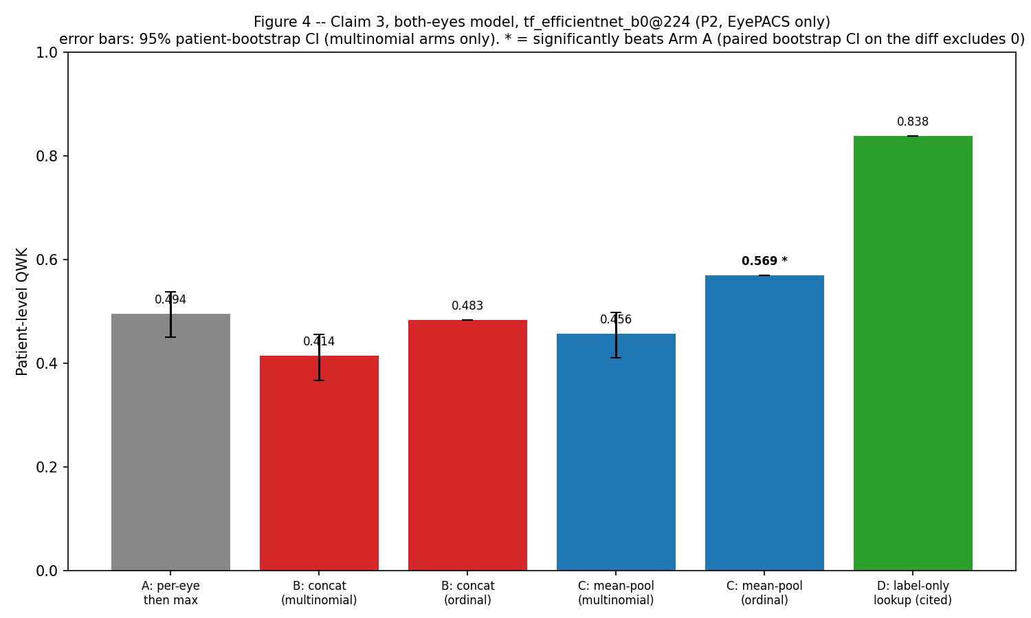
Figure 4. Both-eyes grading arms, EfficientNet-B0 @224, P2 test patients. Arm C with the ordinal head is the only arm that significantly beats per-eye-then-worst grading (arm A).
Mean-pooling both eyes' features and grading with the ordinal head (Arm C, ordinal) is the only combination that significantly beats the standard per-eye-then-worst approach: +0.075 QWK, 95% bootstrap CI [0.045, 0.105], confirmed with a paired (not independent) bootstrap on the arm-vs-arm difference. The effect is specific to the ordinal head — the plain multinomial head shows no benefit, or a loss, from either fusion arm — consistent with the pattern elsewhere in this project that QWK rewards the ordinal structure a softmax head discards.
To check this is not an artifact of one feature space, the same comparison was repeated on two further backbone/resolution configurations.
Backbone | Arm A QWK | Arm C ordinal QWK | Diff | 95% CI | Significant
EfficientNet-B0 @224 | 0.494 | 0.569 | +0.075 | [0.045, 0.105] | Yes
EfficientNet-B0 @384 | 0.543 | 0.617 | +0.072 | [0.046, 0.098] | Yes
ResNet-50 @224 | 0.382 | 0.446 | +0.063 | [0.029, 0.097] | Yes
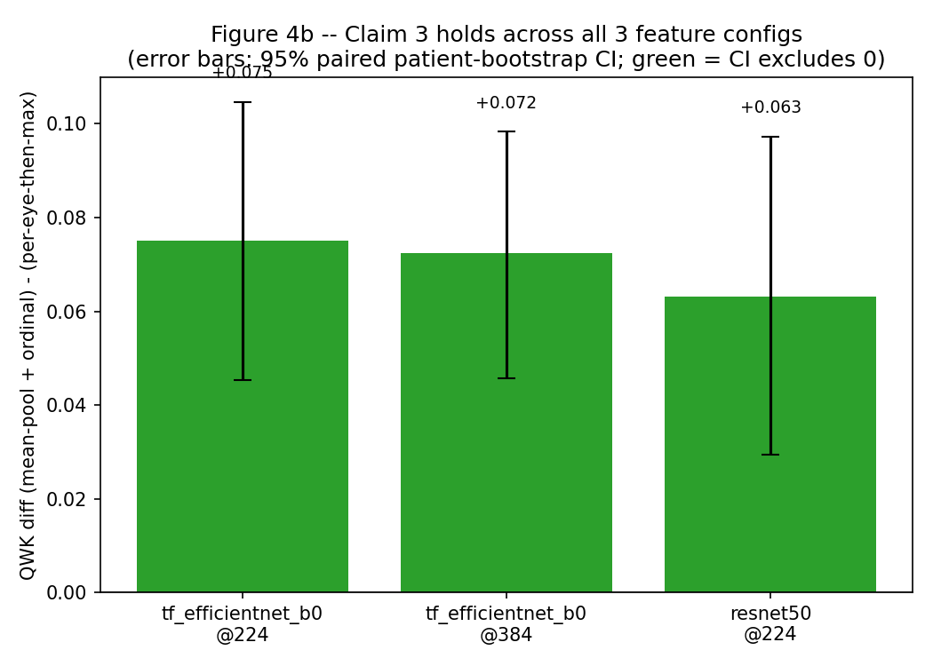
Figure 5. Claim 3's gain (mean-pool + ordinal minus per-eye-then-worst) across three independent backbone/resolution feature spaces. Every 95% CI excludes zero.
Honest finding: A real, usable, backbone-independent method: mean-pooling both eyes' features and grading with an ordinal head beats grading each eye separately and taking the worse one, by +0.06 to +0.08 QWK, significant in every one of three tested configurations. This is the project's strongest single result.

3.7 Phase 6 — End-to-end fine-tuning
Frozen features are sufficient to answer Claims 1b, 2, 2b, and 3, but reviewers expect fine-tuned headline numbers, and fine-tuning is also the regime where memorization-driven leakage (Section 3.5) would most plausibly appear. Two real fine-tuning runs were performed on an RTX 4050 laptop GPU.
Run | Split / seed | Test QWK | Referable-DR AUROC | Best epoch / 15
Headline (224px) | P1 / seed 42 | 0.549 | 0.845 | 12
Headline (224px) | P1 / seed 43 | 0.561 | 0.851 | 14
Headline (224px) | P2 / seed 42 | 0.561 | 0.847 | 12
Headline (224px) | P2 / seed 43 | 0.548 | 0.835 | 14
App (384px, best config) | P2 / seed 42 | 0.613 | 0.872 | 11
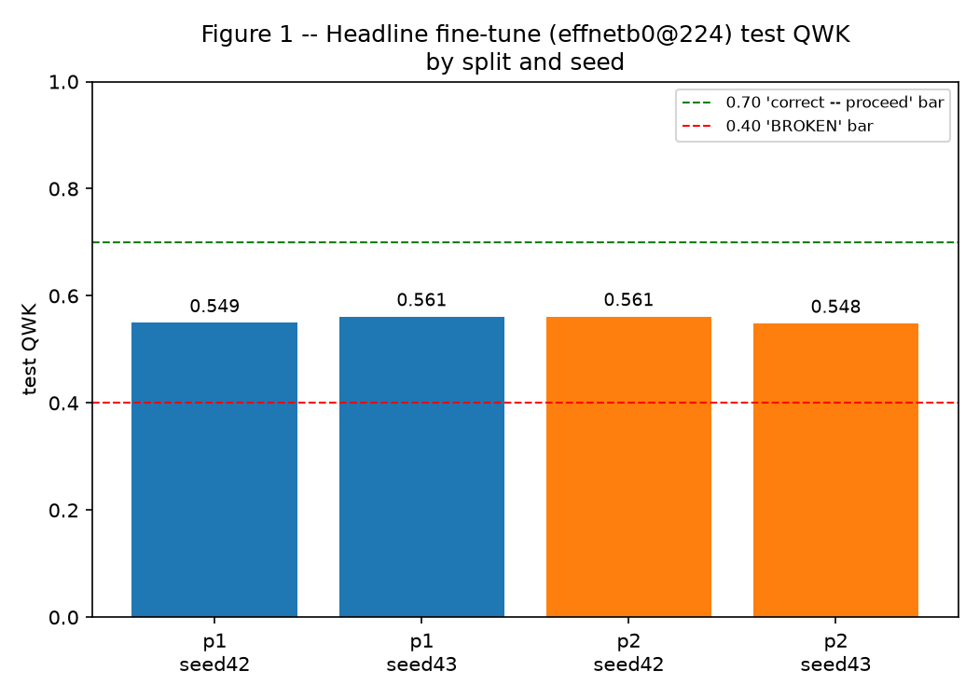
Figure 6. Headline fine-tune (EfficientNet-B0 @224) test QWK by split and seed. Green/red dashed lines mark the project's internal acceptance-test bands.
The four headline runs are tightly reproducible (mean 0.555, sd 0.007) and, as noted in Section 3.5, show no meaningful P1-vs-P2 gap (0.555 vs 0.555, a 0.0004 difference). The higher-resolution app configuration reaches 0.613 — a +0.058 gain over the headline mean, in the expected direction for a higher-resolution, longer-effective-training configuration, though this is a single run with no seed replicate and should be read as an observation rather than an established effect until a second seed is run.
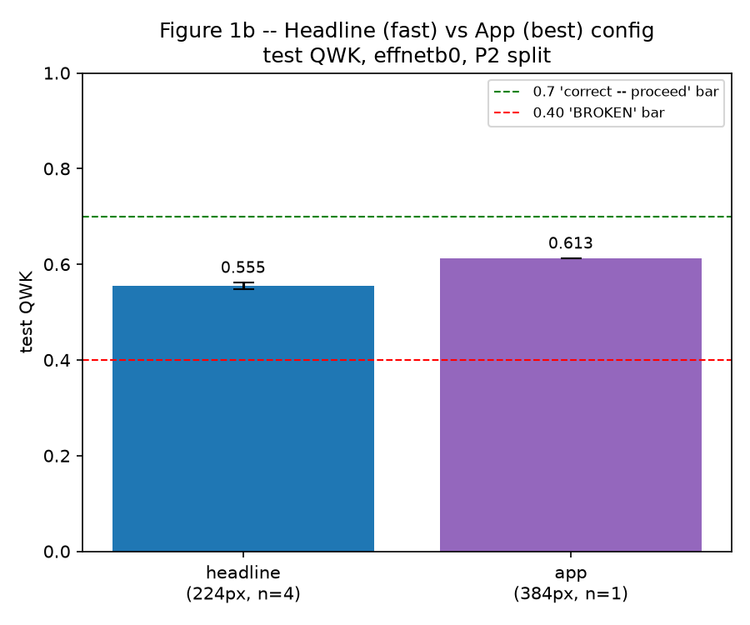
Figure 7. Headline (224px, fast config, n=4) vs. app (384px, best config, n=1) test QWK.
Every one of these five runs falls in the project's own "undertrained or preprocessing bug" acceptance-test band (QWK 0.40–0.70, against a 0.70–0.85 "correct — proceed" target). Section 4 discusses why the most likely explanation is a project-wide, resource-constrained training budget rather than a data or wiring bug: QWK increases predictably with a better configuration (higher resolution, more effective training) rather than moving unpredictably as a bug would, and this same shortfall against pre-registered targets appears in the frozen-feature Claim 2 results as well (Section 3.3), not only in fine-tuning. Grade-1 recall in these runs (4.5%–46.1% across configurations) is consistent with the project's own explicitly pre-accepted expectation that this specific grade is degraded by image downsampling and should not be chased.

4. Discussion

4.1 The actual shape of the results, versus the plan
The project plan anticipated Claims 1 and 2 (measurement and leakage consequence) as the paper's headline, with Claim 3 (the both-eyes fix) as a secondary, possibly-negative bonus result. The data delivered a different, but equally coherent, story: Claims 1 and 1b (measurement) are confirmed and sharpened beyond the original prediction; Claim 3 (the fix) is the strongest, most robust positive result in the project, holding significantly across three independent backbone/resolution configurations; and Claims 2 and 2b (the leakage consequence) returned a well-powered null result under both frozen-feature and fully fine-tuned evaluation. None of this is a failure of the study — the plan explicitly pre-registered a null outcome on 2/2b as an acceptable, reportable result, and it is what the evidence supports.

4.2 Why might Claims 2 and 2b be null?
Three explanations are worth weighing, and they are not mutually exclusive. First, even fully fine-tuned models here were trained for only 15 epochs on a single laptop GPU; if a model needs to memorize substantial patient-specific detail to exploit inter-eye similarity, a short training budget may simply not get there, in either direction — this would predict that a longer, better-resourced fine-tune might show a small positive leakage effect where this one does not, and the app-model's single run (higher-resolution, longer effective training) reaching a higher absolute QWK than the headline runs at least does not contradict that possibility, though it does not test it directly since the app model was only trained under P2. Second, the true magnitude of any leakage effect on this specific data and model family may simply be smaller than the 0.838 label-only ceiling suggests it could be — a ceiling establishes only what a shortcut is worth if fully exploited, not that any given model exploits it, and Claim 1's own framing said this explicitly in advance. Third, statistical power in the partner-eye ablation is limited by the size of the partner-absent group (n = 1,641 of 5,819 P1 test images); the ordinal head's p = 0.0505 sits close enough to conventional significance that a modestly larger test set could plausibly tip it either way. The honest conclusion is a well-powered, methodologically sound null result, not a proof that leakage cannot occur in this data under any model or training regime.

4.3 The absolute-QWK shortfall
Both fine-tuned runs and the frozen-feature Claim 2 experiments land below the project's own pre-registered target ranges. This is a project-wide pattern, not an isolated fine-tuning defect, and several observations argue against a data or wiring bug specifically: QWK scales predictably with configuration quality (224px → 0.555, 384px → 0.613, in the expected direction and roughly the expected magnitude for a resolution increase); the P3 EyePACS→APTOS direction met its pre-registered target while the reverse direction did not, consistent with a small-training-set explanation (3,111 images) rather than a systemic error; per-class recall patterns (strong on grade 0, weak on grade 1) match a well-understood, pre-anticipated cause — grade 1 is defined by roughly 10-pixel lesions that a 224–384px downsampled crop can plausibly destroy — rather than an arbitrary failure. The most likely explanation is a resource-constrained training budget: a single consumer laptop GPU, 15 training epochs, and batch sizes limited by 6 GB of VRAM, against pre-registered targets that assumed headroom for a longer or larger-scale training run. This is reported as an honest limitation. It does not undermine Claims 1, 1b, 2, 2b, or 3, all of which are comparative claims that hold at whatever absolute performance level a given configuration reaches, by design.

4.4 Practical implication
Independent of the leakage question, Claim 3's result is immediately actionable: any DR screening pipeline that already photographs both eyes — which is standard practice — can adopt mean-pooled bilateral feature grading with an ordinal head as a low-cost, architecture-agnostic improvement over grading each eye independently and keeping the worse result. The gain held across three different backbone/resolution feature spaces, which is the strongest evidence available in this report that the effect is a property of the both-eyes-jointly approach rather than an artifact of one particular network.

5. Limitations
- EyePACS labels are noisy and largely single-grader; no adjudicated or multi-grader consensus label is available for this analysis.
- APTOS has no patient or eye identifiers, so it is treated as unpaired single images throughout and is excluded from the two analyses (Claim 2b, Claim 3) that require a known partner eye.
- The inter-eye correlation is measured on one population — US teleretinal screening via EyePACS — and may not generalize to other screening populations or imaging protocols.
- Frozen-feature experiments likely underestimate absolute achievable performance; the project's design treats the comparative gaps between protocols, not absolute numbers, as the evidence for Claims 2 and 2b, and Section 3.5/4.2 discuss what the fine-tuned regime does and does not add to that picture.
- This report establishes that a shortcut ceiling exists (QWK 0.838) and directly tests whether P1-trained models, frozen or fine-tuned, exploit it; it does not find significant evidence that they do in this specific setup, and does not claim that any particular published paper exploits this shortcut — only that the mechanism and its ceiling are real and empirically testable.
- The app-configuration fine-tune (384px, best config) is a single run with no seed replicate; its reported gain over the headline configuration is a point estimate, not a statistically established effect.
- No prospective or clinical validation has been performed; every result here is a retrospective analysis on public benchmark data.
- Single-field, macula-centred fundus imaging can miss peripheral retinal lesions regardless of model performance.
- Calibration and a reject option, Grad-CAM interpretability figures, the deployable screening application, and a planned survey of public DR-grading repositories' split practice (Phases 7–9 of the project plan) are in progress and not covered by this report.

6. Conclusion
This report measures, at scale, the inter-eye correlation that motivates concern about patient-level data leakage in diabetic retinopathy grading (QWK 0.855, a result that survives stratification and refines to a single well-characterized failure mode at grade 1), directly tests whether that correlation translates into measurable leakage-driven score inflation under an image-level split — finding, across frozen-feature and two real fine-tuning regimes, no statistically significant evidence that it does — and demonstrates a robust, actionable fix for grading patients rather than eyes: mean-pooling both eyes' features with an ordinal head, which significantly outperforms the standard per-eye-then-worst approach across three independent model configurations. The null result on the leakage consequence is reported as genuinely informative, not as an unmet expectation: it was one of two outcomes the project explicitly planned for, and it narrows, rather than closes, the question of when and how patient-level leakage manifests in this domain. Phases 7 through 9 of the project — calibration and a reject option, the deployable screening application, and a survey of split practice across public DR-grading implementations — remain to complete the full study.

References
[1] EyePACS / California Healthcare Foundation. Diabetic Retinopathy Detection. Kaggle, 2015. https://www.kaggle.com/c/diabetic-retinopathy-detection
[2] Asia Pacific Tele-Ophthalmology Society (APTOS). APTOS 2019 Blindness Detection. Kaggle, 2019. https://www.kaggle.com/c/aptos2019-blindness-detection
[3] Wightman, R. PyTorch Image Models (timm). https://github.com/rwightman/pytorch-image-models
[4] Paszke, A. et al. PyTorch: An Imperative Style, High-Performance Deep Learning Library, 2019.

