Agentic Workflows for Medical LLMs: A Repeated-Measures Benchmark Reveals Reduced Reliability and Increased Iatrogenic Risk
Wanzhe Liao^{1†}, Haopeng Hong^{1†}, Shuai Zuo¹, Yongzhuo Liu¹, Jiaxu Zhao¹, Shanwen Chen¹, Pengyuan Wang^{1*}
¹ Department of Gastrointestinal Surgery, Peking University First Hospital, Beijing, China
†: W.Z.L. and H.P.H. contributed equally as co-first authors of this manuscript.
*: Correspondence: Pengyuan Wang, Department of Gastrointestinal Surgery, Peking University First Hospital, Beijing, China;
Email: Pengyuan Wang (pengyuan_wang@bjmu.edu.cn)
Abstract
Background: Large language models (LLMs) now achieve high scores on medical examinations, but most benchmarks report single-pass accuracy and under-specify trial-to-trial variability and induced-error risks. As agentic workflows (e.g., planning and self-critique) become common, it is crucial to test whether they improve reliability or amplify instability.
Methods: We conducted a repeated-measures benchmark of 11 LLMs on 165 questions from the 2025 Chinese national postgraduate entrance examination in Clinical Medicine Comprehensive Ability (CMCA; administered December 21, 2025). Each model was evaluated under two protocols: Baseline (direct prompting) and an Agentic Planner–Reasoner–Critic workflow, with five independent repeats per item per protocol (11×165×2×5=18, 150 responses). Reliability was quantified using Fleiss’ κ and answer entropy across repeats. We further introduced Agentic Iatrogenic Risk Analysis (AIRA) to decompose paired majority-vote outcome changes into rescues and iatrogenic flips.
Results: Baseline accuracy ranged from 75.6% to 93.9% across models. The agentic workflow did not yield systematic gains and reduced cohort mean accuracy by 2.53 percentage points (82.74%→80.21%). It also degraded reliability (median Δκ=−0.045) and increased uncertainty (median Δentropy=+0.069 bits). AIRA revealed a safety paradox: iatrogenic flips outnumbered rescues (102 vs 72; damage-to-rescue ratio=1.42; McNemar exact P =0.0276). Psychometric analysis showed more negatively discriminating items under the agentic protocol, suggesting that structured deliberation can alter item functioning and create “reasoning traps.”
Conclusion: In high-stakes medical QA, agentic workflows can trade accuracy for instability and may introduce net harm despite longer reasoning. Medical LLM evaluation should move beyond single-pass accuracy to repeated-measures auditing that reports reliability and induced-error risk.
Keywords: Agentic workflows; Medical large language models; Repeated-measures benchmarking; Iatrogenic risk
- Introduction
The integration of Large Language Models (LLMs) into the medical domain has transitioned from theoretical exploration to demonstrable proficiency. Flagship models, including GPT-4 and Med-PaLM, have successfully cleared the threshold of "expert-level" knowledge, achieving passing scores on high-stakes credentialing examinations such as the United States Medical Licensing Examination (USMLE) ^{1,2}. These milestones have fueled optimism regarding the deployment of LLMs for Clinical Decision Support (CDS). However, the translation of "exam-passing" performance into safe clinical practice is obstructed by a fundamental characteristic of generative AI: stochasticity. Unlike deterministic expert systems, LLMs are probabilistic engines subject to aleatoric uncertainty ³. A model that correctly diagnoses a complex pathology in one inference pass may provide contradictory or hallucinatory advice upon regeneration or trivial prompt perturbation. In high-stakes healthcare environments, where consistency is a prerequisite for trust, a "lucky guess" is indistinguishable from robust knowledge in a single-trial evaluation, yet the consequences of instability are profound ⁴.
Despite this critical concern, the prevailing ecosystem of medical AI evaluation—exemplified by benchmarks such as MedQA and MedMCQA—remains heavily oriented toward single-pass accuracy metrics ⁵. This approach treats models as deterministic databases, inherently masking the stability of their reasoning. It fails to distinguish between a model that is "robustly correct" (consistently reasoning from first principles) and one that is "luckily correct" (stumbling upon the right token within a high-entropy distribution). Furthermore, the field is rapidly pivoting toward Agentic Workflows—systems involving multi-step planning, Chain-of-Thought (CoT) reasoning, and self-correction—to enhance performance ⁶. While these agents often improve aggregate scores, they introduce opaque failure modes. An aggressive reasoning agent might "rescue" a wrong answer, but it may also over-complicate a previously correct baseline answer into an error—a phenomenon we term "iatrogenic error" (system-induced fault) ^{7,8}. Currently, we lack a unified framework to rigorously quantify this safety trade-off.
To bridge this gap, medical AI evaluation must adopt the rigorous "repeated measures" designs found in psychometrics and clinical reliability testing. This necessitates subjecting models to multiple independent inference trials for the same clinical scenario to quantify stability. By treating each independent trial as a virtual 'rater' and applying inter-rater reliability statistics—such as Fleiss’ κ—to a model’s own repeated outputs, researchers can distinguish true proficiency from statistical noise ⁹. Moreover, rigorous model comparison requires non-parametric statistical testing to move beyond simple mean comparisons, which can mislead when variance is high ¹⁰.
In this study, we present a reliability-focused benchmark evaluating 11 mainstream LLMs on 165 questions contained in the Clinical Medicine Comprehensive Ability Test 2025. We selected it for its structural rigor, vertically integrating basic sciences with clinical disciplines, and employing complex "exam-style" (Type B matching, Type X multiple-select) that impose strict penalties on partial hallucinations ^{11,12}. Our experimental design mandates 5 independent inference trials for every model-question pair across two distinct protocols: a Baseline (direct prompting) and an Agentic (multi-agent collaboration) workflow. This design enables us to move beyond static leaderboards to generate a dynamic "reliability profile" for each system.
- Methods and Materials
  - Study design
We conducted a repeated-measures benchmark to evaluate both accuracy and reliability of medical large language models (LLMs) under two inference protocols: (i) Baseline (single-shot direct prompting) and (ii) Agentic (multi-role orchestration: Planner–Reasoner–Critic). We evaluated 11 LLMs on 165 multiple-choice exam questions. For each model–question pair, we executed 5 independent trials per protocol (11 × 165 × 5 trials per protocol), enabling estimation of trial-to-trial variability. In reliability analyses, repeated generations were treated as virtual “raters”.
  - Benchmark dataset
The benchmark was constructed from the Chinese national postgraduate entrance examination in Clinical Medicine Comprehensive Ability (CMCA). The exam was administered on December 21, 2025. This strict temporal cutoff makes inclusion of the questions in pre-training corpora of the evaluated systems less likely, although post-exam dissemination cannot be fully excluded.
The dataset contains 165 items comprising: Type A: single-choice questions (Q1–Q115); Type B: matching questions with shared candidate options (Q116–Q135); and Type X: multiple-select questions (Q136–Q165). All prompts were kept in Chinese to match the original exam language. Some Type A questions share a common stem across a contiguous block, and each Type B group shares a common set of candidate options. For every evaluation call, we reconstructed the full item context by prepending the shared stem (when present) and attaching the shared option bank for Type B items. Gold standard answers (as gold labels) were compiled from reference answer keys provided by “YiKaoBang”, an authoritative med-exam-prep platform, with the reference answers rechecked by 2 senior doctors.
Questions were assigned to disciplines using a predefined index-to-discipline mapping (including Physiology/Biochemistry, Pathology, Internal Medicine, Surgery, and Ethics/Regulation) for aggregate analyses. We further grouped disciplines into basic sciences (Physiology/Biochemistry + Pathology) and clinical disciplines (Internal Medicine + Surgery), while keeping Ethics/Regulation separate.
  - Models and inference configuration
We evaluated 11 LLMs spanning proprietary and open-weight systems: Proprietary: “gemini-3-pro-preview”, “gpt-5.2”, “claude-opus-4.5”, “qwen3-max”; Open-weight: “deepseek-v3.2”, “kimi-k2-thinking”, “minimax-m2.1”, “qwen3-235b-a22b-thinking-2507”, “qwen3-30b-a3b-thinking-2507”, “gpt-oss-20b”, “gpt-oss-120b”. Models were accessed via APIs using a unified client. Depending on availability, requests were routed either through official provider endpoints or via OpenRouter (https://openrouter.ai/). We used OpenAI-compatible chat completion interfaces when supported and provider-specific formats otherwise. No external tools, web browsing, or retrieval were enabled during inference.
For all models and both protocols, we used “temperature=0.0” to eliminate controllable sampling noise, with other settings set default from the provider. Any remaining trial-to-trial variation, therefore, reflects system-level nondeterminism in real-world deployments, providing a practical lower bound on output instability.
Each request used a maximum output budget of 4096 tokens and a timeout of 600s, with up to 3 retries using exponential backoff for transient errors. Requests were executed asynchronously.
  - Baseline protocol (direct prompting)
Each question was formatted using a type-specific Chinese prompt instructing the model to return only the option letter(s) without explanation. Type A/B required a single letter (A–D); Type X required concatenation of all correct letters (2–4 letters). Each item corresponded to one model API call. We recorded raw responses, extracted predictions, correctness, and latency.
  - Agentic protocol (Planner–Reasoner–Critic)
The agentic protocol implemented a multi-role workflow intended to approximate structured peer review while isolating workflow effects: all roles used the same underlying LLM.
For each item, the workflow produced JSON-only outputs: 1. Planner: decomposed the problem and produced a compact plan JSON with the inferred domain, key facts, sub-questions, risk checks (contraindications/red flags), and answer type (single vs multiple); 2. Reasoner: generated a short list of high-level, auditable reasoning steps (≤ 6 items) and a “final_answer” field containing only option letter(s); 3. Critic: reviewed the plan and reasoning for internal consistency and constraint adherence; the Critic did not have access to gold labels.
We allowed at most two rounds. If the Critic rejected the first answer, its required-fix feedback was injected into the Reasoner for one revision. The final scored answer was the Reasoner’s “final_answer” from the last completed round.
  - JSON parsing and repair
We implemented a two-stage structured extraction pipeline for agent outputs. We first attempted to extract the first valid JSON object from the agent text (including stripping code fences and repairing common trailing-comma errors). If parsing failed, we optionally invoked an auxiliary JSON-repair model to convert the malformed text into a strict JSON object conforming to a fixed schema for the role.
To avoid data leakage, the JSON-repair prompt included only the malformed agent output and a schema example, excluding both the medical question content and gold labels. The repair model was used solely for syntactic repair and schema completion; failures were recorded.
  - Answer extraction, normalization, and scoring
For both baseline and agentic protocols, we extracted answer letters from either the parsed JSON “final_answer” field or the raw response using a regular-expression-based extractor. Answers were normalized by uppercasing, removing whitespace/punctuation, de-duplicating, and alphabetically sorting option letters (e.g., “C,A” → “AC”). All items were scored with strict exact match against the gold label set; multi-select items received no partial credit. API errors, parsing failures, or empty outputs were recorded and treated as incorrect.
  - Accuracy and uncertainty across repeated trials
Per trial, accuracy was the fraction of correct items among the 165 questions. We report mean accuracy across the five trials with a 95% t-interval (df=4):
$$\overline{x}±t_{0.975,4}⋅\frac{s}{\sqrt{5}}$$
where $x_{1}…x_{5}$ are per-trial accuracies, and $s$ is their sample standard deviation.
  - Self-consistency and output variability
Using the five repeated outputs per item, we quantified reliability via: 1. Fleiss’ κ (model-level self-consistency): treating the five trials as five raters assigning nominal categories to each item based on normalized answer strings; 2. Strict consistency rate: proportion of items for which all five normalized answers are identical; 3. Per-item Shannon entropy (bits): entropy of the empirical distribution over the five normalized answers for each (model, item); 4. Robust correct/robust wrong: items with 5/5 correct or 0/5 correct, respectively.
  - Latency
Latency was measured as client-side end-to-end wall-clock time (ms), including network transmission and any retries/backoff. Baseline latency corresponds to a single call per item, whereas agentic latency covers the full multi-step workflow (Planner, Reasoner, and Critic).
  - Multi-model comparisons
We tested for differences among models using Friedman’s test on the item-level score matrix, using per-item mean scores averaged across five trials. When significant ($p<0.05)$, we applied a Nemenyi post-hoc test ($α=0.05$) to compute the critical difference (CD) and identify the statistically best tier.
  - Cold-spot analysis
We defined baseline cold-spot items as questions whose baseline accuracy aggregated over all models and trials was <20%:
$$\text{ac}{\text{c}}_{\text{base}}\left(q\right)=\frac{\sum_{m}{\sum_{r}{1\left[\text{correct}\left(m,q,r\right)\right]}}}{N_{\text{models}} N_{\text{trials}}}.$$
For each cold-spot item, we compared baseline vs agentic performance using a paired Wilcoxon signed-rank test across models (each model contributed its mean accuracy over five trials per protocol for that item). We controlled per-item false discovery using Benjamini–Hochberg FDR (BH-FDR) across cold-spot items. We also assessed set-level improvement by comparing each model’s mean accuracy over the cold-spot set between protocols using a paired Wilcoxon test across models.
  - Safety trade-off analysis
We operationalized agentic safety trade-offs via Agentic Iatrogenic Risk Analysis (AIRA) using majority-vote correctness (≥3/5). Transitions from Baseline to Agentic were categorized as: 1→1 Retained Mastery; 1→0 Iatrogenic Error; 0→1 Effective Rescue; and 0→0 Refractory Error. At the aggregate level, we applied McNemar’s exact test to paired majority-vote outcomes, contrasting iatrogenic errors (1→0) against rescues (0→1). For descriptive reporting, we additionally derived per-model indices (safety index, rescue index, and damage-to-rescue ratio).
  - Psychometric validation
To place item difficulty and model ability on a common scale, we fit a 1-Parameter Logistic (1PL) Rasch item response theory (IRT) model to the binary response matrix, treating each model-trial instance as a “person” (N = 55) and each question as an “item” (N = 165). Model ability $\left(θ\right)$ and difficulty $(b)$ were estimated with joint maximum likelihood and an identifiability constraint (mean item difficulty centered at 0). Additionally, under Classical Test Theory (CTT), we computed per-item difficulty (as item easiness, P) and per-item discrimination using the point-biserial correlation ($r_{pbs}$) between item correctness and the total score (excluding the item itself). This dual approach allows us to diagnose whether performance shifts arise from changes in latent ability or item discrimination degradation.
  - Implementation and reproducibility
All experiments were implemented in Python with asynchronous I/O. All source codes have been uploaded to https://github.com/Wanzhe-Liao/LLM-Benchmarks-on-Clinical-Medicine-Examination, which is publicly available. The benchmark contains no patient-identifiable data and therefore does not constitute human-subject research.
- Results
We evaluated 11 LLMs on the CMCA 165-item benchmark under two protocols: Baseline (direct prompting) and Agentic (Planner–Reasoner–Critic). For each model–protocol pair, we conducted five independent inference trials covering all 165 items, yielding 18,150 model–question evaluations (11 models × 165 items × 5 trials × 2 protocols). We first characterize the baseline performance profile, followed by the agentic profile, and finally quantify the net clinical impact of the agentic intervention.
  - Baseline benchmark profile
Performance stratification: Across the 11 models, baseline mean accuracy (averaged over five trials) ranged from 75.64% to 93.94% (Fig. 1A; Table 1). Gemini 3 Pro Preview achieved the highest accuracy (93.94%) with perfect stability (95% CI half-width = 0.00%), whereas GPT OSS 120B achieved the lowest accuracy (75.64%) with observable variability (95% CI half-width = 0.63%). Friedman’s test confirmed that performance differences among models were statistically significant (χ²(10) = 100.566, P = 4.2×10⁻¹⁷). Nemenyi post-hoc analysis yielded a critical difference of 1.175, supporting clear tier separation beyond simple mean ranking (Supplementary Fig. S1).
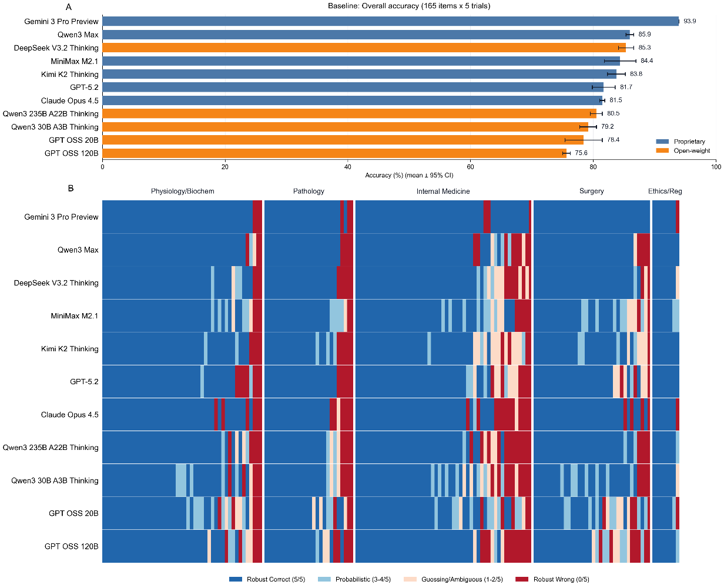
Fig. 1. Baseline benchmark profile. (A) Overall accuracy by model (mean +/- 95% CI across 5 trials; 165 items per trial). Bars are colored by model availability (proprietary vs open-weight), and models are ordered by mean accuracy. (B) Model-item stability map under the baseline protocol. Each cell summarizes the number of correct trials for a given model-question pair (0-5) using four discrete categories: robust correct (5/5), probabilistic (3-4/5), guessing/ambiguous (1-2/5), and robust wrong (0/5). Questions are grouped by discipline and sorted within each discipline from easier to harder based on the across-model mean correct count.
Model | Accuracy (%, mean±95% CI) | Fleiss’s κ | Entropy (bits) | Consistency (%) | Wrong 0/5 (n) | Clin-Basic (pp)
Gemini 3 Pro Preview | 93.94±0.00 | 1 | 0 | 100 | 10 | 4.8
Qwen3 Max | 85.94±0.63 | 0.953 | 0.069 | 92.73 | 19 | -6.77
DeepSeek V3.2 Thinking | 85.33±1.24 | 0.932 | 0.099 | 89.09 | 16 | -3.42
MiniMax M2.1 | 84.36±2.57 | 0.845 | 0.22 | 75.15 | 12 | -3.99
Kimi K2 Thinking | 83.76±1.45 | 0.879 | 0.182 | 81.82 | 14 | -4.85
GPT-5.2 | 81.70±1.87 | 0.924 | 0.109 | 87.88 | 21 | -3.72
Claude Opus 4.5 | 81.45±0.41 | 0.987 | 0.018 | 98.18 | 29 | -2.5
Qwen3 235B A22B Thinking | 80.48±0.98 | 0.932 | 0.095 | 88.48 | 25 | -4.06
Qwen3 30B A3B Thinking | 79.15±1.37 | 0.852 | 0.216 | 74.55 | 22 | -6.42
GPT OSS 20B | 78.42±3.04 | 0.792 | 0.314 | 69.7 | 18 | -0.45
GPT OSS 120B | 75.64±0.63 | 0.896 | 0.145 | 83.03 | 28 | -9.37
Table 1. Baseline model summary metrics on the 165-item CMCA benchmark. Each model was evaluated under the baseline workflow with five independent repeats covering all 165 items. Models are ordered by mean accuracy.
Reliability and uncertainty: Accuracy metrics alone masked substantial instability. While top-tier models were consistent, broader analysis showed Fleiss’ κ ranging from 0.792 to 1.000, and mean output entropy from 0.000 to 0.314 bits (Supplementary Fig. S2 and S4; Table 1). Across models, 95% CI half-widths ranged from 0.00% to 3.04%, strict answer consistency from 69.70% to 100%, and stable-wrong items (0/5 correct) from 10 to 29 per model (Table 1).
Domain and item-level diagnosis: Stratification by medical discipline revealed systematic imbalances. The accuracy gap between Clinical disciplines and Basic Sciences ranged from -9.37 to +4.80 percentage points (Supplementary Fig. S3; Table 1). Item-level stability maps identified shared blind spots: five items were universally failed by all models in all trials (Absolute cold spots: items 7, 9, 35, 39, 42; Fig. 1B). Within this set, items 7, 9, and 39 exhibited a “confident failure” pattern across all models (entropy = 0 and 0/5 correct), indicating universal and highly stable misconceptions (Supplementary Fig. S4 and S7).
  - Agentic benchmark profile
Performance shifts: Under the agentic workflow, mean accuracy ranged from 70.42% to 90.30% (Fig. 2A; Table 2). Gemini 3 Pro Preview remained top-ranked (90.30%; 95% CI half-width = 0.00%), while GPT OSS 20B dropped to the lowest rank (70.42%) with increased instability (95% CI half-width = 1.54%). Model distinctions remained statistically robust under agentic evaluation (Friedman χ²(10) = 111.798, p = 2.31×10⁻¹⁹), with the same Nemenyi CD of 1.175 (k = 11, N = 165, α = 0.05), confirming that the benchmark continues to effectively separate model tiers even after workflow intervention (Supplementary Fig. S1).
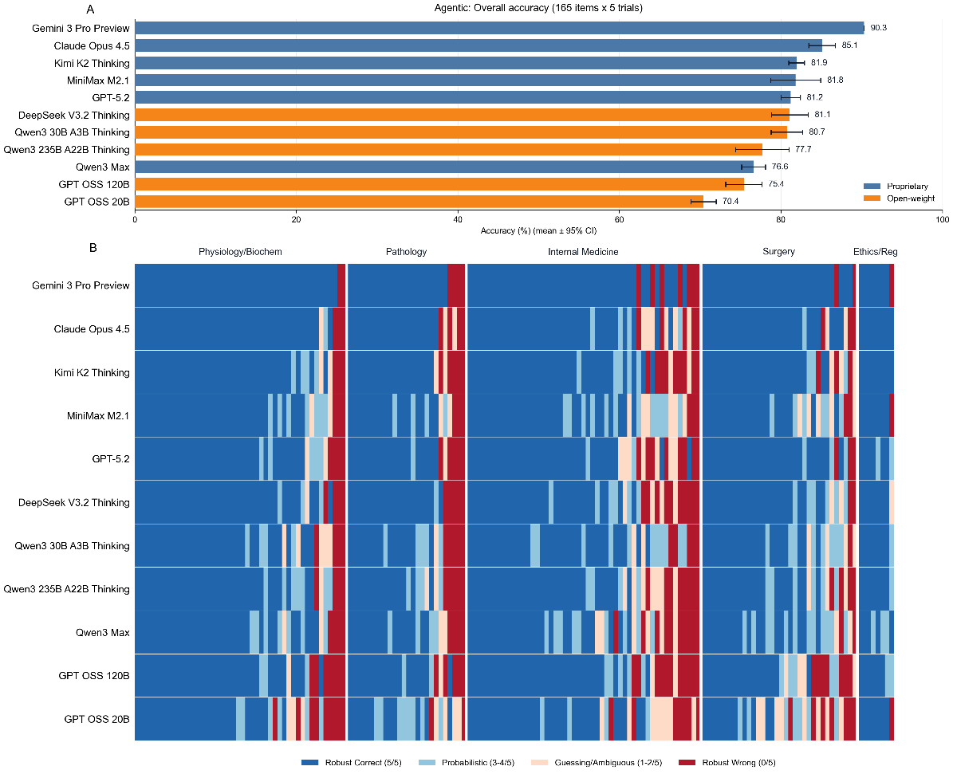
Fig. 2. Agentic benchmark profile (Planner-Reasoner-Critic workflow). (A) Overall accuracy by model (mean +/- 95% CI across 5 trials; 165 items per trial) under the agentic protocol; colors and ordering follow Fig. 1A. (B) Model-item stability map under the agentic protocol, using the same four-category encoding as Fig. 1B. Questions are grouped by discipline and sorted within each discipline from easier to harder based on the across-model mean correct count under the agentic protocol; models are ordered identically to Panel A.
Model | Accuracy (%, mean±95% CI) | Fleiss’s κ | Entropy (bits) | Consistency (%) | Wrong 0/5 (n) | Clin-Basic (pp)
Gemini 3 Pro Preview | 90.30±0.00 | 0.997 | 0.004 | 99.39 | 16 | -2.25
Claude Opus 4.5 | 85.09±1.65 | 0.925 | 0.104 | 88.48 | 15 | -5.85
Kimi K2 Thinking | 81.94±0.98 | 0.894 | 0.153 | 83.03 | 20 | -4.79
MiniMax M2.1 | 81.82±3.10 | 0.8 | 0.304 | 70.91 | 12 | -5.9
GPT-5.2 | 81.21±1.19 | 0.889 | 0.16 | 83.03 | 20 | -2.93
DeepSeek V3.2 Thinking | 81.09±2.28 | 0.879 | 0.177 | 80.61 | 21 | -7.55
Qwen3 30B A3B Thinking | 80.73±1.95 | 0.833 | 0.244 | 73.33 | 15 | 2.33
Qwen3 235B A22B Thinking | 77.70±3.30 | 0.855 | 0.214 | 76.36 | 21 | -6.91
Qwen3 Max | 76.61±1.47 | 0.798 | 0.303 | 66.67 | 20 | -8.79
GPT OSS 120B | 75.39±2.23 | 0.853 | 0.213 | 76.97 | 30 | -10.12
GPT OSS 20B | 70.42±1.54 | 0.739 | 0.383 | 61.82 | 26 | -5.95
Table 2. Agentic model summary metrics on the 165-item CMCA benchmark. Each model was evaluated under the agentic workflow (Planner-Reasoner-Critic) with five independent repeats covering all 165 items. Models are ordered by mean accuracy.
Instability amplification: Contrary to the expectation that reasoning stabilizes output, the agentic workflow degraded reliability for multiple models. Fleiss’ κ values dispersed to a range of 0.739 to 0.997 and mean entropy from 0.004 to 0.383 bits (Supplementary Fig. S2 and S4; Table 2). At the cohort level, the agentic intervention was associated with a median decrease in self-consistency (Δκ = -0.045) and a median increase in uncertainty (ΔEntropy = +0.069 bits). Strict answer consistency dropped as low as 61.82%, reflecting the accumulation of stochasticity across multi-step reasoning chains (Table 2)
Emergent blind spots: Item-level diagnosis revealed that while three Absolute Cold Spots (Items 9, 35, 42) persisted from the baseline, item 137 emerged as new, agentic specific absolute blind spot (Fig. 2B, Supplementary Fig. S7). Crucially, item 137 transitioned to a "Confident Failure" mode (0/5 correct, entropy = 0) under the agentic protocol, suggesting that the workflow actively reinforced an incorrect reasoning path for this specific case (Supplementary Fig. S4).
  - Impact of the agentic workflow
We quantified the net clinical impact of the agentic workflow by treating it as an intervention and analyzing paired outcomes (Fig. 3)
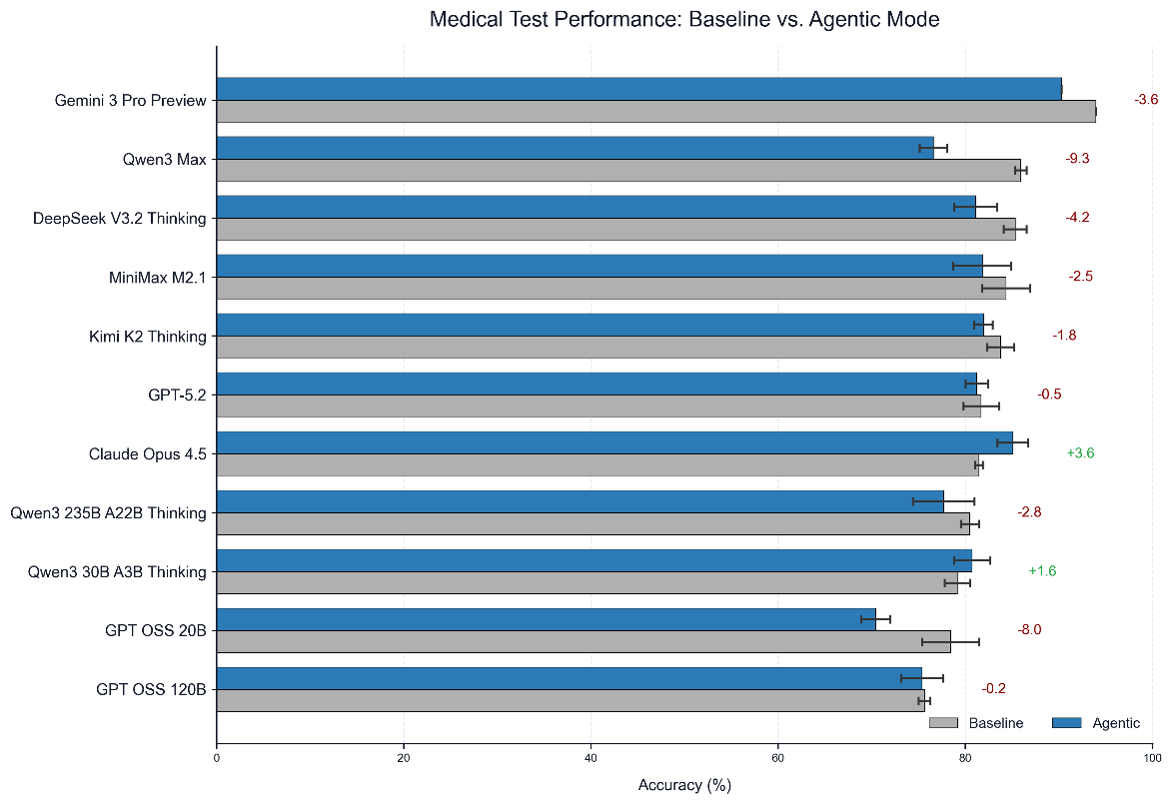
Fig. 3. Overall performance change from baseline to agentic evaluation. For each model, mean accuracy (+/- 95% CI across 5 trials) is shown for baseline (gray) and agentic (blue) protocols. Right-side annotations report the paired difference (agentic - baseline) in percentage points.
The impact of the agentic workflow was highly heterogeneous and predominantly deleterious. Averaged across the cohort, global mean accuracy declined from 82.74% (Baseline) to 80.21% (Agentic), a net shift of -2.53 percentage points. Only 2 of 11 models achieved performance gains, (Claude Opus 4.5: +3.64 percentage points(pp); Qwen3 30B A3B Thinking: +1.58 pp), while 9 models suffered regression. The largest degradations were observed for Qwen3 Max (-9.33 pp) and GPT OSS 20B (-8.00 pp). These shifts resulted in substantial rank re-ordering (Fig. 5). Latency–accuracy trade-offs (Pareto frontiers) under baseline and agentic protocols are shown in Supplementary Fig. S6.
We applied the AIRA framework to mechanistically decompose these shifts (using majority-vote correctness ≥3/5). While the majority of responses remained stable (Retained mastery 1→1: N = 1406; Refractory error 0→0: N = 235), the agentic workflow introduced significantly more Iatrogenic Errors (Correct → Wrong: N = 102) than Effective Rescues (Wrong → Correct: N = 72) (damage-to-rescue ratio = 1.42; Fig. 4). McNemar’s exact test confirmed a significant asymmetry (P = 0.0276), corresponding to a net loss of 30 majority-correct model-item units and a decrease in global majority-vote accuracy from 83.09% to 81.43% (-1.65 pp). Changes in stability-category distributions are summarized in Supplementary Fig. S5.
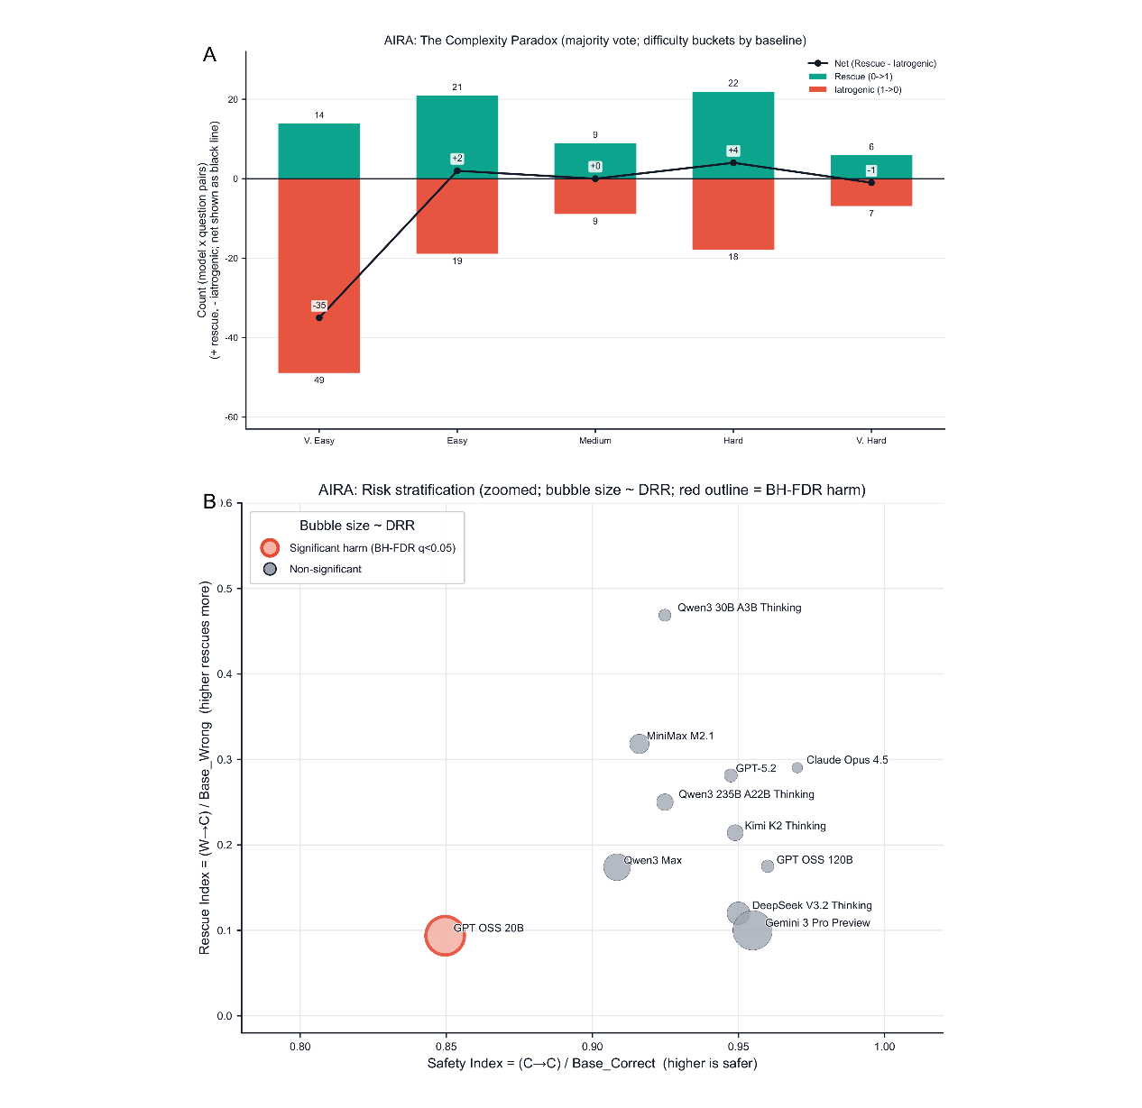
Fig. 4. Agentic Iatrogenic Risk Analysis (AIRA): mechanism and risk stratification. (A) Transition "butterfly" plot summarizing majority-vote correctness transitions from baseline to agentic evaluation, stratified by baseline item difficulty. For each model-item unit, majority correctness is defined as having at least 3 out of 5 trials correct. The plot displays rescue and iatrogenic counts with a net line (rescue - iatrogenic). Baseline difficulty bins are defined by the fraction of models that are majority-correct for an item under baseline (≥80%, 60-80%, 40-60%, 20-40%, <20%). (B) Model-level safety-efficacy trade-off. The Safety Index is the fraction of baseline-majority-correct items that remain majority-correct under agentic evaluation (C→C / Base_Correct). The Rescue Index is the fraction of baseline-majority-wrong items that become majority-correct under agentic evaluation (W→C / Base_Wrong). Bubble size is proportional to the damage-to-rescue ratio, and a red outline indicates statistically significant net harm by McNemar's exact test with Benjamini-Hochberg FDR correction across models (q<0.05).
For model-specific safety, at the individual model level, GPT OSS 20B exhibited a significant negative intervention effect after BH-FDR correction (iatrogenic = 20 vs rescue = 3; P = 4.88×10⁻⁴; q = 5.37×10⁻³). Qwen3 Max showed a nominally negative effect (iatrogenic = 13 vs rescue = 4; p = 0.049) that did not remain significant after correction (q = 0.258). Conversely, while improving models like Claude Opus 4.5 showed favorable trends (9 rescues vs. 4 iatrogenic), these effects did not reach statistical significance after FDR correction.
Refractory cold spots were also of concern. Finally, we assessed whether the agentic workflow could resolve the hardest baseline failures. For the set of 10 Baseline Cold Spot items (accuracy <20%), mean accuracy marginally increased from 5.27% to 6.55% (+1.27 pp). This improvement was not statistically significant (Wilcoxon signed-rank P = 0.281). No individual cold-spot item showed statistically significant improvement after multiple hypothesis correction (all q ≥ 0.312). Notably, absolute cold spots (items 9, 35, 42) remained completely unrecovered (0% accuracy) under the agentic protocol, indicating that the reasoning workflow was insufficient to bridge fundamental knowledge gaps in refractory exam items (Fig. 5).
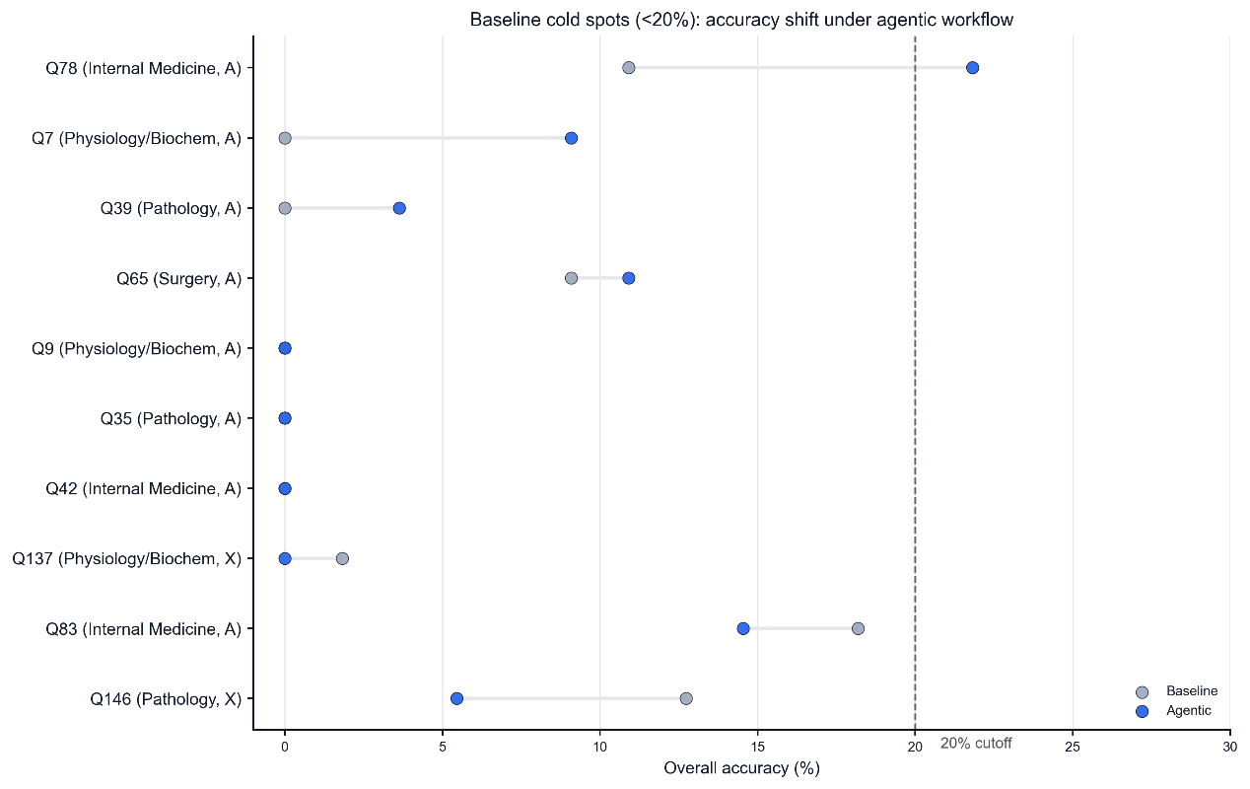
Fig. 5. Baseline-defined cold-spot items and agentic "rescue" analysis. Dumbbell plot of per-item overall accuracy for baseline-defined cold spots (baseline overall accuracy <20% across all model x trial responses). Each row corresponds to one cold-spot item (labeled by question ID, discipline, and question type), with baseline (gray) and agentic (blue) overall accuracies connected by a line; the dashed vertical line marks the 20% cutoff. Items are ordered by agentic improvement (delta accuracy, percentage points).
  - Psychometric Validation
To diagnose the structural causes of performance shifts, we applied psychometric modeling.
The 1PL Rasch model mapped model ability ($θ$) and item difficulty ($b$) onto a shared logit scale (Rasch Wright Maps, Fig. 6). Under both protocols, the item difficulty distribution was skewed toward lower difficulty with a long tail of hard items ($b$ range: -2.36 to 6.07). Crucially, the distribution of model abilities was centered significantly higher than item difficulties, indicating a ceiling effect where the exam discriminates poorly among top-tier models. Furthermore, the mean model ability shifted downward from $θ$ = 3.30 (Baseline) to $θ$ = 2.85 (Agentic), confirming that the workflow intervention systematically suppressed latent proficiency across the cohort.
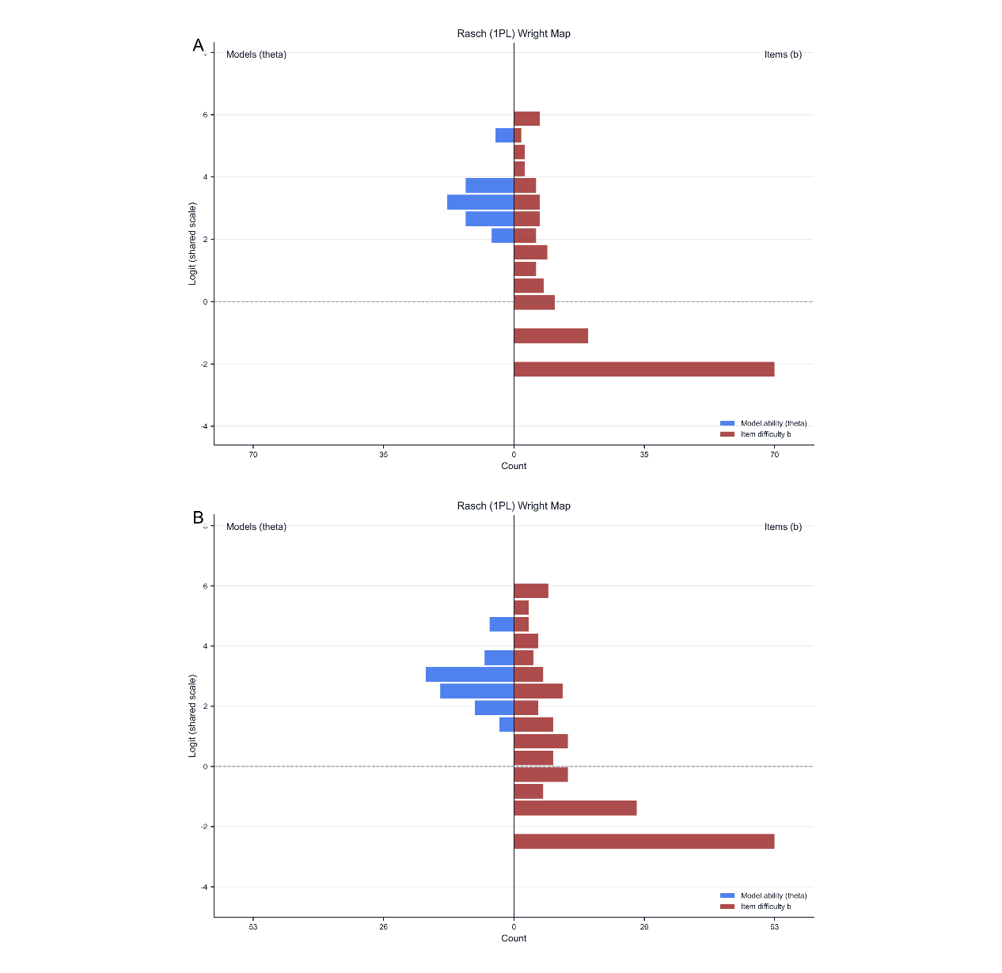
Fig. 6. Rasch (1PL) Wright maps for baseline vs agentic protocols. Rasch (1-parameter logistic) person-item maps showing the distributions of estimated model ability (theta; left histogram) and item difficulty (b; right histogram) on a shared logit scale. "Persons" correspond to model-by-trial instances (11 models x 5 trials), and items correspond to the 165 questions. Panel A: baseline; Panel B: agentic.
CTT analysis revealed a deterioration in item quality under the agentic workflow. While baseline discrimination (point-biserial $r$) ranged from -0.52 to 0.73, the agentic protocol significantly increased the number of items exhibiting negative discrimination ($r$ < 0) from 9 to 19 (Fig. 7). A negative discrimination index implies that higher-performing models were paradoxically more likely to miss these items than lower-performing ones. This suggests that for specific items, the agentic workflow acted as a confounder, effectively transforming valid questions into "reasoning traps" that penalized capable models. Additionally, the number of refractory items (accuracy < 20%) increased from 10 to 13, reinforcing that agentic reasoning failed to breach the hardest content barriers.
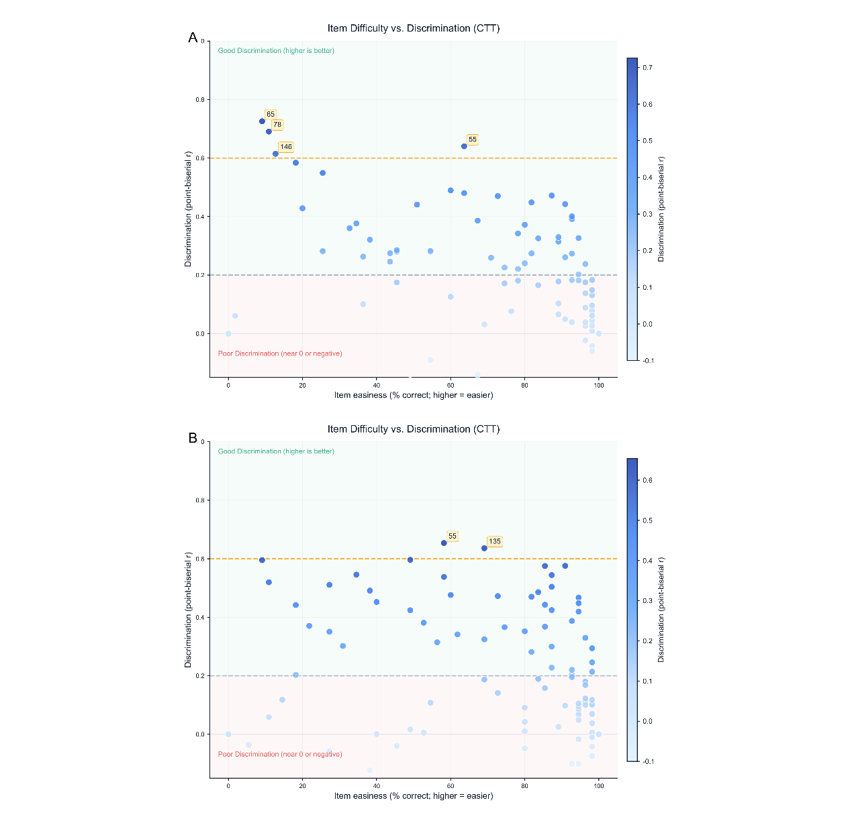
Fig. 7. Classical test theory (CTT) item difficulty vs discrimination. Scatter plots of item easiness (x-axis, % correct across model-by-trial persons) versus discrimination (y-axis, point-biserial correlation between the item score and the total score excluding that item). Point color encodes discrimination. Dashed horizontal reference lines mark r=0.2 and r=0.6. Panel A: baseline; Panel B: agentic.
- Discussion
Agentic workflows are increasingly positioned as a practical route from “exam-passing” LLMs to clinically useful systems, yet our results highlight a central reliability paradox: adding structured deliberation can reduce both performance and safety. In a repeated-measures benchmark on a contemporary, high-stakes medical examination, the Planner–Reasoner–Critic protocol decreased cohort mean accuracy by 2.53 percentage points (82.74% to 80.21%), increased uncertainty (median Δentropy = +0.069 bits), reduced self-consistency (median Δκ = −0.045), and—most importantly—introduced more iatrogenic errors than effective rescues (damage-to-rescue ratio 1.42; McNemar P = 0.0276). These findings refine the current enthusiasm for “more reasoning” in clinical AI and argue for a safety-first evaluation stance in which reliability under repetition is treated as a co-primary endpoint alongside accuracy.
Prior work has established that frontier LLMs can perform impressively on medical exams and related knowledge assessments, motivating downstream clinical decision support proposals and educational use cases ^{13,14}. Our paired protocol comparison suggests that a workflow upgrade should be treated as a clinical-style intervention: it can rescue errors, but it can also cause harm. The AIRA decomposition makes this explicit by tracking transitions at the model–item level. In our cohort, the agentic workflow produced substantially more iatrogenic reversals than rescues, and this asymmetry remained statistically significant at the aggregate level. This pattern aligns with established lessons from safety-critical domains: an assistive system that occasionally “overrides” correct decisions with incorrect ones can be net harmful even if mean accuracy changes appear small ^{15–17}. In medical decision-making, where the cost of an introduced error may outweigh the benefit of an occasional correction, the damage-to-rescue ratio provides a natural safety metric for workflow selection and deployment gating.
Two additional observations sharpen the clinical interpretation. First, the intervention effect was heterogeneous, with some models benefiting while others deteriorated sharply, including a BH-FDR significant harm signal in GPT OSS 20B. This heterogeneity cautions against treating “agentic prompting” as model-agnostic best practice and motivates model-specific safety profiling before deployment. Second, item-level analysis revealed both persistent “absolute cold spots” and a new agentic-specific cold spot (item 137) that became a cohort-wide “confident failure” (entropy = 0; 0/5 correct). Stable-but-wrong behavior is particularly dangerous in clinical settings because it can appear trustworthy to users and downstream systems; low entropy should not be interpreted as robustness unless it aligns with correctness ^{18–21}. Notably, three shared absolute cold spots (items 9, 35, 42) remained unrecovered at 0% under both protocols, and the cold-spot set improved only marginally and not significantly, underscoring that workflow-only “reasoning” is insufficient to bridge certain refractory content gaps.
Why variability persists at temperature = 0, and why agentic chains amplify it? All runs were performed at temperature = 0.0, yet we still observed trial-to-trial variation across multiple models, and this nondeterminism increased under the agentic workflow. This has two implications for clinical translation.
First, any observed instability under temperature = 0.0 should be interpreted as a lower bound on deployment-time variability. Real-world deployment introduces additional sources of variability beyond the controlled benchmark setting, which can further widen output distributions ²². Second, multi-step agentic pipelines can amplify residual nondeterminism because they increase the number of stochastic “decision points” (planning, intermediate reasoning, critique, and revision). Even if each individual call is mostly stable, chaining multiple calls multiplies the opportunities for small perturbations to cascade into different—and sometimes confidently wrong—final answers ^{23–25}.
Mechanistically, several factors likely contribute. Contemporary frontier systems often use complex inference stacks and, in some cases, sparse routing (e.g., mixture-of-experts architectures), where small upstream differences can alter internal computation paths ²⁶. Longer and more structured multi-step generations can increase exposure to hallucination modes and self-reinforcement dynamics, particularly when the workflow relies on internally generated intermediate rationales and self-critique without external verification ^{18,24,25}. In our study, the “Critic” role used the same underlying model and had no access to ground truth; as a result, critique can fail to detect plausible but incorrect rationales and may even stabilize them (as suggested by the agentic-specific confident failure in item 137). This distinction-deliberation without verification-is crucial in medicine: accuracy improvements from reasoning-style prompting in other domains do not guarantee safety gains when errors are subtle, knowledge is incomplete, and external checking is absent ^{24,27,28}.
Psychometric analysis provides an additional lens on how agentic workflows can degrade performance. The Rasch results indicate a downward shift in latent ability (θ = 3.30 to 2.85) under the agentic protocol, consistent with systematic suppression of proficiency rather than random fluctuation; the Wright maps further suggest a ceiling effect in which many items are too easy to cleanly separate top-tier systems, potentially obscuring safety-relevant variance among high-accuracy models. Classical Test Theory further showed that the number of negatively discriminating items increased from 9 to 19 under agentic evaluation. Negative discrimination means higher-performing models are paradoxically more likely to miss an item than lower-performing models, which is an archetypal signature of a confounder that changes how the test functions. In our setting, the confounder is plausibly the workflow itself: a structured reasoning scaffold can turn otherwise well-posed questions into “reasoning traps” that invite over-elaboration, spurious differential diagnosis, or overfitting to irrelevant cues.
This failure mode echoes well-characterized patterns in human diagnostic cognition. Clinicians are vulnerable to cognitive errors and overconfidence, and forcing strategies are often proposed to reduce these failures; however, additional deliberation can also introduce new errors when it triggers inappropriate hypothesis generation or confirmation ^{21,29}. Agentic LLM workflows may similarly shift the error profile: rather than “thinking harder” in a beneficial way, the system can generate a plausible but incorrect narrative and then become anchored to it. The result is not merely wrong answers, but wrong answers with increased coherence and stability-an especially risky outcome for clinical decision support, where users calibrate trust based on consistency and apparent rationale quality ^{15–17}.
Our findings argue for a change in what constitutes “sufficient” evidence for clinical readiness. Benchmark leaderboards that report only single-pass accuracy can hide clinically meaningful instability and can mischaracterize interventions whose harms are concentrated in iatrogenic flips (1→0) rather than uniformly distributed noise. Even broader evaluation frameworks and benchmark suites (e.g., HELM, MMLU) typically emphasize breadth over repeated-measures reliability, leaving stability under repetition under-specified for safety-critical deployment decisions ^{30,31}. A repeated-measures design, treating independent trials as virtual raters, directly supports reliability reporting and aligns with standard practices in safety—critical evaluation, where variance and tail risks matter ²². In the broader machine learning community, attention to variance and replication has repeatedly shown that point estimates can be misleading without repeated runs and uncertainty accounting ²².
For clinical AI specifically, reporting and evaluation guidance is rapidly evolving. While CONSORT-AI and SPIRIT-AI target clinical trials ^{32,33}, and DECIDE-AI targets early-stage clinical evaluation of AI decision support systems ³⁴, all emphasize transparency about study design, endpoints, and failure modes. We suggest that benchmark studies of medical LLM workflows adopt analogous reporting elements: (i) repeated-measures protocols as a default for high-stakes tasks; (ii) explicit safety accounting of intervention effects (e.g., iatrogenic vs rescue transitions); and (iii) item-level diagnostics that identify refractory errors and “confident failure” clusters for targeted mitigation. Similarly, TRIPOD and PROBAST—originally designed for prediction models—offer a useful vocabulary for reporting and assessing bias, applicability, and evaluation rigor that can be adapted to generative medical systems and their workflows ^{35,36}.
Transparency artifacts developed for general AI can also strengthen medical LLM governance. Model Cards and Datasheets encourage disclosure of intended use, limitations, and evaluation settings, which is particularly important when results vary across protocols and models ^{37,38}. Human-AI interaction guidance further suggests that systems should be designed to support appropriate user reliance rather than maximizing automation by default ³⁹. In this light, AIRA-style metrics can be operationalized as “appropriate reliance” indicators: a workflow whose damage-to-rescue ratio exceeds 1.0 should not be enabled by default in clinical settings, even if it occasionally improves performance on difficult items.
The net-negative safety profile of agentic reasoning in our setting should not be read as an argument against agentic systems per se, but as evidence that verification and control must be first-class design goals. Three concrete directions follow: 1. Add external verification pathways, tool-using and retrieval-augmented approaches can ground answers in verifiable sources and may be necessary to address refractory cold spots that persist across prompting strategies ^{23,25,27,28}. Retrieval-augmented pretraining and generation provide a blueprint for integrating external checks rather than relying solely on self-critique ^{27,28}. Importantly, verification should target both correctness and stability: detecting when a workflow has stabilized an incorrect rationale may require cross-checking against trusted references or structured medical knowledge bases. 2. Use selective activation rather than universal agentic prompting. Agentic workflows should be triggered conditionally—e.g., for items where baseline uncertainty is high, or where retrieval indicates insufficient evidence—rather than applied indiscriminately. Modern uncertainty estimation methods (ensembles, Bayesian approximations, calibration) can support such gating, and evaluation under dataset shift should be routine given the distributional variability of clinical inputs ^{40–44}. The key principle is “do no harm”: do not apply a complex workflow to a case where the baseline is already robust and correct if the workflow introduces a nontrivial risk of iatrogenic reversal. 3. Separate roles and diversify critics. Using the same model for Planner, Reasoner, and Critic may encourage correlated errors and confirmation bias. The broader LLM agent literature emphasizes role specialization and multi-agent compositions ²³. In medical contexts, “critique” should ideally be performed by a genuinely independent verifier (a different model family, a tool-enabled checker, or a constrained rule-based validator), not a re-prompted instance of the same system that produced the initial rationale.
This study has limitations. The CMCA benchmark is a multiple-choice examination and cannot fully capture the interactive, multimodal, and context-rich nature of real clinical practice. The evaluation was conducted in Chinese, and language-specific tokenization and medical terminology may influence both performance and stability. Although the exam date reduces the likelihood of training-set leakage, it does not eliminate the possibility of post-exam contamination, which remains a known concern for large models trained on broad web corpora ⁴⁵. Finally, our agentic workflow represents one design point (Planner–Reasoner–Critic, same underlying model, no external tools); alternative agentic designs and verification-augmented systems may shift the harm–benefit profile.
Future work should therefore test: 1. verification-augmented agents (retrieval/tool use with auditable checks); 2. uncertainty-aware gating policies that minimize iatrogenic flips; 3. protocol robustness across languages and clinical subdomains; and 4. prospective evaluations where clinician behavior and trust calibration are measured alongside correctness. In parallel, benchmarking practices should increasingly align with medical reporting standards and safety governance principles, including explicit documentation of model updates, evaluation variance, and failure modes ⁴⁶.
- Conclusion
In summary, our repeated-measures evaluation indicates that agentic workflows can impose a “reliability tax” in medical exam settings—decreasing accuracy, reducing self-consistency, and introducing iatrogenic errors that outweigh rescues. The persistence of nondeterminism at temperature = 0.0 implies that observed instability is a practical lower bound for deployment, and multi-step pipelines may amplify this variability. For clinical translation, the key message is not that reasoning is futile, but that deliberation without verification and safety accounting is insufficient. Medical LLM evaluation should therefore move beyond single-pass accuracy to incorporate repeated-measures reliability, explicit iatrogenic risk quantification, and reporting practices aligned with clinical AI governance.

Generative AI use statement
The authors declare that no generative AI or AI-assisted technologies were used to write, revise, or language-edit this manuscript. Large language models were accessed via APIs solely as experimental systems to generate benchmark responses under the protocols described in the Methods. The authors take full responsibility for the content of this publication.
Author Contributions
Wanzhe Liao and Haopeng Hong: Conceptualization, Methodology, Software, Formal analysis, Visualization, Writing—original draft. Shuai Zuo, Yongzhuo Liu, Jiaxu Zhao, and Shanwen Chen: Investigation, Data curation, Validation, Writing—review & editing. Pengyuan Wang: Conceptualization, Supervision, Project administration, Funding acquisition, Writing—review & editing. Wanzhe Liao and Haopeng Hong contributed equally to this work. All authors read and approved the final manuscript.
Data Availability
Source codes of the study were available in https://github.com/Wanzhe-Liao/LLM-Benchmarks-on-Clinical-Medicine-Examination. Detailed information will be available upon request, please contact pengyuan_wang@bjmu.edu.cn.
Ethical approval
No ethics approval was needed because the benchmark on CMCA contains no patient-identifiable data
Declaration of Competing Interest
The authors declare no conflicts of interest.
Funding
This study is funded by: 1. the National Natural Science Foundation of China (T2541067), 2. Joint Research Project of the Shijiazhuang-Peking University Cooperation Program; 3. Capital’s Funds for Health Improvement and Research (2024-4-40711); and 4. Beijing Natural Science Foundation (7262129); 5. Michigan Medicine-PKUHSC Joint Institute for Translational and Clinical Research; 6. National High-Level Hospital Clinical Research Funding (Youth Clinical Research Project of Peking University First Hospital, 2025YC07)

References
1. Singhal, K. et al. Large language models encode clinical knowledge. Nature 620, 172–180 (2023).
2. Nori, H., King, N., McKinney, S. M., Carignan, D. & Horvitz, E. Capabilities of GPT-4 on Medical Challenge Problems. Preprint at https://doi.org/10.48550/arXiv.2303.13375 (2023).
3. Hüllermeier, E. & Waegeman, W. Aleatoric and epistemic uncertainty in machine learning: an introduction to concepts and methods. Mach. Learn. 110, 457–506 (2021).
4. Thirunavukarasu, A. J. et al. Large language models in medicine. Nat. Med. 29, 1930–1940 (2023).
5. Jin, D. et al. What Disease Does This Patient Have? A Large-Scale Open Domain Question Answering Dataset from Medical Exams. Appl. Sci. 11, 6421 (2021).
6. Liévin, V., Hother, C. E., Motzfeldt, A. G. & Winther, O. Can large language models reason about medical questions? Patterns 5, (2024).
7. Lee, P., Bubeck, S. & Petro, J. Benefits, Limits, and Risks of GPT-4 as an AI Chatbot for Medicine. N. Engl. J. Med. 388, 1233–1239 (2023).
8. Rajpurkar, P., Chen, E., Banerjee, O. & Topol, E. J. AI in health and medicine. Nat. Med. 28, 31–38 (2022).
9. Fleiss, J. L. Measuring nominal scale agreement among many raters. Psychol. Bull. 76, 378–382 (1971).
10. Demšar, J. Statistical Comparisons of Classifiers over Multiple Data Sets. J Mach Learn Res 7, 1–30 (2006).
11. Yu, P. et al. Performance of ChatGPT on the Chinese Postgraduate Examination for Clinical Medicine: Survey Study. JMIR Med. Educ. 10, e48514 (2024).
12. Li, K.-C. et al. Performance of ChatGPT on Chinese Master’s Degree Entrance Examination in Clinical Medicine. PLOS ONE 19, e0301702 (2024).
13. Kung, T. H. et al. Performance of ChatGPT on USMLE: Potential for AI-assisted medical education using large language models. PLOS Digit. Health 2, e0000198 (2023).
14. Topol, E. J. High-performance medicine: the convergence of human and artificial intelligence. Nat. Med. 25, 44–56 (2019).
15. Parasuraman, R. & Riley, V. Humans and Automation: Use, Misuse, Disuse, Abuse. Hum. Factors 39, 230–253 (1997).
16. Lee, J. D. & See, K. A. Trust in Automation: Designing for Appropriate Reliance. Hum. Factors 46, 50–80 (2004).
17. Benda, N. C., Novak, L. L., Reale, C. & Ancker, J. S. Trust in AI: why we should be designing for APPROPRIATE reliance. J. Am. Med. Inform. Assoc. 29, 207–212 (2022).
18. Ji, Z. et al. Survey of Hallucination in Natural Language Generation. ACM Comput. Surv. 55, 1–38 (2023).
19. Manakul, P., Liusie, A. & Gales, M. SelfCheckGPT: Zero-Resource Black-Box Hallucination Detection for Generative Large Language Models. in Proceedings of the 2023 Conference on Empirical Methods in Natural Language Processing (eds Bouamor, H., Pino, J. & Bali, K.) 9004–9017 (Association for Computational Linguistics, Singapore, 2023). doi:10.18653/v1/2023.emnlp-main.557.
20. Lin, S., Hilton, J. & Evans, O. TruthfulQA: Measuring How Models Mimic Human Falsehoods. in Proceedings of the 60th Annual Meeting of the Association for Computational Linguistics (Volume 1: Long Papers) (eds Muresan, S., Nakov, P. & Villavicencio, A.) 3214–3252 (Association for Computational Linguistics, Dublin, Ireland, 2022). doi:10.18653/v1/2022.acl-long.229.
21. Graber, M. L., Franklin, N. & Gordon, R. Diagnostic Error in Internal Medicine. Arch. Intern. Med. 165, 1493–1499 (2005).
22. Henderson, P. et al. Deep reinforcement learning that matters. in Proceedings of the Thirty-Second AAAI Conference on Artificial Intelligence and Thirtieth Innovative Applications of Artificial Intelligence Conference and Eighth AAAI Symposium on Educational Advances in Artificial Intelligence 3207–3214 (AAAI Press, New Orleans, Louisiana, USA, 2018).
23. Wang, L. et al. A survey on large language model based autonomous agents. Front. Comput. Sci. 18, 186345 (2024).
24. Wei, J. et al. Chain-of-Thought Prompting Elicits Reasoning in Large Language Models. Adv. Neural Inf. Process. Syst. 35, 24824–24837 (2022).
25. Yao, S. et al. ReAct: Synergizing Reasoning and Acting in Language Models. Preprint at https://doi.org/10.48550/arXiv.2210.03629 (2023).
26. Fedus, W., Zoph, B. & Shazeer, N. Switch transformers: scaling to trillion parameter models with simple and efficient sparsity. J Mach Learn Res 23, 120:5232-120:5270 (2022).
27. Guu, K., Lee, K., Tung, Z., Pasupat, P. & Chang, M.-W. REALM: retrieval-augmented language model pre-training. in Proceedings of the 37th International Conference on Machine Learning vol. 119 3929–3938 (JMLR.org, 2020).
28. Lewis, P. et al. Retrieval-Augmented Generation for Knowledge-Intensive NLP Tasks. in Advances in Neural Information Processing Systems vol. 33 9459–9474 (Curran Associates, Inc., 2020).
29. Croskerry, P. The Importance of Cognitive Errors in Diagnosis and Strategies to Minimize Them. Acad. Med. 78, 775 (2003).
30. Bommasani, R., Liang, P. & Lee, T. Holistic Evaluation of Language Models. Ann. N. Y. Acad. Sci. 1525, 140–146 (2023).
31. Li, H. et al. CMMLU: Measuring massive multitask language understanding in Chinese. in Findings of the Association for Computational Linguistics: ACL 2024 (eds Ku, L.-W., Martins, A. & Srikumar, V.) 11260–11285 (Association for Computational Linguistics, Bangkok, Thailand, 2024). doi:10.18653/v1/2024.findings-acl.671.
32. Liu, X. et al. Reporting guidelines for clinical trial reports for interventions involving artificial intelligence: the CONSORT-AI extension. Lancet Digit. Health 2, e537–e548 (2020).
33. Rivera, S. C., Liu, X., Chan, A.-W., Denniston, A. K. & Calvert, M. J. Guidelines for clinical trial protocols for interventions involving artificial intelligence: the SPIRIT-AI Extension. https://doi.org/10.1136/bmj.m3210 (2020) doi:10.1136/bmj.m3210.
34. Vasey, B. et al. Reporting guideline for the early stage clinical evaluation of decision support systems driven by artificial intelligence: DECIDE-AI. BMJ 377, e070904 (2022).
35. Collins, G. S., Reitsma, J. B., Altman, D. G. & Moons, K. G. M. Transparent reporting of a multivariable prediction model for individual prognosis or diagnosis (TRIPOD): the TRIPOD statement. BMJ 350, g7594 (2015).
36. Wolff, R. F. et al. PROBAST: A Tool to Assess the Risk of Bias and Applicability of Prediction Model Studies. Ann. Intern. Med. 170, 51–58 (2019).
37. Mitchell, M. et al. Model Cards for Model Reporting. in Proceedings of the Conference on Fairness, Accountability, and Transparency 220–229 (Association for Computing Machinery, New York, NY, USA, 2019). doi:10.1145/3287560.3287596.
38. Gebru, T. et al. Datasheets for Datasets. Preprint at https://doi.org/10.48550/arXiv.1803.09010 (2021).
39. Amershi, S. et al. Guidelines for Human-AI Interaction. in Proceedings of the 2019 CHI Conference on Human Factors in Computing Systems 1–13 (Association for Computing Machinery, New York, NY, USA, 2019). doi:10.1145/3290605.3300233.
40. Gal, Y. & Ghahramani, Z. Dropout as a Bayesian approximation: representing model uncertainty in deep learning. in Proceedings of the 33rd International Conference on International Conference on Machine Learning - Volume 48 1050–1059 (JMLR.org, New York, NY, USA, 2016).
41. Lakshminarayanan, B., Pritzel, A. & Blundell, C. Simple and Scalable Predictive Uncertainty Estimation using Deep Ensembles. in Advances in Neural Information Processing Systems vol. 30 (Curran Associates, Inc., 2017).
42. Gawlikowski, J. et al. A survey of uncertainty in deep neural networks. Artif. Intell. Rev. 56, 1513–1589 (2023).
43. Guo, C., Pleiss, G., Sun, Y. & Weinberger, K. Q. On Calibration of Modern Neural Networks. in Proceedings of the 34th International Conference on Machine Learning 1321–1330 (PMLR, 2017).
44. Ovadia, Y. et al. Can you trust your model’ s uncertainty? Evaluating predictive uncertainty under dataset shift. in Advances in Neural Information Processing Systems vol. 32 (Curran Associates, Inc., 2019).
45. Carlini, N. et al. Extracting Training Data from Large Language Models. Preprint at https://doi.org/10.48550/arXiv.2012.07805 (2021).
46. Reis, A. et al. ETHICS AND GOVERNANCE OF ARTIFICIAL INTELLIGENCE FOR HEALTH: WHO GUIDANCE. (2021).

