Developing a Comprehensive Energy Guide Label for Household Appliances through Consumers Research Survey

R. Saidur, M. A. Sattar, A. Izudin and H. H. Masjuki
Department of Mechanical Engineering

University of Malaya, 50603 Kuala Lumpur, Malaysia

Email: sattar106@yahoo.com
(Received on 15 Oct 2005, revised on 18 Feb 2006)
______________________________________________________________________________________

Abstract

As the energy guide labels are one of the effective ways to inform the consumers about the relative energy performance of a particular appliance, this paper mainly focuses on developing a comprehensive energy guide labels for household appliances. Utilizing the experiences from other countries those who have already implemented, this policy measure, this project has been carried out by conducting consumers’ research survey. This survey was conducted in two phases in Klang valley area (i.e. Kuala Lumpur and Petaling Jaya) to get consumers opinions for the purpose of developing energy guide label. In the first phase of survey, 20 labels from all over the world were selected and placed before consumers with questionnaire to reach a narrow band using their opinions. 3 labels are selected from these 20 labels in this first phase survey. In the second phase survey, consumers’ responses of different questions have been analyzed and presented in this paper in details based on consumer’s responses using the 3 labels selected in first phase survey. From the second phase survey, 2 labels have been finalized taking into account of consumers’ views. The two final proposed labels were designed and presented in this paper using consumers’ response outcome.
______________________________________________________________________________________

Introduction

The energy guide label provides information on energy consumption for comparative purposes [1]. It is a mandatory or voluntary sticker that is affixed to products or their packaging and that contains information on the energy efficiency or energy consumption of the product. Labeling is the most effective way of selecting the most preferable appliances available in the market for one’s need. The label shows how the energy use of the labeled model compares with the energy use of the most and least efficient models of comparable size and features available on the market. Most energy guide labels show the yearly energy cost of operating an appliance [2].

When considered along with the purchase price, the label will help determine which appliance is less expensive to own and operate over its life span [3]. Energy labels also serve as a complement to energy efficiency standards. The labels provide information to the consumers so they can select the more efficient models. Labels also allow utility companies and government energy conservation agencies to offer incentives to the consumers to buy the most energy-efficient products. The effectiveness of energy labels is highly dependent on how information is presented to the consumer [4]. An important aspect of the label is the ability to provide consumers a method of comparing similar units of a product. This has been done in some cases by showing the energy consumption or efficiency of a particular model on a scale that also shows the lowest and highest energy-consuming model [5]. By educating consumers, labeling serves to create competition among the manufacturers. Thus, labeling not only forces manufacturers to comply with baseline efficiency but also encourages them to seek increased market share by improving their products at a reduced cost [6].

There are four types of energy labels namely; (a) seal-of-approval programs, (b) single-attribute certification programs, (c) comparative, and (d) information-disclosure. These labels are outlined as below:

(a) Seal-of-approval programs: These labels offer essentially a “seal of approval” that a product meets certain pre-specified criteria. Seal-of-approval programs award or license the use of a logo to products that the program judges to be less environmentally harmful than other similar products.

Once product categories are chosen, they are then assessed based on a life-cycle analysis (LCA) of several products on the market. The environmental impacts during various stages of a product’s life cycle are taken into account from raw material extraction, manufacturing, transportation and distribution, to product use and disposal. The environmental impacts that are taken into consideration include toxins generation, energy consumption, resource consumption, air and water pollution, and impacts on wildlife. Products within a category must also comply with minimum performance standards. Well known seal-of-approval programs include Germany’s blue Angel, Canada’s Eco-logo, EU flower Eco-Label, and the US’s Green Seal. These types of labels are extensively discussed by [7-10].

(b) Single-attribute certification programs: Single-attribute certification programs certify that claims made for a single-attribute of a product meet a specified definition. Such programs define specific terms such as “recycled” or “biodegradable” and accept applications from marketers for verification that their product attributes meet the program definition. If the programs verify that the product attributes meets their definitions, the program awards the use of the logo to the marketer.

One example of this type of label for energy efficiency is the EPA’s (US Environmental Protection Agency) energy star label. The energy star label is an outgrowth of EPA's (US Environmental Protection Agency) green lights label for efficient lighting and was originally applied to computers that have power-saving features. Its use has since been expanded in the U.S. to cover heating, ventilation and air-conditioning equipment, office equipment, consumer electronics, transformers, lighting and windows, insulation, and some home appliances. The power smart label was developed for a range of electrical products with a similar concept by a California utility [9, 11]

(c) Comparative labels: Comparative labels allow the consumers to compare energy use between all available models in order to make an informed choice. Two subcategories of comparative labels have been developed around the world: one uses a categorical ranking system; the other uses a continuous scale or bar graph to show relative energy use.

The categorical labels use a ranking system that allows consumers to tell how energy-efficient a model is compared to other models in the market. The main emphasis is on establishing clear categories so that the consumer can easily tell, by looking at a single label, how energy-efficient it is relative to others in the market. The European energy label is a comparative label [12]. The continuous-scale labels provide comparative information that allows consumers to choose between models, but do not use specific categories. The US energy guide label is in this category [9].

(d) Information-disclosure: Information-disclosure labels provide information on the technical performance of the single labeled product and offer no simple way to compare energy performance between products. These types of labels are generally not consumer-friendly because they contain only technical information. The Philippine's energy label and US DOE are examples of this type of label [7, 13].
In this paper a survey was conducted among the consumer to develop a comprehensive energy guide labels for household appliances keeping the views of other countries’ experiences in mind. Moreover, consumers are the end users of the products, so their comments and criticisms are very important in designing an effective label. The goal of this paper was to develop an energy guide label that:

- Is easy to understand by the vast majority of consumers;
- Provides motivating and comprehensible information on refrigerator energy; and
- Positively impacts the energy efficiency of consumer appliances purchase decisions.

Understanding of Labeling Around the World

USA

Many major appliances in the United States have carried the energy guide label since 1980. Thorne [14] reported that there is a growing consensus that the current Energy Guide label is failing to meet the program goals because it is confusing to consumers and has little impact on their purchase decisions. In response to these concerns, the American Council for an Energy-Efficient Economy (ACEEE) is leading a multi-tasked, interdisciplinary research effort to document how consumers perceive and use the current Energy Guide label and to explore options for improving the U.S. label building on successful programs elsewhere in the world.

A study of the Energy Guide conducted in the 1980s determined that roughly half of consumers were familiar with the labels and that one-third to one-half of the “label aware” said the label affected their purchase decision in some way [15]. However, this study was based on self-reported survey data after the purchase decision, a method that tends to significantly inflate impact estimates relative to more robust research methods. For example, only 6 to 11% of “label aware” participants in the [15] study said they used the label for comparison purposes, making it difficult to understand how the label influenced the remaining 25 to 40% of shoppers who reported that the label had an impact.

The original label was plagued with additional problems including consumer difficulty understanding certain aspects of the label and the need to regularly update energy prices. A 1989 study by a California utility found that about half of the participants in group interviews “severely misunderstood” the information presented on the Energy Guide labels [3]. In response to these problems, the FTC adopted a new label in 1994 modifying the original design. Interviews by [16]) indicate that consumers also have problems in understanding the new label.

European Union

Since labeling began in Europe in 1992, the average efficiency of refrigerators and freezers has increased by 8 to 17%, varying by country. Many manufacturers have phased out inefficient models and introduced new high-efficiency models. While some of these impacts may be attributable to other programs and policies, it is clear that labeling has significantly contributed to these efficiency gains [5].

A study in the United Kingdom found that 35 to 100 refrigerator purchasers interviewed found the label useful and these consumers on average purchased units that were 20% more efficient than units chosen by people who did not find the label useful [6].

Brazil

In Brazil, a U.S.-style labeling program began in 1986. In the late 1980s, energy efficiency of refrigerators increased approximately 10% as several manufacturers discontinued some inefficient models and introduced new high-efficiency models. More recently, the U.S.-style label was perceived to have limited value and, consequently, Brazil switched to a European-style label [14].

Australia

In Australia, efficiency had increased more rapidly than was expected when the label was introduced. 90% of appliance buyers recognize the label, and studies have found that average appliance efficiency has increased 10% with the introduction of labeling program. Studies also found that kWh per unit volume for refrigerators has decreased approximately 8% from 1993 to 1997, aided by an increase in the number of 5 star (most efficient) models and a decrease in the number of one, two, and three star models [17].

Thailand

In Thailand, appliance retailers report that more than 60% of consumers look at or ask about the label when they buy an appliance. The Thai labeling program is voluntary, with the result that manufacturers only put labels on three-, four-, and five-star products (with five-stars the most efficient). At the beginning of the refrigerator- labeling program in 1995, the proportion of three-, four-, and five-star labels was 32%, 55%, and 13%, respectively. By mid-1997, the proportion had shifted to 1%, 21%, and 78%, indicating a major shift to higher efficiency models [12]. It has been reported that one of the most difficult label to understand is the Philippine’s energy guide label. This has been demonstrated by “readability and accuracy of some of the labels around the world” [18].

Malaysia

Malaysia does not have an established labeling program yet, but is currently in the process of doing necessary preparatory work for the introduction of full-fledged labeling program within next two to three years. A demand-working group on "standard and labeling" has already been formed in collaboration with the university professionals, representative of appliances manufacturers, consumer association, Energy commission of Malaysia, and Standard and Industrial Research Institute of Malaysia (SIRIM) in order to develop energy guide labels for major energy consuming appliances.

As the Malaysian economy has grown more than 7% per year for the last several years (1990-1997), ownership of household appliances increased significantly [19]. Introducing cost effective energy policy like standard and label will help to reduce the energy consumption in the residential sector of Malaysia. So, standard and labeling can be considered as an instrumental tool in saving energy and preventing environmental degradation.

Methodology

There are several steps in developing energy guide labels for household appliances (clasp online). The steps are as below:

- Initial Program Design
- Customizing Testing For the labeling Program
- Label Design
- Program Design And the implementation
However, this research was mainly focused on the element 1 and element 3 which are outlined as below:

Initial program design

This task includes study to find which products that should be labeled. Moreover, this includes whether the labeling program should be a voluntary or mandatory. There are some general rules in initial program design as to implement energy guide label that will work best for those products. The rules are outlined as below:

The products

- That use a significant amount of energy;
- That have a high level of penetration (or where rapid growth is forecasted);
- For which energy efficient technology exists that is not being used in most products on the market
- For which the purchaser also pays the energy bills;
- For which the owner purchases the product at a retailer (i.e. where the owner inspects items prior to purchase); and where there is (or could easily be) significant variation in the energy efficiency of different units.

Label design

The label design is what consumers actually will see when they want to purchase an appliance. While the details of energy labels for different products may differ slightly, it is important to keep a consistent labeling style and format among the product types. This makes easier for consumers, and they can utilize understanding of one type of label (i.e. label for a certain appliance) to evaluate other products. The sections below show how consumer research was carried out and international experience with labeling programs were utilized to design an effective energy guide label.

Labeling Effort through Survey

Phased research approach

Label design efforts involved consumer and stakeholder surveys divided over phases. Consumer research has a major role to play as it provides insight into consumer needs and perceptions and helps in the design of an attractive, comprehensive and motivating energy label that has better chances of being used by consumers. Experiences from other countries reveal that consumer research helps in shaping many important elements of a final label design. One of the comprehensive labeling design efforts was carried out in India for refrigerator-freezers through a phased research approach [20]. So, the aim of the present research approach is to:

- Listen to consumers and stakeholders
- Reflect their needs and wants (i.e. particularly their need for getting quick and reliable information about the relative energy efficiency of various appliances in an easily understandable, uncomplicated and simple manner)
- Develop labels accordingly

The first phase survey is outlined as below:

First phase survey

In the first phase of survey different types of labels (i.e. endorsement, information disclosure, and so on) from different countries around the world were selected. Here, 20 labels from Australia, Brazil, Canada, Japan, Colombia, Philippines, India, Israel, Hong Kong, South Korea, Mexico, Russia, United States of America, European Union, Ireland and Thailand have been chosen. The labels are numbered consecutively (such as 1, 2, 3…) to get the consumers response for a particular label so that the results can be analyzed statistically. These labels are also categorized as type A (Comparative), type B (information only) and type C (endorsement). Among the 20 labels, 18 were from type A, and each from type B and C. These labels can be seen at [4].

These 20 labels were printed in A4 papers with four labels in each paper and then laminated. These laminated labels were then placed before consumers to get their responses. Moreover, a good questionnaire has been made using the tips and hints provided by SPSS and other resources [21] for conducting a survey.

Survey was conducted at various locations around the Kuala Lumpur and University Malaya campus as mentioned earlier. But the survey was mostly conducted in Mega mall Midvalley, one of the strategic places in Kuala Lumpur area as number of supermarkets like Carrefour, Jusco and so on are located over here. Strategic places (like Midvalley supermarket) were selected so that all categories of consumers can be met and interviewed.

All the labels (in laminated conditions) were placed before consumers (i.e. university students, staffs (academic, administrative, and technical)) and the general public in person contact to get their responses in order to establish an energy guide label. A brief discussion was then made explaining the meaning of labeling (i.e. star rating, letter bins, and so on), expected consumer benefit of labeling in terms of energy, bill savings and emission reduction associated with the energy savings. Monthly operating cost and life cycle cost (LCC) has also been illustrated so that the consumers can identify relative advantages of buying an energy efficient appliance. Finally, the consumers were asked to fill out the questionnaire. The survey was conducted in a same way with other people such as professionals and the general public through in person contact and their responses were gathered for the same purpose.

Secondly, a web page containing all the labels, and survey questionnaire was developed using Macromedia Dream Weaver MX. The webpage was registered at the address: www.brinkster.com/energylabel/survey/asp. The email addresses of consumers were collected from different sources and the web page address is sent to the consumers through their email address. Their responses have been compiled using Microsoft Access database as well.

Second phase survey

In the second phase of survey, the survey was conducted among 50 consumers with three different labels, which are shown in Fig. 1. The label in Fig. 1 has been selected from Australian washing machine energy label. Some modifications have been made on the label in Fig. 1 to make sure the respondents understand the label. This star label is one of the comprehensive labels in Australia. Some people also understand the star from hotel rating or movies. In this way it can be easier to understand the star label. More stars mean the performance also better. The label also displayed the energy consumption per year for the appliance. The number of star and yearly energy consumption will help determine the level of efficiency of that particular appliance [4, 14, 17-18, 20].
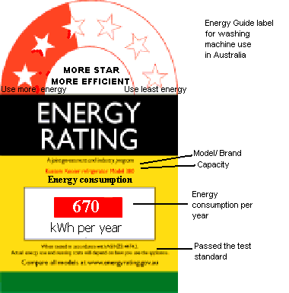

Fig. 1 Modified form an Australian washing machine energy label

The label shown in Fig. 2 has been selected from European Union's labeling program. This label is one of the successful labels around the 16 EU countries. Appliance is ranked into one of 7 bins graded from A to G. The length of the bars increases successively from A to G. The respective length of the bars is intended to reveal the message that A means lower consumption (shorter) while G means higher consumption (longer). Similarly, the G bar is colored bright red while A bar is colored deep green, while the other bars are colored in progression between two hues. The color red means danger and green means environmentally friendly. Attaching a larger black arrow that is aligned to the right and points back at the stacked efficiency class pointed-bars indicates the efficiency of the specific model. The efficiency bar it points to indicate the efficiency of that model. Some people can understand by comparing "A" grading very well while "F" grading is not so good [12, 14].

The label shown in Fig. 3 has been selected from Indian labeling program [20]. The label is also in same type with the Australia star-labeling program. The difference between the labels are only five star used in the label and energy consumption are shown in term of ‘unit’ not ‘kWh’ per day. The symbol money in fist indicates more star more saving of money.

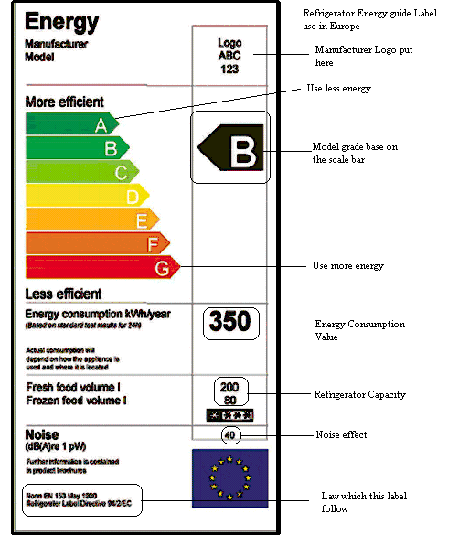

Fig. 2 An example from the European Union’s labeling program

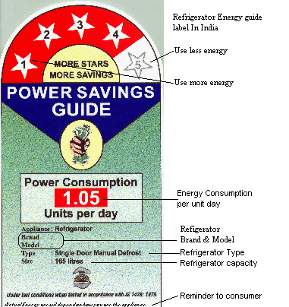

Fig. 3 An example from an Indian labeling program

Results and Discussion

First phase survey result

The interview was conducted among 250 respondents to get their inputs to develop most comprehensive energy guide label. Among the 250 respondents, 47 were refused to answer the questionnaire by the reasons as shown in Fig. 4. Among 203 respondents, 144 (70.9%) are male and 59 (29.1%) are female. According to race, 153 respondents (75.4%) are Malay, 34 (16.7%) are Chinese, and 8 (3.9%) Indian and 8 (3.9%) are other races. It has been observed that most of respondent were from the early 20 years with the age 19-22 years old with 113 (55.7 %) respondents and 23-55years old with 90 (44.3%) respondents. Among the respondents, students were 117 (57.6%) because they are easier to approach than a general worker. The students came from university and private colleges from Kuala Lumpur and Petaling Jaya areas.

The respondents were asked to choose 5 labels, which are easy to understand among 20 labels from different countries. From Fig. 5, it can be seen that the number 1 label scored 14% and number 2 scored 12% out of 203 respondents. These labels are from Australia with comparative category (Type A). The next label that was recognized by the respondents was from India (i.e. label number 9), which scored 11%. From the Fig. 5, it also can be seen that five labels show same percentage (6%) of responses. These five labels are number 4 (Brazil, Type A), number 5 (Canada, Type A), number 17 (Europe, Type A), number 18 (Europe, Type A), and number 19 (Ireland, Type C).

Not free
Want to eat something
Don’t want to interrupt
Busy
Don’t have time
Don’t like to be interview
Have conversation
Still eating
Come with family & don’t want to be interrupted
seating 'lepak'
0
2
4
6
8
10
12
Reasons
Number of respondent

Fig. 4 The reason for refusing to answer the questionnaire
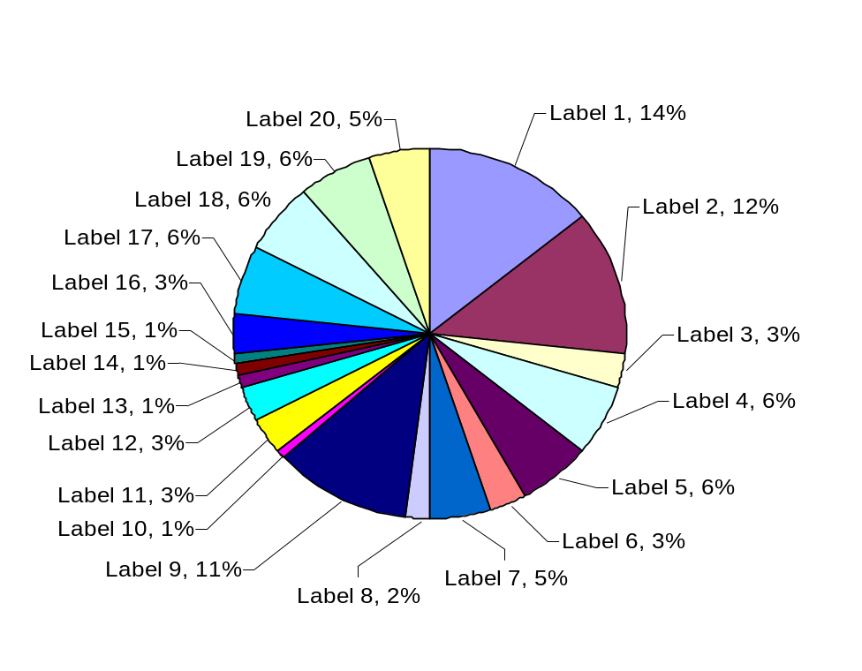
Fig. 5 Percentage of respondents choose the labels

Attractiveness and simplicity of Labels

After looking the labels, it was asked the respondents about the attractiveness of label that was shown to them. From 203 respondents, 132 (65%) agreed that the labels are attractive and 47 (23.2%) very agreed. Only 22 respondents did not agree to that question. Next result shows that 120 respondents (59.1%) agreed that the labels are simple 23 (11.3%) respondents very agree and the remaining 58 (28.6%) of respondents did not agree with that question.

Understanding the term “kWh” and “Unit”

The respondents were also asked about their understanding the term ‘kWh’. For this question, only 40 (19.7%) respondents were not agreed meaning that they didn’t understand the term ‘kWh’. The rest of the respondents were very agreed with 98 (48.3%) respondents and 63 respondents (31.0%) were agreed. The relationship between terms ‘kWh’ and ‘Unit’ usually bears same meaning. 72 (35.5%) of them don’t know that two terms are same. Only 63 (31.0 %) respondents very agreed and others with 66 (32.5%) respondents agreed.

Label help purchasing

From the next question, it has been observed that respondents are agreed that labels will help them in making purchase decision with very agree 67 (33.0%) respondents, agreed with 106 (52.2%) respondents and only 25 (12.3%) respondents believe that labels will not help in making purchase decision. For the next question, 120 respondents (59.1%) are very agreed and 54 respondents (26.6%) agreed that all manufacturers must put energy guide label at their appliances. Only 23 (11.3%) respondents do not agree for that question.

Do present labels give enough information?

Among the respondents 73 (36.0%) respondents don’t agree that the present labels give enough information before buying any appliances and rest of the respondents are agreed with 90 (44.3%) and very agreed are 38 (18.7%) respondents. Most of respondents are agreed to buy the appliances that have the energy guide label rather than doesn’t have label with agreed and very agreed 171 (84.2 %) respondents. 157 (77.3%) respondents are agreed that the government should enforce manufacturers with mandatory regulation to put the energy label at their product 2% no response 78% mandatory 20% volunteer.

The respondents were also asked whether price, size or capacity, brand, and color of appliance should be included on the energy guide labels or not. Their responses are given below

Whether price should be put at the label or not?

Among the respondents, 96 (47.3%) respondents very agree, 67 (33%) respondents agree and 40 (19.7%) respondents do not agree with the above question.

Whether size/capacity should be added to the label or not?

Among the respondents, 85 (41.87%) respondents very agree, 87 (42.86%) respondents agree and 31(15.27%) respondents do not agree with the above question.

Whether brand of appliances should be included or not?

Among the respondents, 73 (35.96%) respondents very agree, 85 (41.87%) respondents agree and 45 (22.17%) respondents do not agree with the above question.
Whether the color of appliances should be included or not?

Among the respondents, 43 (21.18%) respondents very agree, 85 (41.87%) respondents agree and 75 (36.95%) respondents do not agree with the above question.

Results of phase two

Among 50 respondents, 32 (64.0%) were male and 18 (36.0%) are female. Out of 50 respondents 28 (56%) were Malay, 12 or 24% respondent are Chinese, and Indian with 8 (16%) respondent same with other races are 2 (4.0%) only. It was observed that most of the respondents are from the early 20 years with the age 20-23 years old come with 34 (78 %) respondents and 22% respondents from 24-25 years old. This situation happens with the relation of respondent jobs. The survey was mostly conducted at Megamall Midvalley and University of Malaya. About 98% of the respondents were students because they are easier to approach than the workers. The students come from university and private colleges from Kuala Lumpur and Petaling Jaya. From the survey result it can be seen that the label 2 (letter bin) was chosen by 20 (40%) respondents and the remaining 30 (60%) respondents preferred star labeling with label number 1, 14 (28%) respondents and number 3, 16 (32%) respondent. It means more respondents feel that star labels are more comprehensive to them. From Fig. 6, it can be seen that more respondents likely believe that the star labels are attractive to pursue people to read the label.
Label 1(Star)
Label 2 (Letter bin)
Label 3 (Star)
0
10
20
30
40
Percent
Fig. 6 Attractiveness of level

For the next question more respondents agreed that they would read the label attached at appliances before purchasing any appliances with 41 (82%) respondents and 9(18%) respondents do not agree. It means the respondents will notice whether any label attached with the appliances.

Size of the label

About 30 (60%) respondents replied that the sizes of the labels that have been shown them are enough 11(22%) respondents said not enough and 9(18%) respondents said larger.

In discussing the term ‘yearly, monthly and daily energy consumption’, 24 (48%) respondents preferred the term ‘kWh per month’ and 21 (42%) respondents desired term ‘kWh per day’ than to term ‘kWh per year’ with only 5 (10%) respondents. This happens because the people in Malaysia draw their salary monthly. The bills like electricity, water, and telephone in Malaysia also come to the customer every month; this is easier for consumer to budget their electricity bill every month before making a decision to buy any appliances. About 64% of respondents understand the star meaning and remaining 36% do not understand the star meaning. Fig. 7 shows the consumers opinions about the number of color that should be included in a label.

2
3
4
5
Unlimited
Black & White
Number of Color
0
10
20
30
40
Percent

Fig. 7 Number of color for label

Designing Proposed Label

From the outcome of this survey, two types of labels have been developed to represent the survey result. First, the star labeling which is the combination of the number 1 and number 3 label in second phase survey and the secondly letter bins label with some modification for easy understanding by majority of consumers. These two proposed label is shown in the Figs. 8 to 9 respectively.

MORE STARS
MORE SAVINGS
3
A

4
2
B

5
1

C

Appliance Air conditioner
Brand Brand X
Model ABC

Type Spilt type room air conditioner
Cooling Capacity 5.0 kW

ENERGY GUIDE LABEL
D

E

Energy Consumption
350 kWh per month

F

G

Tested with Standard MS XXX
H

Modification to this label is prohibited

Fig. 8 Proposed star labeling

Use Least Energy

Use More Energy

B

G

C

F

E

D

A
C
ManufacturerBrand X
ModelABC
Manufacturer logoLogo
Energy Consumption (kWh/month) 350

Capacity200 liter
SirimSuruhanjaya tenagatest procedure
ENERGY GUIDE LABEL

A

B

C

D
E

F

H
G

Fig. 9 Proposed letter bins labeling

Conclusion

As the consumers are final end users of appliances, their needs and perceptions are crucial inputs in establishing an effective and comprehensive energy guide labels. This survey reflects their opinions that need to be incorporated in designing the energy guide labels. It can be concluded from the overall survey that the respondents preferred clear graphic and details information in the labels in an easy, comprehensive and simple manner. Labels that meet these features will attract people to read and guaranty the success of energy guide label implementation in Malaysia. The information at labels should be justified with the approval from government bodies such as Suruhanjaya Tenaga (Energy commission). Two labels have been designed and proposed for the household appliances through consumer’s research survey.

Malaysia and other countries which have not implemented energy guide labels yet may consider the outcome of this survey as their guideline in implementing energy guide labels for household appliances. This survey results provide considerable amount of information and analysis in order to build up energy guide labels. Labeling design involves so many technical matters; general people may not understand the matters even some people do not understand kWh. So, the most important point is to teach the consumers by introducing appropriate measures.

In this regard, the author recommends some measures for an effective and consumers' comprehensive labeling for Malaysia. Government can initiate a TV program to aware consumers about the labeling. The daily newspaper article on labeling with details of technical explanation benefits of energy guide label, economic, and environmental savings, bill savings, life cycle cost savings etc can help aware consumer. Government can train officials, utility company employees, product manufacturers, product distributors, product salespeople, architects/designers, environmental activists, and/or consumers in designing, developing, and implementing energy guide labels.

Moreover, it can be concluded that this survey has given almost complete information in order to establish an effective labeling program for household appliances.

References

[1] IIEC, “Energy Labeling, Standards and Building Codes: A global survey and assessment for selected developing countries,” Washington (DC): IIEC, GEEI publications, 1996, pp. 1-3. (http://www.weea.org/USAID%20Reports/Documents/Energy%20Labeling.pdf)
[2] R. A. Brown, “Energy label and MEPS,” Electricity supply association of Australia, Sydney, 3 Aug, 1993, pp. 1-20.
[3] E. R. Deter and E. Scmid, “Home energy manual,” Building and appliance energy efficiency office, California energy commission, USA, 1999, pp. 1-11.
[4] http:// www.clasponline.org, 5-11- 2003.
[5] I. Turiel, “Present status of residential appliance energy efficiency standards an international review,” Energy and building, Vol. 26 (1), 1997, pp. 5-15.
[6] J. Maroušek and B. Schwarzkopf, “Labels and standards for appliances,” SEVEn7, 14/a, Czech Republic, 1992, pp. 1-30.
[7] EPA, “Environmental labeling, issues, policies, and practices worldwide,” Environmental protection agency (EPA), EPA 742-R-98-009, Washington DC, United States, 1998, pp. 1-322. (http://www.epa.gov/oppt/epp/pubs/envlab/wwlabel3.pdf)
[8] B. Truffer, J. Markard and R. Wustenhagen, “Eco-labeling of electricity-strategies and tradeoffs in the definition of environmental standards,” Energy policy, Vol. 29 (11), 2001, pp. 885-897.
[9] Banerjee and Solomon, “Eco-labeling for energy efficiency and sustainability: a meta evaluation of US programs,” Energy policy, Vol. 31, 2003, pp. 109-123.
[10] http://www.gen.gr.jp/product_link.html, 5-11- 2003.
[11] EPA, “Proposed environmental standards for major household appliances,” General seal, Washington, DC, 1993, pp. 1-21.
[12] P. Waide, “Appliance energy labeling and minimum energy efficiency standards in the European Union,” PW consulting, UK, 1998, pp. 1-38.
[13] P. Rumsey and T. Flanigan, “Standards and labeling for Philippines air conditioner program,” IIEC, GEEI Publications, Bangkok, Thailand, 1995, pp. 5-11.
[14] http://www.ctech.ac.za/conf/techconf/dueee/2000/as2k/abstracts/html#thorne, 7-8- 2000.
[15] R. F. Dyer and T. J. Maronick, “An evaluation of consumer awareness and use of energy labels in the purchase of major appliances: A longitudinal analysis,” Journal of public policy and management, Vol. 7, 1998, pp. 83-97.
[16] P. D. Pont, “Energy policy and consumer reality: The role of energy in the purchase of household appliances in the U.S. and Thailand,” Ph. D dissertation, University of Delaware, USA, May, 1998 pp. 1-196.
[17] G. Wilkenfeld, “Transition of the new energy label in Australia,” In Proc., Lessons learned in Asia: Regional symposium on energy efficiency standards and labels”, United Nation conference center (UNCC), Thailand, Bangkok, 29-31 May, 2001, pp. 1-7.
[18] P. D. Pont, “Lessons learned: International experience with appliance energy labeling,” Training presentation for Malaysia end-use energy rating work group and sub-work group on refrigerators, Putra world Trade Centre, Kuala Lumpur, Malaysia, 2002, pp. 1-30.
[19] JBEG, “Statistics of electricity supply industry in Malaysia,” JBEG, Kuala Lumpur Malaysia 2000, pp. 1-29.
[20] V. Deshpande, NEXANT, India, “Labeling design effort in India,” In Proc., Lessons learned in Asia: Regional symposium on energy efficiency standards and labels, United Nations conference center (UNCC), Thailand, Bangkok, 29-31 May, 2001, pp. 1-8.
[21] P. L. Alreck, “The Survey Research Handbook,” 3rd ed., McGraw-Hill, USA, 2003, pp. 1-496.

