Computation of Monthly Mean Hourly Global Solar
Radiation from Daily Total

S. Alam*, S. N. Garg** and S. C. Kaushik**
*University Polytechnic, Jamia Millia Islamia University, Jamia Nagar
**Centre for Energy Studies, Indian Institute of Technology, Hauz Khas
New Delhi 110016, India
Email: shah_alam67@yahoo.co.in
(Received on 28 May 2006, revised on 25 Feb 2007)
______________________________________________________________________________________

Abstract

New quadratic equations between global solar radiation fraction and day length have been developed for Indian region in this paper. Measured data over a period of 19 years, 1960–1978, for the four stations, namely New Delhi, Mumbai, Kolkata and Chennai and Gopinathan-Soler approach, have been used in this analysis. The developed correlations are tested for two new stations, Jaipur and Pune, whose recent solar radiation data, 1995 – 2002, is available. The values, computed by present model are compared with those computed by Liu and Jordan model and by Collares-Pereira and Rabl model, in term of statistical error estimators, like root mean square error (RMSE), mean bias error (MBE), and mean absolute percentage error (MAPE). It is found that for large hour angles from solar noon (HFSN), 4.5h and 5.5h, Liu and Jordan model shows 20% - 50% RMSEs, Collares-Pereira and Rabl model, 10% - 20%, while the present model has 5% to 10% RMSE only. For other HFSN, 0.5h to 3.5h, Liu and Jordan model has maximum RMSE 10%, while present model shows only 5% error in most of the cases. For these hours, results of Collares-Pereira and Rabl model are comparable to those of present model. It is found that the present model may be used as an alternative to Collares-Pereira and Rabl model.
______________________________________________________________________________________

Introduction

Hourly solar radiation at the ground level is an important parameter for mathematical simulation of solar energy processes, sizing of thermal storage systems, forestry, agriculture, building design etc. These days, hourly values of global radiation are measured at most of the stations, but still some stations are measuring only sunshine hours. There are various existing correlations by which one can obtain daily global solar radiation from sunshine hours. To obtain the hourly values from daily solar radiation, correlations for hourly values are needed.

Enough work has been carried out in this direction. A. Whillier [1] and Liu and Jordan [2] have developed theoretical models for deriving the monthly mean hourly global and diffuse solar radiation from daily values, assuming that the ratio of hourly to daily values are same on earth surface as it is extraterrestrial. They further assumed that atmospheric transmission does not depend on solar altitude.

Collares –Pereira and Rabl [3] have improved Liu and Jordan equation, to suit the measured data of many stations across the globe and this model has been accepted universally. D. Choudhary [4] and M. Iqbal [5] have also done similar type of work. Gopinathan and Soler [6-7] have proposed a set of polynomial equations for estimating hourly values. Singh [8] have evaluated hourly global radiation for Uttar Pradesh (India), by using regression analysis based on the Al –Sadah model [9]. Wong and Chow [10] have reviewed various solar radiation models. Jacovides [11], Rensheng [12], S. Alam [13] and K. Yang [14] have computed monthly mean hourly global and diffuse solar radiation using existing models and compared these models. Collares-Pereira and Rabl model shows good accuracy for Indian stations, but over 10% error is found during low radiation periods 7– 9 A M in the morning and 5–7 P M in the evening. Although in these periods solar radiation level is low in winter, but in summer and rainy seasons, importance of this radiation cannot be ignored.

In the present study, it is attempted to develop polynomial equations, based on Gopinathan-Soler [7] approach, to evaluate the monthly mean hourly global solar radiation from daily totals, for Indian stations and to see if there is any improvement over the existing correlations.

Existing Models

Liu and Jordan model [2]

Monthly mean hourly global fraction, defined as r_{g} = I_{g} / H_{g}, is given as:

r_{g} = 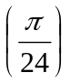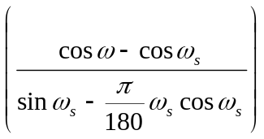 (1)

where,

I_{g} = monthly mean hourly global solar radiation (kWh/m².hr)
H_{g} = monthly mean daily global solar radiation (kWh/m².day)
ω = hour angle (degree)
ω_{s} = sunset hour angle (degree)
ω_{s} = 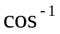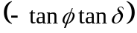
= latitude of location (degree)
δ =solar declination angle (degree)
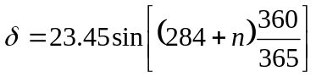
n = no. of days, 1≤ n ≤ 365. For each month mean value of n, as suggested by Iqbal [15] have been used.

Collares – Pereira and Rabl model [3]

Monthly mean hourly global fraction is given as:

r_{g} = 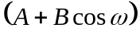 (2)

where,

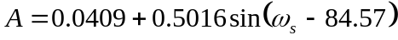
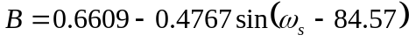

Gopinathan - Soler model [7]

Gopinathan - Soler [7] have used their model to compute monthly mean hourly diffuse fractions for Spain. General form of equation is given as:

r_{d} = aS² + bS + c (3)

where, a, b, c are constants to be determined by regression and S is day length in hours.

Meteorological Data

To develop set of polynomial equations, the necessary solar radiation data was taken from Mani [16]. This measured data is spread over 1960-1978, and conforms to the international meteorological standards as specified by W.M.O. The developed equations were tested for two different stations, Pune and Jaipur and the recent data for these two stations were taken from Indian Meteorological Department (IMD) Pune for the period of 1995 - 2002.

Methodology

Six stations, whose geographical co-ordinates are given below in Table 1, were used in this study.

Table 1 Indian stations used in this study and their geographical parameters

Station Latitude Longitude Elevation
(⁰N) (⁰E) (m, amsl)

New Delhi 28.58 77.20 216
Kolkata 22.65 88.45 6
Mumbai 19.12 72.85 14
Chennai 13.00 80.18 16
Poona 18.53 73.85 559
Jaipur 26.82 75.80 390
_____________________________________________________________________________________

Polynomial equations developed, were based on the meteorological data for four stations namely New Delhi, Mumbai, Kolkata, and Chennai, and these equations were tested on the radiation data of two remaining stations, Pune and Jaipur with recent data. From the measured data of these four stations, hourly global fractions, r_{g}, for different HFSN were calculated. For each HFSN value, a quadratic polynomial between day length, S, and r_{g} is fitted, as shown below:

r_{g} = aS² + bS + c (4)

where, a, b, c are regression coefficients and their values depends upon HFSN.

By using the developed quadratic polynomial (i.e. present model), and Liu and Jordan equation, hourly global solar radiation is computed for these four stations and the comparison with the measured values, in term of root mean square error (RMSE), mean bias error (MBE) and mean absolute percentage error (MAPE), is carried out and the same is shown in Table 2. For two new stations, Pune and Jaipur, the similar results are shown in Table 3. Collares-Pereira and Rabl method is also included for comparison purpose.

Table 2 Percentage of RMSE, MBE and MAPE in hourly global radiation, I_{g}, as computed by [2], and those as computed by present model for four Indian stations.
Station | HFSN | Liu and Jordan model |  |  | Present model
Station | HFSN | RMSE | MBE | MAPE | RMSE | MBE | MAPE
New Delhi | 0.5  1.5  2.5  3.5  4.5  5.5 | 5.4  5.0  3.1  4.2  14.9  35.4 | -0.04  -0.03  -0.01  0.01  0.03  0.04 | 5.0  4.4  2.1  4.3  18.0  19.5 | 3.5  2.4  2.1  1.7  7.7  9.0 | 0.02  -0.01  0  0  -0.02  0 | 3.3  1.7  2.0  1.8  6.6  6.1
Mumbai | 0.5  1.5  2.5  3.5  4.5  5.5 | 5.8  3.1  3.2  13.2  32.1  66.6 | -0.04  -0.01  0.01  0.05  0.06  0.05 | 5.5  3.0  2.6  12.2  31.2  40.4 | 3.4  2.4  5.5  10.0  9.3  9.4 | 0.02  0.01  0.03  0.04  0.01  0.01 | 3.1  1.8  4.9  9.1  6.6  4.4
Kolkata | 0.5  1.5  2.5  3.5  4.5  5.5 | 7.5  7.5  5.4  6.7  20.6  41.1 | -0.05  -0.05  -0.02  0.01  0.04  0.03 | 7.2  7.2  4.3  6.3  22.2  22.9 | 1.7  4.8  3.9  4.7  7.5  9.6 | 0.01  -0.03  -0.01  0  -0.01  0 | 1.4  4.4  3.4  4.6  6.6  7.7
Chennai | 0.5  1.5  2.5  3.5  4.5  5.5 | 6.4  5.9  4.1  4.9  17.6  49.7 | -0.04  -0.03  -0.01  0.02  0.04  0.04 | 5.4  4.6  3.6  3.4  17.1  33.8 | 3.9  4.1  3.9  3.3  5.0  7.5 | 0.02  -0.01  0.01  0  -0.01  0 | 3.6  3.1  3.1  2.6  4.7  4.8

Table 3 Comparison of present model, with [2] and [3]. Recent global radiation data, 1995-2002, of two new stations Pune and Jaipur is used for comparison
Locations | HFSN | Liu and Jordan model |  |  | Collares-Pereira and Rabl  model |  |  | Present model
Locations | HFSN | RMSE | MBE | MAPE | RMSE | MBE | MAPE | RMSE | MBE | MAPE
Pune | 0.5  1.5  2.5  3.5  4.5  5.5 | 9.8  8.2  4.4  10.8  34.3  80.8 | -0.07  -0.05  -0.01  0.04  0.07  0.05 | 9.0  7.3  4.1  10.6  38.5  51.5 | 3.2  4.0  4.4  4.3  12.0  34.0 | 0.02  0.02  0.01  0  -0.02  -0.02 | 2.8  3.1  3.7  3.5  13.1  20.2 | 2.8  5.5  4.1  7.9  10.8  18.3 | -0.01  -0.03  0.01  0.03  0.02  0.01 | 2.5  4.5  3.7  7.5  11.8  11.6
Jaipur | 0.5  1.5  2.5  3.5  4.5  5.5 | 7.9  6.8  3.4  3.9  18.8  59.7 | -0.06  -0.05  -0.02  0.01  0.04  0.06 | 6.2  5.2  2.5  3.2  16.1  33.1 | 2.8  2.9  3.5  7.2  5.7  24.1 | 0  0.01  0.02  0.03  0  -0.02 | 1.8  1.5  2.8  5.4  4.0  11.9 | 2.8  4.2  2.3  2.9  5.9  20.4 | 0.01  -0.02  0  0  -0.01  0.01 | 1.8  2.8  1.7  2.3  4.6  8.8

Results and Discussion

Measured global fractions, r_{g}, for the four stations namely New Delhi, Mumbai, Kolkata and Chennai, are plotted against day length, S, for different values of HFSN, in Figs. 1 and 2. In the same Figs. are shown plots of r_{g} verses S, as computed by Liu and Jordan method. These plots clearly shows that for HFSN = 0.5h and 1.5h, the Liu and Jordan method underestimates the global fraction and for HFSN = 3.5h, 4.5h and 5.5h, it overestimates the global fractions. For HFSN = 2.5h, the data points lie equally above and below the Liu and Jordan curve. From this it is clear that Liu and Jordan method is not suitable to compute global solar radiation fractions.
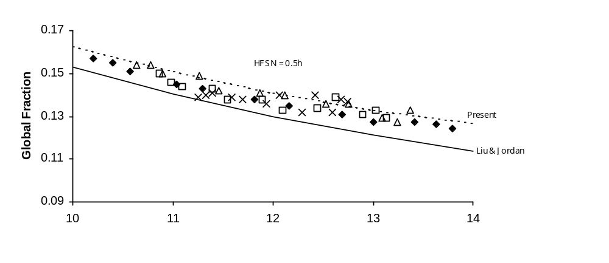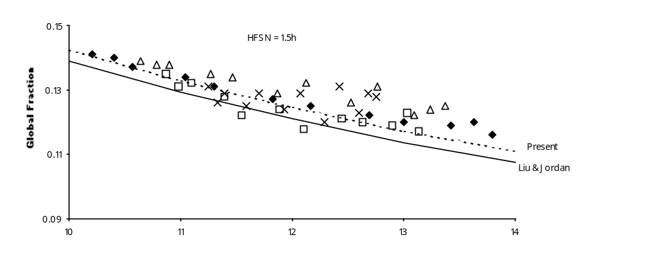

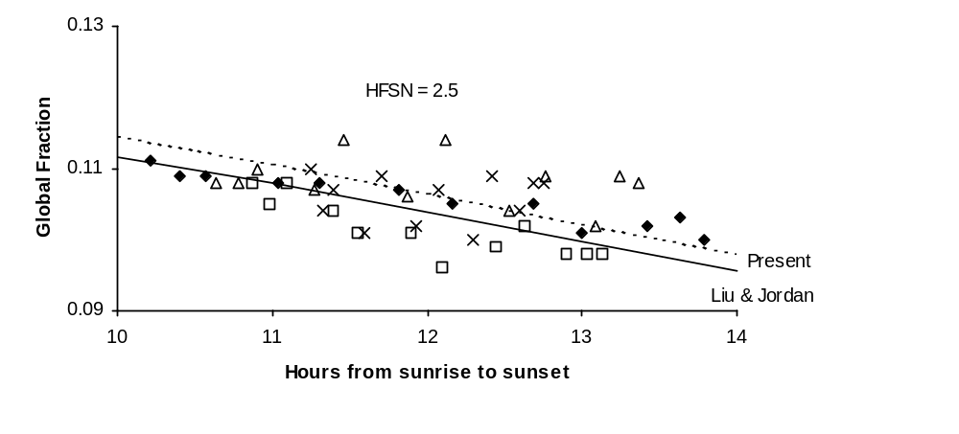
Fig. 1 Measured global fractions (points), those computed by Liu and Jordan model (continuous line) and Present model (dotted line), at different values of HFSN, for four Indian stations
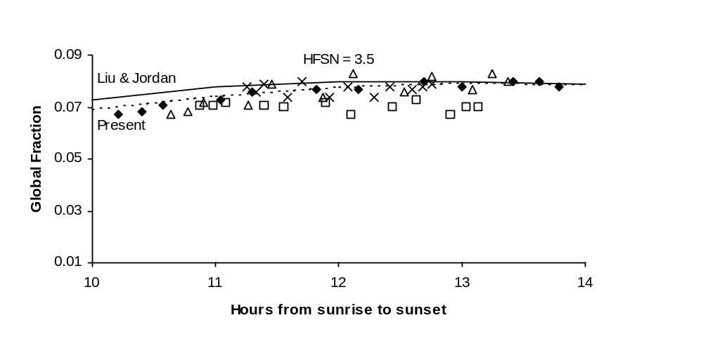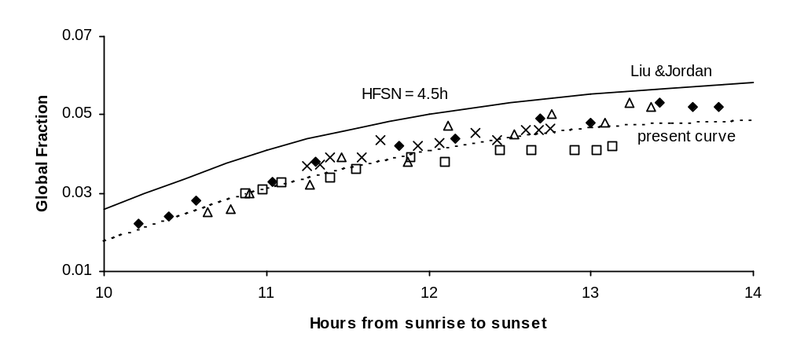

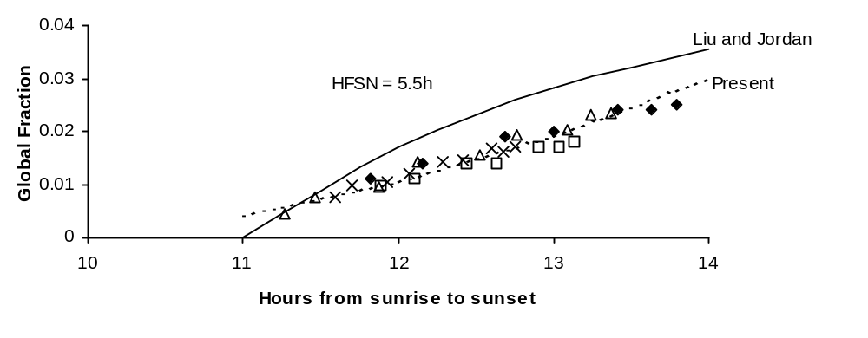
Fig. 2 Measured global fractions (points), those computed by Liu and Jordan model (continuous line) and Present model (dotted line), at different values of HFSN, for four Indian stations

The developed quadratic polynomials for the combined data of the above four stations, are as follows:

HFSN

0.5h r_{g} = 0.0009 S² – 0.0305 S + 0.3774 (5)
1.5h r_{g} = 0.00055 S² – 0.021 S + 0.2974 (6)
2.5h r_{g} = -0.000065 S² – 0.0026 S + 0.147 (7)
3.5h r_{g} = -0.0009 S² + 0.0241 S – 0.082 (8)
4.5h r_{g} = -0.002 S² + 0.0557 S - 0.3393 (9)
5.5h r_{g} = 0.0011 S² – 0.0189 S + 0.079 (10)

Now the global fractions of these four stations were again computed by using equations (4-10). The computed global fractions are also plotted (shown by dotted lines) in Figs. 1 and 2. It is seen that these plots are closer to measured data points than Liu and Jordan plots (shown by thick lines). For these four stations, Table 2 shows the quantitative comparison of the present model with the Liu and Jordan model, in terms of various errors. For HFSN = 0.5h to 3.5h, RMSE in Liu and Jordan model varies from 3% to 13%, while the present approach shows RMSE below 5% only, except for Mumbai where RMSE is 10%. For HFSN= 4.5h and 5.5h, Liu and Jordan model shows RMSE variation from 15% to 66%, while present approach shows 5% to 10% error only. The same trend is observed for other two types of errors also, namely MBE and MAPE. This shows that there is marked improvement in the present model over the Liu and Jordan model, particularly in the morning and evening hours. This result has been conformed by earlier works also [3].

The developed polynomials have been applied to two new stations, Pune and Jaipur, whose measured data was not included in the development of the polynomials and the results are shown in Table 3. For comparison purpose, Collares-Pereira and Rabl method has also been included. The measured global radiation data used for comparison, is for the period 1995 to 2002, which is almost recent data. Here also, Liu and Jordan method shows as high as 80% RMSE for late morning and evening hours, while the present model shows only 20% RMSE. For rest of the hours, RMSE is below 8%. Results of the present model are comparable to those of Collares-Pereira and Rabl model for HFSN = 0.5h to 3.5h and for HFSN = 4.5h and 5.5h, present model shows even better results. For these late hours, the highest RMSE is 34% as per Collares-Pereira and Rabl model, while it is only 20% as per present model.

Conclusion

The Liu and Jordan model is not suitable to compute hourly global fractions from daily values. RMSE goes as high as 66% for Mumbai. Present model, which uses quadratic polynomials to compute r_{g}, shows RMSE within 10% range for the four stations New Delhi, Mumbai, Kolkata and Chennai. The present model results are comparable to those of Collares-Pereira and Rabl model for HFSN = 0.5h to 3.5h, but are definitely better for HFSN = 4.5h and 5.5h. There is always some precision lacking in measuring morning and evening hour solar radiation. In view of the above, the present model can be used as an alternative to Collares-Pereira and Rabl method, to compute r_{g}.

References

[1] A. Whllier, "The determination of hourly values of total radiation from daily summations", Arch., Meteorol. Geophys. Bioklimatol., Series B-7, No. 2, pp. 197-204, 1956.
[2] B. Y .H. Liu and R. C. Jordan, "The inter-relationship and characteristic distribution of direct, diffuse and total solar radiation," Solar Energy, Vol. 4, pp. 1-19, 1960.
[3] M. Collares–Pereira and A. Rabl, "The average distribution of solar radiation, correlations between diffuse and hemispherical and between daily and hourly insolation values", Solar Energy, Vol. 22, No.2, pp. 155-164, 1979.
[4] N. K. D. Choudhary, "Solar radiation at New Delhi", Solar Energy, Vol. 7, pp. 44-46, 1963.
[5] M. Iqbal, “A study of Canadian diffuses and total solar radiation data-1, monthly average daily horizontal radiation", Solar Energy, Vol. 22, pp. 87-90, 1979.
[6] A. Soler and K. K. Gopinathan, "Estimation of monthly mean hourly global radiation for latitudes in the 1⁰N – 81⁰N range", Solar Energy, Vol. 52, No.3, pp. 233-239, 1994.
[7] K. K. Gopinathan and A. Soler, "Techniques for obtaining the monthly mean hourly diffuse radiation from daily values", Solar Energy, Vol. 22, No. 7, pp. 735-742, 1997.
[8] O. P. Singh, S. K. Srivastava and G. N. Pandey, “Estimation of hourly global solar radiation in the plane areas of Uttar Pradesh, India", Energy Convers Management, Vol. 38, No.8, pp. 779-785, 1997.
[9] F. H. Al-Sadah, F. M. Ragab and M. K. Arshad, "Hourly solar radiation over Bahrain", Energy, Vol. 15, pp. 395-399, 1990.
[10] T. Wong, and W. K. Chow, "Solar radiation model", Applied Energy, Vol. 69, pp. 191-224, 2001.
[11] C. P. Jacovides, F. S. Tymvios, V. D. Assimakopoulos and N. A. Kaltsounides, "Comparative study of various correlations in estimating hourly diffuse fraction of global solar radiation", Renewable Energy, Vol. 3, No. 15, pp. 2492-2504, 2006.
[12] R. Chen, E. Kang, X. Ji, J. Yang and J. Wang, "An hourly solar radiation model under actual weather and terrain conditions-a case study in Heihe river basin", Energy, Vol. 32, No. 7, pp. 1148-1157, 2007.
[13] S. Alam, “Prediction of direct and global solar irradiance using broadband models -validation of REST model”, Renewable Energy, Vol.31, No. 8, pp. 1253-1263, 2006.
[14] K. Yang, T. Koike and B. Ye, "Improving estimation of hourly, daily and monthly solar radiation by importing global data sets", Agricultural and Forest Meteorology, Vol. 137, No. 1-2, pp. 43-55, 2006.
[15] M. Iqbal, "An Introduction to solar radiation", Toronto, Academic Press, pp 62-63, 1983.
[16] A. Mani, "Hand book of solar radiation data for India", Allied Publishers Pvt., New Delhi, pp. 99-422, 1980.

