**COMSATS University Islamabad, Lahore Campus**

**Subject :** Object Oriented Programming

**Assignment :** Lab Task

**Submitted To :** Sir Shahid Bhatti

**Submitted By :** Muhammad Waqar

**Registration No :** SP24-BSE-091

**Section :** A

***Data FORM***

**Entry Added**

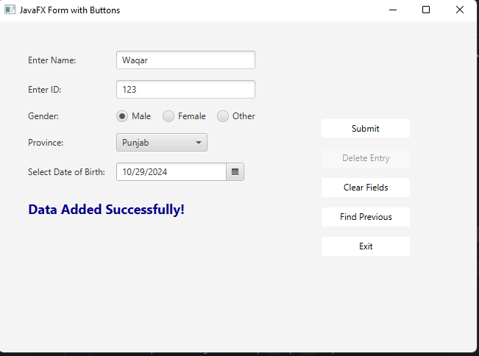

**Finding Entry**

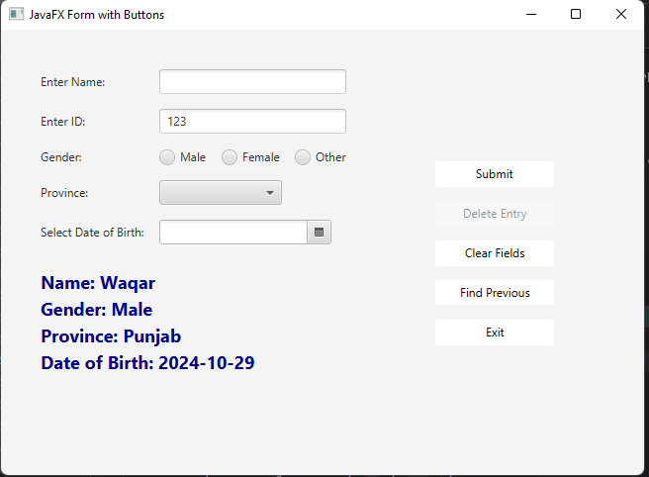

**Data On File**

