

**Ecommerce Dashboard**

**Wireframe Document**

Version 1.0

***By***

**Waqar Aftab**

**Histogram:**

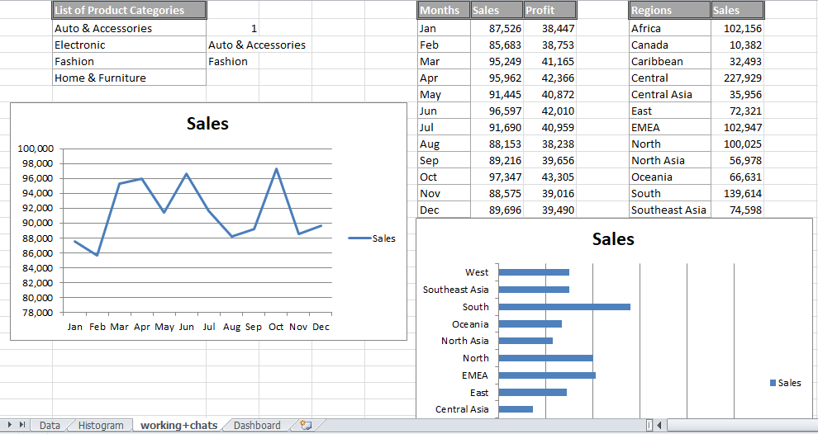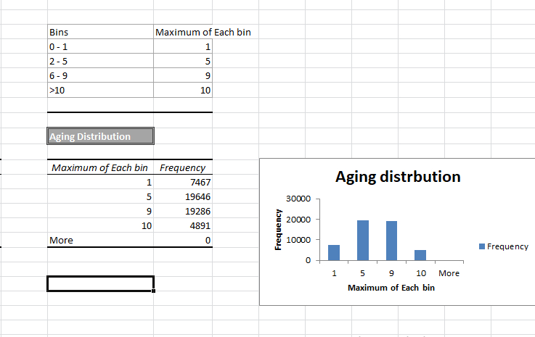

**Working and other charts:**

**Dashboard:**

