SSD · Development Activity 4
Dependency Mapping and Failure Analysis
FYPilot — Navigate Your Final Year
Field | Answer
Project Name | FYPilot (same semester project as Activities 1–3)
Group Members | M. Waqas (23F-3041)
Institution | FAST NUCES Chiniot-Faisalabad · Department of Computer Science
Repository | github.com/Waqas-Chohan/fypilot-prototype
Components analysed | 9 (C1–C9), taken from the actual project code
Critical component | C4 Shared UI Core (assets/js/main.js) — 6 direct dependants
Failure-handling implemented | Fail-closed access guard + safe error screen, session-store failure message, System Status (monitoring) page
Tests | 36/36 automated checks passed (headless Chromium)
Date | 13 October 2026

How this analysis was done
Every component, dependency and reason below was taken from the real source code of FYPilot (HTML pages, login.js, main.js, the page scripts and the Cloudflare Worker), not from a generic architecture. Each dependency was confirmed by finding the function call or data the dependent component needs.
Two failures were then reproduced in a headless browser. Both revealed real problems, which were fixed in the code as the Part 6 failure-handling strategy.

Part 1 — System Components
FYPilot is a static, offline-capable frontend (HTML, CSS, JavaScript) with one external service (Cloudflare Turnstile and its verification Worker). Nine major components were identified. The same order C1–C9 is used in every table, the matrix and the graph.
Symbol | Component Name | Files | Main Responsibility
C1 | Landing Page | index.html | Public entry point: explains FYPilot, links to Login and hosts the contact form.
C2 | Authentication Module | login.html, assets/js/login.js | Validates university credentials, identifies the role, creates the user session and routes the user to the correct dashboard; sign-up and password-reset forms.
C3 | Bot-Verification Service | Cloudflare Turnstile + cloudflare-worker/worker.js | Proves that a sign-in is made by a human; the Worker verifies the Turnstile token server-side with Cloudflare siteverify.
C4 | Shared UI Core | assets/js/main.js (UI helpers) | Common utilities used by every page: toasts, modals, dropdowns, mobile navigation, HTML escaping (FYP.esc) and debounce.
C5 | Session & Access Control | assets/js/main.js (session helpers) + sessionStorage | Reads the current session, guards protected pages by role (FYP.requireRole) and logs users out (FYP.logout).
C6 | Student Dashboard | dashboard.html, assets/js/dashboard.js | Student home: milestone tracker, deliverable upload, originality check, funding requests, grades and masked group PII.
C7 | Supervisor Dashboard | supervisor.html, assets/js/supervisor.js | Supervisor home: approve/reject funding (restricted function), rubric grading, feedback, full group contacts and audit log.
C8 | Proposal & Funding Module | module1.html, assets/js/module1.js | Module 1: validated proposal + funding-request form stored in a JavaScript array with a live “My Requests” list.
C9 | FYP Archive Module | module2.html, assets/js/module2.js | Module 2: search, filter and view details of past FYPs from a sample archive array.

Note on C4 and C5: both live in the same file, assets/js/main.js. They are listed separately because they have different responsibilities (presentation helpers vs. session security), but they fail together if that file fails to load — a key finding in Parts 4 and 5. The role-preview page (roles.html, for Panelist/Coordinator/Library) has the same dependencies as the dashboards and is covered by the same analysis.

Part 2 — Direct Dependencies
A dependency was recorded only when a component needs the other component to perform its own function (for example, it calls the other component's code or needs data that only the other component creates).
Component | Directly Depends On | Reason
C1 Landing Page | C4 Shared UI Core | C4: Mobile navigation, scroll-reveal and contact-form validation/toast are provided by main.js.
C2 Authentication Module | - C3 Bot-Verification Service  - C4 Shared UI Core | - C3: The Login button stays disabled until Turnstile issues a token (verified by the Worker when configured).  - C4: Sign-up and forgot-password modals, demo-account autofill feedback and toasts come from main.js.
C3 Bot-Verification Service | — (none) | Depends only on Cloudflare's external siteverify API, which is outside our system boundary.
C4 Shared UI Core | — (none) | Foundation library; it does not call any other FYPilot component.
C5 Session & Access Control | C2 Authentication Module | C2: requireRole() can only admit a user after login.js has written a valid ‘fypilot_session’ record.
C6 Student Dashboard | - C4 Shared UI Core  - C5 Session & Access Control | - C4: Uses FYP.toast / FYP.esc / modals for uploads, funding requests and notifications.  - C5: Calls FYP.requireRole(['student']) before anything is rendered.
C7 Supervisor Dashboard | - C4 Shared UI Core  - C5 Session & Access Control | - C4: Uses FYP.toast / FYP.esc for approvals, grading, feedback and the audit log.  - C5: Calls FYP.requireRole(['supervisor']) to protect approvals and full PII.
C8 Proposal & Funding Module | - C4 Shared UI Core  - C5 Session & Access Control | - C4: Uses FYP.esc for safe output and FYP.toast for success/error feedback.  - C5: Calls FYP.requireRole() — only signed-in users may submit requests.
C9 FYP Archive Module | - C4 Shared UI Core  - C5 Session & Access Control | - C4: Uses FYP.debounce for live search and FYP.openModal for the details view.  - C5: Calls FYP.requireRole() — only signed-in users may browse the archive.

Communicating pairs deliberately NOT marked as dependencies
As the activity requires, components that merely communicate were not assumed to depend on each other:
From | To | Why it is not a direct dependency
C2 | C6 / C7 | Login only redirects to a dashboard after authenticating; a broken dashboard does not stop authentication itself.
C6 | C8 / C9 | The Student Dashboard only links to the modules (navigation), it does not need them to work.
C7 | C8 | In the prototype the supervisor’s funding queue is sample data; it does not read Module 1’s array (this becomes a dependency on a shared Funding database in the backend phase).
C2 | C5 | login.js writes sessionStorage itself instead of calling main.js — so there is no code dependency, but the session key and role-to-page route table are duplicated in two files (hidden coupling).

Part 3 — Dependency Matrix
Rows are the components that depend; columns are the components they depend on. 1 = direct dependency, 0 = none; the diagonal is 0. Example: row C6, column C5 = 1 means the Student Dashboard depends on Session & Access Control.
Row / Column | C1 | C2 | C3 | C4 | C5 | C6 | C7 | C8 | C9
C1 Landing Page | 0 | 0 | 0 | 1 | 0 | 0 | 0 | 0 | 0
C2 Authentication Module | 0 | 0 | 1 | 1 | 0 | 0 | 0 | 0 | 0
C3 Bot-Verification Service | 0 | 0 | 0 | 0 | 0 | 0 | 0 | 0 | 0
C4 Shared UI Core | 0 | 0 | 0 | 0 | 0 | 0 | 0 | 0 | 0
C5 Session & Access Control | 0 | 1 | 0 | 0 | 0 | 0 | 0 | 0 | 0
C6 Student Dashboard | 0 | 0 | 0 | 1 | 1 | 0 | 0 | 0 | 0
C7 Supervisor Dashboard | 0 | 0 | 0 | 1 | 1 | 0 | 0 | 0 | 0
C8 Proposal & Funding Module | 0 | 0 | 0 | 1 | 1 | 0 | 0 | 0 | 0
C9 FYP Archive Module | 0 | 0 | 0 | 1 | 1 | 0 | 0 | 0 | 0
Column total (direct dependants) | 0 | 1 | 1 | 6 | 4 | 0 | 0 | 0 | 0

Reading the matrix: column C4 has the most 1s (6) and column C5 the next most (4). Rows C6–C9 are identical — all four protected screens rely on the same two core services, so a problem in main.js affects all of them at once. C3 and C4 have empty rows: they are foundations that depend on nothing inside FYPilot.

Part 4 — Component Failure Analysis

Failure Scenario 1 — C2 Authentication Module fails
Question | Answer
Component that fails | C2 Authentication Module — e.g. login.js throws an error, the bot check rejects every token, or the browser blocks sessionStorage so login cannot create a session.
Components that depend directly on it | C5 Session & Access Control — its guard can only admit users that login has registered in the session store.
Components affected indirectly | C6 Student Dashboard, C7 Supervisor Dashboard, C8 Proposal & Funding Module, C9 FYP Archive Module — all reach C2 through C5 (C6–C9 → C5 → C2).
System functions disrupted or degraded | - Sign-in, sign-up and password reset stop.  - New users cannot open any dashboard or module (uploads, originality check, funding requests, archive).  - Supervisors cannot reach the restricted funding-approval function or rubric grading.
What keeps working | C1 Landing page, C3 and C4 are unaffected. Users who are already signed in on this tab keep working until they log out, because their session is already stored — so the failure is degraded, not total.
Observed during testing | With storage blocked, login looked successful, then the guarded dashboard found no session and silently sent the user back to the login page — a confusing loop with no explanation. Fixed (see Part 6).

Failure Scenario 2 — C4 Shared UI Core (assets/js/main.js) fails
Question | Answer
Component that fails | C4 Shared UI Core — main.js fails to load (broken deploy, wrong path, blocked file). Because C5 lives in the same file, C5 Session & Access Control fails with it.
Components that depend directly on it | C1, C2, C6, C7, C8, C9 (6 components).
Components affected indirectly | C5 through C2 (C5 → C2 → C4). In practice C5 is also lost directly, since it is in the same file.
System functions disrupted or degraded | - C1: mobile menu and contact-form validation stop; content is still readable.  - C2: sign-up / forgot-password modals and toasts stop (core sign-in still works, because login.js writes the session itself).  - C6–C9: every page script stopped at window.FYP.requireRole(...) with a TypeError — so the role check never ran.
Security impact found | Fail-open. With main.js blocked, opening supervisor.html without logging in displayed the full group contacts and CNIC (35202-1234567-1) that are supposed to be supervisor-only. The page failed open: the protection disappeared together with the component that provided it.
What keeps working | C3 (external) and the static content of the landing page.

Key insight
A dependency does not always stop the whole system: in Scenario 1 the system degrades (signed-in users continue). But Scenario 2 shows that when a security control is itself a dependency, its failure can remove the protection rather than block access — so security components must be designed to fail closed.

Part 5 — Critical Component
Question | Answer
Selected component | C4 Shared UI Core (assets/js/main.js)
Components that depend directly on it | C1 Landing Page, C2 Authentication Module, C6 Student Dashboard, C7 Supervisor Dashboard, C8 Proposal & Funding Module, C9 FYP Archive Module — the highest column total in the matrix (6). Following the paths, it also reaches C5, i.e. 7 of the other 8 components.
Why its failure has a significant impact | - It is used by every page, so one broken file affects the whole user interface at once.  - It shares a file with C5 (the access guard), so a single loading failure removes both the UI helpers and the security check — a single point of failure.  - Before the fix, this failure exposed protected supervisor data (fail-open), turning a reliability problem into a confidentiality problem.
Runner-up | C5 Session & Access Control (4 direct dependants) — the most security-critical component, because every protected screen trusts it.
Recommendation | Keep the guard fail-closed (implemented), and in the backend phase split main.js into ui.js and session.js and enforce access on the server so no protected data is ever sent to an unauthenticated browser.

Part 6 — Failure-Handling Strategy
Question | Answer
Component that may fail | C4 Shared UI Core / main.js (with C5) — Failure Scenario 2
Proposed strategy | - Fail closed: every protected page now starts hidden (<body class="fyp-guarded">). Content is revealed only after FYP.requireRole() has confirmed the session and role.  - Safe, informative error message: if the guard never runs, a FYP-CORE-UNAVAILABLE screen explains the problem and offers Try again / Back to Home / System status. It appears immediately when main.js fails to load (script onerror) and, even with JavaScript disabled, after a 4-second CSS-only timeout.  - Allow unaffected functions to continue: the landing page and the System Status page do not need the guard and keep working.  - Monitoring and alerting: a new System Status page (status.html) checks every component C1–C9 and, when one is down, immediately shows which components are affected directly and indirectly. It does not load main.js on purpose, so it keeps working when the core fails.
How it reduces the impact | It turns a dangerous failure (protected data shown to anyone) into a safe, visible one: nothing sensitive is displayed, the user understands what happened and has a next step, and the developer can see at once which component failed and what it affects. Page scripts also check for window.FYP first, so they stop cleanly instead of crashing.
Would the whole system need to stop? | No. Only the protected pages pause, and they pause safely. The landing page, the status page, Bot-Verification (C3) and the core sign-in flow continue. Users can retry as soon as the file is available again.

Additional handling for Failure Scenario 1 (C2)
login.js now writes the session and reads it back before redirecting. If the browser blocks session storage, the user stays on the login page and sees a clear FYP-SESSION-STORE message explaining how to fix it; the Login button is re-enabled. This replaces the silent redirect loop. The existing offline fallback for C3 (Turnstile unreachable → demo login still works) was also confirmed.

Part 7 — Dependency Graph
Each node is a component from the matrix; each arrow points from a component to the component it depends on (12 arrows = the 12 ones in the matrix). Blue = pages and modules, amber = identity, green = core library in main.js; the red outline marks the critical component C4.
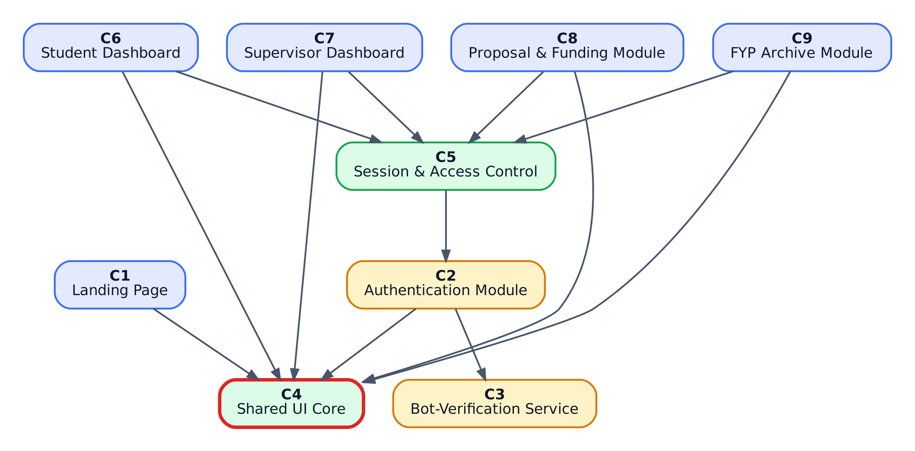
Figure 1 — FYPilot dependency graph (generated from the same data as the matrix)
Dependency paths used for the cascade analysis: C6/C7/C8/C9 → C5 → C2 → C3; C6/C7/C8/C9 → C4; C1 → C4; C2 → C4.

Development — Code Updates
The following changes were made to the existing project (all offline-capable, no backend required):
File | Change
assets/js/main.js | requireRole() reveals the page only after the session and role check pass; ?fault=core demo hook simulates the library failing.
dashboard / supervisor / module1 / module2 / roles .html | Body starts as fyp-guarded; FYP-CORE-UNAVAILABLE fallback screen; onerror on the main.js script tag; System status link in the account menu.
dashboard.js, supervisor.js, module1.js, module2.js, roles.js | Check that window.FYP exists before running; otherwise show the fallback and stop cleanly (no TypeError).
assets/js/login.js + login.html | Session written and verified before redirect; FYP-SESSION-STORE message instead of a silent loop; ?fault=storage demo hook.
status.html + assets/js/status.js (new) | System Status page: live health checks for C1–C9, automatic impact alert, interactive failure-impact simulator over the graph, dependency matrix, fault-injection demo links.
assets/js/dependency-model.js (new) | Components, dependencies and matrix as data — the same data used for this report.
assets/img/dependency-graph.svg (new) | Dependency graph used on the status page.
assets/css/styles.css | Styles for the guard, fallback screen, session alert and status page (appended; existing styles unchanged).
index.html | Footer link to System status.

Testing Results
All checks were automated in headless Chromium against a local server. 36 of 36 passed. T = failure scenarios, R = regression of Activities 1–3, S = status page and responsiveness.
# | Check | Result
1 | T1 fault=core: Student Dashboard content hidden | PASS
2 | T1 fault=core: safe error screen shown immediately | PASS
3 | T1 fault=core: no redirect / no crash loop | PASS
4 | T2 main.js missing: Supervisor PII (CNIC) NOT exposed | PASS
5 | T2 main.js missing: safe error screen shown | PASS
6 | T2 main.js missing: no uncaught script errors | PASS
7 | T2 main.js missing: module1.html fails closed | PASS
8 | T2 main.js missing: module2.html fails closed | PASS
9 | T2 main.js missing: roles.html fails closed | PASS
10 | T3 main.js missing: Landing page still works (unaffected function) | PASS
11 | T4 JavaScript disabled: Supervisor PII hidden | PASS
12 | T4 JavaScript disabled: error screen appears via CSS timeout | PASS
13 | T5 session store blocked: user stays on login (no silent loop) | PASS
14 | T5 session store blocked: informative message shown | PASS
15 | T5 session store blocked: Login button usable again | PASS
16 | T6 ?fault=storage demo: alert shown, still on login | PASS
17 | T7 Turnstile unreachable: login still works via offline fallback | PASS
18 | R1 no session: protected page redirects to login | PASS
19 | R2 Student login -> Student Dashboard visible | PASS
20 | R3 restricted function -> Access Denied for student | PASS
21 | R3b originality check still shows its result | PASS
22 | R4 wrong role -> redirected to own dashboard | PASS
23 | R5 Module 1 valid submission added | PASS
24 | R6 Module 1 empty submission blocked | PASS
25 | R7 Module 2 search returns 1 result | PASS
26 | R8 Status link present in user menu | PASS
27 | R9 logout clears session | PASS
28 | R10 Supervisor login -> full contacts visible to supervisor | PASS
29 | R11 Supervisor approve funding works | PASS
30 | S1 Status page: matrix has 12 dependencies | PASS
31 | S2 Status page: C1,C2,C4-C9 operational, C3 degraded offline (8 ok) | PASS
32 | S3 Simulator C4: 6 direct dependants highlighted | PASS
33 | S4 Simulator C2: 1 direct + 4 indirect | PASS
34 | S5 Monitoring: main.js down -> C4 + C5 reported unavailable + alert | PASS
35 | S6 Status page has no horizontal overflow on mobile | PASS
36 | S7 Error screen fits on mobile | PASS

Problem discovered and how it was corrected
Item | Detail
Problem 1 (Scenario 2) | When main.js could not load, protected pages failed open: supervisor.html showed full contacts and CNIC without any login.
Correction | Fail-closed guard + FYP-CORE-UNAVAILABLE screen; page scripts stop cleanly. Verified: PII hidden with main.js blocked and with JavaScript disabled (tests T1–T4).
Problem 2 (Scenario 1) | When session storage was blocked, login silently looped back to itself with no message.
Correction | Session is verified before redirect; a clear FYP-SESSION-STORE message is shown and the button is re-enabled (tests T5–T6).

Screenshots
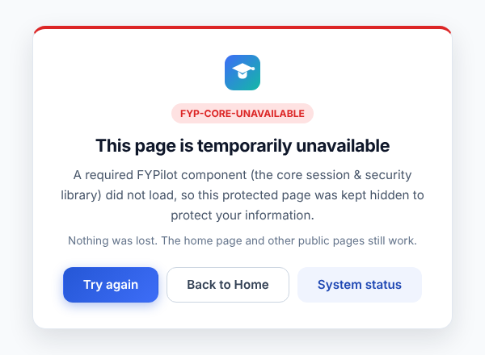
Figure 2 — Fail-closed: Student Dashboard with the core library failed (dashboard.html?fault=core)
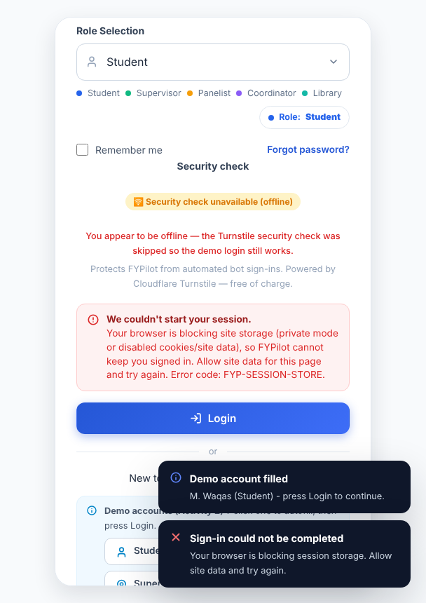
Figure 3 — Scenario 1 handling: clear message when the session store is blocked

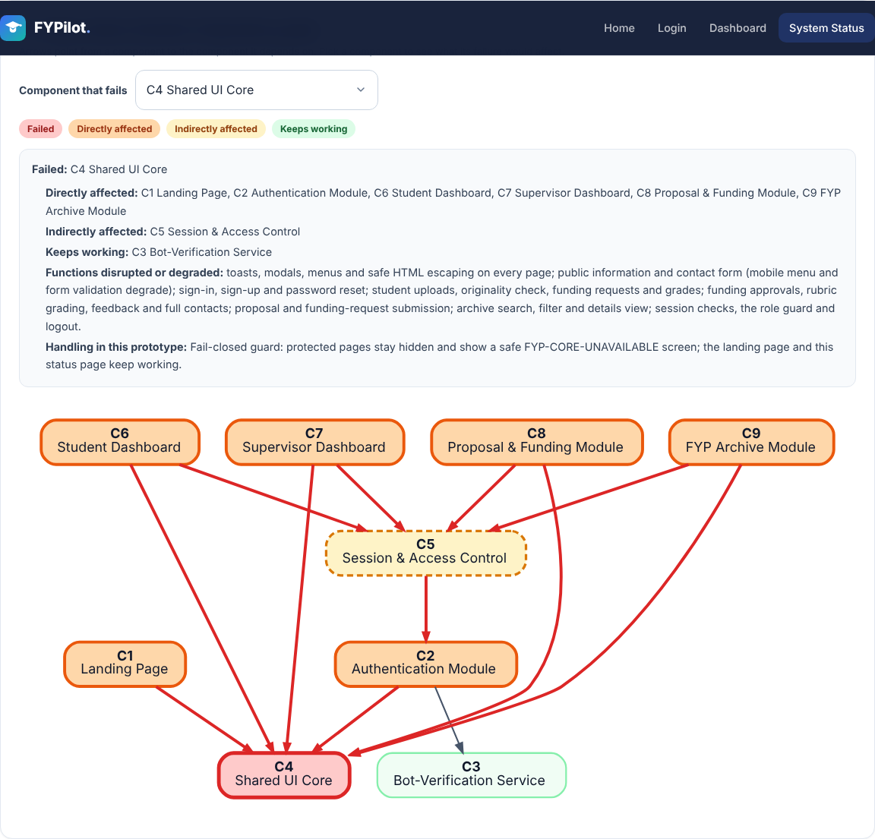
Figure 4 — System Status: failure-impact simulator showing the failure of C4

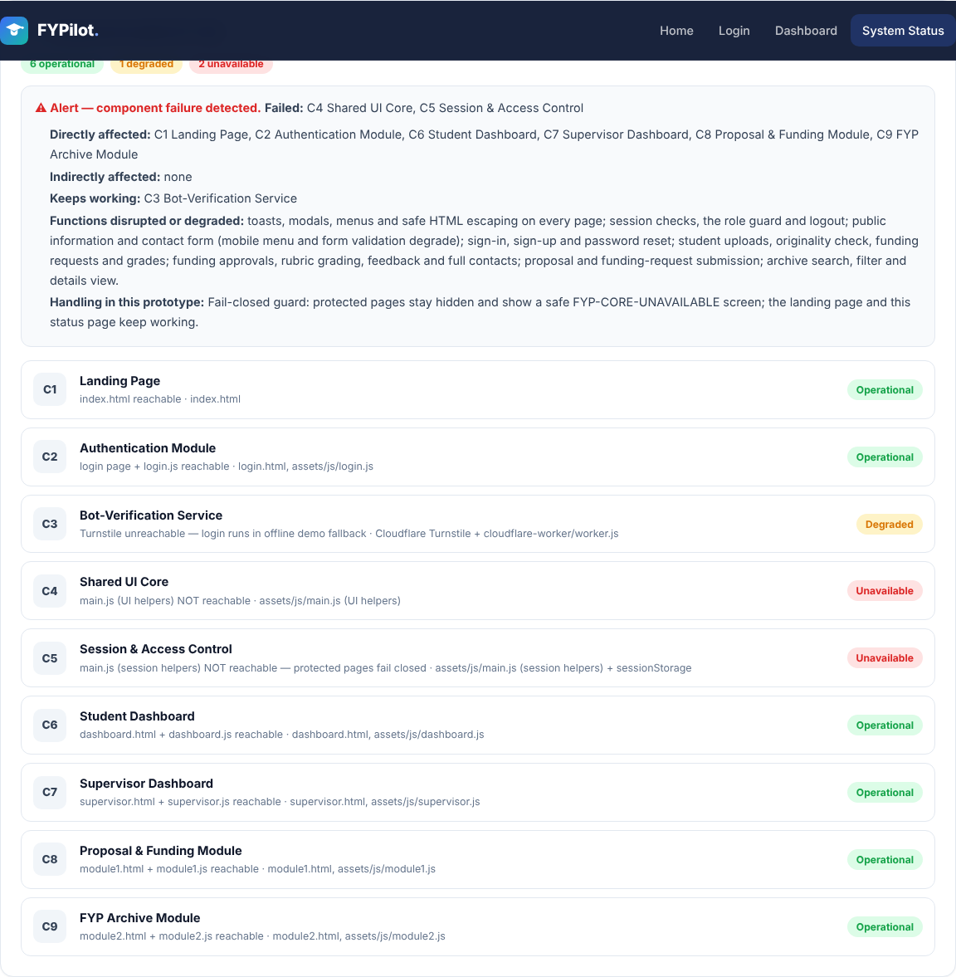
Figure 5 — Monitoring: main.js blocked → C4 and C5 reported unavailable with an automatic impact alert
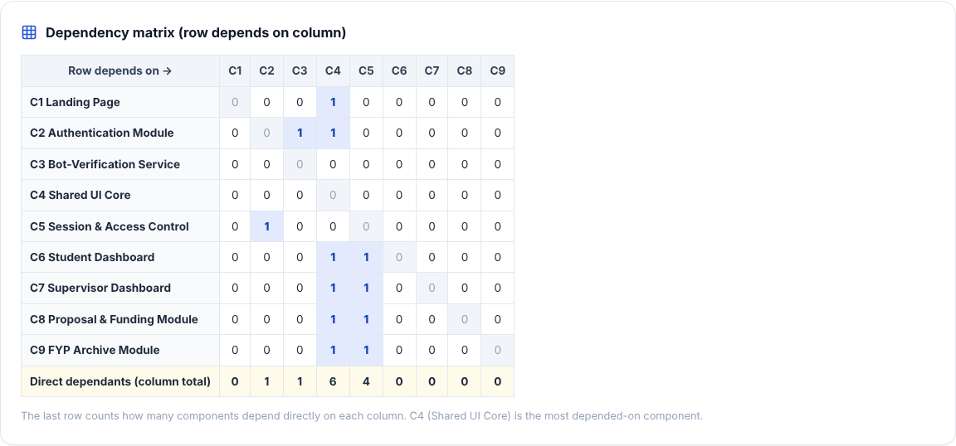
Figure 6 — Dependency matrix rendered on the System Status page

Final Reflection
Dependency mapping showed that FYPilot's reliability and security both rest on one small file, main.js: six components depend on it directly, and it also contains the access guard. Following the dependency paths and actually breaking the components revealed that a failing security dependency can expose data (fail-open) rather than just stop a page, so we redesigned the guard to fail closed and added monitoring. In future phases we will avoid single points of failure by splitting core services and enforcing access on the backend, so no protected data reaches the browser before the server has authorised the user.

Submission Checklist
# | Required item | Status
1 | List of system components and their responsibilities | ✓ Part 1
2 | Direct dependency table | ✓ Part 2
3 | Completed dependency matrix | ✓ Part 3
4 | Analysis of two component-failure scenarios | ✓ Part 4
5 | Identification of a critical component | ✓ Part 5
6 | One proposed failure-handling strategy | ✓ Part 6 (implemented)
7 | Dependency graph | ✓ Part 7
— | Final reflection | ✓

