NAME: WAQAS

REG NO: FA21-BSE-040

Section: 4A

Lab Mid Term

1**: Main success scenario:**

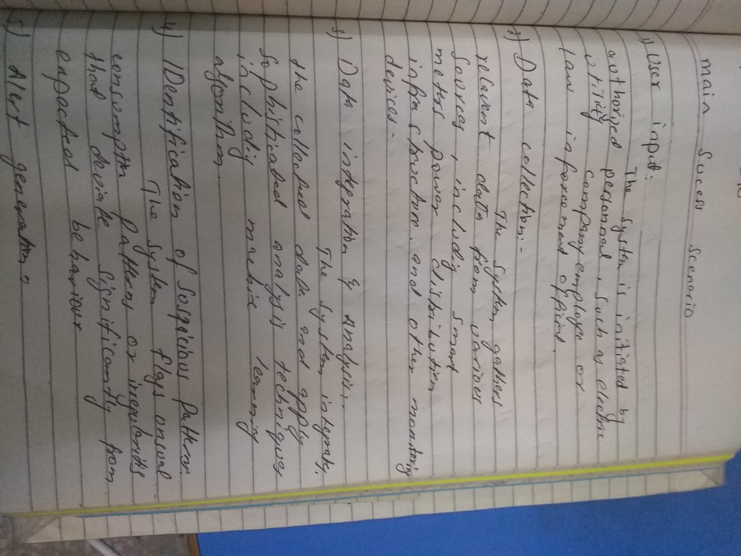

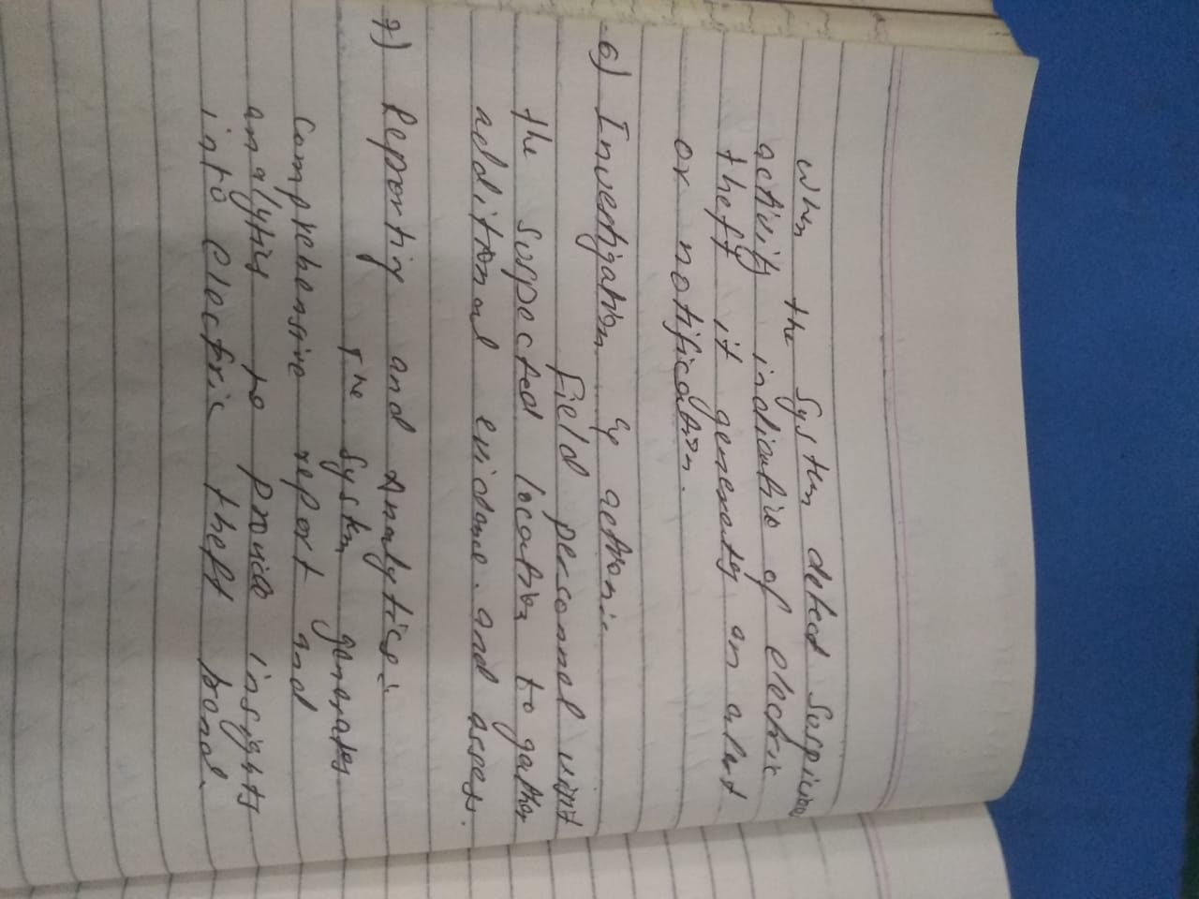

**System Sequence Diagram:**

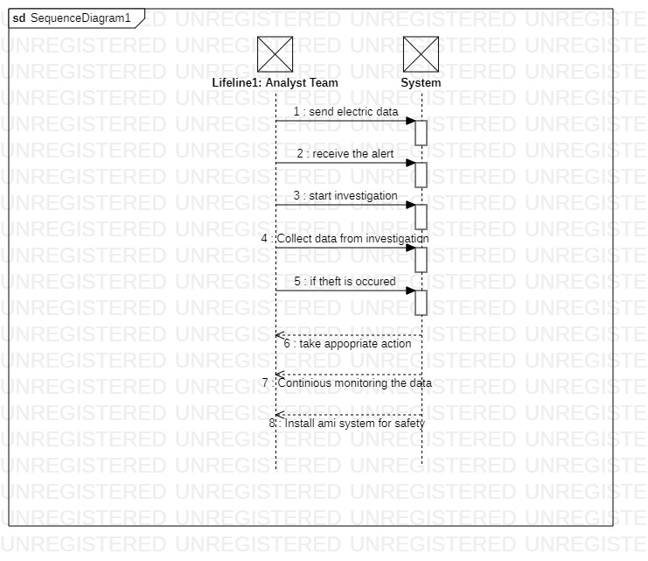

**Prototype:**

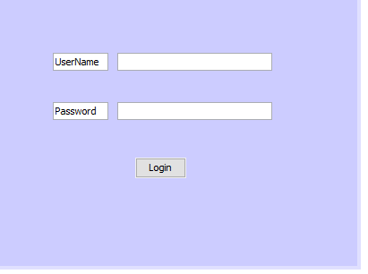**1.**

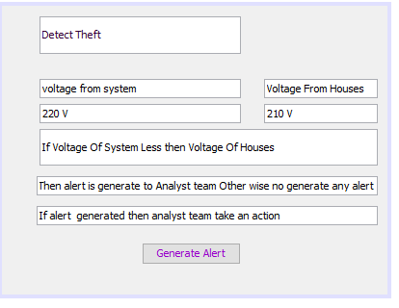**2.**