Assignment

TITLE OF THE Assignment

Student Name

Student Oryx ID
Student LJMU ID

BSc. (Hons) in Computer Science
Oryx University in Partnership with Liverpool John Moores University, Doha Qatar.



Abstract

Abstract I made an emotion detection system that can predict facial expressions from images. I used six classes Angry Fear Happy Neutral Sad Surprised. I worked with a dataset that is already grayscale and faces are mostly centered but i still used preprocessing because i wanted stable input. I resized every image to 48 by 48 and i applied contrast normalization and scaling. I also verified grayscale each time because sometimes an image can be saved in three channels and i do not want my pipeline to break. I scaled pixel values to 0 to 1 because i want training to stay stable and i want the gradients to behave in a smooth way.

I wrote my own neural network using a perceptron style architecture with multiple layers because my task required a customized network. I followed the requirement of the modified activation idea by using a modified input mapping where i use a plus a squared before weight multiplication in each layer. I used sigmoid in hidden layers and softmax in the last layer so i can get a probability for each class. I trained the model with cross entropy loss and sgd and i used mini batches. I added dropout and batch normalization because i did not want the model to overfit and i wanted learning to be stable across many epochs. I also used class weights calculation so if the dataset becomes unbalanced i can still train in a fair way for every class.

I tuned hyperparameters using genetic algorithm because it is required. I searched learning rate hidden layer sizes batch size epochs and dropout. I used validation accuracy as the score because i wanted to pick settings that generalize better instead of only fitting training data. After selecting the best settings i trained longer and i saved the final weights for later use. I evaluated using accuracy precision recall f1 score and confusion matrix and i reported macro scores so each class matters equally. In my final test run i got accuracy 0.3550 and macro f1 0.3416. I also made a real time webcam demo and a single image test mode so i can test the system in practical situations and not only on saved files.

Introduction
I selected facial expression recognition because it is useful in many real systems. I can use it in learning apps health apps and safety monitoring. I also liked it because it mixes image processing and machine learning. I also feel it is an interesting problem because emotions can look very close to each other and the model has to learn small changes in eyes mouth and eyebrows. In daily life people understand emotions quickly but for a computer it is not that easy. So i wanted to build a complete system and understand each step by myself.
In this project I focused on a clean full pipeline. I wanted data loading preprocessing training evaluation and real time testing. I wanted to keep the work clear so if something goes wrong i can find it fast. I also wanted my project to follow the task requirements. The task asked for preprocessing steps and also asked for a custom neural network design with a modified activation idea. So I wrote my own network and training loop instead of using a ready deep learning library. I did this because I wanted full control and i wanted to show the logic clearly in my code.
I kept my final project inside a folder called EmotionDetection_Final. Inside it i used complete_dataset for the data splits. I used insights folder to save result images. I used haarcascade_frontalface_default folder to keep the xml file for face detection. I saved final model weights in weights pkl. I ran training from run py and i ran the live demo from real_time_emotion py. I also added a single image mode in run py so i can test my own images easily. I think this structure is useful because it keeps my code data and results separated and it makes the project easy to run again.

Literature Review
I read about facial expression recognition and i noticed a common pattern. Most systems start with face detection then preprocessing then classification. Some older systems used hand made features like lbp hog or gabor filters. These features work but they need careful tuning. Modern systems often use cnn models because they learn features automatically. But in my task I had a requirement to design a custom perceptron style network so i focused on a multilayer network with a modified input idea.
I also read about normalization and why it matters in training. When input values are large or different for each image training becomes unstable. So many papers use scaling and contrast adjustments. I used clahe because it helps in low light and high light images. I also used batch normalization because it keeps layer activations stable. I used dropout because it reduces overfitting by dropping random units. These ideas are common and they help my model generalize.

System Analysis and Design
I designed the system in simple modules so i can test each part. First module is data loading from folders. Second module is preprocessing of images. Third module is the network and training loop. Fourth module is evaluation and saving outputs. Fifth module is real time demo and single image testing.Inputs are images from complete_dataset folders. Training uses Training folder only. Validation uses Validation folder for tuning and checking model behavior. Testing uses Testing folder only for final evaluation. Outputs are model weights file and result images and console logs. I save plots in insights folder and i save weights in weights pkl. I also print metrics to console so i can record them.

Methodology

Dataset and split
I used complete_dataset as base folder in the final project. Inside it i used Training Validation Testing. When i loaded the dataset my code printed the counts. I had 6000 training images 600 validation images and 600 test images. I used 48 by 48 image size so feature length is 2304.

Preprocessing
Even if images are already grayscale i still verify grayscale. Sometimes an image file is stored in three channels so i convert to gray to keep one consistent channel. Then i resize to 48 by 48 to fix the input shape. Then i apply contrast normalization using clahe because face lighting can change and i want to highlight face details. Then i scale pixel values to 0 to 1 to keep gradients stable. Finally i flatten the image into a vector for the network input.

Neural network design
I built a multilayer perceptron network. I used a modified input step where i use a plus a squared then i do linear layers on that modified input. This matches the requirement idea of using x and x squared. In hidden layers i use sigmoid activation and i use softmax in the last layer for six class prediction. I used dropout to reduce overfitting and i used batch normalization to keep training stable.

Training
I used cross entropy loss with softmax probabilities. I trained with sgd in mini batches. I used momentum weight decay and gradient clipping. Momentum helps smooth updates. Weight decay helps generalization. Gradient clipping helps avoid unstable gradients.

Hyperparameter tuning
The task required genetic algorithm tuning so i used a small genetic algorithm search. I used population size 10 and generations 4 so i evaluated 40 candidate settings. Each candidate had learning rate hidden sizes batch size epochs and dropout. I scored candidates by validation accuracy then I selected best and created new candidates by crossover and mutation. After gap I selected best prams and trained the model longer for 100 epochs.

Results

Final chosen hyper parameters
From my console run i selected these values. Learning rate 0.01. Hidden sizes 256 X 128. Batch size 16. Epochs 30 in the gap candidate. Dropout 0.5 Then i trained 100 epochs with lr decay.

Training and validation
My final validation accuracy at the end was 0.3367. I also printed epoch logs every 5 epochs to see progress. Training accuracy reached around 0.49 at the end. This shows learning happened but there is still a gap. It means the task is hard and some overfitting can still exist even with dropout.

Final test performance
I evaluated the final model on the test set. Test accuracy was 0.3550. Macro precision was 0.3450. Macro recall was 0.3550. Macro f1 score was 0.3416.
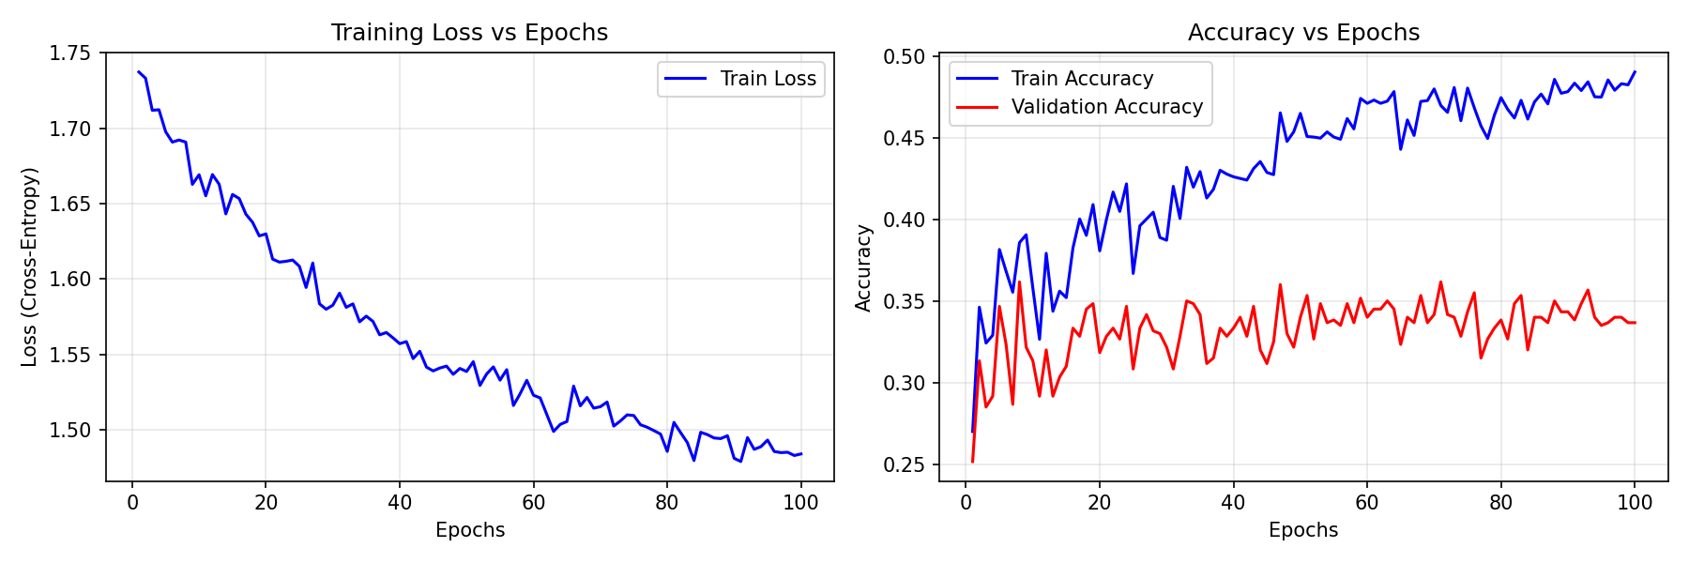

Figure 1 training overview final

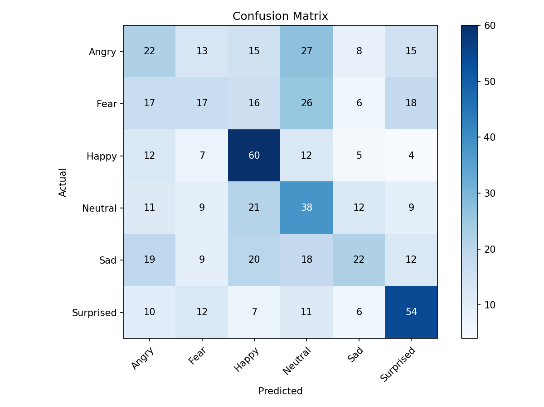

Figure 2 confusion insights final

Discussion
I learned that preprocessing matters even with simple models. When i use resize and normalization the training is more stable. When i use clahe the face details become more clear in many images. I also learned that modified input idea can be implemented cleanly. I used a plus a squared mapping and it gave my network extra non linear signal.
I also learned that genetic algorithm tuning takes time. Even with small population and few generations it trains many models. So i reduced console spam and i kept only summary logs per generation. This helped me focus on the main results. From ga i got a learning rate 0.01 and hidden sizes 256 X 128 which performed best for validation.
I also looked at confusion matrix to understand errors. I saw some emotions are confused with Neutral or Sad. I think it can happen because some faces do not show a strong expression and low resolution also makes small muscle changes hard to see. I also think more augmentation and more training time can improve results.

Conclusion and Future Work
I completed the full system for emotion detection. I loaded dataset splits from complete_dataset. I applied preprocessing with grayscale check resize clahe scaling and flatten. I built a multilayer network with modified input idea and sigmoid and softmax. I trained with cross entropy and sgd. I used batch normalization and dropout to reduce overfitting. I tuned hyperparameters with genetic algorithm. I evaluated using accuracy precision recall f1 and confusion matrix. I saved plots to insights and weights to weights pkl. I also built real time webcam demo and single image testing mode.
For future work i can try more tuning with more generations in ga. I can also add more augmentation like small rotation and shift. I can also try different hidden sizes and learning rate decay settings. I can also try a lightweight cnn if task allows it. I can also improve face detection by using a stronger detector than haarcascade.

Reference
Goodfellow, I.J., Erhan, D., Carrier, P.L., Courville, A., Mirza, M., Hamner, B., Cukierski, W., Tang, Y., Thaler, D., Lee, D.H., Zhou, Y., Ramaiah, C., Feng, F., Li, R., Wang, X., Athanasakis, D., Shawe Taylor, J., Milakov, M. and Ozair, S. (2013) Challenges in representation learning a report on three machine learning contests In Proceedings of the International Conference on Machine Learning ICML 2013
Srivastava, N., Hinton, G., Krizhevsky, A., Sutskever, I. and Salakhutdinov, R. (2014) Dropout a simple way to prevent neural networks from overfitting Journal of Machine Learning Research 15 pp 1929 to 1958
Ioffe, S. and Szegedy, C. (2015) Batch normalization accelerating deep network training by reducing internal covariate shift In Proceedings of the 32nd International Conference on Machine Learning ICML 2015 pp 448 to 456
Bishop, C.M. (2006) Pattern Recognition and Machine Learning New York Springer
Liashchynskyi, P. and Liashchynskyi, P. (2019) Grid search random search genetic algorithm a big comparison for neural architecture search arXiv preprint arXiv 1912 06059

