AI for Barbershop Owners
Fill Empty Chairs, Cut No-Shows, and Win Back Your Time with ChatGPT and Simple AI Tools
Muhammad Waqas
2026

AI for Barbershop Owners: Fill Empty Chairs, Cut No-Shows, and Win Back Your Time with ChatGPT and Simple AI Tools
Copyright © 2026 Muhammad Waqas
All rights reserved. No part of this book may be reproduced in any form without written permission from the author, except for brief quotations in reviews and articles. Buyers may copy the prompts, scripts and worksheets for use in their own shop.
Cedar Street Barbers and the other shops in this book are fictional, and so are the people who work in them. Prices and results in the examples are illustrative, in US dollars, and meant to make the arithmetic easy to follow. Your own numbers will differ.
Artificial intelligence tools, their prices and their features change quickly. The workflows in this book are built to survive those changes: they need a chat assistant, a booking calendar and a spreadsheet, and nothing else. Where a product or rule is named, check its current terms before you rely on it.
This book gives general business information. It is not legal, tax or financial advice. Rules on text messaging, reviews, advertising, privacy and employment vary by country and state. When a decision carries legal risk, talk to a qualified professional where you work.
First edition, 2026

For every barber who has answered the phone
with the clippers still running.

Start here: three ways through this book
You can read this book front to back, and it will make sense that way. But most barbershop owners I know read in the gaps between clients, ten minutes at a time, so here is a shorter route depending on how your shop is set up.

If you work alone
You are the barber, the receptionist, the marketing department and the person who takes the towels home. Your problem is rarely skill. It is that every minute spent on messages, posts and admin is a minute you are not cutting, and the phone does not care that you are mid-fade.
Read Chapter 1 and Chapter 3 first, so the AI knows your shop. Then go straight to Chapter 8 (missed calls and messages) and Chapter 9 (quiet weekday slots). Those two chapters will pay for the book fastest. After that, Chapter 4 makes sure new clients can find you, and Chapter 10 keeps the ones you have coming back.
Keep it simple: one booking link, one place where client messages land, one list of approved replies. You do not need a “tech stack”. You need fewer places to check.

If you have employees
Now there are other people talking to your clients on your behalf, and they will say slightly different things about prices, late arrivals and walk-ins unless somebody writes it down. AI is very good at turning what is in your head into a clear policy sheet, practice scenarios and a checklist.
Read Chapters 1 to 3, then Chapter 12 (team and walk-ins) and Chapter 8 (handoffs between the front desk and the chair). Add the weekly scorecard from Chapter 2 and look at it with your team every Monday or whichever day you are closed.

If you rent chairs
A chair-rental shop is really several small businesses sharing a roof, a sign and a reputation. Each renter usually sets their own prices, keeps their own clients and runs their own booking page. The shop owns the brand, the building and the Google listing.
That means two kinds of marketing: shop-wide marketing that brings people through the door, and each barber’s own marketing to their own book of clients. Before anyone uses AI to message anybody, agree who owns which client list, which message, and which inquiry. Chapter 12 has a responsibility chart for exactly this. Read it early, then Chapters 4 to 6 for the shop-wide work.

What you need
A phone or laptop. A free or paid account with an AI chat assistant such as ChatGPT, Claude, Gemini or Microsoft Copilot. Your booking calendar, whatever it is. A spreadsheet, which can be Google Sheets, Excel or even a notebook if you prefer pencil. That is the whole kit.
Every chapter ends with a short section called “Before your next shift”. It lists the one or two things worth doing this week. If you only ever do those, you will still be ahead of most shops on your street.

A word on the examples
To keep the advice concrete, most chapters follow one fictional shop, Cedar Street Barbers. It has three chairs. The owner, Dre, cuts on the first chair. Tomás is an employee paid on commission. Keisha rents the third chair and runs her own book. Between them they cover all three setups above, and they run into the same problems you do: a dead Tuesday afternoon, a client who swears he called four times, a one-star review written at midnight.
Their menu, used throughout the book:
Service | Price | Time
Standard cut | $35 | 30 min
Skin fade | $40 | 45 min
Beard trim and line-up | $20 | 15 min
Cut and beard | $50 | 45 min
Kids cut (under 12) | $25 | 30 min
Hot towel shave | $45 | 45 min
The full service (cut, beard, hot towel, wash) | $75 | 75 min
Cedar Street is open Tuesday to Friday from 10 a.m. to 7 p.m. and Saturday from 8 a.m. to 5 p.m. It is closed Sunday and Monday. Prices are illustrative and chosen to make the arithmetic easy. Swap in your own as you go.

Introduction: the phone rings mid-fade
It is 2:40 on a Thursday afternoon. You are halfway through a skin fade, blending the line just above the ear, when your phone buzzes on the counter. You glance at it. Unknown number. You keep cutting, because the man in your chair is paying for your full attention and a shaky hand right now would cost you a client.
The phone stops. A minute later it buzzes again: an Instagram message. Yo do you have anything Saturday morning? Then the booking app pings with a cancellation for 4:30. Then a text from a regular asking whether you still do hot towel shaves, because he saw something about it on Google, and is the price still $40? (It isn’t. It’s $45. Google is out of date.)
By the time you finish the fade, brush off the neck and take payment, there are four things waiting for you. You will get to them. Probably. Maybe at 7:15 tonight, sitting in the car, after the shop is swept. By then the unknown caller has booked with the shop down the road, the Saturday DM has gone cold, and the 4:30 slot sat empty.
None of this is a skills problem. You can cut. Your clients come back. The trouble is everything that happens around the chair: the messages, the calendar, the posts, the reviews, the reminders, the reorders, the numbers you know you should look at and never do. That work does not get paid, it never ends, and it lands on you because nobody else will do it.
This book is about handing a big share of that work to an assistant that costs less than a single haircut a month, never gets bored of answering “how much is a cut”, and can draft a week of posts while you sweep up.

What this book is, and what it is not
It is not a book about robots replacing barbers. No software is going to taper a neckline, talk a nervous teenager through his first skin fade, or notice that a regular has gone quiet and ask how his mother is doing. People do not come to a barbershop only for the haircut. A study published in the New England Journal of Medicine in 2018 put pharmacists inside 52 Black-owned barbershops in Los Angeles to help customers with high blood pressure. Barbers encouraged their clients to see the pharmacist during visits, and after six months the average systolic pressure in the shops with the program had dropped by 27 points, compared with about 9 in the shops without it. Health researchers chose barbershops because of something every barber already knows: the chair is a place where people listen and trust.
Nothing in this book should get in the way of that. Everything in it is meant to give you more time for it.
It is also not a book about chasing the newest app. AI products change every few months. Prices move, features get renamed, companies get bought. A book that told you to click a particular button in a particular app would be out of date by the time you read it. So the workflows here are built on three things that will still be around in five years: a chat assistant that can write and summarize, your booking calendar, and a simple spreadsheet. Where a specific product is useful, I name it, but the method never depends on it.
What it is: a practical handbook for independent barbershop owners, written for someone with clippers in one hand and a phone in the other. Every chapter ends with something you can put to work before your next shift. Most of the tools cost nothing or close to it.

The deal: AI drafts, you decide
There is one rule that runs through every page of this book, and it is worth stating plainly now.
AI drafts. You decide.
The AI writes the first version of a message, a post, a policy or a checklist. It summarizes a messy spreadsheet. It suggests five ways to fill a quiet afternoon. It never sets a price, promises a time slot, contacts a client without your approval, or decides who gets a discount. You and your team set prices, check availability, approve messages and choose what to change.
This is not caution for its own sake. AI chat tools are good at producing fluent, confident text, and they will produce it whether or not it is true. Ask one what time your shop opens on Saturday and, if you have not told it, it may guess, and it will guess in a calm, friendly voice that sounds exactly like a correct answer. In 2024, a Canadian tribunal ordered Air Canada to compensate a passenger after the airline’s website chatbot gave him wrong information about a bereavement fare. The airline argued, more or less, that the chatbot was responsible for its own words. The tribunal did not accept that. The business is responsible for what its tools tell customers.
Your shop is the same. If an AI reply promises a client a $30 cut that is really $35, the client will expect $30, and they will be right to. So we build in checks: a written shop brief so the AI works from your facts, test questions before any template goes live, and a human eye on anything that goes out with the shop’s name on it.

Why now
Three things have changed in the last couple of years that make this the right moment for a barbershop owner to pay attention.
First, the tools got easy. You no longer need a developer, an “integration” or a monthly contract with a marketing agency to get useful help. You type what you want in plain English, the way you would explain it to a new front-desk hire, and you get a draft back in seconds.
Second, clients changed how they look for a barber. Many now search on a phone, read reviews, look at photos of actual cuts and book online without calling. Some now ask an AI assistant to recommend a barber, and the assistant pulls from the same reviews and listings that Google uses. A shop with an out-of-date listing, five reviews from 2021 and no booking link is invisible to all of them.
Third, new clients got harder to win. Zenoti, a company that sells booking software to salons and barbershops, publishes yearly benchmarks from the shops on its platform. Its 2026 report found that new-guest visits at barbershops fell 17% in 2025, the steepest drop of any type of beauty business it tracks, while visits from existing guests grew 2%. Whatever the reasons in your area, the pattern is worth noticing: the shops that held up were the ones that kept their regulars coming back. That is precisely where small, consistent effort, the kind AI makes cheap, pays off.

How the book is organized
Part One, Before you touch a tool, covers what AI can and cannot do for a barbershop, how to find where your shop is actually losing bookings, and how to write the one-page “shop brief” that makes every AI answer better. Do not skip it. A chat assistant without your shop’s facts is a confident stranger.
Part Two, Get found and get chosen, is about new clients: your Google Business Profile and local search, turning the cuts you already do into posts, earning honest reviews and referrals, and testing paid ads without burning money.
Part Three, Fill the book and keep it full, is about the calendar: answering every inquiry, filling quiet weekday slots, reducing no-shows and bringing back regulars who drifted.
Part Four, Run a tighter shop, covers pricing by the chair hour, working with employees and chair renters, cutting admin time, and a 30-day plan to put it all in motion.
At the back you will find a library of copy-and-paste prompts, ready-to-adapt scripts, worksheets you can rebuild in any spreadsheet, and three worked cases: a solo barber with quiet afternoons, a busy shop fighting no-shows, and a chair-rental shop sharing one brand.

A promise about numbers
You will see a lot of arithmetic in this book. Do not let that put you off. None of it goes beyond what you already do at the register, and every calculation is walked through step by step. The reason it is there is simple: “We got loads of likes” is not a result. “Seven extra cuts were completed, worth $210 after product costs” is a result. The second kind of sentence is how you decide whether something deserves another week of your time.
One habit makes all the difference: count what actually happened in the chair, not what was booked, liked, clicked or promised. A booking that no-shows is not a client. A post with 2,000 views that brought in nobody is not marketing that worked. Throughout this book, the measure that matters is completed visits, and the money they leave behind after direct costs.
Let’s start with what this technology is actually good for.

Part One: Before you touch a tool
Know what the assistant is good for, find where the shop is leaking, and give AI the facts it needs.

Chapter 1: What AI can and can’t do in a barbershop
Dre Ellis opened Cedar Street Barbers eleven years ago with one chair, a secondhand Belmont and a cash box. He is good with people and better with clippers. He is not, by his own description, “a computer guy”. His nephew set up the booking app. The shop’s Instagram was run by whoever had a free minute, which meant nobody.
The first time Dre tried an AI chat assistant, he typed: write me a post for my barbershop. He got back three paragraphs about “elevating your grooming experience” in “the heart of the community”, with five hashtags and an emoji of a pair of scissors. It sounded like a hotel brochure. He closed the app and did not open it again for a month.
That first attempt is where most barbers stop. The tool did exactly what it was asked, and what it was asked was nearly nothing. It did not know the shop’s name, its prices, its street, its barbers, or what Dre wanted the post to achieve. So it filled the gaps with the most average barbershop post it could imagine.
This chapter explains, without jargon, what is happening when you type into one of these tools, which jobs in a barbershop it does well, which it does badly, and which ones it should never touch.

What a chat assistant actually is
The tools this book uses are called large language models, but you can forget that name. In practice, a chat assistant is a program that has read an enormous amount of text and learned the patterns of how words follow each other. When you give it a request, it writes the response that best fits the patterns, one word after another.
That explains both its strength and its weakness.
The strength: it writes fast and it writes fluently. It knows what a friendly appointment reminder sounds like, what a polite reply to a bad review looks like, and how a price list is usually laid out. Give it your facts and a clear job, and it will draft in ten seconds what might take you twenty minutes on your phone.
The weakness: it does not know anything about your shop unless you tell it. It cannot see your calendar. It does not know that Tomás is off on Wednesdays or that you stopped doing designs last spring. And when it lacks a fact, it does not stop and say so unless you ask it to. It writes whatever would most plausibly come next. Sometimes that plausible guess is right. Sometimes it is a confident, made-up price.
Some assistants can now search the web, read files you upload, or connect to other apps. Those features help, but they do not change the basic rule. The assistant works from what it is given. Your job is to give it the right material and check what comes back.

The main tools, briefly
You do not need all of them. Pick one and get comfortable.
General chat assistants. ChatGPT (from OpenAI), Claude (from Anthropic), Gemini (from Google) and Microsoft Copilot all do the work in this book. Each has a free version and a paid tier, which as I write usually costs around $20 a month. The free tiers are enough to start. Paid tiers usually give you more use per day, better models, and the ability to save instructions or upload files. If you already live in Google’s apps, Gemini will feel familiar. If you use Outlook and Word, Copilot might. Otherwise, try two for a week and keep the one whose writing sounds most like you.
AI features inside booking software. Most booking platforms built for barbers and salons, such as Square Appointments, Booksy, Fresha, Vagaro, SQUIRE and others, have been adding AI features: automatic reminders, waitlists that fill cancellations, suggested replies, marketing campaigns and, in some cases, an AI receptionist that answers calls and messages. These can be useful because they can see your real calendar. Chapter 8 explains how to judge them.
AI receptionists and phone agents. These answer your shop’s phone with a natural-sounding voice, answer basic questions and either book the client or send them a link. Some are built into booking platforms, others are separate services that connect to your calendar. They cost real money each month, so they belong in a later stage, after you have the basics in place.
Design and photo tools. Canva, the editing tools on your phone, and the features built into Instagram and TikTok can now remove backgrounds, fix lighting and suggest captions. Useful for posts, covered in Chapter 5.
You do not need anything else to use this book.

Seven jobs AI does well in a barbershop
Here is where an assistant earns its keep. In each case, it does the first draft and you make the call.
1. Writing messages. Reminders, replies to “how much for a cut”, missed-call texts, rebooking nudges, holiday-hours notices, the message to a regular you have not seen in two months. These are short, repetitive and need to be friendly and correct. That is the sweet spot.
2. Writing for the public. Instagram captions, Google Business Profile posts, the “About” section on your website, the service descriptions on your booking page, a flyer for the gym next door. AI is fast at turning your rough notes into clean copy, and at writing three versions so you can pick.
3. Replying to reviews. It can draft a warm thank-you to a five-star review in your voice, and, more usefully, help you write a calm reply to a harsh one at a moment when you are not calm.
4. Making sense of numbers. Paste in last month’s appointment export (with client names removed) and ask which hours were empty, which services grew, and how many first-time clients came back. It will not replace your accountant, but it will turn a spreadsheet you have been avoiding into three plain sentences.
5. Writing policies and checklists. Late-arrival policy, no-show policy, opening and closing checklists, a new-barber onboarding sheet, a walk-in rule for Saturdays. You know the rules. AI writes them down clearly and consistently.
6. Brainstorming. Ideas for a back-to-school promotion, ten things to post when you have no new cuts to photograph, five ways to partner with the boxing gym down the road. Most ideas will be ordinary. One or two will be good, and that is enough.
7. Practicing conversations. Ask it to play an angry client who was overcharged, or a new client nervous about his first fade, and practice what you would say. This is surprisingly useful for training a new front-desk person or a junior barber.

Five jobs it should not do alone
Setting prices. AI can lay out the arithmetic of a price change (Chapter 11 shows how), but it does not know your rent, your competitors’ quality, or what your clients will tolerate. It should never quote a price that did not come from your menu.
Promising appointments. A chat assistant that is not connected to your live calendar cannot know what is free. Any message that offers a specific time must be checked against the calendar before it goes out. Even AI tools that are connected to your calendar need testing (Chapter 8).
Handling client data carelessly. Do not paste client names, phone numbers, photos, health details (scalp conditions, allergies) or payment information into a general chat assistant. Use placeholders such as [first name] and fill them in inside your booking system. The rule of thumb: if you would not write it on a sticky note and leave it on the counter, do not paste it into a chat window.
Making legal or employment decisions. AI can explain what a chair-rental agreement usually covers or draft questions for your lawyer. It is not a lawyer. The rules on worker classification, texting consent, tips and licensing vary by state and country.
Faking anything. Fake reviews, invented testimonials, “before” photos of someone else’s work, a made-up deadline (“only 2 slots left!” when there are nine). Apart from being dishonest, much of this is illegal. In the United States, a Federal Trade Commission rule announced in 2024 specifically bans fake reviews, including AI-generated ones. Chapter 6 covers this in detail.

Why your first attempt was disappointing
Go back to Dre’s first try: write me a post for my barbershop. It failed because the request had no facts, no goal and no limits. Compare it with this:
Write an Instagram caption for Cedar Street Barbers, a three-chair barbershop at 412 Cedar Street. The photo shows a mid skin fade with a hard part, cut by Tomás. Goal: get people to book a weekday appointment with Tomás. A skin fade costs $40 and takes 45 minutes. Booking link: [booking link]. Tone: relaxed and confident, like a barber talking to a regular, not an advertisement. Keep it under 60 words. No emojis, no hashtags, no words like “elevate” or “experience”. Do not invent any facts that are not in this message.
Same tool, same thirty seconds. Here is the kind of thing it returns:
Mid skin fade with a hard part, done by Tomás this morning. If you’ve been meaning to tighten things up, he has weekday openings this week. Skin fades are $40 and take about 45 minutes. Book with Tomás here: [booking link]
That is a post a barber would actually write. The difference was not the tool. It was the instructions.
Chapter 3 turns this into a habit with a one-page shop brief, so you do not have to retype your facts every time. For now, remember the shape of a good request, because every prompt in this book follows it.
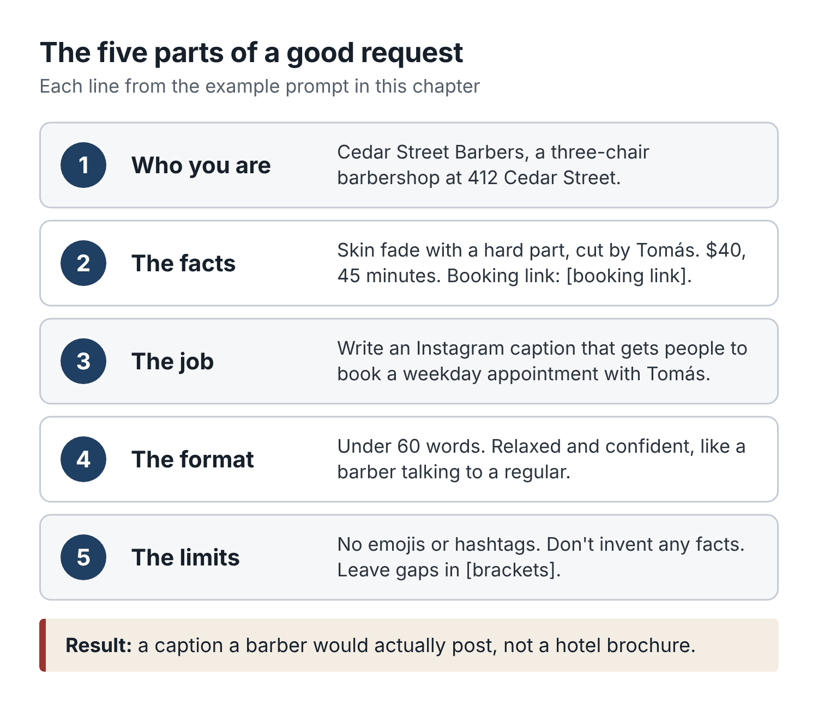
Figure 1. The five parts of a good AI request. Fill in each one and the draft improves immediately.
- Who you are: the shop, the barber, the kind of clients.
- The facts: prices, times, names and links, and only verified ones.
- The job: what to write and what it should achieve.
- The format: length, tone, and where it will be used.
- The limits: what to avoid, plus the instruction to leave gaps in [brackets] and not invent anything.

Talking to it like a new hire
The most useful mindset I know is this: treat the assistant like a bright new front-desk hire on their first morning. Smart, fast, eager, and knows nothing about your shop.
You would not tell a new hire “handle the messages” and walk off. You would say: here is the price list, here is how we handle late arrivals, here’s how we talk to clients, don’t promise anything you’re not sure of, and show me your replies for the first week. Then you would correct them: “Too formal, we don’t say ‘Dear sir’.” “Good, but always put the booking link at the end.”
Do the same with AI. When a draft is off, do not start again from scratch. Tell it what is wrong:
- Shorter. Half the length.
- Too salesy. Sound like a barber texting a regular.
- Remove the second sentence. We don’t offer that.
- Write three more versions, each with a different first line.
Each correction makes the next draft better. After a few rounds you will have a reply you can save as a template and reuse for months.

What it costs, and what it saves
Let us be concrete. A paid chat assistant costs roughly $20 a month. At Cedar Street’s prices, that is less than one standard cut.
Now count the time. Suppose Dre spends twenty minutes a day on messages, posts and replies. Six working days a week, that is two hours a week, or about eight and a half hours a month. If AI drafting cuts that in half, Dre gets back four hours a month. Four hours is eight standard cuts, or $280 at the register if those hours can be filled. Even if only some of them can, the tool pays for itself many times over.
But time saved is not the main prize. The main prize is the work that never gets done at all today: the review that never gets a reply, the overdue regular who never gets a text, the Tuesday that never gets promoted. AI makes those jobs small enough that they finally happen.

A note on privacy you should read twice
Every chapter of this book will remind you of this, so let me explain it once properly.
When you type into a general chat assistant, your words are sent to the company that runs it. Depending on the product and your settings, they may be stored, reviewed by staff for safety, or used to improve future models. Business and team plans often have stricter protections. Either way, treat the chat window as a place for drafting, not for storing client records.
In practice:
- Use placeholders: [first name], [phone], [appointment time], [booking link].
- Remove names and phone numbers before pasting any export of appointments or sales. Replace them with a client number if you need to tell people apart.
- Never paste card details, home addresses or anything about a client’s health.
- Get written permission before you post a client’s photo, and never upload client photos to an AI tool without that permission.
- Keep your booking system and your payment system as the single source of truth. AI summaries are a view, not the record.
Your clients trust you with their faces, their time and their conversation. Keeping that trust is worth more than any shortcut.

Before your next shift
- Pick one chat assistant and create an account. Use the free tier for now.
- Try the Instagram caption prompt from this chapter with a real cut from this week. Edit it once by telling the assistant what to change.
- Write down the three messages you type most often. You will turn them into templates in Chapter 3.

Chapter 2: Find where your shop is losing bookings
Ask most barbershop owners what their business needs and you will hear the same answer: more clients. More followers, more new faces, more people walking in.
Dre said exactly that. “I need new clients. Tuesdays are dead, Wednesdays are dead, and the young guys all go to the place with the neon sign.”
He was half right. Tuesdays and Wednesdays were quiet. But when he sat down and counted, he found something he did not expect. In two weeks, the shop phone had missed 31 calls. Nineteen of those callers never heard back. Only about one in five clients left the shop with their next appointment booked. And of the 26 first-time clients in those two weeks, a later check showed only nine had come back within six weeks.
Dre did not have a new-client problem first. He had a bucket with holes in it. Pouring more water in (ads, posts, a neon sign of his own) would have meant paying to fill a bucket that was leaking at the bottom.
This chapter shows you how to find the holes in your own bucket, using a phone log, your booking calendar and one simple scorecard. It takes about an hour to set up and ten minutes a week after that. It is the least exciting chapter in the book and possibly the most useful.

The journey from stranger to regular
Every regular in your chair today was once a stranger who did not know your shop existed. Between those two points, they went through a series of steps, and at every step some people drop out.
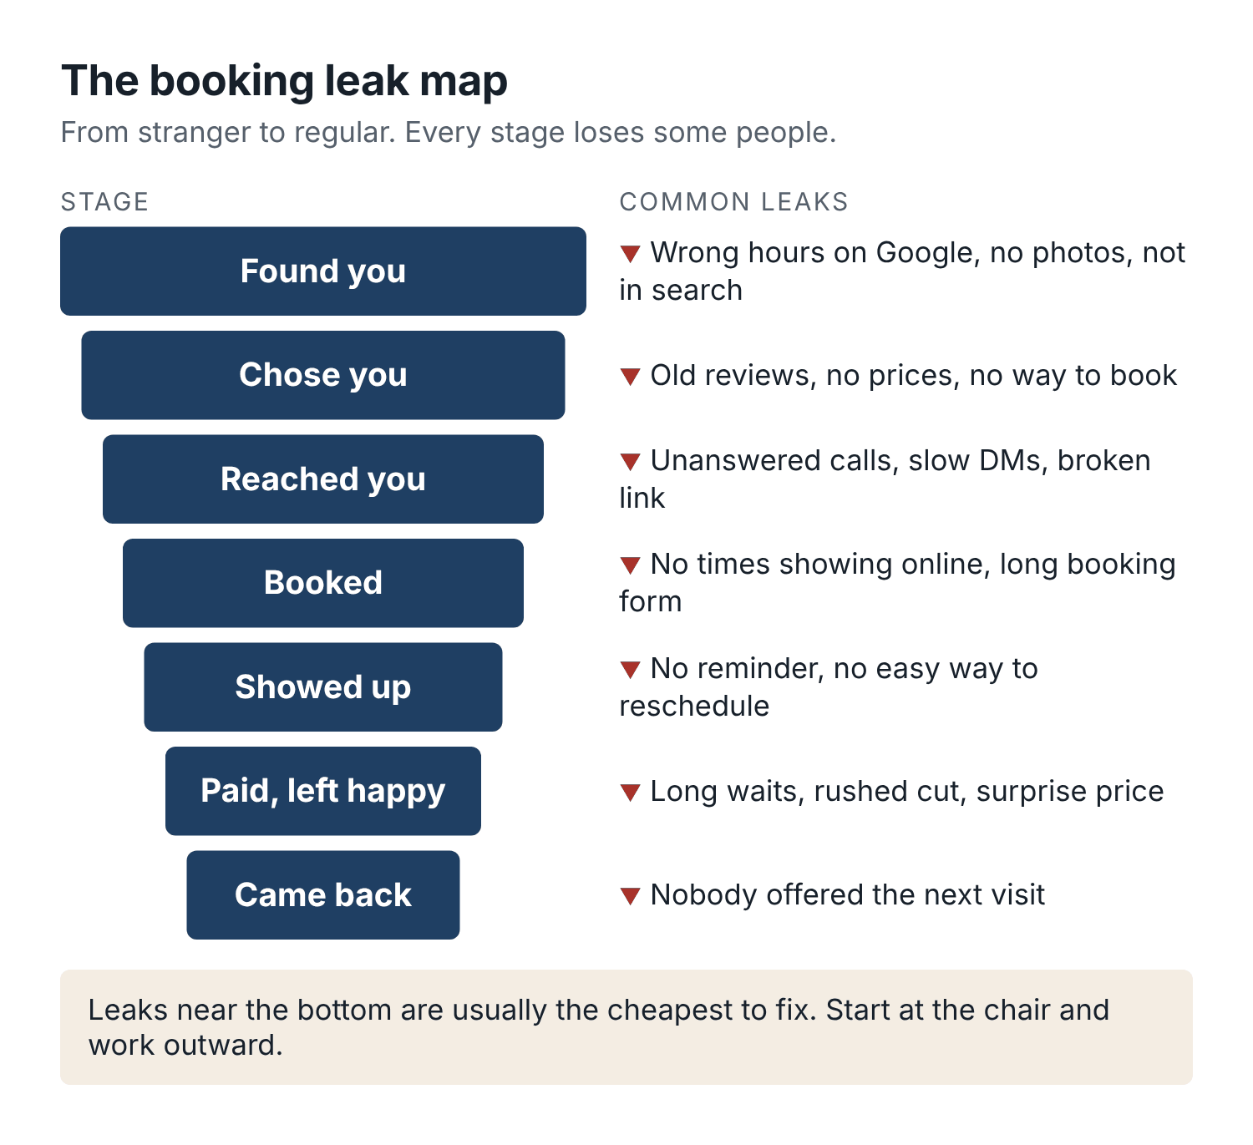
Figure 2. The booking leak map. Every stage loses some people. Your job is to find the stage that loses the most.
Here are the stages, with the most common leaks at each.
Found you. Someone searches “barber near me”, sees a post, walks past, or hears your name from a friend. Leaks: your Google listing shows the wrong hours or no photos; you do not appear in search at all; your posts never mention where you are.
Chose you. They look at your reviews, photos, prices and booking options and decide whether to try you. Leaks: few or old reviews; photos that do not show the cuts they want; no prices anywhere; no obvious way to book.
Reached you. They call, message, click the booking link or walk in. Leaks: calls go unanswered; DMs sit for a day; the booking link is broken or buried; walk-ins see a full shop and leave.
Booked. They get an appointment. Leaks: the online calendar shows no availability even though the barber has gaps; the booking form is too long; the deposit rule scares them off without explanation.
Showed up. They arrive. Leaks: no reminder; reminder sent too late; no easy way to reschedule, so they just do not come.
Paid and left happy. The cut, the conversation, the checkout. Leaks: long waits past the appointment time; a rushed cut; a surprise price.
Came back. They become a regular. Leaks: nobody offered them the next appointment; no reminder when they were due; no reason to choose you over the shop that is closer to their new job.
Here is the important part. A leak near the end of the journey is usually cheaper to fix than a leak at the start. A client who has already sat in your chair and liked the cut is the easiest booking in the world. Asking “same time in three weeks?” at checkout costs nothing. Finding a brand-new client through advertising costs real money. So when you look for leaks, start from the chair and work outward.

Count your sellable chair time
Before you measure anything else, you need to know how much time you actually have to sell. This number is the denominator for half the measures in this book.
Sellable time is the time a barber is in the shop and available to cut, minus time that is not for sale: lunch, cleaning, breaks, meetings, admin blocks. It is not your opening hours, because nobody cuts for nine straight hours without eating.
Here is Cedar Street, for Dre’s chair:
- Tuesday to Friday, 10 a.m. to 7 p.m.: 9 hours a day, 36 hours.
- Saturday, 8 a.m. to 5 p.m.: 9 hours.
- Total time in the shop: 45 hours.
- Minus a 30-minute lunch each day (5 days): 2.5 hours.
- Minus 30 minutes a day for cleaning, restocking and the end-of-day close: 2.5 hours.
- Sellable time: 40 hours, or 2,400 minutes a week.
Do this for each barber, because their hours differ. Tomás works Tuesday to Saturday too, so his number is similar. Keisha, as a chair renter, sets her own hours, and her numbers belong to her. If she chooses to share them, great; if not, you track the shop-level things you control, such as the phone and the Google listing.
Once you know sellable time, you can work out the measure most shop owners never calculate:
Chair utilization = completed service minutes ÷ sellable minutes.
If Dre completed 51 hours of cuts over two weeks (3,060 minutes) out of 4,800 sellable minutes, his utilization was 64%. Count completed minutes: a no-show does not count, and neither does a 45-minute slot where the barber stood around because the client was 25 minutes late.
For a rough sense of scale, Zenoti’s 2026 benchmark report put the median staff utilization at barbershops on its platform at 56%, with the top tenth of shops at 75%. Those are one company’s figures from its own customers, so do not treat them as a law of nature. They do give you a sense of what “busy” looks like. A barber at 50% has roughly half of their sellable time empty. Moving from 56% to 66% on a 40-hour week is four extra hours of cutting, every week, without a single new chair.

Seven numbers to count for two weeks
Pick two normal weeks. Avoid the week before a major holiday, school picture day, or the week the street was dug up. Then count these seven numbers. Most can be pulled from your booking system; one or two need a tally sheet by the register.
1. Completed service minutes, per barber. From your booking export. If your system does not show minutes, multiply each service by its standard time from the menu.
2. Calls missed, and calls never returned. Check your phone’s call log at the end of each day. Count calls that rang out while you were busy, then count how many of those you or anyone else called or texted back. The second number is the painful one.
3. Messages left waiting more than two hours. Instagram DMs, Facebook messages, Google messages, texts. You do not need precision. A tick on a sheet when you notice one that has waited too long is fine.
4. Walk-ins turned away or who left without a cut. A tally by the door. Saturday mornings are where this hides.
5. No-shows and late cancellations. From your booking system. A no-show is a client who did not come and did not tell you. A late cancellation is one who cancelled inside your cutoff (for example, less than 24 hours ahead). Count them separately; they have different fixes.
6. Checkout rebooking. Of the clients who finished a visit, how many left with their next appointment already booked? Count only clients for whom rebooking makes sense. A tourist passing through or a one-off wedding trim does not count.
7. First-time clients, and how many came back. Count first-timers in the two weeks. Then, six weeks later, check how many of them returned. Six weeks works for most standard cuts; if most of your clients come every two to three weeks, use four.
That is it. You do not need ten dashboards. Seven numbers, two weeks, one sheet.

Turn the numbers into rates
Raw counts are hard to compare. Turn each one into a rate, and always keep the number underneath so you can see how big the sample is.
- Missed-call recovery rate = missed calls that got a callback or text ÷ missed calls.
- No-show rate = no-shows ÷ appointments due in the period. Do not include appointments cancelled ahead of time in the bottom number, because those were not “due” anymore.
- Checkout rebooking rate = eligible completed visits that left with a future booking ÷ eligible completed visits.
- First-visit return rate = first-timers who came back within your window ÷ first-timers.
Here is Cedar Street’s two-week baseline for the shop as a whole (Dre and Tomás; Keisha tracked her own):
Measure | Count | Rate
Chair utilization, Dre | 3,060 of 4,800 min | 64%
Chair utilization, Tomás | 2,520 of 4,800 min | 53%
Missed calls returned | 12 of 31 | 39%
No-shows | 9 of 248 due | 3.6%
Checkout rebooking | 47 of 214 eligible | 22%
First-timers back within 6 weeks | 9 of 26 | 35%
Look at that table and the story jumps out. No-shows were low; Dre had been worrying about the wrong thing. The real holes were missed calls (19 people who reached out and got silence), rebooking (four out of five clients walking out with nothing booked), and first-timers who never returned.

Compare like with like
One rule will save you from a lot of bad decisions: compare the same weekdays and the same times of year.
Saturdays are always busier than Tuesdays. The week before school starts is always busier than the week after. December is different from February. If you change something on a Tuesday and compare it with last Saturday, you will learn nothing. If you run a promotion in the week before Christmas and declare it a success, you may be congratulating yourself for the calendar.
So when you check whether something worked, compare:
- Tuesday afternoons with previous Tuesday afternoons, not with the week’s average.
- This March with last March, if you have the data, or with the four weeks before.
- The same barber with themselves. Tomás’s numbers and Dre’s numbers are different businesses in some ways; Tomás has been at the shop eight months and Dre eleven years.
And keep the denominators. “We got 6 rebookings” means nothing until you know whether it was 6 of 10 clients or 6 of 100.

Let AI read the spreadsheet
You do not need to be good with spreadsheets. Most booking systems let you export appointments to a CSV file, which opens in Excel or Google Sheets. Before you go near an AI tool, remove client names, phone numbers and emails. Replace each client with a number if you need to tell repeat visits apart. Then paste the cleaned data, or upload the file if your assistant supports it, with a prompt like this:
Below is two weeks of appointment data from my barbershop, with client names removed. Columns: date, weekday, start time, barber, service, booked length in minutes, status (completed, no-show, cancelled, late-cancel), client ID, first visit (yes/no), next appointment booked at checkout (yes/no).
Sellable time per barber is 2,400 minutes per week.
Please:
- Calculate chair utilization for each barber using completed minutes only.
- List the weekday and time blocks (in 2-hour blocks) with the most unbooked sellable time.
- Calculate the no-show rate and the checkout rebooking rate, and show the counts behind each rate.
- Tell me which single problem looks biggest, and explain why in two or three sentences.
Show your arithmetic. If any data is missing or unclear, say so and do not guess.
[paste data here]
Then check its arithmetic on one or two numbers yourself. AI assistants have become much better at math, but they can still slip, especially with long pasted tables. If the answer does not match what you counted by hand, trust your count and ask the assistant to recheck. Asking it to “show your arithmetic” makes mistakes far easier to spot.
What you get back is a plain summary, something like: Tomás’s chair is 47% empty on Tuesday and Wednesday between noon and 4 p.m. The checkout rebooking rate is 22% (47 of 214). Most first-time clients booked a skin fade. That last line is a clue for Chapter 5: if new clients come for skin fades, your posts should show skin fades.

Build the weekly scorecard
Once you have a baseline, keep the same measures going every week. A scorecard is just a single page you look at on the same day each week, ideally the day the shop is closed, with a coffee.
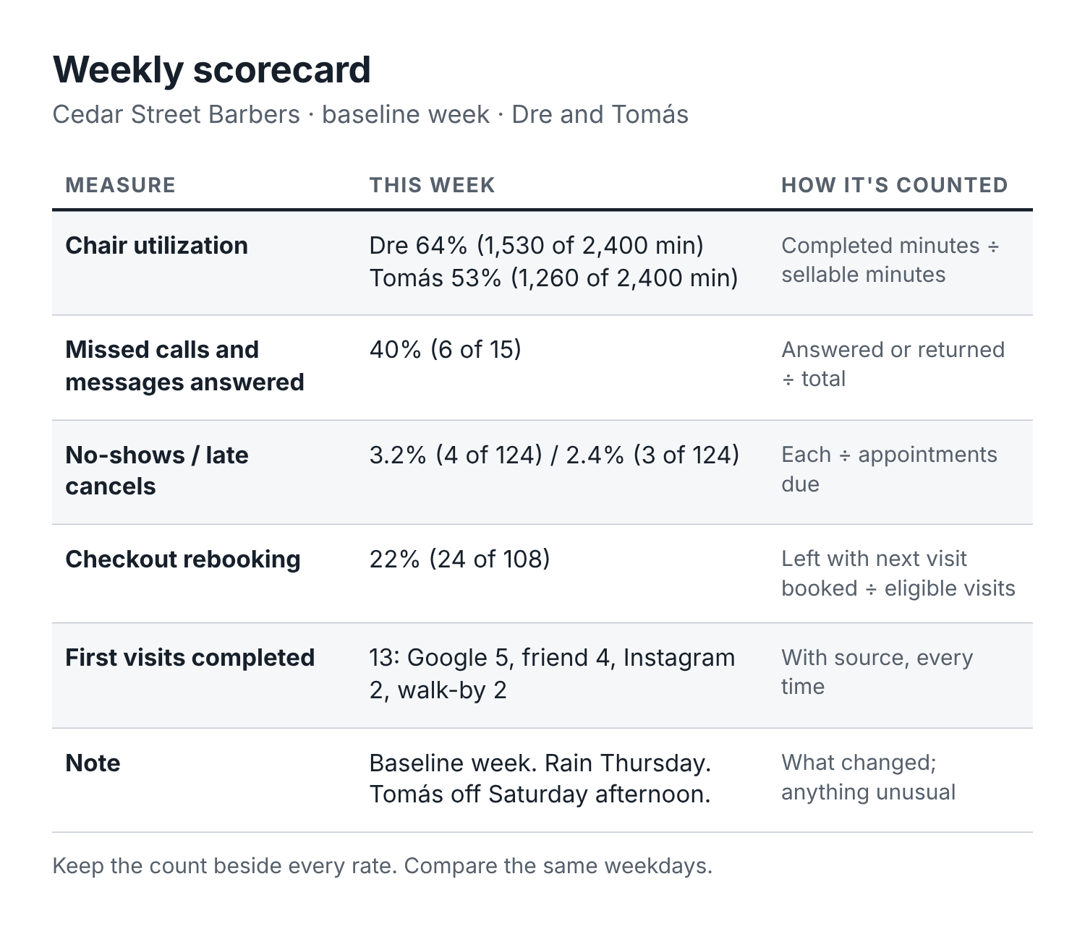
Figure 3. The Cedar Street weekly scorecard. Six numbers, one page, ten minutes a week.
The weekly scorecard has six lines:
- Chair utilization, per barber (completed minutes ÷ sellable minutes).
- Missed-call and message recovery (contacts answered or returned ÷ total).
- No-show rate and late-cancel rate (each ÷ appointments due).
- Checkout rebooking rate (eligible visits with a future booking ÷ eligible visits).
- First visits completed this week, and where they came from.
- One note: what we changed this week, and anything unusual (weather, a holiday, a barber off sick).
That sixth line matters more than it looks. Six weeks from now, when Tuesday suddenly jumps, you will want to know whether it was your new waitlist or the fact that the school down the road had a teacher training day. Write it down while you remember.
You can keep the scorecard in a spreadsheet, on paper, or in a notes app. Appendix C has a version you can copy. What matters is that you look at it every week and that the numbers are counted the same way each time.

Pick one bottleneck
Now the hardest part: choose one problem to work on this month. One.
It is tempting to fix everything at once. Resist that. If you change your reminders, launch an ad, start posting daily and change your prices in the same month, and bookings go up, you will not know why. If they go down, you will not know which change to undo.
To choose, ask three questions about each leak:
- How many bookings does it cost each week? (Nineteen unreturned calls in two weeks is about nine or ten lost contacts a week. If even half would have booked, that is five appointments a week.)
- How cheap is it to fix? (Calling back missed callers costs time and a text template. Ads cost money.)
- How close is it to the chair? (Closer is usually cheaper and faster.)
Dre looked at his table. Missed calls: about five lost bookings a week, almost free to fix. Rebooking: big potential, also free, but needed a habit change at the chair for both barbers. First-timer returns: important, but partly depended on fixing rebooking first. Quiet Tuesdays: real, but some of that empty time might fill itself once missed calls were answered.
He chose missed calls for month one. Rebooking would be month two. Chapter 8 shows what he did.
Your choice may be different. A shop with a 12% no-show rate should start there. A shop with great retention and no online presence should start with Chapter 4. The scorecard tells you; your gut can then argue with it.

The 15-minute alternative
If counting seven numbers for two weeks feels like too much right now, do this instead. It takes fifteen minutes and gets you most of the way.
- Open your phone’s call log. Count missed calls in the last seven days and how many you returned.
- Open your booking app. Count appointments next week, and the empty hours on Tuesday, Wednesday and Thursday.
- Think about your last ten clients. How many left with the next appointment booked?
If more than a few calls a week go unreturned, start with Chapter 8. If you have more than ten empty weekday hours next week, read Chapter 9. If fewer than half of your last ten clients rebooked, read Chapter 10. Then come back and do the full count when you have a quieter week.

Before your next shift
- Work out sellable minutes for each barber, including yourself.
- Put a tally sheet by the register for missed calls, unanswered messages and walk-ins turned away. Run it for two weeks.
- Pull two weeks of appointments from your booking system and remove client names.
- After two weeks, pick one leak to fix this month. Write it at the top of the scorecard.

Chapter 3: Give AI the facts about your shop
On a busy Friday, Tomás got an Instagram message: Do yall take walk ins tomorrow? He was between clients, so he asked a chat assistant to write a friendly reply. It came back in seconds: Absolutely! Walk-ins are always welcome at Cedar Street. Come by anytime and we’ll get you in the chair!
He sent it. It sounded great. It was also wrong. On Saturdays, Cedar Street takes appointments only until 11 a.m., because the morning rush is booked solid weeks ahead. The client showed up at 9:15 with his son, waited forty minutes, and left. His Google review the following week used the word “liars”.
The assistant had not lied. It did not know the walk-in rule because nobody had told it. Asked to be friendly about walk-ins, it wrote the friendliest thing it could.
The fix is a document that takes about an hour to write and saves you from this kind of mistake for years: a one-page shop brief.

What a shop brief is
A shop brief is a single page that holds every fact an AI assistant (or a new employee) needs to answer routine questions correctly. Prices, times, hours, barbers, booking rules, how you talk, and what never to promise.
You paste it at the start of a chat, or save it in the assistant’s settings, and every draft that follows is built on your facts instead of guesses. When a price changes, you change it in one place.
It also turns out to be the best training document you will ever give a new hire. Writing it forces you to decide things you have been deciding on the fly for years. (“Do we charge for a line-up on a kid’s cut? Do we let people be fifteen minutes late or ten?”)

What goes in it
Keep it to one page if you can, two at most. The assistant does not need your life story. It needs facts it can rely on.
The basics. Shop name, address, the cross street or a landmark, parking, phone number, booking link, Instagram handle, opening hours for each day, days closed, and holiday closures coming up.
The barbers. Who works which days, any specialties, who cuts kids, who does designs or color, and whether each barber is an employee or rents their chair (this matters for who handles their bookings).
The menu. Every service with its price, its booked length, and what is included. Write “starting at” if a price varies, and say what makes it vary.
Booking rules. How people book. Whether walk-ins are accepted and when. Deposit rules, if any. The cancellation cutoff. The late-arrival grace period and what happens after it. The no-show rule.
Payments. Cash, card, tap, tips on card, whether you sell gift cards or memberships.
How we talk. Three or four lines describing your voice, plus a short list of words you use and words you never use.
Never promise. The list of things the assistant must not do: confirm a time slot, offer a discount, quote a price not on the menu, comment on a client’s skin or scalp condition, or make up anything not in the brief.
Hand it to a human. Topics that always go to the owner: complaints, refunds, injuries, anything involving a minor without a parent, press, and anything not covered in the brief.

Cedar Street’s brief
Here is the brief Dre wrote after the walk-in mess. Use it as a model. Yours should sound like your shop, not like his.
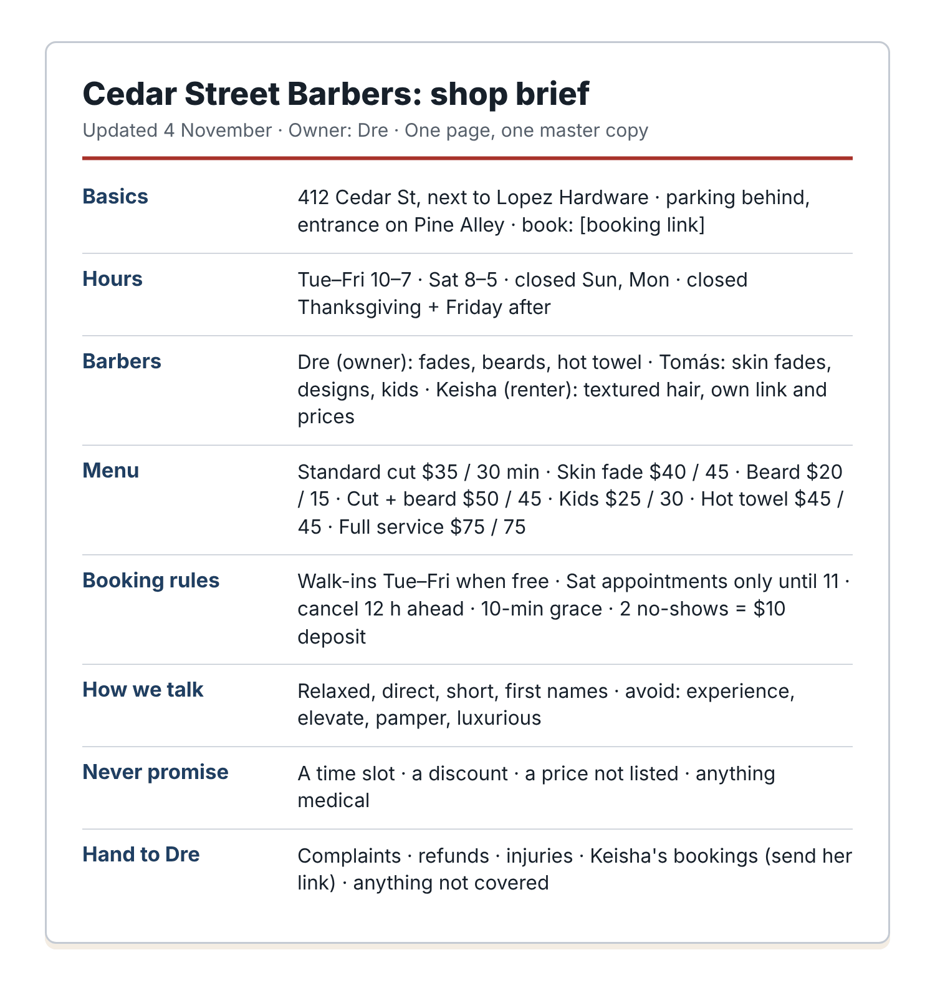
Figure 4. Cedar Street’s one-page shop brief. Every fact in one place, dated, with one owner.
Cedar Street Barbers: shop brief (updated 4 November; owner: Dre)
Basics. 412 Cedar Street, next to Lopez Hardware. Free parking behind the building, entrance on Pine Alley. Phone [shop phone]. Book online at [booking link]. Instagram @[handle].
Hours. Tuesday to Friday 10 a.m. to 7 p.m. Saturday 8 a.m. to 5 p.m. Closed Sunday and Monday. Closed Thanksgiving Day and the Friday after.
Barbers. Dre (owner): Tuesday to Saturday, fades, beard work, hot towel shaves. Tomás: Tuesday to Saturday, skin fades, designs, kids. Keisha: rents her own chair, Wednesday to Saturday, textured hair, women’s short cuts and tapers; she takes her own bookings at [Keisha’s link] and sets her own prices.
Menu (Dre and Tomás). Standard cut $35, 30 min. Skin fade $40, 45 min. Beard trim and line-up $20, 15 min. Cut and beard $50, 45 min. Kids cut, under 12, $25, 30 min. Hot towel shave $45, 45 min. Full service (cut, beard, hot towel, wash) $75, 75 min. Designs from $10 extra; price depends on detail, confirmed in the chair.
Booking rules. Book online or by phone. Walk-ins welcome Tuesday to Friday when a chair is free. Saturday is appointment only until 11 a.m.; walk-ins after 11 if there is space. No deposit for regular services. Cancel or move up to 12 hours ahead with no charge. Late arrivals: 10-minute grace; after that we may shorten the service or rebook. Two no-shows in six months means future bookings need a $10 deposit.
Payments. Cash, card and tap. Tips on card welcome. Gift cards sold in the shop.
How we talk. Like a barber talking to a regular: relaxed, direct, friendly, short. First names. No corporate language. Words we use: cut, fade, line-up, book, slot, chair. Words we avoid: experience, elevate, pamper, luxurious, gentlemen’s grooming, any emoji except an occasional thumbs-up.
Never promise. A specific time slot (always send the booking link or say we’ll confirm). Any discount or free service. A price not listed here. That a walk-in will be seen at a particular time. Anything about medical, skin or scalp conditions.
Always hand to Dre. Complaints, refund requests, injuries or cuts, questions about Keisha’s prices or bookings (send her link), media, job applications, and anything not covered above.
Notice what Dre did with Keisha. She rents her chair, so the shop brief does not quote her prices or promise her time. It points to her link. That one line prevents a whole category of arguments.

How to use the brief
There are three ways to put the brief to work, from simplest to most convenient.
Paste it each time. Keep the brief in a note on your phone. When you start a new chat, paste it first, then add: Use only the facts in this brief. If a question needs a fact that is not in it, write [CHECK] instead of guessing. Then ask for what you need. This works with any free assistant.
Save it in the assistant’s settings. Most paid assistants let you save standing instructions or create a project with files attached. ChatGPT has custom instructions and projects; Claude has projects; Gemini has saved instructions and “Gems”. The names change but the idea is the same: you upload the brief once, and every chat in that project starts with it. This is the setup most owners end up with.
Load it into your booking tool’s AI. If your booking platform has an AI assistant or receptionist, it will have a settings page for business information and frequently asked questions. Copy the relevant parts of the brief there. Then test it (see below), because each platform uses that information a little differently.
Whichever you choose, keep one master copy, date it, and give it an owner. When Tomás raises his skin fade price, the brief gets updated the same day, and the date at the top changes. Old copies floating around in three different apps are how wrong prices end up in client messages.

Teach it your voice
The “How we talk” section of the brief gets you most of the way. To get closer, show the assistant how you actually write.
Scroll back through your texts and DMs and find five or six messages you sent to clients that sound like you at your best. Remove the names. Then:
Here are six messages I’ve sent to clients at my barbershop, with names removed. Describe my writing style in five short bullet points: sentence length, punctuation habits, greetings and sign-offs, words I use often, and anything I never do. Then write a 40-word reminder message for a Saturday appointment in that same style, using [first name], [time] and [barber].
[paste the six messages]
Read the description. If it is accurate, paste those five points into your brief under “How we talk”. If it got something wrong (“you use exclamation marks a lot”), correct it there. From then on, drafts will sound more like you and less like a bank.

Test before anyone uses it
This is the step most people skip, and it is the one that catches the walk-in disaster before it happens.
Write ten test questions, the kind clients actually ask. Include at least three about prices, three about rules (late arrivals, walk-ins, cancellations), two about closed days or holidays, and two trick questions where the right answer is “I’m not sure, let me check” or “we don’t offer that”.
Here are Cedar Street’s:
- How much is a cut and beard?
- Is a skin fade still $35? (It is $40. The right answer corrects the client politely.)
- Do you do kids cuts? How old?
- Can I walk in Saturday at 9?
- I’m running 15 minutes late, is that OK?
- Are you open Monday?
- Are you open the day after Thanksgiving?
- How much does Keisha charge for a taper?
- Do you do perms? (Not on the brief. The right answer: we don’t list that service; let me check with the team.)
- Can you fit me in at 3 today? (The right answer: I can’t confirm a time here; here’s the booking link, or we’ll check and reply.)
Paste the brief, then ask all ten. Mark each answer right or wrong. Look hardest at the trick questions. A good setup will say it does not know. A bad one will cheerfully invent a perm price.
When an answer is wrong, do not just fix the answer. Fix the brief, or add a line to the instructions, and run all ten questions again. When all ten pass, the setup is ready for drafting. Run the test again every time you change the brief, and every few months anyway, because the assistants themselves get updated.

The review checklist
Even with a good brief and passing tests, a person reads every client-facing message before it goes out, at least until you have used a template for a while and trust it. Here is the checklist to run in your head, which takes about ten seconds once it becomes habit:
- Facts: Do the price, time, service, barber and day match the brief and the live calendar?
- Promises: Does it promise a slot, a discount, or anything we did not approve?
- Link: Is the booking link the right one, for the right barber and the right service?
- Placeholders: Are all the [brackets] filled in? Nothing like “[first name]” left in the message?
- Privacy: Does it mention anything personal that should not be in a text that someone else might see on a lock screen?
- Permission: Has this person agreed to hear from us this way (see Chapter 10 for marketing messages)?
- Tone: Would I say this out loud to this client?
Print it and tape it by the register if you have staff drafting messages. It looks fussy for about a week. After that it becomes automatic.

For chair-rental shops: one shop brief, several barber briefs
If your barbers rent their chairs, write two kinds of brief.
The shop brief covers what the shop owns: the address, hours the building is open, parking, the shop’s Instagram and Google listing, shared rules (cleanliness, music, kids in the shop), and a list of barbers with a link to each one’s booking page.
Each barber brief belongs to that barber. It covers their services, prices, booking rules, deposit policy and voice. They write it, they keep it updated, and they decide whether to share it with the shop. Keisha’s brief, for example, has her prices, her 24-hour cancellation rule (stricter than the shop’s), and her note that she does not take walk-ins at all.
Then agree on one rule for shared channels: when a question about a particular barber’s prices or availability arrives on the shop’s Instagram or phone, the reply sends the client to that barber’s link and does not answer for them. Chapter 12 goes further into this.

What to do with the brief this week
You can write the first version in under an hour. Here is a prompt that does most of the typing for you:
I own a barbershop. I’m going to describe it in a messy way. Turn what I say into a one-page shop brief with these headings: Basics, Hours, Barbers, Menu (price and booked length for each service), Booking rules, Payments, How we talk, Never promise, Always hand to the owner. Use short lines. Where I haven’t given a fact, write [MISSING] instead of guessing. At the end, list the five most important questions I haven’t answered.
Here’s my shop: [talk it through in your own words, or record a voice note and paste the transcript]
The list of missing questions at the end is the useful part. It is usually things like “What happens if a client arrives 20 minutes late?” or “Do you charge extra for long hair?”, rules you apply every week but have never written down.

Before your next shift
- Write your shop brief using the prompt above. Fill every [MISSING] gap.
- Run the ten test questions. Fix the brief until all ten pass.
- Save the brief where you will use it: a phone note, your assistant’s project settings, or both.
- Put the review checklist by the register if anyone else sends messages for the shop.

Part Two: Get found and get chosen
Local search, content from the chair, honest reviews, good neighbors, and ads that have to earn their keep.

Chapter 4: Make your shop easy to find locally
One Monday, Dre tried an experiment. He stood outside the boxing gym three blocks from his shop, took out his phone, and searched barber near me. Cedar Street did not appear in the three shops at the top of the map. The neon place did. So did a chain barbershop inside a supermarket a mile away. Cedar Street was fifth, below a salon that did not even cut men’s hair.
Then he opened his own Google Business Profile, which he had not looked at properly in two years. The primary category was “Hair salon”. Saturday hours said 9 to 5; the shop had opened at 8 for eighteen months. There were 23 photos, most of them of the storefront, several from the week the shop opened. No services were listed. No booking link. Thirty-eight reviews, the newest one seven months old, and not a single reply from the shop.
None of this was a disaster. All of it was costing him clients.
For most barbershops, the Google Business Profile is the most important page you have. It is often what a new client sees before they see your website, your Instagram or your front door. This chapter shows you how to fix it in an afternoon, how to keep it fresh with ten minutes a week, and how AI fits in.

How Google decides who shows up
Google’s own help pages say local results are based mainly on three things: relevance, distance and prominence.
Relevance is how well your profile matches what someone searched for. If your category is “Hair salon” and someone searches “barber”, you are a weaker match than a shop listed as “Barber shop”. If someone searches “skin fade” or “beard trim” and your profile lists those services, you look more relevant.
Distance is how far you are from the person searching, or from the place they searched for. You cannot move your shop, so forget this one.
Prominence is how well known your shop is. Google says this is based on information such as how many websites link to your business and how many reviews you have, and that more reviews and positive ratings can help your local ranking. A shop with 300 recent reviews and replies to most of them looks more established than one with 38 old ones.
There is no secret trick. You control relevance through an accurate, complete profile. You influence prominence through honest reviews, real photos and being mentioned around your neighborhood. That is the whole game.
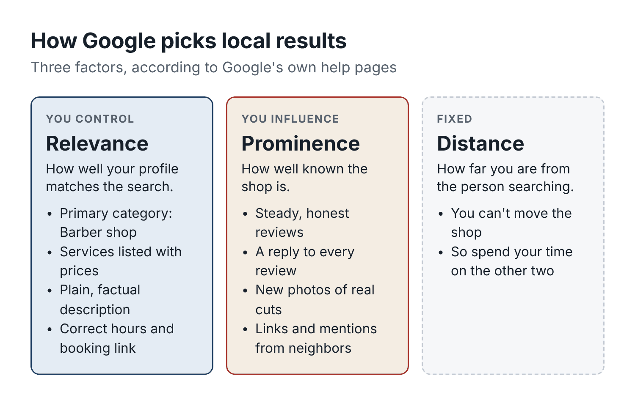
Figure 5. What decides local search, and what you control. Distance is fixed; relevance and prominence are yours to work on.

Step one: decide what you want to be known for
Before you touch the profile, answer one question: when someone in your area thinks of your shop, what should come to mind?
“A good barbershop” is not an answer. Every shop thinks it is a good barbershop. Look at your actual book. Who comes most? What do they ask for? What do your best reviews mention?
For Cedar Street, the answer came out of the Chapter 2 spreadsheet and a read through the reviews: skin fades and beard work, a relaxed shop where the same barber cuts you every time, kids welcome on weekdays, and Keisha for textured hair. That became a single line Dre could use everywhere:
Neighborhood barbershop on Cedar Street for skin fades, beard work and textured hair. Same barber every visit. Kids welcome on weekdays.
AI can help you find yours. Remove names, then paste in your twenty most recent reviews and your service list:
Here are 20 recent reviews of my barbershop and our service menu. Based only on what clients actually say, what are the three things we’re best known for? Quote the review phrases that support each one. Then write three versions of a one-sentence description of the shop, under 25 words each, plain language, no words like “premier”, “elevate” or “experience”.
Do not let the assistant invent a niche. If the reviews mention fades and friendly service, your line should too. If you want to be known for something your reviews never mention, that is a goal, and the work to get there is in the chair, not on Google.

Step two: fix the profile
Sign in to your Google Business Profile (search for it while logged into the Google account that manages your shop). If you have never claimed your shop, Google will walk you through verification. Then work down this list. Most of it takes a couple of minutes per item.
Name. Use your real business name exactly as it appears on your sign. Do not add keywords (“Cedar Street Barbers Best Fades Downtown”). Google’s guidelines forbid it, competitors can report it, and it can get your profile suspended.
Primary category. “Barber shop”, if that is what you are. This is one of the strongest signals you control. You can add a few secondary categories if they are true, but do not pile them on.
Hours, including special hours. Check every day. Add holiday closures ahead of time; Google lets you set special hours for specific dates, and it is one of the most useful things you can do in November and December. Wrong hours lead to the worst kind of review: “drove 20 minutes and they were closed”.
Services. List each service with its price, exactly as on your menu. This helps relevance (“skin fade” now appears on your profile) and answers the first question most people have.
Booking link. Add your online booking link as the appointment link. Some booking platforms connect directly to Google so people can book without leaving the search page; check whether yours does.
Description. You get 750 characters. Use them for facts: what you do, who you serve, where you are, how to book. Here is a prompt:
Using only the facts in my shop brief below, write a Google Business Profile description for my barbershop. Maximum 700 characters. Include: what we’re known for (use this line: [your one-line positioning]), the main services, the area or landmark, parking, and how to book. Plain language, no keyword stuffing, no exaggerated claims, no prices (those go in the services list). Do not mention anything not in the brief.
[paste shop brief]
Count the characters before you paste it in. Assistants are not reliable at counting characters; a phone notes app or a spreadsheet’s LEN() formula is.
Photos. This matters more than most owners think. People choosing a barber want to see cuts, the inside of the shop, the barbers, and the front door so they can find it. Add:
- Ten or more photos of real cuts done in your shop, with good light and a clean background, shot with the client’s permission.
- Three or four of the interior, taken when it is clean and not too crowded.
- One clear photo of the front door and sign from the street, and one of the parking entrance if it is hard to find.
- A photo of each barber at their chair, if they are happy to be shown.
Then add a few new photos every month. A profile whose newest photo is from 2019 tells a visitor the place might not have changed in five years.
Do not use AI-generated images of haircuts. It is tempting, because the generators make flawless fades. But a client who books because of a picture of a cut that never happened, in a shop that does not exist, will notice when they sit in your chair. Use AI to improve your real photos (fix the lighting, blur a messy background) if you like. Do not use it to invent them.
Attributes and details. Payment methods, accessibility (wheelchair-accessible entrance?), parking, whether you welcome kids, languages spoken. Fill in what is true.
Updates. Google lets you post short updates to your profile: a new barber, holiday hours, availability this week. They take two minutes, and AI can draft them. Chapter 5 turns them into a weekly habit.

Step three: make every listing say the same thing
Your shop appears in more places than you think: Apple Maps (managed through Apple Business Connect), Bing Places, Yelp, Facebook, your booking platform’s marketplace page, Instagram, your website, and a long tail of directories you never signed up for.
When those places disagree about your hours, phone number or address, two things happen. People get confused and some of them give up. And search engines are less confident they have the right information about you.
You do not need to chase every directory. Fix the big ones: Google, Apple, Bing, Yelp, Facebook, your booking page and your website. Use exactly the same business name, address format, phone number, hours and booking link in each.
AI is useful here as a checker. Copy the text from each listing into one chat:
Below are my barbershop’s details as listed on six different sites. Compare them line by line against my shop brief. Make a table with one row per detail (name, address, phone, hours for each day, booking link, services and prices) and one column per site. Mark every place that differs from the brief.
[paste shop brief]
[paste each listing, labeled with the site name]
You will almost always find something: an old phone number on Yelp, last year’s prices on Facebook, a closed-on-Tuesday that is no longer true.

Step four: a first-visit page that does its job
If you have a website, its job is simple: help someone who has never been to your shop decide to book. If you do not have one, your booking page and Google profile do this job, and you can skip to the next section.
A first-time visitor wants answers to five questions, usually in this order:
- Can they do the cut I want? (Photos of real cuts, the services list.)
- How much will it cost? (Prices.)
- Where is it, and can I park? (Address, a map, a photo of the door.)
- What’s it like? (A few lines about the shop and the barbers, a couple of real reviews.)
- How do I book? (A booking button that is visible without scrolling on a phone.)
Here is a prompt to brief a web page, whether you build it yourself in Squarespace or Wix or hand the brief to someone else:
Write a brief for a one-page website for my barbershop, aimed at first-time clients who found us on their phone. Use only the facts in the shop brief below. Include:
- A headline and one-sentence subheading.
- The order of sections, with what goes in each.
- Copy for each section, under 80 words per section.
- A list of the photos I need to take, described specifically (for example: “close-up of a skin fade from the side, clean background”).
- Where the booking button should appear.
Plain, friendly language. No claims we can’t prove (“best in the city”). Mark anything you need from me as [MISSING].
[paste shop brief]
Then open the finished page on your phone, standing outside, with one bar of signal. Can you see the booking button? Does the address tap through to the map? Does the page load before you lose patience? Most small-business websites fail this test, and nearly all of their visitors are on phones.

Being found by AI assistants too
More people now ask an AI assistant for recommendations: find me a barber near downtown who’s good with curly hair and open on Saturday. The assistant answers by pulling together what it can find, which typically means listings, reviews, websites and articles.
You cannot control those answers, and you should be wary of anyone selling a service that claims to. But the same work you have just done helps:
- Clear, factual text about what you do, in plain words, on your website and profile. “We cut textured and curly hair” is easy for a machine to understand. “Artistry for every crown” is not.
- Accurate hours, address and booking link everywhere.
- Plenty of recent, honest reviews. When clients mention specifics (“Keisha is great with curly hair”, “they took my 5-year-old without drama”), those details travel.
In other words: describe your shop clearly and truthfully, and let your clients do the talking.

Step five: borrow your neighbors’ customers
Local visibility is not only online. The boxing gym, the tattoo studio, the coffee shop, the school uniform store, the wedding suit rental place: each has customers who need a barber and might ask the staff for a recommendation.
Give the businesses you trust the same thing you give Google: an accurate one-line description, your booking link, and, ideally, a link that shows the booking came from them. Many booking platforms let you create tracked links or add a “how did you hear about us” question. If yours does not, a simple code word (“Tell them Gus from the gym sent you”) works.
Chapter 6 covers partnerships properly. For now, add the obvious neighbors to your list.

How to tell if it worked
Your Google Business Profile shows performance numbers: how many people viewed it, called from it, asked for directions, clicked to your website or booking link. These are useful as a trend, especially after you fix the profile. Look at them monthly rather than daily.
But remember the rule from Chapter 2: views and clicks are not clients. The measure that matters is completed first visits that came from local search. The simplest way to count them is to ask every new client, at booking or at checkout, “How did you find us?”, and record the answer the same way every time: Google, Instagram, friend, walked past, partner, other, unknown. Your booking system may have a field for this. If not, a tally sheet works.
After Dre fixed his category, hours, services, booking link and photos, and replied to every review from the previous year, he tracked first visits from Google for eight weeks against the eight weeks before. They went from 11 to 19. He could not be certain all of that was the profile; it was also the start of spring. But direction requests and booking-link clicks on the profile rose over the same weeks, and the “How did you find us?” answers pointed the same way. Good enough to keep going.

Before your next shift
- Search for your services from three places around your neighborhood, and note where you appear.
- Fix your Google Business Profile: category, hours, special hours, services with prices, booking link, description.
- Take and upload ten real photos this week, with permission from the clients in them.
- Compare your main listings against your shop brief and correct anything that differs.
- Start asking every new client “How did you find us?” and record the answer.

Chapter 5: Turn haircut photos into a local content plan
Tomás posts on his own Instagram every day. His feed is beautiful: sharp fades, hard parts, designs, slow-motion clips of the foil shaver set to music. He has 4,000 followers. In eight months at Cedar Street, the number of clients who booked with him because of a post was, as far as anyone could tell, three.
The trouble was not the quality. It was that the posts did not do the boring parts. They never said where the shop was. They never said what a skin fade cost or how to book. Many of his followers were other barbers, who liked the work and lived in other states. A man two streets away who needed a fade on Thursday could scroll past twenty of Tomás’s posts and still not know he could walk to him.
This chapter is about content that fills chairs, as opposed to content that collects likes. It is less glamorous, and it works. AI helps with the part most barbers hate, which is the writing, the planning and the remembering to post at all.

What local content has to do
A post that brings in clients answers four questions for a local person, quickly:
- What is it? A real cut, by a named barber, in your shop.
- Is it for me? The service name, and who it suits.
- Where? Your shop’s name and neighborhood, every time.
- How do I get it? The price or “from” price, and how to book.
Most barber content nails the first one and skips the other three. Fixing that is mostly a caption job, and caption jobs are where AI is strongest.

Five kinds of post that work for barbershops
You do not need fifty content ideas. You need a handful of formats you can repeat, because repeating them is what makes posting sustainable.
The real cut. A photo or short video of a cut you did this week, with the service, barber, price and booking link. This is your bread and butter. Aim for two a week.
The barber. Introduce each barber: what they love cutting, how long they have been cutting, which days they work, one human detail. People book people. Repeat these every couple of months; your followers change.
The question. Answer something clients ask you every week. “How often should I get a fade touched up?” “What’s the difference between a taper and a fade?” “Can you fix a home haircut?” These posts are useful to local people and easy to write.
The availability post. “Tomás has three openings Wednesday afternoon.” Simple, direct, effective. Chapter 9 covers it in detail.
The shop moment. The new chair arriving, the shop’s anniversary, the kid getting his first haircut (with parental permission), the charity cut day, a short clip of closing time. These remind people that you are a real place with real people.
Seasonal posts slot into these formats: back-to-school cuts in August, wedding and prom season in spring, holiday hours in December, Father’s Day gift cards in June. Note your local events too: the high-school homecoming game, the street fair, the marathon that closes your road.

Getting the photo right
A caption cannot rescue a bad photo. You do not need a professional camera. You need a few habits.
- Shoot near a window or under a consistent light; avoid the yellow overhead light if you can.
- Use a plain background. A dark cape and a clean wall behind the head beat a busy shop floor.
- Take the same angles every time: side profile, back, three-quarter front. Consistency makes your feed look professional and makes before-and-afters honest.
- Clean the neck and brush off hair before the photo. Obvious, often forgotten.
- Get the client’s permission before you shoot, and again before you post. Something like: “Mind if I get a photo of the fade for the shop’s Instagram? I won’t show your face if you’d rather not.” Many clients say yes. Respect those who say no.
AI can help you build a shot list so you are not inventing angles in the moment:
Make a photo and video shot list for a barbershop that wants to post real haircuts on Instagram and Google. For each of these services, list 3 specific shots (angle, distance, what should be in frame, lighting tip): skin fade, cut and beard, kids cut, hot towel shave, textured hair taper. Also list 5 short video ideas under 20 seconds that don’t need talking to camera. Keep each item to one line.
Print the list and tape it by the mirror. It removes the “what do I shoot” question for months.

Writing captions in batches
Here is a workflow that takes about twenty minutes a week and produces a week of posts.
Sunday or Monday (your day off): Pick four or five photos from the week. For each, write a rough note: service, barber, anything notable. “Skin fade, hard part, Tomás, client wanted it to grow out OK for a wedding in 3 weeks.”
Then, in one chat, with your shop brief already pasted:
Write Instagram captions for these four photos, using only facts from my shop brief and my notes. For each caption:
- First line: describe the cut plainly (this shows before “more”).
- Mention the barber’s name and Cedar Street.
- Include the service price from the menu.
- End with the booking link: [booking link].
- Under 50 words. No emojis except at most one. No hashtags in the caption.
- Sound like a barber talking to a regular, not an advert.
After the four captions, give me 8 hashtags I could add in the first comment: 4 local (neighborhood/city) and 4 about the service. Don’t invent neighborhood names; use only: [your neighborhood], [your city].
Photo 1: [note]
Photo 2: [note]
Photo 3: [note]
Photo 4: [note]
Read each caption with the checklist from Chapter 3. Fix anything that sounds off. Then schedule them. Instagram, Facebook and TikTok all let you schedule posts from the app or from Meta’s Business Suite, so you can set up the week in one sitting and forget about it.
Here is what one caption for Tomás’s wedding fade looked like after a single edit:
Skin fade with a hard part, cut to grow out clean for a wedding three weeks from now. Tomás plans the length so it still looks sharp on the day. Skin fades at Cedar Street are $40. Book Tomás: [booking link]
That caption will never go viral. It does not need to. It tells a local man exactly what he can get, from whom, where, for how much, and how to book it.

Short videos without the cringe
Reels and TikToks reach more people who do not already follow you. They also make many barbers uncomfortable, because they picture themselves dancing or talking to the camera.
You do not have to. The videos that work for barbers are usually quiet and process-focused: the last thirty seconds of a fade, the line-up with the trimmer, the hot towel going on, the before-and-after turn of the chair. Add on-screen text with the service and the price, and the shop name in the caption.
AI can write the on-screen text and a simple structure:
Write a script for a 15-second vertical video showing a cut and beard at Cedar Street Barbers. No talking to camera. Give me: 4 shots with timing (for example, 0 to 3 seconds: …), the on-screen text for each shot (max 6 words each), and a 30-word caption with the price from my brief and the booking link. Make the first on-screen text something a local person would stop scrolling for.
If one of your barbers does like talking to camera, let them answer one client question per week on video. “How long should I wait between fades?” in 30 seconds, filmed in the chair. Those videos age well and keep getting found for months.

The four-week calendar
Planning a month at a time removes the daily “what do I post” question. Here is the calendar Dre and Tomás used for their first month. It assumes three posts a week, which is enough for a small shop.
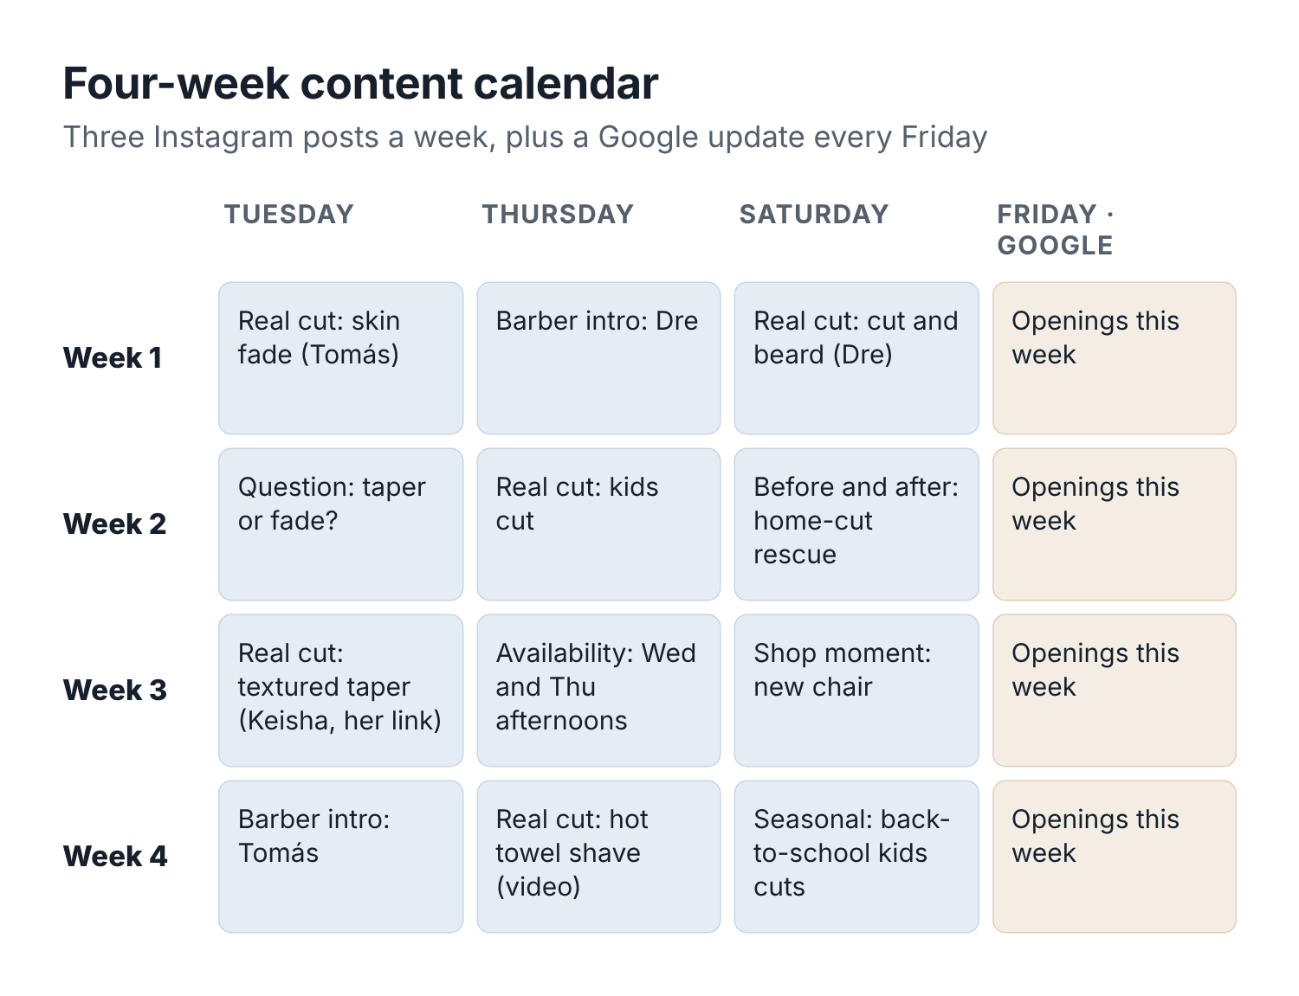
Figure 6. A four-week content calendar for a three-chair shop. Real cuts twice a week, one barber or question post, and Google updates every Friday.
Week 1. Tuesday: real cut (skin fade, Tomás). Thursday: barber introduction (Dre, eleven years on Cedar Street). Saturday: real cut (cut and beard, Dre). Friday: Google update with this week’s openings.
Week 2. Tuesday: question post (“Taper or fade? Here’s the difference”). Thursday: real cut (kids cut, with a parent’s permission). Saturday: before-and-after (a home-haircut rescue, with permission). Friday: Google update.
Week 3. Tuesday: real cut (textured taper, Keisha, posted on the shop account with her agreement and her booking link). Thursday: availability post for Wednesday and Thursday afternoons. Saturday: shop moment (the new barber chair). Friday: Google update.
Week 4. Tuesday: barber introduction (Tomás). Thursday: real cut (hot towel shave, video). Saturday: seasonal post (back-to-school openings and the kids cut price). Friday: Google update.
Here is the prompt that builds a calendar like this for your own shop:
Build a four-week social media calendar for my barbershop using my shop brief. Three Instagram posts per week plus one Google Business Profile update every Friday. Use these formats: real cut, barber introduction, client question, availability post, shop moment, seasonal. Upcoming local events and dates to include: [list them, e.g. school starts 26 August, street fair 7 September]. For each post, give the day, format, which barber, a one-line idea, and the photo or video I need to capture this week. Put it in a table. Don’t invent events or barbers.

Openings and announcements
New barber starting? Moving to a new location? Adding Sunday hours? These are your biggest posting moments, and they deserve a little more planning.
For a new barber, plan three posts: an announcement a week ahead (who they are, their specialty, their start date, how to book), a “first week” post with a real cut, and a barber introduction after they settle in. Ask the assistant to draft all three at once so the details stay consistent, and make sure the new barber approves anything that describes them.
For a shop opening or move, list everything a client needs to know: new address, parking, what changes and what stays the same, the date of the change, and what happens to existing bookings. Then ask AI to produce a short version for Instagram, a Google update, a text for clients who have opted in to messages, and a sign for the door. Read them all side by side before posting; you want the same date and details everywhere.

Track bookings, not likes
Here is the honest truth about social media metrics: views and likes tell you whether people enjoyed a post. They do not tell you whether anyone booked.
To find out what posts actually do, you need two habits.
Use a link that shows where the booking came from. Many booking platforms let you create a separate link for Instagram, or show the source of each online booking. If yours does not, at least put your booking link in your Instagram bio and ask “How did you find us?” at booking or checkout.
Count completed first visits from social, monthly. Not followers, not likes. First-time clients who booked because of a post and actually sat in the chair.
Tomás changed his own captions to include the shop, the price and his booking link. He also started posting the shop’s cuts on the shop account, where most followers were local. Over the next two months, eleven first-time clients told the front desk they had found the shop on Instagram, up from three in the previous eight months. His own feed still gets more likes. The shop’s feed gets more clients.

A word on AI-generated content
You will see advice to “let AI run your social media”. Be careful with that. AI is excellent at the writing and planning. It is not good at being your shop.
What works: real photos and videos of your real work, with captions drafted by AI and edited by you.
What does not: AI-generated images of haircuts you did not do, AI “models” in your chairs, fake client quotes, stock photos of barbershops that are not yours, or a feed of generic tips that could belong to any shop in the country. Apart from being misleading, it does not work. People choosing a barber are looking for evidence that this barber can cut their hair. Only your real work provides that.

Before your next shift
- Print a shot list and tape it by the mirror.
- Shoot four real cuts this week, with permission.
- Batch-write captions for all four in one sitting, using your shop brief.
- Build a four-week calendar and schedule the first week.
- Add a way to track bookings from social: a separate link, a source field, or the “How did you find us?” question.

Chapter 6: Turn reviews and referrals into local discovery
The review arrived at 11:48 on a Saturday night. One star. Showed up with my son at 9:15, they said walk-ins welcome, waited 40 min and nobody even looked at us. Barbers too busy talking to each other. Liars. Never again.
Dre read it in bed. By 11:55 he had typed a reply that began Maybe if you’d actually read our policy and went downhill from there. He did not post it, which is the first good decision in this chapter. In the morning he read the review again, then pasted it into his assistant along with the shop brief and asked for help writing something he would not regret.
Reviews are the closest thing a small shop has to a loudspeaker. Good ones bring in people you will never meet until they sit in your chair. Bad ones, handled badly, can sit at the top of your profile for years. This chapter covers how to earn more honest reviews, how to reply to all of them, and how to turn happy clients and friendly neighbors into a steady trickle of new bookings.

The rules, briefly, because they matter
Before the techniques, the boundaries. Some common review tactics are against platform rules, and some are against the law.
In August 2024 the US Federal Trade Commission announced a final rule on consumer reviews and testimonials. Among other things, it bans:
- fake reviews, including ones written by AI, by someone who never used the business, or that misrepresent the reviewer’s experience;
- offering compensation or other incentives in exchange for reviews that express a particular sentiment, positive or negative, whether that condition is stated or merely implied;
- reviews by owners, managers or staff that do not clearly disclose their connection to the business;
- suppressing negative reviews through threats or intimidation, or presenting a filtered set of reviews as if it were all of them.
The FTC can seek civil penalties against knowing violators. Other countries have similar consumer-protection rules.
Google’s own policy goes further than the FTC on one point. Its Business Profile help pages say that offering incentives, such as free or discounted goods or services, in exchange for customers posting reviews, changing reviews or removing negative ones counts as fake and misleading content and is strictly prohibited. That applies even if you never ask for a particular rating. Google has also said it may restrict profiles that repeatedly break its fake-engagement rules, on top of removing the reviews.
One more practice to avoid, even where no rule names it: asking only the clients who seem happy, or sending happy clients to Google and unhappy ones to a private feedback form. This is sometimes called review gating. It produces a rating that is better than your real one, which is exactly the kind of misleading picture both Google and the FTC are trying to stamp out.
In plain barbershop terms:
- Do ask every client for an honest review, the same way, at the same moment.
- Do not offer a discount, free line-up, raffle entry or anything else for a review. Not even “for any review, good or bad”, on Google.
- Do not ask only the clients who seem happy, or send unhappy ones to a private form instead of the review site.
- Do not write reviews for clients, or let AI write them, even when a client says “you write it, I’ll post it”. Their words or nothing.
- Do not have staff, family or friends review the shop unless the connection is clearly disclosed, and on Google, simply avoid it.
- Do not threaten anyone over a negative review. Reply calmly and, if a review is fake or abusive, report it through the platform.
None of this stops you getting lots of reviews. It just means you get them the slow, honest way, which is the only way that lasts.

Ask at a consistent moment
Most happy clients never leave a review because nobody asked, and the ones who did mean to forgot by the time they got to the car. So build the ask into the visit.
Choose one moment and stick to it. For most shops it is one of these:
- At checkout, in person. “Glad you like it. If you have a minute later, we’d really appreciate an honest review on Google. There’s a QR code on the card.” Hand them a small card with a QR code that opens your review page directly. Google gives you this link in your Business Profile (“Ask for reviews”).
- In a follow-up message, a couple of hours after the visit. Most booking systems can send an automatic thank-you message after a completed appointment. Add the review link.
Do both if you like, but treat every client the same. The point is consistency: everybody gets asked, regardless of how the cut went.
Here is a follow-up message that does the job:
Thanks for coming in today, [first name]. If you’d like to share how your visit went, here’s our Google review link: [review link]. Honest feedback helps us, good or bad. Cedar Street Barbers
Track two numbers each month: how many review requests went out, and how many new reviews arrived. Do not mix them up. If requests go up and reviews do not, your ask needs work (the link is buried, the message is too long, the timing is wrong). If neither moves, nobody is asking.
When Cedar Street started handing out QR cards at checkout and adding the link to the automated thank-you text, new Google reviews went from roughly one a month to eleven in the first month and nine in the second. The average rating barely moved, which is what you would expect when you ask everyone honestly. What changed was the count and the recency, and it is hard to look established with seven-month-old reviews.

Reply to every review
Reply to all of them: the five-star ones, the three-star ones, the one-star ones. Replies show new visitors that the shop is run by people who are paying attention, and they give you a chance to tell your side of a bad story politely.
AI is very good at this job, provided you give it rules.

Replying to good reviews
The danger with positive replies is that they all sound the same. “Thank you for your kind words! We look forward to seeing you again!” forty times in a row looks like a robot, because it usually is. A good reply is short, uses something specific from the review, and sounds like the barber.
Draft a reply to this Google review of my barbershop. Use my shop brief for tone. Under 40 words. Mention one specific thing the reviewer said. Thank the barber they named, if any, by first name. No exclamation marks except at most one. Don’t repeat the shop name more than once. Don’t mention any client details beyond what’s in the review.
Review: “[paste review]”
Batch them. Once a week, paste in all new positive reviews and ask for a reply to each, each with a different opening line. It takes five minutes.

Replying to bad reviews
This is where AI earns its place, because the hardest part of replying to a harsh review is not the writing. It is not writing while angry.
A good reply to a negative review:
- Thanks them for the feedback, briefly.
- Acknowledges what went wrong, in general terms, without arguing about the details in public.
- States the relevant fact or policy plainly, if there is a misunderstanding.
- Says what you have changed, if anything.
- Offers a way to talk privately: the owner’s name and the shop phone or email.
- Never mentions private client details: no “you were late”, “you no-showed twice”, “you didn’t tip”, or anything from your booking records. Other people will read it.
Here is the prompt Dre used:
I need to reply to a negative Google review of my barbershop. Here’s the review and what actually happened. Draft a reply that is calm and short (under 80 words), takes responsibility for what we got wrong, explains our policy plainly where there was a misunderstanding, says what we’ve changed, and invites the reviewer to contact me (Dre) directly at [shop phone]. Don’t argue, don’t blame the client, don’t reveal any private details about the visit, and don’t offer anything free or a discount in the public reply.
Review: “[paste review]”
What happened: [your honest account, in a few lines]
Shop brief: [paste]
And the reply he posted, after one edit:
I’m sorry about Saturday. You were told walk-ins were welcome, and on Saturday mornings we only take booked appointments until 11, so you waited for nothing. That message was our mistake, and we’ve fixed how we answer walk-in questions. I’d like to make it right. Please call me at [shop phone]. Dre, owner
Notice what is not there: no “per our policy”, no blame, no detail about the client or his son. A new client reading that review now sees a shop that admits a mistake and fixes it. Several people who later booked mentioned it.
When the reviewer called, Dre offered him and his son a booked Saturday slot. That kind of make-good is fine in private, as a response to a genuine problem, so long as it is not conditional on changing or removing the review. Google treats incentives to change a review as fake engagement, and you do not want the conversation to sound like a trade.
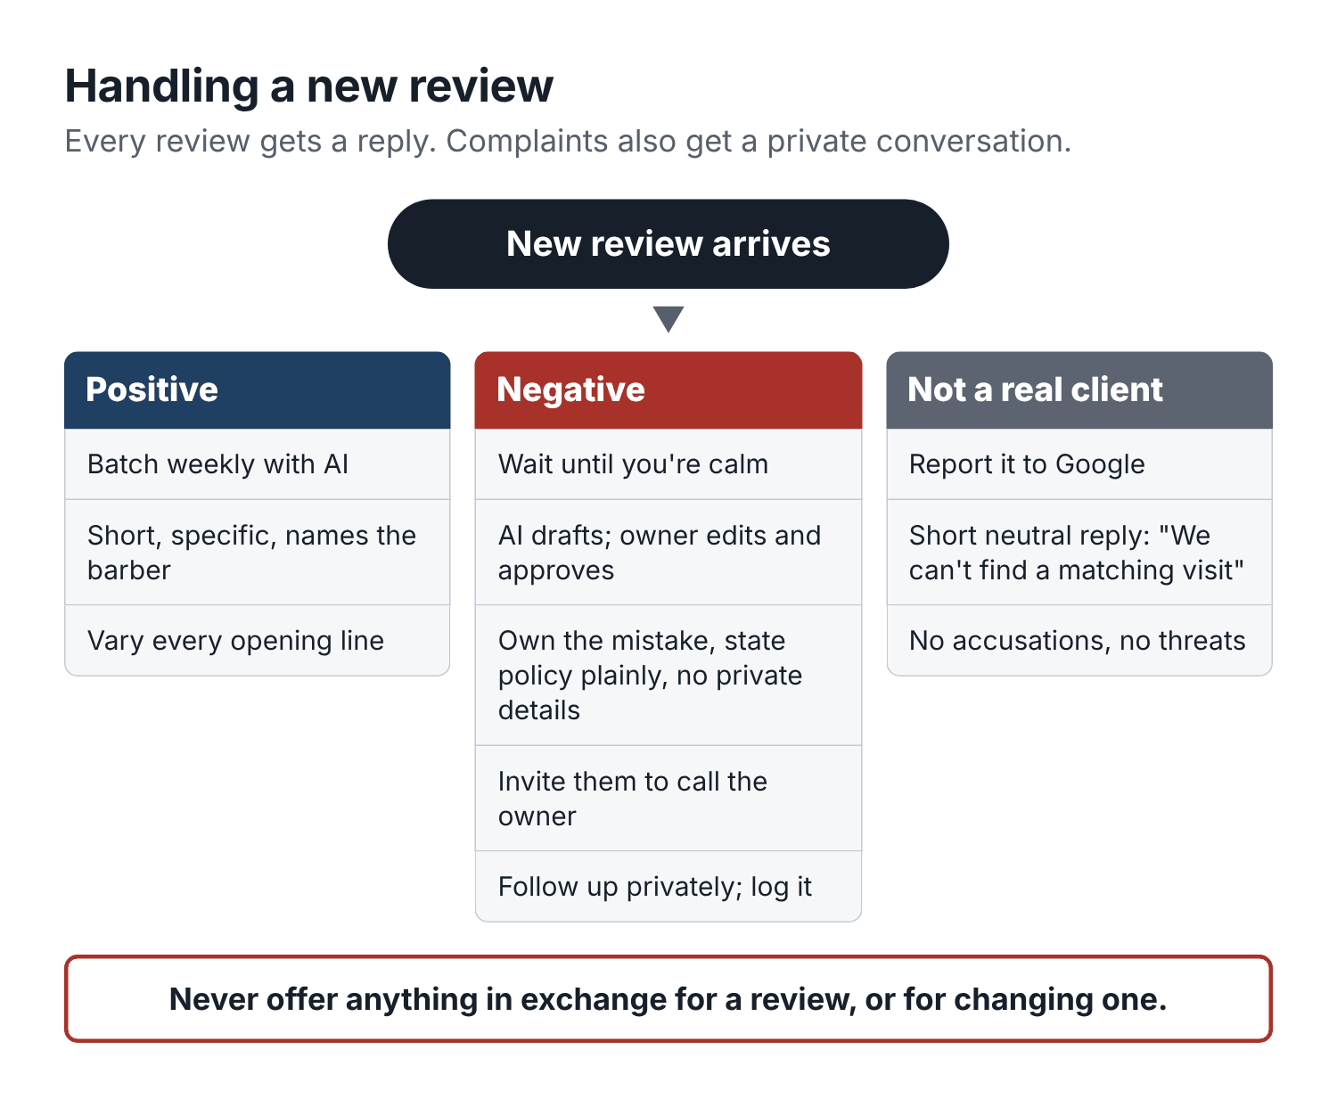
Figure 7. How to handle a new review. Every review gets a reply; complaints get a private conversation too.

Reviews that are not real
Sometimes a review is plainly fake: a person who was never a client, a competitor, an angry ex-employee, or spam. You can report it to Google from your Business Profile. Google decides; you cannot force it. Meanwhile, a short, factual reply is better than silence:
We can’t find any record of a visit matching this, and we’d like to understand what happened. Please call me at [shop phone]. Dre, owner
Do not accuse anyone publicly. Do not threaten legal action in a reply. You will look worse than the review.

Turn complaints into a handoff, not a fight
Most complaints never become reviews if they are handled quickly. Agree, in writing, what happens when a client complains in person, by text, by phone or in a DM. Here is Cedar Street’s version, drafted with AI from Dre’s notes and now pinned by the register:
- Whoever receives the complaint thanks the client, listens, and does not argue or explain policy in the moment.
- They write it down: date, client (in the booking system, not in a chat app), which barber, what happened, what the client wants.
- Dre gets it the same day. If he is away, Tomás.
- Dre contacts the client within 24 hours.
- Standard fixes: a free correction within 7 days for a cut the client is unhappy with; a refund at Dre’s discretion; an apology in every case.
- The complaint goes in a log. Once a month, look for patterns.
AI can help at step 6. Once a month, paste the complaint log and your recent reviews (names removed) and ask:
Here are last month’s complaints and reviews for my barbershop, with names removed. Group them into themes. For each theme, give the count, two short quotes, and one practical change we could test. Separate problems about the haircut itself from problems about booking, waiting, price or communication.
At Cedar Street, the first monthly summary showed that four of the six complaints were about waiting, not cutting. That pointed straight at the Saturday walk-in rule and at Chapter 12.

Referrals: your clients are your best ads
A happy regular who tells a friend is worth more than any ad, because the friend arrives already trusting you. A referral program does not create that behavior, but it can make it a little more likely and a lot more trackable.
Keep it simple, and decide three things before you announce it.
The reward, and who gets it. A common setup is “give $10, get $10”: the new client gets $10 off their first visit, and the regular who referred them gets $10 off their next visit once the friend has completed that first visit. Rewards for completed visits, not bookings, keep no-shows from costing you money.
The cost cap. Decide the most you will spend in a month. At Cedar Street, the cap was 20 rewards a month, or $200 at most in discounts, reviewed after eight weeks.
The redemption rule. How the referral is recorded (the new client gives the regular’s name at booking; or a code), when the reward can be used (next visit, within 90 days), and what it cannot be combined with.
And one firm line: referral rewards are for bringing a friend, never for leaving a review. Keep the two completely separate.
Now the arithmetic, because a referral program is a discount, and discounts cost money. A new client’s first standard cut is $35. With the $10 welcome discount, the shop takes $25. The referring regular gets $10 off their next visit too. Assuming about $5 in direct product costs per cut, here is what one completed referral leaves behind on the first visit:
- Revenue from the new client’s first cut: $35 − $10 = $25.
- Minus direct costs of that cut: $25 − $5 = $20.
- Minus the referrer’s $10 reward on their next cut: $20 − $10 = $10.
So the first visit contributes about $10 instead of $30. That is the cost of acquiring the client: roughly $20 in discounts per new client. Compare it with ads in Chapter 7, which can easily cost more. And if the new client comes back four or five times a year at full price, $20 is cheap.
The risk is paying rewards for people who would have come anyway. If the regular’s brother was going to book next week regardless, the $20 bought you nothing. You cannot avoid this completely, but the cap limits the damage, and the eight-week review tells you whether the program is creating new visits or just discounting existing ones.
AI can write the in-shop card and the message to regulars:
Write a short referral card for my barbershop’s counter and a text message for regulars who’ve opted in to marketing. The offer: a new client gets $10 off their first visit; the regular who referred them gets $10 off their next visit after the friend completes a visit. New client must give the regular’s name when booking. Reward valid for 90 days, one per visit, can’t be combined with other offers. Max 20 rewards per month. Card under 40 words, text under 35 words. Include [booking link] and [opt-out wording if required] in the text. Plain, friendly, no hype.

Partnerships: borrow trust from your neighbors
Your neighborhood is full of businesses whose customers need a barber. Some are obvious: the gym, the boxing club, the tattoo studio, the men’s clothing store, the suit rental shop, the wedding planner, the photographer who shoots proms and graduations. Some are less obvious: the dentist whose waiting room has a noticeboard, the youth football club, the coffee shop where your clients buy their morning cup.
A partnership does not need a contract. It needs a simple, fair swap, a way to track it, and a date to review it.
Pick partners whose customers overlap with yours and who you would genuinely recommend. If you would not send your own clients to them, do not ask them to send theirs to you.
Offer something useful to their customers, not just to them. A gym might put your card at its front desk while you put theirs at your mirror. A wedding photographer might mention you to grooms and include your booking link in their prep guide; you might offer a groom’s-party booking block on Saturday mornings.
Make it trackable. Give each partner their own booking link or code, and ask “How did you find us?” at booking.
Try it for a month or two, then review. Did anyone come? Did the partner get anything back? Be honest; most partnerships fizzle, and that is fine.
Here is the prompt for a pitch that does not sound like spam:
Draft a short message to the owner of [business type, e.g. a boxing gym] three blocks from my barbershop. I know them a little. Propose a simple one-month trial: I put their card at my counter and mention them to clients who ask, they put ours at their front desk with our booking link [link with partner code]. At the end of the month we each check whether we sent or received any customers. Under 90 words. Friendly, direct, no marketing language, no pressure. Sign off as Dre from Cedar Street Barbers.
Dre sent versions to the boxing gym, the tattoo studio and a suit rental shop. The gym said yes; the tattoo studio said maybe; the suit rental shop never replied. Over two months, the gym’s code brought in seven completed first visits. Two of those clients now book every three weeks. The cost was a stack of business cards and one conversation.

Before your next shift
- Set up one consistent review ask: a QR card at checkout, the link in your thank-you message, or both.
- Reply to every review from the last six months, using the prompts above. Start with the negative ones.
- Write down your complaint handoff and pin it by the register.
- If you want a referral program, decide the reward, the cap and the redemption rule before announcing it.
- Pitch one neighboring business on a one-month trial.

Chapter 7: Test paid ads with a fixed budget
Two years ago, Dre pressed the “Boost post” button on a photo of a fade. He spent $50. Instagram told him the post reached 3,100 people and got 42 likes. As far as he knows, nobody booked. He decided ads were a scam and never tried again.
Ads are not a scam, but “boost and hope” is a reliable way to lose money. The way Dre ran his first ad had no target audience beyond “people near here”, no specific service, no booking link designed for the ad, no budget plan, and no way to know whether anyone who saw it came in. It was a $50 lottery ticket.
This chapter treats an ad as a small, controlled experiment. You decide in advance what you are testing, how much you will spend, how you will count results, and what result means “keep going” or “stop”. AI helps you write the ads and read the results. The discipline is yours.

First, should you run ads at all?
Paid ads make a working system bigger. They do not fix a broken one. Before you spend a dollar, check four things:
- You have empty time to sell, in specific windows. If your chairs are 85% full, you do not need more clients; you might need higher prices (Chapter 11). If the gaps are Tuesday and Wednesday afternoons, that is what the ad should sell.
- You answer inquiries. If calls go unreturned and DMs wait a day, ads pay to send people into the same hole. Fix Chapter 8 first.
- Your Google profile and booking page are in shape. Many people who see an ad will look you up before booking. If they find wrong hours and four-year-old photos, the ad was wasted. Chapter 4 first.
- You can tell where a booking came from. Without a tracking link or a “How did you find us?” habit, you will never know whether the ad worked.
If all four are true, an ad test is worth running. If not, the money is better spent on whichever of those four is missing, which is mostly free.

Where barbershops advertise
There are three common places, each suited to a different job.
Meta (Facebook and Instagram). You show an image or short video to people in a radius around your shop. It reaches people who were not searching for a barber, so it works best with a strong photo and a clear reason to book now: a specific service, a barber with openings, a new barber starting. You set a daily or total budget. Ads Manager will show you the current minimum when you set it up.
Google search ads. You pay when someone who searched for something like “barber near me” or “skin fade [your area]” clicks your ad. These people are already looking, which is valuable, but popular local searches can be expensive per click in big cities. Your Google Business Profile, which is free, often does much of this job already.
Booking marketplaces. Some booking platforms list your shop in a consumer marketplace and charge a fee or commission for new clients they send you. That fee is advertising spend, even if it is not called that. Count it the same way: what does each completed first visit cost?
For most small shops, a Meta ad aimed at a radius around the shop is the simplest first test. The method below works for any of them.

The ad test card
Before you open an ad manager, fill in a test card. It is a short list of decisions, and writing it down is what separates a test from a boost.
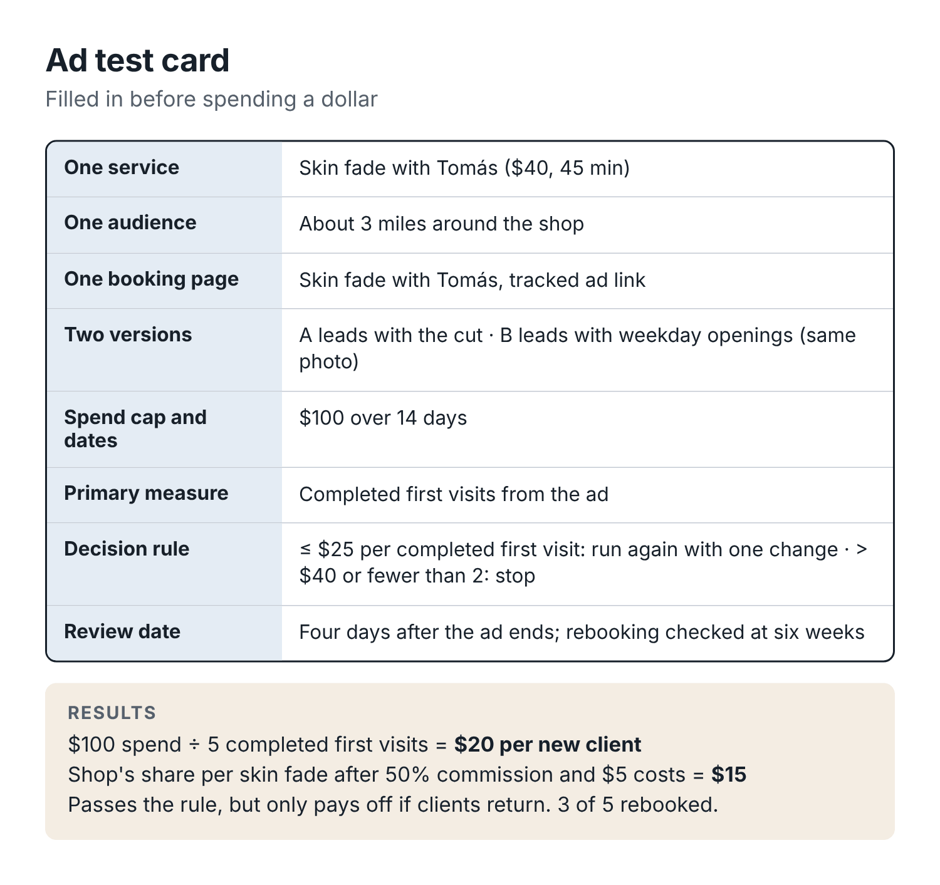
Figure 8. The ad test card. Write it before spending, review it on the date you set.
One service. Not “the shop”. A skin fade, a cut and beard, a kids cut before school starts. One clear thing a person can picture.
One audience. Who the ad is for and where they are. A radius around the shop that matches how far people realistically travel for a haircut, often a couple of miles in a city and more in a suburb or small town. Age range only if it truly matters for the service.
One booking page. A link that goes straight to booking that service, ideally with that barber, and that lets you see bookings that came from the ad. A separate link, a source tag, or at minimum the “How did you find us?” question.
Two versions, one difference. Two ads that differ in one thing only: the photo, or the first line, or the offer. If you change three things at once and one ad wins, you do not know why.
A spend cap and an end date. The total you are willing to lose if it does not work. For a first test, an amount you would not lose sleep over, perhaps $60 to $150, over one to two weeks.
The primary measure. Completed first visits attributed to the ad. Not clicks, not views, not bookings.
The decision rule. Written in advance: “If cost per completed first visit is $25 or less, run it again with one change. If it is over $40 or there are fewer than two completed first visits, stop. In between, try one more version.”
The review date. When you will sit down and look at the numbers, which should be a few days after the end date, so people who booked late in the test have had time to come in.

How much can you afford to pay for a new client?
The decision rule needs a number, and here is how to get one.
Start with what the first visit leaves behind after direct costs. For a $35 standard cut with about $5 in direct costs (products, the share of supplies, card fees), that is $30. If your barbers are paid commission per cut, include that too. If Tomás earns 50% of the service price, the shop’s share of a $35 cut is $17.50, minus $5 in costs, leaves $12.50.
So, for the shop:
- If the barber is the owner (or you are solo), a new standard-cut client acquired for less than $30 pays for themselves on the first visit, before overhead and your own time.
- If the barber is on 50% commission, the shop breaks even on the first visit only below about $12.50.
That second number shocks people. It means that for a commissioned barber, an ad almost never pays back on the first visit. It pays back only if the client returns. Which is why Chapter 10, keeping clients, comes before you scale up ads.
Now add the return visits. Suppose, from your Chapter 2 numbers, about a third of first-time clients become regulars and come back roughly six more times in the year. On average, each new client then brings about two more visits in the year (a third of six). At $30 contribution per visit for an owner’s chair, that is around $60 more. So a new client is worth about $90 in contribution in their first year, on average, and you could pay more than $30 for one and still come out ahead. Over the year, not on the first visit.
Be careful with this kind of arithmetic. It is easy to talk yourself into a high acquisition cost by assuming everyone becomes a regular. Use your own return rate, not a hopeful one. And set your decision rule with some room: if your break-even is $30, aim for $20.

Writing the ads with AI
Ads for a barbershop should look and sound like the shop: a real photo, plain words, the service, the price, the place.
Write two versions of a Facebook and Instagram ad for my barbershop. Use only facts from my shop brief.
Service: skin fade with Tomás, $40, 45 minutes.
Goal: book a weekday appointment, Tuesday to Thursday.
Audience: men within about 3 miles of the shop.
Both versions must use the same photo and the same booking link. They should differ only in the first line: version A leads with the cut, version B leads with weekday availability.
For each: primary text under 40 words, headline under 8 words, call-to-action button suggestion.
No exaggerated claims (“best in town”), no fake urgency, no discount.
Then read both against the checklist from Chapter 3. Ads add one extra check: would a stranger understand, in two seconds, what you are selling and where? If not, cut words.
A few extra cautions:
- Use real photos of your own work, with the client’s permission for ad use specifically. Advertising is a bigger use than a post on your feed, and some clients who are fine with one are not fine with the other.
- Avoid fake urgency. “Only 2 slots left!” when there are nine is dishonest and, in many places, a consumer-protection problem.
- Check the platform’s ad rules. Meta and Google review ads, and certain claims or images can get an ad rejected. A plain ad for a haircut rarely has trouble.

Running the test
Set up the campaign with the budget cap and end date from your card. Turn it on. Then leave it alone. Changing the audience, the budget or the image halfway through ruins the comparison and resets the platform’s learning. Check once or twice that it is running and that the link works.
Meanwhile, at the shop, record the source for every new booking. When someone books through the ad link, or says “I saw your ad”, mark it. Keep the four columns from Chapter 9: booked, completed, cancelled, no-show.

Reading the results
On the review date, gather the numbers: total spend, bookings from the ad, completed first visits from the ad, and whether those clients booked again.
Here is Cedar Street’s first test, for Tomás’s skin fades on weekday afternoons, with a $100 cap over 14 days:
- Spend: $100.
- People who clicked through to the booking page: 64. (Interesting, not decisive.)
- Bookings attributed to the ad: 7.
- Completed first visits: 5. One cancelled ahead, one no-show.
- Cost per completed first visit: $100 ÷ 5 = $20.
Version A (the cut first) and version B (availability first) brought in 3 and 2 completed visits. That is too few to call a winner. With numbers this small, the difference could easily be chance. That is normal; most small-shop ad tests will not produce a clear winner between versions, and that is fine. The main question is whether the ad as a whole was worth it.
Was it? The decision rule said: $25 or less, run again with one change. At $20, it passed. But look closer. Tomás is on commission, so the shop’s share of each $40 skin fade, after his 50% and $5 in costs, is $15. The shop paid $20 to earn $15 on the first visit. It only makes money if those clients come back.
So the real review happened six weeks later. Three of the five had rebooked, two of them at checkout. Over the year, if those three return every four weeks or so, each one brings in a dozen more visits. That is a good result. Dre and Tomás agreed to run a second test with one change: a short video of the same fade instead of the photo.
If your numbers are this small, the honest conclusion is often “promising, test again” rather than “it works”. That is still progress. After three or four tests you will know far more than you did, for a few hundred dollars, and you will never boost a post on hope again.
You can ask AI to help with the review:
Here are the results of an ad test for my barbershop. Spend: $100. Clicks: 64. Bookings attributed: 7. Completed first visits: 5 (version A: 3, version B: 2). No-show: 1. Cancelled ahead: 1. Service: skin fade, $40. Barber is on 50% commission. Direct costs per service: $5. My decision rule: continue if cost per completed first visit is $25 or less.
- Calculate cost per completed first visit and the shop’s contribution from the first visits after commission and costs.
- Tell me whether the difference between versions A and B is meaningful with these numbers, in plain language.
- Apply my decision rule.
- Suggest one single change for the next test.
Show your arithmetic.

When an ad fails
Most ad tests will not pass the first time. When one fails, look for the leak, the same way you did in Chapter 2:
- Plenty of clicks, few bookings? The booking page is the problem. Too many steps, no availability shown, wrong service pre-selected, slow to load on a phone.
- Bookings but no-shows? The reminder process, or the audience. Ad bookings from strangers tend to no-show more than referrals; a reminder sequence (Chapter 10) helps.
- Few clicks? The ad itself, or the audience, or simply not enough spend to learn anything.
- Visits, but nobody returns? Look at the experience and the rebooking habit, not the ad.
Then either fix that one thing and test again, or stop and put the money into something closer to the chair. Stopping is a perfectly good result. You have learned that, right now, this channel does not pay for your shop, and it cost you a capped, known amount to find out.

Before your next shift
- Check the four conditions at the start of this chapter. If any are missing, fix that first.
- Work out what a new client is worth to you, using your own return rate and commission.
- Fill in a test card, including the decision rule and review date, before opening an ad manager.
- Create a tracked booking link for the ad.
- Run the test, leave it alone, and review on the date you set.

Part Three: Fill the book and keep it full
Answer every inquiry, sell the quiet hours, cut no-shows, and bring back the regulars who drifted.

Chapter 8: Never lose a booking to a missed call
Dre’s two-week count in Chapter 2 found 31 missed calls, and 19 of those callers never heard back. He thought about that number on the drive home. Nineteen people had picked up a phone, found the shop’s number and dialed it, which is a lot of effort for a haircut. They were ready to book. And the shop had answered them with silence.
He knew why. When you are cutting, you cannot answer the phone. When you finish, there is a client at the register, another in the chair, and a guy asking about Saturday. By the end of the day, a missed call from 2:40 p.m. feels too old to return. So you don’t.
This chapter is about making sure every person who reaches out, by phone, text, DM or walking in, gets a fast, accurate reply that ends with a way to book. Some of it is automation. Most of it is a few templates and a simple rule about who answers what.

One rule: every reply ends with a way to book
Clients reach a barbershop through more channels than any other small business I can think of: the shop phone, the barber’s personal phone, texts, Instagram DMs, Facebook messages, WhatsApp, the booking app’s chat, a comment under a post, and the front door.
You cannot make all of those go away, and you should not try. People will contact you the way they prefer. What you can do is make every channel lead to the same place: your booking link, or a confirmed slot entered in your calendar by a person.
That is the rule for every template in this chapter. No reply ends with “let me know!” or “hit me up”. It ends with the link, or with “I’ve booked you for 3:30 Thursday with Tomás, see you then”, entered in the calendar before the message is sent.
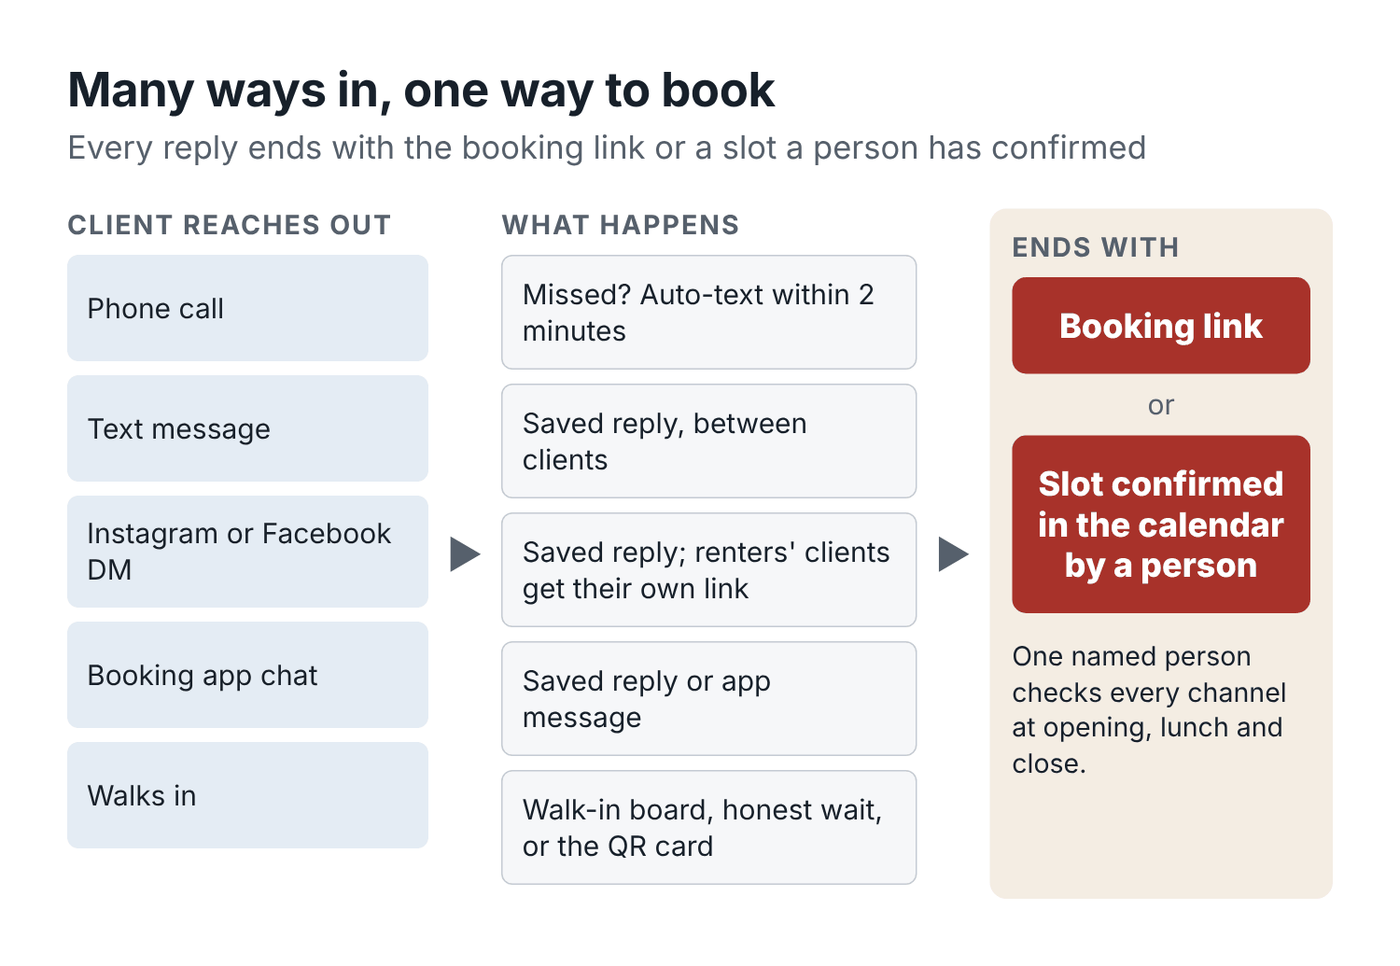
Figure 9. Many ways in, one way to book. Every channel ends at the booking link or a slot a person has confirmed in the calendar.

The missed-call text-back
This is the single most effective fix in this book for most shops, and it is nearly free.
When a call to the shop goes unanswered, the caller automatically gets a text within a minute or two. Many business phone services, VoIP apps and booking platforms can do this; check the settings of whatever you use, or ask your provider. If yours cannot, a cheap business phone app that can is worth switching to.
The text should do three things: tell them who it is, give them the fastest way to book, and invite them to reply if they have a question.
Hi, this is Cedar Street Barbers. Sorry we missed your call, we’re probably mid-cut. You can book any time here: [booking link]. Or reply to this text and we’ll get back to you between clients.
That is all. Short, friendly, useful. It is a reply to someone who just called you, about the thing they called about, so it is not a marketing message. Keep it that way: no offers, no promotions, no “follow us on Instagram”.
Then, for anyone who replies by text instead of booking, answer between clients using the saved replies below.
Dre set this up through his phone provider in about twenty minutes. In the next two weeks, the shop missed 28 calls. Eleven of those callers booked online straight from the text. Another nine replied with a question and were answered within the hour. Of the remaining eight, Dre called back four at the end of the day. Missed-call recovery went from 39% to 86%, and at least eleven bookings came from people who in the old system would have heard nothing.

A voicemail that helps
Some people still leave voicemails, and most voicemail greetings waste their time. Rewrite yours:
Write a voicemail greeting for my barbershop, under 20 seconds when spoken aloud. Say the shop name, that we’re probably cutting, that the fastest way to book is the link we’ll text them, and that they can leave a message if they have a question. Mention our hours from the brief. Natural, not corporate. Read it aloud and count: under 50 words.
Record it in a quiet moment, in your own voice. A real barber’s voice beats a robotic one.

Saved replies for the questions you answer every day
Look at your DMs and texts from the last month. You will find that about ten questions make up most of them. Cedar Street’s were:
- How much is a cut / fade / beard?
- Do you have anything today / tomorrow / Saturday?
- Do you take walk-ins?
- Where are you / where do I park?
- Can I book with [barber]?
- Do you cut kids? How old?
- How long does a [service] take?
- Do you cut textured or curly hair?
- I need to cancel / move my appointment.
- Are you open on [holiday]?
Write one reply for each, built from your shop brief, and save them where you will use them. Instagram and Facebook both have saved replies in their business tools; your phone’s keyboard can store text shortcuts; your booking app may have message templates.
Using only my shop brief, write saved replies for these 10 questions clients send my barbershop by text and DM. Each reply under 40 words. Each ends with the booking link [booking link] or, for questions about a specific barber who rents a chair, that barber’s own link. For questions about availability, never name a specific time; send the link or say we’ll check and reply. Write [CHECK] where the brief doesn’t give the answer.
Questions: [paste your ten]
Shop brief: [paste]
Read every reply, fix the tone, fill the [CHECK] gaps, and test them with a friend who texts you the questions. Then use them. Replying to “how much for a fade” now takes three seconds instead of thirty, and the answer is always right.

What to do with “Do you have anything today?”
This is the question a chat assistant must never answer on its own unless it is connected to your live calendar, because the honest answer changes every few minutes.
There are two good replies. Either send the link (“Here’s what’s open today, it’s live: [link]”), or check the calendar yourself and offer a real slot. If you offer a slot, put it in the calendar before or immediately after sending, so nobody else books it.
Hey, Tomás has 4:15 today for a skin fade. Want it? I’ll hold it for 15 minutes.
And then actually hold it: mark it in the calendar as “held for DM, 15 min”, and release it if they do not reply. A slot promised in a DM and booked online by someone else five minutes later is how you lose two clients at once.

Handing a booking across barbers
Sometimes a client asks for one barber who is full, and another barber is free. Handle this with care, especially in a shop with chair renters, where each barber’s client list is their own business.
The rule at Cedar Street:
- Between Dre and Tomás (both on the shop’s books): the front desk may offer the other barber, by name, saying why. “Tomás is booked until Friday. Dre has 2:30 tomorrow if you’d like it, or I can put you on Tomás’s waitlist.”
- With Keisha (a renter): the shop never moves Keisha’s clients to anyone else, and never books into Keisha’s calendar. If someone asks for her, they get her link. If someone asks the shop for a textured cut and Dre and Tomás are both full, the shop may say “Keisha specializes in textured hair; here is her booking link”, because she agreed to that in advance.
Write your version down. It prevents a surprising number of arguments.

The walk-in who cannot be seen
On a busy Saturday, someone walks in and there is no chance of a chair for two hours. The worst outcome is that they leave and you never see them again. The second worst is that they wait 40 minutes, give up, and write a review.
Give them a way to book a future time, on the spot. At Cedar Street there is a small card by the door: We’re fully booked right now. Grab your next cut here, with a QR code to the booking page. Whoever is nearest says: “Sorry, we’re booked up until 2. Here’s the card, you can book any open time in ten seconds. Tuesday and Wednesday afternoons are usually easy.”
That last sentence does double duty: it is honest, and it steers walk-ins toward your quiet hours.
Chapter 12 covers walk-in rules and the walk-in board for shops that take a lot of them.

AI receptionists: worth it, and when
An AI receptionist answers your shop phone (and sometimes your messages) with a natural-sounding voice. Depending on the product, it can tell callers your hours and prices, send a booking link by text, check your live calendar, book an appointment, take a message, or transfer the call.
Some barber and salon booking platforms now offer one as a paid add-on, connected to their own calendar. Independent services also exist that connect to popular calendars. Prices vary widely, usually a monthly fee with some limit on minutes or calls, and they change often enough that I will not quote them. Check current pricing and read the terms on call recording and data.
Are they worth it? It depends on how many calls you miss after the text-back is in place. Do the text-back first; it is far cheaper, and for many shops it solves most of the problem. If you still miss a lot of calls, especially from people who will not book online (older clients, people with questions), an AI receptionist may be worth testing.
If you test one, judge it on these questions:
- Does it see your live calendar? If not, it can only send a link or take a message. That may still be useful, but it is not a receptionist.
- What does it say when it does not know? Call it and ask for a service you do not offer, a price that is not on your menu, and a time you are closed. It should say it does not know, or take a message. It must not invent.
- How does it hand off? Can it transfer to a person, or send you a summary immediately when a caller is upset or asks for something unusual?
- What does it cost per month, and per extra minute? Work out the cost per completed booking it produces, the same way you did for ads.
- Does it record calls, and does it tell callers? Some US states require everyone on a call to consent to a recording. Make sure the greeting discloses it and that you understand the vendor’s terms.
- Can you switch it off instantly? You want a way to pause it in seconds if it starts giving wrong answers.
Then test it like you tested your shop brief: twenty scripted calls, including the awkward ones (an angry client, a parent booking for a child, someone asking for a barber who left, someone asking about a scalp condition). Run it after hours only for the first two weeks, review every call summary, and expand only when you trust it.
Remember the Air Canada case from the introduction. If your AI receptionist promises a client a $30 fade, that promise is yours.

Response time: a simple standard
How fast is fast enough? There is no magic number, but people who contact a barbershop are usually choosing between you and one or two others, and the first useful reply often wins.
Cedar Street’s standard is simple:
- Missed calls get the automatic text within two minutes, always.
- Texts and DMs during opening hours get a reply between clients, within 30 minutes.
- Messages after hours get an automatic reply where the channel allows (“We’re closed for the night; book any time here: [link]. We’ll answer questions from 10 a.m.”), and a personal reply when the shop opens.
- One person checks all channels at opening, at lunch and at close. That person is named on the schedule each day.
That last line is the one that makes the rest work. “Everybody checks the DMs” means nobody does.

The front-desk script sheet
Put your most-used replies on one page, by the register, and in the notes app of everyone who answers for the shop. Appendix B has a full set. Cedar Street’s sheet has six entries:
- Missed-call text-back.
- “Do you have anything today?” (send the link, or offer and hold a real slot).
- Walk-in when fully booked (the card and the line about Tuesday afternoons).
- Booking with a full barber (offer the other employee by name, or the waitlist; renters get their own link).
- Running-late client (“Thanks for the heads-up. We can still do a [shorter service] in the time left, or move you to [next slot]. Which works?”).
- Reschedule request (the link, or offer two real times).
AI drafted them all from the brief in one go. Dre edited each one until it sounded like him, then had Tomás and his nephew Jaylen read them aloud to check they sounded natural.

Before your next shift
- Turn on a missed-call text-back on the shop phone.
- Rewrite and re-record your voicemail greeting.
- Write saved replies for your top ten questions and load them into Instagram, Facebook and your phone.
- Decide who checks messages at opening, lunch and close, and put a name on each day of the schedule.
- Print a walk-in card with a QR code to your booking page.

Chapter 9: Fill quiet weekday slots
It is Monday morning, the shop is closed, and Dre is checking next week’s calendar at his kitchen table. Saturday is almost full. Friday after 3 is filling. But Tuesday and Wednesday, between noon and 4, Tomás’s chair has twelve half-hour openings.
Dre’s first thought is the one every owner has: post “20% off all cuts this week”. It feels like action. It would probably bring a few people in.
Before he does that, it is worth asking a different question. Who could use those times at the full price, if they only knew the times were open?
The regular who works evenings and has been meaning to get a cut. The man who asked last week to be told if a Wednesday slot came up. The guy who works from home two streets over and has never thought of getting his hair cut at lunchtime on a Tuesday. All of them can fill a chair at $35. A public discount is a separate decision, one you can test later once you know what plain availability does on its own.
This chapter walks through a one-week campaign to fill those gaps, step by step, with the messages, the tracking and the arithmetic. It is the most hands-on chapter in the book. Run it once, and you will have a routine you can repeat whenever the calendar has holes.

Find the gaps that repeat
One empty Tuesday is bad luck. Empty Tuesdays every week are a pattern, and patterns can be worked on.
Pull eight weeks of appointment data (names removed) and look at which hours are empty most often. You can do it by eye on a printed calendar, or let AI do the counting:
Here are 8 weeks of appointments from my barbershop, names removed. Columns: date, weekday, start time, end time, barber, service, status. Each barber’s sellable hours are [list per barber, minus lunch].
For each barber, make a table of weekdays (rows) by hour blocks (columns: 10-12, 12-2, 2-4, 4-7 on weekdays; 8-11, 11-2, 2-5 on Saturday) showing the average share of sellable time that was booked and completed. Then list the three emptiest blocks for each barber, with the average number of empty hours per week in each. Show your method.
What you get is a heatmap, even if it is just numbers in a table. Cedar Street’s looked like this.
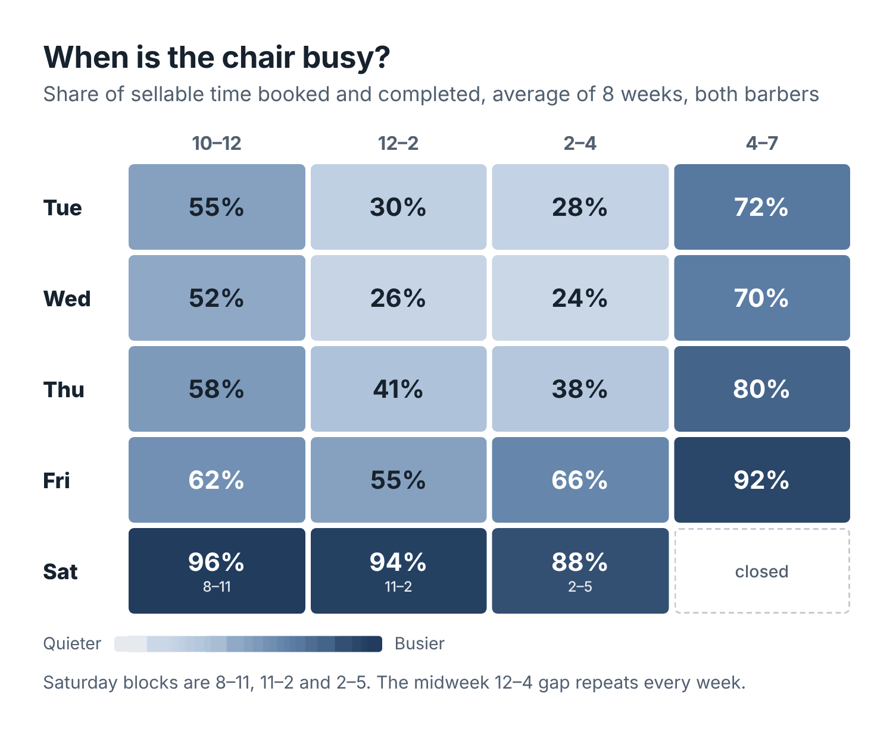
Figure 10. Cedar Street’s quiet hours, averaged over eight weeks. Darker means busier. The midweek early afternoon is the obvious gap.
The midweek gap between noon and 4 was there every single week, for both barbers, and worst for Tomás, who has a smaller base of regulars. Friday evening and all of Saturday were close to full. That pattern is very common. Weekday afternoons are hard because most people with nine-to-five jobs cannot come.
Which raises the question: who can?

Who could use a weekday afternoon?
Make a list of the kinds of people in your area who are free in your quiet window. For a midweek early afternoon, Cedar Street’s list was:
- Regulars who work evenings, nights or shifts (bartenders, nurses, warehouse and restaurant workers).
- People who work from home or have flexible hours.
- Retirees.
- Students with afternoons free.
- People who work nearby and could come on a lunch break, if the cut is quick.
- Anyone already waiting for a weekday opening (the waitlist).
You probably know which of these groups your clients belong to. If you want help thinking it through, describe your neighborhood and ask the assistant for more ideas, then cross out the ones that do not fit.
Notice what is not on the list: kids. School is in session. Kids’ cuts belong after 3:30, and promoting them for 1 p.m. on a Tuesday wastes a message.

Count the openings you can actually sell
Before you tell anyone about an opening, make sure it is real.
Block out lunch, cleaning, breaks and any time the barber is busy with something else. Then count only gaps long enough for the service you are promoting. A 20-minute gap between two appointments looks free on the calendar, but it cannot hold a 30-minute cut. If two barbers share the calendar, write the barber’s name next to each opening.
Then open your live booking page as a client would, choose the service you are promoting, and confirm the openings show up there. It is surprisingly common for a gap to exist on the barber’s calendar but not appear online, because of a buffer setting, a service length mismatch, or the barber being marked as unavailable. If it does not show online, clients cannot book it, and your campaign will fail for a reason that has nothing to do with marketing.
If you make a list of openings to plan your outreach, write the time on it (“as of Monday 9 a.m.”). The calendar will change while you are writing messages.
For Cedar Street’s campaign week, the target was Tomás’s chair, Tuesday and Wednesday, noon to 4. After blocking his lunch, there were twelve half-hour openings for a standard cut, all visible on the live booking page.

Match each opening to the right audience
There are three ways to tell people about an opening. Each suits a different audience, and they work best together.
The waitlist. Clients who asked to be told about a specific day, time or barber. They have already said yes; they just need the message. Offer a specific opening, and use your live booking link or a clear hold-and-release process so two people cannot claim the same slot.
Overdue regulars. Clients who are past their usual return interval and have agreed to receive marketing messages from you. Leave out anyone who already has a booking coming up, anyone who has opted out, and anyone who has not given you permission to send them promotional texts or emails. (Chapter 10 explains why permission matters, and the rules on texting.)
The public. Everyone who follows you or finds you: an availability post on Instagram and a Google Business Profile update, with the service, price, barber and live booking link. Keep the post accurate as openings fill.
Cedar Street had a waitlist of three people for weekday slots with Tomás. Looking at clients who had opted in to texts, had not been in for longer than their usual gap, and had nothing booked, there were 24 eligible regulars. Every appointment could fill only one opening, even when several channels pointed people at it.

Write the messages
Give the assistant the verified price, the window, the tone and the placeholders. Keep the actual client list in your booking system; the AI only needs to know what kind of message to write.
Draft three messages for Cedar Street Barbers.
- A short text for a regular who opted in to marketing and is overdue for a visit.
- A reply to someone on the waitlist for a Wednesday opening with Tomás.
- A public availability post for Instagram and Google.
Facts: a standard cut is $35 and takes 30 minutes. The window is Tuesday and Wednesday, noon to 4 p.m., with Tomás. Use these placeholders: [first name], [barber], [verified slot], [booking link], [opt-out wording if required].
Keep each message under 45 words. Relaxed, plainspoken tone, like a barber texting. Leave missing facts in brackets. Don’t invent prices, deadlines, availability or offers.
Here is what came back, after one round of editing:
Overdue regular
Hey [first name], [barber] at Cedar Street has a few weekday openings this week if you’re due for a cut. Standard cut is $35. See what’s still free: [booking link]. [Opt-out wording if required]
Waitlist opening
Hey [first name], the Wednesday opening you asked about just came up. [Barber] has [verified slot] for a standard cut. You can grab it here: [booking link]. The calendar shows if it’s still open.
Public availability post
Got half an hour Tuesday or Wednesday? Tomás has a few openings between noon and 4 at Cedar Street. Standard cuts are $35. Pick a time: [booking link]
Notice what none of them say. No “limited time”, no “only 3 left”, no “don’t miss out”. Just what is available, what it costs, and how to book.

Before you press send
Read each message as if you were the client. Can you tell who it is from, what it costs and how to book? Then check the practical things:
- The link opens the right service, with the right barber, and shows the openings.
- The shop (or the barber) has permission to contact each person on the list in this way.
- Every placeholder is filled.
Send the first batch yourself, not through an automation, so you can handle replies and notice awkward wording. If two people reply asking about the same time, you will know immediately.
As slots fill, stop promoting those times. Edit the public post or add a comment: “Tuesday’s gone, two left Wednesday.” An availability post that is out of date is worse than none.
One more thing. If someone replies asking for a cut and beard, check that the longer service fits. A 30-minute opening fits a standard cut, not a 45-minute cut and beard. Offer a time that works for both services, and quote the correct price from the menu, $50, not $35.

Keep track while the day is busy
The point of the week is to learn what works, and you cannot learn without records. The record-keeping needs to be quick, because you are cutting hair.
At booking, record the source once: the campaign link, the client’s reply to a text, or a quick “How did you find this opening?” at the chair. If you cannot tell, write “Unknown”. Do not guess later; guesses always flatter the campaign.
Keep four columns: booked, completed, cancelled, no-show. If a client who already had an appointment moved it into one of the target slots, mark it as a reschedule. That matters, because moving an existing booking into a quiet slot does not fill a gap; it just moves one.
A paper sheet by the register is fine. So is a note in the booking system.

Review the week before you repeat it
On Friday, pull the records for the twelve target openings. At Cedar Street, eight were booked, seven cuts were completed, and one client did not show up. Nobody had moved an existing appointment into these slots.
Booking source | Booked | Completed
Outreach to 24 eligible regulars | 4 | 3
Waitlist replies | 2 | 2
Local search or Google profile | 1 | 1
Public availability post | 1 | 1
Total | 8 | 7
The shop booked 8 of 12 openings (67%) and completed 7 of 12 (58%). Three of the 24 regulars in the outreach group completed a cut, or 12.5%. The waitlist and the public post reached different audiences, so their raw counts answer a different question; you cannot say one “beat” the other. Always keep the numbers next to the number they came from.

What the completed cuts were worth
The seven cuts brought in $245 in service revenue (7 × $35). At $5 in direct costs per cut, that leaves $210 before Tomás’s commission, owner labor, fixed overhead and the time spent on the campaign. If your shop pays commission per cut or pays card fees, include those in your version. For Cedar Street, after Tomás’s 50%, the shop’s share was $87.50, and Tomás earned $122.50 for chair time that would otherwise have been empty.
That $210 describes the completed cuts. It does not prove the campaign caused all of them. Some of those regulars might have booked anyway that week. To estimate the campaign’s real effect, compare with similar weeks (the same Tuesday and Wednesday window over the previous four weeks), or run the outreach on alternate weeks and compare. Cedar Street’s previous four weeks had averaged three completed cuts in that window for Tomás. So a fair estimate of the extra cuts is about four, not seven.

Test a discount only if the gap is still there
Now, and only now, is it worth thinking about a discount, and only for the openings that are still empty.
Here is the arithmetic. With $5 in direct costs, a $35 cut contributes $30. A $5 discount drops that to $25. If all seven completed cuts in this example had received the discount, the shop would need nine discounted cuts to beat the original $210. Eight would contribute $200 (8 × $25). Nine would contribute $225 (9 × $25).
In other words, the discount has to bring in at least two extra completed cuts just to break even, and there have to be openings left to hold them. Check that before you try it. And remember that a discount offered to everyone also goes to the regulars who would have booked at full price.
Use the same arithmetic for a referral reward or a bundle. The question is always the same: how many extra completed visits does this need to pay for itself, and is there room in the chair for them?

Choose what to do next week
Cedar Street’s decisions after the first week:
- Keep using the waitlist for openings that match. It cost nothing and both people came.
- Check whether the four people who booked through outreach included anyone who was already about to book. (Two of them had been in five weeks earlier, inside their usual interval. Next time, the “overdue” filter would be a week longer.)
- Repeat the test the following week, same window, same messages, with one change: post the availability update at 8 a.m. on Monday instead of Tuesday morning.
Change one thing at a time. That way, when you look at the numbers next week, you will know what made the difference.

Make it a routine
After two or three runs, this stops being a campaign and becomes a weekly habit that takes about 20 minutes:
- On Monday, check the coming week’s calendar and count real openings in the quiet windows.
- Also on Monday, message the waitlist for matching openings.
- On Monday or Tuesday, send the overdue-regular message to eligible clients who have not had one in the last month. Do not text the same people every week.
- On Tuesday morning, post the availability update on Instagram and Google.
- During the week, update the post as slots fill and record sources at booking.
- On Friday or Saturday, count booked, completed, cancelled and no-shows in the target slots, and write one line on the scorecard.
Some shops also offer regulars a standing appointment: “same time every three weeks”. A client who works evenings and always comes at 1 p.m. on a Tuesday is the most reliable filler of a quiet slot there is.

Before your next shift
- Pull eight weeks of appointments and find your emptiest recurring windows.
- Check that those openings show on your live booking page for the service you want to promote.
- Start a waitlist if you don’t have one. Most booking apps support it; a note works too.
- Run the one-week campaign: waitlist, eligible overdue regulars, public post.
- Record sources and the four columns, then review on Friday before repeating.

Chapter 10: No-shows, rebooking and the regulars who drifted away
Every barber has a client like Marcus. For three years he came in every third Thursday at 5:30. Same cut, same chair, same conversation about the Lakers. Then one month he did not come. Dre noticed, sort of, in the way you notice that a song you used to hear on the radio has stopped playing. Six months later, Dre saw Marcus at the gas station with a fresh cut from somewhere else.
Nothing went wrong. Marcus changed jobs, his new office was across town, and one Thursday he got a cut near work because it was easier. Then the next one. Nobody from Cedar Street ever asked him to come back.
This chapter is about the end of the journey from Chapter 2: making sure booked clients show up, that they leave with their next visit booked, and that the ones who drift get a friendly nudge before they become someone else’s regular. It is the cheapest growth in the book, because every one of these people already knows you and likes your work.

Why this is where the money is
Look again at the numbers from Zenoti’s 2026 benchmark. New-guest visits at barbershops in its data fell 17% in 2025; existing-guest visits grew 2%. The same report looked at rebooking and cancellations across the salon businesses on its platform, barbershops included. Among clients who had rebooked twice or more, the cancellation rate was 4%. That is a vendor’s data from its own customers, so treat it as a signal rather than a law. But it points at something most barbers know by instinct: once a client is in a rhythm of booking the next visit, they tend to stay.
Your own numbers will tell you more. At Cedar Street, only 22% of eligible clients left with the next appointment booked. Imagine raising that to 50%. Those are clients whose next visit is already in the calendar, who get a reminder, and who are far less likely to drift to the place near their new job.

Part one: getting booked clients to show up
Start with no-shows, because they are the most annoying and, for most shops, the easiest to reduce.
First, know your number. Use the definition from Chapter 2: no-shows divided by appointments that were due. Count late cancellations separately. Published figures for barbershops vary hugely, from the low single digits in some booking-software data to well over 10% in surveys of individual shops, partly because everyone counts differently. Your own rate, measured the same way every week, is the only one that matters.
If yours is low (Cedar Street’s was 3.6%), do not spend a month on it. If it is high, here are the fixes, roughly in order of cost.

Reminders that are actually useful
Most booking systems send reminders automatically. Most shops never look at what those reminders say. Check yours. A good reminder:
- Arrives at a useful time. A common pattern is one the day before and one a couple of hours before. Test what works for your clients.
- Says the day, time, barber and service clearly.
- Makes rescheduling easy, with a link, so clients move the appointment instead of skipping it.
- States your late and cancellation policy in one short, friendly line.
Rewrite my barbershop’s appointment reminders. I need two: one sent the day before and one sent 2 hours before. Use [first name], [day], [time], [barber], [service], [reschedule link]. Include our policy in one friendly line: cancel or move up to 12 hours ahead at no charge; 10-minute grace for late arrivals. Under 40 words each. Tone: from my shop brief. No emojis.
Cedar Street’s day-before reminder became:
Hi [first name], see you tomorrow at [time] with [barber] for your [service]. Need to move it? Use this link up to 12 hours before: [reschedule link]. Cedar Street Barbers
Reminders about an appointment the client booked are service messages, not marketing. Keep them that way: no promotions bolted on the end.

Deposits and card-on-file, used carefully
A deposit or a card on file, with a clear fee for no-shows, reduces no-shows in most shops that use it. It also puts off some clients, particularly new ones and walk-in-minded regulars, and it adds friction to booking. Many booking platforms report big drops in no-shows after shops turn deposits on, but those figures usually come from the platforms selling the feature, without much detail on how they were measured.
A middle path that works well for many shops is a deposit only where the risk is: first-time online bookings, long services (a 75-minute full service), peak Saturday slots, and clients who have no-showed before. Cedar Street’s rule is in its brief: two no-shows in six months means future bookings need a $10 deposit, applied to the service.
If you change your policy, write it out plainly, put it on the booking page, in the brief and in the reminders, and explain it in person to regulars before it bites them. AI can help with the wording:
Write a short, friendly explanation of a new no-show policy for my barbershop’s booking page and a 2-sentence version for reminder texts. Policy: [describe it]. Explain why (empty chairs mean lost income for the barber and lost time for clients who wanted that slot) without guilt-tripping. Under 70 words for the booking page.

The no-show recovery message
When someone does not show, send a single message that same day. Not a scolding. A door left open.
Hey [first name], we missed you today at [time]. No worries, life happens. Want to rebook? Here’s the link: [booking link]
Most people who no-show feel slightly embarrassed. A friendly message makes rebooking easy; a cold one or silence makes it easier to try another shop. Record the no-show in your booking system so the deposit rule applies if it becomes a habit.

Part two: book the next visit before they leave
This is the single biggest habit change in the chapter, and it costs nothing.
When the cut is finished and the client is looking in the mirror, happy, that is the moment to book the next one. Not at the register while they are reaching for their card, and not in a text three weeks later. In the chair, while they are pleased.
The line Dre and Tomás settled on:
“Want me to put you in for the same time in three weeks? I can see what’s open.”
Three things make it work. It is a question, not a sales pitch. It suggests a specific interval, which is a helpful bit of expertise (a skin fade grows out faster than a standard taper). And “I can see what’s open” means the barber picks up the phone or tablet and books it right there, rather than asking the client to remember.
If they say no, that is fine. “No problem, I’ll send you a reminder when you’re due, if that’s OK.” Which leads to the next part.

Know each service’s return interval
Different services have different natural rhythms. Write yours down, because it drives the rebooking question, the reminders and the win-back messages:
Service | Typical return | Overdue after
Skin fade | 2 to 3 weeks | 5 weeks
Standard cut | 3 to 5 weeks | 7 weeks
Beard trim and line-up | 1 to 2 weeks | 4 weeks
Kids cut | 4 to 6 weeks | 8 weeks
These are Cedar Street’s, from its own data; yours may differ. AI can find yours:
Here’s a year of appointment data, names replaced with client IDs. For each service, calculate the median number of days between visits for clients who came at least 3 times. Then suggest an “overdue” threshold for each service: roughly the point where most clients who are going to return already have. Show the counts behind each number.

Measure it, every week
Checkout rebooking rate = eligible completed visits that left with a future appointment ÷ eligible completed visits.
Decide in advance what “eligible” means. A tourist, a wedding guest from out of town or a client who says they are moving away is not eligible. Then put the number on the scorecard and talk about it with your barbers weekly. Cedar Street’s went from 22% to 41% in the first month after both barbers started asking at the mirror, and to 48% by the third month. Tomás, who had felt awkward asking, found it easier once he had a single line he said the same way every time.
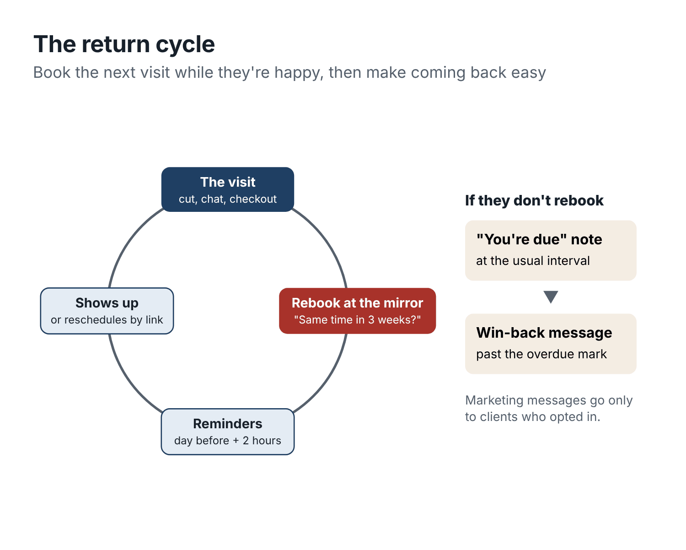
Figure 11. The return cycle. Rebook at the mirror, remind before the visit, and reach out when a regular passes their usual interval.

Part three: bring back the regulars who drifted
Some clients will always say no at the mirror, and some who rebook will cancel. That is where a win-back message comes in: a friendly note to a regular who has gone past their usual return interval.

Permission first
This is the part people skip, and it can be expensive. In the United States, the Telephone Consumer Protection Act (TCPA) and the Federal Communications Commission’s rules under it govern marketing texts. As a general rule, sending marketing texts with an automated system requires the client’s prior express written consent, a clear opt-out (replying STOP must work and must be honored promptly), and respect for quiet hours, which under the federal rules means no telephone solicitations before 8 a.m. or after 9 p.m. in the recipient’s time zone. Some states add their own rules, and lawsuits over marketing texts are common.
A win-back message (“we’ve got openings, come back”) is marketing. A reminder about an appointment the client already booked is not. Treat them differently.
In practice:
- Ask for marketing consent clearly and separately at booking, or on a paper or tablet form at checkout. A checkbox like “Text me about openings and offers from Cedar Street. Reply STOP any time” works if it is not pre-ticked, and your booking system should record it.
- Keep a record of who agreed, when and how.
- Include opt-out wording in marketing texts, and honor it immediately.
- Send marketing texts during reasonable daytime hours.
- Most texting platforms that send business messages in the US also require you to register your business and use case with the carriers (often called 10DLC registration). Your booking or texting provider will usually walk you through it.
Email has its own rules (in the US, the CAN-SPAM Act), which are less strict on consent but require an unsubscribe link and your business address. Rules in Canada, the UK, the EU and Australia are generally stricter. If you are not sure, keep win-back messages for clients who have clearly opted in, and ask your booking provider what their compliance features cover. For anything high-stakes, ask a lawyer.
This sounds like a lot. In practice, once your booking system records consent and handles opt-outs, it is a checkbox.

The win-back message
Once a month, pull the list of clients who are past their “overdue” threshold, have opted in to marketing, have nothing booked, and have not had a win-back message in the last couple of months. Your booking system can usually filter this; if not, AI can help you sort an export (names replaced with IDs, as always).
Then send a short, personal-sounding message. It should not sound like a campaign, even though it is one.
Write three versions of a win-back text for regulars who haven’t been to my barbershop in longer than usual and have opted in to marketing texts. Use [first name], [barber], [booking link] and [opt-out wording]. Under 35 words. Warm, low-pressure, from the barber who usually cuts them. No discount, no guilt (“we miss you!!”), no fake urgency. One version should mention weekday openings.
The one Dre uses most:
Hey [first name], it’s Dre at Cedar Street. It’s been a while, hope all’s good. If you’re due for a cut, I’ve got openings this week: [booking link]. [Opt-out wording]
Notice there is no discount. Start without one. Most lapsed regulars do not need a bribe; they need a reminder and an easy link. Measure what plain messages do before you add an offer, exactly as you did in Chapter 9.

Measure it honestly
Win-back rate = clients who completed a visit within, say, 30 days of the message ÷ clients messaged.
Some of those clients would have come back anyway. For a fairer picture, hold back a small random group each month (every fifth eligible client, for example) and do not message them. Compare how many of each group returned. If the messaged group returns more often, the difference is roughly what the message did. If not, rewrite the message or reconsider the timing.
When Dre ran this for three months, 61 eligible lapsed regulars got the message, and 14 completed a visit within 30 days (23%). Of the 15 held back, 2 came back on their own (13%). So the messages were bringing back roughly one extra client in every ten messaged. Small numbers, but each of those clients was worth several visits a year, and the whole thing took twenty minutes a month.

The ones who left for a reason
Some lapsed clients left because something went wrong: a bad cut, a long wait, a rude moment. A win-back text will not fix that. If a client replies with a complaint, treat it as one (Chapter 6): thank them, pass it to the owner, and call.
And some clients moved, changed jobs or simply found somewhere closer. That is life. Marcus, it turned out, was happy with his new barber near work. He still books with Dre in December, though, when he is home for two weeks. That December visit happens because Dre texted him in November.

Before your next shift
- Check your reminder messages, and rewrite them so rescheduling is one tap.
- Write a no-show recovery message and send it the same day, every time.
- Agree on one rebooking line with your barbers, and start counting the checkout rebooking rate.
- Set a return interval and an “overdue” threshold for each service.
- Check how your booking system records marketing consent. Fix it before you send any win-back message.

Part Four: Run a tighter shop
Price for the chair hour, run a team without crossed wires, shrink the admin, and put it all in motion in thirty days.

Chapter 11: Price for chair time, not just per cut
Ask a barber which service makes the most money and you will usually hear “the full service” or “the cut and beard”, because those have the biggest price. Dre would have said the same. Then he worked out what each service earned per hour of chair time, and the answer surprised him. His $40 skin fade, one of the most popular services in the shop, earned less per hour than a plain $35 cut.
Your chair is the one thing you cannot make more of. There are only so many hours in a week, and on a Saturday, every one of them is already spoken for. So the useful question is not “how much does this service cost?” It is “how much does this service leave behind for each hour it occupies the chair?”
This chapter shows you how to work that out, how to use it to set prices and bundles, and how to check the arithmetic on discounts, memberships and gift cards before you commit to them. AI is handy for the calculations and for the wording of any price change. The decisions are yours.

Contribution per chair hour
Here is the measure, in one line:
Contribution per chair hour = (price − discounts − direct costs) ÷ booked minutes × 60.
Direct costs are the costs that come with each service: product used, disposable supplies, laundry, card fees, and commission if the barber is paid per service. Not rent, not the electricity bill, not the owner’s salary. Those are overhead; they are there whether you cut one head or forty.
Booked minutes are the time the service blocks in the calendar, including any buffer you build in. If a skin fade is booked for 45 minutes, it costs the chair 45 minutes, even if Tomás finishes in 38.
Here is Cedar Street’s menu, worked out for the owner’s chair (no commission):
Service | Price | Direct costs | Minutes | Per chair hour
Beard trim and line-up | $20 | $3 | 15 | $68.00
Standard cut | $35 | $5 | 30 | $60.00
Cut and beard | $50 | $7 | 45 | $57.33
Full service | $75 | $12 | 75 | $50.40
Hot towel shave | $45 | $8 | 45 | $49.33
Skin fade | $40 | $5 | 45 | $46.67
Kids cut | $25 | $4 | 30 | $42.00
Take the skin fade: $40 − $5 = $35, divided by 45 minutes, times 60 = $46.67 per chair hour. The standard cut: $35 − $5 = $30, divided by 30, times 60 = $60.
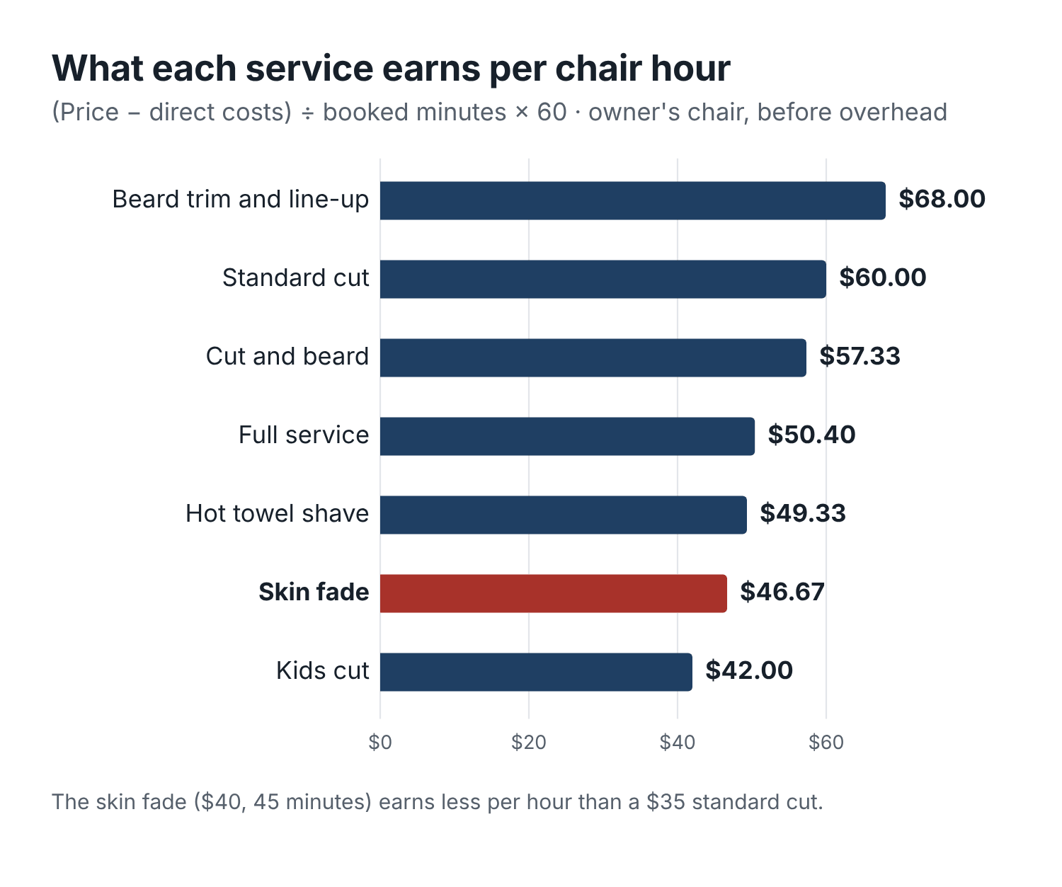
Figure 12. Contribution per chair hour at Cedar Street. The popular skin fade earns the least per hour of any adult service.
You can have AI build this table from your own menu:
Here’s my barbershop menu with price, booked minutes and my estimate of direct costs per service (product, supplies, card fees). For each service, calculate contribution per chair hour = (price − direct costs) ÷ minutes × 60. Sort from highest to lowest. Then calculate the same thing assuming the barber is paid [X]% commission on the service price. Show the arithmetic for the first two rows so I can check it.
[paste menu]
Estimate direct costs roughly; you do not need precision to the cent. Look at what you spend on product and supplies in a month and divide by the number of services. Add card fees (often around 3% of the price). That gets you close enough.

What the numbers tell you, and what they don’t
The table told Dre three things.
The skin fade was underpriced for its time. It took 50% longer than a standard cut but cost only 14% more. Every Saturday slot that went to a skin fade earned less than the same time spent on standard cuts or beard trims.
The kids cut was the lowest earner. That was a choice Dre was happy with. Kids cuts bring families, and families bring fathers who book their own cuts. Some services earn their place in other ways. Just make that choice on purpose.
The beard trim earned the most per hour, because it is short. That did not mean he should only do beard trims. It meant a short add-on slotted into a 15-minute gap earned real money.
And one thing the table does not tell you: contribution per chair hour matters most when the chair would otherwise be full. On a Saturday morning with a waiting list, every hour is precious and the highest-earning services deserve priority. On a Tuesday afternoon with empty slots, a $21 kids cut is $21 more than an empty chair. The measure is for setting prices and guarding peak hours, not for turning clients away when you have nothing else to do.

Three ways to fix an underpriced service
Once you spot a service that earns too little per hour, you have three options.
Raise the price. If the skin fade went to $45, its contribution would be $40 per 45 minutes, or $53.33 an hour. Still below the standard cut, but much closer.
Shorten the booked time, honestly. If Tomás consistently finishes skin fades in 35 to 40 minutes, maybe the booked time should be 40. But do not squeeze it so hard that clients feel rushed or the next client waits. Look at real finishing times for a couple of weeks before changing.
Charge more at peak times. Some shops charge a few dollars more on Saturday or after 5 p.m., or for a specific barber with a long waitlist. This rewards clients who can come off-peak and protects the hours everyone wants. It needs clear explanation on the booking page, and it works better in some neighborhoods than others.
Dre chose the first: skin fades went to $45, with four weeks’ notice.

How many clients can you lose after a price rise?
The fear with any price rise is that clients leave. The arithmetic tells you how many could leave before you are worse off.
Take the skin fade. At $40, each one contributes $35 (after $5 in costs). At $45, each contributes $40. To earn the same total contribution, you need $35 ÷ $40 = 0.875 times as many skin fades. In other words, you could lose 12.5% of your skin fade clients and still earn the same. And you would have freed up chair time for other clients.
The general formula: break-even volume = old contribution per service ÷ new contribution per service. If the answer is 0.875, you can lose up to 12.5% of volume. Remember to use contribution (after direct costs), not price; the result is quite different.
In practice, a modest price increase on a well-liked service, explained well, rarely loses anywhere near that many. Dre’s skin fade numbers over the next two months were down by about 4% compared with the same weeks the year before, well inside the margin.

Announcing a price change
Tell people ahead of time, in plain language, without apologizing too much or explaining your rent. AI is good at this:
Write a short announcement of a price change at my barbershop, for a sign at the counter, an Instagram post and a text to opted-in regulars. Skin fade goes from $40 to $45 on [date]. All other prices stay the same. Reason, if one is needed: skin fades take longer than our other cuts and we want to keep giving them the time they need. Plain and confident, not apologetic, not corporate. Sign: under 30 words. Post: under 50 words. Text: under 30 words with [opt-out wording].
Update the price everywhere on the same day: booking page, Google Business Profile services list, website, shop brief, saved replies, and the sign. A price that changed on the sign but not on Google is a recipe for an awkward conversation at the register.

Bundles: do they help?
A bundle combines services at a price below their separate total. Cedar Street’s cut and beard is $50, against $35 + $20 = $55 separately, a $5 saving. Is it a good deal for the shop?
Separately, a standard cut (30 minutes) plus a beard trim (15 minutes) takes 45 minutes and contributes $30 + $17 = $47. The bundle takes the same 45 minutes and contributes $43 (with $7 in costs). So the bundle earns $4 less than selling the two separately.
That is fine if the bundle persuades some clients to add a beard trim they would otherwise have skipped. For those clients, the shop earns $43 instead of $30. If most bundle clients would have booked both anyway, the bundle is just a discount.
You can test it the same way as anything else: look at how many cut-only clients started adding the beard after the bundle was introduced. AI can help you estimate from your appointment data. If the bundle is not changing behavior, consider pricing it at the full $55, or making the bundle include something small that costs you little and clients value (a hot towel finish, for instance).

Discounts: count the clients who would have come anyway
Chapter 9 showed the arithmetic for a $5 weekday discount: with $30 contribution per cut, a $5 discount drops it to $25, so you need 20% more completed cuts just to break even. Here is the general formula, worth writing on the inside of a cabinet door:
Extra visits needed to break even = old contribution ÷ new contribution.
If the result is 1.2, you need 20% more visits. If it is 1.5, you need 50% more.
And the hidden cost: a public discount goes to everyone who books in that window, including the regulars who would have come at full price. The more of your discounted visits come from people who would have booked anyway, the worse the deal.
That is why the order in this book is: fill gaps with availability messages first, discounts last, and only where there is still room.

Add-ons and retail
Products on the shelf and small add-ons (a hot towel finish, an eyebrow tidy, a scalp massage, a design) can add meaningful money without much chair time. They are worth looking at with the same arithmetic.
A pomade that costs the shop $9 and sells for $20 contributes $11 in about a minute of conversation. A $10 design add-on that takes 10 minutes contributes about $10, or $60 an hour, the same rate as a standard cut.
The trick is to recommend, not sell. Clients can tell the difference instantly. “I used the matte clay today. It’s what keeps it from looking flat by the afternoon. It’s on the shelf if you want it” works. A hard pitch at the register does not. AI can help you write short product cards for the shelf: what it is, what hair it suits, how to use it, the price.
Write a shelf card for each of these grooming products in my barbershop. For each: product name, what it does in one plain sentence, which hair types it suits, how to use it in one sentence, and price. Under 35 words per card. No marketing claims I can’t back up (“best”, “miracle”, “all day hold guaranteed”).
[list products with your notes and prices]
Track retail attach (completed visits that included a product sale ÷ completed visits) monthly. If it moves, you will see it.

Memberships
Memberships, where clients pay a monthly fee for a set number of services, have become popular in barbershops. Zenoti’s 2026 benchmark reported that membership sales at the barbershops on its platform grew 20% in 2025. For the shop, a membership means predictable income and more regular visits. For the client, it means a small saving and, often, priority booking.
Before launching one, work through four questions. AI can help with the arithmetic, but these are judgment calls.
What does it include, and what does it cost? Example: $65 a month for two standard cuts, against $70 at full price, plus priority access to weekday evening slots.
What does it do to contribution per visit? Two cuts at $32.50 each, minus $5 costs, gives $27.50 per visit instead of $30. A small discount, in exchange for visits that are already booked and paid.
Can the calendar hold it? If 40 members each use two cuts a month, that is 80 cuts, or 40 hours of chair time a month. Where will those hours come from? If they all want Saturday mornings, they will crowd out your other clients. Many shops steer membership visits toward weekdays, which is fine if it is clear at sign-up.
What happens with unused visits and cancellations? Do not build your plan on members paying for visits they never use. It feels bad to members when they notice, and they will. Decide whether unused visits roll over, expire monthly or carry over for one month. Make cancelling easy and the renewal terms clear. Many US states have automatic-renewal laws that require clear disclosure of terms and an easy way to cancel, and other countries have similar rules; check yours, and use a booking or payment platform that handles recurring billing properly.
Start small: offer it to regulars who already come every three weeks, cap the first round at a number your calendar can absorb, and review after three months.

Gift cards
Gift cards sell well before Father’s Day and the December holidays. They bring cash in early and often bring in new clients, since the person using the card may never have visited.
Two things to plan for. First, capacity: many cards get used in the weeks after the holiday that prompted them. If you sell 60 cards in December, a good number of those visits may land in January. That is useful if January is usually quiet; check your calendar. Second, the rules: in the United States, the federal Credit CARD Act generally does not allow gift cards to expire within five years of purchase, and some states go further. Do not count on unused cards as profit.
Write gift card terms plainly and keep a record of every card sold and redeemed. Your booking or payment system almost certainly does this already.

The offer break-even calculator
Every offer in this chapter (a discount, a bundle, a referral reward, a membership) can be checked with the same four lines. Appendix C has a worksheet version. Here it is in words:
- Contribution per visit now = price − direct costs.
- Contribution per visit with the offer = price − discount − direct costs.
- Visits needed to break even = current visits × (line 1 ÷ line 2).
- Room in the calendar? Are there enough open slots of the right length, at times clients will book, to hold the extra visits?
If line 3 asks for more visits than line 4 can hold, the offer cannot pay for itself, however popular it is.
Help me check whether this offer at my barbershop can pay for itself. Current price: [ ]. Direct costs per visit: [ ]. Proposed offer: [describe]. Visits I usually get in this time window: [ ]. Open slots in the window: [ ]. Calculate contribution per visit before and after, the number of visits needed to break even, and whether my open slots can hold them. Then list two risks I should watch for, such as discounting clients who would have booked anyway. Show the arithmetic.

Before your next shift
- Estimate direct costs per service and work out contribution per chair hour for your whole menu.
- Spot the service that earns the least per hour and decide whether that is a choice or an accident.
- Before your next discount, bundle, membership or gift card promotion, run it through the four-line break-even check.
- If you change a price, update every listing on the same day.

Chapter 12: Coordinate your team and manage walk-ins
The worst Saturday in Cedar Street’s recent history went like this.
At 11:05, as the appointment-only morning ended, five walk-ins arrived within ten minutes. Nobody had written down who came first. Two of them wanted Tomás, who was running twenty minutes behind. Jaylen, Dre’s nephew, told one man “about fifteen minutes”, which turned into forty-five. At noon, a client who had been seeing Keisha for a year turned up on Tomás’s books; he had booked through the shop’s Instagram, which sent him to the shop link instead of hers. Keisha found out when she saw him in Tomás’s chair. And at 1 p.m. a woman asked for the “$5 off weekday cuts” she had seen on the shop’s Instagram, at Keisha’s chair. Keisha had never agreed to it.
Nobody did anything terrible. Everybody was busy, and nobody had written down the rules. That is how most shop arguments start.
This chapter covers the agreements a shop with more than one barber needs: who owns what, how walk-ins work, what happens when someone runs late, how shared promotions work, and how to bring a new barber up to speed. AI is very good at turning loose verbal agreements into clear one-page documents. The agreements themselves have to come from a conversation between the people involved.

Know which kind of shop you are
The rules depend heavily on how your barbers work with you. Broadly:
Employees work hours you set, use your products, follow your prices and policies, and the clients they serve are clients of the shop. You can direct how they work.
Commission barbers are often employees too, paid a percentage of what they cut. Same control, different pay.
Chair renters pay you rent for the chair and run their own small business inside your shop. In most places they set their own prices, hours and policies, keep their own client lists and book their own clients. You generally should not be directing how they do their work.
That last point matters legally as well as practically. In the US, whether someone is truly an independent contractor depends on how much control the shop has over their work, and the tests vary by state. If you set a renter’s hours, prices and services, you may be treating them like an employee in a way that creates tax and employment obligations. If you are not sure which side of the line your arrangements fall on, talk to an accountant or employment lawyer in your state. This book will not make that call for you, and neither should an AI chat.
What this chapter can help with is making sure everyone knows what the arrangement is.

The responsibility chart
Sit down with your barbers, ideally on a day the shop is closed, and agree who owns each of these. Then write it on one page and put it on the wall.
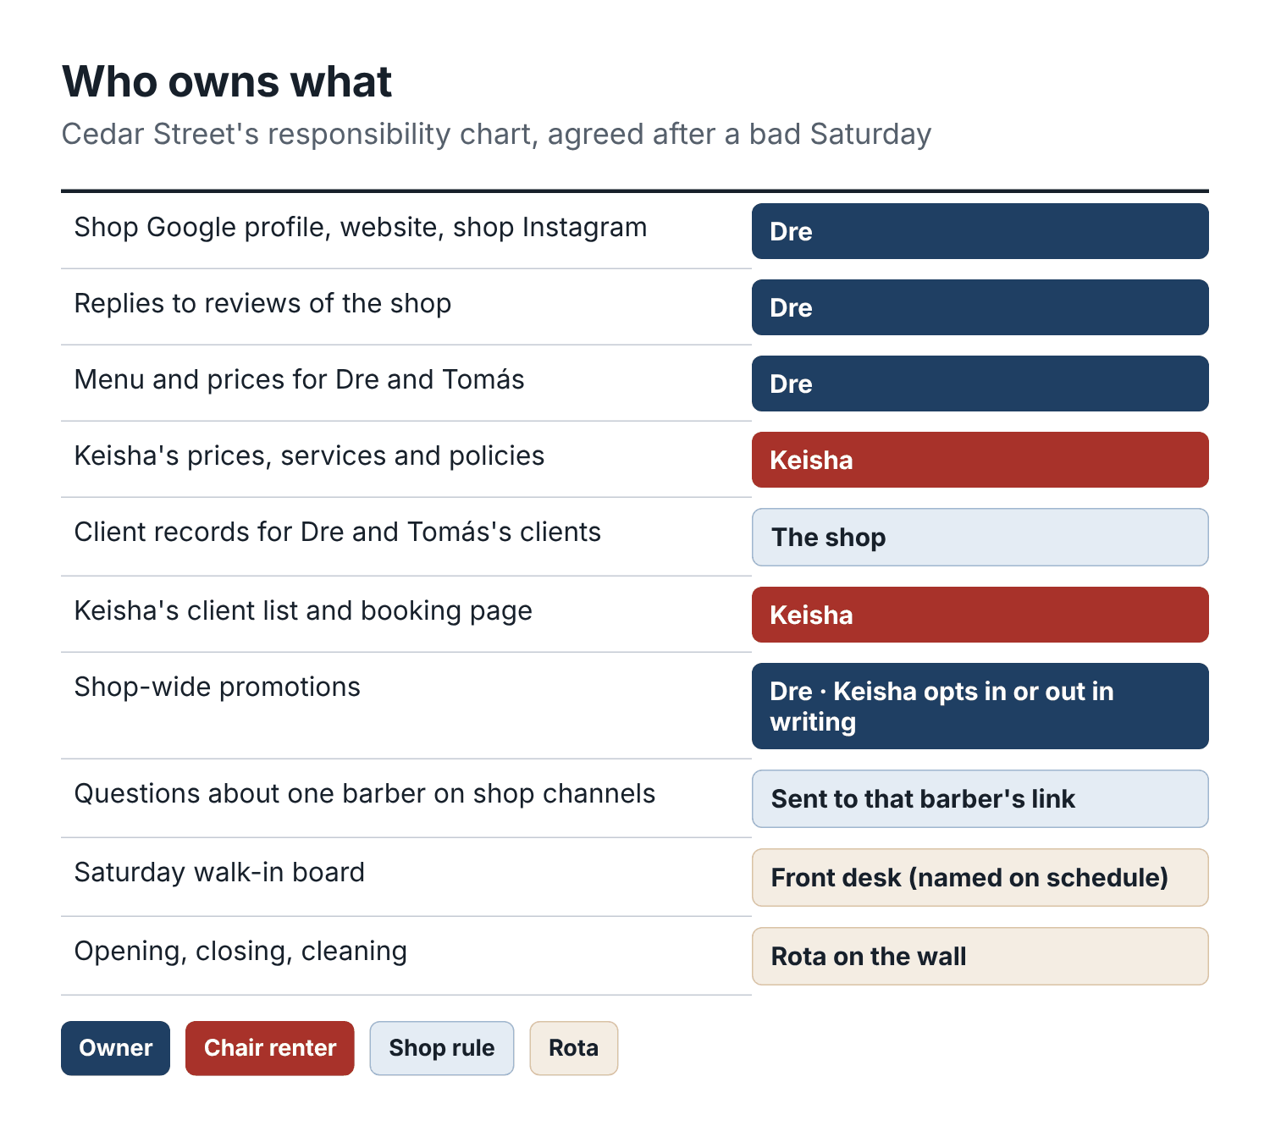
Figure 13. Cedar Street’s responsibility chart. One owner per row. The renter owns her own book; the shop owns the brand.
Cedar Street’s version, after the bad Saturday:
Area | Who owns it
Shop Google profile, website, shop Instagram | Dre
Replies to reviews of the shop | Dre (Tomás drafts if Dre is away)
Shop menu and prices (Dre and Tomás) | Dre
Keisha’s prices, services, policies | Keisha
Client records for Dre and Tomás’s clients | The shop
Keisha’s client list and booking page | Keisha
Shop-wide promotions | Dre; Keisha opts in or out in writing for each one
Messages on shop channels about a specific barber | Sent to that barber’s link
Walk-in board on Saturdays | Whoever is on front desk (named on the schedule)
Complaints | Dre; Keisha handles her own clients’ complaints
Opening, closing, cleaning | Rota, on the wall
Shared stock (towels, neck strips, disinfectant) | Dre orders; everyone records when they open the last box
Each barber’s own products | That barber
Two rows on that chart prevented both of the noon and 1 p.m. problems. Shop channels now send any question about a specific barber to that barber’s link, and a shop-wide promotion applies to Keisha’s chair only if she says yes in writing. When Dre ran a back-to-school kids cut post, he messaged Keisha first. She said no, because she does not cut kids under 10. The post mentioned Dre and Tomás only.
AI can turn your conversation into the chart:
I run a barbershop with [number] barbers: [describe each one’s arrangement: employee, commission, renter]. Here are my notes from a meeting where we agreed who’s responsible for what: [paste notes]. Turn these into a one-page responsibility chart with two columns, Area and Who owns it, with one owner per row. Then list any area that’s usually important in a barbershop but that my notes don’t cover, so we can decide it. Flag anything in my notes that sounds like the shop controlling a chair renter’s prices, hours or client list.
That last instruction is useful. It will not give you legal advice, but it will point out lines like “Keisha must work Saturdays”, which you may want to discuss with a professional.

Who can contact which clients
This is the question that causes the most bad feeling in shared shops, and it is worth a clear written answer.
At Cedar Street:
- The shop may send service messages (reminders, changes, closures) to any client booked through the shop’s system.
- Marketing messages to Dre and Tomás’s clients come from the shop, using clients who opted in to the shop’s messages.
- Nobody contacts Keisha’s clients except Keisha. The shop does not export, copy or message her list.
- If a client of one barber asks to switch to another, that is the client’s choice. The new barber tells the old one, as a courtesy.
- If a barber leaves, what happens to “their” clients depends on their arrangement. Agree it in writing at the start, not the week they leave.
AI should never be given a renter’s client list by the shop, and the shop’s AI drafts should never include a renter’s clients.

Walk-ins without the chaos
Walk-ins are good business, especially in neighborhoods with lots of foot traffic. They are also the main source of waiting-room tension. The fix is a visible, fair system and honest waiting times.

The walk-in board
A whiteboard by the door, a tablet, or the walk-in queue feature in your booking app. Each walk-in gets a line: name, time arrived, service, preferred barber or “next available”. That is all.
The rules, written on or next to the board:
- First come, first served, within each barber’s queue.
- “Next available” goes to whichever barber frees up first.
- Booked appointments come first; walk-ins fill the gaps.
- Walk-ins close at a set time before closing, so the last client is not rushed.
- Wait times are estimates. If yours is going to be more than 30 minutes, we’ll tell you and offer a booked time instead.
Cedar Street’s sign, drafted with AI and edited by Dre:
Walk-ins welcome after 11 on Saturdays, any time Tuesday to Friday. Add your name to the board. Booked appointments go first, then walk-ins in order. Ask us how long the wait is. We’ll be straight with you. Don’t want to wait? Book your next cut by scanning the code.

Honest wait times
The single most damaging thing at the walk-in board is an optimistic estimate. “About fifteen minutes” that becomes forty-five turns a satisfied walk-in into a one-star review.
Give a range, based on what is actually ahead: “There are two booked and one walk-in ahead of you with Tomás, so probably 45 minutes to an hour. Dre might be free sooner, around 30.” Then offer the alternative: a booked time later today or another day, from the walk-in card.
People are remarkably patient with honest waits and remarkably angry about dishonest ones.

When a barber runs late
Every barber runs late sometimes. A complicated cut, a client who arrived ten minutes late, a long conversation. The fix is not to never run late. It is to tell the next client early.
The rule at Cedar Street: if a barber is going to be more than 15 minutes behind, whoever is on the desk texts the next client with an honest estimate and a choice.
Hi [first name], [barber] is running about [minutes] behind today. You’re welcome to come at [new time], or if you’d rather, [other barber] can take you at your original time. Just reply and let us know.
Only offer the other barber if that barber is an employee of the shop and is genuinely free, or if a renter has agreed to take overflow. Never offer a renter’s time without asking them.

Closing tasks that actually get done
Closing is where “somebody” does everything and nobody does anything. A rota and a checklist fix it.
Write a closing checklist for a three-chair barbershop. Group it by area: each barber’s own station, shared areas, front desk and register, back room. Under 25 items total. Each item starts with a verb and is specific (“Empty and disinfect clipper guards”, not “Clean tools”). Add a line at the end for the person closing to sign and note anything that needs restocking.
Print it, laminate it, put a marker next to it. Assign closing on a rota. On the day you notice the trash was not emptied, look at who signed.

Hiring: define the role before you post the ad
When Cedar Street needed a Saturday front-desk person, Dre’s first instinct was to post “Hiring! DM me”. He got eleven replies, mostly from barbers looking for a chair, which was not what he needed.
Write down the role before you advertise it. What hours, what tasks, what pay, what skills matter, what does a good first month look like? AI can turn your notes into a role description and an ad:
I need to hire a part-time front-desk assistant for my barbershop, Saturdays 8 a.m. to 5 p.m. Tasks: greet clients, run the walk-in board, answer the phone and DMs using our saved replies, take payments, keep the waiting area tidy, restock towels. Pay: [rate]. Write: 1) a one-page role description, 2) a job ad under 120 words, 3) six interview questions, including two scenarios (an angry walk-in, a client asking for a price we don’t have). Keep the ad free of language that could discourage applicants based on age, gender, race or other protected characteristics.
Then check the ad and questions against your local employment rules. For a barber role, add a trial cut with a clear scoring sheet, agreed with your existing barbers in advance, so you are judging everyone on the same things.

Onboarding a new barber or front-desk hire
A new person absorbs the shop’s habits in the first two weeks. If they absorb them by guessing, you will be correcting them for months.
Give every new hire four things on day one:
- The shop brief from Chapter 3.
- The responsibility chart from this chapter.
- The front-desk script sheet from Chapter 8, if they will talk to clients.
- A shift checklist for opening, during the day and closing.
Then use AI for something it is surprisingly good at: practice. Have the new hire open a chat with the shop brief loaded, and ask it to play difficult clients:
You’re going to help train a new front-desk assistant at a barbershop. Using the shop brief below, play a client in each of these situations, one at a time. Stay in character, be realistic, not cartoonish. After each conversation, step out of character and give the trainee three points of feedback based only on the shop brief: what they got right, what they got wrong, and what to say next time.
Situations: 1) a walk-in who’s been waiting 40 minutes and is angry; 2) a client who insists the price was $35 last time; 3) a parent who wants to book a kids cut for a 2-year-old; 4) someone asking for a barber who left the shop; 5) a client who wants a refund for a cut he didn’t like.
Shop brief: [paste]
Thirty minutes of this, followed by a real conversation with you about what came up, beats a week of learning on live clients. Tomás used it to train Jaylen on the phone; he said it was the first time Jaylen had heard the walk-in policy explained five different ways until it stuck.

A shop AI policy, in five lines
If several people use AI on the shop’s behalf, agree on a few rules. Cedar Street’s fit on an index card:
- Use AI to draft. A person reads everything before it goes to a client.
- No client names, phone numbers, photos or health details in AI chats. Use placeholders.
- Prices, times and policies come from the shop brief only.
- Saved replies and templates are approved by Dre before use.
- Keisha decides what is said about Keisha.

The fifteen-minute team meeting
Once a week, on the same day, spend fifteen minutes with the team on the scorecard from Chapter 2. Not a lecture; a look at the numbers together. Rebooking rate per barber, no-shows, walk-ins turned away, one thing that went well, one thing to try next week.
Barbers who rent their chairs can choose whether to join. Many will, especially for the shop-wide parts (walk-ins, the Google profile, reviews), because those affect their business too.

Before your next shift
- Agree a responsibility chart with your barbers and put it on the wall.
- Write down who can contact which clients, especially if anyone rents a chair.
- Set up a walk-in board with written rules and honest wait times.
- Write the running-late text and agree when to send it.
- Print and laminate a closing checklist, and start a rota.

Chapter 13: Cut the admin and keep shop records straight
On a Saturday in March, at 10:40 a.m., with every chair full and three walk-ins on the board, Cedar Street ran out of neck strips. Jaylen ran to the beauty supply store two miles away. Dre cut with towels tucked into collars for forty minutes and apologized to every client.
The following Sunday night, doing the books at his kitchen table, Dre found that the week’s card payments were $85 lower than the services marked as completed in the booking system. He spent an hour trying to work out why. He never found out. He suspected a refund that nobody had written down, or a cut marked as paid in cash that had actually been comped for a friend. He let it go, the way most owners let these things go, and felt vaguely uneasy about it for a week.
None of this is exciting. All of it costs time and money, and almost every shop has some version of it. This chapter is about getting the back office (stock, end-of-week checks, commission and rent records, and automations) down to about an hour a week, with AI doing the drafting and summarizing and your booking and payment systems remaining the source of truth.

The source-of-truth rule
Before anything else, decide where the real records live, and say it out loud to your team.
At Cedar Street:
- The booking system is the record of appointments: who was booked, with whom, for what, and whether they showed up.
- The payment system (card reader and register) is the record of money taken: card, cash, tips, refunds.
- The accounting software or the accountant is the record of the business’s finances.
AI summaries, spreadsheets you build, notes on your phone: those are views. They help you understand the records. They never replace them. If an AI summary says you took $4,120 last week and the payment system says $4,035, the payment system is right, and your job is to find out why the summary is wrong.
This sounds obvious. It stops being obvious at 11 p.m. on a Sunday when an AI tool has given you a tidy table and the real export is a mess.

The stock sheet
Running out of something on a Saturday is a planning problem, not bad luck. The fix is a reorder point for every item you cannot work without.
A reorder point is the stock level at which you order more, so that the new stock arrives before you run out. The formula is simple:
Reorder point = weekly use × weeks it takes to arrive + a safety buffer.
Neck strips at Cedar Street: about 6 rolls a week across three chairs, delivery takes about one week from the supplier, and Dre wants a week of buffer for busy periods. Reorder point = 6 × 1 + 6 = 12 rolls. When the shelf drops to 12 rolls, order.
Make a list of the items that would stop the shop or embarrass you if they ran out: neck strips, disinfectant, towels (or laundry pickups), blades and guards, shaving cream, the products you use on every client, retail stock that sells well, receipt paper, cleaning supplies. For each, estimate weekly use and delivery time. You do not need precision. A reasonable guess beats running out.
Here’s a list of supplies for my barbershop with my rough estimate of weekly use and how long each takes to arrive after I order it. For each item, calculate a reorder point using: weekly use × delivery time in weeks + one week of safety stock. Put it in a table with columns: item, weekly use, delivery time, reorder point, and a suggested order quantity of about 4 weeks’ use. Flag any item where I’ve given a delivery time longer than 2 weeks, as those need extra attention.
[paste list]
Put the table on the stockroom door. The rule: whoever opens the box that takes an item below its reorder point writes it on the order list. Dre places one order a week, on Tuesday morning, from the list. He has not run out of neck strips since.

The weekly close
Once a week, on your quiet day, spend 20 minutes checking that what happened in the chairs matches what happened in the till. This is where a missing $85 gets caught while you can still remember the week.
The weekly close checks four things.
1. Services against payments. Total value of completed services in the booking system for the week, against total payments taken (card plus cash), allowing for tips and gift card redemptions. They should match closely. If they do not, look for the gaps: a service marked complete but never paid, a payment with no matching service, a discount applied at the register but not in the booking system.
2. Refunds, voids and discounts. List every refund and void, every discount, and every service marked as free. Each should have a reason and a name. A discount that is not on your approved list (the referral reward, the make-good after a complaint) needs a conversation.
3. Booking changes after the fact. Appointments edited after they happened, services changed after completion, no-shows changed to completed. Most will be innocent corrections. A pattern is worth a look.
4. Cash. Count the drawer against the cash recorded. Small differences happen. The same difference every week does not.
AI is helpful here as a summarizer, provided you remove client names and card details first. Export the week from both systems, strip the personal columns, and ask:
Below are two exports from my barbershop for the week of [dates], with client names and card details removed. Export 1 is completed services from the booking system (date, time, barber, service, price, discount, status). Export 2 is payments from the card reader and register (date, time, amount, tip, method, refund yes/no).
- Total completed service value (after discounts) and total payments (excluding tips).
- The difference between them.
- Try to match services to payments by date, time and amount, and list any services with no matching payment and any payments with no matching service.
- List every refund, void and discount with its date and amount.
Show your working. If the data doesn’t let you match something confidently, say so rather than guessing.
Then check the AI’s totals against the totals in each system. If they match, use its list of unmatched items as your starting point. If they do not, the AI made an error with the data, and you go back to the systems.
When Dre started doing this weekly, the first close found two cuts marked “completed” on a Friday that had been comped for Tomás’s cousins without a note, and a $45 refund processed on the card reader for a hot towel shave that a client had complained about, which had never been recorded in the complaint log. Neither was a problem. Both had a reason. But now there was a rule: every comp and every refund gets a note with a reason and a name, the same day. The next month’s closes matched to within a few dollars of tips.

Commission and rent records
If your barbers are on commission, the weekly close is also where commission gets calculated. Use the booking system’s completed services, not memory, and give each barber a short written statement: services completed, total value, commission rate, commission due, any adjustments with reasons. AI can draft the template; the numbers come from the system.
If your barbers rent their chairs, keep a simple record of rent due and rent paid, with dates. Agree in writing what happens when a payment is late. Renters run their own businesses, so their sales and their clients’ payments are theirs to track, not yours.
Either way, a clear written statement every week or month prevents most money arguments before they start.

Bookkeeping: what AI can and cannot do
AI chat tools can help with the edges of bookkeeping. They can sort a bank export into categories you choose (supplies, rent, utilities, marketing, equipment), turn a pile of receipts into a list, draft questions for your accountant, and explain a term you do not understand in your accountant’s email.
They should not be your bookkeeper, file your taxes, or decide how to classify a payment for tax purposes. Use proper accounting software or a bookkeeper for the records, and an accountant for tax. Before you paste a bank export into a chat, remove account numbers and anything identifying other people.
A useful habit: once a quarter, ask AI to turn your notes into a list of questions for your accountant. Twenty minutes of preparation makes a one-hour meeting far more useful.

Automations: start in draft, keep a pause switch
By now, a lot of the shop’s routine messages could run automatically: reminders, missed-call texts, review requests after completed visits, waitlist offers when a slot opens, rebooking nudges when a client is due. Most booking platforms can do much of this. Some AI tools can go further, reading messages and drafting or sending replies.
Automation saves a great deal of time. It can also send the wrong message to two hundred people in a minute. So bring automations in slowly, one at a time, up a ladder.
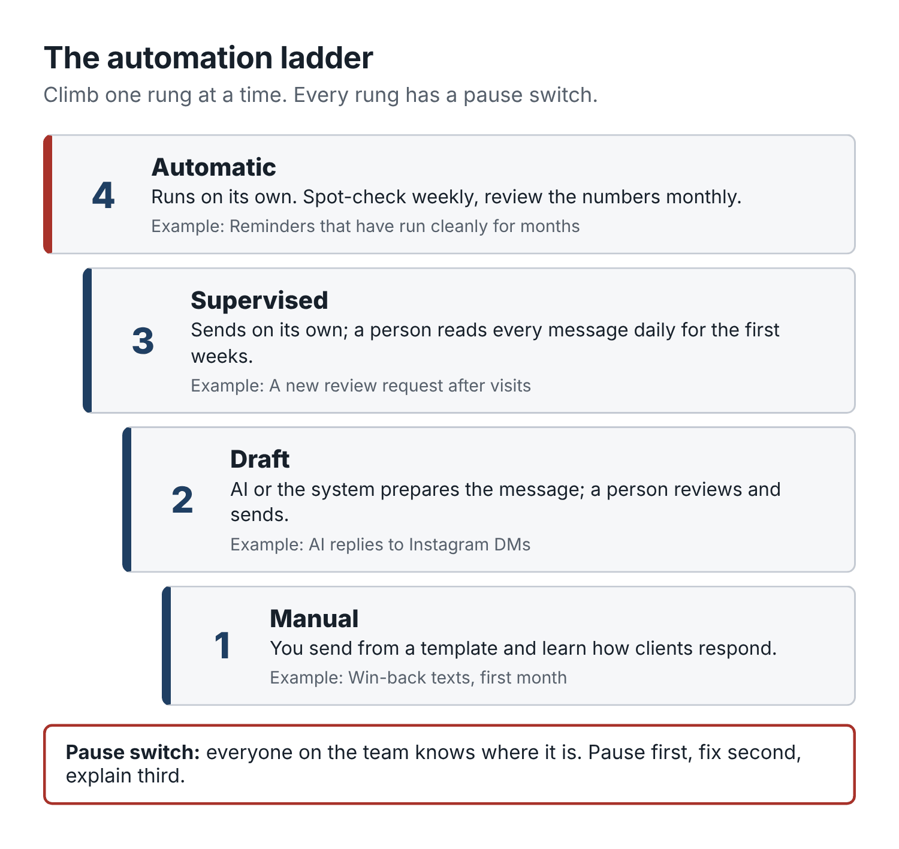
Figure 14. The automation ladder. Each new automation climbs one rung at a time, and every rung has a pause switch.
Rung 1: Manual. You send the message yourself, from a template. You learn what clients reply and which wording works.
Rung 2: Draft. The system or AI prepares the message; a person reviews and sends it. You check what it would have said.
Rung 3: Supervised. The automation sends on its own, and a person reads every message it sent, daily, for the first couple of weeks.
Rung 4: Automatic. It runs on its own. Someone spot-checks weekly and reviews the numbers monthly.
Do not skip rungs for anything that goes to clients. A reminder template that has been running on rung 4 for a year is fine. A new AI reply assistant on your Instagram DMs should start at rung 2.

The automation test plan
For each new automation, write a short test plan before you switch it on. It fits on an index card:
- What it does: “Sends a review request 2 hours after a completed visit.”
- Trigger: what makes it fire.
- Who it messages: and who it must not (clients who opted out, clients with an open complaint, renters’ clients).
- The message: the exact template, approved.
- Test: three fake clients (yourself, a team member, a friend) run through every path before any real client.
- First 20 sends: read every one.
- Pause switch: where it is and who can use it. Everyone on the team should know how to pause it.
- Owner and review date: one person, one date.
Here is a prompt that drafts the card for you:
I want to set up this automation in my barbershop: [describe it]. Write a one-page test plan with these headings: What it does, Trigger, Who it messages, Who it must never message, Message template, How to test it before going live (with 3 test cases), What to check in the first 20 messages, How to pause it, Owner, Review date. Point out anything that could go wrong, for example sending to someone who opted out, sending twice, or sending at night.
And when something goes wrong, which it will at some point, pause first, fix second, explain third. A short, honest apology to anyone affected (“Sorry, that message was sent by mistake, please ignore it”) is enough in most cases.

An hour a week, mapped out
Here is how Dre’s back-office hour on Monday mornings breaks down now:
- 20 minutes: the weekly close (services against payments, refunds and discounts, cash).
- 10 minutes: the scorecard (Chapter 2), filled in from the booking system.
- 10 minutes: stock check against reorder points; order placed.
- 10 minutes: reply to the week’s reviews (Chapter 6), batched with AI.
- 10 minutes: the quiet-slot routine (Chapter 9), messages drafted for the week.
It used to be three hours on a Sunday night, done badly. It is now one hour on Monday morning, with coffee, done properly.

Before your next shift
- Write down your sources of truth: booking system, payment system, accounting.
- Make a stock sheet with reorder points for every item that would stop the shop, and put it on the stockroom door.
- Do one weekly close this week. Note every gap you find and its reason.
- Make a rule that every refund and comp gets a note with a reason and a name, the same day.
- List your current automations and decide which rung each one is on.

Chapter 14: Your first 30 days
You have now read about a dozen things you could change in your shop. The mistake to avoid is trying all of them next week.
When owners finish a book like this, they often go home fired up and, on Monday, set up new reminders, a new Instagram plan, a referral program, an ad, a membership and a new walk-in rule, all at once. For about ten days it is exciting. Then the shop gets busy, half of it slips, and by the end of the month nobody can tell what worked, because everything changed at the same time.
This chapter is a slower plan that works better. One baseline, one problem, one change a week, and an honest look at the results before you add more. It is the plan Dre followed, and it is the one I would give any owner starting on Monday.
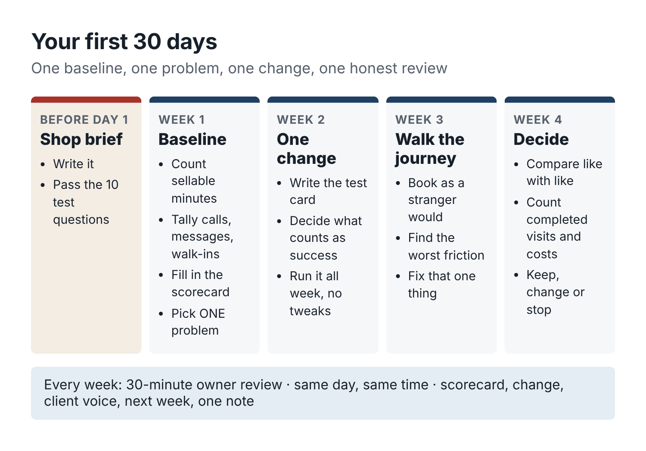
Figure 15. The 30-day rollout. One change per week, measured against the same baseline.

Before day one: the shop brief
If you have not written your shop brief (Chapter 3) and passed the ten test questions, do that first. Every other step in this plan depends on AI working from your real facts. Allow an hour.

Week 1: baseline
The goal this week is to know where you are, not to change anything.
- Work out sellable minutes for each barber (Chapter 2).
- Start the tally sheet by the register: missed calls, messages waiting more than two hours, walk-ins turned away.
- Pull the last two weeks of appointments from your booking system, remove names, and calculate utilization, no-show rate, and checkout rebooking rate. Use the prompt in Chapter 2 if you want help.
- Check your Google Business Profile against your shop brief. Note what is wrong, but leave fixing it for a later week unless it is something urgent like the wrong opening hours.
- Fill in the first weekly scorecard.
At the end of the week, pick one problem. Use the three questions from Chapter 2: how many bookings it costs, how cheap it is to fix, how close it is to the chair.
Typical choices:
- Too many missed calls or slow replies → Chapter 8.
- A big recurring gap in the calendar → Chapter 9.
- A high no-show rate or low rebooking → Chapter 10.
- Hard to find on Google, few recent reviews → Chapters 4 and 6.
Write it at the top of the scorecard: This month we are fixing ___.

Week 2: one change
Make the change that addresses your chosen problem. Only that change. Before you start, decide four things and write them on a test card:
- What exactly changes, and from which day.
- Who approves any message that goes to clients.
- What you will count, using the definitions from Chapter 2.
- What counts as success, decided now, not after you see the numbers.
Then do it. Run it for the whole week, record sources at booking, and resist the urge to tweak it halfway.
Dre’s week 2: switch on the missed-call text-back, record a new voicemail greeting, and load ten saved replies into Instagram and his phone. What he counted: missed calls, missed calls recovered (by the text or a callback), and bookings from those callers. Success: recovering at least 75% of missed calls.

Week 3: follow one client all the way through
This week, keep the week 2 change running and add no new ones. Instead, walk through your shop as a new client would, from start to finish, and look for friction.
Pick a real inquiry, or pretend to be one. Search for your shop on Google from your phone. Look at the photos, prices and reviews. Click the booking link. Try to book the service you advertise most. Call the shop during a busy hour and see what happens. Send a DM and time the reply. If you can, have a friend who has never been in book a real cut and tell you everything that annoyed them, from the parking to the checkout.
Look for these in particular:
- A price that is different in two places.
- A broken or confusing booking link.
- A service that will not show available times online when the barber is free.
- A call or message that took too long to answer.
- A checkout where nobody offered to book the next visit.
- A reminder that is confusing or arrives at a bad time.
Fix the single worst one. Write down the rest for later months.
Dre’s friend, who had never been to Cedar Street, found that the booking page listed the skin fade under “Specialty services” on page two, where she did not see it. Moving it to the top of the list took two minutes.

Week 4: results and decision
Now compare. Use the same weekdays and windows as your baseline, and the same definitions.
Count completed services, not bookings. Note direct costs, including any discounts and any money spent. Note the time it took you and the team. Note any complaints or awkward moments.
Then make one of three decisions about the change you made:
- Keep it if it met the success line you set in week 2.
- Change it if it nearly worked, or worked in a way you did not expect. Pick one thing to adjust and run it again next month.
- Stop it if it did not work and you cannot see a clear reason it would with a tweak.
All three are good outcomes. Stopping something that does not work frees your time for something that might, which is worth as much as keeping a change that does.
Dre’s numbers at the end of week 4: missed-call recovery at 86%, against 39% in the baseline. At least eleven bookings traced to the text-back in the two weeks it ran. Decision: keep. Next month’s problem: checkout rebooking.

The weekly owner review
Every week of the 30 days, and every week after, spend about 30 minutes on a short review, alone or with the team. Same day, same time. The agenda:
- Scorecard. Fill in this week’s numbers. Compare with last week and the baseline. (10 minutes.)
- This month’s change. Is it running as planned? Anything to fix that is not a change to the test itself? (5 minutes.)
- Client voice. New reviews, complaints and comments from the week. Anything that repeats? (5 minutes.)
- Next week. One quiet-slot plan (Chapter 9), staffing, stock, anything coming up locally. (5 minutes.)
- One note for the scorecard: what changed, and anything unusual about the week. (5 minutes.)
If you want AI to help, paste in the scorecard and the week’s notes and ask for a two-paragraph summary with one question you should be asking. Keep the decisions to yourself.

After the first month
At the end of 30 days, you have a baseline, one fix that is working (or a clear lesson), a weekly review habit, and a list of other problems you noticed along the way. That is a strong position.
Start month two the same way: pick the next problem from the list, one change, measured against the same scorecard. Over six months, one change a month, you will have worked through most of this book and know which parts actually move the numbers in your shop.
Here is roughly how Cedar Street’s first six months went, one problem a month:
- Missed calls and slow replies (Chapter 8).
- Checkout rebooking (Chapter 10).
- Google Business Profile, photos and reviews (Chapters 4 and 6).
- Quiet Tuesday and Wednesday afternoons (Chapter 9).
- Skin fade price and the menu (Chapter 11).
- A first paid ad test for Tomás (Chapter 7).
By month six, compared with the same weeks a year earlier, Tomás’s chair utilization had gone from 53% to 67%, Dre’s from 64% to 71%, and checkout rebooking was close to 50%. New Google reviews were arriving every week. Some of that was the season, some was Tomás building his own book of regulars, and some was the work in this book. Dre is honest that he cannot split it exactly. But the scorecard, kept the same way every week, showed the direction clearly, and that was enough to keep going.

Before your next shift
- Write your shop brief if you have not already.
- Put the weekly owner review in your calendar as a repeating appointment.
- Start week 1 on your next working day: baseline only, no changes.

Closing: the chair is still the point
A few months after Cedar Street started the work in this book, a regular named Earl came in for his usual Thursday cut. Earl is 71, has been coming to the shop since the week it opened, and does not own a smartphone. He has never booked online and never will. He calls the shop, and if nobody answers, he calls again.
That Thursday, Earl mentioned that his wife had been in hospital. Dre stopped cutting for a minute, put the clippers down, and listened. They talked for most of the cut. Dre ran eight minutes over. The next client got a text from Jaylen at the front desk saying Dre was running a little behind, and was fine with it.
That is the whole idea of this book, in one Thursday afternoon. The missed-call text, the saved replies, the scorecard, the reminders, the walk-in board: none of it is the point. They exist to take the small, repetitive, forgettable work off your hands so you have more time and attention for the part no software can do. The part where a man who has sat in your chair for eleven years tells you something he has not told anyone else.
AI tools will keep changing. By the time you read this, some of the products I named will have new features, new prices, or new owners. That is why the methods in this book do not depend on any one of them. Give the assistant your real facts. Let it draft; you decide. Count completed visits, not likes. Change one thing at a time. Keep client details out of chat windows. Ask everyone for an honest review and reply to every one. Never fake anything.
Do those things with any tool, and your shop will be easier to find, easier to book, and easier to come back to. And you will have a few more hours each week to spend on the cut in front of you and the person under the cape.
That is a good trade.

Appendix A: The prompt library
Here are 100 prompts, grouped by job, ready to copy and adapt. Most are short versions of prompts explained in the chapters; others cover jobs the chapters only mention.
Two habits make every one of them work better.
First, start each chat with your shop brief (Chapter 3) and this line:
Use only the facts in this brief. Where you need a fact that isn’t in it, write [CHECK] instead of guessing. Never invent prices, times, availability, offers, reviews or client details.
Second, never paste client names, phone numbers, photos, health details or payment information. Use placeholders such as [first name], [time], [barber] and [booking link], and fill them in inside your booking system.
Words in [square brackets] are for you to fill in or for the AI to leave as placeholders.

Setting up
1. Draft the shop brief from a voice note
Turn my rambling description below into a one-page shop brief with these headings: Basics, Hours, Barbers, Menu (price and booked minutes per service), Booking rules, Payments, How we talk, Never promise, Always hand to the owner. Short lines. Write [MISSING] for any fact I haven’t given. Finish with the five most important questions I haven’t answered. [paste description]
2. Find gaps in an existing brief
Read my shop brief and list every question a client commonly asks a barbershop that this brief can’t answer. Group them by topic. Don’t answer them; I’ll fill them in.
3. Describe my writing voice
Here are six messages I’ve sent to clients, names removed. Describe my style in five bullet points (sentence length, punctuation, greetings, common words, things I never do). Then write a 30-word reminder in that style. [paste messages]
4. Write the ten test questions
Write ten test questions a client might ask my barbershop, to check that an AI assistant answers correctly from my brief. Include three about prices, three about rules, two about closed days, and two trick questions where the right answer is “I’m not sure” or “we don’t offer that”.
5. Grade the answers
Here are the ten test questions and the answers an assistant gave. Compare each answer with my shop brief. Mark each Correct, Wrong or Invented, and explain any problem in one line. [paste questions and answers]
6. Write a renter’s own brief
I rent a chair in a barbershop. Turn my notes into a one-page brief for my own business: my services, prices, booked minutes, booking link, deposit and cancellation rules, hours, how I talk to clients, and what I never promise. Mark [MISSING] gaps. [paste notes]
7. Shop AI policy
Write a five-line AI policy for staff at my barbershop. Cover: AI drafts and a person approves; no client personal data in AI chats; facts come only from the shop brief; templates need owner approval; chair renters decide what is said about their business. Plain language, fits on an index card.
8. Update everything after a change
I’ve changed this in my shop brief: [describe change]. List every place a barbershop usually shows this information (booking page, Google profile, website, saved replies, signs, reminders) so I can update them all today.

Numbers and planning
9. Baseline from an appointment export
Here’s two weeks of appointments, names removed. Columns: [list]. Sellable time per barber is [minutes] per week. Calculate each barber’s utilization from completed minutes, the no-show rate, and the checkout rebooking rate, with the counts behind each. Tell me the biggest single problem in two sentences. Show your arithmetic. [paste]
10. Sellable minutes
Calculate sellable minutes per week for each barber. Hours in the shop: [per barber, per day]. Subtract lunch of [ ] minutes per day and [ ] minutes per day for cleaning and admin. Show it per day and per week.
11. Quiet-hours heatmap
From 8 weeks of appointment data (names removed), make a table for each barber of weekdays by 2-hour blocks, showing the average share of sellable time that was booked and completed. List the three emptiest blocks for each barber with average empty hours per week. [paste]
12. Return intervals by service
From this year of appointments (client IDs, no names), calculate the median days between visits for each service among clients with at least 3 visits. Suggest an “overdue” threshold for each service. Show the counts. [paste]
13. First-visit return rate
From this data (client IDs, no names), find all first visits between [date] and [date], then count how many of those clients completed another visit within [ ] weeks. Give the rate with counts, by barber and by first service booked. [paste]
14. Weekly scorecard summary
Here’s this week’s scorecard and the last four weeks. In two short paragraphs, tell me what changed, what stayed flat, and one question I should be asking. Don’t recommend more than one action. [paste]
15. Pick this month’s problem
Here are my baseline numbers. For each possible problem (missed calls, quiet slots, no-shows, rebooking, first-visit returns, local visibility), estimate how many bookings it costs per week, how cheap it is to fix, and how close it is to the chair. Then recommend one problem to work on this month, with your reasoning. [paste]
16. Compare like with like
I changed [what] on [date]. Here are completed services for the four weeks before and the four weeks after, by weekday and time block. Compare only matching weekdays and windows. Tell me whether the change looks like it helped, and what else could explain the difference (season, holidays, staffing). [paste]
17. Count sources of new clients
Here are the answers to “How did you find us?” for new clients over the last 3 months, with completed yes/no. Group them into Google, Instagram, friend or referral, partner, walked past, ad, other, unknown. Give booked and completed counts for each. [paste]
18. Explain a number simply
Explain in plain words, as if to a barber with no business training, what [metric] means, how to calculate it, and one mistake people make when measuring it.

Google and local search
19. One-line positioning from reviews
Here are 20 recent reviews (names removed) and my menu. What three things are we best known for, based only on what clients say? Quote supporting phrases. Then write three one-sentence descriptions of the shop under 25 words, plain language. [paste]
20. Google Business Profile description
Write a Google Business Profile description, maximum 700 characters, using only my brief: what we’re known for, main services, area or landmark, parking, how to book. No keyword stuffing, no claims we can’t prove, no prices.
21. Services list for Google
Turn my menu into a Google Business Profile services list: service name, price, and a one-sentence plain description of each, under 120 characters. Don’t add services that aren’t on my menu.
22. Listing consistency check
Here are my shop details from [list sites]. Compare each line by line with my shop brief and make a table showing every difference: name, address, phone, hours for each day, booking link, services and prices. [paste]
23. Holiday hours update
Write a Google Business Profile update and an Instagram post announcing our hours for [holiday period]: [list dates and hours]. Include the booking link. Under 50 words each.
24. Weekly Google update
Write a Google Business Profile update for this week. Topic: [openings this week / new barber / real cut / seasonal]. Under 60 words, includes the booking link, no hashtags, no emojis.
25. First-visit web page brief
Write a brief for a one-page website for first-time clients on their phones: headline, subheading, section order, copy for each section under 80 words, the photos I need, and where the booking button goes. Use only my brief. Mark [MISSING] gaps.
26. “What to expect on your first visit”
Write a short “First time here?” section for my website and booking page: how to book, where to park and enter, what happens when you arrive, how long the service takes, how to pay, and our late policy. Under 120 words, friendly.
27. Photo list for the profile
List the 20 photos my barbershop’s Google profile should have, described specifically (angle, subject, lighting), covering real cuts, interior, exterior and entrance, parking, and the team. Note which need client permission.
28. Local partner list
I run a barbershop at [area description]. List 15 kinds of nearby businesses whose customers might need a barber, with one line on why each fits and one idea for a simple, fair swap with them.

Social content
29. Shot list
Make a photo and video shot list for my barbershop: three specific shots for each of [services], plus five video ideas under 20 seconds with no talking to camera. One line per item.
30. Weekly caption batch
Write Instagram captions for these four photos using my brief and notes. First line describes the cut plainly. Mention the barber and the shop. Include the price from the menu and end with [booking link]. Under 50 words, at most one emoji, no hashtags in the caption. Then suggest 8 hashtags for the first comment: 4 local using only [neighborhood] and [city], 4 about the service. [notes]
31. Barber introduction
Write an Instagram post introducing [barber] at my shop: how long they’ve cut, what they love cutting, the days they work, one human detail from my notes, and how to book them. Under 70 words. [notes]
32. Client question post
Write an Instagram post answering this question clients ask us: “[question]”. Plain, accurate, under 80 words, ending with how to book. Don’t give medical advice.
33. Before-and-after caption
Write a caption for a before-and-after photo of [service]. Describe what we changed in plain terms, without making fun of the “before”. Name the barber, the price, and [booking link]. Under 45 words.
34. Reel script
Write a 15-second vertical video script for [service]. No talking to camera. Give four shots with timings, on-screen text for each (max 6 words), and a 30-word caption with the price and [booking link].
35. Talking-head tip
Write a 30-second script for [barber] to say to camera answering “[question]”. Conversational, no jargon, ends with one line about booking. Under 80 words when spoken.
36. Four-week calendar
Build a four-week content calendar: three Instagram posts a week plus a Google update every Friday. Formats: real cut, barber intro, client question, availability post, shop moment, seasonal. Local dates: [list]. Table with day, format, barber, idea, and the photo I need.
37. Seasonal ideas
List ten post ideas for my barbershop for [season or month], tied to real events that happen every year (school, holidays, sports seasons, weddings, graduations). For each, one line and the service it promotes.
38. New barber launch posts
Write three posts announcing a new barber, [name], starting [date]: an announcement a week before, a first-week post with a real cut, and an introduction after two weeks. Keep the facts consistent across all three: [facts].
39. Shop move or change announcement
We’re changing [what] on [date]. Write a short Instagram post, a Google update, a text for opted-in clients with [opt-out wording], and a door sign. Every version must give the same date and details: [facts].
40. Caption rewrite
Rewrite this caption so it sounds like a barber talking to a regular, not an advert. Keep all the facts. Cut it by a third. Remove any word like “elevate”, “experience” or “premier”. [paste caption]
41. Repurpose one cut five ways
From this one note about a cut, write: an Instagram caption, a Google update, a 15-second reel script, a story text overlay, and a short line for the shop’s window board. [note]
42. Monthly content review
Here are last month’s posts with views, likes, link clicks, and new clients who said they found us through each post. Which formats brought clients, not just likes? Recommend one change for next month. [paste]

Reviews, referrals and partners
43. Review request message
Write a short thank-you text sent two hours after a completed visit, asking for an honest Google review with [review link]. Under 35 words. Must not offer anything in return or suggest what rating to give.
44. Review request card
Write the text for a small counter card with a QR code asking clients for an honest review. Under 25 words. No incentives, no “5 stars” language.
45. Reply to a positive review
Draft a reply to this review: under 40 words, mention one specific thing they said, thank the barber they named by first name, no more than one exclamation mark, no client details beyond the review. “[review]”
46. Batch replies
Write a reply to each of these positive reviews, each under 35 words, each with a different opening line, each mentioning something specific from that review. [paste reviews]
47. Reply to a negative review
Draft a calm reply under 80 words to this negative review. Take responsibility for what we got wrong, explain our policy plainly where there was a misunderstanding, say what we’ve changed, invite them to contact [owner] at [phone]. No arguing, no private details, no offer of anything free in public. Review: “[ ]”. What happened: [ ].
48. Reply to a suspected fake review
Draft a short, neutral reply to a review we believe isn’t from a real client. Say we can’t find a matching visit and invite them to call [phone]. No accusations, no threats, under 40 words.
49. Monthly feedback themes
Here are last month’s reviews and complaints, names removed. Group them into themes with counts and two short quotes each. Separate the haircut itself from booking, waiting, price and communication. Suggest one change to test for each theme. [paste]
50. Complaint handoff procedure
Turn these notes into a six-step complaint procedure for my barbershop staff: what to say in the moment, what to record and where, who gets told and when, how fast the owner responds, the standard fixes, and the monthly review. [notes]
51. Referral program wording
Write a referral counter card (under 40 words) and an opted-in client text (under 35 words, with [opt-out wording]) for this offer: [new client reward], [referrer reward after the friend completes a visit], how it’s recorded, 90-day expiry, monthly cap of [ ]. Plain and friendly.
52. Referral program check
Check this referral offer: first visit price [ ], direct cost per visit [ ], new client discount [ ], referrer reward [ ]. Calculate the contribution from the first visit and the total discount cost per completed new client. List two risks.
53. Partnership pitch
Draft a short message to [business] near my shop proposing a one-month trial swap: [what each side does]. Each side gets a tracked link or code: [ ]. At the end we compare results. Under 90 words, friendly, no pressure. Signed [name], [shop].
54. Partner one-pager
Write a one-page sheet for a partner business’s front desk: who we are in one line, what we’re good at, address and parking, prices for our three most popular services, and our booking link with their code. Under 120 words.

Paid ads
55. Ad test card
Help me fill in an ad test card: one service [ ], one audience [ ], one booking page [ ], two versions differing only in [ ], spend cap [ ], end date [ ], primary measure (completed first visits), decision rule, review date. Point out anything I’ve left vague.
56. What can I pay for a new client?
Price [ ], direct costs [ ], commission [ ]%. About [ ]% of first-time clients become regulars who return [ ] more times a year. Calculate the contribution from a first visit for the shop, the average contribution per new client over a year, and a cautious maximum acquisition cost. Show the arithmetic.
57. Two ad versions
Write two Facebook and Instagram ads for [service, barber, price]. Goal: book [days/times]. Same photo and link; they differ only in the first line (A leads with the cut, B with availability). Primary text under 40 words, headline under 8 words. No “best in town”, no fake urgency.
58. Ad results review
Ad test results: spend [ ], clicks [ ], attributed bookings [ ], completed first visits [ ] (A: [ ], B: [ ]), no-shows [ ]. Service price [ ], commission [ ]%, direct costs [ ]. My decision rule: [ ]. Calculate cost per completed first visit and first-visit contribution, say whether A versus B is meaningful at these numbers, apply my rule, and suggest one change. Show the arithmetic.
59. Diagnose a failed ad
My ad got [clicks] clicks, [bookings] bookings and [completed] completed visits on [spend]. Walk through where the leak most likely is (ad, audience, booking page, reminders, the visit itself), and suggest the one cheapest thing to check first.
60. Marketplace fee check
A booking marketplace charges [fee or %] for each new client it sends. With my price [ ], direct costs [ ] and commission [ ], what does each new client cost me and what does the shop keep on the first visit? How many return visits does it take to cover the fee?

Calls, messages and the front desk
61. Missed-call text-back
Write a missed-call auto-text for my barbershop: who we are, that we’re probably mid-cut, the booking link, and that they can reply with questions. Under 40 words. No promotions.
62. Voicemail greeting
Write a voicemail greeting under 50 words: shop name, we’re probably cutting, the fastest way to book is the link we’ll text you, our hours, leave a message if you have a question. Natural, not corporate.
63. Top ten saved replies
Write saved replies for these 10 questions, under 40 words each, from my brief. Each ends with [booking link], or a renter’s own link for questions about that barber. Never name a specific available time. Write [CHECK] where the brief has no answer. [questions]
64. After-hours auto-reply
Write an after-hours auto-reply for Instagram and text: we’re closed, our hours, book any time at [link], we’ll answer questions from [opening time]. Under 35 words.
65. Offering a held slot
Write a short message offering a specific open slot ([barber], [time], [service]) and saying we’ll hold it for 15 minutes. Under 30 words. Then write the follow-up if they don’t reply in time.
66. Barber is full
Write a reply for when a client asks for [barber], who is fully booked. Offer the waitlist and, as an alternative, [other employee barber] by name with their next opening [ ]. Under 40 words.
67. Fully booked walk-in
Write what front-desk staff should say to a walk-in when we’re fully booked for the next two hours, and the text for a small card with a QR code to book. Honest, friendly, and steer them toward [quiet days].
68. Running late, client side
Write a reply to a client who texts that they’re running [ ] minutes late. Our grace period is 10 minutes. Offer a shorter service in the time left or the next opening. Under 35 words, friendly.
69. Front-desk script sheet
Using my brief, write a one-page front-desk script sheet with short replies for: missed-call text, “anything today?”, fully booked walk-in, barber is full, client running late, reschedule request. Under 40 words each.
70. AI receptionist test calls
Write 20 test calls to check an AI phone receptionist for my barbershop. Include ordinary bookings, price questions, closed days, a service we don’t offer, an angry client, a parent booking for a child, a request for a barber who left, and a question about a scalp condition. For each, write what a correct response looks like.

Quiet slots, reminders and rebooking
71. Who’s free when we’re quiet
My quiet window is [days, times]. My area is [description]. List the kinds of people likely to be free then and one message idea for each. Leave out groups who can’t come then (for example kids during school hours).
72. Three quiet-slot messages
Draft three messages: a text to an opted-in overdue regular, a reply to someone on the waitlist for [day], and a public availability post. Facts: [service, price, minutes, window, barber]. Placeholders [first name], [barber], [verified slot], [booking link], [opt-out wording if required]. Under 45 words each. No invented offers or deadlines.
73. Update a filling availability post
Rewrite this availability post to show that [slots] are now taken and [slots] are still open. Keep it short and accurate. [paste post]
74. Quiet-week review
Here are the results for [number] target openings: booked, completed, cancelled, no-show and source for each. Calculate fill rates with counts, revenue and contribution at [price] and [costs], and compare with the average for the same window over the previous four weeks. [paste]
75. Day-before and same-day reminders
Rewrite my reminders: one the day before, one 2 hours before. Use [first name], [day], [time], [barber], [service], [reschedule link]. Include our cancellation and late policy in one friendly line: [policy]. Under 40 words each.
76. No-show recovery
Write a friendly same-day message to a client who missed their appointment: no guilt, easy rebooking with [booking link]. Under 30 words.
77. Deposit policy wording
Explain this deposit and no-show policy for my booking page (under 70 words) and in two sentences for reminders: [policy]. Say why without guilt-tripping.
78. Rebooking line for the mirror
Give me five ways a barber could offer to book the next visit at the end of a cut, each under 20 words, natural and low-pressure. Include the interval for [service].
79. “When you’re due” reminder
Write a reminder sent when an opted-in client reaches their usual return interval for [service]. Under 30 words, from [barber], with [booking link] and [opt-out wording].
80. Win-back text
Write three versions of a win-back text for regulars who’ve gone longer than usual and opted in to marketing. Under 35 words, warm, from [barber], with [booking link] and [opt-out wording]. No discount, no guilt, no fake urgency.
81. Win-back results with a holdout group
I messaged [ ] lapsed regulars and held back [ ] at random. Within 30 days, [ ] messaged and [ ] held-back clients completed a visit. Calculate both return rates, the difference, and what it suggests the message actually did. Explain the uncertainty with numbers this small.
82. Marketing consent wording
Write a short, clear opt-in line for my booking form and a paper sign-up sheet that asks clients if they’d like texts about openings and offers, says how to opt out (reply STOP), and is separate from appointment reminders. Under 30 words. Flag that I should check it against the rules where I operate.

Pricing and offers
83. Contribution per chair hour
For each service on my menu, calculate contribution per chair hour = (price − direct costs) ÷ booked minutes × 60. Sort highest to lowest. Repeat assuming [ ]% commission. Show the arithmetic for two rows. [menu with prices, minutes, costs]
84. Price rise break-even
I want to raise [service] from [old price] to [new price]. Direct costs are [ ]. How many of these services can I lose and still earn the same total contribution? Show the formula and the arithmetic.
85. Price change announcement
Write a price change announcement: [service] goes from [ ] to [ ] on [date]; everything else stays the same. A counter sign under 30 words, a post under 50 words, and a text under 30 words with [opt-out wording]. Confident, not apologetic.
86. Bundle check
Compare selling [service A] and [service B] separately with selling them as a bundle at [price]. Prices, minutes and direct costs: [ ]. Calculate contribution and contribution per chair hour for each option, and tell me what share of bundle clients would need to be “extra” for the bundle to pay off.
87. Offer break-even
Check whether this offer can pay for itself. Price [ ], direct costs [ ], offer [ ], usual visits in this window [ ], open slots [ ]. Calculate contribution per visit before and after, visits needed to break even, and whether the open slots can hold them. List two risks. Show the arithmetic.
88. Membership design check
I’m considering a membership: [price] per month for [what’s included]. Normal price of those services [ ], direct costs [ ]. If [ ] members join, how many chair hours per month will they use, what’s the contribution per visit, and what questions should I answer about unused visits, cancellations and peak times before launching?
89. Product shelf cards
Write a shelf card for each product: name, what it does in one plain sentence, which hair it suits, how to use it in one sentence, and price. Under 35 words each. No claims I can’t back up. [products and notes]

Team and training
90. Responsibility chart
Turn our meeting notes into a one-page responsibility chart with one owner per row. Then list important areas my notes don’t cover, and flag anything that sounds like the shop controlling a chair renter’s prices, hours or clients. [notes]
91. Walk-in board rules and sign
Write rules for our walk-in board (first come first served, “next available” option, booked clients first, walk-in cutoff time [ ], honest wait estimates) and a door sign under 60 words.
92. Running-late text, shop side
Write a text to send a client when their barber is running [ ] minutes behind: an honest new estimate and a choice of a later time or [other barber] at the original time. Under 40 words.
93. Closing checklist
Write a closing checklist for a [ ]-chair barbershop, grouped by station, shared areas, front desk and back room. Under 25 items, each starting with a verb and specific. Add a sign-off line with a space to note restocking needs.
94. Role description and job ad
Write a role description, a job ad under 120 words, and six interview questions (including two scenarios) for this role at my barbershop: [hours, tasks, pay]. Keep the ad free of language that could discourage applicants based on protected characteristics.
95. Trial cut scoring sheet
Create a scoring sheet for a barber’s trial cut at my shop. Cover consultation, sanitation, technique for [service], finishing, timing against our booked minutes, and how they talk to the client. Score each 1 to 4 with a one-line description of what each score looks like.
96. Role-play training
Using the shop brief, play a client in each situation one at a time: [list situations]. Stay in character and be realistic. After each, step out and give the trainee three points of feedback based only on the brief.

Back office
97. Reorder points
For each supply, calculate a reorder point = weekly use × delivery time in weeks + one week of safety stock, and suggest an order quantity of about four weeks’ use. Flag items with delivery over two weeks. [list with weekly use and delivery time]
98. Weekly close
Two exports for [dates], names and card details removed: completed services (date, time, barber, service, price, discount, status) and payments (date, time, amount, tip, method, refund). Give total completed service value after discounts, total payments excluding tips, the difference, unmatched services and payments, and every refund, void and discount. Show your working; don’t guess matches. [paste]
99. Commission statement template
Create a weekly commission statement template for a barber: services completed (count and value from the booking system), commission rate, commission due, adjustments with reasons, and a line for both signatures. Then fill it in with this week’s numbers: [ ].
100. Automation test plan
I want to set up this automation: [describe]. Write a one-page test plan: what it does, trigger, who it messages, who it must never message, the message template, three test cases before going live, what to check in the first 20 sends, how to pause it, owner, review date. Point out anything that could go wrong.

Appendix B: Scripts and messages to adapt
These are finished examples, written for Cedar Street and edited by a person. Swap in your own facts, read them aloud, and change anything that does not sound like you. Placeholders are in [square brackets].
Marketing messages (anything that promotes openings, offers or the shop to someone who has not just contacted you) go only to clients who have agreed to receive them, with opt-out wording where required. Service messages (replies, reminders about a booked appointment, missed-call texts) do not carry promotions.

Phone and messages
Missed-call text-back
Hi, this is Cedar Street Barbers. Sorry we missed your call, we’re probably mid-cut. You can book any time here: [booking link]. Or reply to this text and we’ll get back to you between clients.
Voicemail greeting
You’ve reached Cedar Street Barbers. We’re probably cutting right now. The quickest way to book is the link we’ll text you in a minute. We’re open Tuesday to Friday 10 to 7 and Saturday 8 to 5. If you have a question, leave a message and we’ll call you back.
After-hours auto-reply
We’re closed for the night. You can book any time here: [booking link]. If you have a question, we’ll answer from 10 a.m. Cedar Street Barbers
“How much is a cut?”
A standard cut is $35, skin fades are $45, and cut and beard is $50. Full menu and booking: [booking link]
“Do you have anything today?”
Here’s what’s open today, it’s live: [booking link]. If you don’t see a time that works, tell me roughly when and I’ll check.
Offering and holding a slot
[Barber] has [time] today for a [service]. Want it? I’ll hold it for 15 minutes.
If they don’t reply in time
No worries, I’ve released that slot. Here’s what’s open if you want another time: [booking link]
Barber is fully booked
[Barber] is booked up until [day]. I can add you to the waitlist for an earlier spot, or [other barber] has [time] if you’d like that instead.
Question about a chair renter
Keisha books her own clients and sets her own prices. You can see her menu and openings here: [Keisha’s link]
Running late (client texts)
Thanks for the heads-up. We’ve got a 10-minute grace period. If you’ll be later than that, we can do a [shorter service] in the time left, or move you to [next slot]. Which works better?
Barber running behind (shop texts)
Hi [first name], [barber] is running about [minutes] minutes behind today. You’re welcome to come at [new time], or [other barber] can take you at your original time. Just reply and let us know.

In the shop
Fully booked walk-in
Sorry, we’re booked up until [time]. Here’s a card, you can book any open time in a few seconds. Tuesday and Wednesday afternoons are usually easy to get.
Honest wait estimate
There are [number] ahead of you with [barber], so probably [range]. [Other barber] might be free sooner, around [time]. Or I can book you a time later today.
Rebooking at the mirror
Want me to put you in for the same time in [interval]? I can see what’s open.
If they say no
No problem. I’ll send you a reminder when you’re due, if that’s OK with you.
Asking for a review at checkout
Glad you like it. If you get a minute later, we’d really appreciate an honest review on Google. The code’s on this card.
Asking permission for a photo
Mind if I get a photo of the fade for the shop’s Instagram? I can leave your face out if you’d rather. And it’s totally fine to say no.
Recommending a product
I used the matte clay today. It’s what keeps it from going flat by the afternoon. It’s on the shelf if you want to try it.

Reminders and follow-ups
Day-before reminder
Hi [first name], see you tomorrow at [time] with [barber] for your [service]. Need to move it? Use this link up to 12 hours before: [reschedule link]. Cedar Street Barbers
Two-hour reminder
See you at [time] with [barber], [first name]. Running late? Reply here and we’ll sort it out. Cedar Street Barbers
Thank-you and review request
Thanks for coming in today, [first name]. If you’d like to share how your visit went, here’s our Google review link: [review link]. Honest feedback helps us, good or bad. Cedar Street Barbers
No-show recovery
Hey [first name], we missed you today at [time]. No worries, life happens. Want to rebook? Here’s the link: [booking link]
“You’re due” reminder (marketing; opted-in clients only)
Hey [first name], it’s [barber] at Cedar Street. It’s been about [interval] since your last [service]. Want to grab a time? [booking link] [Opt-out wording]
Win-back (opted-in clients only)
Hey [first name], it’s Dre at Cedar Street. It’s been a while, hope all’s good. If you’re due for a cut, I’ve got openings this week: [booking link]. [Opt-out wording]
Quiet-slot message to an overdue regular (opted-in)
Hey [first name], [barber] at Cedar Street has a few weekday openings this week if you’re due for a cut. Standard cut is $35. See what’s still free: [booking link]. [Opt-out wording]
Waitlist opening
Hey [first name], the [day] opening you asked about just came up. [Barber] has [verified slot] for a [service]. You can grab it here: [booking link]. The calendar shows if it’s still open.
Public availability post
Got half an hour Tuesday or Wednesday? Tomás has a few openings between noon and 4 at Cedar Street. Standard cuts are $35. Pick a time: [booking link]

Reviews and complaints
Reply to a positive review (three variations)
Thanks, [name]. Tomás will be glad the fade held up for the wedding. See you next time. Dre
Appreciate you taking the time, [name]. Keeping the line-up sharp is what Dre lives for. See you in a few weeks.
Glad your son was comfortable for his first cut. That’s the best part of the job. Thanks for the review.
Reply to a negative review
I’m sorry about your visit. [What went wrong, in one plain sentence, owning our part.] We’ve [what we changed]. I’d like to hear more and make it right. Please call me at [shop phone]. [Name], owner
Reply to a review you believe is not genuine
We can’t find a visit that matches this, and we’d like to understand what happened. Please call me at [shop phone]. [Name], owner
In-person complaint, first words
Thanks for telling me. I want to get this right. Can you tell me what happened? I’ll make sure Dre hears about it today, and he’ll call you by tomorrow.

Referrals and partners
Referral card
Bring a friend to Cedar Street. They get $10 off their first visit. You get $10 off your next one after they’ve been in. Just have them give your name when they book.
Referral text (opted-in clients)
[First name], if a friend needs a barber, send them our way: they get $10 off their first cut and you get $10 off your next. They just give your name when booking: [booking link]. [Opt-out wording]
Partnership pitch
Hi [name], it’s Dre from Cedar Street Barbers up the road. Would you be up for a simple one-month trial? I’ll keep your cards at my counter and mention you when clients ask, and you put ours at your front desk with a link that has your code on it. At the end of the month we check whether either of us got anyone. No pressure either way.
Partner front-desk sheet
Cedar Street Barbers, 412 Cedar Street (parking behind, entrance on Pine Alley). Skin fades, beard work and textured hair. Standard cut $35, skin fade $45, cut and beard $50. Book here with your code: [partner link]

Team
Telling a renter about a shop-wide promotion
Hey Keisha, we’re thinking of running [promotion] from [date] to [date]. Do you want your chair included? Totally your call. If not, the posts will mention Dre and Tomás only.
New barber announcement
Starting [date], [name] joins Cedar Street on [days]. [One line on their specialty and background.] Bookings open now: [link]
Price change announcement (counter sign)
From [date], skin fades are $45. Everything else stays the same. Thanks for keeping us busy.

Appendix C: Worksheets
Each worksheet can be rebuilt in a spreadsheet in a few minutes, or copied onto paper. Formulas are written in words so they work in any tool. If you want a spreadsheet version, paste a worksheet into your AI assistant and ask: Turn this into a Google Sheets layout with column headers and the formulas written out for row 2.

1. Sellable minutes
For each barber, for one week:
Line | What to enter
A | Minutes in the shop each day, added up for the week
B | Lunch minutes per day × days worked
C | Cleaning, restocking and admin minutes per day × days worked
D | Any other blocked time (meetings, training, personal)
Sellable minutes | A − B − C − D
Cedar Street, Dre: A = 2,700, B = 150, C = 150, D = 0. Sellable = 2,400.

2. The weekly scorecard
Fill in on the same day each week. Keep the count next to every rate.
Measure | How to calculate | This week | Last week | Baseline
Utilization, per barber | Completed service minutes ÷ sellable minutes
Missed-contact recovery | Calls and messages answered or returned ÷ total missed
No-show rate | No-shows ÷ appointments due (exclude cancellations made in time)
Late-cancel rate | Late cancellations ÷ appointments due
Checkout rebooking | Eligible visits leaving with a future booking ÷ eligible completed visits
First visits completed | Count, with source (Google, Instagram, referral, partner, ad, walk-by, other, unknown)
Note | What we changed; anything unusual this week
Optional monthly lines: new reviews and review requests (counted separately), first-visit return rate, retail attach rate, contribution per occupied chair hour.
Contribution per occupied chair hour = (service revenue after discounts − direct variable service costs) ÷ completed service minutes × 60.

3. Seven-number baseline tally
Keep by the register for two weeks. One tick per event.
Day | Missed calls | Calls returned | Messages waiting 2+ hours | Walk-ins turned away | Notes
Tue
Wed
Thu
Fri
Sat
The other numbers (completed minutes, no-shows, late cancellations, checkout rebooking, first visits) come from your booking system.

4. Channel tracking
One row per channel. Review monthly.
Channel | Action this month | Spend or reward cost | Bookings | Completed first visits | Cost per completed first visit
Google profile
Instagram and social
Reviews | Requests sent: / New reviews:
Referrals
Partners
Paid ads
Walk-by
Cost per completed first visit = spend (or reward cost) ÷ completed first visits. If there were no completed first visits, write the spend and “0 completed”. Do not divide by zero and do not leave it blank.

5. Menu and chair-hour worksheet
Service | Price | Costs | Minutes | Contribution | Per chair hour
Contribution = price − direct costs. Per chair hour = contribution ÷ minutes × 60. Add a second version of the table for commissioned barbers, where contribution = price − (price × commission rate) − direct costs. Some shops split product costs with commissioned barbers; use whatever your arrangement actually is.

6. Offer break-even calculator
Line | Item | Value
1 | Normal price
2 | Direct costs per visit
3 | Contribution now (1 − 2)
4 | Discount or reward per visit
5 | Contribution with offer (1 − 4 − 2)
6 | Usual completed visits in this window
7 | Visits needed to break even (6 × 3 ÷ 5)
8 | Extra visits needed (7 − 6)
9 | Open slots available in the window
10 | Can the calendar hold line 8? (yes if 9 ≥ 8)
Cedar Street example, $5 off a $35 cut, 7 usual visits: line 3 = $30, line 5 = $25, line 7 = 7 × 30 ÷ 25 = 8.4, so 9 visits; line 8 = 2 extra visits needed.

7. Price rise check
Line | Item | Value
1 | Old contribution per service (old price − direct costs)
2 | New contribution per service (new price − direct costs)
3 | Break-even share of volume (1 ÷ 2)
4 | Volume you can lose and still earn the same (1 − line 3), as a percentage
Skin fade, $40 to $45 with $5 costs: line 1 = $35, line 2 = $40, line 3 = 0.875, line 4 = 12.5%.

8. Ad test card
Item | Your decision
One service
One audience (area, radius, age if relevant)
One booking page (with tracking)
Version A
Version B (one difference only)
Spend cap
Start and end dates
Primary measure | Completed first visits attributed to the ad
Break-even cost per completed first visit
Decision rule (keep / change / stop)
Review date

9. This week’s test card
Use for any change: a quiet-slot campaign, a new reminder, a referral offer.
Item | Your decision
Target window
Sellable openings
Audience
Message or offer
Who approves messages
Budget or discount cap
Primary measure
Review date
Repeat, change or stop if

10. Quiet-slot campaign record
Opening (day, time, barber) | Source | Outcome
Outcome is one of: booked and completed, cancelled, no-show, or reschedule of an existing booking. Record the source once, at booking. If you cannot tell, write “Unknown”.

11. Stock sheet
Item | Weekly use | Delivery (weeks) | Reorder point | Order quantity
Neck strips (rolls) | 6 | 1 | 12 | 24
Reorder point = weekly use × delivery time in weeks + one week of safety stock. Order quantity = about four weeks’ use. Add an “on hand” column if you count stock on the sheet itself.

12. Weekly close checklist
- Total completed service value (booking system), after discounts: ______
- Total payments, card plus cash, excluding tips and gift card sales: ______
- Gift card redemptions this week: ______
- Difference (1 − 2 − 3): ______ Explained? Yes / No
- Refunds and voids: list each with date, amount, reason, name.
- Discounts and comps: list each; check each is on the approved list.
- Appointments edited after completion: list and check.
- Cash drawer counted against recorded cash: difference ______
- Commission statements prepared (if applicable).
- Signed: ______ Date: ______

13. Automation test plan
Item | Your plan
What it does
Trigger
Who it messages
Who it must never message
Message template (approved)
Test cases before going live (3)
Check the first 20 sends
How to pause it, and who can
Owner
Review date
Current rung (manual, draft, supervised, automatic)

14. Responsibility chart
Area | Who owns it
Google profile, website, shop social
Review replies
Shop menu and prices
Each renter’s prices and policies
Client records (employees’ clients)
Renters’ client lists
Shop-wide promotions (and renter opt-in)
Messages about a specific barber
Walk-in board
Complaints
Opening, closing and cleaning rota
Shared stock
Automations and their pause switches

15. Weekly owner review agenda
- Scorecard: this week, last week, baseline. (10 minutes)
- This month’s change: running as planned? (5 minutes)
- Client voice: new reviews, complaints, comments. Anything repeating? (5 minutes)
- Next week: quiet-slot plan, staffing, stock, local events. (5 minutes)
- One note for the scorecard. (5 minutes)

Appendix D: Three worked cases
These three shops are fictional, like Cedar Street, but their problems are among the most common I hear about. Each case follows the same pattern as the book: baseline, one problem, one change at a time, an honest review.

Case 1: A solo barber with quiet afternoons
The shop. Sam Okafor rents a small private suite in a salon studio building. One chair, appointment only, no front desk. Sam works Tuesday to Saturday, 10 a.m. to 7 p.m. (Saturday 9 to 4), and charges $40 for a cut, booked at 40 minutes. Direct costs are about $5 a cut, plus the weekly suite rent, which is overhead.
The baseline. Sam’s sellable time, after a 30-minute lunch and 20 minutes of cleaning and admin a day, came to about 2,330 minutes, or just under 39 hours, a week. Over two normal weeks, Sam completed 50 hours of cuts out of about 78 sellable hours: 64% utilization. Saturdays and weekday evenings were full. Tuesday to Thursday between 1 and 4 p.m. averaged 11 empty hours a week. Missed calls were low, because nearly all clients booked online. Checkout rebooking was already 55%; Sam had always asked.
The problem chosen. The weekday afternoon gap. Eleven hours a week is about 16 cuts, or roughly $640 in revenue that the chair was not earning.
Who could come then? Sam knew the client base well and listed: nurses and technicians from the hospital ten minutes away, who work 12-hour shifts on rotating days; two restaurant managers; a handful of remote workers; and retirees from the apartment building across the road.
What Sam did, week by week.
Week 1. Wrote a shop brief (one page, ten minutes with AI), tested it, and started a waitlist in the booking app with a “weekday afternoons” tag.
Week 2. Messaged the 31 opted-in clients whose last visit was past their usual interval and who had nothing booked, using a plain availability text (no discount). Posted a weekday availability update on Instagram and Google every Monday morning.
Week 3. Started offering standing appointments to clients with fixed off-days: “Want me to lock in every third Wednesday at 1:20?” Six clients said yes in the first two weeks, mostly shift workers who were tired of hunting for slots.
Week 4. Left a short stack of cards at the hospital staff coffee shop, with the owner’s permission, offering nothing but the facts: weekday afternoon openings, price, booking link with a code.
The results. Over six weeks, compared with the six weeks before:
- The 1 to 4 p.m. weekday window went from an average of 5 completed cuts a week to 10, filling about half the gap.
- Of the extra completed cuts, the standing appointments accounted for about 2 a week, outreach to overdue regulars about 1.5, the waitlist about 1, and the hospital cards and posts together about half a cut a week. (Sam kept a source column and compared like-for-like weeks; the numbers are small and rough.)
- Five extra cuts a week at $35 contribution each is about $175 a week, or a little over $9,000 a year if it held, with no discounts.
- Time spent: about 30 minutes a week on messages and posts once the routine settled.
What Sam decided. Keep the standing appointments and the Monday availability post. Stop leaving cards at the coffee shop after one more month unless they started producing visits. Try a modest “weekday afternoon” price only if the gap was still there after three months. It wasn’t, quite: by then the window was about 70% full, and Sam decided to use the remaining time for a monthly education day instead.
The lesson. The biggest single gain came from the least technical change: offering a regular time to people whose schedules suited the quiet hours. AI’s role was small but useful: it made the brief, the messages and the posts quick enough that Sam actually did them every week.

Case 2: A busy shop with a no-show problem
The shop. Northside Cuts has six chairs, all barbers employed on 50% commission, and a front-desk person on Friday and Saturday. Prices are $38 for a standard cut (30 minutes) and $48 for a fade (40 minutes). Clients book mainly online, many through a booking marketplace that sends new clients for a fee.
The baseline. Friday and Saturday were packed, but the barbers were angry. Across those two days, the no-show rate was 12% over four weeks: 58 no-shows out of 483 appointments due. Most were first-time clients who had booked through the marketplace. Late cancellations added another 4%. On a Saturday with 120 appointments, that was about 14 empty slots, many in prime time, and barbers who had turned down walk-ins to keep those slots open.
The money. At an average ticket of about $43 and $5 in direct costs, each no-show cost the shop its share (half of $43, minus $5, or about $16.50) and cost the barber about $21.50. Fifty-eight no-shows in four weeks meant roughly $960 lost to the shop and $1,250 to the barbers, before counting the walk-ins turned away.
The problem chosen. Friday and Saturday no-shows.
What the owner did, one change a week.
Week 1. Read the existing reminders. There was only one, sent 24 hours ahead, with no reschedule link and a generic message from the software. The owner had AI rewrite it, added a reschedule link, and added a second reminder 2 hours before.
Week 2. Started sending the same-day no-show recovery message (“we missed you today, no worries, here’s the link”) so clients who skipped had an easy path back, and recorded every no-show against the client profile.
Week 3. Introduced a $10 deposit, applied to the service, for first-time online bookings on Friday and Saturday only, and for any client with two no-shows in six months. The booking page, reminders and shop brief all explained it in one plain sentence, written with AI and edited by the owner.
Week 4. Gave front-desk staff a short script for regulars who asked about the deposit: “It’s only for first-time online bookings on our busiest days. You won’t see it, because you always show up.”
The results. Over the following eight weeks, compared with the four-week baseline on the same days:
- The no-show rate on Friday and Saturday fell from 12% to 5% (24 of 498 appointments due).
- Late cancellations stayed about the same, around 4%. Many of those clients now moved their booking using the reschedule link rather than vanishing.
- First-time online bookings on Friday and Saturday fell by about 6%. Some people did not want to pay a deposit to a shop they had never visited. The owner judged that acceptable: the slots filled with regulars and walk-ins instead.
- Barbers stopped holding chairs empty for clients who were not coming, and walk-ins turned away fell.
What the owner decided. Keep both reminders and the recovery message permanently. Keep the deposit for first-time online bookings on peak days, and review it every quarter. Look at the marketplace’s fee against how many of its clients came back (Chapter 7, worksheet 4), which became the next month’s problem.
The lesson. Most of the improvement came from the deposit, but the reminders and reschedule link mattered too, because they turned some no-shows into reschedules. And the deposit worked because it was narrow (busy days, new online bookers, repeat offenders) and explained plainly, rather than applied to everyone.

Case 3: A chair-rental shop sharing one brand
The shop. Union Avenue Barber Co. has five chairs. The owner, Lena, cuts on one of them. The other four are rented by independent barbers, each with their own prices, booking page, Instagram and client list. The shop has one sign, one Google Business Profile and one shop Instagram account.
The baseline. The shop’s Google profile listed prices that only applied to Lena. Two renters had no link from the profile at all. The shop Instagram posted cuts by whoever remembered, sometimes with the wrong barber tagged. A “$5 off for students” post the previous autumn had caused a row when students asked for the discount at renters’ chairs. Review replies were sporadic, and once a renter had replied, angrily, to a review about Lena. When asked, three of the five barbers said they were not sure who was allowed to reply to reviews on the shop’s profile.
The problem chosen. Not a booking leak, exactly. The problem was that the shared brand was confusing to clients and causing friction between barbers, and the shop’s local visibility (Chapter 4) was suffering for it.
What Lena did.
Week 1. Called a one-hour meeting on a Monday, with food, and talked through a responsibility chart (Chapter 12). Lena brought a draft generated from her notes by AI, with a list of areas her notes had missed. The barbers changed six lines. The final chart said: the shop owns the Google profile, the shop Instagram, shop-wide rules and review replies on the shop profile; each renter owns their prices, services, booking, client list, policies and own social accounts; shop-wide promotions apply to a renter’s chair only if they opt in, in writing, each time.
Week 2. Wrote a shop brief covering only what the shop owns (address, parking, building hours, shared rules, and a list of barbers with a one-line specialty and booking link for each). Each renter wrote their own barber brief, using prompt 6 in Appendix A, and decided whether to share it with the shop. Three did.
Week 3. Rebuilt the Google profile around the shop brief. The services list showed the range of services offered in the shop without quoting individual barbers’ prices; the description named the specialties; the booking link went to a simple page listing all five barbers with their own links. New photos included each barber at their station, with their agreement.
Week 4. Set up a shop-wide content rota: one shop Instagram post a week featuring a different barber in turn, written with AI from the barber’s own notes, approved by that barber before posting, with their own booking link. Lena took over review replies on the shop profile, using the prompts in Chapter 6, and agreed to pass any review about a particular barber to that barber before replying, so they could add context or ask her not to reply.
The results. After three months:
- No more pricing disputes at the chair. Questions on the shop channels about a specific barber went to that barber’s link, every time.
- The shop profile went from 61 reviews, mostly old, to 104, with a reply on every one. Reviews increasingly mentioned barbers by name, which helped each of them.
- Renters reported more new clients saying they found them “on Google” or “on the shop’s Instagram”. Since each renter tracked their own sources, Lena did not have exact numbers for the whole shop, and she did not ask for them. Two renters chose to share theirs: first visits citing Google or the shop account went from 4 to 11 per month between them.
- One renter opted out of the shop content rota entirely, preferring to run her own feed. That was fine; the chart said she could.
The lesson. In a chair-rental shop, the first job is not marketing. It is agreeing who owns what, so that marketing does not create arguments. Once that was settled, AI made the shared work (the brief, the profile, the weekly post, the review replies) quick enough for one person to do without resentment, and each barber kept full control of their own business.

Notes and sources
Web addresses were checked in November 2026. Pages move and policies change; if a link no longer works, search for the title.

Introduction
The barbershop blood pressure study: Ronald G. Victor and colleagues, “A Cluster-Randomized Trial of Blood-Pressure Reduction in Black Barbershops,” New England Journal of Medicine 378 (2018): 1291–1301. The trial enrolled 319 Black men with high blood pressure from 52 barbershops in Los Angeles County. At six months, mean systolic pressure fell by 27.0 mm Hg in the intervention group and 9.3 mm Hg in the control group. Free full text: https://pmc.ncbi.nlm.nih.gov/articles/PMC6018053/
The Air Canada chatbot case: Moffatt v. Air Canada, 2024 BCCRT 149, decided by the Civil Resolution Tribunal of British Columbia in February 2024. The tribunal found the airline responsible for incorrect bereavement-fare information given by the chatbot on its website and awarded the passenger $650.88 in damages, plus interest and fees, about C$812 in total. Decisions are published at https://decisions.civilresolutionbc.ca
New and existing guest visits at barbershops: Zenoti, “Barbershop Trends 2026: 6 Revenue Growth Strategies,” published 19 May 2026, drawing on Zenoti’s 2026 Beauty and Wellness Benchmark Report. The page reports a 17% same-store decline in new-guest visits at barbershops in 2025 against an industry average of 10%, and 2% growth in existing-guest visits. https://www.zenoti.com/thecheckin/barbershop-trends-2026. These are figures from businesses that use Zenoti’s software in North America; the company notes that year-over-year comparisons are directional because the group of businesses changes between editions.

Chapter 1
The FTC rule on fake reviews is described in the notes to Chapter 6.
Prices for AI chat assistants are as advertised by their makers at the time of writing, and change often.

Chapter 2
Staff utilization benchmarks (median 56%, 75th percentile 66%, top 10% 75%) are from the Zenoti page cited for the introduction.

Chapter 4
Google’s description of relevance, distance and prominence, and its statement that more reviews and positive ratings can help local ranking: Google Business Profile Help, “Tips to improve your local ranking on Google,” https://support.google.com/business/answer/7091
The 750-character limit on Business Profile descriptions, the services list, special hours and the guidelines against adding keywords to a business name are described in Google Business Profile Help. Search for “Guidelines for representing your business on Google”.

Chapter 6
Federal Trade Commission, “Federal Trade Commission Announces Final Rule Banning Fake Reviews and Testimonials,” press release, 14 August 2024, https://www.ftc.gov/news-events/news/press-releases/2024/08/federal-trade-commission-announces-final-rule-banning-fake-reviews-testimonials. The release lists the practices covered: fake or false reviews and testimonials, including AI-generated ones; buying positive or negative reviews through incentives conditioned on sentiment; undisclosed insider reviews; company-controlled review sites; review suppression; and fake social media indicators.
Google’s policy on incentives for reviews: Google Business Profile Help, “Tips to get more reviews,” https://support.google.com/business/answer/3474122. The page says that offering incentives such as free or discounted goods or services in exchange for posting, changing or removing reviews is considered fake and misleading content and is strictly prohibited, and links to Google’s Maps user-contributed content policy.

Chapter 7
Minimum ad budgets and ad review rules differ by platform and change frequently. Check the current figures shown in Meta Ads Manager or Google Ads when you set up a campaign.

Chapter 8
Recording laws: several US states require the consent of everyone on a call before it is recorded. If you use a service that records calls, read its terms and make sure callers are told.

Chapter 9
The quiet-slot campaign is a worked example with fictional numbers.

Chapter 10
Rebooking and cancellation figures, no-show and cancellation rates for barbershops (4% each in 2025), and membership growth are from the Zenoti page cited for the introduction. The rebooking table on that page covers “salon businesses, which includes barbershops”.
Quiet hours for telephone solicitations (not before 8 a.m. or after 9 p.m. at the called party’s location): 47 CFR § 64.1200(c)(1), https://www.ecfr.gov/current/title-47/chapter-I/subchapter-B/part-64/subpart-L/section-64.1200. The same section sets out the consent requirements for telemarketing calls and texts. The rules have been interpreted by courts and amended by the FCC many times; this book describes them only in general terms.
Published no-show rates for barbershops vary widely depending on who collects them and how they are counted. Booking-software vendors publish many of the figures, often without full methods. That is why Chapter 2 asks you to measure your own.

Chapter 11
Gift card expiry: in the United States, the Credit CARD Act of 2009 and the Federal Reserve’s Regulation E (12 CFR § 1005.20) generally prohibit gift cards from expiring within five years of issue or the last time money was loaded. Some states go further.
Membership sales growth at barbershops (20% in 2025): Zenoti page cited for the introduction.

Chapter 12
Worker classification rules differ by country and, in the United States, by state. The US Department of Labor and state labor departments publish guidance on independent contractors; an accountant or employment lawyer can tell you how the rules apply to your arrangements.

About the examples
Cedar Street Barbers, Northside Cuts, Union Avenue Barber Co., and every person who works in them are fictional. Their prices and results are illustrative and were chosen to make the arithmetic easy to follow.

A small request
If this book saved you an hour, filled a quiet Tuesday or stopped one bad reply from going out at midnight, please leave an honest review wherever you bought it. Reviews are how other shop owners find a book like this, the same way they are how new clients find your shop.
And if you know a barber who is still answering the phone with the clippers running, pass it on.

About the author
Muhammad Waqas writes practical guides for owners of small, local businesses who want to use new tools without losing what makes their business personal. He is interested in the unglamorous side of running a shop: the missed call, the empty hour, the review that needs a reply. AI for Barbershop Owners grew out of a simple question: what would a busy barber actually use, between clients, on a phone?

