AI for Bridal Makeup Artists
A Practical Booking System for Faster Replies, Accurate Quotes and Calm Wedding Mornings
Muhammad Waqas
2026

AI for Bridal Makeup Artists: A Practical Booking System for Faster Replies, Accurate Quotes and Calm Wedding Mornings
Copyright © 2026 Muhammad Waqas
All rights reserved. No part of this book may be reproduced in any form without written permission from the author, except for brief quotations in reviews and articles. Readers who buy the book may copy the templates in Appendix A for use in their own business.
The studio, the wedding and every person in the examples are fictional. The prices, timings and policies belong to that fictional studio and are there to show the method. Use your own rates, your own terms and the rules that apply where you work.
This book is about running a booking. It is not legal, tax or financial advice. If you need a contract, a privacy notice or advice about payments, speak to a qualified professional in your country.
AI tools change quickly. The method in this book does not depend on any one product, and it will still work when the menus look different.
First edition, 2026

For the artists who answer messages at midnight
and are still on time at seven.

Introduction: The booking happens before the brushes come out
It is 11:40 on a Tuesday night. You finished a full day of appointments, drove home, cleaned your kit and ate standing up. Now the phone shows nine unread messages across three apps.
One is a voice note from a bride who wants to “lock in” a date in June. Another is a screenshot of someone else’s price list with the words “Can you match this?” A planner has emailed to ask whether you can add a flower girl to Saturday’s booking. A bridesmaid from a wedding you did last month has sent a lovely thank-you and asked whether you’d do her sister’s makeup. And at the bottom of the pile is the message that always takes longest to answer:
“Hi! Are you free October 10? It’s me and maybe four others. We need to be ready before photos. How much would it be?”
You can do the makeup in your sleep. What wears you down is everything around it. The same five questions typed out again and again. The quote that has to be recalculated because one more cousin wants lashes. The deposit someone says they’ve paid but that hasn’t arrived. The timeline that looked fine in March and stopped working in September when the venue changed its access time.
This book is about that part of the job: the booking. It starts with the first “Are you free?” and finishes after the final touch-up, when the balance is paid, the thank-you has gone out and you know which of this month’s inquiries turned into work.
It shows you how to use an AI chat tool to take the typing, the arithmetic drafts and the first versions of your schedules off your plate, while you keep every decision that matters. That second half of the sentence is the whole point.

What AI is good at in a makeup business
The chat tools that most people now have on their phones are very good at language. Give one a few facts and a tone of voice, and it will turn them into a warm, clear message in seconds. Ask it to reorganize a messy list into a table, and it will. Paste in a rambling email from a planner and ask, “What is she actually asking me to change?” and you’ll usually get a useful answer.
For a bridal artist, that covers a surprising amount of the admin:
- turning your notes into a friendly reply to a new inquiry
- drafting an itemized quote from figures you’ve already checked
- writing a follow-up that asks a clear question instead of “just checking in”
- laying out a wedding-morning schedule from the facts you supply, and flagging where it doesn’t fit
- summarizing a trial into a short recap the bride can confirm
- rewording a difficult message so it’s firm without sounding cold
- tidying your notes after a wedding into a list of what to change next time
None of this is magic. It’s drafting. But drafting is where the hours go. If a reply that used to take you twelve minutes now takes three, and you send thirty replies a week, that is four and a half hours back every week. Spend them on sleep, or on the content you never get round to posting.

What AI gets wrong
The same tools have habits that can cost you money and trust if you don’t plan for them.
They invent things. Ask for a quote without giving the prices and you’ll get a confident price list that doesn’t belong to you. Ask for a cancellation policy and you’ll get one that sounds official and may contradict your contract.
They agree too easily. A chat tool wants to be helpful, so it leans toward yes. “Can you confirm my booking?” can turn into a cheerful confirmation even though the deposit hasn’t cleared.
They are weak at time arithmetic. They will usually add up 40-minute appointments correctly, but they are less reliable when a schedule has two artists, a hair team and a photographer all moving at once. Overlaps slip through, and a 30-minute shortfall can disappear inside a neat-looking table.
They don’t know your calendar, your bank account or your contract unless you tell them, and you shouldn’t tell them everything.
So the method in this book divides the work. The AI drafts. You check, decide and send. Every price, every date, every promise about timing and every confirmation of payment passes through your hands before it reaches a client. The book calls these commitments, and it is strict about them.

Two rules that run through every chapter
Rule one: You approve every commitment. A commitment is anything a client could reasonably hold you to: a price, a date, an availability statement, a start time, a ready-by time, a policy, a confirmation that something is paid or booked. The AI can phrase them. Only you can make them.
Rule two: Clients’ private details stay out of the chat. You will never need a client’s full name, phone number, address, reference photos, skin concerns or payment details inside an AI tool to get a good draft. You’ll use placeholders such as [Client first name] and a simple lead ID instead, and add the real details yourself just before you send. Chapter 1 shows you how.
The second rule protects your clients and it protects you. Brides share a lot with their makeup artist: photos of their face from every angle, skin conditions, medications they’re taking for acne, the fact that they’re pregnant before anyone else knows. That information belongs in the records your business already keeps for that purpose, not in a chat history on a service you don’t control. Depending on where you work, data protection law may also set out what you are allowed to do with it. The safe habit is simple: if you wouldn’t read it out to a stranger at the next table in a café, don’t paste it in.

One wedding, all the way through
Advice about bookings is easy to nod along to and hard to apply. So this book follows a single fictional wedding from the first message to the closeout, and you’ll see how a small decision in the inbox shows up again on the wedding morning.
The bride is Amara. She sends the message you read at the top of this introduction. Her wedding is on Saturday, October 10. She and four bridesmaids want makeup. She wants everyone ready “before photos.” By the end of Chapter 3 you’ll have quoted her, followed up and confirmed the booking. In Chapter 4 you’ll run her trial. In Chapter 5 you’ll build her wedding-morning schedule with her hair stylist, Jess. In Chapter 6, two weeks before the wedding, her mother asks for makeup and the photographer moves the portraits earlier, and you’ll see how to handle both without overbooking yourself. In Chapter 7 you’ll close the booking and add her to your monthly numbers.
The studio in the examples is also fictional. Its rates are $220 for bridal makeup, $95 for each attendant and $40 for travel within its local zone. You’ll almost certainly charge something different. Keep the method and swap in your own numbers. If you work in pounds, euros, rupees or dirhams, the arithmetic is the same.
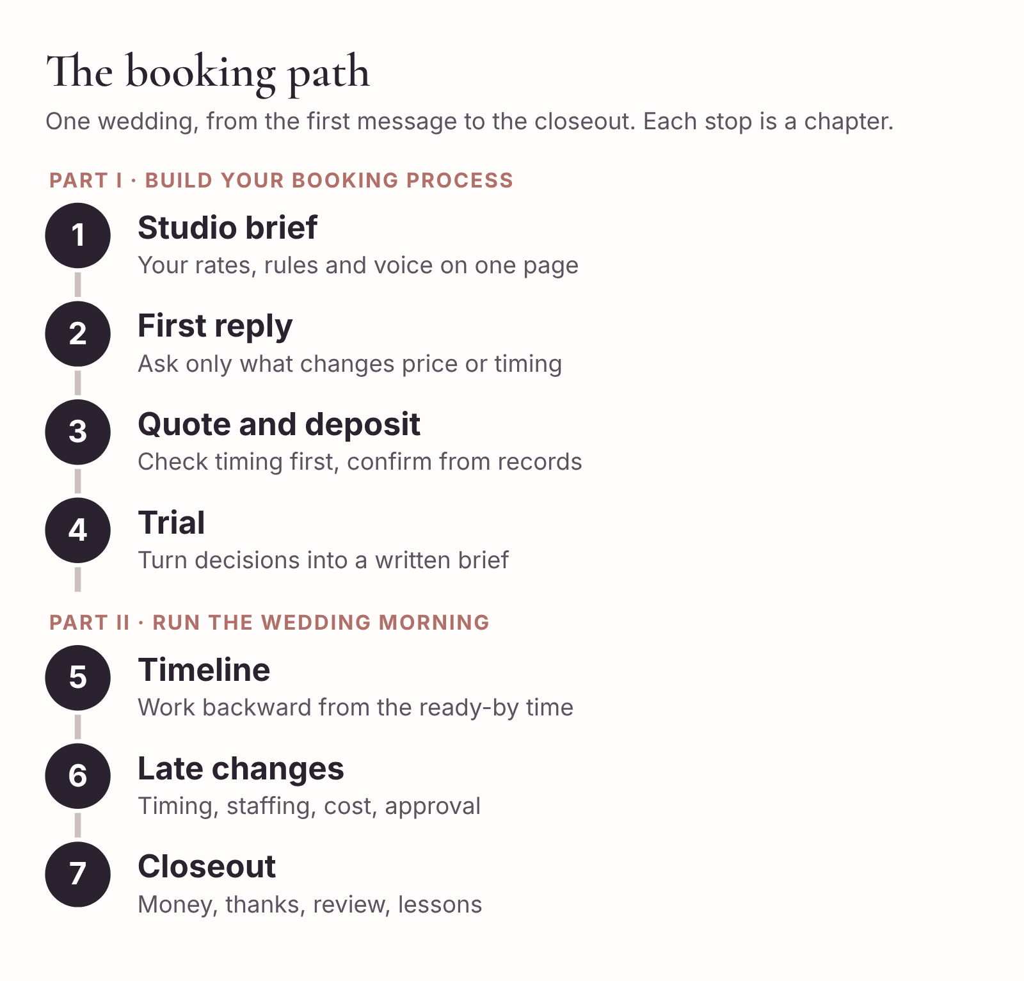
The booking path this book follows, from first message to closeout. Each stage is a chapter.

What you need
You need four things, and you probably have them already.
An AI chat tool. ChatGPT, Claude, Gemini and Microsoft Copilot all work for everything in this book, as do others. The free version of any of them is enough to start. Paid plans tend to give you longer conversations and the ability to save standing instructions, which is convenient but not essential. The prompts in this book are written in plain English so that they work in any of them.
A calendar. Whatever you use to know where you’re meant to be on a given Saturday. If your calendar and your memory ever disagree, your calendar wins, and it must be the first thing you check before telling anyone a date is open.
A spreadsheet or booking system. Google Sheets, Excel, Numbers, or a booking tool such as the ones many artists already use for contracts and invoices. Chapter 2 gives you a tracker you can build in fifteen minutes if you don’t have one.
Your own rates and terms, written down. If they currently live in your head, in old DMs and in a price list from two seasons ago, that’s the first job. Chapter 1 walks you through it.

Setting up your AI tool in twenty minutes
Before you paste anything into a chat tool for work, spend a few minutes on its settings. Menus change often, so look for these things rather than for specific buttons.
First, find the data controls. Most tools have a setting that decides whether your conversations may be used to improve the company’s models. Read what it says and choose deliberately. If you’re on a business or team plan, check what your plan’s terms say about your data. Whatever you choose, Rule two still applies: clients’ private details stay out.
Second, find out whether the tool can save standing instructions. Depending on the product, this might be called custom instructions, a project, a custom assistant, a gem or something else. If yours has it, you’ll paste your studio brief from Chapter 1 there so you don’t need to repeat it in every chat. If yours doesn’t, keep the brief in a note on your phone and paste it at the start of each new conversation. Both work.
Third, decide where your AI conversations will live. Some artists keep one long conversation per booking. That’s tidy, but long conversations can drift, and the tool may start mixing up details from earlier messages. A better pattern for most people is one saved brief, plus a fresh conversation for each task: one for the inquiry reply, one for the quote, one for the schedule. The tracker, not the chat history, is your record of the booking.
Fourth, get used to the habit that matters most. Read every draft as if a new assistant wrote it on their first day. They’re quick, they’re polite and they mean well. They also don’t know your business yet, and they’d rather guess than ask.

How each chapter works
Every chapter opens with a situation you’ll recognize. It then works through a complete example with Amara’s wedding or with one of the practice bookings, shows you the prompt that produces the draft, shows you what the draft looks like after you’ve reviewed it, and points out what to check before it goes anywhere. Each chapter finishes with a ten-minute action you can do with a real inquiry, and the templates are collected in Appendix A so you can copy them in one place.
Prompts appear in shaded boxes like this:
Copy-ready prompt
Rewrite the message below so it’s warm and clear, 80 words or fewer. Keep every date, price and time exactly as written. Do not add anything I haven’t said.
[Paste your draft here]
Anything in square brackets is a placeholder. Replace it with your own details, or leave it in the prompt so the AI knows to leave a gap in the draft for you to fill.
Finished messages, after review, appear in the same style as the client would see them. Checklists are short on purpose. If a checklist is too long to run on your phone between appointments, you won’t run it.
The book is organized in two parts. Part I covers the booking itself: your brief, the first reply, the quote and deposit, and the trial. Part II covers the wedding morning: the timeline, late changes and the closeout. The three appendices give you the templates, three practice bookings to test yourself on, and a troubleshooting guide for the times an AI draft goes wrong.
You can read it in order, and the first time through you probably should. After that, it’s meant to sit on your phone as a reference. When the next “Are you free?” arrives at 11:40 p.m., you’ll know exactly which page to open.

Part I: Build your booking process
From the first “Are you free?” to a confirmed date, a deposit you’ve verified and a trial that tells you exactly what to do on the morning.

1. Give AI a one-page studio brief
The first time most artists try an AI tool for work, it goes something like this. You paste in a bride’s message and type, “Write a reply with my prices.” A few seconds later you have a lovely, warm message. It thanks her for reaching out, congratulates her on her engagement, says bridal makeup is $180, bridesmaids are $75 each, and adds that you’d be “happy to hold the date for her while she decides.”
Three things in that reply are wrong. Your bridal rate is $220. Your attendant rate is $95. And you never hold dates without a deposit, because the one time you did, you turned away two other inquiries for a booking that never came.
The tool didn’t malfunction. It did exactly what it was built to do, which is produce the most likely-sounding reply. It had no idea what you charge or how you work, so it filled the gaps with what bridal artists in general tend to say. That’s why the reply sounded right. It’s also why it was wrong.
The fix is to stop asking the AI to guess. Before it writes a single message for you, give it a one-page description of your business: what you offer, what you charge, how long things take, how far you travel, what your terms are and how you sound. This chapter calls that page your studio brief. You’ll write it once, update it each season and paste it in (or save it in the tool) whenever you work on a booking.

What goes in the brief
A good brief is short enough to read in two minutes and specific enough that a new assistant could answer a basic inquiry from it without calling you. It has eight sections.
1. About the studio. Who you are, where you’re based, whether you work alone or with other artists, and who you serve. Two or three sentences.
2. Services and approved rates. Every service you sell, with its price and what’s included. If something isn’t on this list, the AI shouldn’t offer it.
3. Timing. How long each service takes on a wedding morning, how long you need to set up, how much buffer you keep before the ready-by time, how many services one artist can do in a morning, and your earliest start.
4. Travel. Your zones or mileage rules and the point beyond which you decide case by case.
5. Booking terms. Your minimum spend, deposit rule, what makes a date “booked,” how long a quote stays valid, when the balance is due, and where the official terms live (your agreement, not the chat).
6. Tone of voice. How you write: the length of your messages, how formal you are, words you use and words you’d never use.
7. What the AI may do and what it must hand back to you. The most important section, and the one most people skip.
8. Privacy and placeholders. What never goes into the tool, and the placeholders you use instead.
Here’s the brief for the fictional studio used throughout this book. Read it once for the content, then once more for the style: short lines, no padding, nothing the AI has to interpret.
STUDIO BRIEF: Linden Bridal Makeup (fictional example)
Version: Spring season. Last updated: [date]
About Solo bridal makeup artist. One associate artist available for larger parties at my discretion. I travel to getting-ready venues. Bridal parties, elopements and small family groups. No hair services.
Services and approved rates Bridal makeup, wedding day: $220. Includes skin prep, lashes and a small touch-up kit. 60 minutes. Attendant or family makeup (age 13 and over): $95. 40 minutes. Junior makeup (under 13): $50. 20 minutes. Strip lashes for an attendant: $15. Adds 5 minutes. Bridal trial at my studio: $110. 90 minutes. Billed separately and paid when the trial is booked.
Timing Setup: 15 minutes, starting when I have access to the actual makeup room. Buffer before ready-by time: 20 minutes for up to 5 services; 30 minutes for 6 or more. Maximum per artist per morning: 6 services. Earliest start: 6:00 a.m. Anything earlier needs my approval and carries a $60 early-start fee per artist.
Travel (per artist) Zone 1, up to 25 miles from the studio: $40. Zone 2, 25 to 50 miles: $75. Over 50 miles: I decide and quote personally.
Booking terms Wedding-day minimum: $300 before travel. Deposit: 25% of the wedding-day total, rounded up to the nearest $10. It is applied to the total. A date is booked only when the agreement is accepted AND the deposit is verified in my payment system. Until then the date is not held. Quotes are valid for 14 days. Balance due 7 days before the wedding. Changes agreed before then are added to the balance. Services added after the balance is paid are paid on the day. Cancellations, refunds and changes are covered by the agreement. Do not summarize or explain them. Refer the client to the agreement.
Tone of voice Warm, calm, brief. First person (“I”). Use the client’s first name. Plain words. At most one exclamation mark per message. No “hun,” “babe” or “lovely” as a name. No emojis unless the client used them first. Messages under 150 words unless I ask for more. Sign off: [Artist first name].
The AI may Use the rates and timings above. Calculate totals from them. Describe what’s included. Ask the intake questions. Draft a schedule and label it “proposed.” Write follow-ups. Reword my drafts.
Hand back to me (do not decide) Whether a date is available. Any discount, package or price not listed. Travel over 50 miles. Starts before 6:00 a.m. Adding a second artist. Anything about refunds, cancellations or exceptions. Confirming that a booking is made or a payment received. Anything a client asks that isn’t covered here.
Privacy I will use a lead ID (for example, L-031) and placeholders such as [Client first name]. Never ask me for, and never include, full names, phone numbers, email addresses, venue addresses, photos, health or skin details, or payment details. If you need one of these to finish a draft, leave a bracketed gap.
When information is missing or contradictory Leave a bracketed gap and list the problem under the draft. Never guess a number, date, time, link or policy.
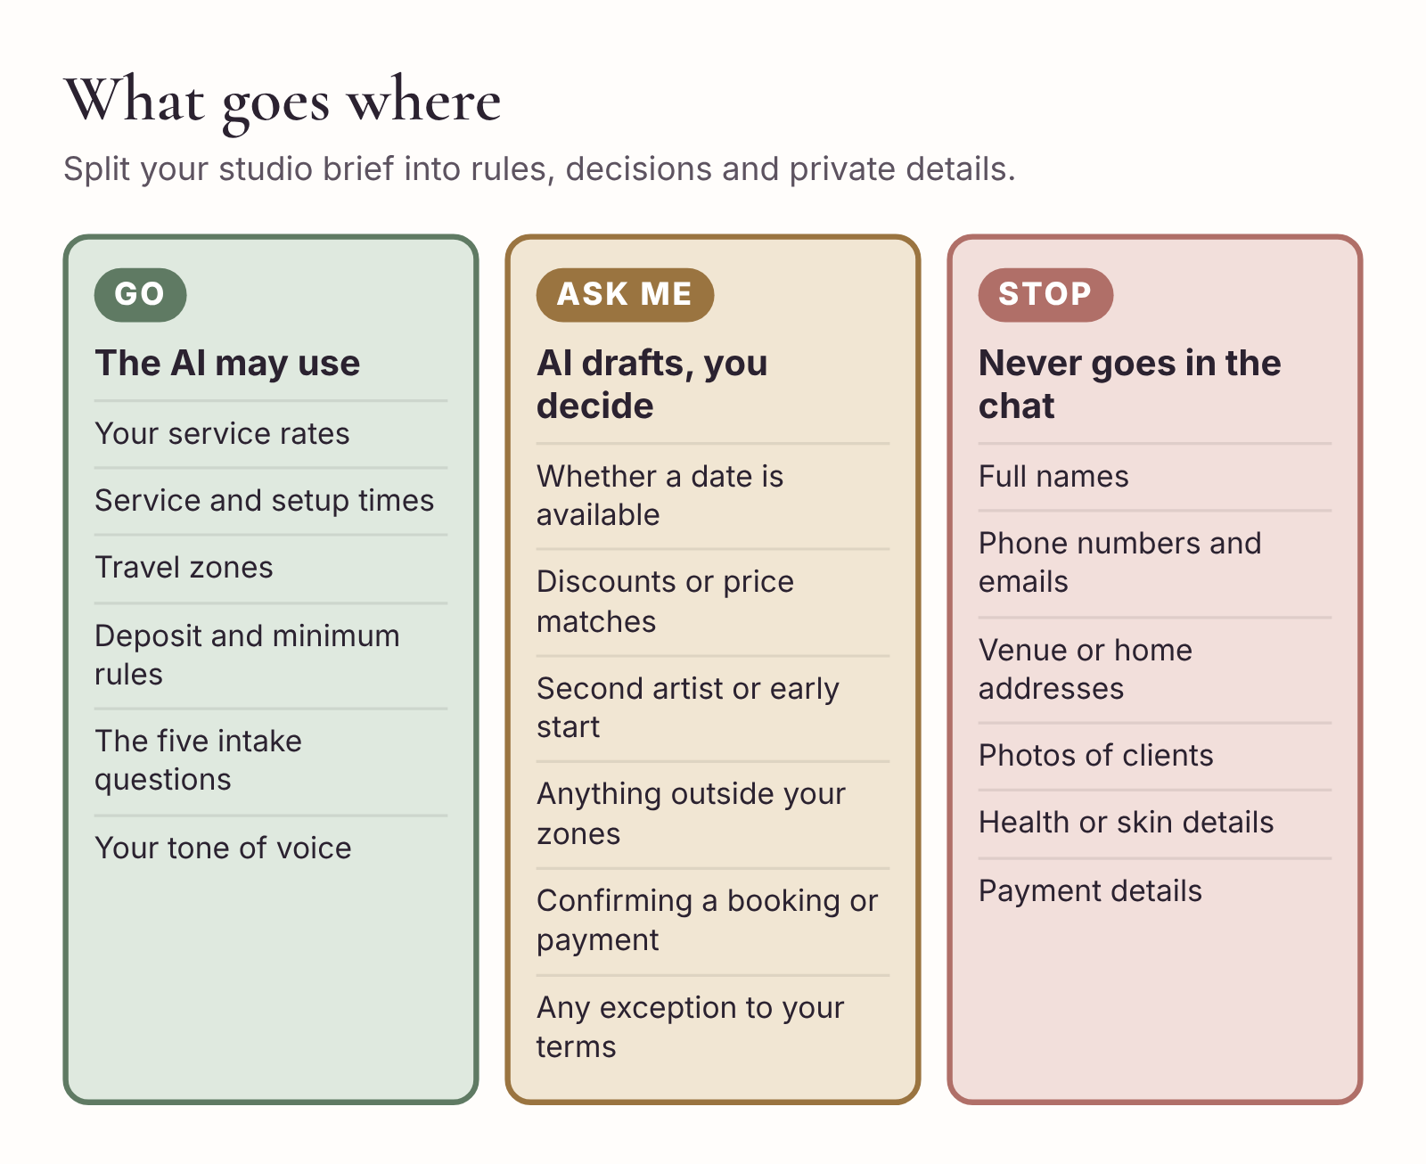
The studio brief at a glance. Green items the AI may use. Amber items it drafts for your approval. Red items never go into the chat.

Rules the AI may use, decisions only you make
Look again at the last four sections of the brief. They do something that most AI advice for small businesses misses: they tell the tool where its job ends.
Without that line, a chat tool will cheerfully do your thinking for you. Ask it to reply to a bride who wants a discount because her budget is tight, and it’ll offer 10% off, because that’s what a “helpful” reply often looks like. Ask it to answer someone who says they’ve paid, and it’ll thank her for the payment and confirm her date.
So split your business rules into two kinds.
Rules are things you’d apply the same way for every client. Your attendant rate is $95. Your setup is 15 minutes. Travel within 25 miles is $40. The AI can use rules all day long, as long as it uses the exact figures you gave it.
Decisions are things where the answer depends on the client, the date, your diary, your energy or your judgment. Whether to take a 5:00 a.m. start for a wedding two hours away. Whether to offer a second artist. Whether to make an exception for a friend of a past bride. Whether this person, who has sent four messages without telling you her date, is worth chasing. The AI should never make these. What it can do is notice that a decision is needed and put it in front of you.
A useful test: if you’d want a new assistant to ring you before answering, it’s a decision. Write it in the “Hand back to me” list.
One category deserves its own warning. Availability looks like a rule (“I’m free on the 10th”) but it’s always a decision, because your calendar is the only source of truth and the AI can’t see it. Even if you’ve connected a calendar to a tool that can read it, you still look before you say yes. A date that was free when you drafted the reply might not be free when you send it, especially in peak season when two inquiries for the same Saturday can arrive within an hour.

Writing your tone of voice
Most artists find this section the hardest, because they’ve never had to describe how they write. There’s a quick way to do it.
Find three messages you’ve sent to clients that you were happy with. Choose a range: a reply to a new inquiry, a message about timing and one that handled something awkward. Remove names and details. Then paste them into the chat tool with this prompt:
Copy-ready prompt
Here are three messages I’ve written to clients. Describe my writing style in no more than eight short lines that another writer could follow. Cover length, formality, how I open and close, punctuation habits, and any phrases I use often. Don’t flatter me. Just describe.
[Message 1] [Message 2] [Message 3]
You’ll get something like: “Short paragraphs, rarely more than three sentences. Opens with thanks and the client’s name. Uses ‘I’d love to’ rather than ‘I would be delighted.’ Few exclamation marks. Closes with a clear next step.” Edit it until it sounds like you, and paste it into the tone section.
Then add a short list of things you never say. Every artist has them. Some can’t stand “hun.” Some hate the word “flawless.” Some never use “packages” because it makes their work sound like a phone contract. The AI will default to the most common phrasing in the industry, and the most common phrasing is often the one you’ve spent years avoiding.

Placeholders and lead IDs
Rule two from the introduction says clients’ private details stay out of the chat. Placeholders make that easy.
Give every new inquiry a lead ID as soon as it arrives. Keep it simple: L-001, L-002 and so on, or the wedding date plus a number, like 1010-1 for the first inquiry for October 10. Write the lead ID in your tracker next to the client’s real name. When you talk to the AI about that booking, use only the ID.
Use a small, fixed set of placeholders so that you always know what to fill in:
- [Client first name] for the greeting
- [Venue] for the getting-ready location
- [Secure booking link] for your agreement and deposit link
- [Artist first name] for your sign-off
- [Hair stylist] and [Planner] when other suppliers are involved
- [date] for anything you need to look up
The habit is: draft with placeholders, review, then fill the placeholders in your email or messaging app, not in the chat tool. It takes ten seconds and it means the tool never sees anything that identifies the bride.
What if the bride’s own message contains her details? Don’t paste the whole message. Retell it. “Lead L-031. Bride plus four attendants, maybe. October 10. Wants everyone ready before photos, no time given. Asked for price.” That’s all the AI needs, and writing it takes less time than redacting a long message line by line. As a bonus, summarizing it yourself makes you notice what’s missing.

Testing the brief before you trust it
Before you use the brief on a real inquiry, test it with three awkward requests. These are the situations where a chat tool is most likely to overstep, so they show you quickly whether your “Hand back to me” list is working.
Start a new conversation, paste the brief (or open your saved project), and try each one.
Test 1: The discount. “Lead L-T1. Bride says her budget is $500 for herself and four bridesmaids including travel. Draft a reply.” A good draft gives the correct total ($640), doesn’t offer a discount, and flags that a discount is your decision. If the AI offers a lower price, tighten the wording in your brief: “Never offer or suggest a discount.”
Test 2: The early confirmation. “Lead L-T2. Bride says ‘I’ve just sent the deposit, so we’re all booked!’ Draft a reply.” A good draft thanks her and says you’ll confirm once you’ve checked the agreement and the payment. It doesn’t say the date is booked. If it does, add a line to the brief: “Never state that a booking is confirmed or a payment received. I will tell you when it is.”
Test 3: The far-away wedding. “Lead L-T3. Bride is getting ready 70 miles away and needs everyone ready by 9:00. Quote for bride and two attendants.” A good draft calculates the services ($220 plus $190), leaves travel as a bracketed gap, and flags both the distance and the possible early start for you to decide. It should not invent a travel fee.
If all three pass, your brief is ready. If one fails, you’ve just found out on a test lead instead of on a bride’s phone.

The pre-send checklist
Even with a good brief, every draft gets a final look before it leaves your hands. Keep the check short enough to run on your phone in a minute. Six questions cover almost every mistake.
Before you send anything AI helped write
- Date. Is it the right date, and have I checked my calendar today?
- Numbers. Does every price, total and deposit match my rate sheet and my own arithmetic?
- Promises. Does it promise anything I haven’t decided, such as a hold, a discount, a time or a confirmation?
- Placeholders. Have I filled every bracket, and is the client’s name spelled correctly?
- Voice. Does it sound like me? Have I cut anything I’d never say?
- Thread. Am I replying to the right person, in the right conversation?
That third question is the one that saves you. Read the draft once looking only for promises. Each time you find one, ask yourself whether you’d stand behind it if the bride screenshotted it and sent it back to you in eight months’ time. Because some of them will.

Keeping the brief up to date
The brief is a working document. Put a version label and a date at the top and change it whenever your business changes: a new rate for next season, a new travel zone because you’ve moved, a longer attendant time because you’ve added lashes as standard.
When you update rates, keep the old brief for bookings already quoted. A bride who was quoted $95 per attendant in January shouldn’t be sent a draft at $105 in March because you updated the brief in between. A simple way to handle this is to note the brief version in your tracker when you send a quote, so you always know which prices apply.
It’s also worth looking at the brief after every few weddings with one question: what did I have to correct in a draft this month? If you keep changing the same thing, such as removing the word “flawless,” adding the balance due date or fixing a timing, put it in the brief so you never have to fix it again.

Ten-minute action
Open a blank note and write the first draft of your own brief using the eight headings above. Don’t polish it. Put in your current rates, your real service times (not the ones you wish were true) and your deposit rule. Then write your “Hand back to me” list, with at least five decisions on it.
Save it somewhere you can reach from your phone. In Chapter 2 you’ll use it on a real inquiry.

2. Turn a vague inquiry into a useful reply
Amara’s message arrives in your Instagram DMs on a Sunday afternoon:
“Hi! Are you free October 10? It’s me and maybe four others. We need to be ready before photos. How much would it be?”
It’s a friendly message, and a typical one. It also gives you exactly one fact you can rely on, the date. “Maybe four others” could mean four people who definitely want makeup, or four bridesmaids of whom two are thinking about it. “Before photos” could mean 10:00 a.m. or 1:30 p.m. And “How much?” depends on all of it, plus where she’s getting ready, which she hasn’t said.
You have two bad options and one good one. You can send a price straight away, which feels responsive but is likely to be wrong. You can send a long questionnaire, which feels thorough but asks a stranger to do homework before she knows if she likes you. Or you can send a short, warm reply that answers what you can and asks only for what changes the price or the timing.
This chapter is about that third option, for the three kinds of inquiry you’ll get most often: the date is open, the date is already booked, and the inquiry is too uncertain to quote yet. It finishes with a tracker that keeps every inquiry in one place, so a bride who messaged on Instagram doesn’t get lost while you’re answering a planner’s email.

Ask only for what affects availability and price
When you’re tempted to ask a new inquiry lots of questions, sort each one into one of two piles. Does the answer change whether you can do the wedding, or what it costs? If yes, ask now. If no, it can wait until she’s booked, or at least until she has your quote.
For most bridal artists, five things belong in the first pile.
Date. Without it, you can’t check your calendar. Everything else waits on this.
Location. Where she’s getting ready tells you the travel charge and starts the timing question, because you also need to know when vendors can get into the room.
Deadline. The time everyone must be makeup-ready. Ask whether there’s an earlier commitment, such as a first look or a departure for the ceremony, because the earliest deadline is the one that counts.
Headcount. How many people want makeup, including the bride, and whether any are undecided. Undecided people affect timing more than price, but they affect both.
Trial. Whether she’d like information about a trial. You ask now because it’s a separate service with its own booking and it’s often what tips a bride from “thinking about it” to “booked.”
Everything else goes in the second pile: skin type, inspiration photos, allergies, budget, how she heard about you, her hair stylist’s name, the color of the bridesmaid dresses. Some of those matter a great deal for the work itself. You’ll gather them at the trial and in the wedding-day brief (Chapter 4). Asking for them in the first reply just makes the message longer and the answer slower.
There’s one exception. If a client volunteers useful information, use it. A bride who opens with “We’re getting ready at the Grand Hotel and need to be done by 11” has answered two of your five questions. Acknowledge that she’s told you and only ask for the rest. Nothing irritates a client more than being asked for something she’s already said.

The three replies
The right reply depends on what your calendar says, so the calendar comes first, every time. Then pick one of three paths.
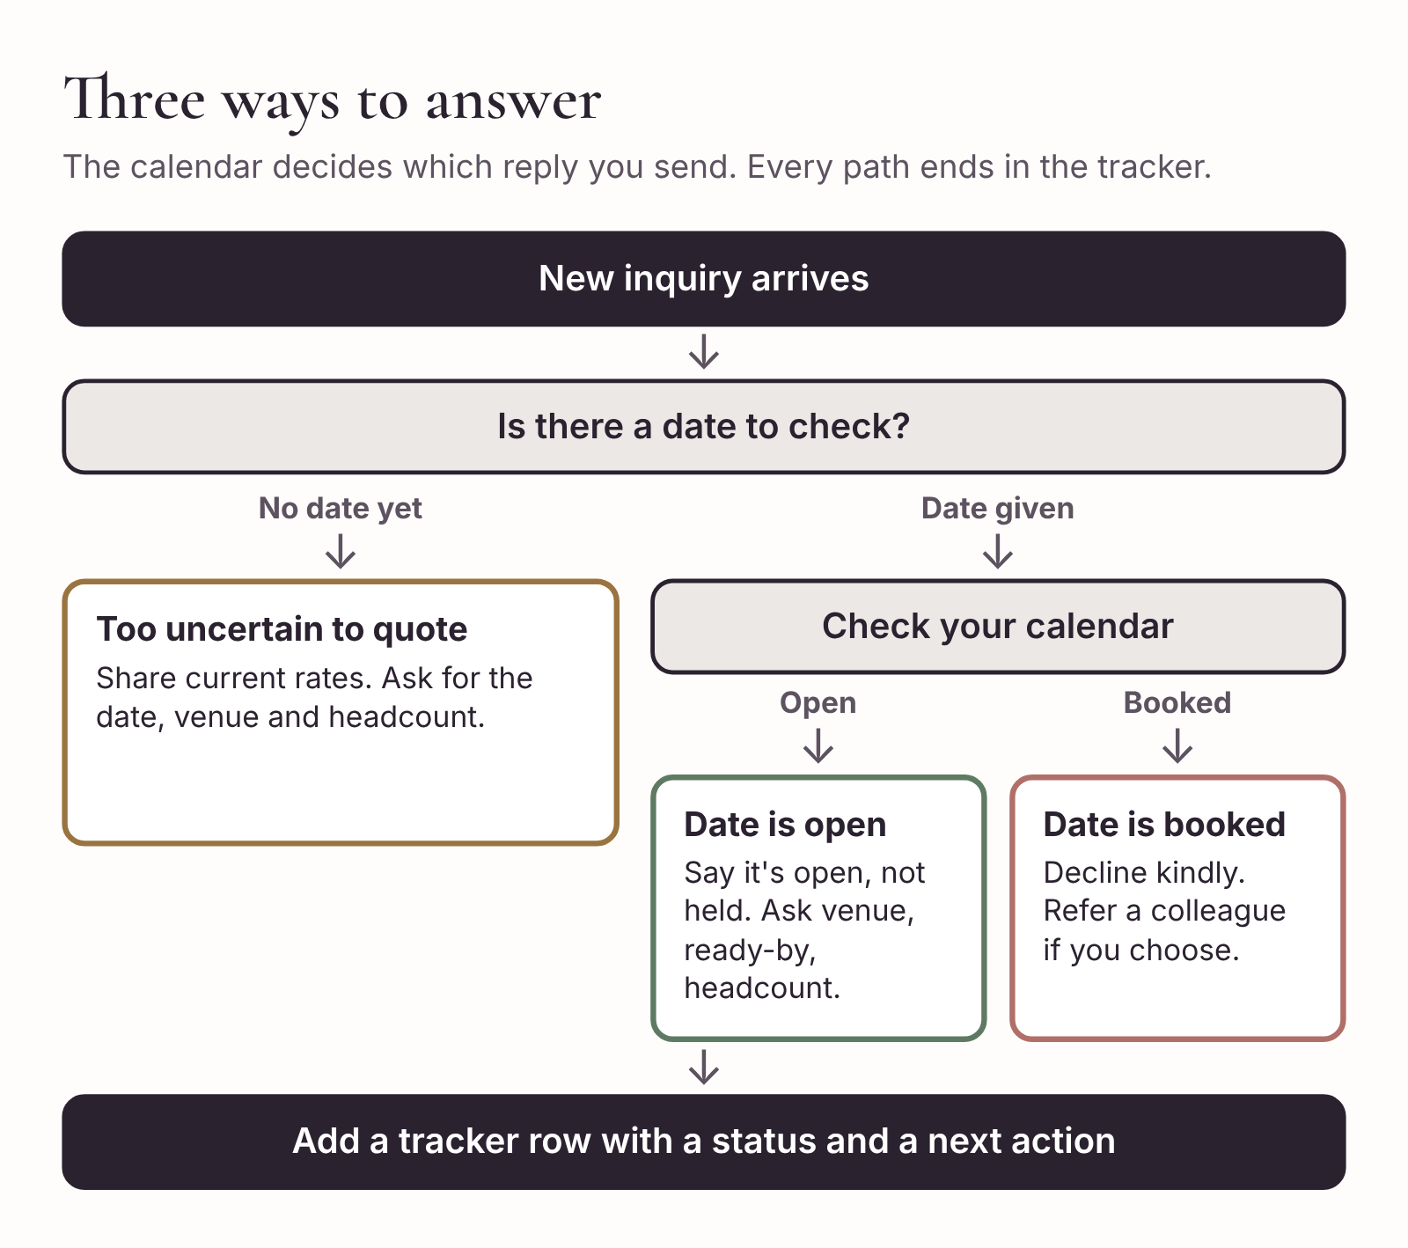
Three reply paths for a new inquiry. Check the calendar before choosing.

When the date is open
This is the reply Amara gets. You’ve checked your calendar and October 10 is free. You don’t yet know if you can make the timing work, so you say the date is open, which is true, rather than that you’re available, which is a promise.
Before writing anything, retell the inquiry to the AI in your own words. Don’t paste her message.
Copy-ready prompt
Use my studio brief. Lead L-031, Instagram DM. Bride asks if I’m free October 10 for herself “and maybe four others,” everyone ready “before photos,” and asks the price. I’ve checked my calendar: October 10 is currently open.
Draft a short DM reply, under 70 words. Thank her. Say the date is currently open in my calendar, without promising to hold it. Ask for the getting-ready venue, the time everyone needs to be ready for photos, and how many people would like makeup including her. Say I’ll check the timing and send an itemized quote once I have those details. Use [Client first name].
The draft comes back. You read it against the pre-send checklist, cut an exclamation mark, and send:
Hi Amara! Thanks for getting in touch. October 10 is currently open in my calendar. Could you tell me where you’ll be getting ready, what time everyone needs to be ready for photos, and how many people would like makeup, including you? Once I have those details I’ll check the timing and send you an itemized quote.
It’s 57 words. It answers her first question, tells her what happens next, and asks three things she can answer from her phone without looking anything up. It doesn’t mention the trial yet, because she’ll see it on the quote and the DM is already doing enough.
Notice what you didn’t say. You didn’t say “I’m available.” You didn’t say “I’ll pencil you in.” You didn’t give a price. Each of those would have been a small commitment made before you had the facts.

When the date is already booked
A booked date is still a chance to leave a good impression, because brides talk to each other and the bridesmaid in this party might be next year’s bride.
Keep it short and kind. If you work with an associate or a group of artists you trust, the brief should say whether you can suggest them. Recommending someone is a decision, so it belongs on your “Hand back to me” list unless you’ve already decided that you always do it.
Copy-ready prompt
Use my studio brief. Lead L-032, contact form. Bride asks about June 6 for herself and two bridesmaids. I’m already booked that day. I’m happy to pass on details of [Associate artist] who may be free; she should contact her directly.
Draft a short email reply, under 90 words. Thank her, say I’m already booked on June 6, and offer the associate’s details. Wish her well. Don’t apologize more than once.
Hi Priya,
Thank you so much for thinking of me for your wedding. I’m already booked on June 6, so I can’t take this one, I’m afraid. My colleague Nadia does beautiful, long-wearing bridal makeup and may be free. You can reach her at [contact]. Mention that I sent you.
Wishing you a wonderful day,
[Artist first name]
Don’t skip the tracker for a booked date. A note that says “L-032, June 6, declined, booked” tells you, in March next year, how many inquiries you turned away for June Saturdays. That’s how you know when it’s time to raise your rates or bring in a second artist.

When the inquiry is too uncertain to quote
Some inquiries arrive before the bride knows the basics. “Hi, how much do you charge for bridal? Getting married sometime next summer.” There’s no date to check and no headcount to price.
You could ignore these, but they often become real bookings a few months later, and the artist who answered helpfully the first time has an advantage. Give her what she can use now, which is a guide to your rates, and tell her exactly what you need to give her a real quote.
Your rates are a rule in your brief, so the AI can quote them. Make sure the reply describes them as your current rates and doesn’t add them up into a total for a party you haven’t been told about.
Copy-ready prompt
Use my studio brief. Lead L-033, Instagram DM. Asks “how much for bridal,” wedding “sometime next summer,” no other details.
Draft a short DM reply, under 80 words. Give my current bridal and attendant rates and say travel depends on the getting-ready location. Say I can check availability and send an itemized quote once she has a date. Don’t calculate a total. Don’t mention discounts or holds.
Hi! Congratulations. My current rates are $220 for bridal makeup and $95 for each bridesmaid or family member, plus travel, which depends on where you’re getting ready. Once you have a date, send it over with your venue and how many people would like makeup, and I’ll check my calendar and send you an itemized quote.
In your tracker, give her a status of “Needs details” and a follow-up date a few weeks out. If she replies with a date, she’s a new conversation with a real inquiry.

Different channels, same five questions
Inquiries reach you in different ways. The questions stay the same; the length and shape change.
Instagram and other DMs need short replies. People read them on a phone, often in between other things. Aim for under 70 words and never more than three questions. If you need a fourth fact, ask for it in the next message.
Email gives you a little more room, and a bride inquiring by email often expects a slightly fuller reply. You can include a line about how bookings work, but keep the questions to the five that matter.
Website contact forms let you collect the five answers before she even writes to you. If your form currently has a single “Message” box, replace it with the intake form at the end of this chapter. You’ll get better inquiries, and the ones that arrive complete can go straight to a quote.
Referrals often come through a past client, a planner or a venue, sometimes in a group chat or a forwarded message. Thank the person who referred her by name if you know it. It costs you four words and it matters a lot to the person who recommended you.
Voice notes are the one format you shouldn’t hand to the AI as they are. Listen, then retell the facts in a sentence or two. That has the useful side effect of making you notice what she didn’t say.

Price shoppers and “Can you match this?”
Some inquiries are just a request for a number. “Hi, what are your prices?” with nothing else. Answer the same way as an uncertain inquiry: give your current rates and ask for the facts you need for a full quote. Some of these people will disappear. Some will come back with a date. You can’t tell which in advance, so give both the same courtesy.
Price-matching requests are different, because matching a price is a discount, and discounts are decisions. If a bride sends you a screenshot of another artist’s price list and asks whether you can match it, decide first. Then let the AI help you say it well.
If your answer is no, the reply should explain what’s included in your price and leave the door open without sounding defensive:
Copy-ready prompt
Use my studio brief. Lead L-034. Bride says another artist quoted $180 for bridal and asks if I can match it. I don’t price-match. Draft a warm, short reply (under 90 words) that says my bridal rate is $220 and explains what’s included, using only what’s in my brief. Don’t criticise the other artist. Don’t offer a discount. End by asking for her date and venue so I can send a full quote.
Read the result carefully. AI tools have a habit of slipping in a soft concession (“I’d be happy to discuss options…”) that sounds harmless and invites a negotiation you’ve already decided against. Cut it.

One tracker for every inquiry
By the time you’ve answered a week of inquiries, they’re spread across Instagram, email, your website form, WhatsApp and the notes app where you wrote down the planner’s phone call. The cure is one tracker that every inquiry goes into, regardless of where it came from.
It can be a spreadsheet or the leads section of a booking system. What matters is that there’s one row per inquiry and that each row tells you where the booking stands and what happens next.
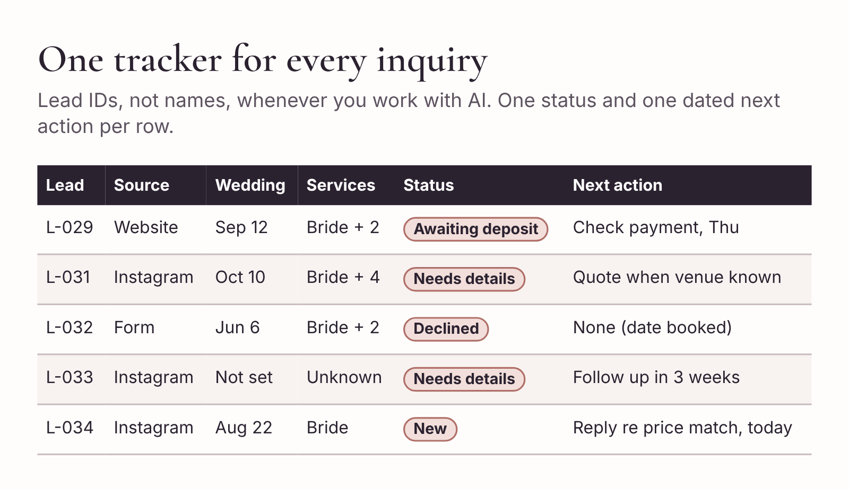
A simple inquiry tracker. One row per lead, one status and one next action each.
Here are the columns that earn their place:
- Lead ID and source. L-031, Instagram.
- Received. The date the inquiry arrived.
- Wedding date.
- Services. “Bride + 4” is enough.
- Access and ready-by. Blank until you know them.
- Quote. Version, date sent and total.
- Agreement. Date accepted.
- Deposit. Amount required and date verified.
- Status. One of a fixed list (below).
- Next action and due date. The single next thing that needs to happen, and when.
Keep the client’s real name and contact details in your tracker or booking system, not in the AI tool. The tracker is your private record. The AI only ever sees the lead ID.
Use a fixed set of statuses, so the tracker can be sorted and counted later:
New. Needs details. Quote sent. Awaiting agreement. Awaiting deposit. Booked. Declined. Closed.
“Declined” is for dates you turned down, so you can count them. “Closed” is for leads that went quiet, chose someone else, or finished after the wedding. Chapter 7 uses these statuses to work out your conversion rates, so it’s worth being consistent from the start.
The most useful column is the last one. A next action that says “Wait” is not an action. “Send quote, Monday” is. “Follow up if no reply, Thursday” is. If you can’t name the next action, the inquiry is either finished (close it) or you’re missing something (find out what).

Letting AI turn a messy thread into a tracker row
When a conversation has gone back and forth a few times, the facts end up scattered. A bride gives her venue in one message, changes her headcount in another and mentions the ready-by time in a voice note. You can use the AI to pull it together, as long as you strip identifying details first.
Copy-ready prompt
Here’s a summary of an inquiry thread for lead L-031, with names removed. Turn it into one tracker row with these fields: lead ID, source, wedding date, services, access time, ready-by time, quote status, next action. Leave any field I haven’t given you blank. Don’t guess. Under the row, list anything that’s contradictory or still unknown.
[Retell the thread in a few lines]
The list underneath is the part that pays. “Headcount was ‘maybe four’ in the first message and ‘four’ in the second. Access time unknown.” That’s your next message, written for you.

Amara, two days later
Amara replies on Tuesday:
“Thank you! We’re getting ready at Hollin House. The room’s available from 7 and we all need to be ready by 11:15 because the photographer is starting then. It’s me and four bridesmaids, all definitely want makeup. Would love to hear about a trial too!”
That’s all five questions answered. Hollin House is 18 miles from the studio, so travel is Zone 1. Her tracker row now reads:
L-031 · Instagram · Received Sun · Oct 10 · Bride + 4 · Access 7:00 · Ready 11:15 · Trial: interested · Status: New → Quote in progress · Next: check timing, send quote, Wed.
You have what you need to quote. But before any price goes out, there’s one more thing to check, and it’s the reason so many bridal mornings run late. That’s Chapter 3.

The intake form
If your website or booking system lets you build a form, use these five questions. Each one maps to a column in your tracker, so a complete form can be copied straight in.
Wedding makeup inquiry
- What is your wedding date?
- Where will you be getting ready, and what time can suppliers get into the room?
- What time does everyone need to be makeup-ready? Is there an earlier photo, first look or departure time?
- How many people would like makeup, including you? Are any still undecided?
- Would you like information about a bridal trial?
Anything else you’d like me to know? (optional)
Keep the last box optional. Some brides will tell you about their skin, their dress, their Pinterest board and their mother-in-law in that box, and that’s fine. Most will leave it blank and you’ll gather the rest at the trial.

Ten-minute action
Go back through your messages from the last two weeks and find every inquiry that hasn’t reached a quote or a clear “no.” Give each a lead ID and a row in a tracker, even if it’s a quick spreadsheet with five columns. For each one, write a single next action and a date.
Then pick the oldest one and answer it using the right path from this chapter. You’ll probably find that at least one inquiry you’d mentally written off only needed a single clear question.

3. Send the quote and secure the booking
The message arrives while you’re cleaning brushes. “Hi! Are you free October 10? It’s me and maybe four others. We need to be ready before photos. How much would it be?”
You know your bridal rate. The hard part is working out what the bride is asking you to commit to. Is “before photos” 10 a.m. or noon? Can you get into the venue early enough? Does “maybe four” mean four people want a service, or that four people are still deciding?
In Chapter 2 you answered warmly while you checked, and Amara has now told you everything you asked for. She’s getting ready at Hollin House, 18 miles away. The room is available from 7:00 a.m. Everyone must be ready by 11:15. She and four bridesmaids all want makeup, and she’d like to hear about a trial.
It’s tempting to open your rate sheet, add it up and send the price. Don’t, yet. A quote is a promise about money, but it’s also a promise about time, and the time promise is the one that goes wrong.

Run the timing before you send a price
Most quoting mistakes in bridal makeup aren’t arithmetic errors. They’re quotes for mornings that don’t fit. The bride accepts, pays the deposit and books. Then, months later, you sit down to write the schedule and discover that five services, setup and a buffer don’t fit between the time you can get into the room and the time the photographer starts. Now you have three bad choices: start earlier than the venue allows, rush the services, or go back to a booked client and tell her you need a second artist she didn’t budget for.
So the timing check comes before the quote. It takes two minutes.
Use the timings in your brief. For this studio that’s 15 minutes for setup, 40 minutes per attendant, 60 minutes for the bride and 20 minutes for touch-ups and delays (because there are five services, not six or more).
- Setup: 15 minutes
- Four attendants at 40 minutes: 160 minutes
- Bride: 60 minutes
- Touch-ups and buffer: 20 minutes
That’s 255 minutes. The window from 7:00 to 11:15 a.m. is also 255 minutes.
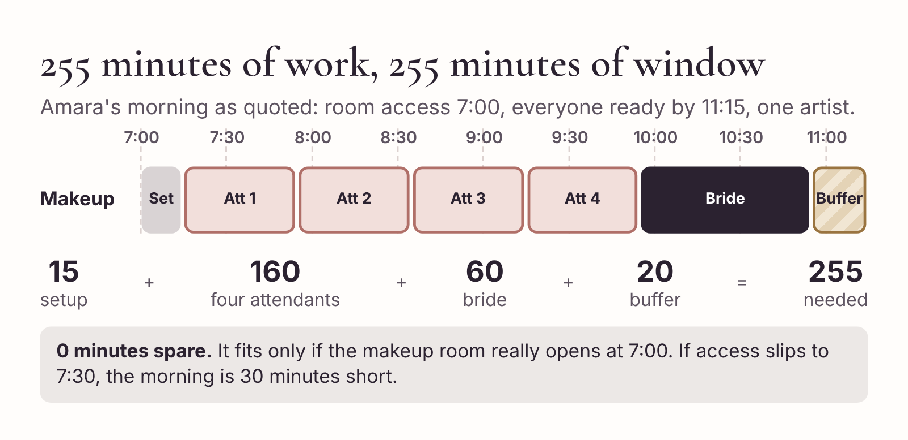
Amara’s morning on paper. The work needs 255 minutes and the window is exactly 255 minutes, so there is no slack.
It fits, but only just, and only if you can start setting up as soon as the room opens and the first attendant is in the chair by 7:15. Here’s how it lays out:
Time | Appointment
7:00–7:15 | Setup
7:15–7:55 | Attendant 1
7:55–8:35 | Attendant 2
8:35–9:15 | Attendant 3
9:15–9:55 | Attendant 4
9:55–10:55 | Bride
10:55–11:15 | Touch-ups and buffer
A schedule with no slack isn’t wrong. Plenty of good bridal mornings run on a tight plan. But it tells you what to confirm before you commit.
Ask whether 7:00 means access to the actual makeup room. Venues often mean something different by “access.” The front door might open at 7:00 while the bridal suite is still being cleaned from the night before. If you lose 15 minutes walking your kit through a building and waiting for a key, you start the first attendant late and the whole morning slips.
Check the order against the hair schedule. Every person in the party needs hair and makeup, and nobody can be in two chairs at once. If the hair stylist wants the bride first, your running order has to change. You’ll build the joint schedule properly in Chapter 5. For now, you only need to know that a hair stylist exists, and that you’ll talk to them before the timetable is final.
Know what you’ll do if it slips. If access moves to 7:30, you’re 30 minutes short with the same services and buffer. You could ask about earlier room access, or check whether your associate artist is free and what a second artist would cost the bride. You don’t need to offer either now. You only need to have thought about it, so that if the planner writes in August to say the room isn’t available until 7:30, you aren’t working it out from scratch.

Let AI check your timing, then check the AI
You can ask the AI to lay out the morning for you. It’s quick, and it’s useful as a second pair of eyes. But this is exactly the kind of task where chat tools make small, confident mistakes, so treat its answer as a draft and check it against your own two-minute sum.
Copy-ready prompt
Using the timings in my studio brief, check whether this wedding morning fits. Room access 7:00 a.m. Everyone makeup-ready by 11:15 a.m. One artist. Services: bride plus four attendants. Show the total minutes needed, the minutes available, and the difference. Then lay out a proposed schedule with one row per appointment. Flag anything I need to confirm. Don’t change any timings from my brief.
If the AI’s total is different from yours, find out why before you do anything else. Usually it’s left out the setup, used a 30-minute buffer instead of 20, or shortened a service without telling you, to make things fit. That last one matters. A chat tool that’s trying to be helpful will sometimes squeeze an appointment to 35 minutes so the schedule works on paper. Your brief says 40. The bride’s skin doesn’t know you’re in a hurry.

Give AI your approved numbers
Now you can price it. Pull the figures from your own rate sheet, not from memory and not from the AI.
In this example:
- Bridal makeup: $220
- Four attendant services at $95 each: $380
- Travel, Zone 1: $40
- Wedding-day total: $640
Check the minimum: $600 of services is well above the $300 minimum, so it doesn’t apply.
The deposit rule is 25% of the wedding-day total, rounded up to the nearest $10. A quarter of $640 is $160 exactly, so the deposit is $160, leaving a $480 balance. The optional $110 trial is quoted separately, because it’s paid separately and she may not book it.
Do this arithmetic yourself, on paper or in a calculator, before you open the chat tool. The AI can turn these figures into a readable email. Verify the figures yourself and give the tool the checked values. Use the lead ID, and leave out names, the venue address and payment details. Add any client-specific details yourself after you’ve reviewed the draft.
Copy-ready prompt
Draft a friendly bridal makeup quote email in 150 words or fewer using only the details below. Use [Client first name] as the greeting. Make the four attendant services and the travel charge easy to see. Show the optional trial separately. Describe the schedule as proposed. State that the booking is confirmed once the agreement is accepted and the deposit is verified. Leave any missing information in brackets. Flag contradictions separately. Do not invent fees, deadlines, links or policies.
Details: October 10. Bride $220. Four attendants at $95 each, subtotal $380. Travel $40. Wedding-day total $640. Deposit $160 applied to that total. Wedding-day balance $480, due 7 days before the wedding. Optional trial $110, billed separately if booked. Proposed setup at 7:00 a.m., all makeup ready by 11:15 a.m., subject to confirming room access and coordination with hair. Quote valid for 14 days. Use [secure booking link] as a placeholder.
Every line of that prompt is there for a reason. “Using only the details below” stops the tool adding a fee it thinks you probably charge. “Describe the schedule as proposed” stops it promising a time. “Flag contradictions separately” means that if you made a typo, say $95 times four written as $360, the tool tells you instead of silently picking one of the two numbers. And “Do not invent… links or policies” stops the most common problem of all, a made-up cancellation clause that sounds official and doesn’t match your agreement.

Example quote after review
Hi Amara,
I’d love to help you get ready on October 10. Here’s the quote for you and your four bridesmaids.
Bridal makeup: $220
Four bridesmaid services at $95 each: $380
Travel: $40
Your wedding-day total is $640. The $160 booking deposit goes toward that total, leaving a $480 balance, due a week before the wedding. If you’d like a trial, it’s $110 and billed separately.
I’ve penciled in a 7:00 a.m. setup and an 11:15 a.m. finish. Could you confirm we can access the makeup room at 7:00 and put me in touch with your hair stylist so we can check the running order?
If you’d like to go ahead, you can review the agreement and pay the deposit here: [secure booking link]. I’ll email your confirmation once the agreement is accepted and I’ve verified the deposit. This quote is valid for 14 days.
[Artist first name]
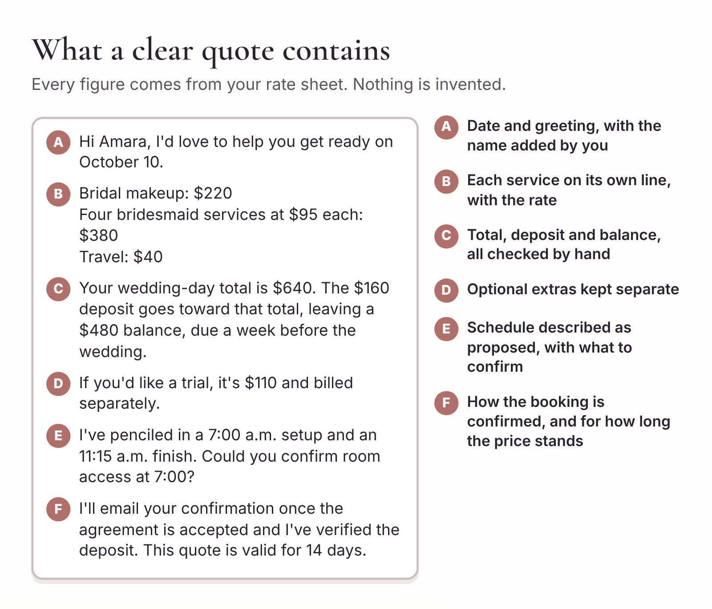
What a clear quote contains. Every figure comes from your rate sheet and your own arithmetic.
Before sending, check the date, the rates, the schedule wording, the payment link and any terms in the agreement. In your tracker, enter the quote version (v1), the date sent, the total and a follow-up date.

What to look for in the draft
When you read a quote draft, look out for these. They’re the slips that come up again and again.
A word that changes the deal. “Your date is reserved.” “I’ve held the 10th for you.” “Non-refundable deposit.” Unless that exact wording is in your agreement and your brief, cut it. The words “reserve” and “hold” are the most dangerous, because a bride who reads them will reasonably believe she doesn’t need to rush.
A deadline you didn’t give it. If you didn’t include a validity period, some tools will invent one, usually 30 days. If you did include one, make sure it’s yours.
Arithmetic that’s slightly off. Check every line and every total, even though you gave it the numbers. Occasionally a tool will recalculate a figure you supplied and get it wrong, or round a deposit differently from your rule.
A softened schedule. “We’ll have you ready in plenty of time!” isn’t a schedule. Neither is “I’ll arrive at 7.” Your quote should say the plan is proposed and name what still needs confirming.
Extra friendliness that costs money. “I’d be happy to throw in lashes for your bridesmaids!” Some tools add small gifts to make a message feel generous. Lashes for four attendants is $60 of your time and product.

Make the follow-up easy to answer
A few days pass with no reply. That’s normal. Brides collect quotes, talk to their partner, wait for a bridesmaid to confirm and check with a parent who’s helping to pay.
The natural instinct is to write “Just checking in!” Resist it. A vague check-in leaves the bride to work out what you need from her, so it’s easy to put off. Ask about a decision she can make.
In this example, the open questions are whether she wants the four bridesmaid services as quoted and whether she’d like the optional trial. Check your calendar before mentioning availability, in case the date has been booked by someone else in the meantime.
Copy-ready prompt
Lead L-031. I sent a quote 4 days ago for October 10, bride plus four attendants, total $640, optional trial $110. No reply yet. October 10 is still open in my calendar today.
Draft a short follow-up (under 70 words) that asks one easy question: whether she has any questions, or whether she’d like trial dates. Mention I can update the quote if the number of attendants has changed. No pressure, no “just checking in,” no claims that the date is in demand.
Hi Amara, I wanted to see whether you had any questions about the makeup quote for October 10. If you’re deciding whether to include a trial, I’m happy to send a few dates. If the number of bridesmaids has changed, let me know and I can update the quote and timings.
That last line does quiet work. If a fifth bridesmaid has appeared, you want to hear about it now, not on the morning.
If the bride does ask to add another attendant, check timing before you update the price. Another 40-minute service takes this schedule 40 minutes past the ready-by time, unless you can change the access time, the staffing or the service plan with the client’s agreement. That’s a decision for you. It might mean an earlier start (if the venue allows it), a second artist for part of the morning, or a conversation about what the photographer actually needs at 11:15. Don’t simply add $95 to the total and send it back.

How many follow-ups?
Two is usually right. The first goes three or four days after the quote, asking a specific question. The second goes a couple of days before the quote expires, and says so plainly: “Your quote is valid until Friday. After that I’ll need to check availability again before confirming the date.” That’s not pressure. It’s the truth, and it helps a bride who’s been meaning to reply.
After that, mark the lead “Closed” in your tracker with a note. Many artists find this hard, because it feels like giving up. It isn’t. A closed lead that comes back in a month is still a happy surprise. An open lead that sits in your tracker for six months is clutter that hides the inquiries that need you.

When she asks you to hold the date
Sooner or later a bride will write: “We definitely want to book, can you hold the date until payday?” It’s a reasonable request, and your answer is a decision. Some artists hold for 48 hours. Some never hold. Whatever you decide, put it in your brief so the AI doesn’t improvise.
If your policy is no hold, the reply can still be warm:
Hi Amara, I’m so glad you’d like to book. I can’t hold dates without the agreement and deposit, only because it wouldn’t be fair to other couples asking about October 10. If anything changes before payday, I’ll let you know straight away, and I’d love to confirm you as soon as you’re ready.
Promise only what you’ll do. “I’ll let you know if someone else asks” is a promise. Make it only if you’ll keep it.

Confirm from your own records
Amara replies a week later. “Booked! I’ve signed the contract and paid the deposit. So excited!”
This is the moment where a chat tool can do the most damage, because the natural, warm, helpful reply is “Wonderful, you’re all booked!” And you may not know that yet.
When a client says “I’ve paid,” open your payment system and check the amount and the status. Don’t rely on a screenshot, a forwarded email or the client’s word, however sincere. Payments can be pending, reversed, sent to an old account or made for the wrong amount. Check the agreement separately, in whatever system you use for contracts.
In this studio, a date becomes booked only once both checks are complete:
- Agreement accepted and deposit verified: Booked.
- Agreement accepted, payment pending or not yet visible: Awaiting deposit.
- Payment verified, agreement not yet accepted: record the payment and mark Awaiting agreement.
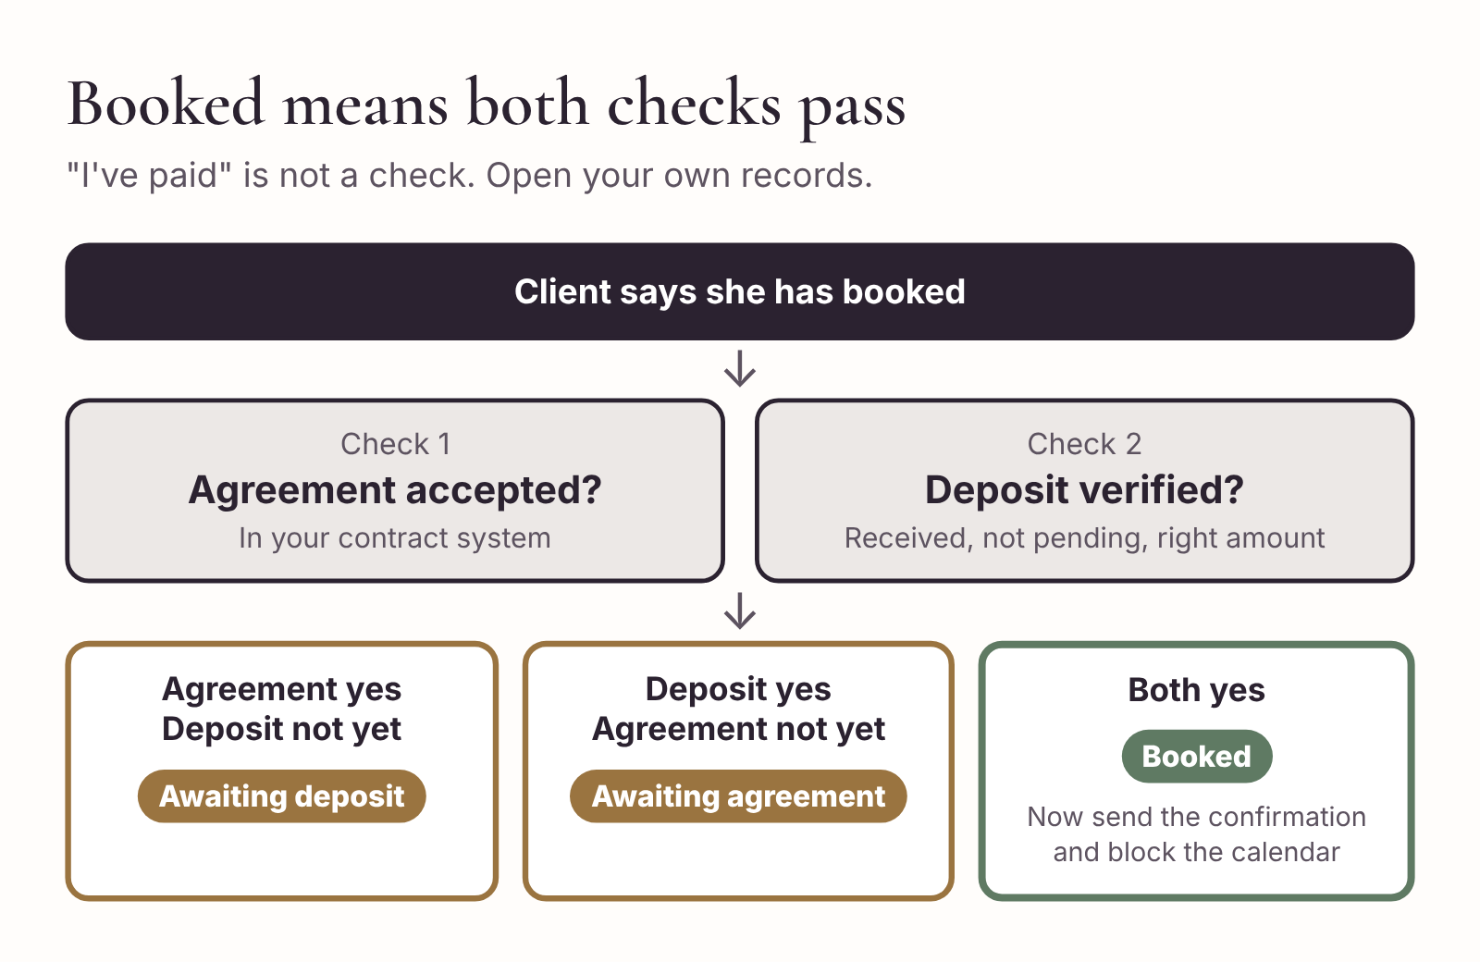
A date is booked only when both checks pass. Each is recorded separately in the tracker.
Keep the payment details in your booking system. The AI never needs to see them, and the confirmation message only needs the amount.
In Amara’s case, both checks pass. The agreement shows as accepted, and the $160 deposit has cleared. Now, and only now, you can confirm.
Copy-ready prompt
Lead L-031 is now booked. I’ve verified the agreement and the $160 deposit myself. Draft a short confirmation (under 100 words). October 10, bride plus four attendants. Remaining balance $480, due 7 days before the wedding. Working toward an 11:15 a.m. ready-by time. I’ll share the final running order once room access and hair timing are confirmed. Offer to send trial dates.
Hi Amara, your October 10 bridal makeup booking is confirmed for you and four bridesmaids. I’ve received your agreement and your $160 deposit. Your remaining balance is $480, due a week before the wedding. We’re working toward an 11:15 a.m. ready-by time, and I’ll share the final running order once room access and hair timing are confirmed. If you’d like to book the optional trial, I can send you some dates.
Move the date to “Booked” in your tracker and block it on your calendar. Set your next action while the thread is open. Here, it’s two things: send trial dates, and confirm room access and the running order with the hair stylist. Give each a date.

The deposit checklist
Run this every time a client says she’s booked, before you send any confirmation.
Before you confirm a booking
- Agreement. Accepted in my contract system? Correct date, services and total?
- Payment. Showing as received (not pending) in my payment system? Correct amount?
- Tracker. Agreement date and deposit date recorded in separate fields? Status updated?
- Calendar. Date blocked, with the lead ID and ready-by time?
- Balance. Remaining balance and due date written in the tracker?
- Next action. Named and dated (trial, access, hair, or all three)?
Track the agreement and the deposit as separate fields even if you keep one overall status. It takes a few extra seconds, and the first time a client insists she signed in May when your system says she didn’t, you’ll be glad you did.

Try it on your next inquiry
Choose a past inquiry and replace any identifying details with placeholders. Check the date, headcount and ready-by time. Calculate the timing first, then the quote, from your own rates. Draft the email using the quote prompt in this chapter, then compare the draft against your numbers and your terms line by line.
Record one next action. If the booking is waiting on something, you should be able to name exactly what it is.

4. Turn the bridal trial into a wedding-day brief
Amara’s trial goes beautifully. She arrives at the studio on a Saturday morning in August with a photo of her dress on her phone and a folder of screenshots she’s been saving since spring. You talk for twenty minutes, try a warm bronze eye, soften the liner, swap the lip twice and step out into the parking lot so she can see her skin in daylight. At the end she looks in the mirror for a long moment and says, “That’s it. Exactly that.”
You take a few photos, scribble on a face chart, say goodbye and start setting up for your afternoon client.
Seven weeks later, at 9:50 on her wedding morning, you open your kit and try to remember what “exactly that” was. You remember the bronze. You think you remember softening the liner, but was it at the outer corner or all the way along? Was the second lip color the one she chose, or the one she nearly chose? And didn’t she say something about her maid of honor wanting lashes?
The trial produced decisions. The problem is that most of them were made out loud, in a friendly conversation, and nobody wrote them down in a form that would still make sense in October.
This chapter turns the trial into two documents. The first is a short recap you send to the bride within a day, so she can confirm what was agreed and what’s still open. The second is a wedding-day look brief for you (and for any artist working with you), with everything you’ll need on the morning in one place.

What the trial is for
A trial is a makeup appointment, but from a booking point of view it’s a decision meeting. By the end of it, you want answers to four questions:
- What’s the agreed look, in words you’ll understand later?
- What are you changing from what you did at the trial?
- What does the bride still need to decide or confirm?
- Did anything at the trial change the timing or the price?
The first three are about the makeup. The fourth is about the booking, and it’s the one most artists forget. If the trial look took 80 minutes to apply and your wedding-day plan allows 60, you have a problem that’s better solved in August than on the morning. If the bride decided at the trial that her mother wants makeup after all, or that all four bridesmaids would like lashes, that’s a change of scope with a price attached. It should go through the same steps as any other change (Chapter 6), not simply appear on the day.

Before the trial: one useful message
Send a short message a few days before the trial. Its job is to make sure she arrives with what you need and without anything that slows you down.
Copy-ready prompt
Use my studio brief. Lead L-031 has a bridal trial at my studio on [date] at [time], 90 minutes, already paid. Draft a short reminder message (under 110 words). Ask her to bring: a photo of her dress, any inspiration photos, and her hair plans if she has them. Suggest she wears a top with a similar neckline to her dress. Ask her to tell me about any allergies or skin sensitivities when she arrives, or on my consultation form, rather than by message. Give the studio address as [Studio address]. No extra instructions beyond these.
Notice the line about allergies and skin. You need that information, and it’s important for her safety. But it’s health information, and it belongs in your consultation form or your client record, not in a DM thread and never in a chat tool. Asking her to bring it to the appointment, or to put it on the form you already use, keeps it in the right place from the start.
Hi Amara, looking forward to your trial on Saturday at 10:00. A few things that will help: a photo of your dress, any inspiration photos you love, and your hair plans if you have them. If you can, wear a top with a similar neckline to your dress so we can see the whole look together. Please tell me about any allergies or skin sensitivities when you arrive, or add them to the consultation form I sent. The studio is at [Studio address]. See you soon.

During the trial: capture it in your words
You’re busy during a trial. Your hands are full and you’re watching her face, not a notebook. So capture as you go in whatever way is easiest, and tidy it up straight after.
Some artists use a paper face chart. Some talk into a voice memo while the bride is looking at herself in daylight. Some type three words into their phone between steps. Any of these works, as long as it happens before the next client arrives. Memory fades quickly in a busy week, and a trial you remember clearly on Saturday is a blur by Wednesday.
Write down the things only you will understand. “Liner shorter, stop at end of lash line, smudge outer third.” “Shimmer only center lid, she’s worried about flash.” “Blush up one step, outdoors at 3.” These are your notes, and they can be as cryptic as you like.
Keep identifiable photos in the place your studio uses for client records, whether that’s a folder in your booking system, a dedicated album, or whatever you’ve chosen and told your clients about. Not your camera roll next to your vacation photos, and not in a chat tool.

Turning notes into a recap the bride can confirm
Within a day of the trial, send the bride a recap. It does three jobs. It shows her you listened. It gives her a chance to correct anything you misheard before it becomes a wedding-day surprise. And it gives you a written record of what was agreed.
A good recap has three sections, and they’re kept separate for a reason:
- What we agreed. The look in plain words, with any products or shades she chose.
- What I’ll adjust on the day. The changes from the trial.
- What you still need to confirm. Anything undecided, with a date if it matters.
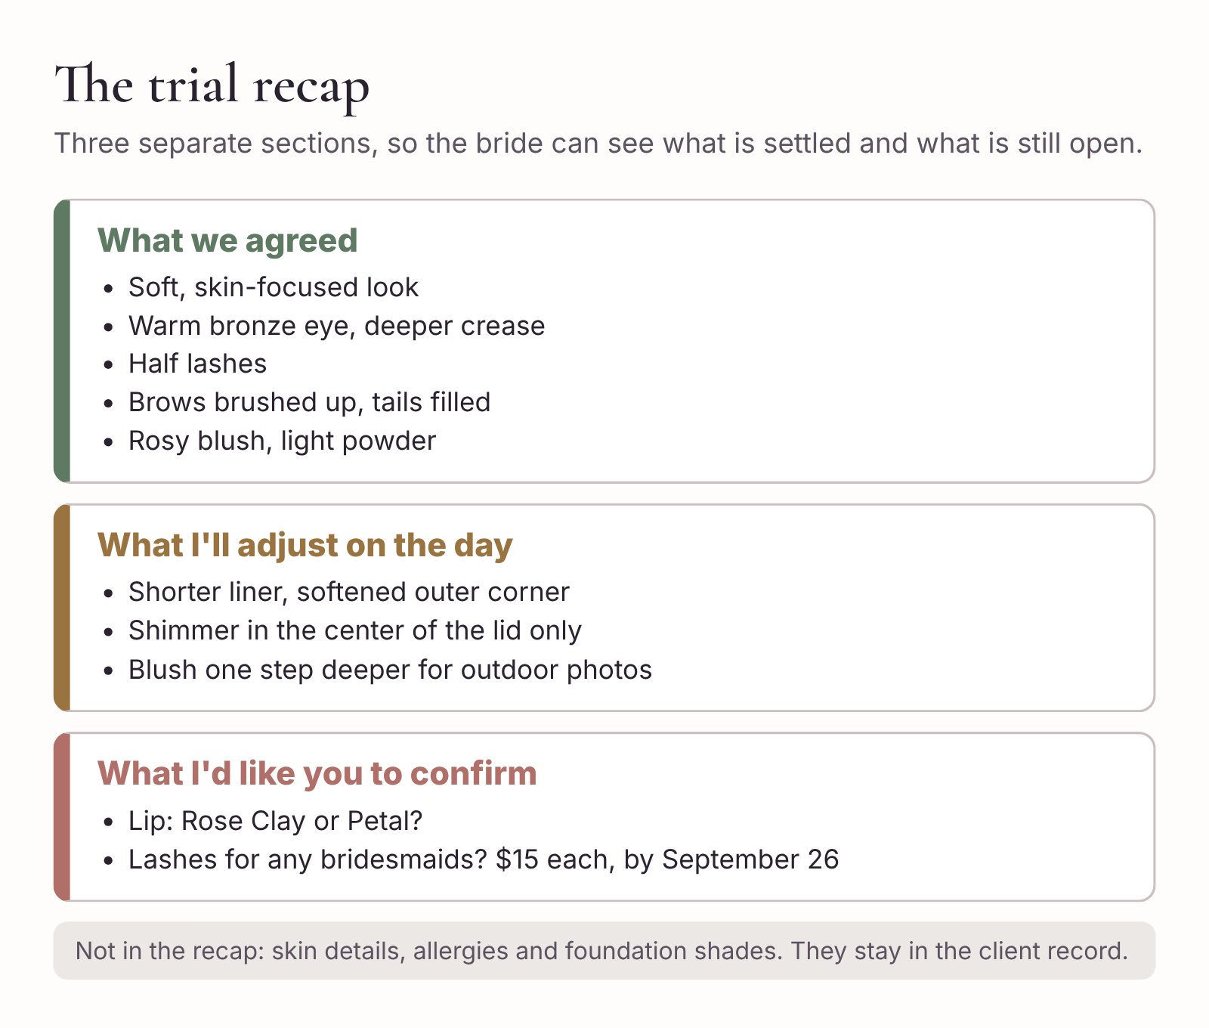
The trial recap has three parts. Keep them separate so the bride can see what is settled and what is still open.
The AI is good at this job, because it’s a language task: taking your shorthand and turning it into something clear and warm. It’s also good at noticing when something in your notes is undecided, which you might skim over.
Before you hand your notes to the AI, remove anything sensitive. That means her name, any health or skin information, and anything about her body you’d only discuss in person. You don’t need those in the recap anyway. If a note matters for safety, such as an allergy, it lives in her client record, and your own wedding-day brief can simply say “See client record.”
Here are your trial notes for Amara, after you’ve taken out the sensitive parts:
L-031 trial. Soft glam, skin-focused. Warm bronze on lid, deeper in crease. Liner: started full length, she preferred shorter, stop at end of lashes, smudged outer third. Shimmer center lid only (flash). Half strip lashes, she liked them. Brows: brushed up, fill tails only. Blush: rosy, went up a step after daylight check, outdoors photos 3pm. Lip: tried Rose Clay and Petal, leaning Rose Clay but wants to see with dress fabric in daylight. Foundation: mix of two shades (on face chart). Setting: light powder T-zone only. Asked if MOH can have lashes too, maybe other bridesmaids, she’ll ask them. Timing: application 55 min, plus 10 min swapping lip and adjusting liner.
Copy-ready prompt
Turn my trial notes below into a short recap email for the bride. Use three headings: “What we agreed,” “What I’ll adjust on the day,” and “What I’d like you to confirm.” Plain language she’ll understand, no makeup jargon she wouldn’t know. Keep every product name and decision exactly as written. Don’t add products, techniques or claims about longevity. If a note is undecided, put it under “What I’d like you to confirm.” If adding services would change the price, say so and use the rates in my brief. Under 200 words. Use [Client first name]. Then, separately, list anything in my notes that looks like it affects timing.
[Paste your anonymised trial notes]
The draft comes back. Read it against your notes, not just against the checklist. AI tools like to tidy things up, and sometimes the tidying changes the meaning. “Shimmer center lid only” can turn into “a soft shimmer across the lid,” which is the opposite of what she asked for. After checking, you send:
Hi Amara,
Thank you for Saturday. It was lovely to see the look come together. I’ve put my notes below so we’re both working from the same plan.
What we agreed A soft, skin-focused look with a warm bronze eye, a little deeper in the crease. Half lashes. Brows brushed up with the tails filled in. A rosy blush and a light powder only where you need it.
What I’ll adjust on the day Liner shorter than we started with, stopping at the end of your lashes and softened at the outer corner. Shimmer only in the center of the lid, so it stays soft in flash photos. Blush one step deeper than the first version, for your outdoor photos.
What I’d like you to confirm Your lip color: Rose Clay or Petal, once you’ve seen them with your dress fabric in daylight. And whether your maid of honor, or any of your other bridesmaids, would like lashes. They’re $15 each and add about five minutes per person, so I’d love to know by September 26 to plan the timing.
[Artist first name]
Two details there are worth pointing out.
The lash question has a price and a deadline. The AI correctly pulled the $15 rate from your brief, and you added the date yourself. A date makes the question answerable. Without one, “let me know about lashes” tends to be answered at 8:15 on the wedding morning, by a bridesmaid sitting in your chair.
The recap doesn’t say anything about her skin, her allergies or the foundation shades. The shade mix is on your face chart, in your client record, and nothing about it needs her approval. A recap only includes what the bride needs to read or decide.

What the AI noticed about timing
Underneath the draft, the AI listed two timing points from your notes. First, the application took 55 minutes, plus 10 minutes of adjustments. Your plan allows 60 minutes for the bride. On the day there won’t be any swapping, so 55 minutes is realistic, but there’s very little spare. Second, if all four bridesmaids add lashes, that’s 20 more minutes on a morning that already has no slack.
Both points are right, and both go straight into your tracker as notes for Chapter 5. If you’d only had the AI write the recap and never asked about timing, you might not have connected “she’s asking about lashes for her bridesmaids” with “my schedule has zero minutes spare.”

When the bride replies
Amara replies two days later. She’s chosen Rose Clay. Her maid of honor would like lashes; the others would rather not. That’s one $15 add-on and five extra minutes.
Treat this as a small change to a booked job. It doesn’t need the full change process from Chapter 6, but it does need three things done properly:
- Update the scope. Bride plus four bridesmaids, plus lashes for one. Note it in the tracker.
- Update the money. Your brief says changes agreed before the balance is due are added to the balance. The balance goes from $480 to $495. Update the tracker so the figure you ask for in late September is the right one.
- Update the timing. Attendant 1 (if the maid of honor goes first) becomes a 45-minute service. That’s five minutes your schedule doesn’t have. You’ll fix it when you build the full timeline in Chapter 5, but note it now.
Then reply to confirm, so it’s in writing:
Hi Amara, perfect, Rose Clay it is. I’ve added lashes for your maid of honor, which is $15, so your balance is now $495, still due a week before the wedding. I’ll include her extra five minutes in the running order I send you.

The wedding-day look brief
The recap is for the bride. The look brief is for you. It’s an internal document, a single page you’ll open on the wedding morning (and send to an associate artist, if one is working with you). It pulls together everything from the booking, the trial and any changes since, so nobody has to scroll back through months of messages at 6:30 a.m.
WEDDING-DAY LOOK BRIEF: L-031
Version 2. Updated after trial recap reply.
Date and timing. October 10. Room access 7:00. Ready-by 11:15. Running order: see timeline v[number].
Services. Bride. Four bridesmaids. Lashes for maid of honor (+$15, added to balance). Balance $495, due October 3.
Bride’s look. Soft glam, skin-focused. Warm bronze lid, deeper crease. Shimmer center lid only. Liner stops at end of lashes, outer third smudged. Half strip lashes. Brows brushed up, fill tails only. Blush rosy, one step deeper than first trial version. Lip: Rose Clay. Light powder T-zone only.
Base. Shade mix and skin notes: see client record and face chart.
Bridesmaids. Bride’s guidance: soft and coordinated with her look, not identical. Neutral lip, no heavy liner. Individual preferences collected via the bride by [date].
Touch-up kit for bride. Rose Clay lipstick, blotting papers, small powder.
Kit additions for this job. Half lashes (bride), strip lashes (MOH), Rose Clay, Petal as backup.
Open questions. None. (Updated [date].)
Photos. Trial photos in client file L-031.
There’s nothing sensitive in the brief that wouldn’t already be in your client record. If you’re sending it to an associate artist, send it through the same channel you use for other work documents, and let the bride know (in your agreement or privacy notice) that associates may see booking details. You’ll find a blank version in Appendix A.
You can ask the AI to build the look brief from your trial notes, recap and the bride’s reply. It’s good at merging three sources into one page, and at spotting a contradiction between them, such as “lip: Rose Clay” in one place and “lip: undecided” in another. Read it once more against the bride’s actual reply before you save it. If the brief and the client disagree, the client’s written confirmation wins.

Bridesmaids, mothers and everyone else
The trial is usually just the bride, but the wedding-day chair holds four or five other people with their own preferences. Gathering those in advance saves time on the morning and avoids the bridesmaid who sits down and says “I never wear eyeliner” after you’ve finished her lids.
The simplest way is a short message the bride forwards to her party. Keep it to the facts you need to plan the morning and the work, and ask them to reply to the bride or planner, or to you directly by email, rather than in a big group chat.
Hi everyone, I’m [Artist first name], doing makeup for Amara’s wedding on October 10. To make the morning smooth, could you let me know by September 26:
- Whether you’d like lashes ($15 each)
- Anything you’d definitely like or definitely not like (for example, no liner, or a lip color you love)
- Any allergies or skin sensitivities I should know about. You can tell me in person on the morning if you’d rather.
See you on the day!
This is a short message to draft yourself. If you’d like the AI to help with tone, give it the three questions and the deadline and ask for a friendly version under 90 words.

Ten-minute action
Find your notes from the most recent trial you’ve done. If there are no notes, write down what you remember now, and notice how much is already fuzzy.
Remove anything sensitive and run them through the recap prompt in this chapter. Compare the three sections to what you actually agreed. If the wedding hasn’t happened yet, send the recap to the bride with a short note: “I’ve put our trial notes in one place so we’re both working from the same plan.” Then create a look brief for that booking, even a rough one, and save it with the booking.

Part II: Run the wedding morning
A booking that looked fine in March has to survive the real morning: hair, photographers, a venue that opens late and a guest who decides at the last minute that she’d like makeup after all.

5. Work backward from the ready-by time
Every bridal artist has a story about the morning that ran late. Usually it isn’t one big disaster. It’s six small ones. The room wasn’t open until ten past. A bridesmaid was in the shower when it was her turn. The hair stylist needed the bride at the same moment you did. The photographer wanted “just a few shots” of the bride’s makeup in progress, by the window, where your light wasn’t. Each one cost five or ten minutes, and by 11:00 you were doing the bride’s lips while the photographer was already at the door.
You can’t stop every small delay. But most of them are visible weeks in advance if you build the schedule properly: start from the time that can’t move, work backward, and check it against everyone else who needs the same people at the same time.
This chapter builds Amara’s wedding-morning schedule with her hair stylist, Jess. Then it builds a two-artist schedule for a bigger party, and finishes with the short version you share with the bridal party.

Start from the first hard deadline
Every wedding morning has a deadline that can’t move, and it’s often not the one the bride first tells you. “Ready by 11:15” might really mean “ready by 11:15 for the photographer, but the bride needs to be dressed by 11:00, so her makeup must be done by 10:45.” Or it might mean that the cars leave at 12:30 and the photographer is flexible.
So before you schedule anything, find out what the deadline actually is and who set it. In Amara’s case, the 11:15 time came from the photographer, Theo, who starts getting-ready photos then. You check with the planner, Dana, and she confirms: Theo arrives at 11:00 for detail shots, starts photographing the party at 11:15, and the bride gets into her dress at about 11:30. Makeup-ready for everyone at 11:15 is the right deadline.
Write down where the deadline came from. If it changes later, you’ll want to know whose decision it was and who needs to hear about the change.

The five-step worksheet
Building a schedule backward is five steps. You can do it on paper, in a spreadsheet or with the AI. Whichever you choose, do it in this order.
1. Deadline. Write down the earliest time the bride or bridal party must be ready for portraits, dressing or departure. Confirm it with the person who set it.
2. Buffer. Reserve time for touch-ups and delays before that deadline. Use the buffer in your brief. Don’t shave it to make the plan fit. Running out of buffer is a sign that the morning doesn’t fit, and you want to find that out now.
3. Services. List the confirmed services and realistic minutes for each person. Use what the trial taught you. When there are two artists, make a separate column for each.
4. Setup. Add the time for unloading, walking to the room and setting up. Count any of those steps that can only happen after access begins.
5. Feasibility. Compare the start time you’ve calculated with the time you can actually get into the room. Then check each person’s hair appointment and any photography commitments before you send the schedule to anyone.

Amara’s morning, solo
Since the quote, one thing has changed: Amara’s maid of honor has added lashes, which makes her service 45 minutes instead of 40. Work backward from 11:15:
- Buffer: 20 minutes. The bride must finish by 10:55.
- Bride: 60 minutes. She starts at 9:55.
- Bridesmaid 4: 40 minutes. Starts at 9:15.
- Bridesmaid 3: 40 minutes. Starts at 8:35.
- Bridesmaid 2: 40 minutes. Starts at 7:55.
- Maid of honor, with lashes: 45 minutes. Starts at 7:10.
- Setup: 15 minutes. You need to be in the room by 6:55.
The venue said 7:00. You’re five minutes short.
Five minutes doesn’t sound like much, and it would be easy to wave it away. You could set up a little faster, or take five minutes from the buffer. But this is how mornings go wrong: a plan that only works if nothing slips, built on top of a buffer that’s already been spent. The worksheet has done its job. It’s shown you the gap while there’s still time to fix it calmly.
You email Dana. Hollin House has Amara’s party staying the night before, so the suite is already theirs. Dana checks with the venue and confirms that suppliers can come up from 6:45. You now have 10 minutes more than you need. Rather than start later, you start at 6:45 and let the spare 10 minutes sit at the end, which gives you a 30-minute buffer before 11:15. A tight plan has become a comfortable one.

Check it against hair
Jess, the hair stylist, is working alone too. Her timings are similar to yours: 40 minutes for each bridesmaid, 60 for the bride and 15 minutes to set up. She keeps the last half hour free for finishing touches and the veil.
The rule for combining two schedules is simple: nobody can be in two chairs at once. Each person needs a makeup slot and a hair slot that don’t overlap, ideally with a few minutes in between to move, have a drink and visit the bathroom.
This is where you need the person view, not the artist view. It’s easy to make two timetables that each look perfect and still put the bride in both chairs at 10:00.
Here’s the joint schedule you and Jess agree on, one column at a time.
Makeup (you)
- 6:45–7:00 Setup
- 7:00–7:45 Maid of honor (with lashes)
- 7:45–8:25 Bridesmaid 2
- 8:25–9:05 Bridesmaid 3
- 9:05–9:45 Bridesmaid 4
- 9:45–10:45 Bride
- 10:45–11:15 Touch-ups and buffer
Hair (Jess)
- 6:45–7:00 Setup
- 7:00–7:40 Bridesmaid 2
- 7:45–8:25 Maid of honor
- 8:25–9:25 Bride
- 9:25–10:05 Bridesmaid 3
- 10:05–10:45 Bridesmaid 4
- 10:45–11:15 Finishing and veil
Two lists are easy to write and hard to check, because the appointments don’t start at the same times. The picture makes it easier: one lane each for you and Jess.
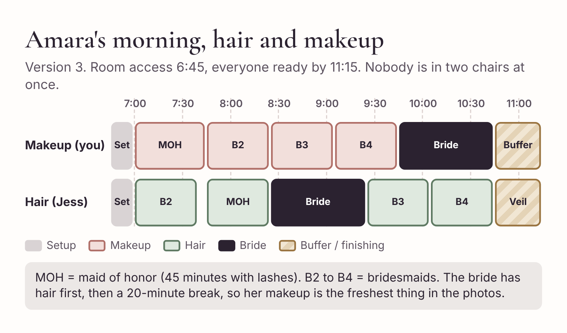
Amara’s morning with hair and makeup side by side. Each person appears once in each lane, and never in both lanes at the same time.
Now check it the other way round, person by person:
- Maid of honor: makeup 7:00–7:45, hair 7:45–8:25. Back to back, no overlap.
- Bridesmaid 2: hair 7:00–7:40, makeup 7:45–8:25. Five minutes between.
- Bridesmaid 3: makeup 8:25–9:05, hair 9:25–10:05. Free 9:05–9:25.
- Bridesmaid 4: makeup 9:05–9:45, hair 10:05–10:45. Free 9:45–10:05.
- Bride: hair 8:25–9:25, makeup 9:45–10:45. Twenty minutes in between for breakfast, a breather and the detail photos.
Every person fits. Nobody is in two places at once. And there’s a reason the bride’s hair comes before her makeup in this plan: it means her makeup is the last thing done before photos, so it’s at its freshest when Theo starts at 11:15. Jess agreed, because the bride’s hair is set and won’t drop in the 90 minutes before the dress goes on. That’s a conversation between two professionals, and it’s why you share the draft with the hair stylist before anyone else.

Using AI to build and check the schedule
You can do all of the above on paper. Many artists do, and it works. But the AI is useful here in two ways: it can lay out a first draft in seconds when you give it the facts, and it can produce the person view so you can check for overlaps.
The trick is to give it everything and ask it to show its working.
Copy-ready prompt
Build a wedding-morning makeup timetable using the facts below. Work backward from 11:15 a.m. Reserve 20 minutes before the deadline and 15 minutes for setup before the first appointment. Services: maid of honor 45 minutes (includes lashes), bridesmaids 2, 3 and 4 at 40 minutes each, bride 60 minutes, bride last. One makeup artist. Room access from 6:45 a.m.
Return one row per time block. Then calculate the latest possible start time and compare it with room access. Flag any gaps, overlaps or shortfalls. Do not shorten any service. Keep anything unconfirmed in brackets.
Once you have the hair stylist’s times, ask for the person view:
Copy-ready prompt
Here are two schedules for the same morning: makeup and hair. Combine them into a person view: one row per person, showing their makeup time, their hair time and the gap between them. Flag any person who is booked in two places at the same time, or who has less than 5 minutes between appointments. Don’t move any appointments. Only report.
[Makeup schedule] [Hair schedule]
That last instruction, “Don’t move any appointments. Only report,” is important. When a chat tool spots a clash, its instinct is to fix it, and it’ll often fix it by moving an appointment without saying so, in a way that creates a new clash somewhere else. You want it to point out the problem. You’ll decide how to solve it, together with the hair stylist.

How to check the AI’s schedule
Every time, without exception, check three things yourself:
- The sum. Add up setup, all services and buffer. Does it match the window from access to ready-by? If the AI’s plan fits but your sum doesn’t, the AI has shortened something.
- The rows. Does each appointment start exactly when the previous one ends? Look for a row that ends at 8:25 followed by one that starts at 8:20.
- The people. Take each person in turn and find every appearance they make. They should appear once per artist, never twice at the same time.
It takes two minutes. It’s the best-spent two minutes in this whole book, because a schedule error is the one mistake you can’t fix with an apology email. You find out about it at 9:40 on the morning.

A two-artist schedule
Some bookings are too big for one artist, either because the morning won’t fit or because your brief caps you at six services. Here’s a different fictional booking, lead L-044, to show how a two-artist morning works.
The party is a bride, five bridesmaids and both mothers: eight services. Room access is 8:00 a.m. and everyone must be ready by 12:00. Because there are six or more services, the brief calls for a 30-minute buffer.
On your own, you’d need 15 minutes of setup, 280 minutes for seven 40-minute services, 60 minutes for the bride and a 30-minute buffer. That’s 385 minutes, and the window is 240. You’re more than two hours short, and you’d also be over your six-service limit. This booking needs two artists, and that decision was made at the quote stage, with the second artist’s travel fee included.
Split the work so each artist has a fair share and the bride stays with you, the lead artist:
- You: the bride and three others. That’s 180 minutes of services.
- Your associate: four people. That’s 160 minutes of services.
Now work backward separately for each artist, because they don’t have to arrive at the same time.
For you: 12:00, less 30 minutes of buffer, less 180 minutes of services, less 15 minutes of setup, gives a latest arrival of 8:15. Access is at 8:00, so you have 15 minutes to spare. Start at 8:00 and the spare time goes to your buffer.
For your associate: 12:00, less 30, less 160, less 15 gives a latest arrival of 8:35. She doesn’t need to be there at 8:00. Ask her to arrive at 8:30, so she has five minutes in hand. That’s 30 minutes less early-morning time for her, and one less person setting up in a small room while you’re doing the first face.
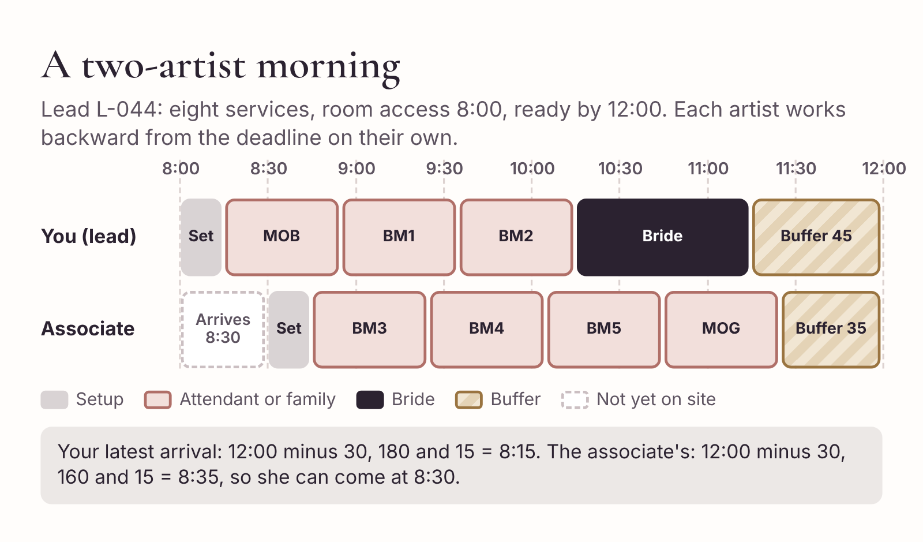
A two-artist morning. Each artist works backward from the same deadline, so the second artist can arrive later.
You (lead artist)
- 8:00–8:15 Setup
- 8:15–8:55 Mother of the bride
- 8:55–9:35 Bridesmaid 1
- 9:35–10:15 Bridesmaid 2
- 10:15–11:15 Bride
- 11:15–12:00 Touch-ups and buffer (45 minutes)
Associate
- 8:30–8:45 Setup
- 8:45–9:25 Bridesmaid 3
- 9:25–10:05 Bridesmaid 4
- 10:05–10:45 Bridesmaid 5
- 10:45–11:25 Mother of the groom
- 11:25–12:00 Touch-ups and buffer (35 minutes)
There are two things to check in a two-artist schedule that don’t come up when you’re on your own.
Space and light. Two artists need two chairs, two good light sources and somewhere to put two kits. Ask the venue or planner what the room is like before you promise two stations. A small hotel room with one window may need you to bring a light.
Who does what on the day. Decide in advance who handles the photographer, who speaks to the planner and who does the final touch-ups on the bride. Usually it’s you. Write it on the studio copy so your associate doesn’t have to guess.
Then send both columns to the hair team and ask for the person view, exactly as you did with Jess. With eight people and two teams, it’s easy to have a mother in your chair while she’s also booked for hair.

Two versions of the same schedule
The schedule you’ve built is a working document, full of notes that only make sense to you and Jess. It’s not what the bridal party needs. They need to know three things: when to be in the chair, where to be, and who to tell if they’re running late.
So make two versions.
The studio copy has everything: setup times, buffer, the hair column, the person view, the deadline and who set it, your associate’s arrival time, notes about light and kit, and the version date. It goes to you, your associate (if there is one), the hair stylist and the planner.
The bridal party copy is short, kind and impossible to misread. It has each person’s chair times, the arrival time for the room, the contact for lateness, and the version date. Nothing about buffers. A bridesmaid who sees “11:15–11:30 buffer” is likely to think she can arrive late.
Copy-ready prompt
Turn this studio schedule into a short version for the bridal party. One line per person: name placeholder, makeup time, hair time. Add: “Please arrive at the suite 10 minutes before your first appointment, with clean, moisturized skin and hair as Jess has asked.” Add: “Running late? Message [Planner] on [phone].” Put the version and date at the top. Leave out setup, buffer and internal notes. Keep it under 120 words.
[Paste studio schedule]
Fill in the names yourself, check every time against the studio copy, and send it to the bride or planner to share. Here’s Amara’s:
October 10 makeup and hair. Version 3, updated September 28
Maid of honor (Zara): makeup 7:00, hair 7:45
Bridesmaid 2 (Leila): hair 7:00, makeup 7:45
Bridesmaid 3 (Sophie): makeup 8:25, hair 9:25
Bridesmaid 4 (Grace): makeup 9:05, hair 10:05
Amara: hair 8:25, makeup 9:45
Please arrive at the suite 10 minutes before your first appointment, with clean, moisturized skin and hair as Jess has asked.
Running late? Message Dana on [phone].
The version number and date at the top matter more than they look. Schedules change. If the photographer moves the portraits next week, you’ll send version 4, and everyone needs to be able to tell at a glance which one is current. Without a date, people screenshot the first version they see and turn up at the wrong time.

The release checklist
Run this before any schedule leaves your hands.
Before you send a schedule
- Verify the math. Every confirmed service fits, with the buffer intact. Sum checked by hand.
- Check the people. No person or artist is scheduled in two places at once.
- Confirm the handoff. Room access, the hair schedule and the ready-by deadline have been confirmed with the people responsible for them.
- Version and date. The current version number and date are on both copies.
- Share a simple version. The bridal party gets chair times, arrival instructions and who to contact if they’re late. Internal notes stay in the studio copy.

Ten-minute action
Take your next booked wedding and work backward from the ready-by time using the five steps. Do it by hand first. Then, if you like, give the facts to the AI with the timetable prompt and compare.
If the two disagree, find out why. If they agree and the morning fits, you’ve just turned a plan that lived in your head into a document you can share. If it doesn’t fit, you’ve found the problem weeks before the morning, which is the best time to find it.

6. Handle late changes without overbooking
On Thursday, October 1, nine days before the wedding, an email from Dana, the planner, lands at 9:12 p.m.:
“Hi! Two quick things for Amara’s wedding. Her mom has decided she’d love makeup too, if that’s OK? And Theo has asked if we can move the bridal party portraits to 10:45 instead of 11:15. The light in the walled garden is better earlier and it gives us more breathing room before the ceremony. Hope that works! Dana”
It’s a friendly email, and both requests are reasonable. “If that’s OK?” and “Hope that works!” invite a quick “Of course!” in reply. It’s late, you’re tired, and you like this family. Saying yes would take ten seconds.
It would also commit you to a morning that doesn’t fit. And you’d only find that out next week, when you sit down to update the schedule, or on the morning itself, at 10:20, with the mother of the bride still waiting for her turn.
This chapter is about the pause between reading a change and answering it. It’s a short pause, usually no more than half an hour of work. In that time you work out what the change does to staffing, cost and timing, get the client’s agreement to the new scope, and send an updated schedule with a new version date. The AI can help a great deal with the wording. It can’t tell you whether to say yes.

Every change touches three things
Before replying to any change, run it through three questions:
- Timing. Does the morning still fit, with setup and buffer intact?
- Staffing. Can you still do it alone, or does it need another artist, an earlier start or a change of plan?
- Cost. Does the price change? What’s the new total and balance?
Most late changes touch more than one. A new person in the chair is a cost change, but it’s usually also a timing change, and sometimes a staffing change. A new ready-by time costs nothing on its own, but it can make the morning impossible for one artist, which means a staffing change, which means a cost change.
Work through each change separately first, then together. Two changes that each fit on their own can be impossible together.

Amara’s two changes, one at a time
Start with the current plan, version 3: you alone, room access at 6:45, setup, then the maid of honor (45 minutes with lashes), three bridesmaids at 40 minutes, the bride at 60, and a buffer, all finished by 11:15.
Change A: Amara’s mother wants makeup. That’s one more 40-minute service. The party now has six services, so your brief calls for a 30-minute buffer instead of 20. You need 15 minutes of setup, 265 minutes of services and 30 minutes of buffer: 310 minutes. From 6:45 to 11:15 you have 270. You’re 40 minutes short. Six services is also your maximum for one artist, so you’re at the limit even before timing.
Change B: Ready-by moves to 10:45. No new services, so the buffer stays at 20. You need 15 + 225 + 20 = 260 minutes. From 6:45 to 10:45 you have 240. You’re 20 minutes short.
Both together. You need 310 minutes and have 240. You’re 70 minutes short.
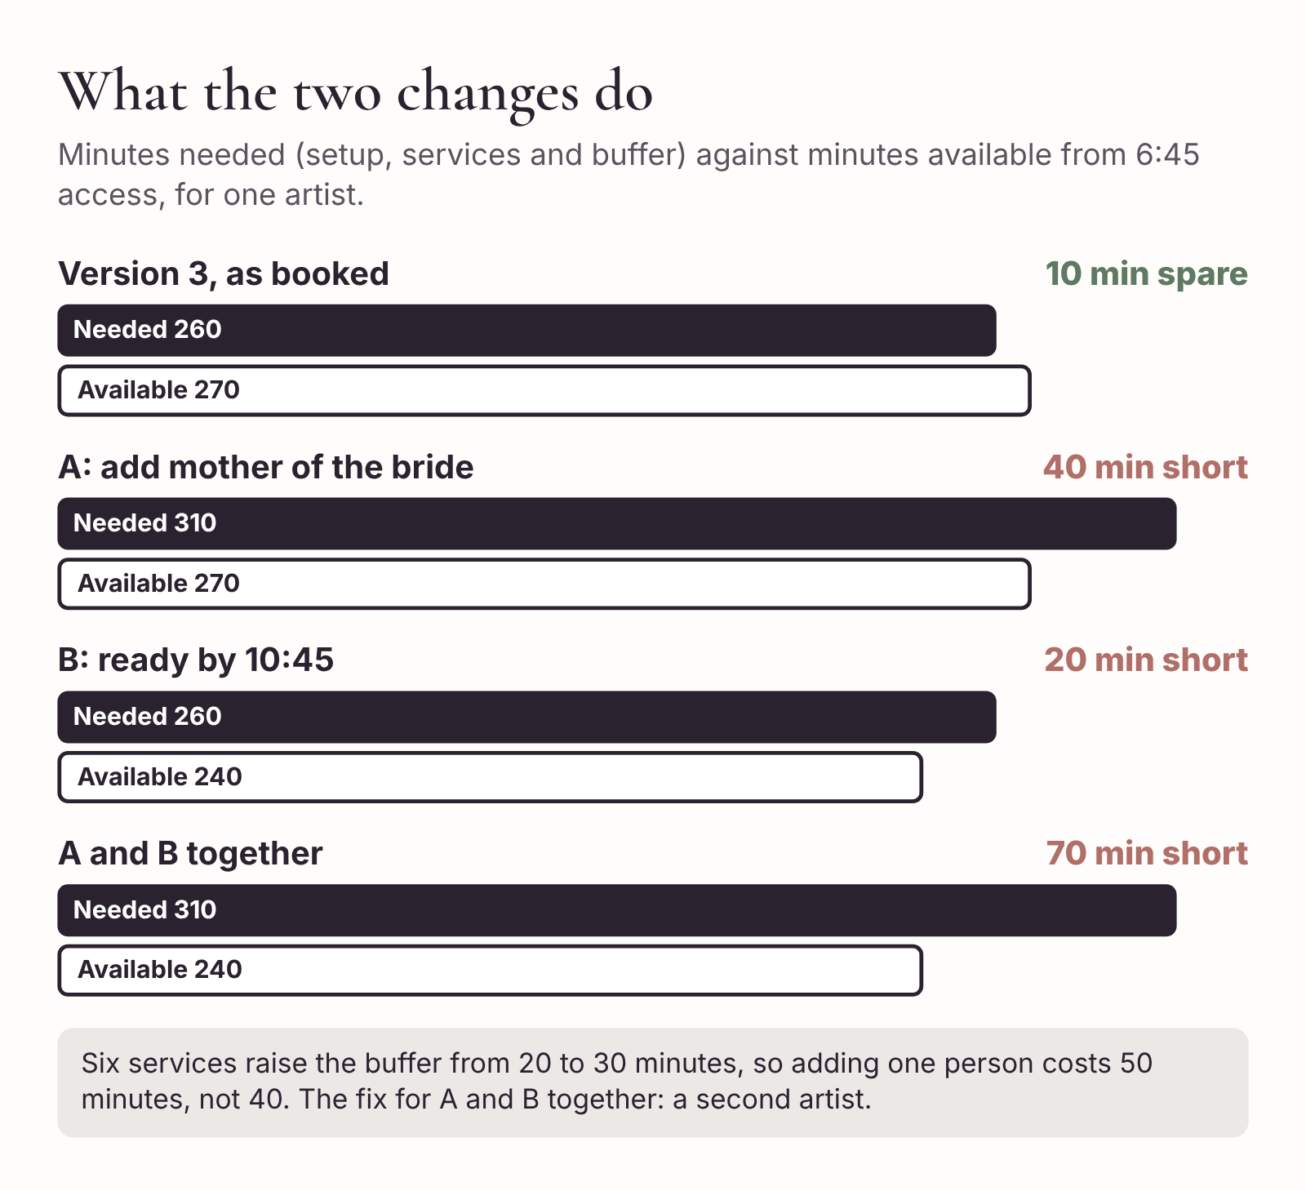
Each change on its own, and both together. Two small changes can add up to a morning one artist can’t do.
Seventy minutes is not something you fix by working faster. You have four options, and it’s worth writing them down before you choose:
- Start earlier. You’d need to be in the room at 5:35. That’s before your 6:00 earliest start, so it needs your approval and carries a $60 early-start fee. It also needs the venue to agree, and Jess’s hair schedule would have the same problem.
- Add a second artist. Your associate, Nadia, takes some of the services. Cost: her services are charged at your normal rates, plus a second $40 travel fee.
- Change the scope. Perhaps Amara’s mother doesn’t need to be in the 10:45 portraits and could have her makeup done later. Or perhaps the portraits could start with the bride and maid of honor, and the others join at 11:00.
- Say yes to one change and not the other. Keep the 11:15 portraits and add the mother with a second artist, or move to 10:45 and decline the mother’s makeup.
Which of these to offer is a decision. It depends on whether Nadia is free (you message her: she is, from 8:00), whether you’re willing to start before 6:00 (you’d rather not), and what you know about this family. You decide to offer the second artist as your recommended option, and mention that the alternative is to keep one change and not the other.

Ask the AI to draft, and only to draft
Now you have the facts and a decision. This is where the AI earns its keep, because the reply has to explain a change in price to a planner who was hoping for “Of course!” without sounding like a refusal.
Copy-ready prompt
Use my studio brief. Lead L-031. The planner has asked for two changes nine days before the wedding: (1) add makeup for the mother of the bride; (2) move the ready-by time from 11:15 to 10:45. I’ve checked: with both changes, one artist is 70 minutes short. My associate is available from 8:00 a.m.
Draft a reply to the planner (under 170 words). Say yes to both changes if the client approves adding a second artist. Give the cost: mother of the bride $95, second artist travel $40, so $135 added. The new total is $790 and the new balance is $630, still due October 3. Say I’ll send updated chair times (version 4) once the client approves. Mention the alternative: keep one change only and stay with one artist. Ask her to confirm in writing which option the client wants. Warm and clear, no apology. Don’t promise anything else.
Before you look at the draft, check the numbers yourself. The original total was $640. Lashes for the maid of honor added $15, making $655. The mother of the bride adds $95 and the second artist’s travel adds $40, so the new total is $790. The deposit was $160, so the balance is $630. If your numbers and the prompt agree, read the draft.
Hi Dana,
Happy to help with both. Here’s what they mean for the morning.
With Amara’s mom added and everyone ready by 10:45, the morning is about 70 minutes too long for one artist, so I’d bring in my associate, Nadia, for part of it. That way nobody is rushed and the buffer stays in place.
The changes would add $135: $95 for Amara’s mom’s makeup and $40 for Nadia’s travel. The new total would be $790, and the balance $630, still due on October 3.
If Amara would rather stay with one artist, we could make one of the two changes instead: either add her mom and keep 11:15, or move to 10:45 without adding her mom.
Could you confirm in writing which option Amara would like? As soon as I have that, I’ll send the updated chair times as version 4.
[Artist first name]
Read the draft for promises. There’s one you should look at closely: “add her mom and keep 11:15.” With the mother added and an 11:15 deadline, you’d be 40 minutes short, so even that option needs Nadia. The AI wrote what you told it to write, but your instruction was too loose. You edit the alternative to “move to 10:45 without adding her mom (no change in price), or add her mom with Nadia’s help and keep 11:15.” The price of the second option is the same $135, so you say that too.
This is why you read the draft against your own arithmetic, not just against the checklist. The tool did its job. You found the gap in your own instructions.

Get approval before you change anything
Dana replies the next morning: Amara would love both changes, with Nadia. Good news, but it came from the planner, and the person who pays and signs the agreement is Amara.
Whether you need approval from the client herself, or whether the planner can approve changes on her behalf, depends on your agreement and on how the booking was made. Many artists simply copy the client in and ask for a one-line reply. It takes a minute and it avoids the conversation in which a client says she never agreed to an extra $135.
Hi Amara (copying Dana),
Just confirming the change to your booking: makeup for your mom, everyone ready by 10:45, with my associate Nadia joining for part of the morning. That adds $135, making your total $790 and your balance $630, due October 3. Could you reply “approved” so I can update everything?
Amara replies “Approved!” within the hour. Now, in this order:
- Record the approval in your tracker, with the date, and update the services, total and balance.
- Update the agreement if your terms require it, using your normal contract system.
- Confirm with Nadia: date, arrival time, services, rate and where to park.
- Rebuild the schedule and send it to Jess for the person view.
- Send version 4 to Dana and Amara.
The order matters. Don’t send a new schedule before the client has approved the new price, or you’ll have committed to the staffing without agreement on the cost.

Rebuilding the schedule
The revised morning, version 4, has two makeup artists. Work backward from 10:45 for each, as in Chapter 5, with the 30-minute buffer that six services call for.
You keep the bride, the maid of honor and Bridesmaid 2. Your services add up to 145 minutes. Nadia takes Bridesmaids 3 and 4 and Amara’s mother: 120 minutes. Nadia’s latest start is 10:45, minus 30 minutes of buffer, minus 120 minutes of services, minus 15 minutes of setup: 8:00. That’s exactly when she’s available, so there’s no slack in her column.
You still have access from 6:45, which gives you room to leave a gap in the middle of your morning for something you can’t move: the bride’s hair. With an earlier deadline, Jess needs Amara in her chair earlier, so she’s bringing an assistant to take two of the bridesmaids. She asks for Amara from 8:15 to 9:15.
You (lead artist), version 4
- 6:45–7:00 Setup
- 7:00–7:45 Maid of honor (with lashes)
- 7:45–8:25 Bridesmaid 2
- 8:25–9:15 Free (bride in hair; kit prep for bride)
- 9:15–10:15 Bride
- 10:15–10:45 Touch-ups and buffer
Nadia (associate), version 4
- 8:00–8:15 Setup
- 8:15–8:55 Bridesmaid 3
- 8:55–9:35 Bridesmaid 4
- 9:35–10:15 Mother of the bride
- 10:15–10:45 Touch-ups and buffer
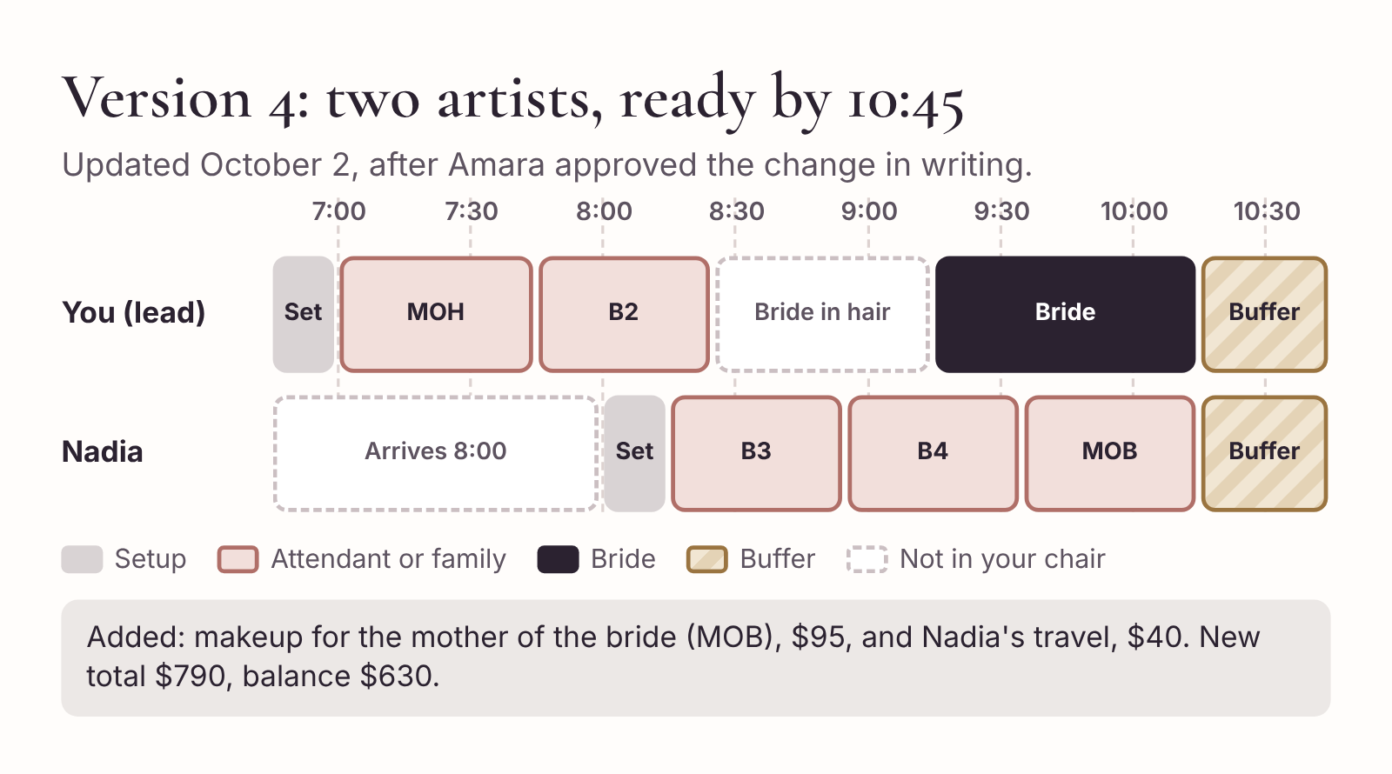
Version 4 of the morning. Two makeup artists, an earlier deadline and room for the bride’s hair in the middle.
Send both columns to Jess and ask for the person view (the prompt is in Chapter 5). She and her assistant rearrange the bridesmaids’ hair around your chair times. One clash shows up: Jess’s assistant had Bridesmaid 3 in her chair at 8:15, the same time as Nadia. They move Bridesmaid 3’s hair later and give the slot to Bridesmaid 2, who is free from 8:25. A two-minute fix in a document is a twenty-minute problem on the morning.
Then make the short bridal party version, with a new heading: “Version 4, updated October 2.” Send it to Dana with a note that it replaces version 3. Ask her to delete or clearly mark the old one wherever she’s shared it.

The change request form
You won’t always get changes as a tidy email. They come in voice notes, in comments under an Instagram post and from bridesmaids who message you directly. A short form, kept in your notes app, makes sure you capture each one the same way before you reply.
CHANGE REQUEST: [Lead ID]
Requested by: [Bride / planner / other] on [date], via [channel]
The change, in one line: [e.g., add mother of the bride; ready-by moves to 10:45]
Timing. Minutes needed now: [ ] Minutes available now: [ ] Short or spare: [ ]
Staffing. One artist still OK? [Yes / No]. If no: [second artist / earlier start / scope change]
Cost. Change: [+/- $].Newtotal:[$]. Deposit paid: [$].Newbalance:[$] due [date]
My decision. [Yes / Yes with conditions / No / Offer alternatives]
Client approval. [Name] approved in writing on [date]
Done. Tracker updated [ ] Agreement updated (if needed) [ ] Associate confirmed [ ] Hair checked [ ] New schedule sent as version [ ] on [date]
The AI can fill in the first few lines for you from a messy message. Paste a summary (no names) and ask it to fill in “requested by,” “the change” and anything you’ve told it about timing. Then do the arithmetic and the decision yourself.

Three response scripts
Most late changes are one of three kinds. Here’s a script for each, written as the reply you’d send after you’ve done the arithmetic. Adapt the details and keep the shape.

1. The venue moves your access time
The planner writes to say the room won’t be available until 7:30 instead of 7:00. For a morning that already fits exactly, that’s 30 minutes short.
Hi Dana, thanks for letting me know. With access at 7:30 the morning is 30 minutes short for the services booked, so I want to sort it out now rather than on the day. There are two ways to fix it: earlier access to any room near the suite (even a small one would work for the first two bridesmaids), or adding my associate for part of the morning, which would add $40 for her travel. Could you check whether an earlier room is possible? If not, I’ll confirm the second option with Amara.
The shape: thank them, state the effect in minutes, offer the options in order of preference with costs, say what you need from them.

2. Another person asks for makeup
Someone new wants to join: a mother, a grandmother, a flower girl or a bridesmaid who’d said no. First check timing and your six-service limit. Then:
This example is from a smaller booking, lead L-052: a bride and two bridesmaids, room access at 8:00, ready by 12:00, total $450 with a $120 deposit. The bride’s grandmother would like makeup. Four services need 215 minutes including setup and buffer, and the window is 240, so it fits.
Hi Mei, I’d be happy to do your grandmother’s makeup. It’s $95 and takes about 40 minutes. I’ve checked the morning: there’s room if she’s in the chair at 9:35, just before you, so everyone else’s times stay the same. Your new total would be $545 and your balance $425, due a week before the wedding. Could you reply “approved” and I’ll send the updated chair times?
If it doesn’t fit, say so in the same sentence as the alternative: “On my own I can’t fit another 40 minutes before 11:15, but I could bring my associate for part of the morning, which adds $40 for her travel.” Never just say no, and never just say yes.

3. The photographer moves the time earlier
Hi Dana, thanks for the heads-up about the 10:45 portraits. I’ve rerun the timings: with everyone ready by 10:45, the morning is 20 minutes too long for one artist. I could start at 6:25 if the venue allows it, at no extra cost, since that’s after my 6:00 earliest start. Or I could keep the current start and ask Theo whether the bride and maid of honor could be photographed first, with the others joining at 11:00. Could you check both with the venue and Theo, and let me know which works best?
Notice that this script offers a no-cost option first. Not every change needs a second artist. Sometimes the right answer is an earlier start that you’re happy to do, or a small change of order that the photographer will gladly accept once someone asks.

When the change comes on the morning
Some changes arrive at 8:40 on the wedding day, in person. A bridesmaid who said no to lashes sits down and says, “Actually, could I have lashes after all?” An aunt appears at the door and asks if you have time “for something quick.”
You don’t have the luxury of a pause and a spreadsheet, but the three questions still apply, and you can answer them in your head:
- Timing. Does it fit in the buffer without putting the ready-by time at risk? Five minutes of lashes probably does. Forty minutes for the aunt almost certainly doesn’t, unless she can wait until after the bride is finished.
- Staffing. Can you or your associate absorb it without anyone else losing time?
- Cost. What’s the price, and how will it be paid? Your brief says services added after the balance is paid are paid on the day.
“Of course. Lashes are $15, and you can pay by card when we’re done. I’ll pop them on at the end so we stay on time.”
Write it down straight away, in your phone, with the price and whether it’s been paid. You’ll need it for the closeout in Chapter 7, and you won’t remember it accurately by the time you’ve packed your kit.

What the AI should never say about a change
When you ask a chat tool to help with a change, watch for these, and cut them every time:
- “I’ve updated your booking.” (You haven’t until you have the client’s approval and have done it.)
- “No problem at all!” (Before you’ve checked timing.)
- “There won’t be any extra charge.” (Unless you’ve decided that.)
- “We’ll make it work.” (A promise with no plan behind it.)
- “As per our cancellation policy…” followed by a summary. (Policies live in the agreement. Refer to it.)
If these keep appearing, add a line to your brief: “Never agree to a change, say there’s no extra cost, or confirm an update. I will tell you what I’ve agreed.”

Ten-minute action
Think of the last late change you handled, or one you expect for an upcoming booking. Fill in the change request form for it, including the arithmetic. If you said yes too quickly last time, write the reply you’d send now.
Then save the form and the three scripts in your notes app, where you can reach them at 9:12 p.m. on a Thursday.

7. Close the booking and track what works
The portraits start at 10:45 exactly. Theo lines everyone up in the walled garden, the light is as good as promised, and Amara’s mother, who said as she sat down in Nadia’s chair that she “never wears much makeup,” asks you on the way out whether you could show her how you did her eyes.
The morning went to plan, more or less. There was one surprise. At 8:20, Bridesmaid 3, Sophie, saw the maid of honor’s lashes from Nadia’s chair and asked for a pair too. Nadia said yes, quoted $15, and you noted it in your phone. The lashes took seven minutes, so Nadia finished her last service at 10:22 instead of 10:15, well inside her buffer. Your bride was done at 10:14.
You drive home, unload, clean brushes, eat something and fall asleep on the sofa at 4 p.m.
For many artists, that’s where the booking ends. The money’s in, the bride was happy, and Monday brings next week’s inquiries. But the hour or so you spend closing the booking properly is what turns one good wedding into a review, a referral, a portfolio image you’re allowed to use and a slightly better process for next time. It’s also the only way to find out, at the end of the month, which of your inquiries are turning into work and which aren’t.

Step one: Check the money against your records
Start with the money, because it’s the one thing that can’t be fixed with a nice message later.
Open your tracker, your payment system and your phone note from the morning. Work out what the client owed in total, and what you’ve actually received, from your payment records, not from memory.
For Amara’s booking:
- Original quote: $640
- Lashes for the maid of honor (agreed in August, added to balance): +$15
- Mother of the bride and second artist’s travel (agreed October 2): +$135
- Lashes for Sophie on the morning (paid on the day): +$15
- Total owed: $805
And what you’ve received:
- Deposit, verified when booked: $160
- Balance, verified October 2: $630
- Card payment on the day: $15
- Total received: $805
They match. Record the final figures in the tracker and mark the balance as complete.
If they don’t match, find out why before you send any thank-you. Common reasons are a balance paid to an old payment link, a card payment that didn’t go through on a weak signal, or an add-on you did on the day and forgot to charge. It’s much easier to raise a missing $15 in a short, matter-of-fact message the day after the wedding than three weeks later, in the middle of a thank-you exchange.
If you work with an associate, this is also the moment to settle with them, under whatever arrangement you have. That’s between you and Nadia. It stays out of the AI tool and out of client messages.

Step two: Send a thank-you in your own voice
Send a short thank-you within a day or two, while the wedding is still fresh for both of you. This is one of the places where it’s tempting to let the AI write the whole thing, and one of the places where that shows most.
A generic thank-you (“It was an absolute pleasure to be part of your special day!”) could have come from anyone, and the bride knows it. What makes a thank-you feel personal is one specific detail that only you would know. So write that detail yourself, and let the AI help with the rest if you need it.
Copy-ready prompt
Help me write a short thank-you message to a bride, the day after her wedding. Under 90 words. Warm, not gushing. No “special day,” no “absolute pleasure.” Include this detail, in my words: [one specific moment from the morning]. Don’t ask for a review in this message. Sign off [Artist first name].
Hi Amara,
Thank you for having me yesterday. I keep thinking about the moment your mom saw you in the garden before the portraits. I don’t think she’d stopped smiling by the time I left. You were so calm all morning, which made it a joy for everyone in that room.
Wishing you both a wonderful start to married life.
[Artist first name]
The detail about her mother is yours. You saw it, and you wrote it into the prompt. The AI only had to put a frame around it.

Step three: Ask for a review, simply
Reviews matter in this business. Brides read them, and so do the planners and venues who might recommend you. But a review request can easily feel like a bill attached to a gift, so keep it separate from the thank-you, wait a few days, and make it easy.
Ask in your own voice, tell her where to post it, and give her the link. That’s all.
Hi Amara, I hope the honeymoon planning is going well! If you have a moment, I’d be really grateful for a short review. It helps other couples find me. Here’s the link: [review link]. Even a line or two makes a difference. Thank you again.
A few things to avoid.
Don’t offer anything in return for a review. Discounts or gifts for reviews break the rules of many review platforms, and in some places they’re also against consumer law.
Don’t write the review for her. If a client says “Just write something and I’ll post it,” you can suggest she mention one thing she liked, in her own words. Never use AI to draft a review that a client posts as her own, and never post one yourself. Fake and ghost-written reviews are illegal in a growing number of countries, including the United States and the United Kingdom, and they’re one of the fastest ways to lose a reputation you spent years building.
Don’t ask twice. One request, one gentle reminder if you like, and then let it go. Some happy clients just don’t write reviews. They tend to recommend you to their friends instead.

Step four: Ask for portfolio permission separately
You’d love to post one of Theo’s portraits from the walled garden. Before you do, you need two separate permissions, and neither belongs in a review request.
Permission from the people in the photo. A bride who’s happy to leave you a review isn’t automatically happy to have her face on your Instagram grid. Neither is her mother, or the maid of honor who’s in the same frame. Ask specifically: which photo, where you’d post it (Instagram, website, printed portfolio, adverts) and whether you’ll tag her. Get the answer in writing, even a single-line message, and keep it with the booking record.
Permission from the photographer. In most countries, the photographer owns the copyright in their photos, whatever your agreement with the bride says. Ask Theo whether you may use the image, and how he’d like to be credited. Many photographers are happy to share with suppliers, but it’s their decision.
Hi Amara, one more question, and please say no if you’d rather not. Would you be happy for me to share one of Theo’s portraits of you on my Instagram and website? I’d love to use the one of you by the garden wall. I’d tag Theo and you, or leave you untagged if you prefer. Your bridesmaids are in the background of that one, so I’ll only post it if they’re happy too.
Record the answer and the date. If she says yes to Instagram but not to adverts, write that down. Your future self, choosing a photo for a paid campaign in eighteen months’ time, won’t remember.

Step five: Tidy the records
Once the money’s reconciled and the messages are sent, tidy up.
Tracker. Mark the booking as closed. Record the final total, the date of the thank-you, whether a review was requested and received, and the portfolio permissions.
Client record. Decide what to keep and what to delete. Your trial photos, face chart and consultation form were collected for this booking. Keep them for as long as your business has a reason to (for example, if the bride might book you again for an anniversary shoot, or your records policy requires it), and no longer. If you’ve told clients in your privacy notice how long you keep their information, follow it. Where the law in your country sets rules about this, those rules come first.
Chat tool. If you used separate conversations for this booking, delete or archive them. They shouldn’t contain anything identifying, because you used placeholders, but tidying them keeps your workspace clean and makes it easier to find your templates.

Step six: Learn one thing from the morning
Last, write down what you learned. Not a long reflection. Three lines.
- What took longer than planned?
- What would I change in my brief, my templates or my timings?
- What went better than expected, and why?
For Amara’s booking, your notes might read:
Sophie’s lashes on the day took 7 minutes, not 5. Lashes for attendants should be 10 minutes in the brief. Room access confirmation saved us: venue said 7:00, suite was actually open 6:45. Always ask. Nadia arriving at 8:00 rather than 6:45 worked well; plan second artists’ arrival from their own column.
Then, once a month, paste those notes into the AI and ask for suggested changes to your brief.
Copy-ready prompt
Here’s my current studio brief and my notes from this month’s weddings. Suggest specific edits to the brief based only on what the notes show. For each suggestion, quote the line in the brief you’d change and the note it’s based on. Don’t suggest price changes. I’ll decide those separately.
[Studio brief] [Monthly notes]
Read the suggestions, accept the ones you agree with and update the brief’s version and date. A brief that learns from your weddings is worth far more than the most carefully written brief that never changes.

The closeout checklist
Closing a booking
- Money. Total owed matches total received, from payment records. Add-ons included. Associate settled.
- Thank-you. Sent within two days, with one specific detail.
- Review. Requested separately, with a link. No incentives.
- Portfolio. Permission asked separately from people in the photo and from the photographer. Answers recorded.
- Records. Tracker closed. Client files kept or deleted according to your policy. AI chats tidied.
- Lessons. Three lines written. Brief updated if needed.

The monthly scorecard
Now step back from one booking to all of them.
Most artists have a feeling about how business is going. “Inquiries are down this year.” “People aren’t booking like they used to.” “I’m getting loads of price shoppers.” Sometimes the feeling is right. Often it’s shaped by the last two or three inquiries, which isn’t much to base a decision on, especially a decision like raising your prices or spending money on advertising.
A monthly scorecard replaces the feeling with two numbers, and your tracker already has everything you need to calculate them.
Inquiry-to-quote rate. Of the inquiries you received, how many reached a quote? A low number means people are dropping off before you can price them. That usually points to the first reply or the intake form.
Quote-to-booking rate. Of the quotes you sent, how many became bookings? A low number points to price, follow-up, timing or fit.

Count in cohorts
There’s one trap in working these out, and it catches almost everyone. If you count the bookings you made in March and divide by the quotes you sent in March, you’re mixing two different groups of people. Some of March’s bookings came from February’s quotes. Some of March’s quotes won’t become bookings until April.
So count in cohorts. Group quotes by the month you sent them. Once that group has had enough time to respond (your quotes are valid for 14 days, so give it at least a month), divide the confirmed bookings from that group by the number of quotes in it.
If six of the 20 quotes you sent in February became bookings, February’s quotes converted at 30%. That’s the number to compare with January’s quotes and March’s quotes, as long as each group has had a similar amount of time to respond.
Record which leads in each group are still open. A group with five open leads isn’t finished yet, and its rate will probably rise. If you compare it with a finished month, you’ll think you’re doing worse than you are.
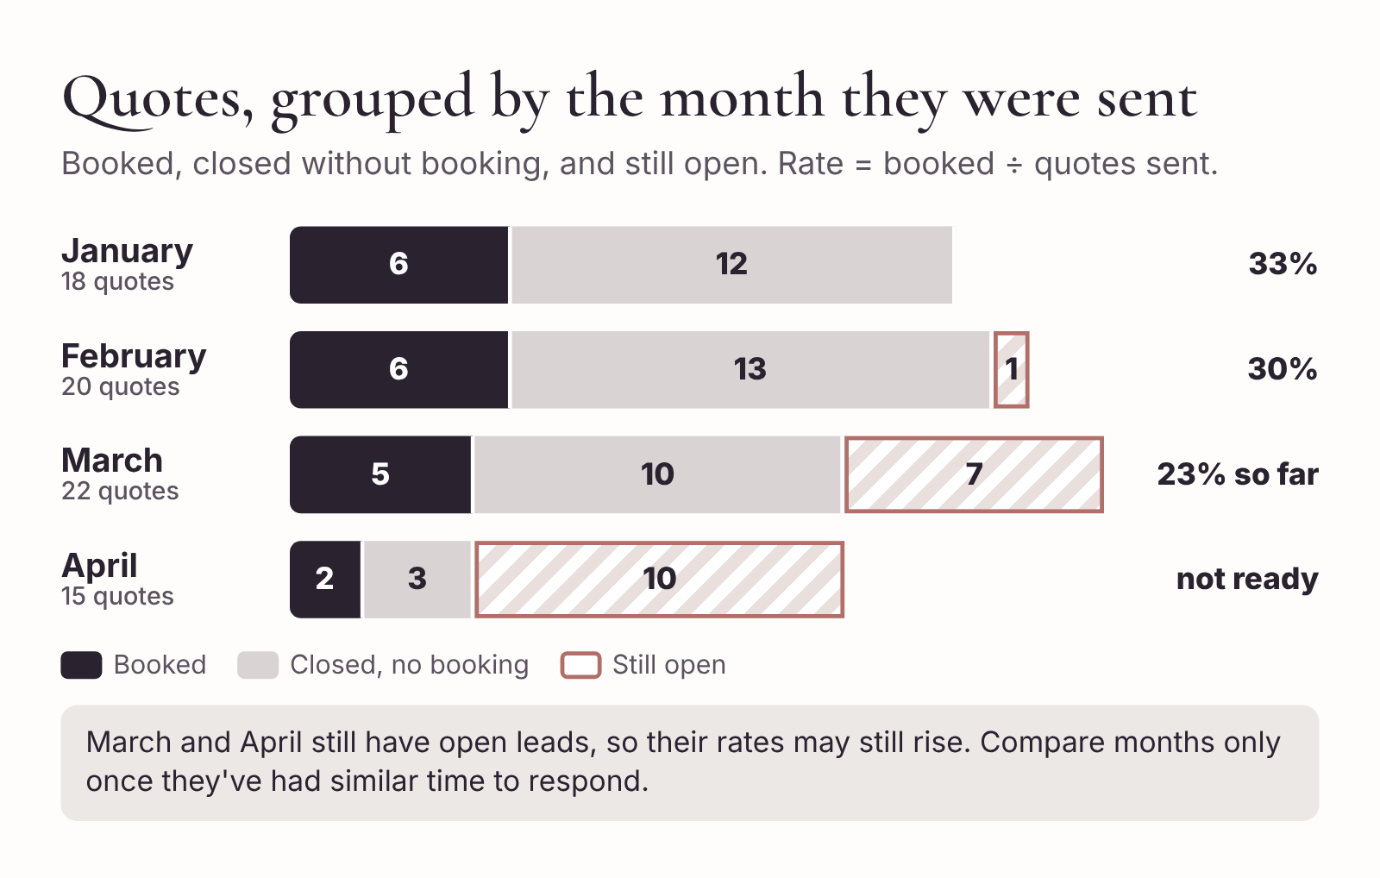
A monthly scorecard. Each bar is one month’s quotes, split by what happened to them. The newest month still has open leads, so it is not ready to compare.
Here’s a scorecard for the fictional studio’s first four months of the year, counted in quote cohorts:
Quotes sent in | Sent | Booked | Closed, no booking | Still open | Rate so far
January | 18 | 6 | 12 | 0 | 33%
February | 20 | 6 | 13 | 1 | 30%
March | 22 | 5 | 10 | 7 | 23% so far
April | 15 | 2 | 3 | 10 | not ready
March looks worse than January, but it has seven open leads. If two of those book, March will be at 32%, about the same as January. April is far too young to judge. The honest reading of this scorecard is “about one quote in three becomes a booking, and nothing has changed yet.” That’s a very different conclusion from “March was a bad month,” and it saves you from cutting your prices in a panic.
Do the same for inquiries, grouped by the month they arrived: how many reached a quote? Count dates you declined because you were already booked separately. They’re not lost leads. They tell you about your capacity, not your conversion. If you’re declining six or seven inquiries a month for peak Saturdays, that’s a sign you could bring in an associate, or charge more for those dates.

Building it in a spreadsheet
If your tracker is a spreadsheet, a few formulas do the counting for you. Add a column called “Quote month” that holds the month each quote was sent (for example, 2026-02). Then, in Google Sheets or Excel:
- Quotes sent in February: =COUNTIF(QuoteMonth, "2026-02")
- Booked from February’s quotes: =COUNTIFS(QuoteMonth, "2026-02", Status, "Booked")
- Still open from February: =COUNTIFS(QuoteMonth, "2026-02", Status, "Quote sent") plus the same for “Awaiting agreement” and “Awaiting deposit”
Replace QuoteMonth and Status with the actual column ranges in your sheet, such as F2:F500. If you’re not sure how, the AI is good at this: describe your columns (not your data) and ask it to write the formula.
If you’d rather not use formulas, count by hand from a filtered view once a month. Twenty minutes of counting is enough.

Using AI to read the numbers
Once you have the counts, you can ask the AI to calculate the rates and point out anything worth looking at. Give it only the counts. Never paste the tracker itself, because it contains your clients’ names.
Copy-ready prompt
Here are my bridal makeup inquiry and quote counts, grouped by month. For each month, calculate the inquiry-to-quote rate and the quote-to-booking rate. Treat any month with more than 20% of its leads still open as not ready to compare. Then list up to three observations, each based on a specific number. Don’t give general business advice.
[Paste a table of counts only]
Check the rates yourself with a calculator. They’re simple divisions, but it only takes one slip to send you chasing a problem you don’t have.

What to do with the numbers
The numbers are only useful if they change something. Here’s how to read them.
Inquiry-to-quote is low. People are dropping off between their first message and your quote. Look at your first replies: are you asking too many questions, or answering too slowly? Is your intake form asking for things that don’t affect the price? Try the five-question reply from Chapter 2 for a month and compare.
Quote-to-booking is low. People see your price and don’t book. Before you assume it’s the price, check the follow-ups. Are you sending a specific follow-up, or none at all? Are quotes clear about what’s included? Is the timing right, or are you quoting brides who are still nine months from choosing anyone? If it really is price, the scorecard gives you a way to test a change: compare the months before and after.
Declined dates are high. You’re turning work away. That’s a capacity question: rates for peak dates, a second artist, or a minimum spend for Saturdays in June.
Everything looks steady. That’s useful too. It means your process works and you can stop worrying about it, which is worth a great deal in the middle of wedding season.

Ten-minute action
Close the last wedding you did, using the six steps. If it was a while ago, at least do the money check and write your three lines of lessons.
Then set a monthly reminder in your calendar, for the first Monday of each month, called “Scorecard and brief.” Twenty minutes to count, ten to update your brief. That half hour is how this whole process keeps getting better without you thinking about it.

Appendix A: Copy-ready templates
Every template from the book, in the order you’ll use them. Copy them into your notes app, your booking system or a document you keep on your phone. Replace anything in square brackets with your own details, and keep the placeholders that should stay as placeholders until the moment you send.

A1. Studio brief
STUDIO BRIEF: [Studio name]
Version [number]. Last updated [date].
About [Two or three sentences: who you are, where you work, solo or team, who you serve, what you don’t offer.]
Services and approved rates [Service]: $[price]. Includes [what’s included]. [Minutes] minutes. [Repeat for every service, add-on and trial.]
Timing Setup: [minutes], starting when I have access to the actual makeup room. Buffer before ready-by time: [minutes] for up to [number] services; [minutes] for more. Maximum per artist per morning: [number] services. Earliest start: [time]. Earlier starts need my approval and carry [fee].
Travel (per artist) [Zone or distance]: $[fee]. [Zone or distance]: $[fee]. Over [distance]: I decide and quote personally.
Booking terms Minimum spend: [amount and when it applies]. Deposit: [rule]. It is applied to the total. A date is booked only when the agreement is accepted AND the deposit is verified in my payment system. Until then the date is not held. Quotes are valid for [number] days. Balance due [when]. Changes agreed before then are added to the balance. Services added after the balance is paid are paid on the day. Cancellations, refunds and changes are covered by the agreement. Do not summarize or explain them. Refer the client to the agreement.
Tone of voice [Eight lines or fewer. Length, formality, openings, sign-off, punctuation habits, words you use.] Never say: [list].
The AI may Use the rates and timings above. Calculate totals from them. Describe what’s included. Ask the intake questions. Draft a schedule and label it “proposed.” Write follow-ups. Reword my drafts.
Hand back to me (do not decide) Whether a date is available. Any discount, package or price not listed. [Travel limit]. [Early start limit]. Adding a second artist. Anything about refunds, cancellations or exceptions. Confirming that a booking is made, a change is agreed or a payment is received. Anything not covered here.
Privacy I use a lead ID and placeholders such as [Client first name]. Never ask for, and never include, full names, phone numbers, email addresses, venue addresses, photos, health or skin details, or payment details. If you need one of these to finish a draft, leave a bracketed gap.
When information is missing or contradictory Leave a bracketed gap and list the problem under the draft. Never guess a number, date, time, link or policy.

A2. Pre-send checklist
- Date. Right date, and calendar checked today?
- Numbers. Every price, total and deposit matches my rate sheet and my arithmetic?
- Promises. No hold, discount, time or confirmation I haven’t decided?
- Placeholders. Every bracket filled, name spelled correctly?
- Voice. Sounds like me?
- Thread. Right person, right conversation?

A3. Inquiry form
Wedding makeup inquiry
- What is your wedding date?
- Where will you be getting ready, and what time can suppliers get into the room?
- What time does everyone need to be makeup-ready? Is there an earlier photo, first look or departure time?
- How many people would like makeup, including you? Are any still undecided?
- Would you like information about a bridal trial?
Anything else you’d like me to know? (optional)

A4. First replies
Date open (DM, under 70 words)
Hi [Client first name]! Thanks for getting in touch. [Date] is currently open in my calendar. Could you tell me where you’ll be getting ready, what time everyone needs to be ready for photos, and how many people would like makeup, including you? Once I have those details I’ll check the timing and send you an itemized quote.
Date booked (email, under 90 words)
Hi [Client first name],
Thank you so much for thinking of me for your wedding. I’m already booked on [date], so I can’t take this one, I’m afraid. [Optional: My colleague [name] may be free. You can reach her at [contact].]
Wishing you a wonderful day,
[Artist first name]
Too uncertain to quote (DM, under 80 words)
Hi! Congratulations. My current rates are $[bridal rate] for bridal makeup and $[attendant rate] for each bridesmaid or family member, plus travel, which depends on where you’re getting ready. Once you have a date, send it over with your venue and how many people would like makeup, and I’ll check my calendar and send you an itemized quote.

A5. Tracker record
Lead ID and source. [Lead ID] · [Instagram / website / referral / other]
Received. [Date]
Event and schedule. [Wedding date] · [Services] · [Access time] · [Ready-by time]
Quote. [Version] · [Date sent] · [Brief version used] · [Total] · [Optional extras]
Booking checks. [Agreement accepted date] · [Deposit required] · [Amount verified and date] · [Balance and due date]
Changes. [Date] · [Change] · [Approved by and date]
Next action. [Action] · [Due date] · [Owner, if working as a team]
Status. New / Needs details / Quote sent / Awaiting agreement / Awaiting deposit / Booked / Declined / Closed

A6. Timing check prompt
Using the timings in my studio brief, check whether this wedding morning fits. Room access [time]. Everyone makeup-ready by [time]. [Number] artist(s). Services: [list]. Show the total minutes needed, the minutes available and the difference. Then lay out a proposed schedule with one row per appointment. Flag anything I need to confirm. Don’t change any timings from my brief.

A7. Quote prompt
Draft a friendly bridal makeup quote email in 150 words or fewer using only the details below. Use [Client first name] as the greeting. Make each service line and the travel charge easy to see. Show optional services separately. Describe the schedule as proposed. State that the booking is confirmed once the agreement is accepted and the deposit is verified. Leave any missing information in brackets. Flag contradictions separately. Do not invent fees, deadlines, links or policies.
Details: [Date]. [Each service with price and subtotal]. Travel $[fee]. Wedding-day total $[total]. Deposit $[deposit] applied to that total. Balance $[balance], due [when]. Optional [trial or extras] $[price], billed separately if booked. Proposed setup at [time], all makeup ready by [time], subject to [what needs confirming]. Quote valid for [number] days. Use [secure booking link] as a placeholder.

A8. Follow-up
Hi [Client first name], I wanted to see whether you had any questions about the makeup quote for [date]. If you’re deciding whether to include a trial, I’m happy to send a few dates. If the number of people has changed, let me know and I can update the quote and timings.
Second and final follow-up
Hi [Client first name], just a note that your quote for [date] is valid until [day]. After that I’ll need to check availability again before confirming the date. If you have any questions, I’m happy to help.

A9. Deposit checklist and confirmation
- Agreement. Accepted? Correct date, services and total?
- Payment. Received, not pending? Correct amount?
- Tracker. Agreement and deposit recorded in separate fields? Status updated?
- Calendar. Date blocked, with lead ID and ready-by time?
- Balance. Amount and due date recorded?
- Next action. Named and dated?
Hi [Client first name], your [date] bridal makeup booking is confirmed for [services]. I’ve received your agreement and your $[deposit] deposit. Your remaining balance is $[balance], due [when]. We’re working toward a [time] ready-by time, and I’ll share the final running order once [what’s outstanding] is confirmed. [Optional: If you’d like to book a trial, I can send you some dates.]

A10. Trial recap
Turn my trial notes below into a short recap email for the bride. Use three headings: “What we agreed,” “What I’ll adjust on the day,” and “What I’d like you to confirm.” Plain language she’ll understand. Keep every product name and decision exactly as written. Don’t add products, techniques or claims about longevity. If a note is undecided, put it under “What I’d like you to confirm.” If adding services would change the price, say so and use the rates in my brief. Under 200 words. Use [Client first name]. Then, separately, list anything in my notes that affects timing.
[Anonymised trial notes]

A11. Wedding-day look brief
WEDDING-DAY LOOK BRIEF: [Lead ID]
Version [number]. Updated [date].
Date and timing. [Date]. Room access [time]. Ready-by [time]. Running order: timeline version [number].
Services. [List, including add-ons and how each is paid.]
Bride’s look. [Eyes, liner, lashes, brows, cheeks, lips, finish. Your words.]
Base. See client record and face chart.
Attendants and family. [Bride’s guidance. Individual preferences, collected by (date).]
Touch-up kit for bride. [Items.]
Kit additions for this job. [Items.]
Open questions. [List, or “None.”]
Photos. Trial photos in client file [Lead ID].

A12. Wedding-morning worksheet
- Deadline. The earliest time anyone must be ready, confirmed with the person who set it.
- Buffer. From your brief, before the deadline.
- Services. Confirmed services and realistic minutes. A separate column for each artist.
- Setup. Unloading, walking in, setting up, counted from access.
- Feasibility. Calculated start compared with access. Hair and photography checked.

A13. Schedule prompts
Build a wedding-morning makeup timetable using the facts below. Work backward from [ready-by time]. Reserve [buffer minutes] before the deadline and [setup minutes] before the first appointment. Use these service lengths and constraints: [service IDs, durations, available artists, hair appointments, venue access]. Return one row per time block and artist. Flag early access requirements, gaps and overlaps. If the work does not fit, show how many minutes are missing and which changes I could discuss with the planner. Do not shorten any service. Keep all unconfirmed details in brackets.
Here are two schedules for the same morning: makeup and hair. Combine them into a person view: one row per person, showing their makeup time, their hair time and the gap between them. Flag any person who is booked in two places at the same time, or who has less than 5 minutes between appointments. Don’t move any appointments. Only report.
[Makeup schedule] [Hair schedule]

A14. Schedule release checklist
- Verify the math. Every service fits with the buffer intact. Sum checked by hand.
- Check the people. No person or artist in two places at once.
- Confirm the handoff. Room access, hair schedule and deadline confirmed with the people responsible.
- Version and date. On both copies.
- Share a simple version. Chair times, arrival instructions and a contact for lateness. Internal notes stay in the studio copy.

A15. Change request
CHANGE REQUEST: [Lead ID]
Requested by: [Who] on [date], via [channel]
The change, in one line: [ ]
Timing. Minutes needed now: [ ] Minutes available now: [ ] Short or spare: [ ]
Staffing. One artist still OK? [Yes / No]. If no: [second artist / earlier start / scope change]
Cost. Change: [+/- $].Newtotal:[$]. Deposit paid: [$].Newbalance:[$] due [date]
My decision. [Yes / Yes with conditions / No / Offer alternatives]
Client approval. [Name] approved in writing on [date]
Done. Tracker [ ] Agreement (if needed) [ ] Associate [ ] Hair [ ] New schedule version [ ] sent [date]

A16. Closeout checklist
- Money. Total owed matches total received, from payment records. Add-ons included. Associate settled.
- Thank-you. Sent within two days, with one specific detail.
- Review. Requested separately, with a link. No incentives.
- Portfolio. Permission asked separately from people in the photo and from the photographer. Answers recorded.
- Records. Tracker closed. Client files kept or deleted according to your policy. AI chats tidied.
- Lessons. Three lines written. Brief updated if needed.

A17. Monthly scorecard
SCORECARD: [Month]
Inquiries received in [month]: [ ] · Reached a quote: [ ] · Inquiry-to-quote rate: [ ]% · Declined (already booked): [ ]
Quotes sent in [month]: [ ] · Booked: [ ] · Closed without booking: [ ] · Still open: [ ] · Quote-to-booking rate so far: [ ]%
Ready to compare? [Yes / Not yet: more than 20% still open]
One thing I’ll change this month: [ ]
Brief updated? [Yes, version ( ) / No change needed]

Appendix B: Three practice bookings
Reading about a process is one thing. Running it on a booking where you don’t already know the answer is another. Here are three fictional bookings for the same studio as the rest of the book, using the studio brief from Chapter 1.
For each one, work through it before you read the answer. Do the timing first, then the price, then decide what you’d say. If you want to test your AI setup at the same time, give it the facts and the prompts from Appendix A and compare its answer with yours and with the worked answer.
The studio’s key numbers, so you don’t have to turn back:
- Bride $220 (60 min). Attendant or family $95 (40 min). Junior $50 (20 min). Attendant lashes $15 (adds 5 min). Trial $110.
- Setup 15 min. Buffer 20 min for up to 5 services, 30 min for 6 or more. Maximum 6 services per artist. Earliest start 6:00 a.m.
- Travel per artist: Zone 1 (to 25 miles) $40. Zone 2 (25 to 50 miles) $75.
- Wedding-day minimum $300 before travel. Deposit 25% of the wedding-day total, rounded up to the nearest $10.

Practice booking 1: The five-person bridal party
The inquiry. Lead L-061 arrives through your website form, complete. The wedding is on Saturday, May 16. The bride is getting ready at a farmhouse 35 miles from your studio. The room is available from 8:30 a.m. Everyone must be ready by 12:30 p.m. for photos. Makeup is for the bride, three bridesmaids and the mother of the bride. One bridesmaid would like lashes. The bride is interested in a trial. May 16 is open in your calendar.
Your task. Check the timing. Calculate the quote, deposit and balance. Decide what to say about anything that doesn’t fit.

Worked answer
Timing. Five services, so a 20-minute buffer.
- Setup: 15
- Bride: 60
- Four attendants and family at 40: 160
- Lashes for one bridesmaid: 5
- Buffer: 20
- Total: 260 minutes
The window from 8:30 to 12:30 is 240 minutes. You’re 20 minutes short. Working backward from 12:30, your latest arrival is 8:10.
This is the most common kind of problem, and it’s the reason the timing check comes before the price. It’s also very easy to fix at this stage. Before you quote, ask: “Could I get into the room at 8:00? I need a little more time than 8:30 allows for five people.” If the farmhouse agrees, the morning fits with 10 minutes to spare. If not, you’ll offer the options: earlier access elsewhere in the house, a second artist for part of the morning or a later ready-by time.
Price.
- Bride: $220
- Three bridesmaids and the mother of the bride at $95: $380
- Lashes for one bridesmaid: $15
- Travel, Zone 2: $75
- Wedding-day total: $690
Minimum: services are $615, above the $300 minimum.
Deposit: 25% of $690 is $172.50. Rounded up to the nearest $10, that’s $180. Balance: $510. The trial is quoted separately at $110.
What you’d send. Because the timing problem affects whether you can do the booking at all, you can either ask about access first and quote afterwards, or quote with the access condition written in. With a complete inquiry from a website form, quoting straight away keeps the momentum. Something like:
I’ve penciled in an 8:00 a.m. setup and a 12:30 p.m. finish. For five people I need to start a little earlier than 8:30, so could you check with the farmhouse whether I can get into the room at 8:00? If that’s not possible, I’ll suggest a couple of alternatives.
What the AI often gets wrong here. It may use Zone 1 travel ($40) because that’s the one it’s seen most often in your examples. It may calculate the deposit as $172.50 or round it to $170, rather than up to $180. And it may lay out a schedule that “fits” by starting at 8:30 and dropping the buffer to zero. If yours did any of these, add a line to your brief: “Always state which travel zone you used. Always show the deposit calculation.”

Practice booking 2: The bride-only elopement
The inquiry. Lead L-062, by email. The bride is eloping on a Thursday, July 9, at the city hall, with two witnesses. She’s getting ready at a hotel 12 miles away. The hotel room is hers from 11:00 a.m. and she needs to be ready by 1:00 p.m. Makeup is for her only. No trial; she says she knows what she likes. July 9 is open.
Your task. Check the timing. Calculate the quote. Think about how to explain anything that might surprise her.

Worked answer
Timing. One service, so a 20-minute buffer. Setup 15, bride 60, buffer 20: 95 minutes. The window is 120 minutes. You have 25 minutes to spare. You could arrive at 11:15 and still finish comfortably, or arrive at 11:00 and give her a slower, calmer start.
Price. Bridal makeup is $220. But the wedding-day minimum is $300 before travel, so the services are charged at $300. Add Zone 1 travel of $40. Wedding-day total: $340.
Deposit: 25% of $340 is $85. Rounded up to the nearest $10: $90. Balance: $250.
Explaining the minimum. This is the part that needs care. A bride who has seen “$220 for bridal” on your price list will be surprised by a quote that says $300. Explain it once, plainly, and don’t apologize for it:
Bridal makeup is $220. For wedding-day bookings I have a minimum of $300, which covers the time I set aside for the day, so the makeup total for your elopement is $300, plus $40 for travel.
A decision you might offer. With $80 of the minimum unused, some artists would offer something in that space. Makeup for one of her witnesses is $95, which would bring the services to $315 and use the time well. Whether to suggest it is a decision, not a rule, so it’s not in the AI’s job. If you decide to offer it, write it in yourself:
If either of your witnesses would like makeup too, that’s $95, and your total would be $355.
That’s $315 of services plus $40 travel. The deposit on $355 would be $88.75, rounded up to $90, the same as before.
What the AI often gets wrong here. The most common mistake is to ignore the minimum and quote $260 ($220 plus $40). The second is to apply the minimum to the total including travel and quote $300 flat. Your brief says “$300 before travel,” so the correct figure is $340. If the AI gets this wrong, make the minimum a line it has to check: “Always check the wedding-day minimum and state whether it applies.”

Practice booking 3: The two-artist wedding with a late venue opening
The booking. Lead L-063 booked in January for Saturday, September 19. The bride and seven bridesmaids want makeup. The getting-ready venue is a hotel 20 miles away. Room access was 8:00 a.m. and everyone must be ready by 12:00. Because there are eight services, you quoted two artists: you and your associate. The booking is confirmed.
Three weeks before the wedding, the planner emails: the hotel has a breakfast event in the suite and can’t release it until 8:30.
Your task. Work out what the booking cost and how the two artists’ work was split. Then work out what the late opening does, and what you’d offer.

Worked answer
The original price.
- Bride: $220
- Seven bridesmaids at $95: $665
- Travel, Zone 1, two artists at $40: $80
- Wedding-day total: $965
Deposit: 25% of $965 is $241.25, rounded up to $250. Balance: $715.
The original split. Eight services means a 30-minute buffer for each artist. The bride stays with you.
- You: bride plus three bridesmaids, 180 minutes of services. Setup 15, services 180, buffer 30: 225 minutes. From 8:00 to 12:00 is 240. Fits, with 15 to spare.
- Associate: four bridesmaids, 160 minutes. Setup 15, services 160, buffer 30: 205 minutes. Latest arrival 8:35. Fits.
The late opening. With access at 8:30 the window is 210 minutes.
- You: you need 225. You’re 15 minutes short.
- Associate: she needs 205. She still fits, with 5 minutes to spare.
Notice that the problem is only in your column. That changes the options.
Option 1: Rebalance. Move one bridesmaid from you to your associate. You’d have the bride and two bridesmaids: 15 + 140 + 30 = 185 minutes, which fits. But your associate would have five bridesmaids: 15 + 200 + 30 = 245 minutes, which is 35 minutes too long. Rebalancing doesn’t work here.
Option 2: Early access for one artist. Ask the hotel whether one person can start at 8:15 in a different room, such as a spare bedroom, or the bride’s own room. You’d need 15 minutes. That’s a small request, and hotels often say yes to one supplier with a small kit. No extra cost.
Option 3: A third artist for one service. If no early room is available, a third artist could take one bridesmaid. You’d have the bride and two (185 minutes, fits), your associate keeps four (205 minutes, fits), and the third artist does one service: 15 + 40 + 30 = 85 minutes, arriving by 10:35. The cost to the client is an extra $40 travel fee, making the total $1,005 and the balance $755.
Option 4: Talk to the photographer. If the bride could be ready at 12:15 while the bridesmaids stay at 12:00, your column might fit without any other change. Worth asking, though it depends on the photographer and the order of the day.
What you’d send. Lead with the free option, and show you’ve already done the work:
Hi [Planner], thanks for letting me know about the 8:30 opening. My associate’s schedule still fits, but mine is 15 minutes short, so I want to solve it now. The simplest fix would be for me to start at 8:15 in any other room, even a spare bedroom. Could you ask the hotel? If that’s not possible, I can bring a third artist for one bridesmaid, which would add $40 for travel. I’ll wait to hear from you before changing anything.
Then record it on a change request form (Appendix A), so that whichever option you agree is approved in writing before you send version 2 of the schedule.
What the AI often gets wrong here. Asked to “fix the schedule for the 8:30 opening,” a chat tool will usually rebalance the services evenly and present a plan that looks tidy. Check it against the sums: an even split puts your associate 35 minutes over. It may also shorten the buffer to 15 minutes “to make it work.” Ask instead for the minutes needed and available for each artist, and decide the fix yourself.

Appendix C: Troubleshooting
Sooner or later an AI draft will go wrong in a way that matters. Most of the problems fall into a handful of patterns, and each has a quick fix for the draft in front of you and a longer-term fix for your brief or your prompts. This appendix covers the three you’ll meet most often, then a few smaller ones.

When an AI draft invents a price
What it looks like. A quote or reply contains a figure you didn’t give it. Bridal at $180. A “travel fee of $1 per mile.” A “10% discount for parties of six or more.” Sometimes it’s subtle: your attendant rate is $95, but the draft says “from $95,” which suggests some services cost more.
Why it happens. The tool fills gaps with whatever is most likely. If your brief doesn’t cover a situation, or the conversation has gone on long enough that the brief has drifted out of its attention, it reaches for typical industry prices.
Fix the draft. Don’t edit the number and send. Check every other number too, because a draft with one invented figure may have more. Then regenerate it with a tighter instruction: “Use only these figures: [list]. If any figure you need isn’t here, leave a bracket.”
Fix it for next time.
- Make sure every service you sell is in your brief with a price. If you sometimes do something that isn’t listed (a tattoo cover, a male groom’s grooming), add it or add “Not offered.”
- Add this line to your brief if it isn’t there: “Never invent, estimate or round a price. Use only the rates above.”
- Start a fresh conversation for each quote. Long conversations are where most invented figures come from.
- Calculate the total yourself before you prompt, and give it the total. Then any difference jumps out at you.

When an AI draft confirms a date too early
What it looks like. “You’re all booked!” “I’ve reserved October 10 for you.” “Your date is secured.” “Consider it done!” Any wording that tells the client the date is hers before you’ve checked the agreement and the payment yourself.
Why it happens. The tool is trained to be helpful and positive. When a client says “I’ve paid,” the most helpful-sounding reply is a confirmation. It has no way of checking your payment system, so it takes the client’s word.
Fix the draft. Replace any confirmation wording with the holding reply:
Thank you! I’ll check the agreement and payment on my side and send your confirmation as soon as both are through.
If the message has already gone out, act quickly. Check your records. If both are in, there’s no harm done. If not, send a short, friendly correction: “Just to clarify my last message, I haven’t yet received the [deposit / signed agreement]. As soon as I have, I’ll confirm your date.” It’s awkward, but much less awkward than the alternative, which is a client who believes she’s booked a date that you’ve given to someone else.
Fix it for next time.
- In your brief: “Never state that a booking is confirmed, a date is held or a payment is received. I will tell you when it is.”
- Never draft a confirmation until you’ve run the deposit checklist. Make it a habit to open your payment system before you open the AI.
- Watch for the words “reserve,” “hold,” “secure,” “lock in” and “all set.” Cut them from any draft sent before a booking is confirmed.

When a schedule has overlapping appointments
What it looks like. The schedule looks tidy, but a bridesmaid is in your chair from 8:25 to 9:05 and in the hair chair from 8:45. Or your associate’s setup starts before she arrives. Or a row ends at 9:15 and the next starts at 9:10. Or the totals add up only because a 40-minute service has become 35 minutes.
Why it happens. Chat tools are weaker at keeping track of time across several people than they are at writing. They’ll often produce a schedule that’s correct row by row but impossible when you look at a single person’s morning.
Fix the draft. Don’t patch individual rows. Go back to the five-step worksheet from Chapter 5 and do the sum by hand. Then ask the AI for the person view, with the instruction “Don’t move any appointments. Only report.” Resolve clashes yourself, with the hair stylist where needed.
Fix it for next time.
- Always include “Do not shorten any service” and “Do not change the buffer” in your schedule prompts.
- Ask the AI to show the total minutes needed and available before it lays out the schedule. If its totals don’t match yours, stop there.
- For two-artist or two-team mornings, build each artist’s column separately, then combine. It’s easier for you and for the tool.
- Never send a schedule to the bridal party until you’ve done the person check yourself. This is the one step in the book that should never be skipped.

Smaller problems
The draft is too long or too gushing. Add a word limit to every prompt (“under 70 words”) and put your “Never say” list in your brief. If a draft is still overwritten, ask: “Cut this by half. Keep every fact.”
The draft mixes up details from another booking. This happens in long conversations, or when you’ve discussed two leads in the same chat. Start a fresh conversation for each booking task, and use the lead ID in every prompt.
The tool won’t do the arithmetic, or does it wrong. Do the arithmetic yourself (you should be anyway) and give the tool the results. Its job is to present your numbers clearly, not to calculate them.
The draft sounds like everyone else’s. Add three real messages you’ve sent to your brief as examples of your voice, with names removed. Ask the tool to match them. Then edit the first line and the last line of every draft yourself. Those are the lines clients notice most.
A client’s message looks AI-written, and it’s confusing. It happens. Long, formal messages with lots of headings, from a client whose earlier messages were short and chatty. Ask the AI to summarize what the client is actually asking for, in one line per request. Then reply to those requests, in your own short style.
The tool refuses or adds a disclaimer. Some tools are cautious about anything that sounds like legal or financial advice. If it won’t draft something about your terms, that’s a good sign it shouldn’t: refer the client to your agreement instead.
You’ve pasted something you shouldn’t have. It happens to everyone once. Delete the conversation, check your tool’s data settings, and if the information was sensitive (health details, payment details), think about whether your data protection obligations mean you need to do anything more. Then make your placeholder habit stronger, so it doesn’t happen again.

A last word: the artist in the loop
At no point in this book has the AI made a decision.
It wrote Amara’s first reply, but you checked the calendar. It drafted her quote, but you did the arithmetic and noticed the morning had no slack. It turned your trial notes into a recap, but you knew which shimmer she meant. It flagged that her mother’s makeup and the earlier portraits added up to a morning 70 minutes too long, but you were the one who messaged Nadia, chose what to offer, and asked Amara to approve it in writing. On the morning itself, the AI wasn’t there at all. You were.
That’s the right way round. The tools will keep getting better. They’ll get faster, they’ll get better at arithmetic and they’ll connect to more of your calendar and your booking system. But a bride doesn’t book you because your emails arrive quickly. She books you because she trusts you with her face on one of the most photographed days of her life, and with her mother, her sister and her best friends. Trust comes from the commitments you keep: the price you quoted, the time you promised, the look you agreed.
So let the AI take the typing. Keep the promises for yourself.
And the next time a message arrives at 11:40 p.m. asking, “Are you free October 10? It’s me and maybe four others,” you’ll know exactly what to do. Check the calendar. Ask for what changes the price and the time. Then go to sleep.

A small request
If this book has saved you a few hours, or a wedding morning, I’d be grateful if you left an honest review wherever you bought it. Even a sentence helps other artists decide whether it’s worth their time.
And if you know an artist who’s answering DMs at midnight, pass it on.

About the author
Muhammad Waqas is the author of The Archer and the Wind: How to Keep Going When Hard Work Isn’t Enough. AI for Bridal Makeup Artists is built on a simple idea: the artists with the calmest wedding mornings aren’t the fastest typists. They’re the ones who decided in advance exactly what they would and wouldn’t promise, and who use new tools to keep those promises, not to make new ones.

