Design Document

**Project: Book Booth**

**Group members:**

Waqas Javed: 33784

Ali Ariz :35467

Hamna Asif : 34822

**Brief Introduction:**

The Book Booth is a website solution for sale/purchase of Old books. The website helps in connecting sellers to buyers .The aim of this project is to provide hard copy of the book at best price and let books easily available to all. Seller and Buyer shall be connected through the website and then they can proceed the transaction by physically meeting or other methods they agreed on. The transfer of book and money shall be the responsibility of seller and buyer respectively.

# **Scenario Diagram:**

# Registration:

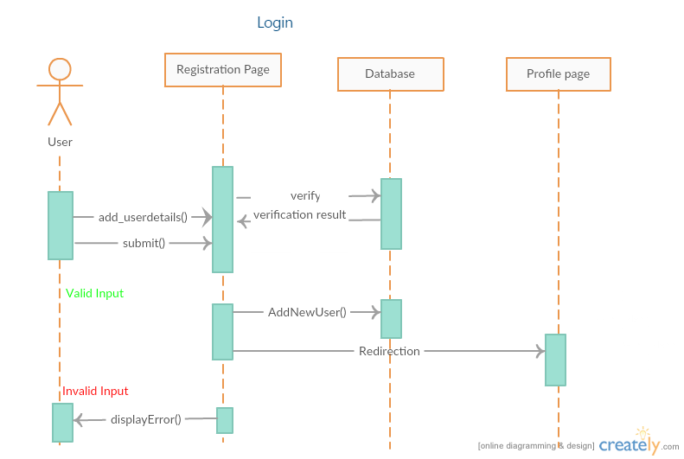

# Login:

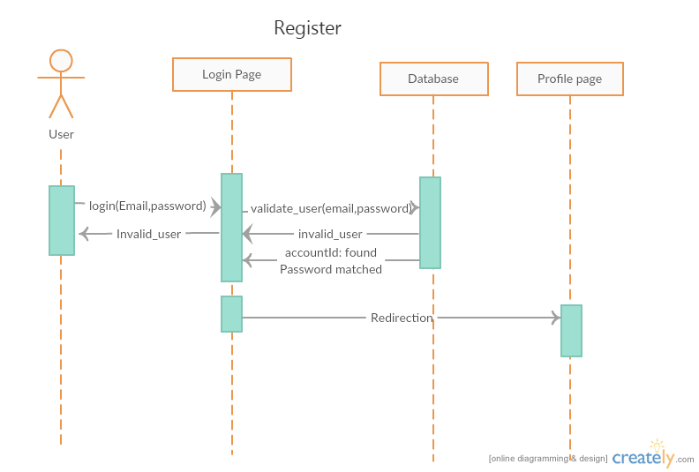

# Add Book:

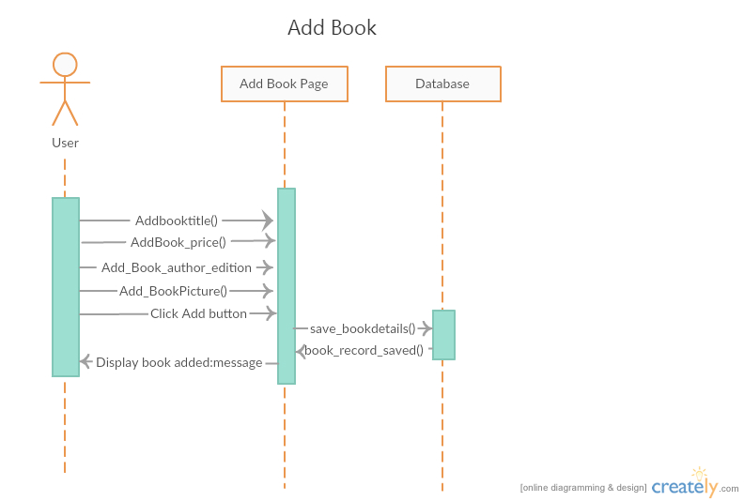

# Add Profile Details:

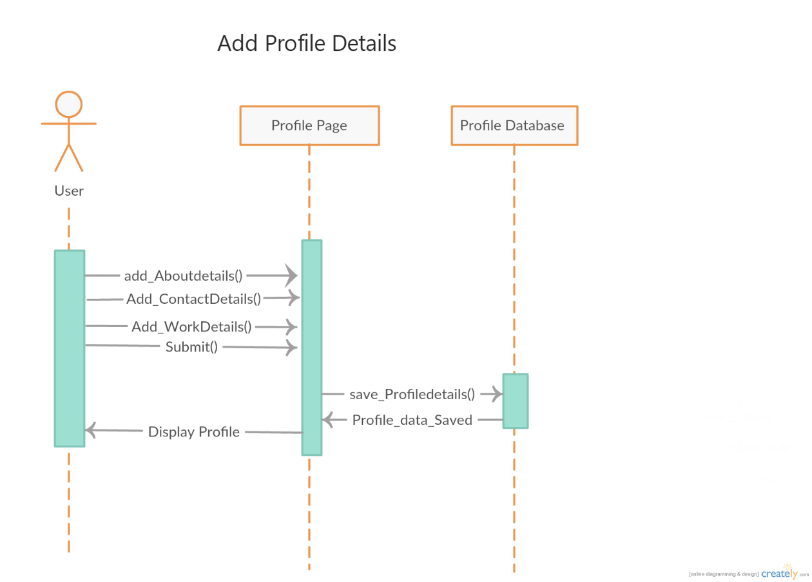

# Edit Profile Details:

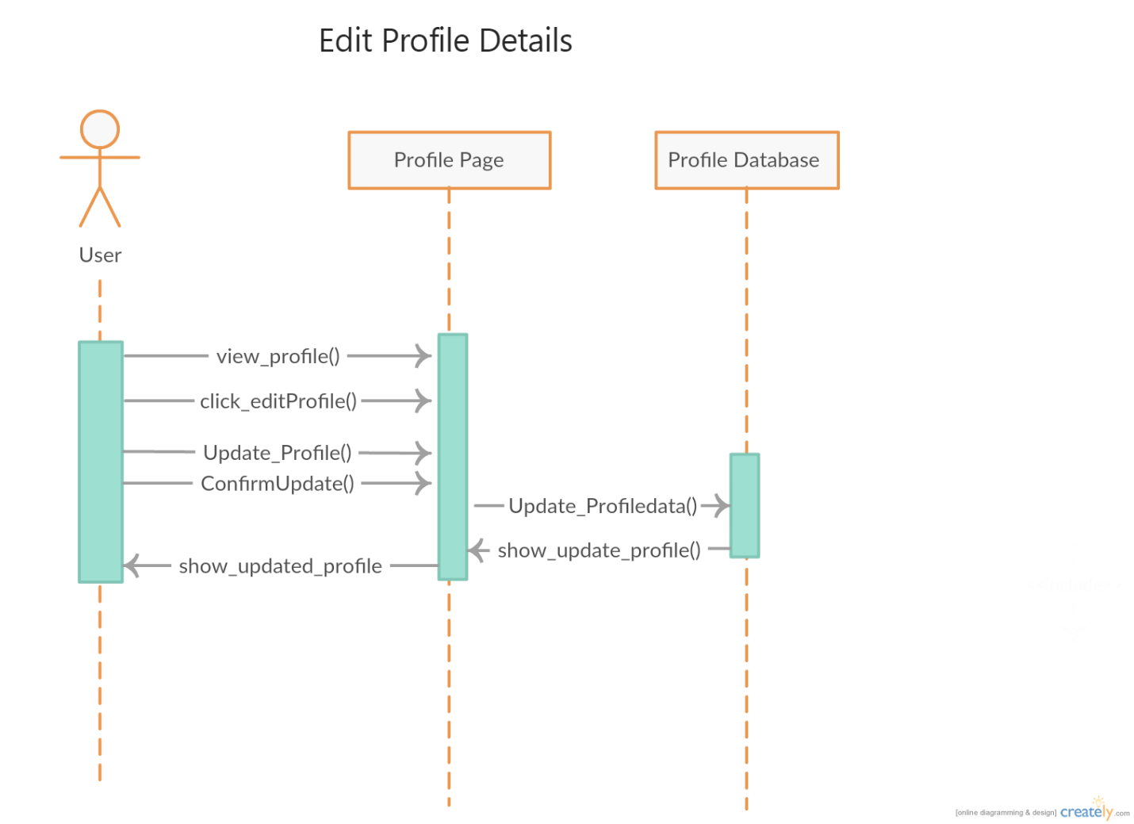

# Search Book:

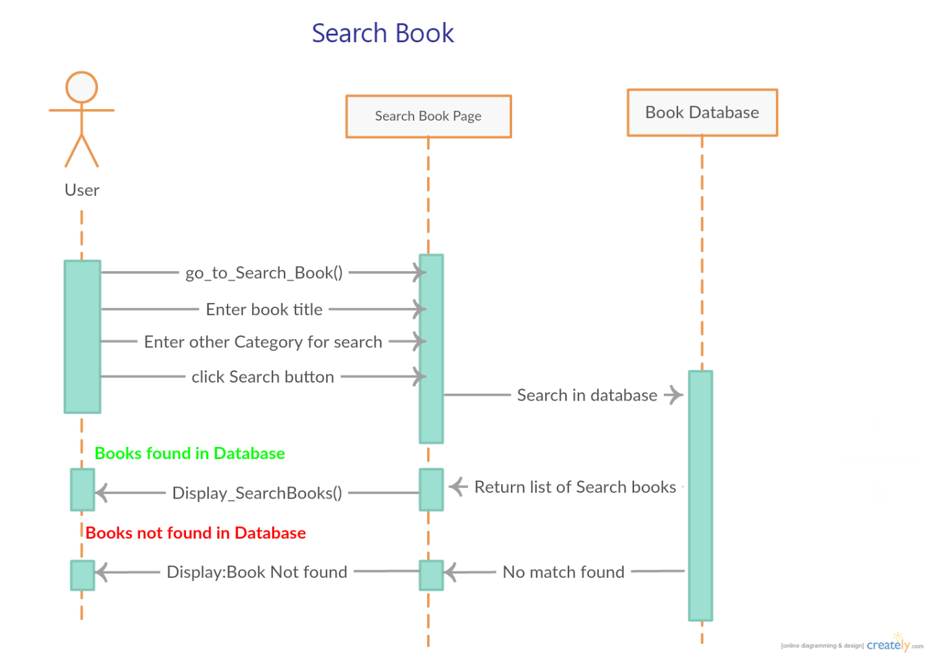Search Profile:

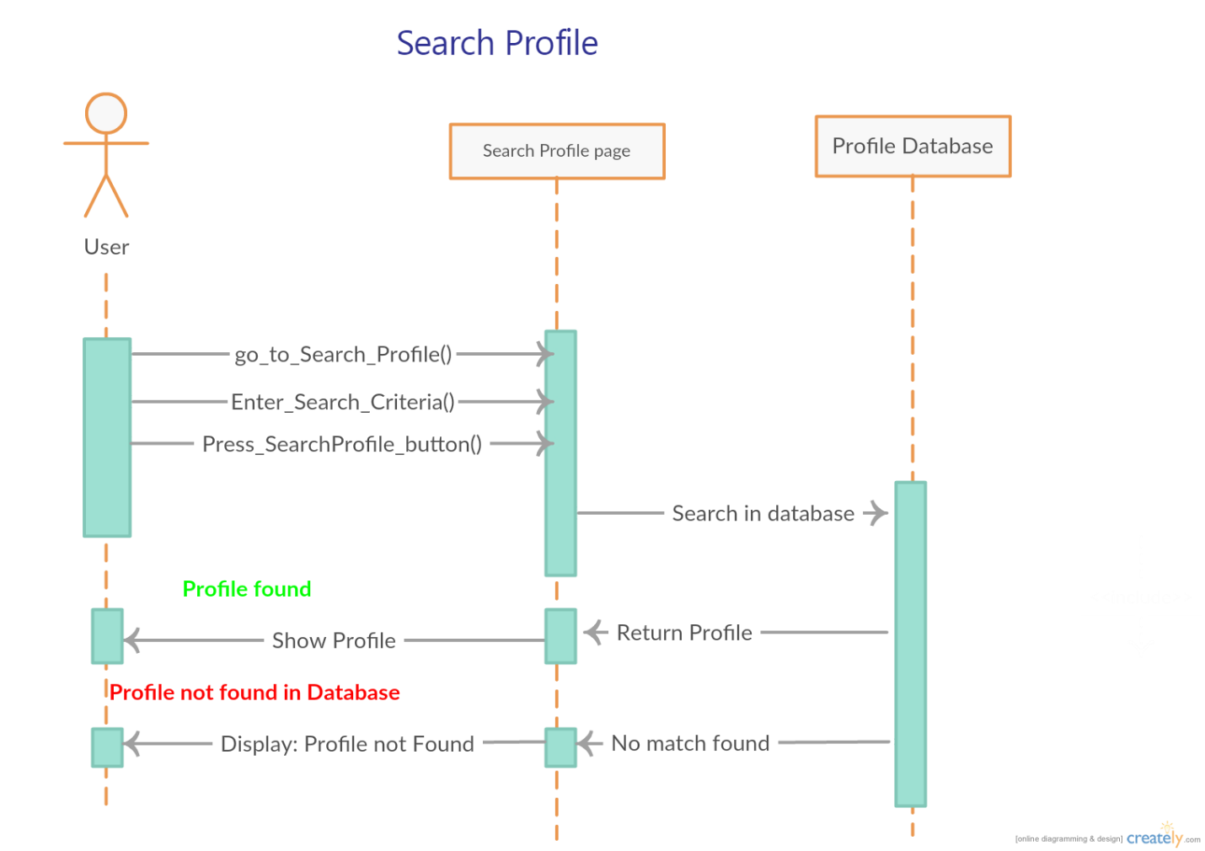

# Add friend:

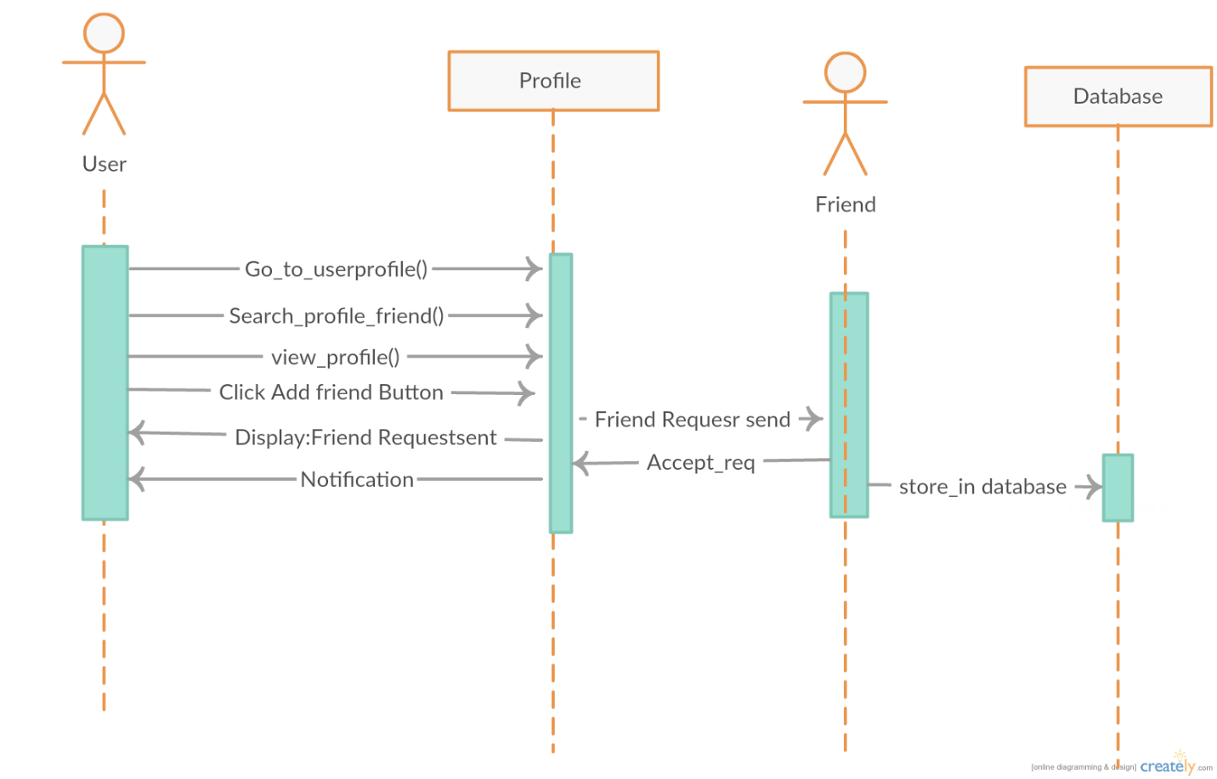

# View Profile**:**

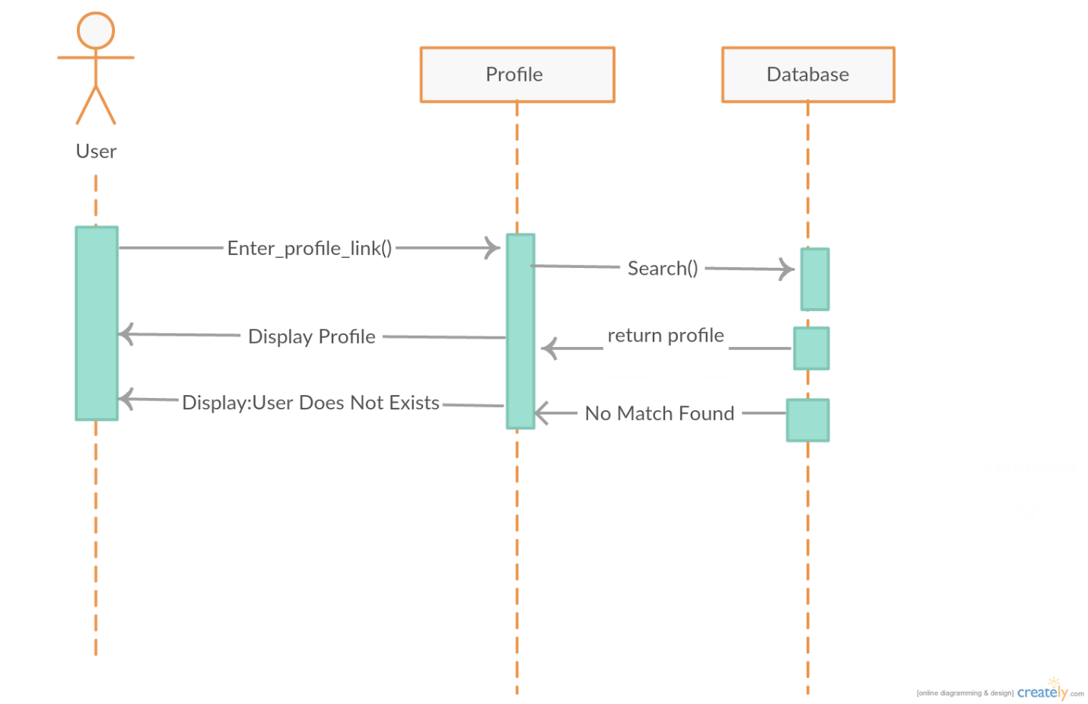

# Mark books As Sold

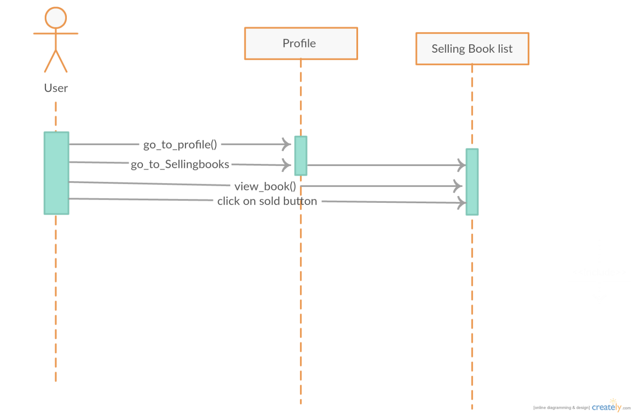

# Send Message to a friend

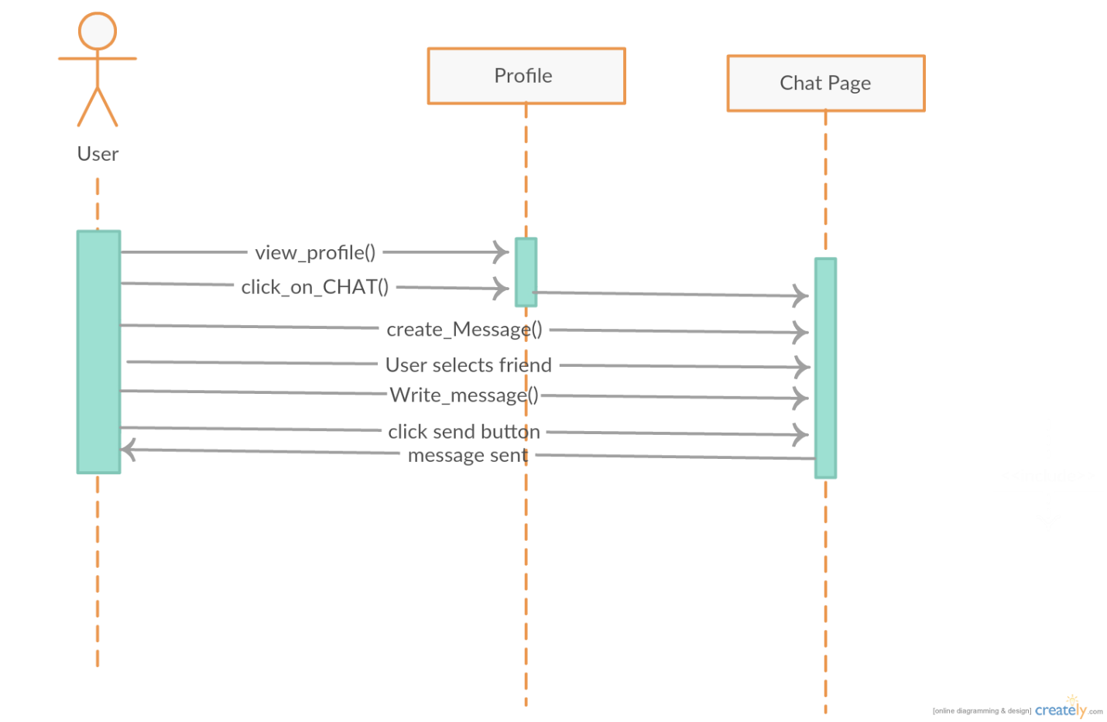

# Block Profile

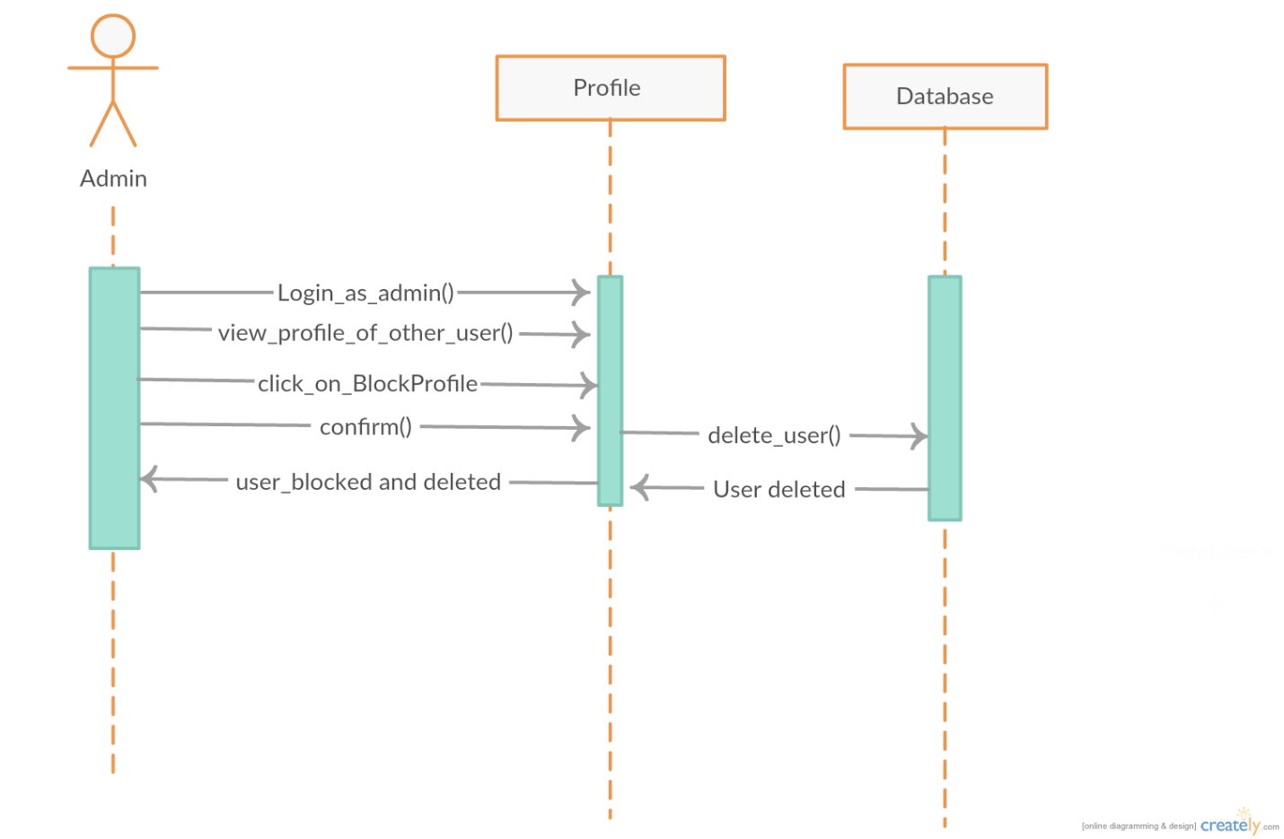

# **Class Diagram:**