Ap Assignment

Waqas Javed(33784)

## Analysis

Dictionary loading + Parsing + sorting take time = 2sec Approx.

Total Words in Dictionary = 86034

Graph of all words: 12 Min for 1.7 GHZ processor

Finding all chain(May take much time)

Statistics for upto two letter only:

Time to find graph:0.03 secs

Time to find all chain: 15 secs

Total words with no chain: zero

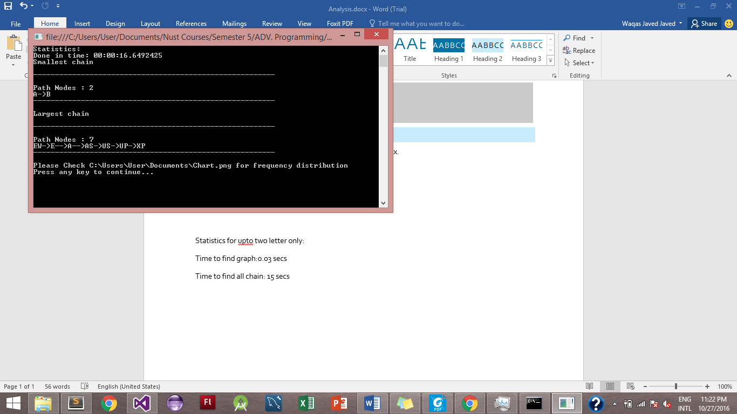

Frequency Distribution:

