Cloud Computing (Lab 4)
Name : Sarosh Majeed
Reg no : 2023-BSE-059

Task 1 – Verify VM resources in VMware
Confirm the VM resources that were allocated in Lab 1.
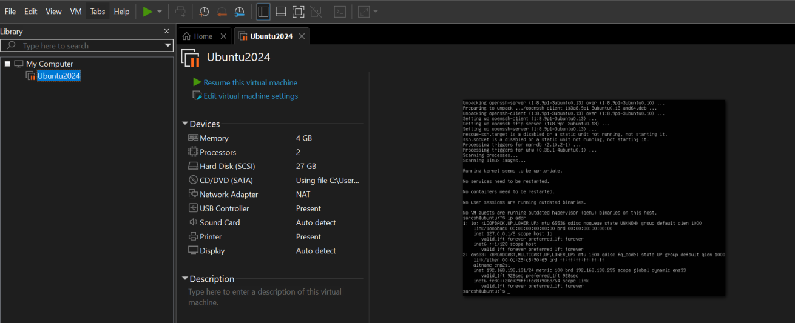
Open VMware Workstation and locate the Ubuntu Server VM you used in Lab 1. Inspect VM settings and note the following (no commands required for GUI): VM name, RAM, CPU, disk, and network adapter type. Take a screenshot of the VM settings window showing RAM, CPU, disk and networking.

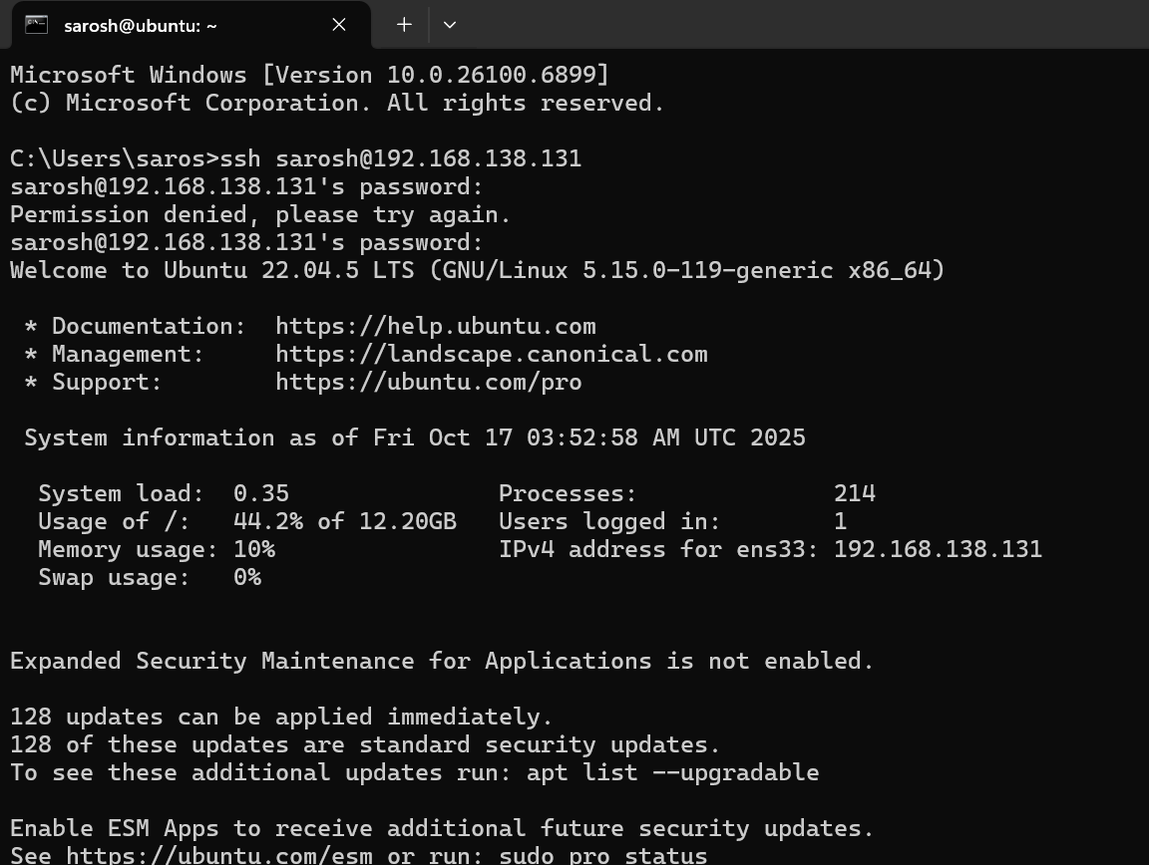
Task 2 – Start VM and log in (use your preferred host terminal method only)

Use a single preferred host-terminal method to connect to the VM. Do not switch between methods during the task. Start (or resume) the VM in VMware Workstation on your host.
From your host, open your preferred terminal (for example: Windows Command Prompt, PowerShell, macOS Terminal, or Linux Terminal) and connect to the VM using SSH. Example:
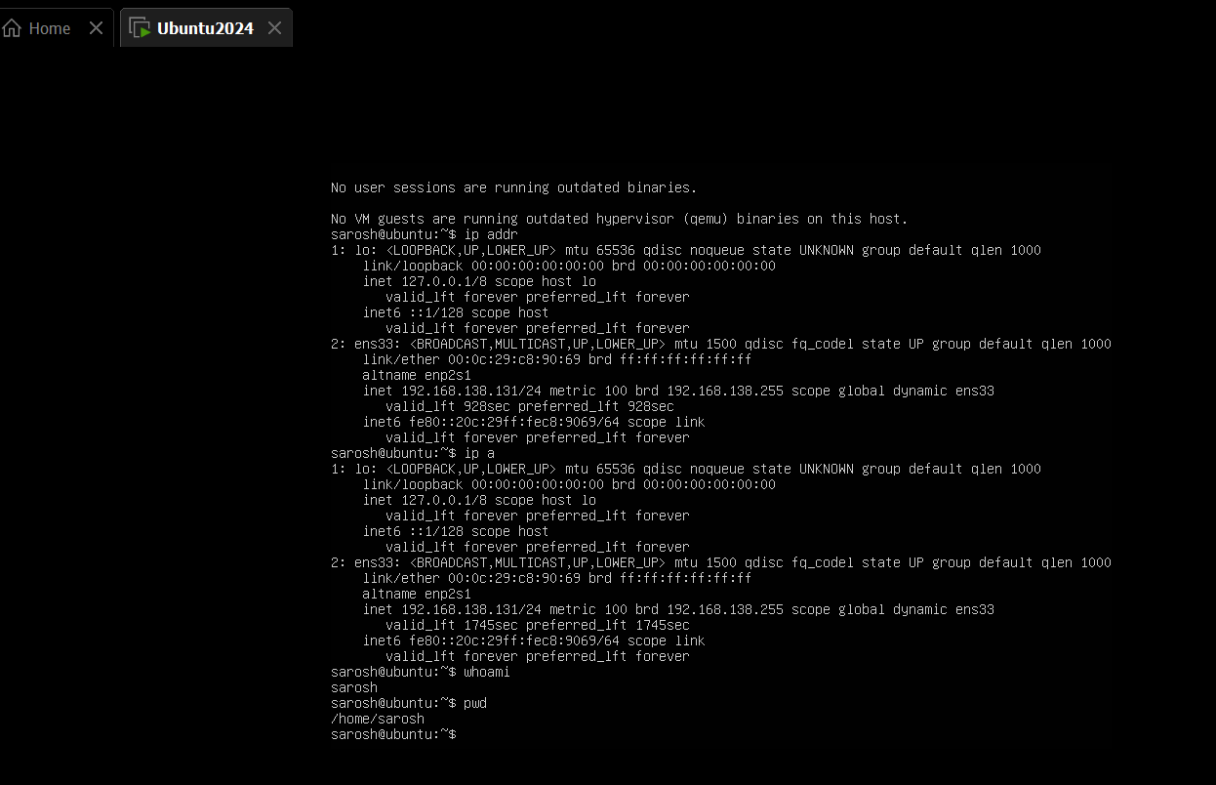
ssh student@<vm-ip-address>

Task 3 – Filesystem exploration — root tree and dotfiles
Explore Linux filesystem layout and hidden files. Capture outputs using screenshots only (do not create text files). For the short explanation required in this task, write the paragraph in an editor and capture it as a screenshot (answers_md.png) — do not supply the .md file.
Steps (run inside VM terminal)

List root directory contents:
ls -la /
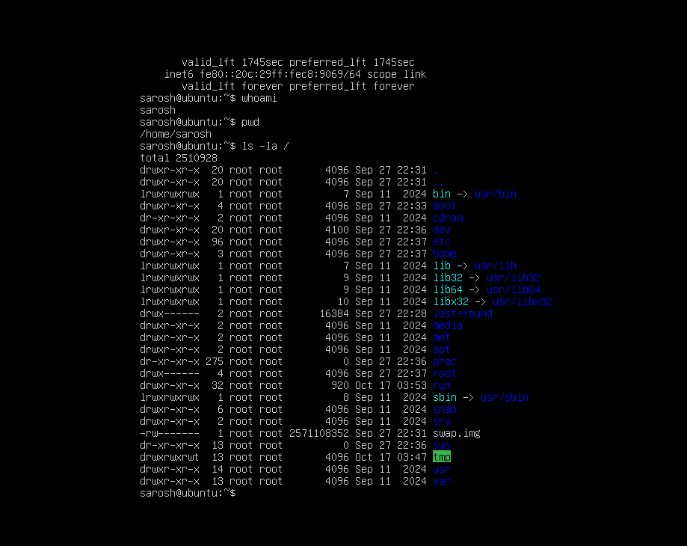

View OS release information:
cat /etc/os-release
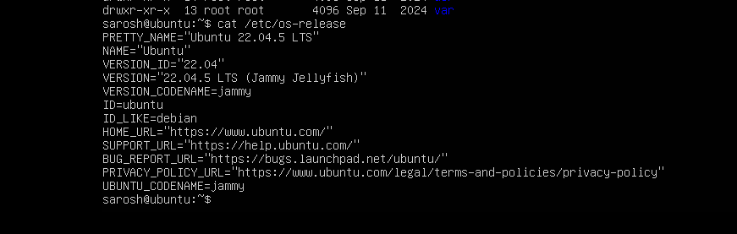

Inspect these directories (run each command and screenshot the output):
ls -la /bin

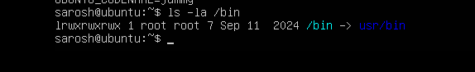

ls -la /sbin

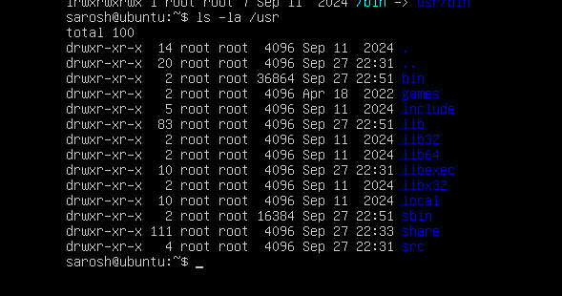
ls -la /usr

ls -la /opt
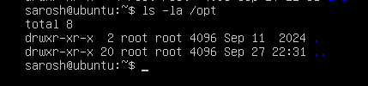

ls -la /etc

ls -la /dev
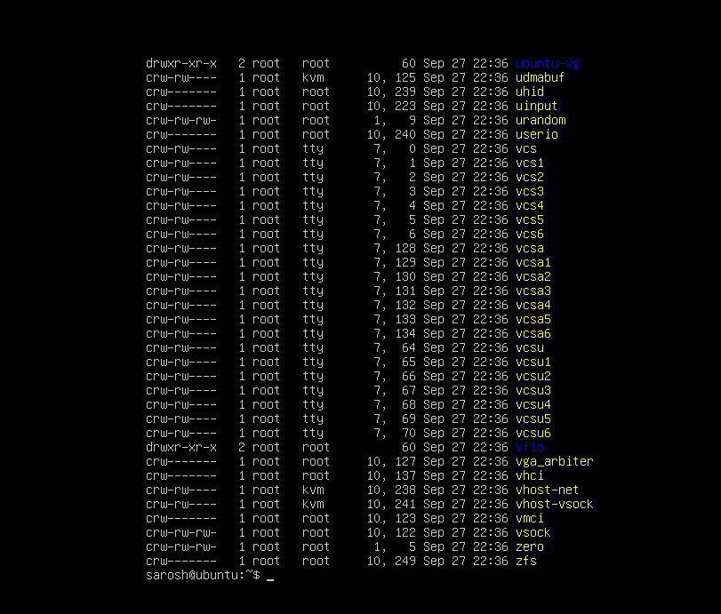

ls -la /var
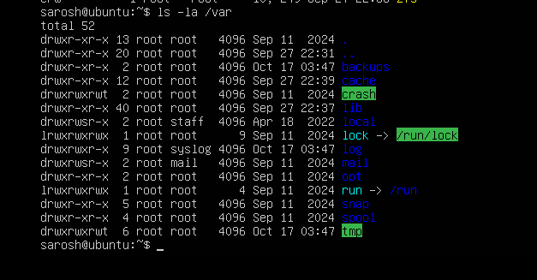

ls -la /tmp

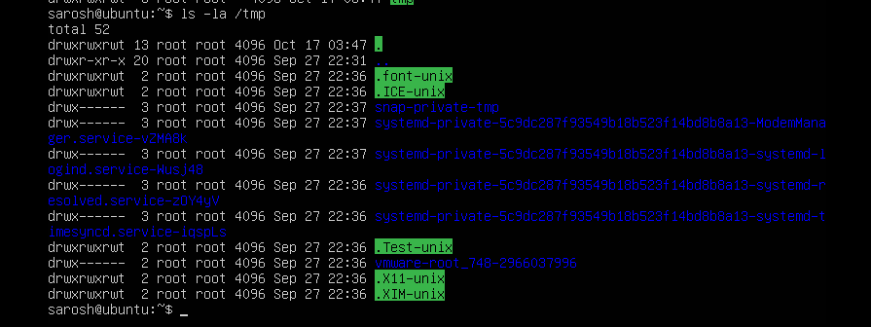

List your home directory and show hidden (dot) files:
ls -la ~
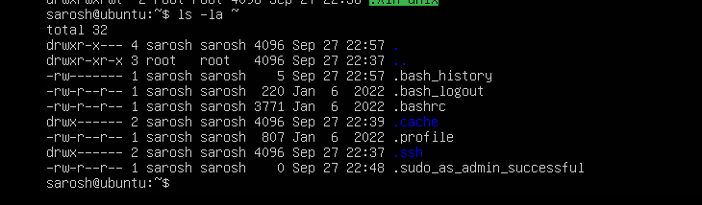

Write a short paragraph (3–5 sentences) that explains the difference between /bin, /usr/bin and /usr/local/bin. Open your editor:
nano ~/answers.md
Type the paragraph in the editor, save and exit.
After saving, open the editor display (or show the file) and capture a screenshot of the paragraph.
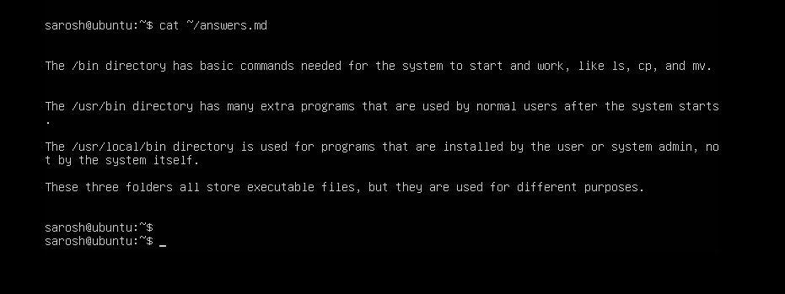
Reminder: Do not upload the .md file—submit the screenshot answers_md.png as proof of your written answer.

Task 4 – Essential CLI tasks — navigation and file operations

Steps (inside VM terminal)
Create a workspace and navigate:
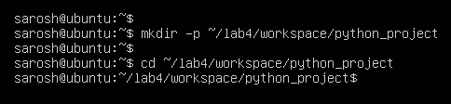
mkdir -p ~/lab4/workspace/python_project

cd ~/lab4/workspace/python_project
pwd
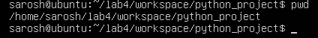

Create files using an editor (open each editor session and save a screenshot showing content):
nano README.md and Inside nano add: Lab 4 README and save.
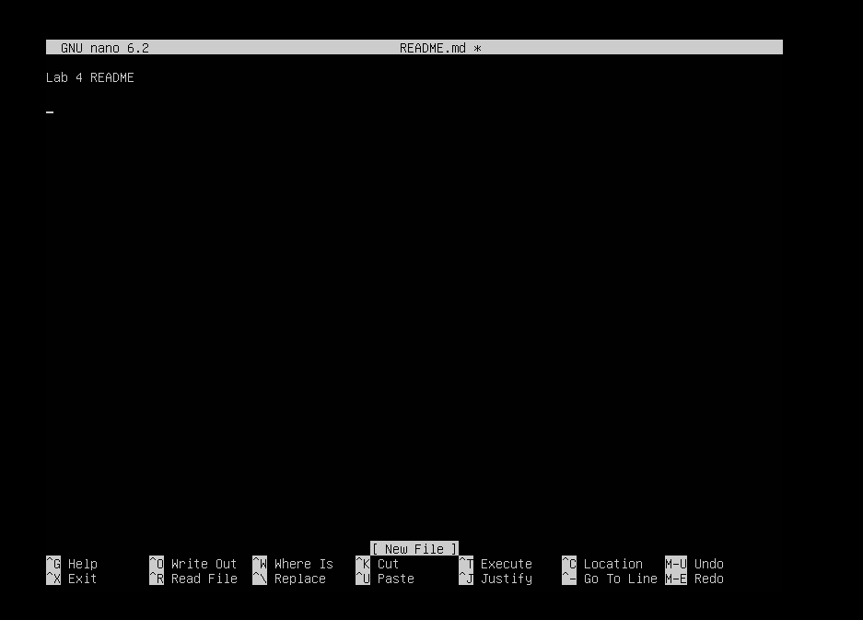

nano main.py and Inside nano add: print("hello lab4") and save.
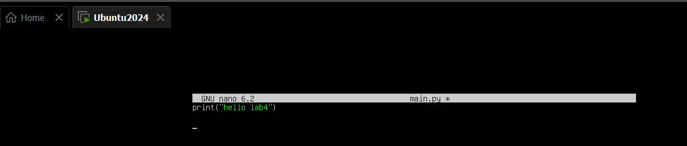
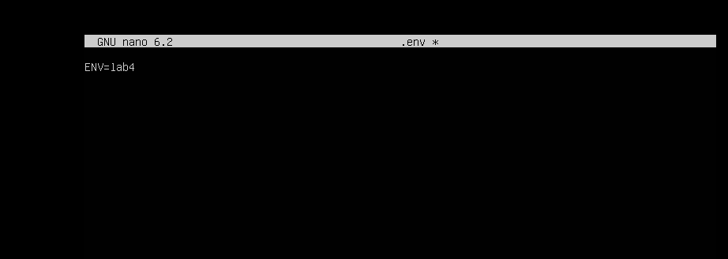
nano .env and Inside nano add: ENV=lab4 and save.

List files and capture:
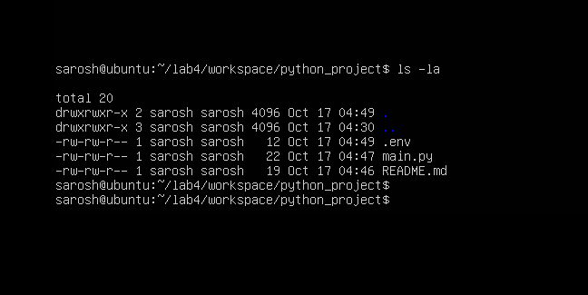
ls -la

Copy, move and remove: cp README.md README.copy.md and mv README.copy.md and README.dev.md
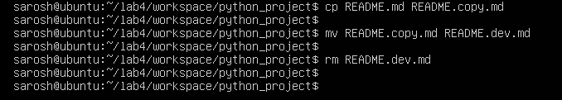

mkdir -p ~/lab4/workspace/java_app
cp -r ~/lab4/workspace/python_project ~/lab4/workspace/java_app_copy

ls -la ~/lab4/workspace
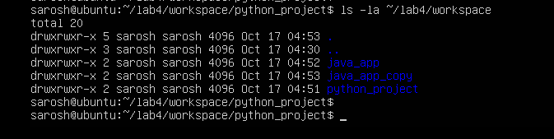

Use command history and tab completion:
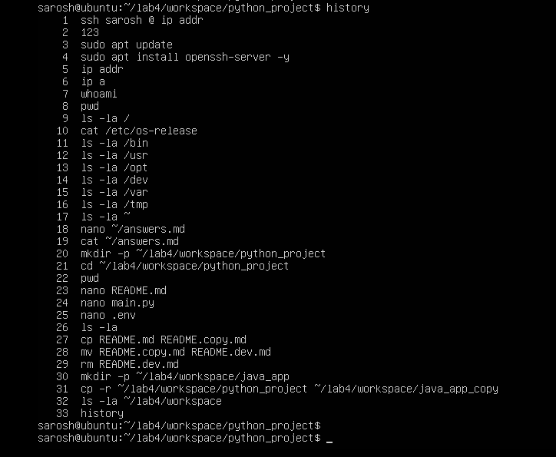
history

tab_completion
Task 5 – System info, resources & processes
Steps (inside VM terminal)
Kernel and OS: uname -a
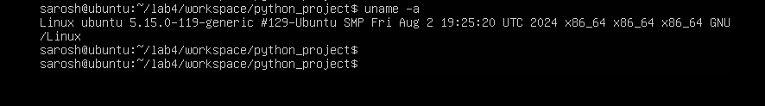

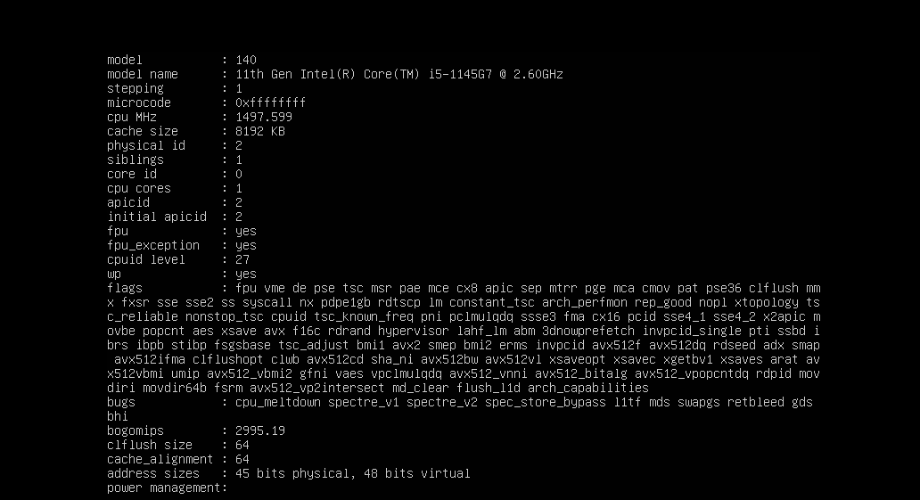
CPU (ensure model name visible): cat /proc/cpuinfo

Memory: free -h
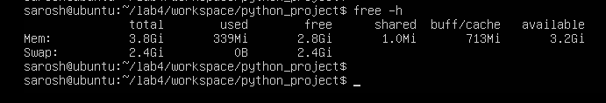

Disk: df -h
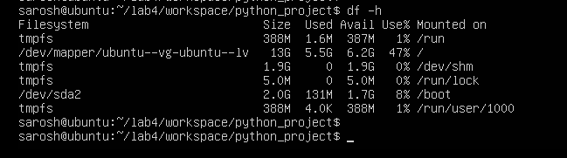

Os Release: cat /etc/os-release
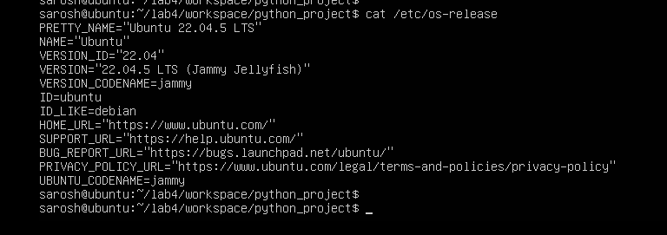

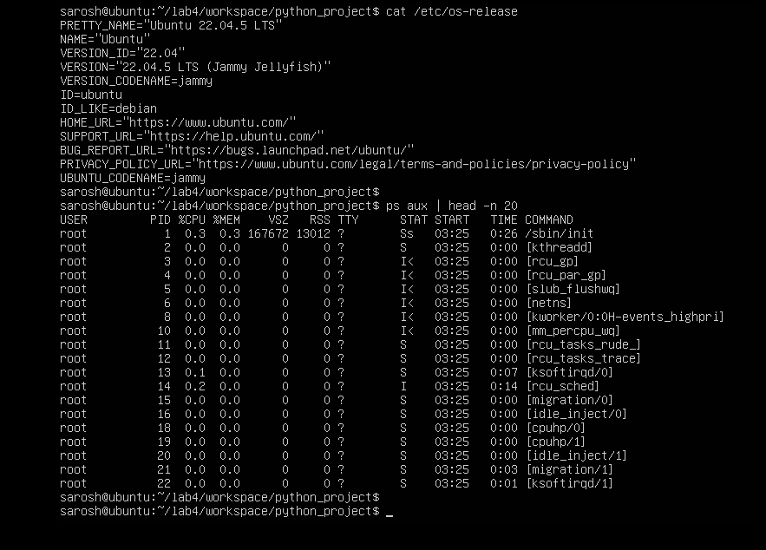
Processes (show top lines of ps output): ps aux

Task 6 – Users and account verification (no sudo group change)
Create a non‑root user and verify the account exists. This task does NOT add the created user to the sudo group.
Steps (inside VM terminal)
Create a new user named lab4user: sudo adduser lab4user

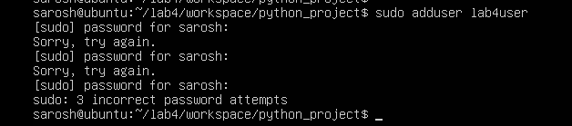

Verify the user entry: getent passwd lab4user
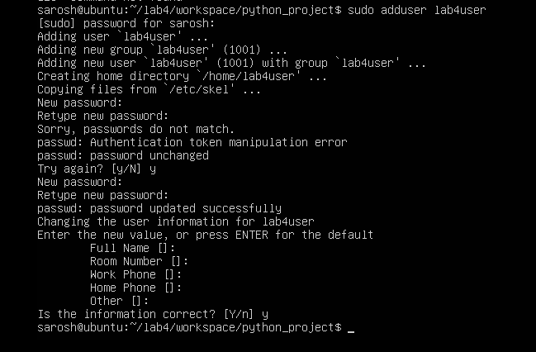

Verification (Optional)
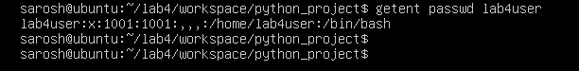

Switch to the new user to verify login: su - lab4user

From the new user you may attempt a sudo command to show that sudo is not available for this account (expected failure), e.g.: sudo whoami
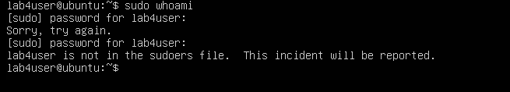

Return to the original user:
exit
