In the key store, I created a key with name “default” and type none: (this key was compulsory for adding repository, inventory and task template so have no other choice except creating a one with type none)
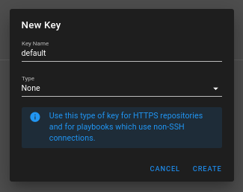
In environment: (this was also compulsory so created a default one)
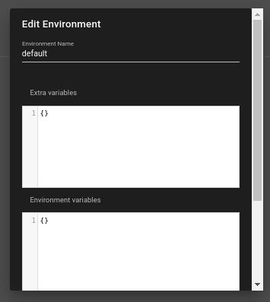

In inventory:
Pasted the inventory file as it is by keeping type static and using the default credentials:
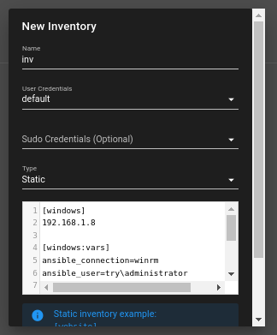
In repositories, i added the repo link:
https://github.com/tehreem-0514/forensics.git
and used the key named “default” i created previously
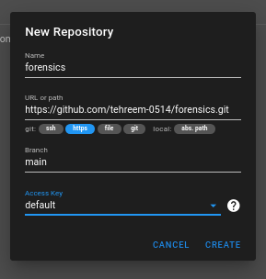
in task templates, i created a new template named “forensics”, my playbook name in the repo was playbook.yml so used that, inventory, repo and environment were selected by the names they were created previously:
