SITETRACE / MCPA

SiteTrace Web Application — Engineer and Architect User Manual
Field equipment requests, transfers, inspection and returns
Version 1.0
Prepared 12 October 2026
Engineer and Architect accounts
Based on the inspected repository. Genuine isolated training screenshots. Production deployment remains unverified.

Table of contents
Document control
Chapter 1 — Introduction
Chapter 2 — Getting Started
Chapter 3 — Equipment Tracking
Chapter 4 — Equipment Requests
Chapter 5 — QR Code Equipment Transfers
Chapter 6 — Equipment Receipt Confirmation
Chapter 7 — Equipment Returns
Chapter 8 — Other Authorized Operations
Chapter 9 — Troubleshooting and Best Practices
Glossary
Evidence, validation and revision information

Document control
Item | Value
Version | 1.0
Prepared | 12 October 2026 · Asia/Manila
Audience | Active Engineer and Architect accounts
Basis | Current repository; source and isolated browser review
Scope | 10 authorized primary modules; identical role permissions
Companion | Administrator manual and SiteTrace_System_Module_and_Role_Review.md

Naming: these documents use the requested SiteTrace title. The inspected application displays MCPA (Material & Construction Property Allocation), Construction Asset Management and Accountability System, and BuildRight Corp. Follow the on-screen MCPA labels when using the application. No application branding was changed.
Verification scope: instructions describe the current repository implementation. Genuine interface screenshots were captured from the unmodified application using isolated local PGlite test records. Authentication and account-service capability responses were modeled locally. They are training illustrations, not production screenshots or proof of deployed services.
The capture browser blocked external HTTPS and permitted business reads only after fixture setup. No live login, migration, invitation, stock change, approval, handover, receipt, return, role change, or notification-read update was performed. The live REQ-00001 test was not accessed. Its unchanged state was not independently compared because production was not contacted.
Operational availability: use the procedures only in an authorized company workspace whose required Supabase database functions, policies and services are installed. Source-confirmed write procedures were not executed in the capture browser. Supabase deployment, email delivery, private file retrieval, optical QR scanning and the monitoring scheduler remain unverified in production.
Screenshot conventions: all figure captions identify the local training environment. Fixture names, example.test addresses, asset references beginning DOC-, and transaction numbers in the 007xx range are synthetic. Password fields are empty or absent. No authentication tokens or receiving QR secrets are embedded in the manuals. Figures are numbered separately in each manual.

Chapter 1 — Introduction

1.1 Purpose and responsibilities
SiteTrace/MCPA records the location, holder and condition of construction tools and materials. Engineer and Architect accounts request available equipment for assigned projects, coordinate transfers of equipment they hold, inspect equipment addressed to them, record returns and report damage/loss. The application uses permanent company profile IDs for accountability, even if names are duplicated.
Engineer and Architect have the same route, action and backend ownership permissions. Only the displayed role label differs. Actual visible records depend on individual custody, requester/sender/receiver identity, active project assignment and current transaction state. An empty list for one Architect is not a different role policy.

1.2 Access requirements
• An issued active company account with a valid Auth-to-company-profile link and a modern JavaScript browser.
• Working Internet to read/save company records; the correct existing project assignment for requests and new receiving/direct-transfer workflows.
• HTTPS or localhost, a supported phone/browser camera and granted camera permission for optical scanning. Manual receiving details and handover-code entry are available alternatives.
• Enough time to physically inspect and test every received non-missing tool before receipt. The application requires individual conditions and explicit damaged-custody decisions.
Your company administrator manages accounts, project assignments, approvals, repair completion and missing recovery. You cannot add/edit inventory, edit projects, manage users, approve requests, complete repairs, confirm recovery, use Reports, Material Requests or Purchases. The presence of legacy files or a URL does not grant those permissions.
Source evidence: js/permissions.js; js/auth.js; js/navigation.js; supabase/migrations/202610040001_authenticated_access.sql and 202610060002_recipient_identity.sql.

Chapter 2 — Getting Started

2.1 Access and login

Sign in to your company workspace
Purpose: Open the pages and actions authorized for your company identity.
Access / prerequisites: An issued company account, a confirmed invitation if applicable, and an Active company profile.
1. Open the application address supplied by your administrator. Both index.html and 2-engr/index.html use authenticated role checks; the URL alone does not select your role.
2. In Welcome back, enter your company Email and Password. Show reveals the password locally; Hide masks it again. Keep passwords out of shared screenshots.
3. Select Sign In, or press Enter in a completed login form. Wait for your profile and authorized navigation to load.
4. Check the account name and role in the top-right Account menu and sidebar. If they are wrong, stop and contact Admin.
Expected result: The application opens the role’s home module. Admin, Engineer, Architect and Tool Handler open Dashboard; Secretary opens Material Requests.
Limits / errors: An Auth login without an authorized active profile is refused. Incorrect email or password., an inactive-account message, or a profile-verification failure requires correction or administrator assistance. There is no public account registration.
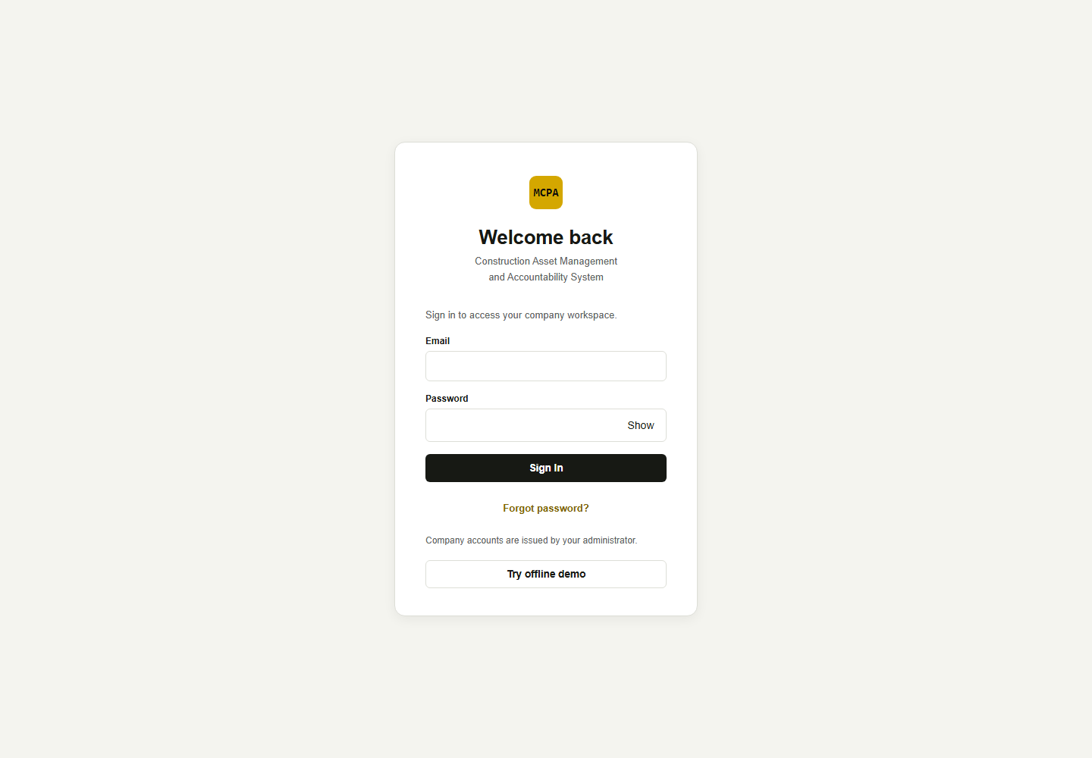
Figure 1. Company sign-in screen; local capture with empty credential fields. [Isolated local training environment.]

Accept an invitation or reset a password
Purpose: Set a password for an issued account or recover access.
Access / prerequisites: A valid invitation or password-reset email, configured Supabase Auth redirects and working email delivery.
1. For a new account, open the administrator-issued invitation link. For a reset, enter your Email on the login page and select Forgot password?.
2. For a reset request, read the neutral response: If an account exists for this email, a password reset link has been sent. This message does not confirm that the email exists or that delivery succeeded.
3. Open the fresh email link and use Set your password. Enter a New password of at least 12 characters and select Save password.
4. After the application signs you out, sign in with the new password. Cancel and sign out abandons the setup screen.
Expected result: The password is saved by Supabase Auth and the user signs in again.
Limits / errors: An invalid, expired or unavailable invitation session needs a fresh invitation or password reset. This documentation session did not send or receive email.

2.2 Dashboard and navigation
Dashboard opens Movement overview with My assigned equipment, quantity-based equipment totals, project summaries, movement charts, incoming transfers, open requests, maintenance/missing alerts and custody indicators. Request Tools, Receive / Transfer, Return Tools and Report an Issue open the relevant modules. Use Open in Next actions or a linked recent activity entry for the supporting transaction.
Dashboard inventory is a personal custody view, while project summaries and movement context use other authorized data. Equipment Tracking is specifically restricted to equipment whose current_holder_id matches your permanent company profile. Requests uses a separate eligible catalog so you can request available company stock. These scopes should not be treated as the same list.
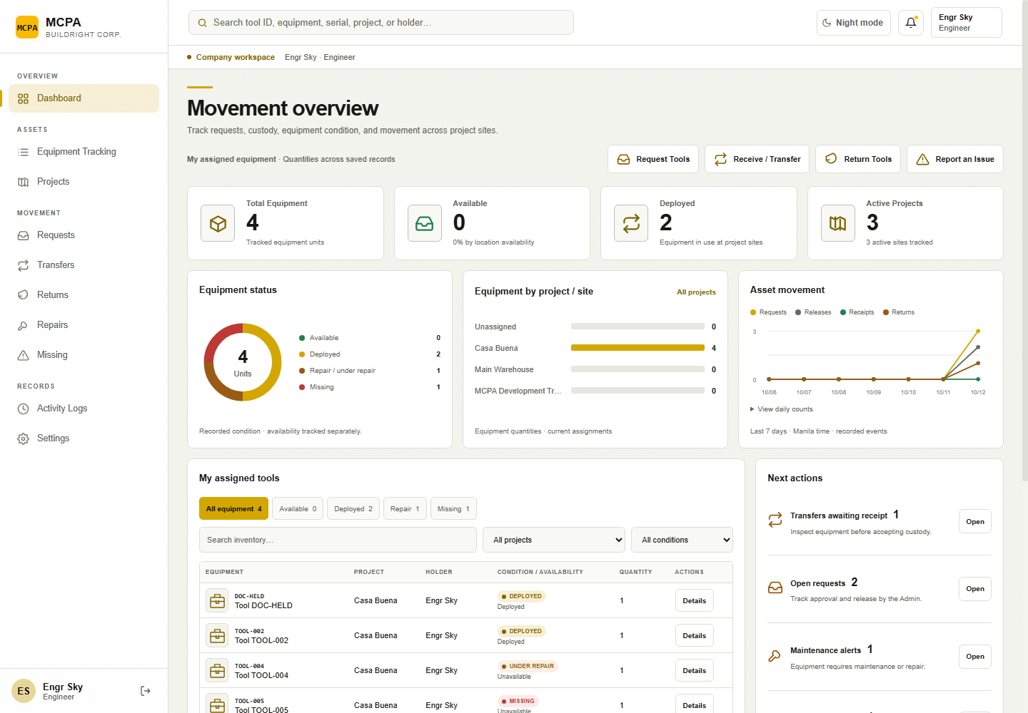
Figure 2. Engineer dashboard and authorized sidebar with isolated records. [Isolated local training environment.]
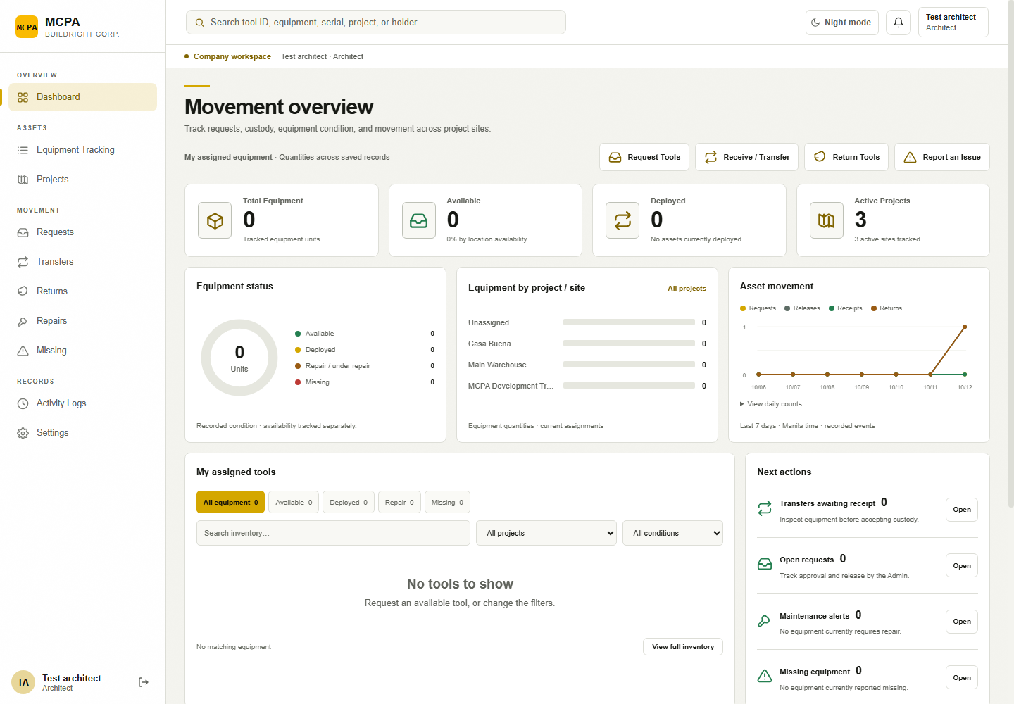
Figure 3. Architect dashboard. Its role policies match Engineer; this fixture account has different assigned records. [Isolated local training environment.]
Sidebar label | What you can do
Dashboard | Monitor your custody and authorized action queues.
Equipment Tracking | Search and inspect equipment in your confirmed custody.
Projects | View projects assigned to your profile, their authorized inventory and history.
Requests | Submit equipment requests and follow approval/release; withdraw/cancel when eligible.
Transfers | Send Transfer, Receive Transfer and History; scan/enter codes, inspect and follow up.
Returns | Record a return for eligible held tools and review saved returns.
Repairs | Report held-tool faults and follow repair status.
Missing | Report held-tool loss and follow recovery status.
Activity Logs | Read/search/export authorized movement history.
Settings | My account identity, display mode and logout.

Material Requests appears in an old menu definition but is removed by the current permission filter for Engineer/Architect. Reports, Purchases and People & Accountability are also restricted. On phones/tablets, open the navigation drawer, select a module and use horizontal scrolling for wide tables if needed.

Review your account, change display mode, and log out
Purpose: Confirm your identity, select a display preference and close your session.
Access / prerequisites: Any authorized role; offline demo uses Exit demo.
1. Open the top-right Account menu and select My Account, or select Settings in the sidebar.
2. Review the name, role and Active company account message. Account roles are managed by an administrator.
3. Select Change light / night mode. The Account menu also offers Change theme. The preference is stored in the current browser.
4. Select Log Out from My account or the Account menu. Wait for the sign-in screen and its sign-out confirmation.
Expected result: Display mode changes immediately. Log Out clears the local application workspace and asks Supabase to end the local session.
Limits / errors: Sign out could not be confirmed. requires Retry sign out before leaving a shared device. Settings does not provide a profile editor, email editor, role switcher or in-session password-change form.
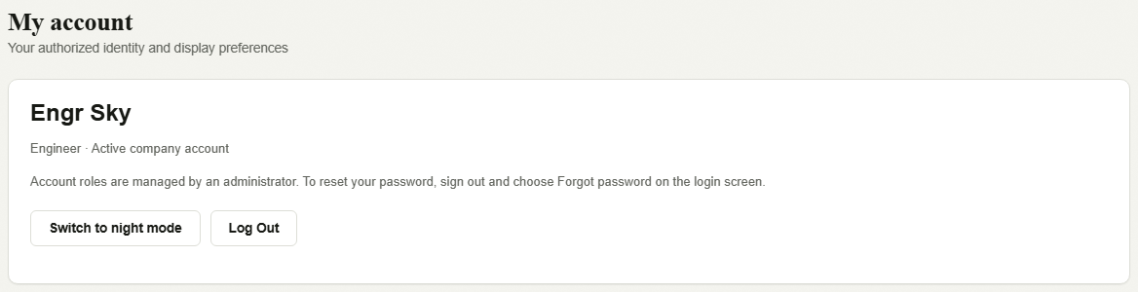
Figure 4. Engineer My account identity and preference controls. [Isolated local training environment.]
Source evidence: js/dashboard-view.js; js/movement-overview.js; js/app.js module selection; 1-admin/modules/settings/settings.js.

Chapter 3 — Equipment Tracking

3.1 Your assigned equipment
Equipment Tracking reads the narrow personal-equipment snapshot. It shows equipment in your confirmed custody and relevant authorized movement history. Equipment reserved for you or sent to you does not become personal custody until receipt. No equipment is currently assigned to you. is a valid empty state; go to Requests to request available stock, or Transfers to inspect an incoming handover.
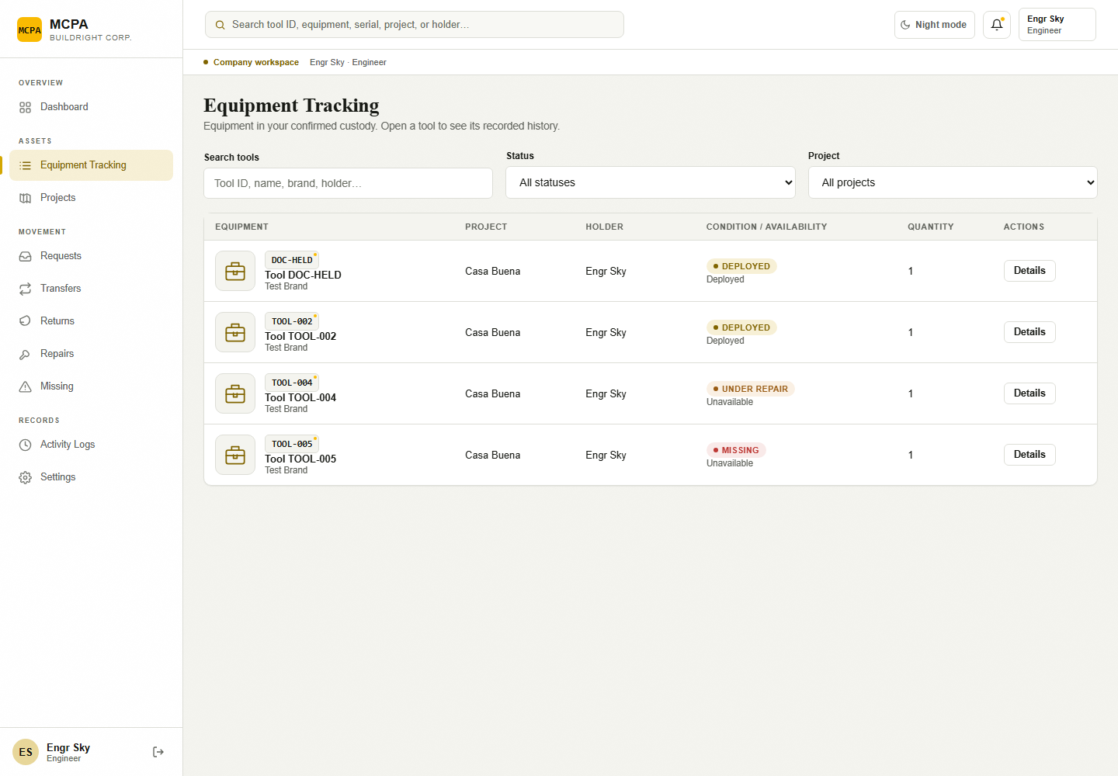
Figure 5. Personal Equipment Tracking for an Engineer fixture account. [Isolated local training environment.]
Status and availability are separate. The current availability helper shows Deployed for equipment at a project with In Use status, Available when there is no project or the normalized state is In Office, and Unavailable otherwise. An Available status at a project can therefore display Unavailable. Request eligibility separately requires available stock with no holder, positive quantity and no approved reservation or pending/refused transfer. Do not use a dashboard count or availability caption alone as permission to issue equipment. Movement summary totals can also include Withdrawn/Canceled records in the open count; use each saved status badge to decide what remains actionable.

3.2 Search equipment and open Details
Purpose: Locate a held tool and review its accountable state.
Access / prerequisites: Engineer or Architect; equipment in confirmed custody.
1. Select Equipment Tracking.
2. Enter a tool ID, name, brand, holder or related text in Search tools. Select Status and Project filters if helpful. Clear filters if an expected item is absent.
3. Select Details on the correct equipment row.
4. Review Current holder, Project, Status, Quantity and Movement history. Select Close to return.
Expected result: The tool detail and authorized recorded events are displayed without changing custody.
Limits / errors: Tools no longer in your custody leave the personal view. Incoming/reserved equipment belongs in Transfers/Requests; all-project equipment is not a personal assignment. A detail action such as Transfer only opens the module; it does not complete that action.
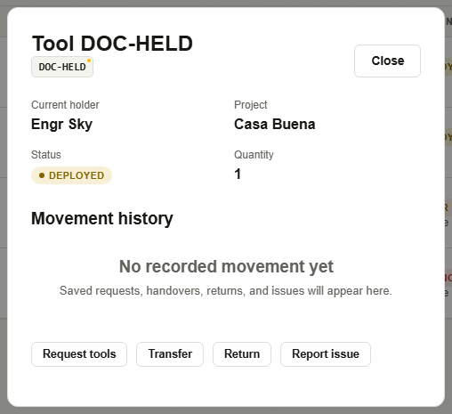
Figure 6. Held tool Details and its authorized movement history. [Isolated local training environment.]

3.3 Status interpretation
Record / label | Meaning and next step
Request: Pending review | Awaiting Admin approval or rejection. The requester may Withdraw request while eligible.
Request: Approved | Selected whole asset records are reserved; custody is unchanged. Admin can release. The requester may Cancel reservation before release.
Request: Released | A linked transfer and handover code exist. This does not mean the receiver has accepted custody.
Request: Inspected / completed | The linked receiver inspection has completed. Review its actual per-tool conditions and any damage/missing cases.
Request: Rejected / Withdrawn / Canceled | The original record stays in history. Rejection includes a reason. There is no edit-and-resubmit action for the saved request; submit a new request if needed.
Transfer: Awaiting receipt | Pending handover. Sender custody and the tool reservation remain until inspection/receipt or eligible cancellation.
Transfer: Damage refused · awaiting sender | The entire handover is held. Custody and reservations remain. Eligible sender/requester follow-up is required.
Transfer: Inspected / completed | The named receiver submitted all inspections. Review the recorded conditions; completion may include accepted damage or missing items.
Return: Returned | A saved return record; the implementation has no separate Admin approval queue for returns.
Repair: Reported / Under repair / Completed | Report created; Admin started work; Admin closed the case after completion. Under repair can be derived from the repair case rather than a different raw equipment value.
Missing: Missing / Recovered | Unresolved loss report, or an Admin-recorded recovery. Damaged recovery opens a repair case.

The equipment status vocabulary includes Available, In Use, For Repair, Under Repair, Missing and Disposed in the current views. Product planning text also mentions Borrowed, Transferred, For Return, Repaired and Sold, but separate user-facing lifecycles for those labels were not confirmed. Use saved request/transfer/report states to understand what actually happened.
Source evidence: js/movement-overview.js: personal, detail, load; js/equipment-tracking.js; supabase/migrations/202610100001_engineer_portal.sql: mcpa_personal_equipment_snapshot.

Chapter 4 — Equipment Requests

4.1 Request catalog and prerequisites
Requests offers positive-quantity, Available equipment not already reserved or in a pending/refused transfer. The backend additionally refuses requests for equipment with a current holder. Ask the current holder to transfer an in-use tool rather than requesting it as available stock. Choose an existing destination assigned to your profile; the broad destination dropdown may show projects you cannot request for, so confirm assignment first.
Selecting a tool moves the whole asset record and its quantity. There is no per-request partial-quantity field or bulk-record split. If the record represents a set or a bulk stock, coordinate the actual whole-record allocation with Admin.

4.2 Create and submit an equipment request
Purpose: Ask Admin to allocate available equipment for assigned project work.
Access / prerequisites: Active Engineer/Architect; an assigned destination and eligible available, unheld stock.
1. Select Requests. In Request tools, use Search available tools to locate equipment by name, ID or project.
2. Tick the required records under Choose asset records. Check the displayed Qty (whole record) and selection count.
3. Choose Destination project. Optionally enter Needed until; if supplied, it must be a valid date not in the past in Manila.
4. Enter Purpose explaining the work, using at most 2,000 characters.
5. Select Submit request and wait for Request saved successfully.
6. Note the REQ- reference and open it in Your requests.
Expected result: A Pending review request is saved for your identity; no equipment is received or assigned yet.
Limits / errors: A Pending request does not reserve stock until Admin approves. Competing requests can exist; approval rechecks stock. Blank purpose, no selection, invalid date, unauthorized project or held/reserved stock is refused.
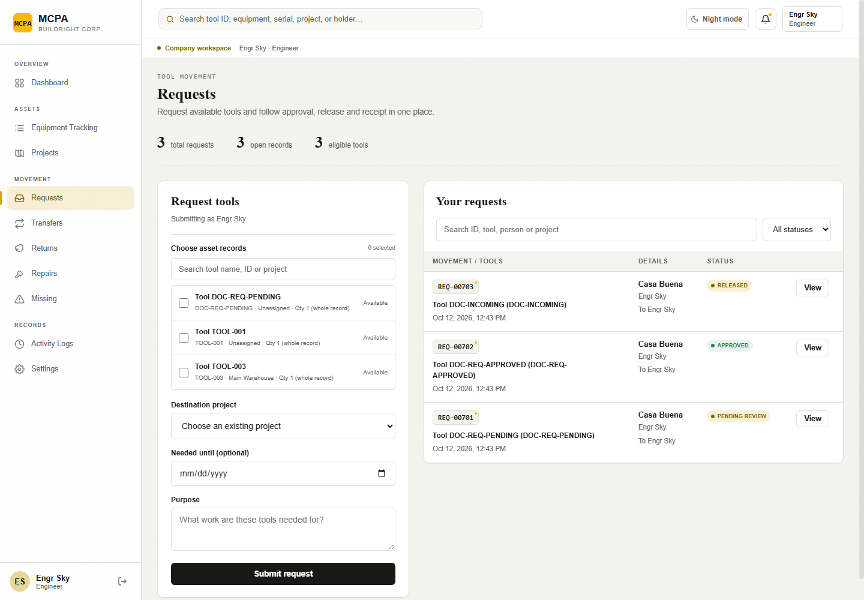
Figure 7. Request tools form and request history; isolated catalog. [Isolated local training environment.]

4.3 Monitor approval, release and request history
Purpose: Understand whether equipment is reviewed, allocated or awaiting receipt.
Access / prerequisites: Requester or another account with authorized visibility.
1. Stay in Requests and use Search movement records and status filtering. Select View on the correct REQ- record.
2. Read Pending review, Approved, Rejected or Released. Review rejection reason when present.
3. For a Released request, review Handover code and select Open transfer.
4. Go to Transfers > Receive Transfer to inspect the physical handover before confirming custody.
Expected result: The saved request explains approval and release; linked transfer details guide receipt.
Limits / errors: Approved means reserved, not received. Released means a transfer exists. A saved request has no editable tool/date/purpose form or automatic resubmission control.

4.4 Withdraw a pending request or cancel an approved reservation
Purpose: Close your unfulfilled need while preserving the original history.
Access / prerequisites: The original Engineer/Architect requester; Pending review for withdrawal, Approved without a transfer for reservation cancellation; cancellation migration installed.
1. Open the request in Requests.
2. If eligible, use Withdraw request or Cancel reservation in the record detail.
3. Enter Reason and tick I confirm this action for the displayed reference.
4. Select the matching action button and review the status/message.
Expected result: Withdrawal saves Withdrawn. Reservation cancellation saves Canceled and releases allocation; custody is unchanged.
Limits / errors: These controls disappear when state/ownership is ineligible. Once release creates a transfer, use the eligible transfer cancellation procedure. Admin cannot perform these new field cancellations. You cannot restore a withdrawn/canceled request; create a new request if still needed.
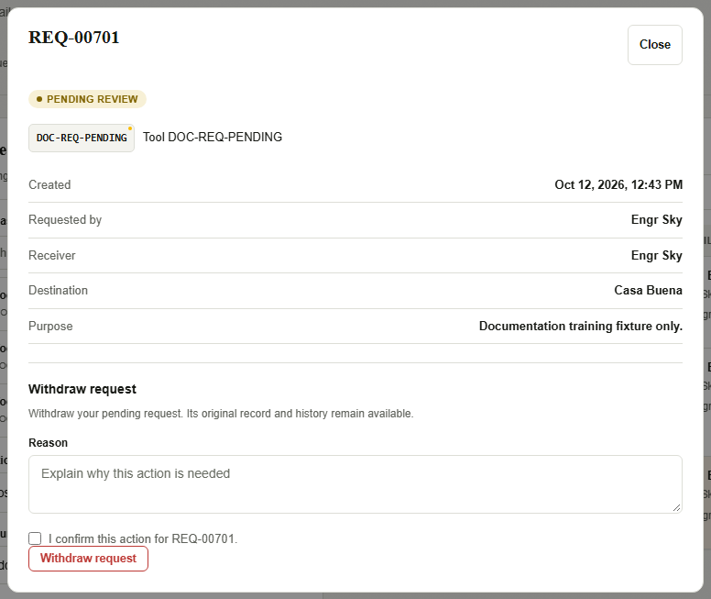
Figure 8. Pending request detail with requester withdrawal fields. No action is submitted. [Isolated local training environment.]
Source evidence: js/movement-ui.js: eligibleTools, createForm, adjustmentForm, submit; js/movement-cloud.js; migrations 202610060002_recipient_identity.sql and 202610100004_movement_cancellation.sql.

Chapter 5 — QR Code Equipment Transfers

5.1 Distinguish the three QR purposes
Code / QR | Purpose | What it does not do
Your receiving QR | Identify the active receiving person and their assigned active project before dispatch. Payload begins MCPA-RECEIVER:. | It does not create a transfer, reserve tools or accept custody.
Transfer handover QR / code | Identify the TRF- handover created after dispatch, for lookup and inspection by the named receiver. | It does not bypass inspection or make another person the receiver.
Equipment tag | Identify an asset ID. The handover scan path may match a unique pending handover addressed to you. | It cannot transfer ownership merely because it was scanned.

The receiving QR expires after 15 minutes. Generate My Receiving QR revokes older references for the same receiver; Revoke receiving QR invalidates the current reference. A valid QR can assist multiple transfers while valid, but each dispatch still checks the current account and project assignment. Transfer handover codes are saved references, not the 15-minute receiving tokens.

5.2 Show your receiving QR to a sender
Purpose: Provide a verified receiving identity and project before transfer creation.
Access / prerequisites: Active Engineer/Architect assigned to at least one active receiving project; portal RPC and QR display library.
1. Select Transfers > Receive Transfer. Locate Your receiving QR.
2. Select Receiving project if more than one assigned active project is offered. For one project the selector is disabled.
3. Select Generate My Receiving QR. Show the displayed QR to the sender and verify the displayed name/project.
4. Check the expiry message. Generate a fresh code if it expires, or select Revoke receiving QR when it should no longer be used.
Expected result: The sender can resolve the short-lived receiver/project context. No equipment custody changes.
Limits / errors: No assigned receiving project. requires Admin to assign an active project. Generating a QR writes only its own ephemeral reference and revokes older ones. QR bitmaps and optical scanning were unavailable in this capture session; the genuine receiving interface is shown before generation.
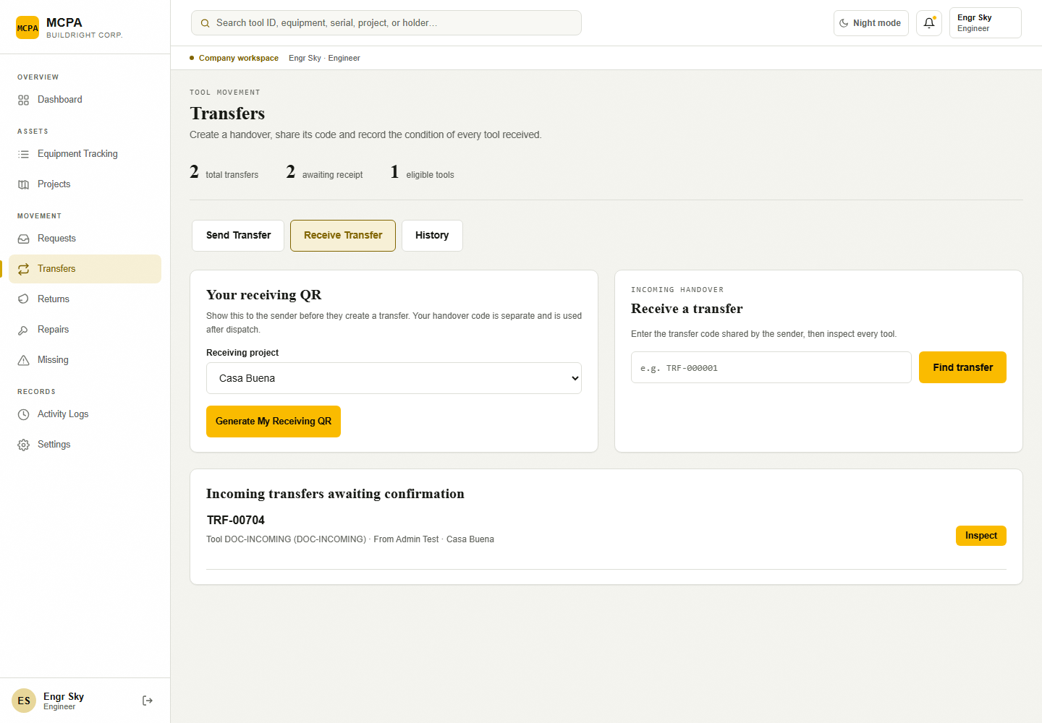
Figure 9. Receive Transfer: Your receiving QR, receiving-project selection, handover lookup and incoming transfers. No token was generated. [Isolated local training environment.]

5.3 Initiate a transfer with a receiving QR or manual details
Purpose: Dispatch equipment currently held by you to the intended field receiver.
Access / prerequisites: Active Engineer/Architect; positive-quantity In Use tools in your custody, no reservation/pending transfer; active receiving Engineer/Architect assigned to the active destination.
1. Select Transfers > Send Transfer. Choose Scan Receiver QR and ask the receiver to show their current receiving QR.
2. Grant camera permission and scan the receiving QR. Read Verified receiving account, name and project. If the library/camera is unavailable, choose Enter Details Manually instead.
3. For manual entry, choose Destination project and Receiving Engineer / Architect. Review the role/project descriptions; identify the exact person if names are duplicated.
4. Tick eligible records under Choose asset records and review whole-record quantities. Optionally enter Handover notes.
5. Select Create transfer. Record the returned TRF- reference and share the Handover code with the named receiver.
Expected result: An Awaiting receipt handover reserves the selected records. Original custody remains until the named receiver inspects/receives or an eligible cancellation occurs.
Limits / errors: Scanning only fills receiver/project. Submit rechecks active assignment and QR validity if used. Stale QR, mismatched name/project, changed assignment, held-by-other stock and reserved equipment are refused. Record dispatch before equipment leaves the source, in line with company process.
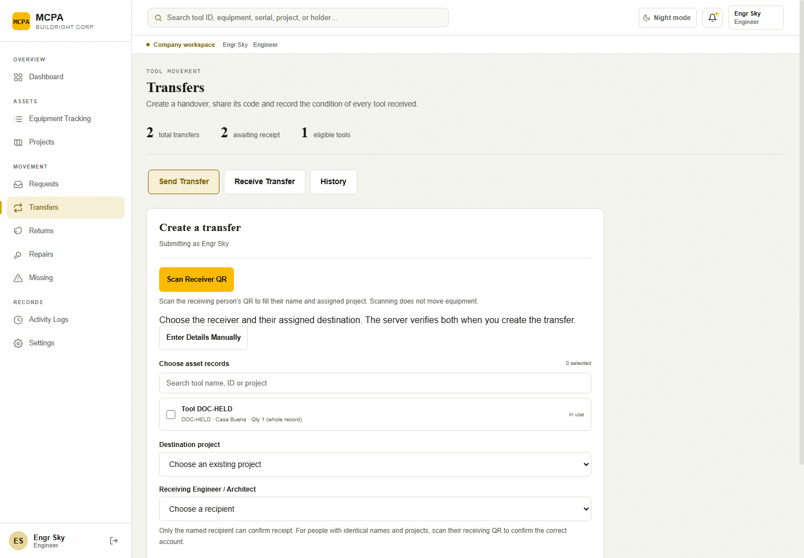
Figure 10. Send Transfer with manual destination and receiver fields revealed. No transfer is created. [Isolated local training environment.]

5.4 View and share a transfer reference
Purpose: Coordinate the saved handover with its named receiver.
Access / prerequisites: Authorized sender/receiver; saved transfer.
1. Select Transfers > History. Search by reference, tool, person or project and filter status when needed.
2. Select View on the correct transfer.
3. Read the receiver/destination and use Copy handover code. When the QR display library is available, the same handover reference is rendered as a QR.
4. Share the reference only with the intended receiver through the approved work channel; ask them to inspect actual tools.
Expected result: The named receiver can find the handover by its code.
Limits / errors: Clipboard permissions may block copying; use the visible reference manually. An unavailable QR bitmap does not prevent manual code lookup. No messaging integration automatically sends the code.
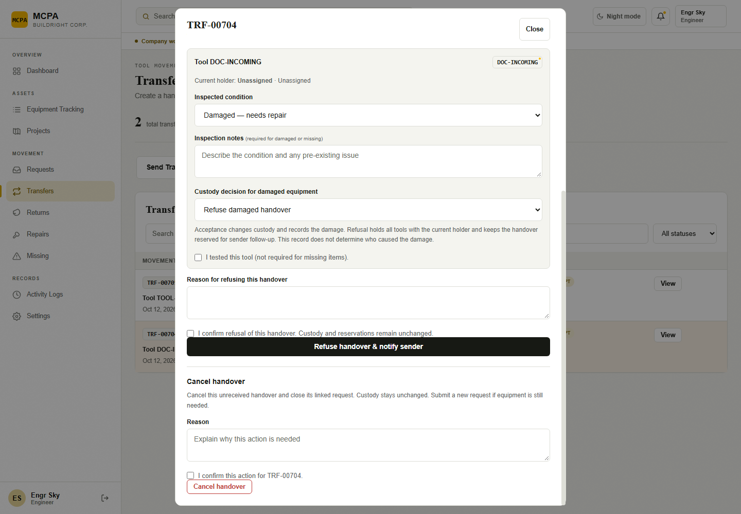
Figure 11. Transfer History and saved local transfer references. [Isolated local training environment.]

5.5 Find an incoming handover by code or scan
Purpose: Open the saved transaction before recording receipt.
Access / prerequisites: Named receiving Engineer/Architect; existing authorized handover.
1. Select Transfers > Receive Transfer.
2. Enter the sender’s exact code in Transfer code and select Find transfer. Alternatively select the incoming record’s inspection/view control.
3. If Scan Handover QR is available, grant camera access and scan the original handover QR or asset tag. Stop camera closes capture.
4. Confirm the saved receiver, destination, tools and current holders before proceeding to inspection.
Expected result: The saved handover opens. No custody changes from lookup/scanning.
Limits / errors: No transfer found for that code. requires the original reference and current company data. An asset-tag scan may show details only when no pending handover is addressed to you. Multiple pending matches require the transfer reference and Admin review. The manual lookup dialog can display an authorized record even when you are not its receiver, but it does not offer receipt permission.

5.6 Cancel or reopen an eligible unreceived handover
Purpose: Resolve an interrupted dispatch without rewriting history.
Access / prerequisites: Engineer/Architect original field sender, or linked released-request requester for cancellation; original field sender only for reopening; eligible pending/refused state.
1. Select Transfers > History and View the handover.
2. Use Cancel handover if eligible and equipment has not been received. For a refused handover, the original field sender may instead use Reopen for receiver inspection.
3. Enter Reason, tick the displayed confirmation and select the matching action.
4. Review the new saved status and coordinate the physical tools with the receiver.
Expected result: Cancellation saves Canceled, releases the reservation and leaves custody unchanged; a linked released request is also closed. Reopening returns the refused transfer to Awaiting receipt without changing custody/reservations.
Limits / errors: Refused tools remain reserved until eligible follow-up. Completed receipt cannot be undone by cancellation. A request-linked Admin release can be canceled by its eligible field requester, but that requester is not the original Admin sender and cannot reopen it through the field-sender action.
Source evidence: js/movement-ui.js: receivingProjects, generateReceivingQr, resolveReceivingQr, startCamera, transferLookup, renderDetail; migrations 202610100001_engineer_portal.sql and 202610100004_movement_cancellation.sql.

Chapter 6 — Equipment Receipt Confirmation

6.1 Receiver responsibilities
Inspect physical identity, quantity and condition against the saved tool list. Record each tool as Good — ready for use, Damaged — needs repair or Missing — not received. A non-missing item must be tested and explicitly marked I tested this tool. Damage/missing notes are mandatory. This interface has no inspection-photo upload or partial-quantity acceptance; it records a condition for each entire asset record.

6.2 Inspect and confirm an incoming transfer
Purpose: Accept accountability only for inspected equipment.
Access / prerequisites: The named receiving Engineer/Architect; Awaiting receipt transfer with unchanged source custody/status/quantity.
1. Open the incoming transfer from Receive Transfer or History. Check Receiver, Destination, tool IDs and Current holder.
2. Under Inspect the handover, select Inspected condition for every tool. Physically test every non-missing tool and tick I tested this tool.
3. For damaged/missing items, enter factual Inspection notes (at most 2,000 characters per item).
4. For each damaged item, choose Custody decision for damaged equipment. Select Accept custody with recorded damage if you accept it. Missing items are not accepted into custody.
5. When no eligible damaged item is refused, select Confirm receipt of all inspected tools. Wait for Receipt confirmed. Custody and any repair or missing reports have been updated.
6. Review the saved Recorded condition, your Equipment Tracking and any Repairs/Missing follow-up.
Expected result: Good items change to your holder/project and In Use. Accepted damaged items change to your holder/project and For repair, with a repair case. Missing items keep source holder/location, become Missing and open a missing case. The handover is Inspected / completed.
Limits / errors: Every tool must be represented once; testing is not required for missing items. Receipt is blocked if source custody/status/quantity changed after dispatch or another action already completed the handover. Completion does not mean every item was physically received in good condition.
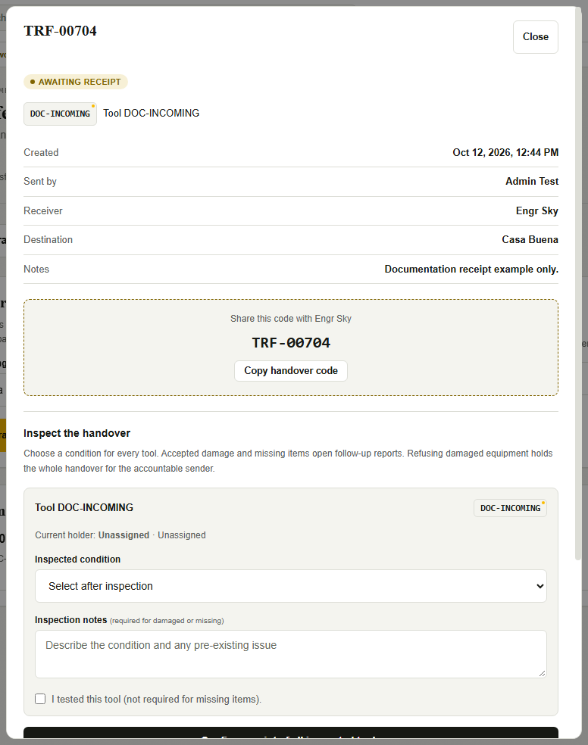
Figure 12. Incoming transfer inspection dialog before any confirmation. QR bitmap was unavailable; the original code remains visible. [Isolated local training environment.]
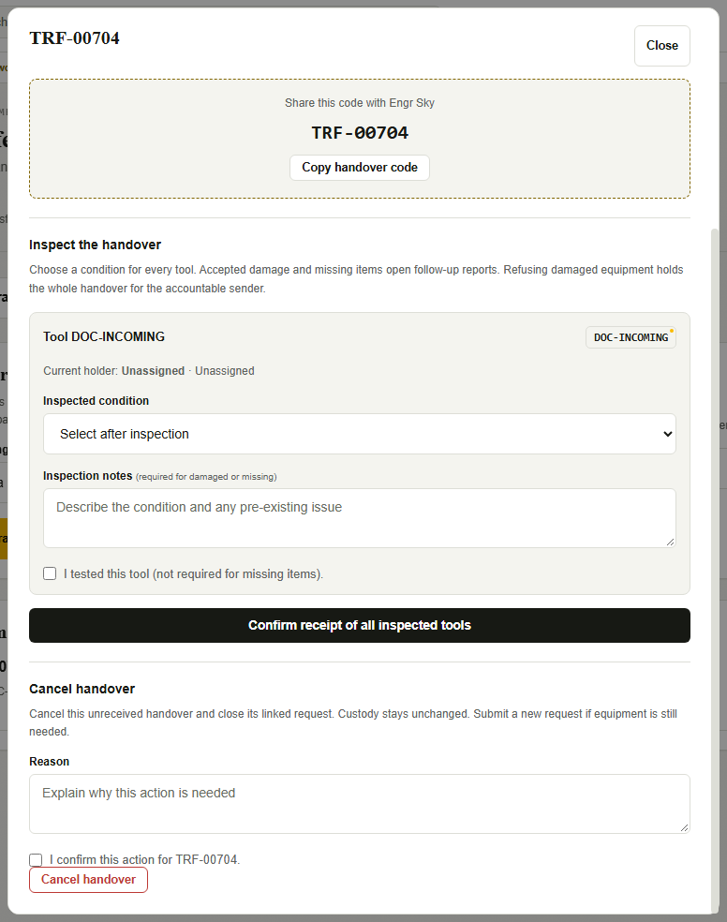
Figure 13. Lower inspection form showing the required test checkbox and Confirm receipt of all inspected tools. [Isolated local training environment.]

6.3 Refuse eligible damaged equipment
Purpose: Record a damage refusal and hold the handover for accountable follow-up.
Access / prerequisites: Named Engineer/Architect receiver of an eligible pending handover: active field sender, or initial released request owned by this receiver; cancellation/refusal migration installed.
1. Open the handover and complete each tool’s condition, notes and non-missing test checks.
2. For at least one damaged tool, choose Refuse damaged handover under Custody decision for damaged equipment.
3. Enter Reason for refusing this handover and tick the refusal confirmation.
4. Select Refuse handover & notify sender and review the saved refusal status.
5. Contact the original sender/requester to resolve the physical handover and choose eligible cancellation or sender reopening.
Expected result: The whole transfer becomes Damage refused · awaiting sender. All custody/status and reservations stay with their original source state, including the other tools; inspection evidence is saved.
Limits / errors: Refusal is not a generic reject button for any transfer. A Tool Handler dispatch without an eligible linked request does not offer this refusal option. If unavailable and custody cannot be accepted, contact the sender/Admin before confirming. Refusal does not determine who caused damage and does not itself open an accepted-damage repair case.
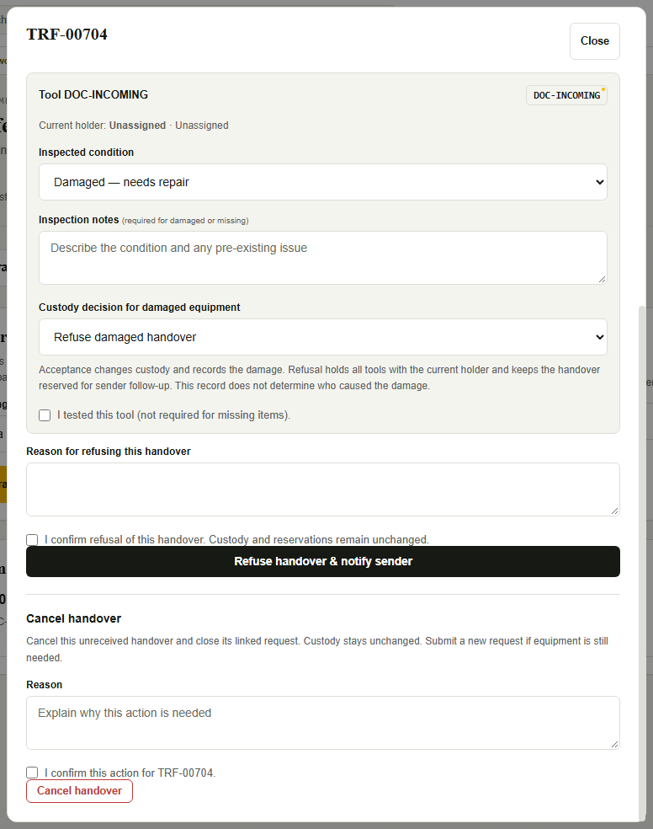
Figure 14. Actual damage-refusal form after unsaved condition selections. No refusal is submitted. [Isolated local training environment.]

6.4 Discrepancies and accountability
For not-received equipment, choose Missing and explain the discrepancy; do not mark it Good to close the screen. Missing items retain the original custody/location while the missing case is recorded. For accepted damage, the receiver takes custody with the condition documented. The whole-record model cannot record receipt of only part of a quantity; resolve partial-quantity discrepancies with Admin before submitting an inaccurate whole-record inspection.
Source evidence: js/movement-ui.js: conditionFields, readConditions, submit; supabase/migrations/202610060002_recipient_identity.sql: receipt updates; 202610100004_movement_cancellation.sql: refusal eligibility and immutable evidence.

Chapter 7 — Equipment Returns

7.1 Which tools can be returned
Returns is for positive-quantity In Use equipment held by your identity and not reserved for an approved request or pending/refused handover. The application does not maintain a separately scheduled For Return queue or return-specific QR workflow. Needed until dates and Currently overdue notices help you identify tools whose expected use period ended.

7.2 Record a return and inspect its outcome
Purpose: Record actual return condition and release good-tool custody.
Access / prerequisites: Engineer/Architect current holder; eligible In Use tools; actual destination and physical return checked.
1. Select Returns. In Return tools, tick the records under Choose asset records. Review that each selection represents a whole record.
2. Choose Return destination from existing projects. Riverside Warehouse is only a preselection if that actual name exists; choose the real destination.
3. Select Inspected condition for every selected tool. Enter Inspection notes for damaged or missing tools. Optionally enter Return notes.
4. Select Confirm return only after the real handover/count is established under company procedure.
5. Read Return saved successfully., open the RTN- record and compare Recorded condition with current custody/status. Check Repairs/Missing when generated.
Expected result: The return is saved immediately. Good tools clear the holder, move to the chosen destination and become Available. Damaged tools move to the destination, retain the existing holder and open repair cases. Missing tools keep source holder/location, become Missing and open missing cases.
Limits / errors: There is no second Admin acceptance action. Damaged/missing tools do not automatically clear accountability. Returned good tools at a project may still show Unavailable by the location-based helper; read status, holder and eligibility together.
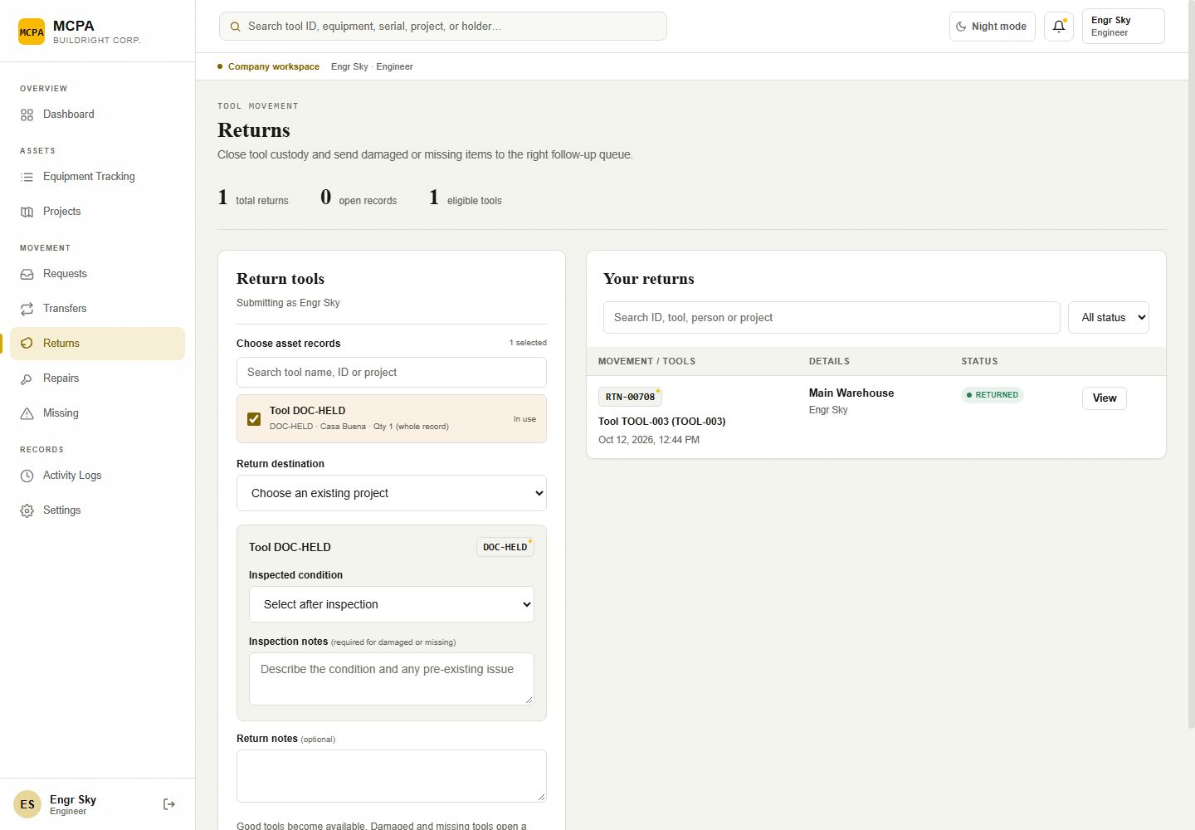
Figure 15. Return tools form with a selected asset and per-tool condition fields. [Isolated local training environment.]

7.3 Review return history and unresolved accountability
Purpose: Confirm the saved return and follow-up cases.
Access / prerequisites: Authorized Engineer/Architect returner or readable related record.
1. In Returns, use Search movement records/status filtering and select View on the RTN- record.
2. Review Returned by, destination, notes and per-tool Recorded condition.
3. Check Equipment Tracking for tools still held and Repairs/Missing for pending resolution.
4. Use Activity Logs to inspect the original saved return and related events.
Expected result: The recorded return and any continuing damaged/missing accountability can be reconciled.
Limits / errors: Return records have no cancellation, edit, delete, scheduling or separate receipt-confirmation controls in the current interface.
Source evidence: js/movement-ui.js: createForm, syncReturnConditions, submit; supabase/migrations/202610060002_recipient_identity.sql: createReturn and per-condition inventory updates.

Chapter 8 — Other Authorized Operations

8.1 View assigned Projects and their equipment
Purpose: Review project accountability and authorized inventory.
Access / prerequisites: Engineer/Architect assigned to a project; project snapshot/history dependency installed.
1. Select Projects. Use Search projects and, if needed, Include archived projects. The page is limited to assigned projects.
2. Open the project card. Read Accountable Engineer / Architect, Equipment at Project, Last Inventory Check and Last Movement.
3. Select Review Assigned Tools to search/filter the project’s equipment including zero-quantity records.
4. Select Project History for authorized metadata history or View movement history → for movement records.
5. Close review dialogs and return to All Projects as needed.
Expected result: The real accountable profile and permitted project equipment/history are visible.
Limits / errors: Add/Edit/Archive/Restore controls are removed for field accounts. All projects cannot broaden the server scope. Project equipment may be held by someone else; it is not your personal custody. One project has one accountable person. The reviewed deployment note identifies a project_history dependency problem whose live fix remains unverified.
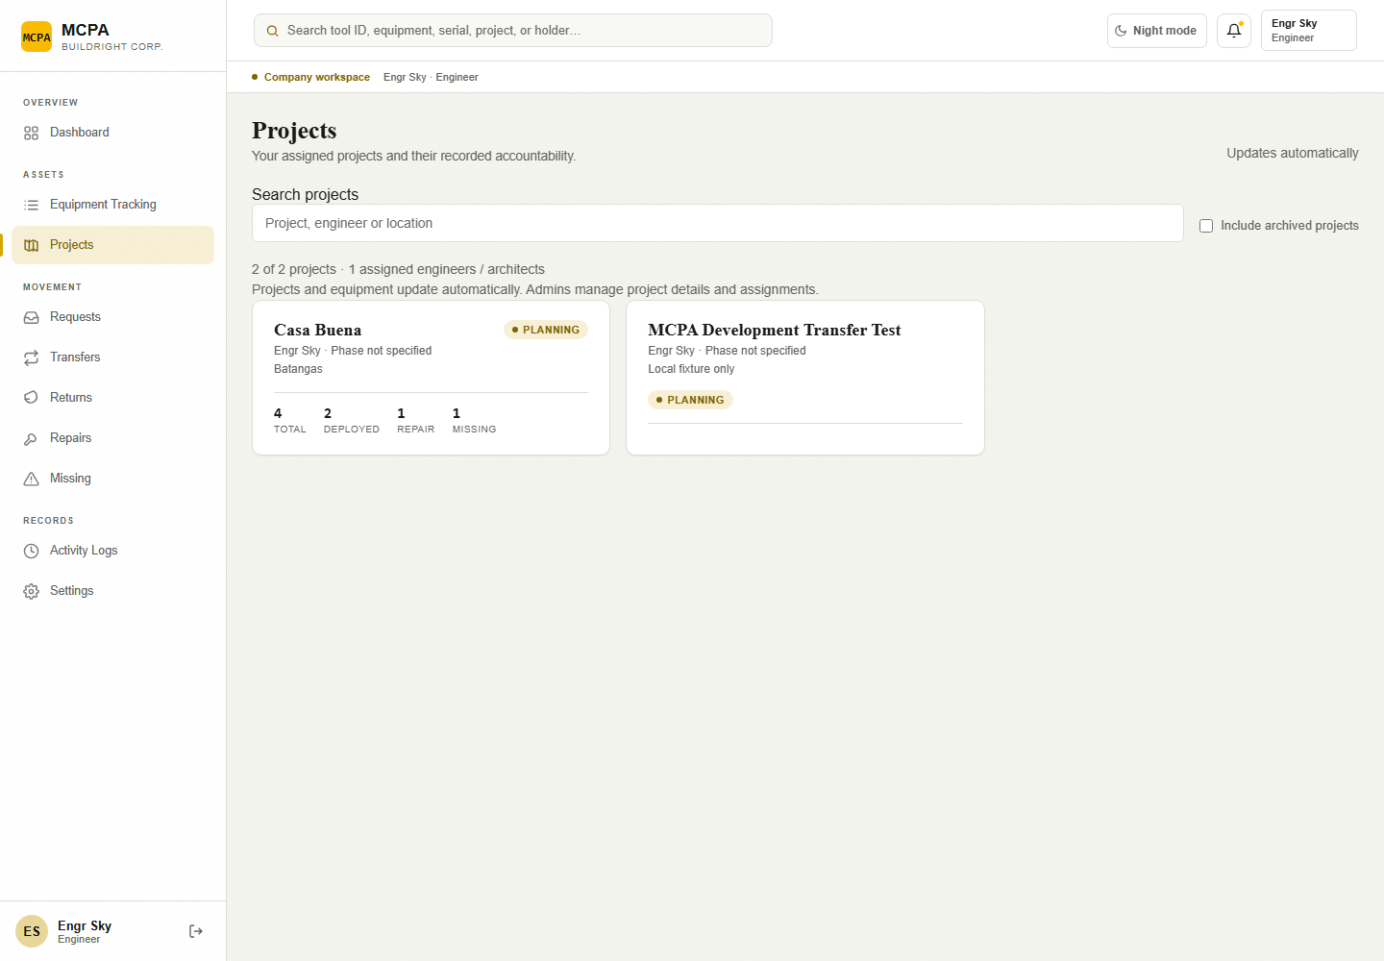
Figure 16. Assigned Projects for the Engineer fixture identity. [Isolated local training environment.]

8.2 Report tool damage or a repair need
Purpose: Make an equipment fault visible for Admin resolution.
Access / prerequisites: Engineer/Architect holder; eligible positive-quantity In Use tool without a reservation/pending transfer.
1. Select Repairs. In Report a repair, choose Tool.
2. Enter Damage / issue details, describing the fault and circumstances in at most 2,000 characters.
3. Select Submit repair report.
4. Open the saved REP- record to follow Reported, Under repair or Completed. Coordinate actual repair/release with Admin.
Expected result: The tool becomes For repair, holder remains, and a reported repair case/activity entry is saved.
Limits / errors: You cannot Start repair or Complete repair. Do not submit duplicate reports for an already locked/repair tool. No repair-image attachment, repair-cost editor or technician assignment was confirmed.
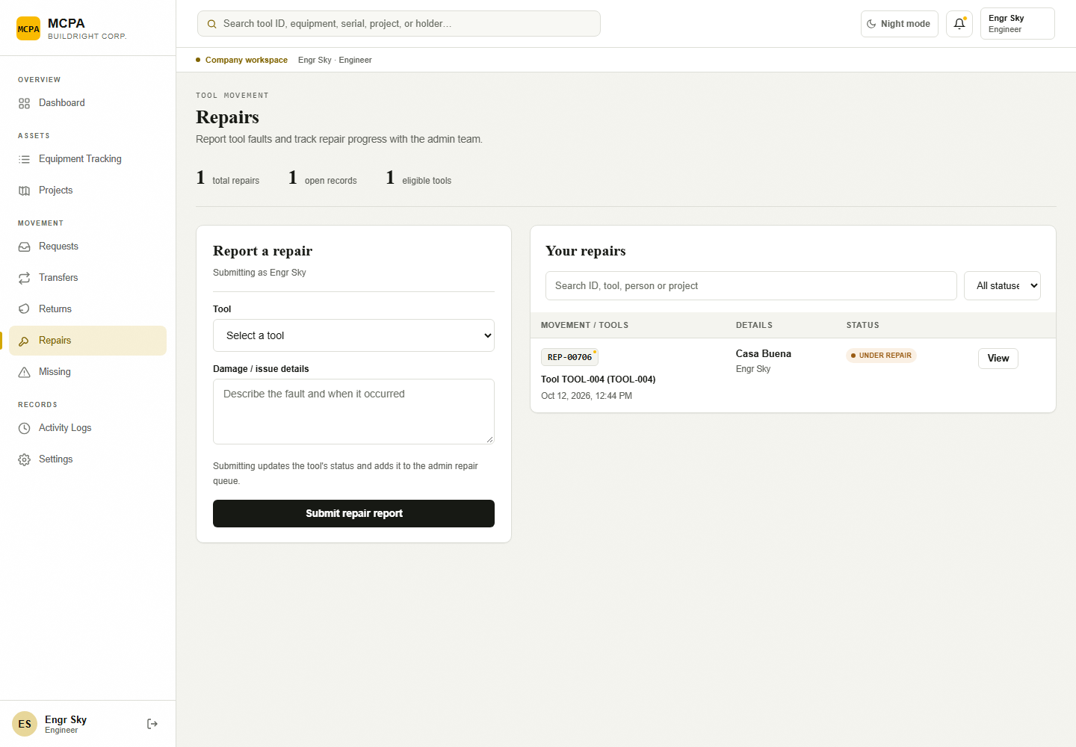
Figure 17. Report a repair form with authorized eligible-tool selection. [Isolated local training environment.]

8.3 Report a missing tool
Purpose: Document a loss and preserve the existing accountability chain.
Access / prerequisites: Engineer/Architect holder; eligible In Use tool without reservation/pending handover.
1. Select Missing. Choose Tool in Report a missing tool.
2. Enter Last seen and circumstances with factual details (at most 2,000 characters).
3. Select Submit missing report and note the MIS- reference.
4. Review the saved case and inform Admin when the equipment is found so Admin can record the inspected recovery.
Expected result: The tool becomes Missing and a case/activity entry is saved; existing holder/location remain.
Limits / errors: Only Admin can Confirm recovery. This report does not assign blame. Do not manually replace custody or hide the original case after finding equipment.
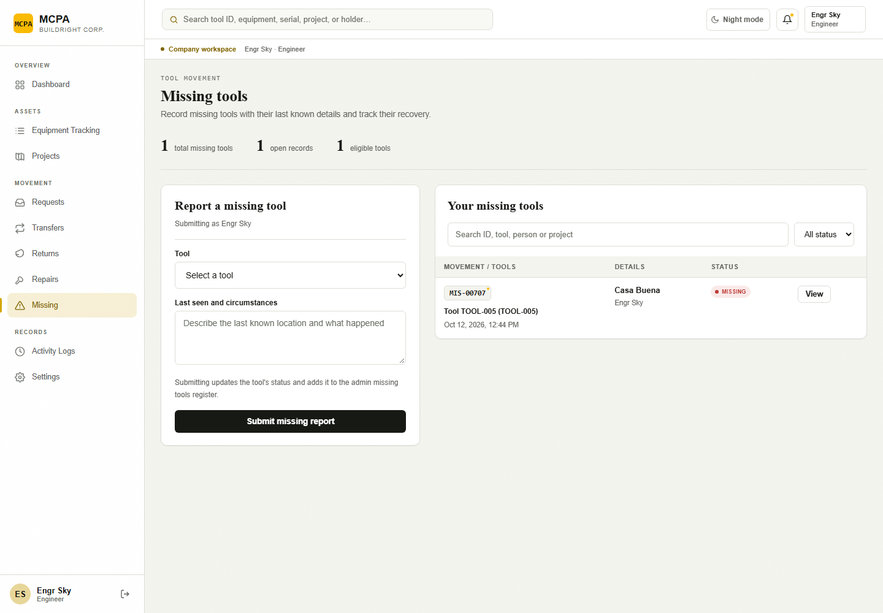
Figure 18. Report a missing tool form; no loss is submitted. [Isolated local training environment.]

8.4 Read notifications and follow overdue equipment
Purpose: Follow authorized alerts to their supporting records.
Access / prerequisites: Engineer/Architect with monitoring configured; relevant recorded notices.
1. Select the topbar bell to open Notifications.
2. Review Currently overdue requests, tool IDs and days past the needed-until date. Select a request reference to inspect it.
3. For a recorded notice, select Open and mark read to update your notice and open its authorized target.
4. Review the original request/transfer before taking the appropriate return or follow-up action.
Expected result: Your own recorded notices and authorized overdue requests are visible.
Limits / errors: Opening the bell alone does not mark all notices read. Overdue/weekly generation requires the trusted backend scheduler. A direct transfer without a linked received request/needed-until date is not automatically the same overdue loan. No SMS, push or email-reminder workflow was confirmed.

8.5 Search/export authorized movement history
Purpose: Keep a record of your permitted equipment transactions.
Access / prerequisites: Engineer/Architect; Activity Logs access.
1. Select Activity Logs. Enter a reference, tool ID, person, action or summary text in Search activity.
2. Select a linked action/reference to open its saved request, transfer, return or report.
3. Select Export CSV when a local copy is required and open mcpa-movement-activity.csv.
Expected result: An authorized movement-event history is displayed or exported.
Limits / errors: The CSV contains authorized movement activity matching the current activity search. It is not an account/purchase/material audit. Preserve private work data when sharing.
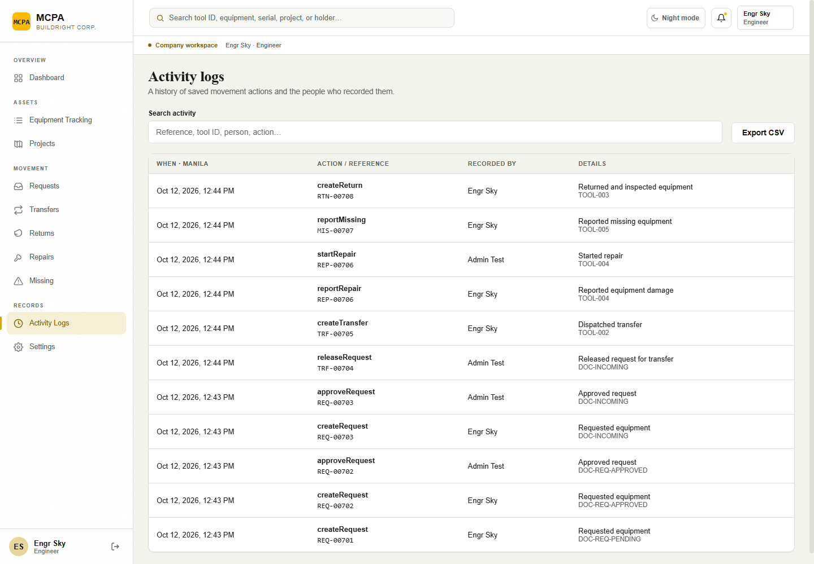
Figure 19. Engineer Activity Logs and movement links. [Isolated local training environment.]

8.6 Preferences and offline demo
Settings offers My account, display mode and Log Out as described in Chapter 2. Password reset begins after signing out. The login page’s Try offline demo offers Admin, Engineer or Architect sample identities and browser-only records. Demo has no live database access and hides accounts, Material Requests and Purchases; Projects is read-only and Your receiving QR requires an authenticated company account. Do not treat demo records as company transactions.
Source evidence: 1-admin/modules/sites/sites.js; js/movement-ui.js; js/movement-overview.js; js/monitoring.js; js/auth.js and js/permissions.js.

Chapter 9 — Troubleshooting and Best Practices

9.1 Common issues
Symptom / message | What to do
Incorrect email or password. | Re-enter the issued email and password. Use Forgot password? with a valid email if needed.
Inactive / unauthorized profile | Contact Admin to verify account status and Auth linkage. A successful Auth login alone does not grant application access.
Access restricted | Use Return to your workspace. Changing the URL does not provide a missing permission.
Unable to load this screen | Use Retry after checking the connection. A module download failure is different from a database configuration failure.
Saved successfully, but the updated records could not load. | Refresh and check the original reference before any new submission. The save may already have committed.
Unable to sync changes. Retrying automatically… | The active page retries on focus, reconnect and roughly every 30 seconds while visible. Keep drafts and compare refreshed records before acting.
This record is unavailable or your account no longer has access. | Refresh the activity list. The record may have changed or be outside your role/ownership scope.
Projects needs a database configuration update. | Report the message to the system maintainer. Repository deployment notes identify project_history as a required dependency. Do not rerun legacy setup scripts as an end-user workaround.
No eligible tools are available. | Check the tool’s current holder, status, quantity, approved reservation and pending/refused transfer. Request unheld stock; transfer/return only your eligible held tools.
Request tools for a project assigned to your account. | Ask Admin to assign your actual profile; choosing a destination in the dropdown does not grant project authority.
No assigned receiving project. | Ask Admin for an active receiving-project assignment. A separate project may be needed because the model has one accountable profile per project.
This receiving QR is expired or revoked. | Ask the receiver to generate a fresh QR, or use verified manual details. Generating a new QR invalidates older ones.
This is not a receiving QR. | Use Your receiving QR before sending. Use the handover code/QR after dispatch, and the equipment tag only for identification.
Camera scanning could not load / requires HTTPS or localhost | Use the configured secure application, allow permission, or use Enter Details Manually / handover-code entry. A missing scanner library cannot be fixed by submitting an unverified transaction.
Camera permission denied or scan not detected | Allow camera access in the browser, use the rear camera, show the original code clearly and retry. Close/Stop camera when finished. Optical scanning and actual device permissions were not verified here.
Inspect every selected tool / Test each received tool | Select every condition; add damage/missing notes; test/check every non-missing tool; choose a damaged-custody decision.
Only the named receiver can confirm receipt. | Ask the correctly named receiving account to sign in. Possession of a code does not grant receipt permission.
Tool custody or status changed after dispatch. | Refresh and coordinate the original transfer with Admin/sender. Do not create another handover to conceal a conflict.
Refused handover remains locked | The reservation is intentionally held. Eligible original sender may reopen/cancel; the linked-request requester may cancel. Admin monitors.
Expected tool disappears after return/transfer | Successful good return or accepted transfer changes custody. Check its saved history in Returns/Transfers/Activity Logs. Damaged/missing items can remain your responsibility.

9.2 Frequently Asked Questions
Are Engineer and Architect permissions different? No. They share the same modules/actions and backend checks; individual ownership and assignment can produce different visible records.
Can I transfer a tool held by another person? No. The current holder sends it. Tool Handler dispatch is separately limited to eligible available equipment with no holder.
Does scanning a QR accept custody? No. Receiving QR fills a verified receiver/project; handover lookup opens the transaction. Receipt requires all saved inspections and confirmation.
Can I accept part of a bulk quantity? No partial-quantity split/receipt field is implemented for equipment records. Resolve the physical discrepancy before recording a whole-record outcome.
Can I edit/cancel a completed transfer or saved return? No current UI procedure supports undoing completed custody or deleting history. Contact Admin and preserve the original reference.
Can I request materials or open reports? Engineer/Architect cannot access Material Requests, Purchases or Reports under the current role map. Ask Admin or Secretary for materials workflow; Activity Logs CSV remains available to you.
Who clears damaged/lost-tool accountability? The damage/loss is recorded first; Admin completion/recovery clears or resolves custody as implemented. Good returns clear the holder immediately. An accepted damaged transfer assigns the receiver and opens repair follow-up.

9.3 Field best practices
• Check asset identity and whole-record quantity before selection. Keep the physical count consistent with the saved asset record.
• Record dispatch before tools leave the source. Confirm exact receiver/project, especially where names are similar.
• Use a fresh receiving QR and the original transfer reference. Do not send authentication passwords or receiving secrets in screenshots.
• Physically inspect and test tools before confirming receipt; document damage/missing facts. Refuse eligible damaged handovers when appropriate and coordinate follow-up.
• Keep original references for pending/refused/canceled transactions. Do not create duplicate handovers to work around a lock.
• Submit returns using actual destinations and per-tool condition. Damaged/missing outcomes preserve accountability until resolution.
• Check saved records after connection loss before starting a new operation. Preserve drafts and wait for refresh after a confirmed save.
• Review overdue notices and authorized history, protect exports, and use Log Out on shared devices.

Glossary
Term | Meaning
Accountable profile | Permanent company person record linked to an Auth login. Custody and history remain attached to this identity.
Active account | Authorized profile whose account_status is active and whose Auth linkage is valid.
Asset record | One inventory record identified by an asset ID. It may represent one item or an entire bulk quantity.
Availability | Location/state-derived caption; separate from movement eligibility and equipment condition.
Custody / holder | The person recorded as accountable for the equipment. Pending dispatch does not change the holder.
Destination project | Existing project selected for a request, transfer, return or resolution.
Receiving QR | A short-lived receiver-and-project reference generated before dispatch; valid for 15 minutes and revocable. It never confirms receipt.
Handover code / QR | The transfer reference shared after dispatch, for example TRF-00705. It opens the saved transfer for inspection.
Equipment tag | An asset ID QR tag used to identify equipment. It does not grant custody or override named-recipient rules.
Reservation | Allocation of the whole selected asset record to an approved request or pending/refused transfer.
Inspection | Per-tool condition, notes when needed, testing confirmation for received non-missing items, and a custody decision for damaged items.
REQ / TRF / RTN / REP / MIS | Equipment request, transfer, return, repair and missing-report reference prefixes. Numbering comes from a shared sequence; gaps are normal.
CR / PUR | Consumable purchase request and record-only purchase ledger reference prefixes. These are different from equipment requests.
RPC | Database function called by the application. It validates the authenticated role, current state and ownership.
RLS | Row-level security: database rules restricting which records an authenticated account may read or change.
Snapshot | An observation of inventory saved at an actual capture time. It does not reconstruct earlier inventory.
Offline demonstration | Explicit browser-only workspace with sample identities and records, separate from live company data.

Evidence, validation and revision information
The companion system review includes the role-permission matrix, current module list, relevant source files, screenshot manifest and limitations. Screenshots prove actual local rendering under the stated fixture conditions. They do not prove real optical QR capture, deployed Auth/Storage/email/scheduler behavior or successful execution of every documented company write.
Version | Date | Revision
1.0 | 12 October 2026 | Initial Engineer/Architect manual, identical role-policy finding, genuine isolated UI captures, explicit custody/return/refusal and deployment limits.

Future revision: update this manual whenever labels, eligibility, ownership rules, role maps or backend migrations change. Capture new figures with safe dedicated staging records; preserve protected live transactions.

