This is the first screenshot from image_s6.cpp that demonstrates the first image:

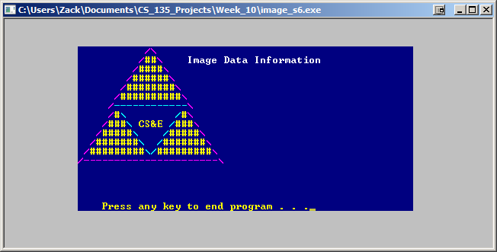

This is the second screenshot from image_s6.cpp that demonstrates the first image with different X and Y offsets:

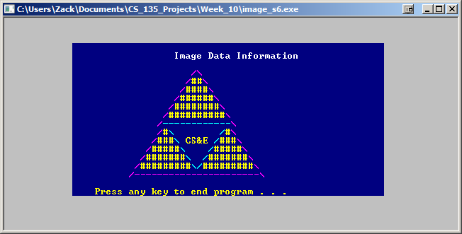

This is the third screenshot from image_s6.cpp that demonstrates the first image with different X and Y offsets:

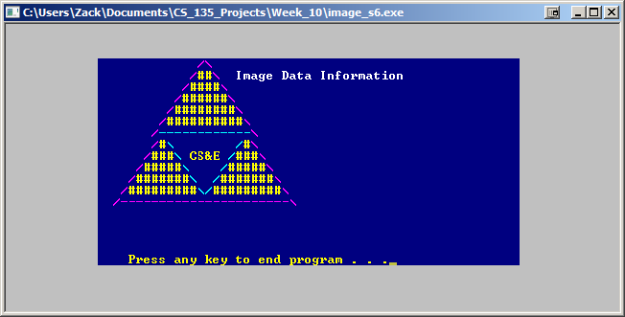

This is the fourth screenshot from image_s6.cpp that demonstrates the second image:

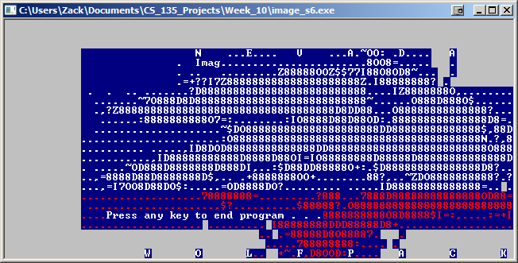

This is the fifth screenshot from image_s6.cpp that demonstrates failure to read:

