Here is the first output created by forcecalc_s4.cpp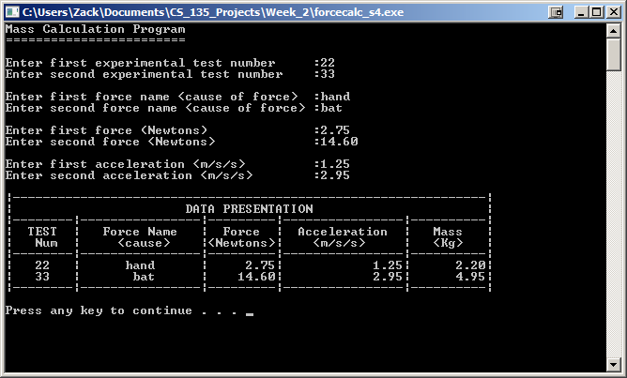

Here is the second output created by forcecalc_s4.cpp

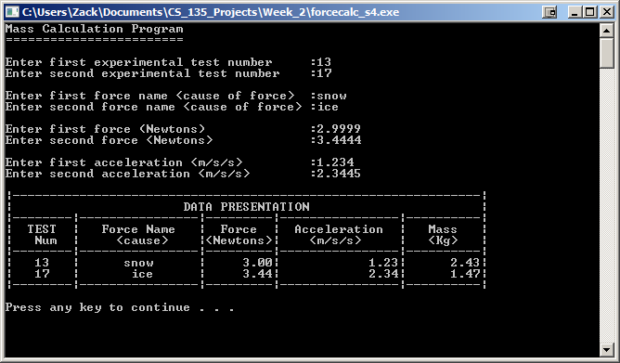

Here is the third output created by forcecalc_s4.cpp

