Here is the first output created by wvcalc_s4.cpp 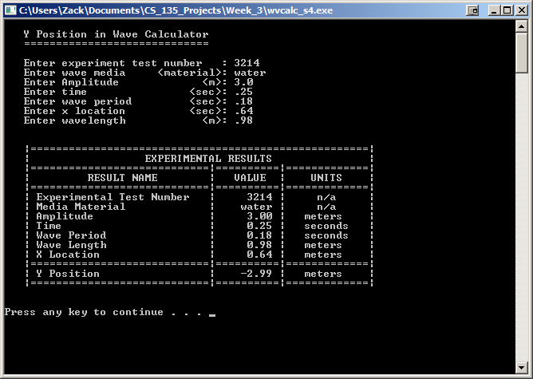 Here is the second output created by wvcalc_s4.cpp

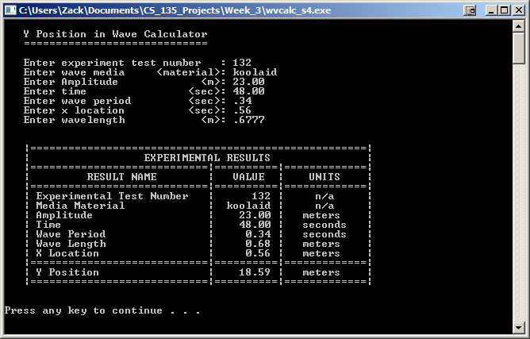

Here is the third output created by wvcalc_s4.cpp 