Here is the first output created by ticket_s6.cpp following the condition that the amount tendered is at least $20 more than the total:

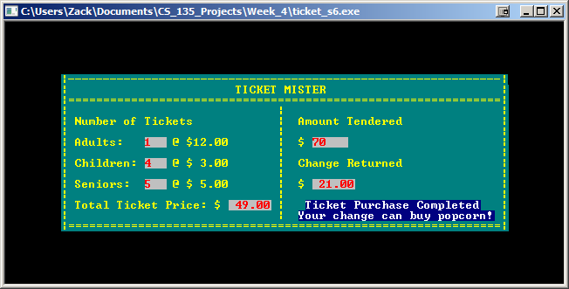

Here is the second output created by ticket_s6.cpp following the condition that the amount tendered is between$10 and $20 more than the total:

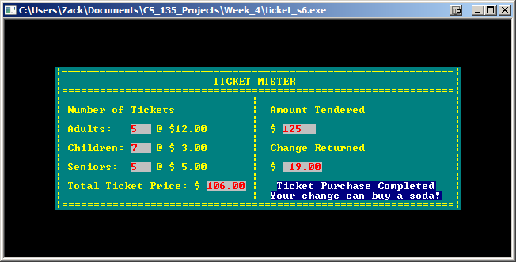

Here is the third output created by ticket_s6.cpp following the condition that the amount tendered is less than $10 more than the total:

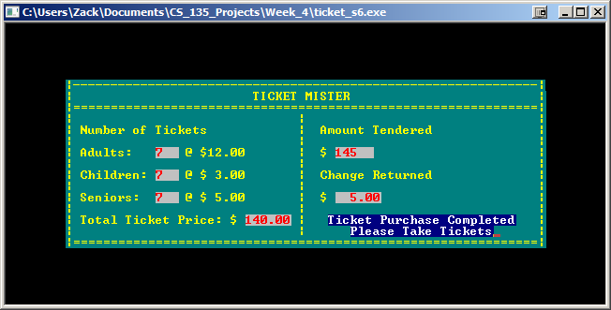

Here is the fourth output created by ticket_s6.cpp following the condition that the amount tendered is exactly the same as the total:

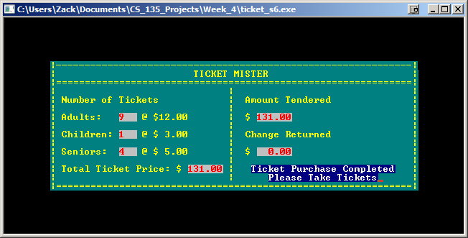

Here is the second output created by ticket_s6.cpp following the condition that the amount tendered is less than the total:

