This is the first screenshot from triangle_s6.cpp:

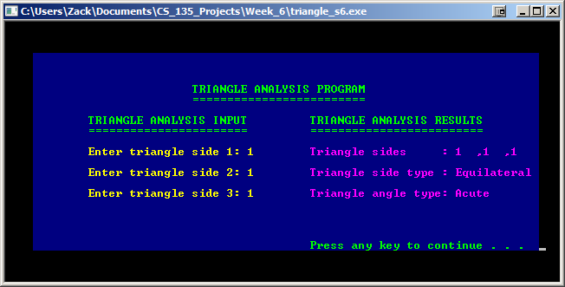

This is the second screenshot from triangle_s6.cpp:

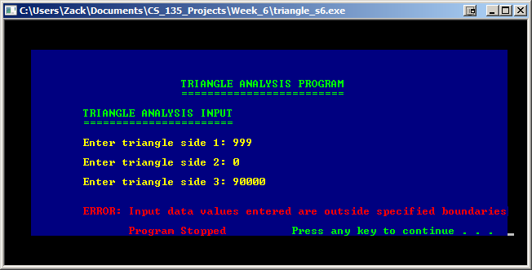

This is the third screenshot from triangle_s6.cpp:

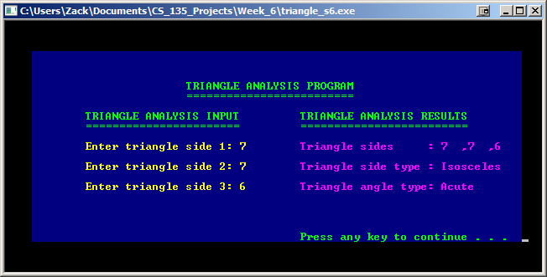

This is the fourth screenshot from triangle_s6.cpp:

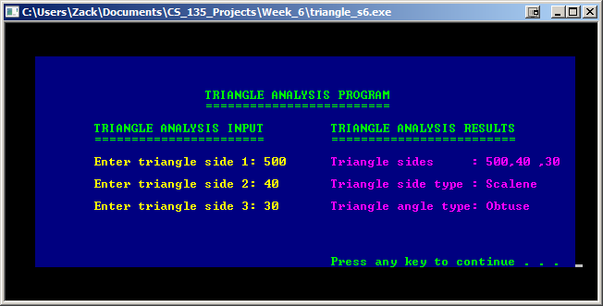

This is the fifth screenshot from triangle_s6.cpp:

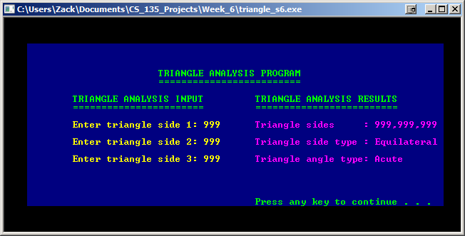

This is the sixth screenshot from triangle_s6.cpp:

