This is the first (addition) screenshot from fraccalc_s6v2.cpp:

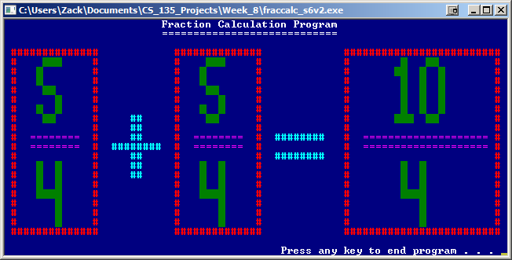

This is the second (subtraction) screenshot from fraccalc_s6v2.cpp:

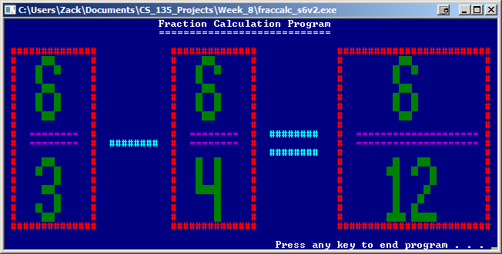

This is the third (multiplication) screenshot from fraccalc_s6v2.cpp:

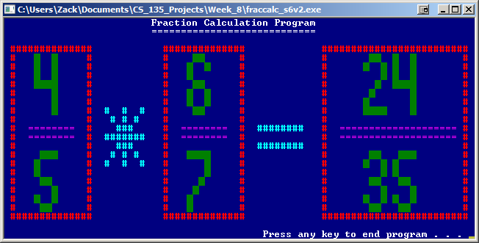

This is the fourth (division) screenshot from fraccalc_s6v2.cpp:

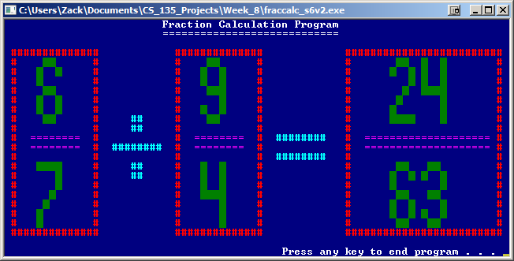

This is the fifth (negative and one digit result) screenshot from fraccalc_s6v2.cpp:

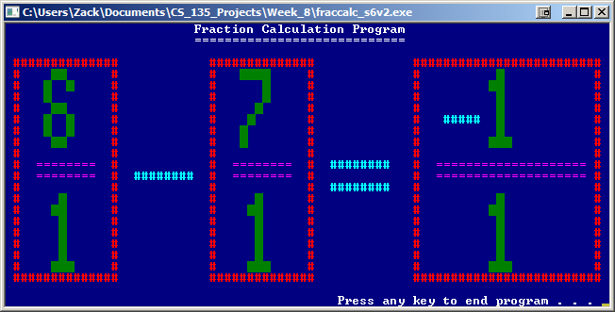

This is the sixth (negative and two digit result) screenshot from fraccalc_s6v2.cpp:

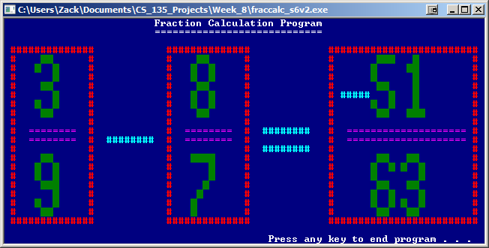

This is the seventh (three digits) screenshot from fraccalc_s6v2.cpp:

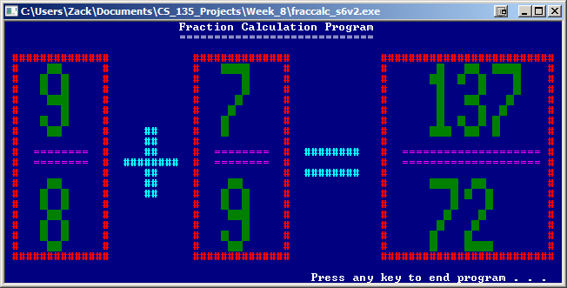

This is an extra screenshot showing an error message for wrong input from fraccalc_s6v2.cpp:

