Here is the rectangle output created by Rectangle_1.cpp: 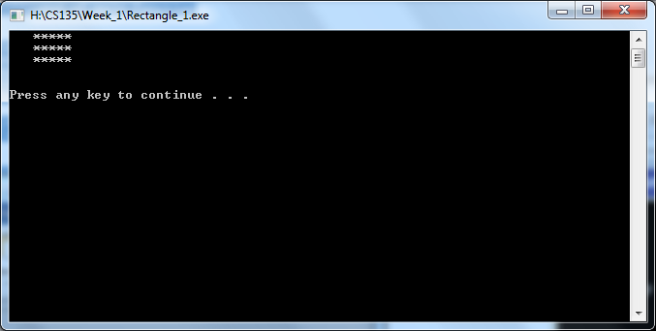 Here is the rectangle output created by Triangle_1.cpp:
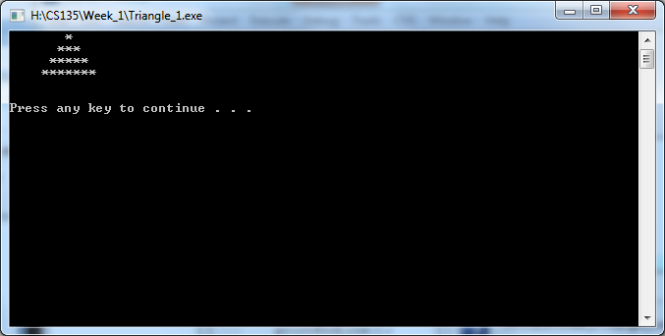
Here is the rectangle output created by Diamond_1.cpp: 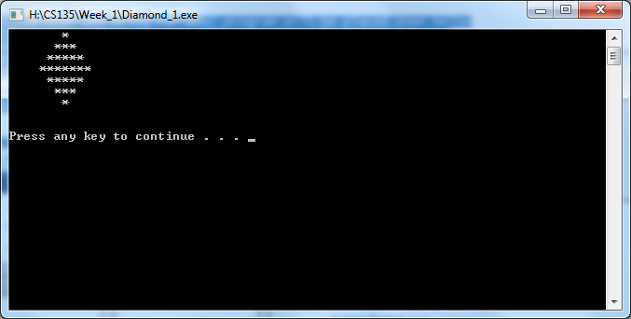
Here is the rectangle output created by Rectangle_2.cpp:
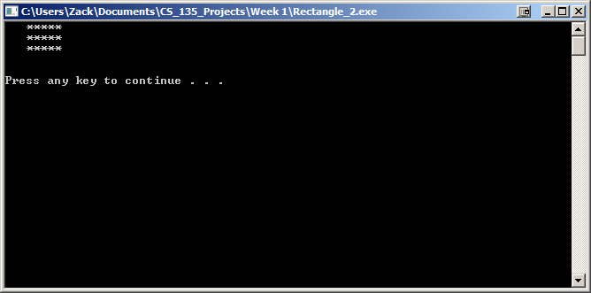

Here is the rectangle output created by Triangle_2.cpp:
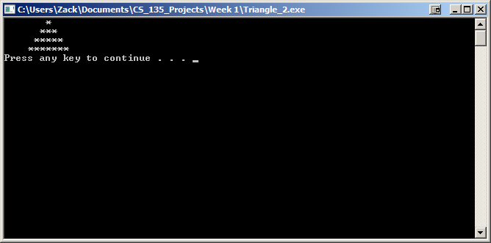
Here is the rectangle output created by Diamond_2.cpp:

Here is the rectangle output created by Rectangle_3.cpp:
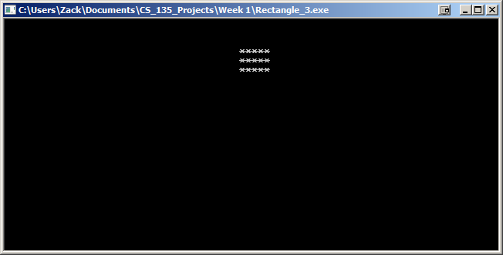
Here is the rectangle output created by Triangle_3.cpp:
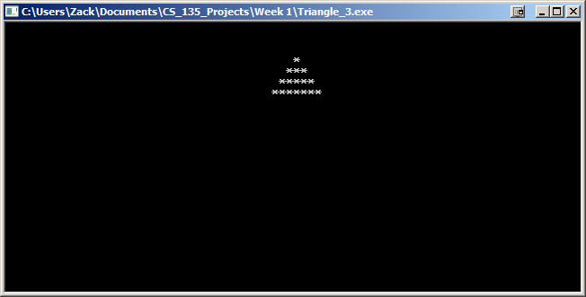

Here is the rectangle output created by Diamond_3.cpp:
