This is the first screenshot from starmaze_s6.cpp that demonstrates the splash screen:
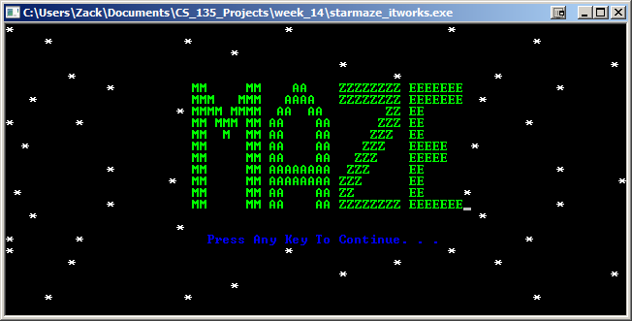
This is the second screenshot from starmaze_s6.cpp that demonstrates the exit screen:
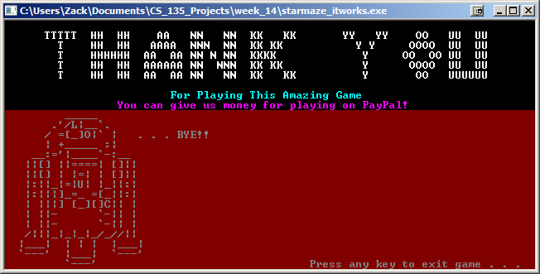

This is the third screenshot from starmaze_s6.cpp that demonstrates the hard difficulty screen:
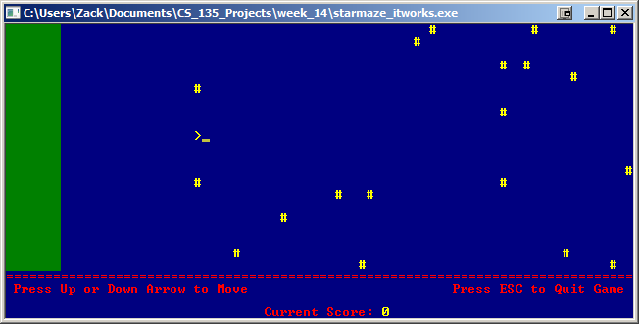
This is the fourth screenshot from starmaze_s6.cpp that demonstrates the medium difficulty screen:
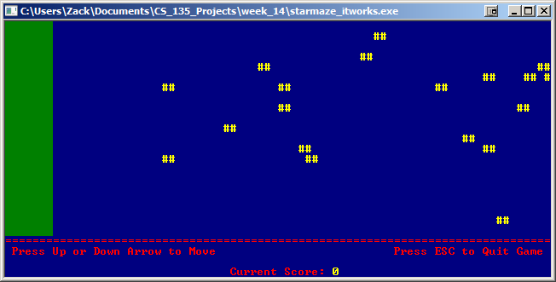

This is the fifth screenshot from starmaze_s6.cpp that demonstrates the easy difficulty screen:
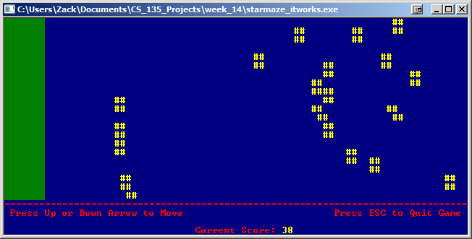
This is the sixth screenshot from starmaze_s6.cpp that demonstrates the user being prompted for their name:
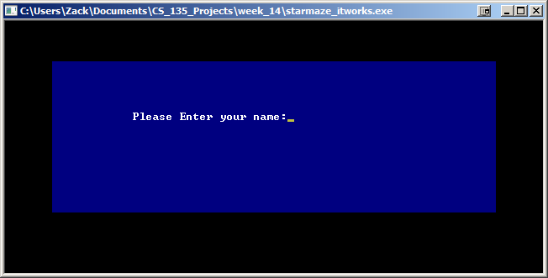

This is the seventh screenshot from starmaze_s6.cpp that demonstrates the empty list of top scores:
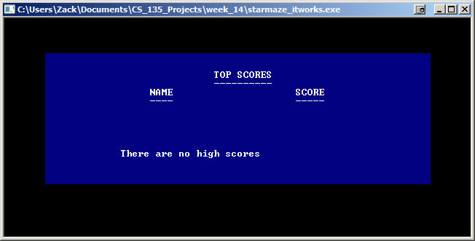
This is the eighth screenshot from starmaze_s6.cpp that demonstrates the list with three items:
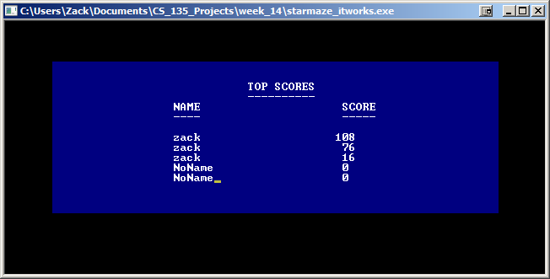

This is the ninth screenshot from starmaze_s6.cpp that demonstrates the list with five items:
