CPE 400: Computer Communication Networks

Zachary Carlson

Saturday, October 4, 2014

**Project 1 (Total 30 points)**

Instructions and Dependencies for running main.py

**Dependencies:**

Operation System: Ubuntu 12.04

Language: Python 2 (recommended 2.7.3)

External Python Libraries: Matplotlib – used for graphing functionality

**Instructions:**

Ubuntu 12.04 comes with Python 2 already installed. The following instructions will include installing Matplotlib and running the program (main.py).

**Installing Matplotlib:**

1. Enter in the terminal the following lines:
   1. sudo apt-get update
   2. sudo apt-get install python-pip
   3. sudo pip install matplotlib
   4. sudo apt-get update
   5. sudo apt-get build-dep python-matplot
2. If for some reason when executing the program Matplotlib was not installed, please refer to the following link for installation instructions: <http://matplotlib.org/contents.html>

**Running the program.**

1. Make sure you are using the right version of python by entering the following command in the terminal:
   1. python --version
2. Via the terminal, enter the directory where main.py is located. This is dependent on where you have saved the folder. (~/…/Carlson_proj1/)
3. Type in the terminal
   1. python main.py
   2. The program may take a few minutes before it outputs the results because it is set to run 50 simulations per case. It also runs all 5 simulations.
4. Done!

Screenshots and Output from main.py

**Initial Output after the program has run:**

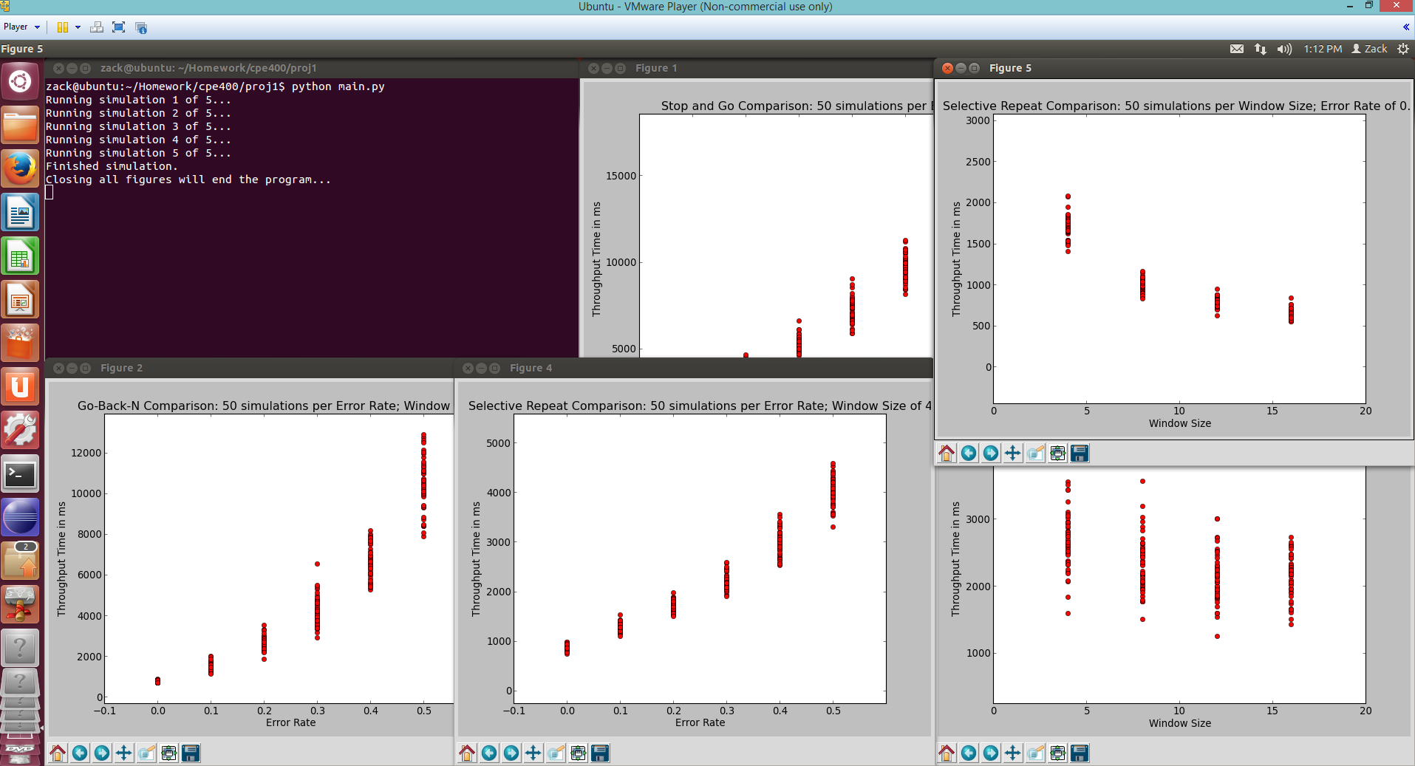

**Closer look at all 5 figures:**

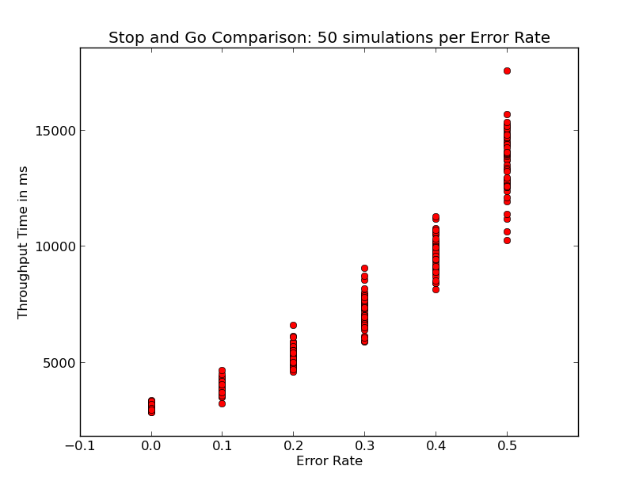

**Figure 1**: Stop and Go Comparison with 50 simulations per Error Rate.

Error Rate: {0.0, 0.1, 0.2, 0.3, 0.4, 0.5}

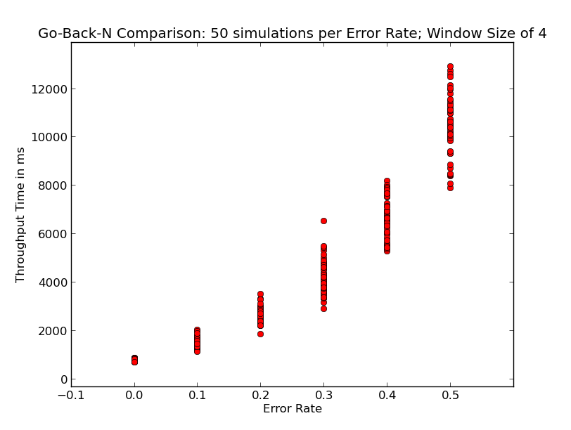

**Figure 2**: Go-Back-N Comparison with 50 simulations per Error Rate and a Window Size of 4.

Error Rate: {0.0, 0.1, 0.2, 0.3, 0.4, 0.5}

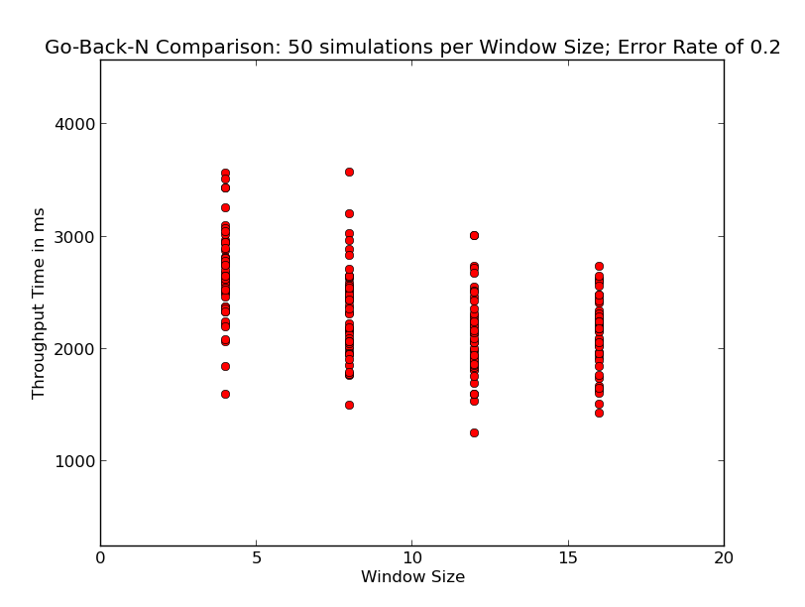

**Figure 3**: Go-Back-N Comparison with 50 simulations per Window Size and an Error Rate of 0.2.

Window Size: {4, 8, 12, 16}

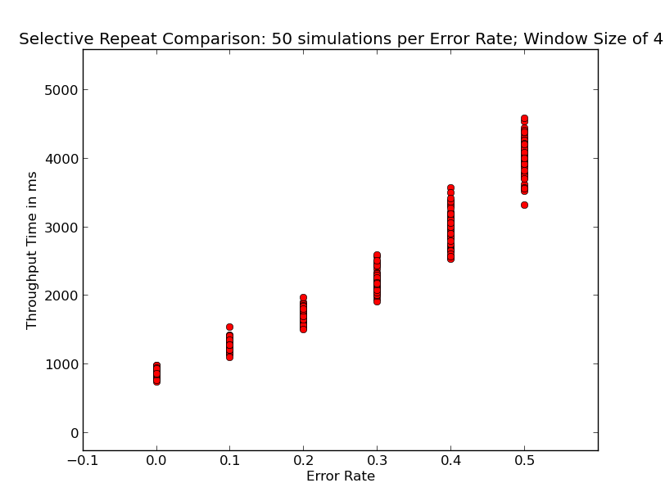

**Figure 4**: Selective Repeat Comparison with 50 simulations per Error Rate with a Window Size of 4.

Error Rate: {0.0, 0.1, 0.2, 0.3, 0.4, 0.5}

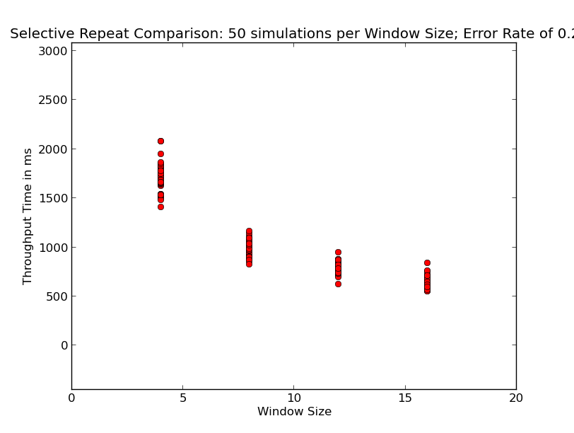

**Figure 5**: Selective Repeat Comparison with 50 simulations per Window Size and an Error Rate of 0.2.

Window Size: {4, 8, 12, 16}

Answers and Explanations

1. For the above scenarios, plot the throughout comparisons for all three protocols with respect to varying packet error rate and varying transmitter window size. From the results, explain which protocol is better under what conditions and why. If the number of packets is increased to 1000 instead of 100, will the trend be same? Comment.

**ANSWER**:

Selective Repeat with a high window size and an error rate around 0.2 (see Fig. 5) is the better protocol because the throughput time in ms is significantly faster than any other protocol for 100 packets of data. This trend will continue to be the same if packets were increased from 100 to 1,000 because window size and error rate are constant values. The variable we are measuring is throughput time in ms which would increase as the packet size increases, but the trends would still be the same with respect to window size and error rate.

Problem B on next page…

1. For the above scenarios (with number of packets as 100), compare the number of retransmissions needed among three protocols. If the number of packet is increased to 1000, compare the number of retransmissions. Comment on the trend.

**ANSWER**:

Along with this submission there is a program called *main-problemB.py*. This program is a modified version of *main.py* that generates the following bar graph comparing the means for each condition and the retransmissions. The means are calculated over 50 simulations per condition. Along the x-axis are the 5 groups:

A = Stop and Go with varying error rates

B = Go Back N with varying error rates and a window size of 4

C = Go Back N with varying window sizes and an error rate of 0.2

D = Selective Repeat with varying error rates and a window size of 4

E = Selective Repeat with varying window sizes and an error rate of 0.2

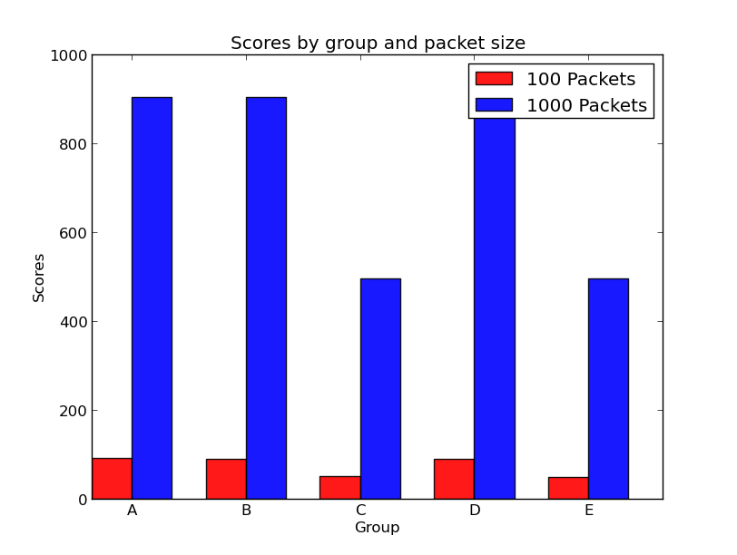

As we can see above, the number of packets that are retransmitted when increased to 1000 from 100, is roughly 10 times more in every condition.

Problem C on next page…

1. To avoid erroneous receiving (as we saw in class slides) what should be the relationship between transmitter window size and sequence number range? With the transmitter window varying from 4 – 16, what should be the ideal sequence number range and how many bits should be used for sequence number field? Explain your answer by providing a flowchart (as we saw in the class) for the case when transmitter window size is 4.

**ANSWER**: