**2020-09-28**

1. CRNN部分计划：

* 裸CRNN（bidirectional, dropout）

1. 训练：≤100 epoch
2. 评估

* Data augmentation+CRNN

1. 训练
2. 评估

* 参照成熟方案，调整训练x评估方式

1. 9 fold训练，1 fold评估
2. ~~7 fold训练，3 fold评估~~

* 翻DCASE，看SOTA
* 在不同模型上实验

**2020-09-29**

1. 裸CRNN训练1

23 epochs, 0.6 smoothing

C:\Users\43476\Desktop\3\CRNN\crnn\saved_cv\0928_231804

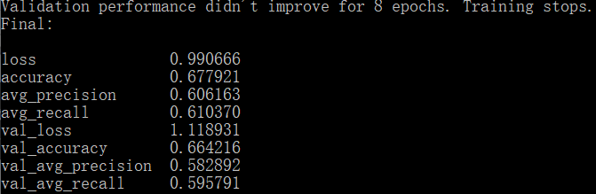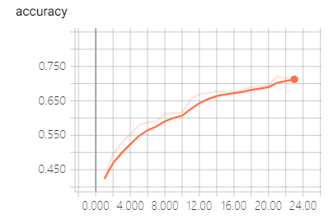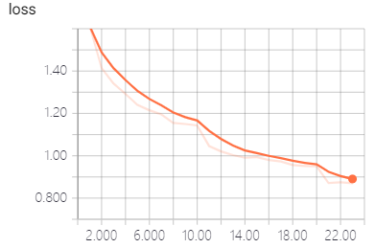

1. 裸CRNN训练2

42 epochs, 0.6 smoothing

C:\Users\43476\Desktop\3\CRNN\crnn\saved_cv\0929_102705

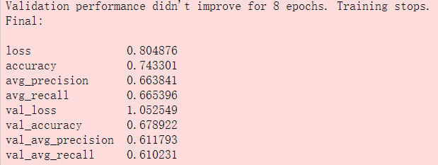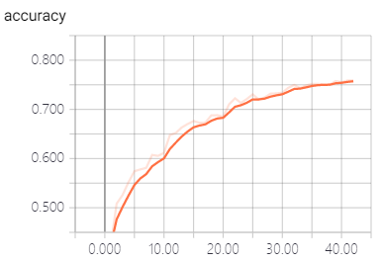 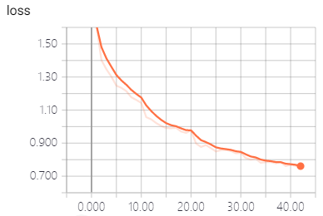

1. 裸CRNN训练3

15epochs, 0.6 smoothing

C:\Users\43476\Desktop\3\CRNN\crnn\saved_cv\0929_112221

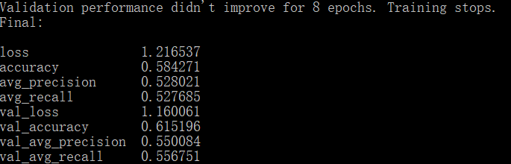 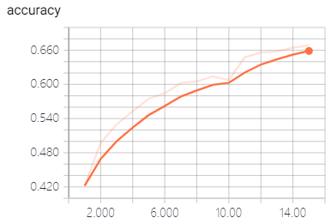 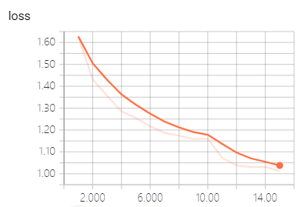

1. 裸CRNN训练4

59 epochs, 0.6 smoothing

C:\Users\43476\Desktop\3\CRNN\crnn\saved_cv\0929_115439

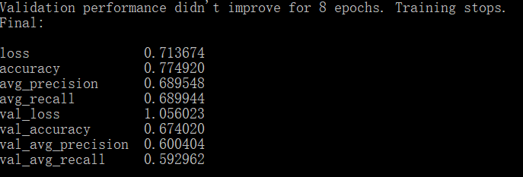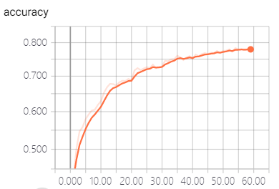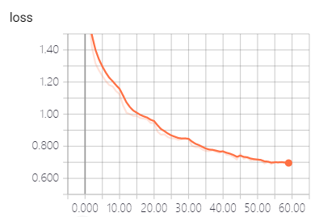

1. 裸CRNN训练5

43 epochs, 0.6 smoothing

C:\Users\43476\Desktop\3\CRNN\crnn\saved_cv\0929_172356

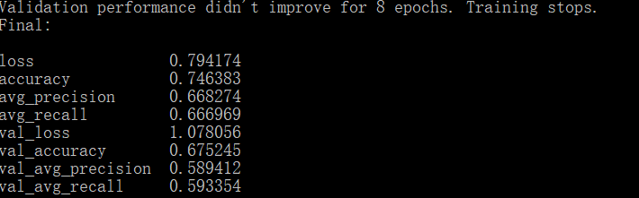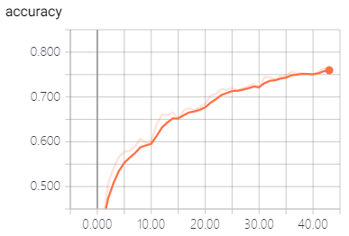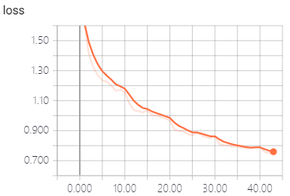

1. 裸CRNN训练6

26 epochs, 0.6 smoothing

C:\Users\43476\Desktop\3\CRNN\crnn\saved_cv\0929_182754

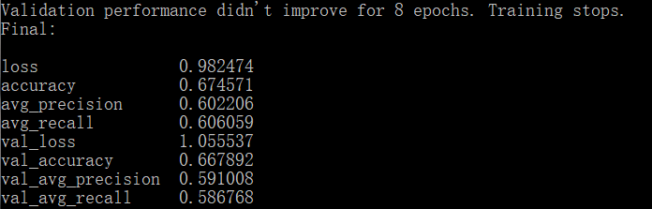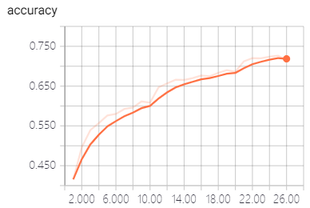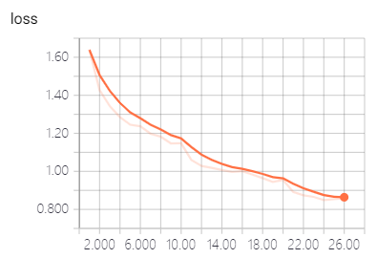

1. 裸CRNN训练7

28 epochs, 0.6 smoothing

C:\Users\43476\Desktop\3\CRNN\crnn\saved_cv\0929_191646

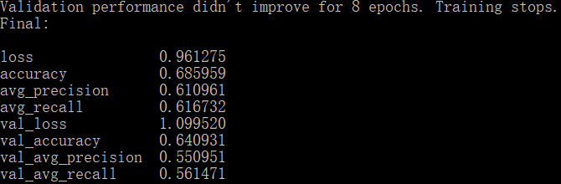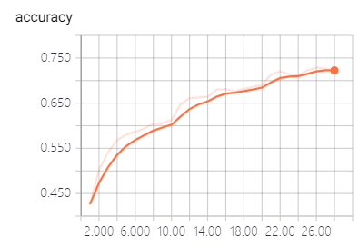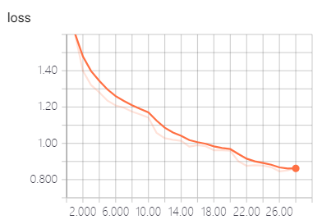

1. 裸CRNN训练8

75 epochs, 0.6 smoothing

C:\Users\43476\Desktop\3\CRNN\crnn\saved_cv\0929_195247

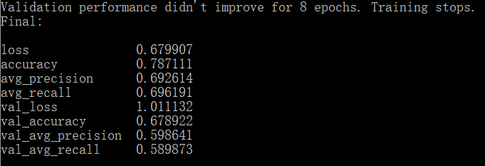 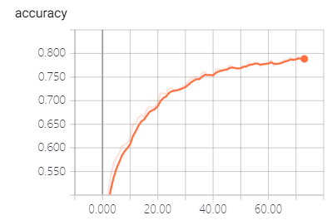 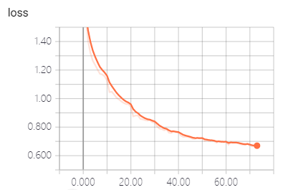

1. 裸CRNN训练9

31 epochs, 0.6 smoothing

C:\Users\43476\Desktop\3\CRNN\crnn\saved_cv\0929_213210

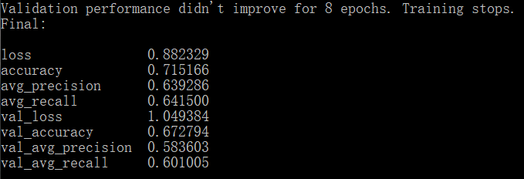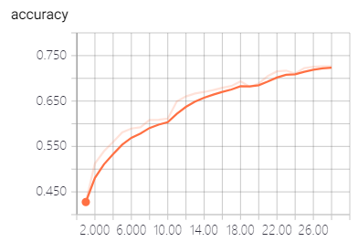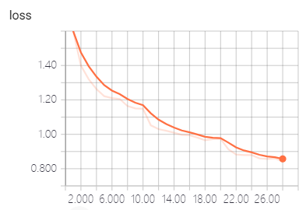

1. 裸CRNN训练10

33 epochs, 0.6 smoothing

C:\Users\43476\Desktop\3\CRNN\crnn\saved_cv\0929_221559

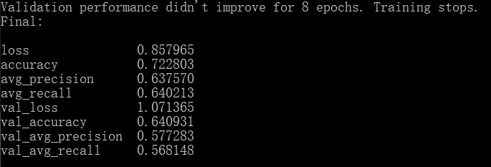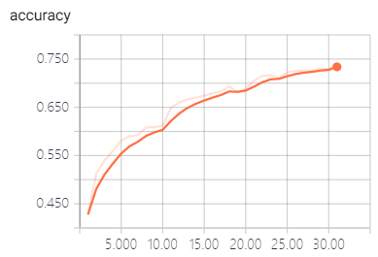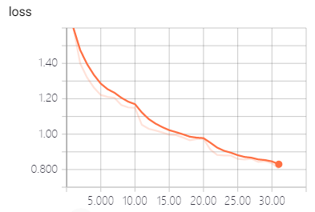

1. 每次epoch相差太大：说明loss函数在高维空间中的局部最优差异比较大

**2020-09-30**

1. 裸CRNN训练11

41 epochs, 0.6 smoothing

C:\Users\43476\Desktop\3\CRNN\crnn\saved_cv\0930_221235

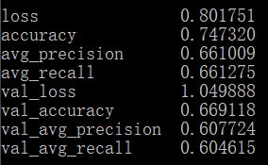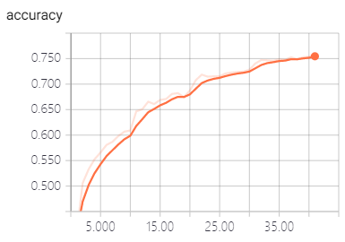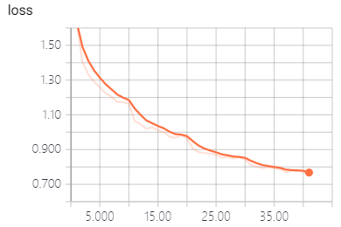

1. 裸CRNN训练12

26 epochs, 0.6 smoothing

C:\Users\43476\Desktop\3\CRNN\crnn\saved_cv\0930_231140

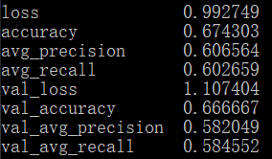 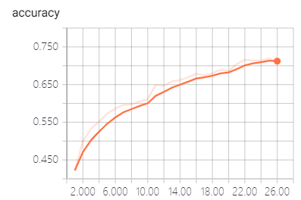 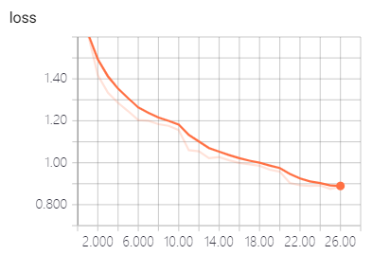

1. 裸CRNN训练13

30 epochs, 0.6 smoothing

C:\Users\43476\Desktop\3\CRNN\crnn\saved_cv\1001_205912

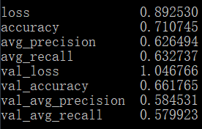 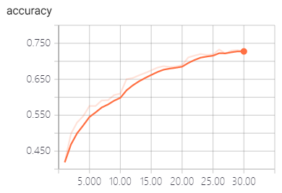 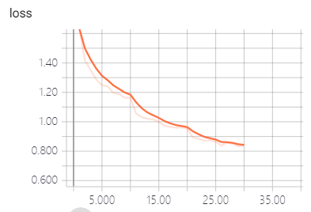

1. 裸CRNN训练14

16 epochs, 0.6 smoothing

C:\Users\43476\Desktop\3\CRNN\crnn\saved_cv\1001_213933

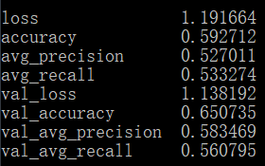

1. 裸CRNN训练15
2. epochs, 0.6 smoothing

C:\Users\43476\Desktop\3\CRNN\crnn\saved_cv\1001_220054

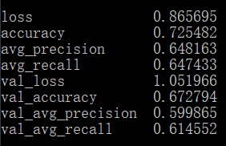

1. 裸CRNN训练16
2. epochs, 0.6 smoothing

C:\Users\43476\Desktop\3\CRNN\crnn\saved_cv\1001_224531

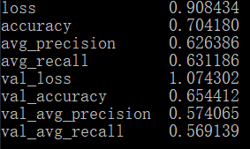

1. 裸CRNN训练17
2. epochs, 0.6 smoothing

C:\Users\43476\Desktop\3\CRNN\crnn\saved_cv\1001_233315

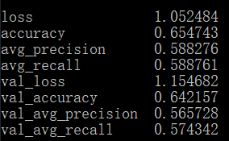

1. 裸CRNN训练18
2. epochs, 0.6 smoothing

C:\Users\43476\Desktop\3\CRNN\crnn\saved_cv\1002_100754

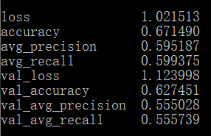

1. 裸CRNN训练19
2. epochs, 0.6 smoothing

C:\Users\43476\Desktop\3\CRNN\crnn\saved_cv\1002_105401

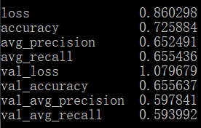

1. 裸CRNN训练20
2. epochs, 0.6 smoothing

C:\Users\43476\Desktop\3\CRNN\crnn\saved_cv\1002_114727

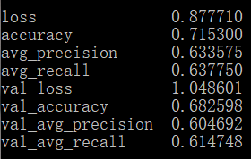

1. 裸CRNN训练21
2. epochs, 0.6 smoothing

C:\Users\43476\Desktop\3\CRNN\crnn\saved_cv\1002_131524

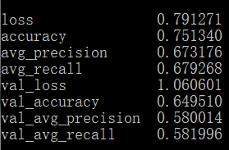

1. 裸CRNN训练22
2. epochs, 0.6 smoothing

C:\Users\43476\Desktop\3\CRNN\crnn\saved_cv\1002_214602

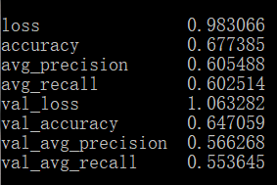

1. 裸CRNN训练23
2. epochs, 0.6 smoothing

C:\Users\43476\Desktop\3\CRNN\crnn\saved_cv\1002_222419

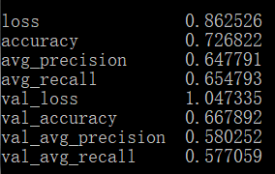

1. 裸CRNN训练24
2. epochs, 0.6 smoothing

C:\Users\43476\Desktop\3\CRNN\crnn\saved_cv\1003_221332

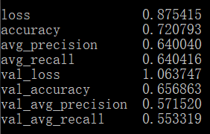

1. 裸CRNN训练25
2. epochs, 0.6 smoothing

C:\Users\43476\Desktop\3\CRNN\crnn\saved_cv\1003_230108

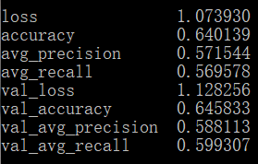

1. 裸CRNN训练26
2. epochs, 0.6 smoothing

C:\Users\43476\Desktop\3\CRNN\crnn\saved_cv\1003_233932

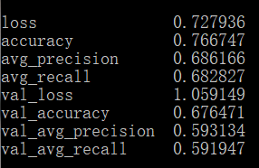

**2020-10-05**

1. augmented CRNN训练1

35 epochs, 0.6 smoothing

C:\Users\43476\Desktop\3\CRNN\crnn\saved_cv\1005_105353

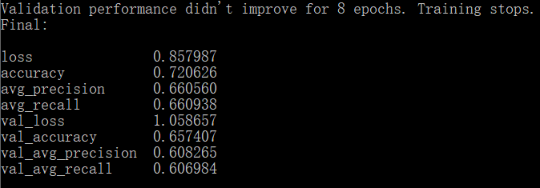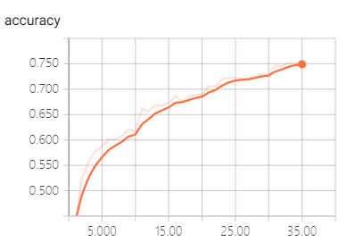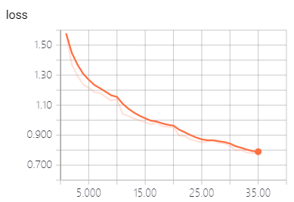

1. augmented CRNN训练2

22 epochs, 0.6 smoothing

C:\Users\43476\Desktop\3\CRNN\crnn\saved_cv\1005_121951

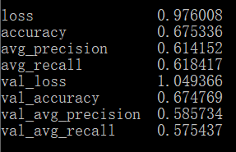

1. augmented CRNN训练3

30 epochs, 0.6 smoothing

C:\Users\43476\Desktop\3\CRNN\crnn\saved_cv\1005_125154

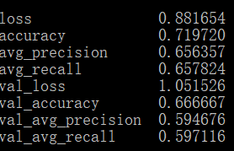

1. augmented CRNN训练4

30 epochs, 0.6 smoothing

C:\Users\43476\Desktop\3\CRNN\crnn\saved_cv\1005_132955

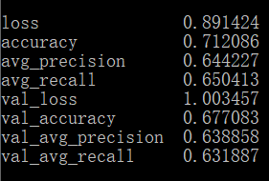

1. augmented CRNN训练5
2. epochs, 0.6 smoothing

C:\Users\43476\Desktop\3\CRNN\crnn\saved_cv\1005_141353

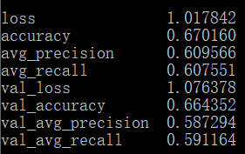

1. augmented CRNN训练6

45 epochs, 0.6 smoothing

C:\Users\43476\Desktop\3\CRNN\crnn\saved_cv\1005_155509

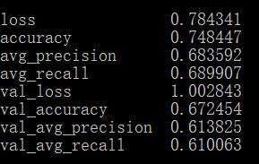

1. augmented CRNN训练7
2. epochs, 0.6 smoothing

C:\Users\43476\Desktop\3\CRNN\crnn\saved_cv\1005_220211

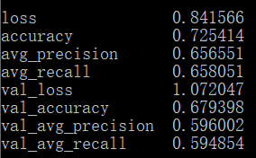

1. augmented CRNN训练8
2. epochs, 0.6 smoothing

C:\Users\43476\Desktop\3\CRNN\crnn\saved_cv\1005_231614

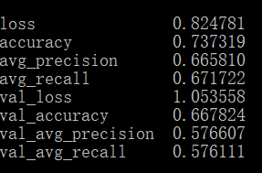

1. augmented CRNN训练9
2. epochs, 0.6 smoothing

C:\Users\43476\Desktop\3\CRNN\crnn\saved_cv\1006_120813

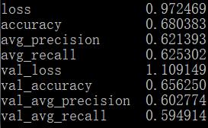

1. augmented CRNN训练10
2. epochs, 0.6 smoothing

C:\Users\43476\Desktop\3\CRNN\crnn\saved_cv\1006_123905

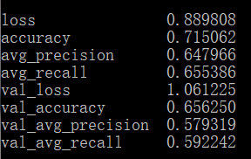

1. augmented CRNN训练11
2. epochs, 0.6 smoothing

C:\Users\43476\Desktop\3\CRNN\crnn\saved_cv\1007_101100

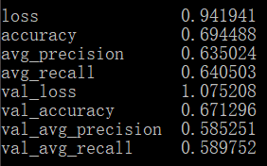

1. augmented CRNN训练12
2. epochs, 0.6 smoothing

C:\Users\43476\Desktop\3\CRNN\crnn\saved_cv\1007_104640

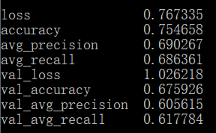

1. augmented CRNN训练13
2. epochs, 0.6 smoothing

C:\Users\43476\Desktop\3\CRNN\crnn\saved_cv\1007_113848

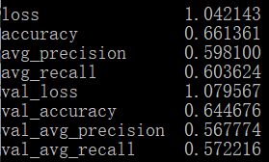

1. augmented CRNN训练14

33 epochs, 0.6 smoothing

C:\Users\43476\Desktop\3\CRNN\crnn\saved_cv\1007_120824

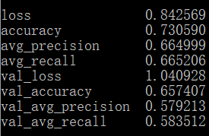

1. augmented CRNN训练15

23 epochs, 0.6 smoothing

C:\Users\43476\Desktop\3\CRNN\crnn\saved_cv\1007_130522

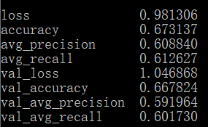

1. augmented CRNN训练16
2. epochs, 0.6 smoothing

C:\Users\43476\Desktop\3\CRNN\crnn\saved_cv\1007_230057

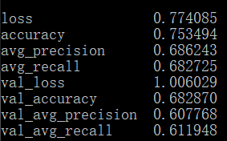

1. augmented CRNN训练17
2. epochs, 0.6 smoothing

C:\Users\43476\Desktop\3\CRNN\crnn\saved_cv\1008_000929

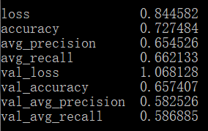

1. augmented CRNN训练18
2. epochs, 0.6 smoothing

C:\Users\43476\Desktop\3\CRNN\crnn\saved_cv\1008_105917

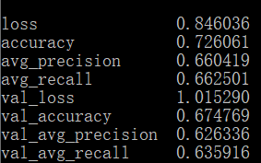

1. augmented CRNN训练19
2. epochs, 0.6 smoothing

C:\Users\43476\Desktop\3\CRNN\crnn\saved_cv\1008_115131

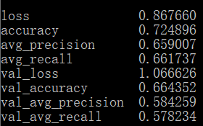

1. augmented CRNN训练20
2. epochs, 0.6 smoothing

C:\Users\43476\Desktop\3\CRNN\crnn\saved_cv\1008_123750

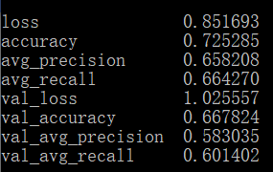

**2020-10-09**

1. **跟xuanpeng老师讨论：从检测角度来看，confidence低于一定阈值是无效结果，可以走的实验思路：**

* confidence直方图
* 不加阈值直接最大似然的准确性
* 加阈值的结果，考虑低于阈值的判别为无效检测，分析阈值、数据增强对准确性的记过
* 准确率、召回率等指标

**技术手册**

**模型**

1. 模型的定义：通过PyTorch cfg parser定义在crnn.cfg文件中

**训练**

1. 训练
2. 打开conda，启动env环境
3. 转至工程所在目录
4. 开始训练

python ./run.py train -c config.json --cfg crnn.cfg

1. 评估
2. 打开eval.py
3. 修改torch.load地址，执行
4. 得到gunshot.csv，查看
5. 使用jupyter训练
6. 打开conda，启动env环境
7. 打开jupyter

jupyter notebook

1. 使用命令
2. 最好还是用cmd打开tensorboard…
3. 查看tensorboard

tensorboard --logdir=C:\Users\43476\Desktop\3\CRNN\crnn\saved_cv\0928_231804\logs\train

需更改

https://www.cnblogs.com/ipersevere/p/10843115.html