

AMERICAN INTERNATIONAL UNIVERSITY–BANGLADESH (AIUB)

Faculty of Science and Technology

Dept. of Computer Science

COURSE: SOFTWARE ENGINEERING

Summer 2025-2026

Section: DD

Group No: H

Software Requirement Specification [SRS] Document On

Project Name: Agentic Operations and Dynamic Scheduling Platform for Field Services

Supervised By:

Sourav Akib Sarkar

Submitted By

Name |  | ID
1. | Abrar Tajwar Khan | 24-57356-2
2. | Ahmed Aahan Addin | 24-57325-2
3. | Lasker Sifwat Hossein | 24-57368-2
4. | Sadnan Shahad | 24-57524-2

1. INTRODUCTION
Service-based businesses—such as automotive detailing centers, HVAC repair agencies, and on-demand field maintenance providers—rely heavily on efficient appointment management and field resource coordination to maintain profitability. Currently, many small-to-medium enterprises (SMEs) manage bookings, technician assignments, customer updates, and invoicing through fragmented channels like phone calls, spreadsheet logs, and manual messaging apps.
This disconnected approach introduces several critical operational inefficiencies:
- Scheduling Conflicts & Idle Time: Manual time-slot allocation frequently results in double-bookings, overlapping appointments, or unoptimized schedule gaps that waste billable technician hours.
- High Customer No-Show Rates: Without automated status triggers and real-time confirmations, customers often forget appointments or lack visibility into technician arrival times.
- Uncoordinated Field Dispatch: Service managers lack real-time oversight of staff availability, skill sets, and location proximity, making dynamic job routing inefficient.
- Manual Revenue Leakage: Delayed paper-based invoicing, lack of upfront booking deposits, and manual payment tracking lead to lost revenue from last-minute cancellations and unpaid balances.
This project addresses these operational gaps by proposing a centralized, web-based Operations and Dynamic Scheduling Platform powered by agentic workflows. The system integrates automated time-slot calculation, finite state-machine job tracking, event-driven CRM webhooks, and streamlined billing into a single unified platform, providing service providers, field technicians, and customers with a real-time, synchronized operational view.

2. SCOPES & FEATURES

2.1 Scope 1: Dynamic Scheduling & Agentic Slot Engine
- User Authentication & RBAC: Multi-role authentication (Admin, Manager, Field Staff, Customer) with secure session handling.
- Intelligent Slot Calculation: An agentic backend tool that evaluates service duration, buffer times, and technician working hours to expose valid booking windows.
- Concurrency Locking: Database-level transactional locks to prevent concurrent booking race conditions on identical time slots.

2.2 Scope 2: State-Machine Lifecycle & Dispatch Management
- Finite State Engine: Enforces linear job state progression: Pending - Scheduled - En Route - In Progress - Completed - Billed.
- Skill-Based Dispatching: Management interface enabling dispatchers to assign technicians based on active availability, location buffers, and required technical skills.
- Technician Mobile Portal: Lightweight UI for field staff to transition job states and record client digital sign-offs.

2.3 Scope 3: Automated CRM & Event-Driven Webhooks
- Automated Status Alerts: Webhook-driven messaging engine dispatching context-aware SMS/WhatsApp updates to customers upon state changes.
- Customer Self-Service History: Client portal displaying active booking statuses, technician ETA links, and historical service records.

2.4 Scope 4: Invoicing, Deposits & Analytics Dashboard
- Upfront Deposit Processing: Payment gateway integration to collect partial deposits during initial booking to mitigate no-shows.
- Automated Final Invoicing: Auto-generation of itemized final invoices upon job completion.
- Operational Analytics Dashboard: Visual metrics tracking daily booking counts, overall revenue, technician productivity, and customer feedback.

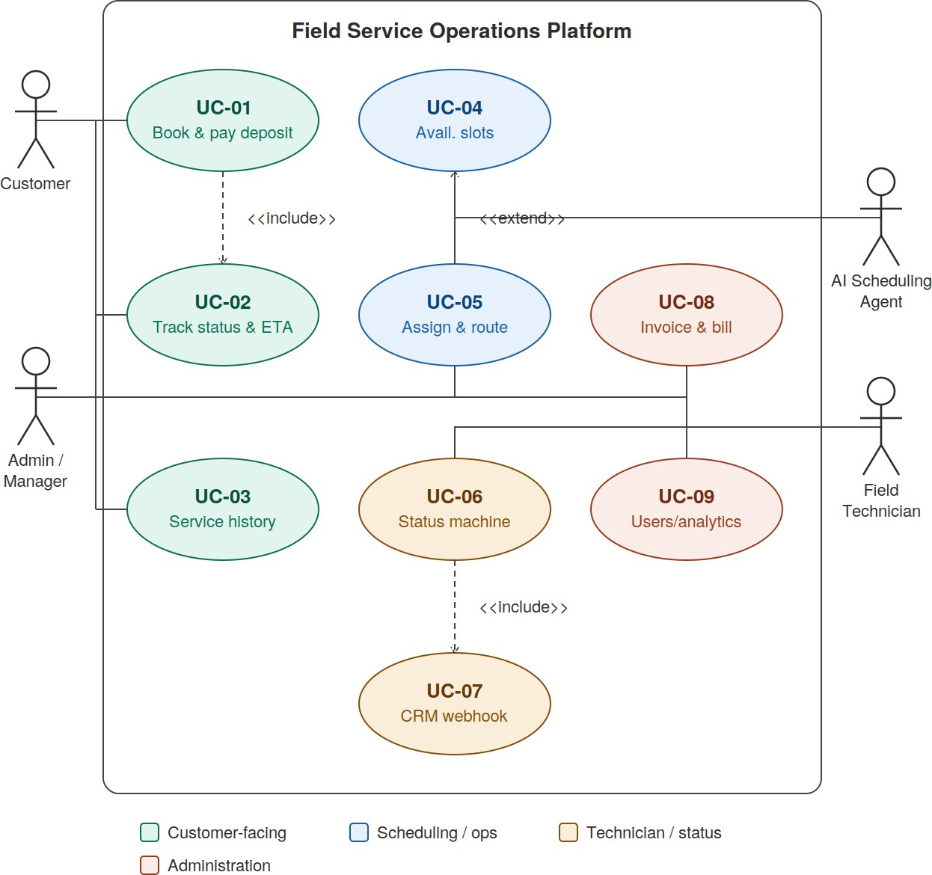
3. USE CASE DIAGRAM

Use Case Reference

Code | Use case name
UC-01 | Book Appointment & Pay Deposit
UC-02 | Track Job Status & ETA
UC-03 | View Service History
UC-04 | Calculate Available Slots
UC-05 | Assign Technician & Route
UC-06 | Update Status State Machine
UC-07 | Trigger CRM Webhook Alert
UC-08 | Generate Invoice & Billing
UC-09 | Manage Users & Analytics

Diagram Description:
The system interacts with four primary actors: Customer, Admin/Manager, Field Technician, and the AI Scheduling Agent. The Customer initiates bookings (UC-01), tracks real-time status (UC-02), and reviews histories (UC-03). The AI Scheduling Agent dynamically evaluates database states to calculate valid slots (UC-04) and assists in routing (UC-05). The Field Technician interacts with the state machine to advance job progression (UC-06), which automatically triggers external CRM webhooks (UC-07). The Admin/Manager oversees dispatching, billing (UC-08), and platform analytics (UC-09).

4. USER STORY TABLE
User Story ID | As a [Role] | I want to [Goal / Action] | So that I can [Benefit / Value] | Priority
US-01 | Customer | book a service by selecting an available time slot | secure my preferred appointment time without calling. | High
US-02 | Customer | pay an upfront deposit online | confirm my booking and prevent slot forfeitures. | High
US-03 | Customer | receive automated SMS/WhatsApp ETA updates | know exactly when the technician will arrive. | Medium
US-04 | Field Tech | update job status from "En Route" to "In Progress" | keep dispatchers and clients informed of job progress. | High
US-05 | Dispatcher | assign available technicians to pending jobs | optimize field resource utilization and travel time. | High
US-06 | System | prevent overlapping appointment bookings | avoid double-booking race conditions in the database. | High
US-07 | Admin | view a daily revenue and booking dashboard | assess business performance and team efficiency. | Medium
US-08 | Customer | access itemized billing statements online | review pricing breakdowns and keep service records. | Low

5. REQUIREMENT TRACEABILITY MATRIX

5.1 Functional Requirements
Req ID | Requirement Description | Mapped User Story | Mapped Scope Module | Verification Method
FR-01 | The system shall authenticate users using encrypted credentials and enforce Role-Based Access Control (RBAC). | US-01, US-04, US-07 | Scope 1 | Unit / Security Test
FR-02 | The system shall calculate available booking slots dynamically based on service length and existing calendar entries. | US-01, US-06 | Scope 1 | Integration Test
FR-03 | The system shall enforce database row-level locks during slot reservation to prevent race conditions. | US-06 | Scope 1 | Concurrency Test
FR-04 | The state engine shall strictly enforce the linear progression: Pending - Scheduled - En Route - In Progress - Completed - Billed. | US-04, US-05 | Scope 2 | System Test
FR-05 | The system shall emit asynchronous webhook calls to third-party messaging providers upon state machine transitions. | US-03 | Scope 3 | Integration Test
FR-06 | The system shall collect partial deposit payments through an integrated payment gateway prior to booking lock. | US-02 | Scope 4 | End-to-End Test
FR-07 | The system shall auto-generate PDF invoices upon job status transition to "Billed". | US-08 | Scope 4 | Functional Test
FR-08 | The admin dashboard shall display aggregated revenue, booking counts, and technician utilization rates. | US-07 | Scope 4 | Acceptance Test

5.2 Non-Functional Requirements
Req ID | NFR Category | Requirement Specification | Measurement / Benchmark
NFR-01 | Performance | Slot calculation and API query response times must remain under threshold under normal loads. | Response time < 200 ms for 95% of queries
NFR-02 | Availability | System uptime must support continuous operational availability for dispatch and bookings. | 99.5% service availability
NFR-03 | Security | All sensitive data in transit must be encrypted; passwords must be hashed using strong industry algorithms. | TLS 1.3 encryption and bcrypt password hashing
NFR-04 | Usability | The mobile interface for field technicians must render responsively across devices. | 100% mobile-responsive layout compliance
NFR-05 | Scalability | The database structure must support horizontal growth without structural redesign. | Supports growth up to $10,000+ active monthly bookings

