Sault college

Name: Gurpreet Singh

Student ID: 23059357

LAB 2

Professor : Nawaz Chowdhary

Course : Introduction to Programming

**Program 1**

Create a Python program to calculate the average daily high temperature and the average monthly high temperature.

**Instructions:**

1. Ask the user to enter the number of years.
2. Prompt the user to input the average high temperature for each month.
3. You must use **while loops** here.
4. After receiving the monthly inputs per year, you must calculate the average high temperature for every year, along with the average monthly high temperature over the full period.

**Program 2**

Write a Python program for the following scenario using functions and for loop.

**Instructions:**

1. Let us suppose your doctor asks you to record your daily data intake of calories during a diet.
2. Note that every day, the number of calories should be increased by a certain small percentage.
3. Ask the user to enter the following:
   1. Starting daily calorie intake.
   2. Average daily percentage decrease.
   3. The number of days.
4. The user must enter only positive values, otherwise an error will be printed on the console, and the user must be prompted to enter the values again.
5. If the values are positive, you must decrease by the percentage for the specified number of days to the start of the diet.  
   NOTE: If the diet decreases calories below 1200 then you must stop decreases and produce a note when the diet stabilized.
6. Note: Day 1 count will start from the original starting count.
7. Print the calories data on the daily basis.

**Program 3**

**Instructions:**

Write a Python program using **nested for loop** to print the following pattern:



**Program 4**

Write a Python program for the following scenario by using lists, functions, and loops.

**Instructions:**

1. Declare and initialize a 9-integer list with the name “myNumbers.”
2. During the initialization of this list, store the following numbers in it: 4,6,9,12,17,22,27,33,44.
3. By using the concept of loops, iterate through the elements of the list one by one and print them on the console.
4. Sort the list as follows:
   1. First, move through the list and find the largest number left in the list.
   2. Swap that number for the last element in the unsorted list.
   3. Reduce the range of the list you are sorting by 1 and repeat steps a and b until there is only 1 element left to consider.
   4. Print the sorted list.

# Program3

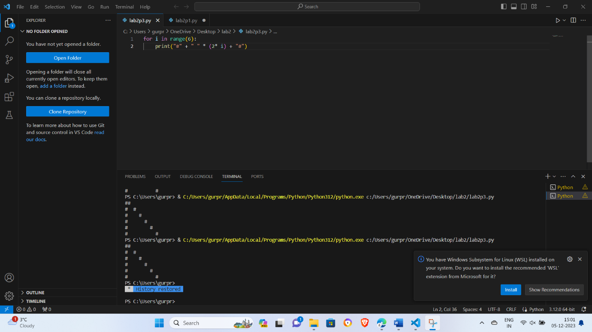

# Program4

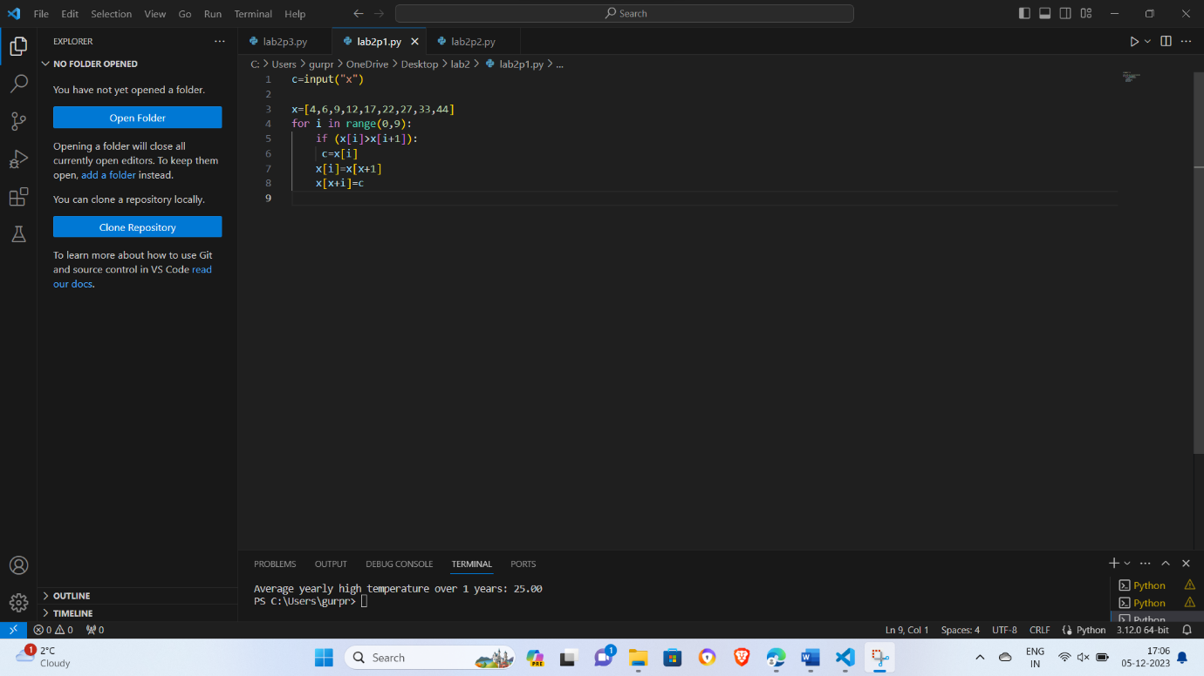

# Program1

