Sault college

Name: Gurpreet Singh

Student ID: 23059357

Test 1

Professor : Nawaz Chowdhary

Course : Introduction to Programming

#### **Question 1 (25%)**

Write a Python program using **if-elif-else** approach for the following problem.

Display the following messages and get inputs from the user:

* Enter the month in the **numeric** form.
* Enter the day in **numeric** form.
* Enter the year in two **numeric** digits (for example: 98, 20, 21).

In case of an invalid user input for day, month, or year, print the following messages:

* Month: “Error: Invalid Month Input”
* Day: “Error: Invalid Day Input”
* Year: “Error: Invalid Year Input”

Check that you have been given an appropriate day input for a particular month. For example, the 48th of a month or the 30th of February are not valid. For simplicity’s sake, you can assume that any 4th year has a 29th of February rather than do the full calculation. If the day is not appropriate, print the following message: “Error: There is no such date in the calendar.”

For all valid inputs from the user, print the date with all three inputs in a date format along with the following message:

“Success: Congratulations! You entered a correct date.”

**Demo outputs:**

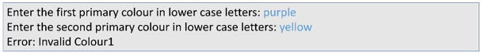



#### **Question 2 (25%)**

Write a Python program using **if-elif-else and nested if-else** for the following.

**Note: The user must enter the colour in lowercase letters.**

Declare the following global variables for the three colours with the following values:  
RED = "red"  
BLUE = "blue"  
YELLOW = "yellow"

This program must prompt the user to input two **different** primary colours: “colour1” and “colour2.”  
Consider the following situations:

1. If color1 is not a primary colour (RED, BLUE, or YELLOW), then print the error message: “Error: Invalid Colour1.”
2. If color2 is not a primary colour, then print the error message: “Error: Invalid Colour2.”
3. If colour1 and colour2 are the same, then print the error message: “Error: The two colours you entered are the same.”
4. Otherwise, if the inputs are valid, the program will report the secondary colour which is the mix of the two primary colours as follows:
   1. When first colour is “RED”:
      1. RED+BLUE=PURPLE
      2. RED+YELLOW=ORANGE
   2. When first colour is “BLUE”:
      1. BLUE+RED=PURPLE
      2. BLUE+YELLOW=GREEN
   3. When first colour is “YELLOW”:
      1. YELLOW+RED=ORANGE
      2. YELLOW+BLUE=GREEN

**Demo output:**



#### **Question 3 (50%)**

Write a Python program for the following problem.

Let us assume our user is currently working in Germany and wishes to migrate to another country. Ask the user to enter their annual salary in euros. Prompt the user to enter the country to which they want to migrate. Acceptable inputs are: ‘Canada’, ‘USA’, ‘Cambodia’, and ‘United Kingdom’. Other inputs must be rejected.

By calling the function **“convertSalary()”**, convert the user’s salary into the corresponding currency based on the conversion rates given below:



Compare the converted user’s salary against the average salaries of the respective country given below and print, “You will be <rich/poor> in <Country Name> with a salary of <Converted Amount> <Currency Name>.”

Average salaries of countries:



**Note:**

1. Students must use the concept of functions during conversions and all the other calculations.
2. The function must return the final output value back to the function call.

**Demo program operation 1:**

Please enter your salary in Germany in euros: 17,000

Enter the country you want to migrate to: Canada

You will be poor in Canada with a salary of 26520 CAD.

**Demo program operation 2:**

Please enter your salary in Germany in euros: 17,000

Enter the country you want to migrate to: Cambodia

You will be rich in Cambodia with a salary of 79,120,890 Cambodian Riel.

# Program1

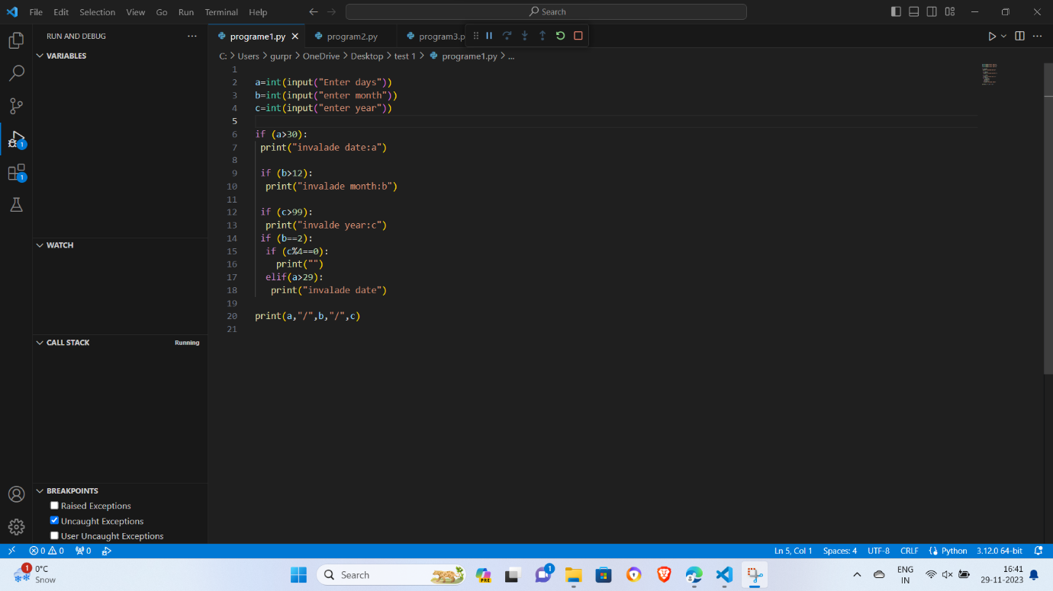

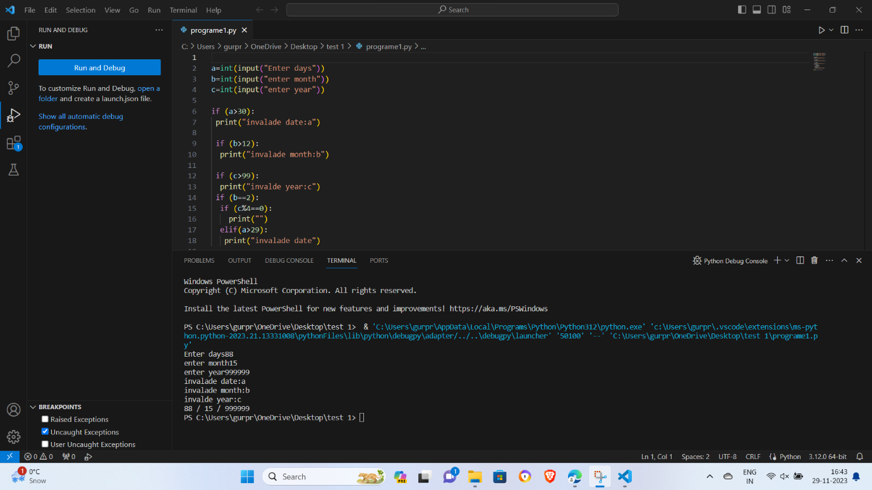

# Program2

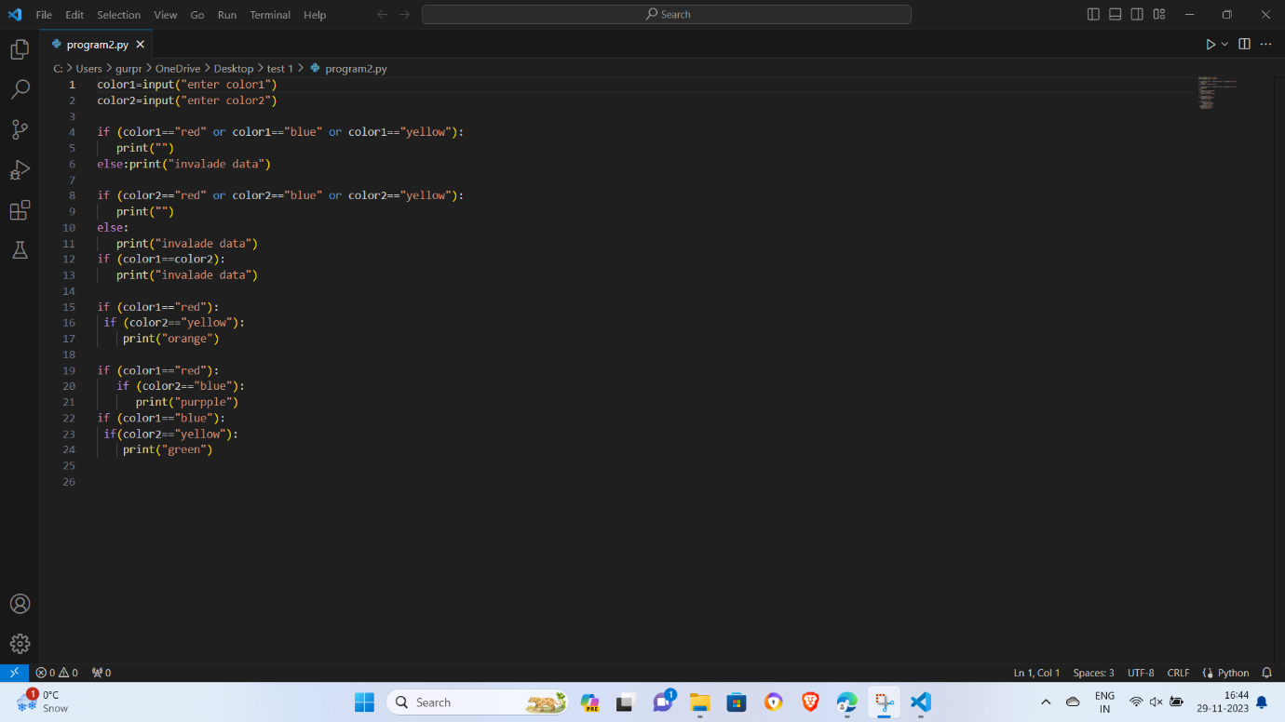

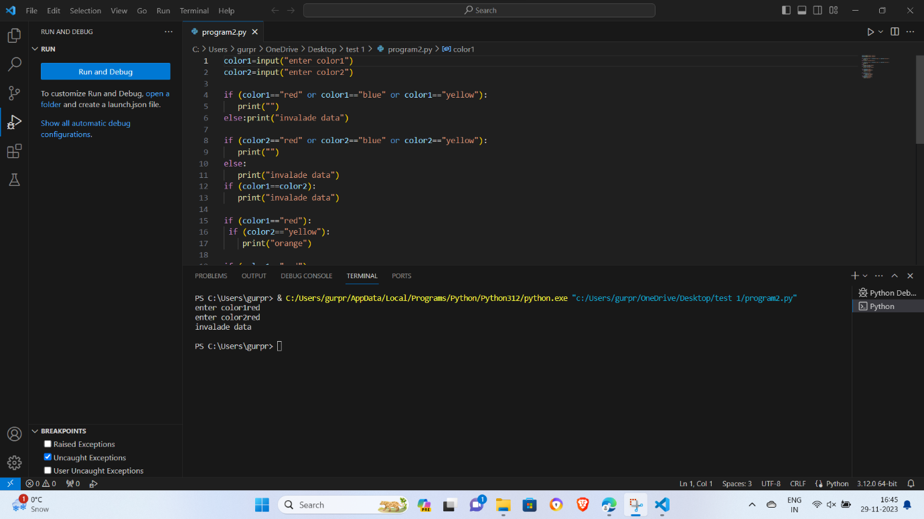

# Program3

