# Set-Ups

## Code Template



## Add Shortcuts



## Sublime Command line



## C++ Data types

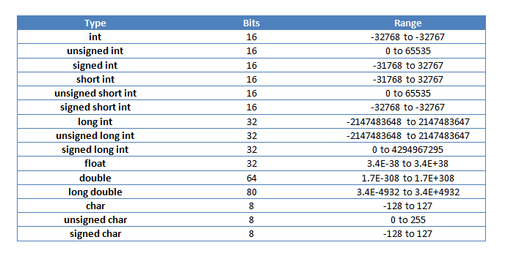

## RNG



## Bits functions



## Timings



## Input / Output



## Debug Code



# Notes







’

# Math

## Fast Power



## Extended Euclidean GCD



## Fibonacci Numbers



## Linear Sieve



## Phi Values



## nCk / nPk



## FFT



## NTT



# Data Structures

## DSU



## DSU With Roll-Back







## BIT/ Fenwick



## BIT/ Fenwick 2D



## Ranged BIT/Fenwick



## Segment tree Classic





## Segment tree Compressed





## Segment tree Persistent





## Trie



## Ordered Set



# Dynamic Programming

## Convex Hull trick Multiset



## Li Chao Tree





## Convex Hull trick Multiset



## Alien Trick



## Knuth's Optimization









## Convex Hull trick Multiset



# Strings

## Hashing



## KMP



# Geometry

## 3D Geometry





## 2D Geometry





## Distance Between a Point and a line segment



## Check if a point is to the left or right to a line



## Plane Equation



# Graph

## Strongly Connected Components



## Bridges and Articulation Points



## Bridges Online







## FloyedWarshall



## Bellman Ford



## Cycle in Directed Graph



## 2-SAT





## Maximum Matching



## Maximum Matching Slow



## Shortest Cycle Undirected Graph



# Trees

## LCA





## Auxiliary Tree

## Centroid Decomposition

## Sack

## Heavy Light decomposition (HLD)



# Flows

## Dinic Max Flow



## Ford Fulkerson Min Cut



# Extras

## Matrix Fast Power

## Farthest 2 Points Manhattan Distance



## Longest increasing Subsequance

## Disjoint Sparse Table

## Maximum Subset Xor



Table Of Contents

Set-Ups 1

Code Template 1

Add Shortcuts 1

Sublime Command line 1

C++ Data types 2

RNG 2

Bits functions 2

Input / Output 3

Debug Code 3

Notes 4

Math 7

Fast Power 7

Extended Euclidean GCD 7

Fibonacci Numbers 8

Linear Sieve 8

Phi Values 9

nCk / nPk 9

FFT 10

NTT 11

Data Structures 12

DSU 12

DSU With Roll-Back 13

BIT/ Fenwick 16

BIT/ Fenwick 2D 17

Ranged BIT/Fenwick 18

Segment tree Classic 19

Segment tree Compressed 21

Segment tree Persistent 23

Trie 25

Ordered Set 26

Dynamic Programming 27

Convex Hull trick Multiset 27

Li Chao Tree 28

Convex Hull trick Multiset 30

Alien Trick 31

Knuth's Optimization 32

Convex Hull trick Multiset 35

Strings 36

Hashing 36

KMP 37

Geometry 38

3D Geometry 38

2D Geometry 40

Distance Between a Point and a line segment 42

Check if a point is to the left or right to a line 42

Plane Equation 43

Graph 44

Strongly Connected Components 44

Bridges and Articulation Points 45

Bridges Online 46

FloyedWarshall 48

Bellman Ford 49

Cycle in Directed Graph 50

2-SAT 51

Maximum Matching 53

Maximum Matching Slow 54

Shortest Cycle Undirected Graph 55

Trees 56

LCA 56

Auxiliary Tree 58

Centroid Decomposition 59

Sack 60

Heavy Light decomposition (HLD) 61

Flows 63

Dinic Max Flow 63

Ford Fulkerson Min Cut 65

Extras 67

Matrix Fast Power 67

Farthest 2 Points Manhattan Distance 68

Longest increasing Subsequance 69

Disjoint Sparse Table 70

Maximum Subset Xor 71