OTIS-MCAT Quick Start Guide

Adam S. Ward

Last Updated: 1-March-2016

Accompanies MANUSCRIPT TITLE AND PUB INFO HERE

Author contact information:

School of Public and Environmental Affairs

Indiana University

430 MSB-II

Bloomington, IN 47405

Email: adamward@indiana.edu

Phone: 812-856-4820

**STEP 1: Download and the OTIS-MCAT code from GitHub**

Download the OTIS-MCAT code distribution as a *.zip file, and extract the files on your machine in a working directory.

**STEP 2: Download the appropriate OTIS executable file**

Execution of the OTIS-MCAT requires that an executable version of the OTIS code that is compiled for your machine is available. Bundled with the code on GitHub are executable files for UNIX and Microsoft Windows 64-bit operating systems. Additional executable files are available for download from the USGS at:

<http://water.usgs.gov/software/OTIS/>

Users should verify that the executable works on their machine by carefully reviewing the OTIS documentation from the USGS, and successfully executing Example 1in the sample files available with the OTIS download.

To verify that the executable already bundled with the software will work on your machine, it is suggested to test the appropriate executable in the folder “code/OTIS-MCAT_TEST/” (either OTIS.EXE for Windows OS, or otis for UNIX).

The key outcome of STEP 2 is to place a working OTIS executable in the folder “code/OTIS-MCAT_TEST/”, with a filename matching exactly the existing executable files.

**STEP 3: Build the required input files**

Templates are provided with the code download. The files and their preparation are detailed below.

***upstream.csv*** – time-series of in-stream concentration at the upstream end of the solute tracer study. This is commonly the data observed at the well-mixed location downstream of the injection. Note that times should be specified in hours. It is recommended to prepare this file using a spreadsheet tool or write-out the data from another computer program.

***downstream.csv*** – time-series of in-stream concentration at the downstream end of the study reach. Same preparation and formatting instructions as the ***upstream.csv*** file.

***OTIS_MCAT_CONTROL.txt*** – the primary input file to specify model options and parameter ranges. It is recommended to edit this file in a plaintext editor (e.g., TextEdit, TextPad, TextWrangler) rather than a WYSIWYG editor (e.g., MS Word, Pages). Line-by-line specifications of the inputs and relevant notes are presented in this section.

***Figure 1. Example input file for OTIS-MCAT.***

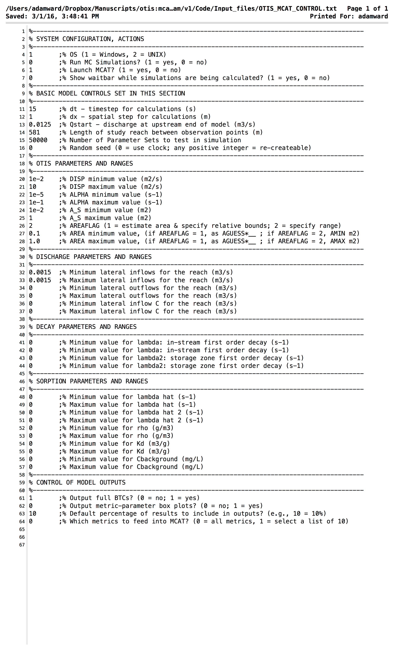

***SYSTEM CONFIGURATION, ACTIONS.*** These inputs control which modules in the OTIS-MCAT are executed, and which complied OTIS code is used for simulations.

Line 4 – specify the operating system of your machine. Current options are “1” for Windows and 2 for UNIX.

Line 5 – optional to execute or skip the execution of the Monte Carlo simulations. If simulations have been previously run, specify 0 to skip re-running and simply launch the MCAT. If simulations have not been run, or you desire to re-run the simulations, specify 1.

Line 6 – specify 1 to launch the MCAT upon completion of the Monte Carlo simulations (if requested on Line 6). Specify 0 to skip launch of MCAT tool.

Line 7 – specify 1 for an interactive waitbar to be displayed during Monte Carlo simulations. Specify 0 to suppress this visualization.

NOTE – for execution of the Monte Carlo simulations, users may with to use a high-performance computer or “cluster” computer available on their campus. For this case, set lines 6-7 to 0 to suppress visualizations, which commonly cause errors in command-line UNIX commands issued on these systems.

***BASIC MODEL CONTROLS SET IN THIS SECTION***. These inputs control the geometry and time steps used in the OTIS model.

Line 11 – computational time step for OTIS (s)

Line 12 – spatial increment for OTIS (m)

Line 13 – discharge at the upstream end of the study reach (m3 s-1)

Line 14 – total distance between the locations where upstream.csv and downstream.csv were observed (m)

Line 15 – number of parameter sets to generate for the Monte Carlo simulations

Line 16 – random seed option. Specifying a value of 0 uses the current time and date as the seed for the random number generator in Matlab, providing true randomization of data. For most users, a value of 0 will be sufficient. Specifying any positive integer uses that value to “seed” (i.e., initiate) the random number generator. Users who wish to use the same random distribution for multiple data sets should specify a non-zero value.

***OTIS PARAMETERS AND RANGES.*** These inputs control the physical transport processes to be simulated within OTIS. For each parameter, set the minimum and maximum values to an identical value to fix that value. All parameter values must be positive (non-zero) for the code to properly run.

Lines 20-21. Specify minimum and maximum values for in-stream longitudinal dispersion (m2 s-1).

Lines 22-23. Specify minimum and maximum values for fractional stream-storage exchange coefficient (s-1). To remove the impacts of transient storage from the simulations, set these values to an infinitesimally small non-zero value (e.g., 1E-20).

Lines 24-25. Specify minimum and maximum values for cross-sectional area of the transient storage domain (m2).

Line 26. Specify one of two options for area calculations.

For a value of 1, area is estimated based on discharge, stream distance, and the modal transit time observed in the specified upstream.csv and downstream.csv files. Use this option if the area range is unknown.

For a value of 2, area is specified in the same format as other parameters. Use this option if you know the range of areas you want to consider.

Lines 27-28.

For Line 26 = 1, specify the relative range of areas to explore around the estimate described in the previous section. Specified values are used to define the minimum and maximum areas as:

Amin = Aestimate * Line 30

Amax = Aestimate * Line 31

As an example, entering values of 0.5 and 1.5 results in exploring a range of areas ranging from 50 to 150% of the estimated value.

For Line 26 = 2, specify minimum and maximum cross-sectional area of the stream.

***DISCHARGE PARAMETERS AND RANGES.*** These inputs control the lateral inflows and outflows to be simulated within OTIS. For each parameter, set the minimum and maximum values to an identical value to fix that value. All parameter values must be positive (non-zero) for the code to properly run. To omit a parameter from the study, set both maximum and minimum values to zero.

Lines 32-33. Specify the range of lateral inflows to the study reach (m3 s-1). Lateral inflows are distributed evenly along the length of study reach defined on Line 15.

Lines 34-35. Specify the range of lateral outflows to the study reach (m3 s-1). Lateral outflows are distributed evenly along the length of study reach defined on Line 15.

Lines 36-37. Specify the range of lateral inflow concentrations to the study reach (g m3), associated with the inflow rates specified on lines 38-39.

***DECAY PARAMETERS AND RANGES.*** These inputs control first order decay of the solute to be simulated within OTIS. For each parameter, set the minimum and maximum values to an identical value to fix that value. All parameter values must be positive (non-zero) for the code to properly run. To omit a parameter from the study, set both maximum and minimum values to zero.

Lines 41-42. Specify the range of main channel first order decay coefficient (s-1).

Lines 43-44. Specify the range of storage zone first order decay coefficient (s-1).

***SORPTION PARAMETERS AND RANGES.*** These inputs control the streambed and hyporheic sorption and desorption processes to be simulated within OTIS. For each parameter, set the minimum and maximum values to an identical value to fix that value. All parameter values must be positive (non-zero) for the code to properly run. To omit a parameter from the study, set both maximum and minimum values to zero.

Lines 48-49. Specify the range of main channel sorption rate coefficient (s-1).

Lines 50-51. Specify the range of storage zone sorption rate coefficient (s-1).

Lines 52-53. Specify the range of sediment mass accessible per volume of water (g m-3).

Lines 54-55. Specify the range of distribution coefficients for sorption (m3 g-1).

Lines 56-57. Specify the range of background storage zone concentration (g m-3).

***CONTROL OF MODEL OUTPUTS.*** These inputs control what is automatically stored from the Monte Carlo runs and the MCAT.

Line 61. Specify 1 to store the full simulated solute tracer breakthrough curves at the downstream end of the study reach, or 0 to omit them. Storing the full breakthrough curves may generate large output files, but is required for several of the MCAT tools (e.g., DYNIA). These tools are included in the software but not discussed in detail in the manuscript.

Line 62. Specify 1 to automatically generate a series of boxplots comparing model results for all possible objective functions, after Figure X in the manuscript, automatically stored in the folder “Output_files/boxplots”. Specify 0 to skip this output.

Line 63. Specify the default fraction of model runs, in percentage, to include in when MCAT is launched, and for visualization in the boxplots (line 62).

Line 64. Specify which objective functions to load into the MCAT. A value of 0 loads all objective functions. However, some MCAT functions that are included in the software but not specifically detailed in the manuscript (e.g., multi-objective plots, simulation pixel plots, time-series surface plots) do not work with too large of a number of objective functions. Specifying a value of 1 will request the user to interactively specify up to 10 metrics on the command line prior to launching the MCAT.

ADD CODE FROM CHRISTA HERE

**STEP 4: Execute Monte Carlo Simulations**

With input files created, OTIS-MCAT is run by executing the file “OTISMCAT.m” from the Matlab command line. It is advisable to execute a small test-case of 100-1000 runs to test the software and troubleshoot any limitations on your machine prior to execution of a large suite of Monte Carlo simulations. Upon completion of the simulations, the parameter values and objective functions will be stored in the *.mat files in the folder “Output_files”.

**STEP 5 (OPTIONAL): Integration with OTIS-P**

OTIS-MCAT is designed to interface with OTIS-P. When the code is run to launch the MCAT, the code will automatically complete one of the following steps:

***IF*** OTIS-P has been run and the input and output files placed in the folder “OTIS-P_files” (detected by the presence of “star.out” in that folder),

***THEN*** code will load the OTIS-P results from the file “star.out” and display the final best-fit OTIS-P parameters and the associated 95% confidence intervals on dotty plots produced in the MCAT.

***IF*** OTIS-P has not been run (detected by the presence of “star.out” in that folder),

***THEN*** the input files required to execute OTIS-P will be automatically created and stored in the folder “OTIS-P_files”. At this point, users could readily execute OTIS-P, and repeat STEP 5 to launch the MCAT and read-in the OTIS-P results for visualization.

**STEP 6: Launch MCAT**

If line 6 was set to a value of 1 when the code was executed, output visualizations (boxplots as set on Line XX, CHRISTA VIS) and OTIS-P files (if OTIS-P has not yet been run) will be generated. Recommended practice to first run and store the Monte Carlo simulations (Line 5 = 1, Line 6 = 0), then to launch the MCAT to analyze the already-stored data (Line 5 = 0, Line 6 = 1). This is suggested in order to prevent accidentally overwriting the *.mat outputs from the Monte Carlo runs, and to separate the time-intensive Monte Carlo simulations from the subsequent analysis.

If line 64 is set to 0, the MCAT will automatically launch and display dotty-plots. If line 64 is set to 1, a command line prompt will allow the user to specify up to 10 objective functions to load into the MCAT.

**ACKNOWLEDGEMENTS**

Any opinions, findings, and conclusions or recommendations expressed in this material are those of the authors and do not necessarily reflect the views of funding agencies related to the initial development of the code (National Science Foundation, U.S. Geological Survey, Lilly Endowment, Inc.). Reference to specific software companies and programs does not indicate an endorsement of the funding agencies.