WARDA YOUSAF
SP23-BSE-042
LAB 4
wireshok
Screenshot
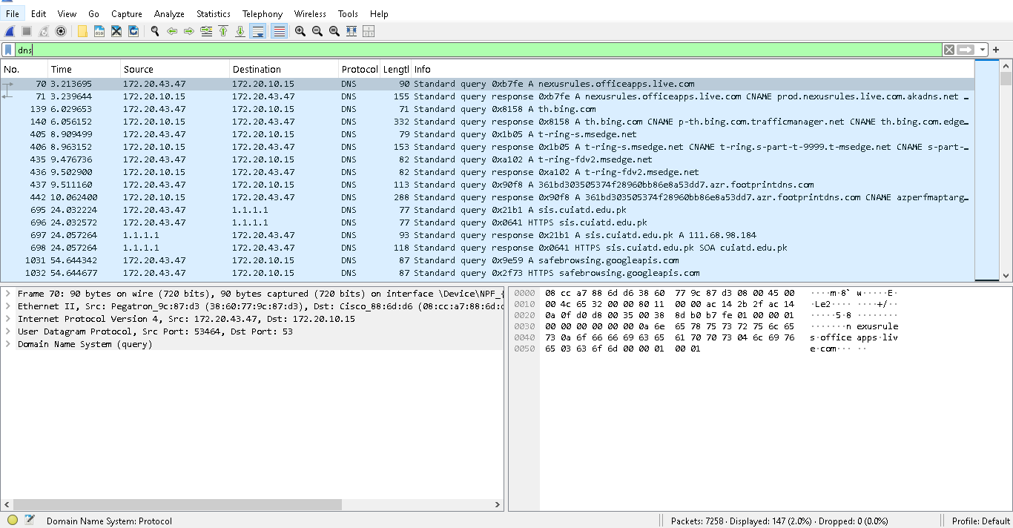

- What is the destination port for the DNS query message? What is the source port of DNSresponse message?
Destination port
53
Source port
53
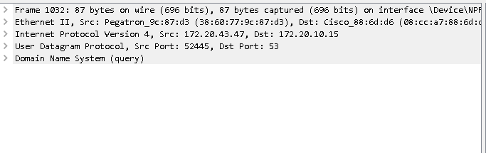
2. To what IP address is the DNS query message sent? Is this the IP address of your default localDNS server?
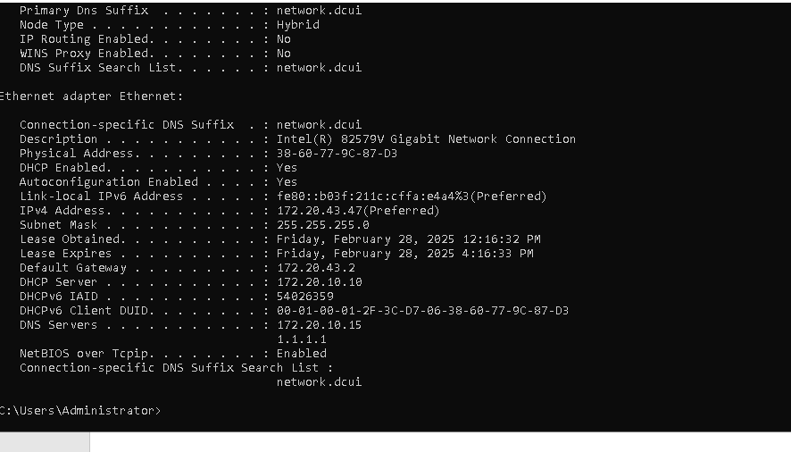
Dns server
172.20.10.15
Src 172.20.43.47
Dest 172.20.10.15
So both are same so ip address is local default DNS
3.Examine the DNS query message. What “Type” of DNS query is it? Does the query messagecontain any “answers”?

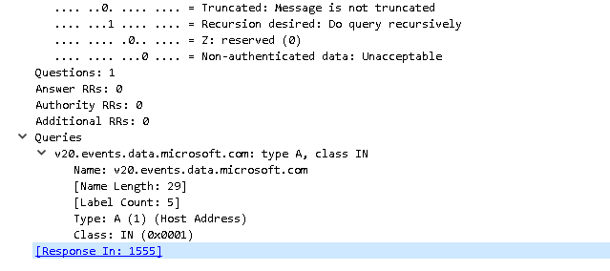

TYPE IS A
ANSWER 0

4.Examine the DNS response message. How many “answers” are provided? What do each of these answers contain?
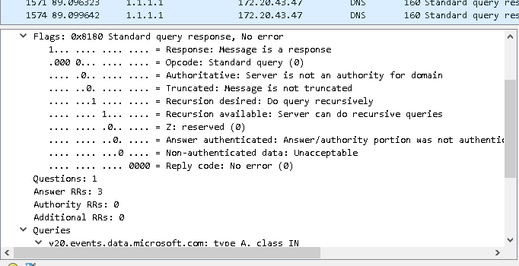
Cisco packet tracker

