
PROJECT PROPOSAL

BIG DATA
INSTRUCTED BY: SOHAIL IMRAN

TITLE: MODEL COMPARISON

GROUP MEMBERS:
S.NO | SID | NAME
01 | 13019 | Ammar Mushtaq
02 | 13016 | Shahzaib Khan
03 | 12210 | Warda Ashraf Rana

Model Random Forest Classifier

Split in 75 and 25
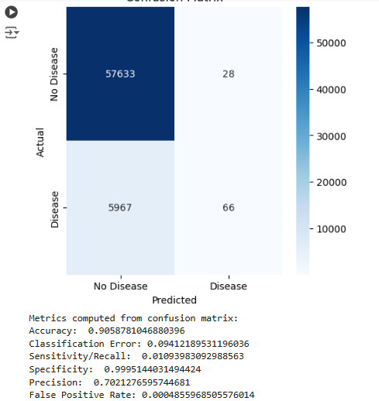

Split in 80 and 20

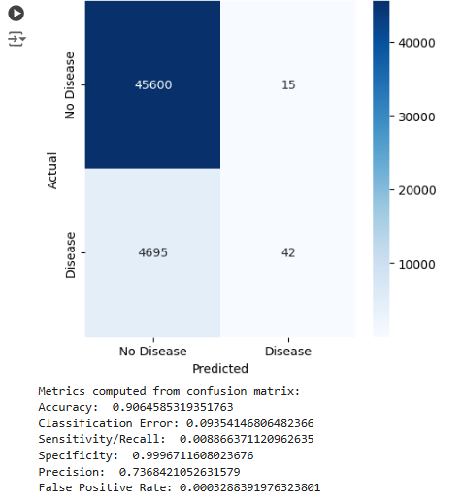

Split in 70 and 30

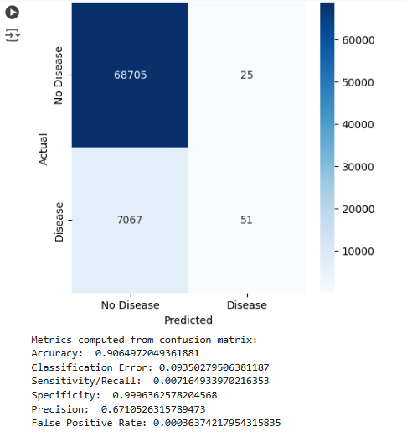

Comparison of the splits
Split | Accuracy | Recall | Specificity | Precision | False Positive Rate
70-30 | 0.9065 | 0.0072 | 0.9996 | 0.6711 | 0.00036
80-20 | 0.9065 | 0.0089 | 0.9997 | 0.7368 | 0.00033
75-25 | 0.9059 | 0.0109 | 0.9995 | 0.7021 | 0.00049

Best Split: 80-20

Reason
- Precision is highest (73.68%):
  - This means the model is better at correctly identifying true positives compared to the other splits, reducing false positives.
- Specificity is highest (99.97%):
  - The model correctly identifies negatives (no disease cases) most often, reducing false alarms.
- Recall (0.89%) is better than 70-30:
  - Although Recall is slightly lower than 75-25, it strikes a better balance with Precision.
- Accuracy is very high (90.65%):
  - It maintains strong overall accuracy similar to the 70-30 split.
- False Positive Rate is lowest (0.00033):
  - It has the fewest false alarms, which is critical for a health-related application.

Why not the others?
- 70-30:
  - Lower Precision and Recall compared to 80-20.
  - Slightly higher False Positive Rate.
- 75-25:
  - Higher Recall, but sacrifices Precision and has a higher False Positive Rate.
  - Lower Specificity, leading to slightly more false alarms.

Model Logistic Regression

Split in 75 and 25
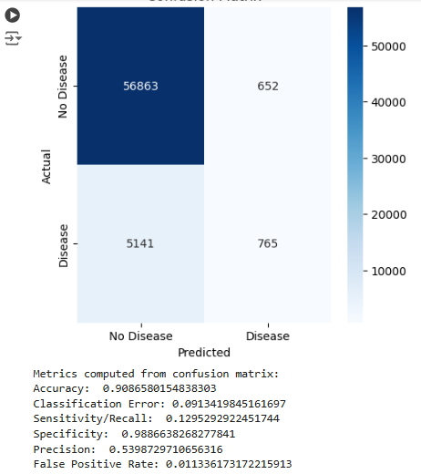

Split in 70 and 30

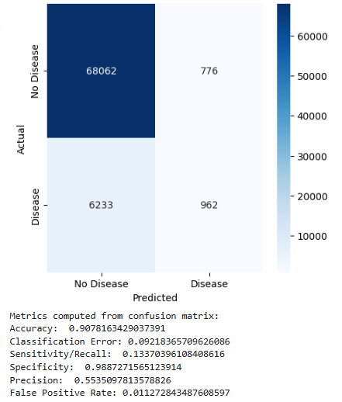

Split in 80 and 20

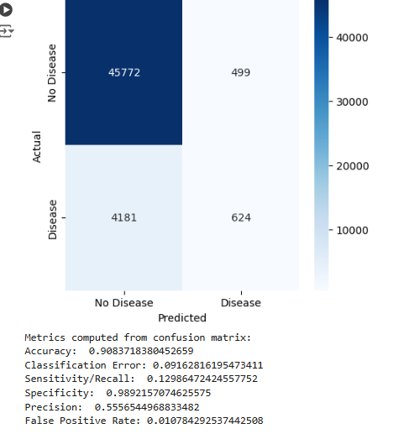

Comparison of the splits
Split | Accuracy | Recall | Specificity | Precision | False Positive Rate
75-25 | 0.9087 | 0.1295 | 0.9887 | 0.5399 | 0.01134
70-30 | 0.9078 | 0.1337 | 0.9887 | 0.5535 | 0.01127
80-20 | 0.9084 | 0.1299 | 0.9892 | 0.5557 | 0.01078

Best Split: 80-20

Reason
- Highest Specificity (98.92%):
  - Best at identifying true negatives (no disease), reducing false alarms.
- Precision is highest (55.57%):
  - This means the model is most accurate at predicting true positives, minimizing false positives.
- Balanced Recall (12.99%):
  - Recall is slightly lower than 70-30 but still within a reasonable range while compensating with better Precision and Specificity.
- Lowest False Positive Rate (1.08%):
  - The model generates the fewest false alarms, which is crucial in health-related predictions.
- Accuracy is very high (90.84%):
  - Comparable to 75-25, with better Precision and Specificity.

Why not the others?
- 75-25:
  - Slightly higher Recall, but Precision and Specificity are lower.
  - Higher False Positive Rate, making it less reliable.
- 70-30:
  - Better Recall than 80-20 but sacrifices Precision and Specificity.
  - Marginally lower Accuracy.

Metrics Comparison
Model | Accuracy | Recall | Specificity | Precision | False Positive Rate
Random Forest | 0.9065 | 0.0089 | 0.9997 | 0.7368 | 0.00033
Logistic Regression | 0.9084 | 0.1299 | 0.9892 | 0.5557 | 0.01078

Best Model: Logistic Regression

Reason
- Higher Sensitivity (Recall):
  - Logistic Regression (12.99%) significantly outperforms Random Forest (0.89%).
  - Higher Recall ensures the model detects more true positives (disease cases), which is critical in health predictions.
- Comparable Accuracy:
  - Logistic Regression (90.84%) has slightly higher Accuracy than Random Forest (90.65%).
- Balanced Specificity:
  - Logistic Regression's Specificity (98.92%) is slightly lower than Random Forest's (99.97%) but still very high.
  - While RF is better at identifying true negatives, LR balances Recall and Specificity better.
- Precision Trade-off:
  - Random Forest has higher Precision (73.68%) than Logistic Regression (55.57%), meaning it produces fewer false positives.
  - However, the extremely low Recall for RF makes it less reliable in detecting true positives, despite its Precision.
- False Positive Rate:
  - Random Forest has a lower FPR (0.033%) compared to Logistic Regression (1.08%). However, the drastic difference in Recall (true positive detection) makes Logistic Regression preferable in health-related contexts where missing true positives can have severe consequences.

Conclusion
- Logistic Regression is better for this use case because it achieves a good balance between Recall, Accuracy, and Specificity while maintaining reasonable Precision.
- Random Forest fails to detect most true positives (low Recall), making it less suitable for health predictions, where identifying disease cases is critical.

Report: Feature Selection and Algorithm Choice

1. Feature Selection
Features Chosen:
- In this case, the features included were numerical variables, selected based on:
  - Their relevance to predicting the target variable (HeartDiseaseorAttack).
  - Correlation analysis to understand how strongly each feature is related to the target.
Dropped Features:
- skin triceps and bp_diastolic were dropped because:
  - These columns were considered irrelevant or redundant for the prediction task.
  - Irrelevant features can reduce the model’s performance by adding noise or unnecessary complexity.
  - For example, bp_diastolic may not contribute significantly if another related feature like bp_systolic is included.
Correlation Analysis:
- A heat map was used to visualize correlations between features.
  - Features with high correlation to the target variable (HeartDiseaseorAttack) were prioritized.
  - Features with very low correlation to all other variables might have been ignored to reduce dimensionality.
Reason for Feature Selection:
- To improve the model's accuracy by:
  - Keeping only the most relevant features.
  - Reducing the noise introduced by irrelevant variables.
  - Ensuring the model does not over fit or underperform.

2. Algorithm Choice: Random Forest
Why Random Forest?
- Random Forest was chosen for its ability to handle:
  - Non-linearity in the data.
  - High-dimensionality (a large number of features).
  - Imbalanced datasets (if one class is under represented, such as fewer cases of heart disease).

Key Advantages of Random Forest:
- Feature Importance:
  - It automatically calculates the importance of each feature, helping to interpret the model and refine the dataset.
  - The bar plot of feature importance clearly shows which features have the most influence on predictions.
- Ensemble Learning:
  - Combines multiple decision trees to reduce the risk of overfitting.
  - The aggregation of multiple trees ensures more stable and accurate predictions.
- Handles Missing Data:
  - Random Forest can handle missing data or noise better than many other algorithms.
- Flexibility:
  - Works well for both classification and regression tasks.
  - Can handle categorical, numerical, or mixed-type features.
- Imbalanced Datasets:
  - By tweaking hyper parameters like class weights, Random Forest can perform well even if the dataset is imbalanced.

Benefits of Using Random Forest in This Case
- Accuracy:
  - The model achieved a high accuracy of 90.65%, which is significant for health-related predictions.
- Sensitivity and Specificity:
  - While the recall (sensitivity) was low (0.71%), the specificity was extremely high (99.96%).
  - This indicates the model is excellent at correctly identifying cases where there is no disease but struggles with predicting actual disease cases (likely due to class imbalance).
- Robustness:
  - Random Forest is less prone to overfitting compared to other tree-based models like decision trees.
- Explain ability:
  - The importance of features can be visualized, making the model transparent and easy to explain to stakeholders.
- Error Reduction:
  - By combining multiple decision trees, Random Forest reduces classification error to 9.35%, which is quite low.

Report: Feature Selection and Algorithm Choice

1. Feature Selection
The features were selected by:
  - Correlation Analysis:
    - Numerical features were analyzed using a heat map to assess their correlation with the target variable (HeartDiseaseorAttack) and among each other.
    - Features with stronger correlations with the target variable were prioritized.
  - Relevance to the Problem:
    - Features were chosen based on their medical or statistical relevance to heart disease prediction.
Dropped Features:
Skin triceps and bp_diastolic were dropped because:
  - They might have low correlation with the target variable or high correlation with other features, making them redundant.
  - Reducing redundant or irrelevant features decreases noise in the model and improves performance.
Reason for Feature Selection:
To simplify the model and improve its predictive power by:
  - Removing unnecessary variables that do not add significant information.
  - Focusing on features that are directly or indirectly indicative of heart disease.

2. Algorithm Choice: Logistic Regression
  - Simple and Efficient:
    - A straightforward algorithm works well for binary classification tasks like predicting heart disease.
  - Interpretable:
    - Provides coefficients for each feature, allowing us to understand the relationship between features and the target variable.
    - Positive coefficients indicate a positive relationship with the target, while negative coefficients indicate a negative relationship.
  - Well-Suited for Linearly Separable Data:
    - Logistic Regression performs well when the features are linearly related to the log-odds of the target variable.
Key Advantages of Logistic Regression:
- Interpretability:
  - The coefficients make it easy to identify the impact of each feature on the prediction outcome.
  - For example, a higher coefficient for a feature suggests a stronger influence on the likelihood of heart disease.
- Probability-Based Predictions:
  - Logistic Regression outputs probabilities, which can be thresholder to make predictions.
  - This allows flexibility in setting thresholds for specific use cases (e.g., reducing false negatives in medical predictions).
- Fast Training:
  - Logistic Regression is computationally efficient and trains faster than more complex models like Random Forest.
- Handles Multicollinearity:
  - Regularization techniques (e.g., L1 or L2 penalties) can be applied to reduce the impact of highly correlated features.

- Works Well with Balanced Datasets:
  - Logistic Regression performs best when the dataset is balanced (similar number of samples in each class).

Evaluation Metrics:
The model's performance was evaluated based on the following metrics:
- Confusion Matrix:
  - Provides a breakdown of true positives (TP), true negatives (TN), false positives (FP), and false negatives (FN).
  - Helps assess the model's accuracy in predicting both classes.
- Derived Metrics:
  - Accuracy: Measures the proportion of correct predictions out of all predictions.
  - Recall/Sensitivity: The ability of the model to correctly identify positive cases (heart disease).
  - Specificity: The ability of the model to correctly identify negative cases (no heart disease).
  - Precision: The proportion of positive predictions that were actually correct.
  - False Positive Rate: The proportion of negative cases that were misclassified as positive.

Comparison with Random Forest:
- Strengths of Logistic Regression:
  - More interpretable compared to Random Forest.
  - Faster to train, especially on large datasets.
  - Works well when features are linearly related to the target.
- Limitations:
  - Logistic Regression struggles with non-linear relationships.
  - It is less robust in handling high-dimensional or highly complex datasets.
- Why Random Forest Could Be Better:
  - Handles non-linearity effectively.
  - Can manage imbalanced datasets with hyper parameter tuning (e.g., class weights).

Why Columns Were Dropped
- Example Dropped Columns (skin triceps, bp_diastolic):
  - These columns are not part of the dataset you shared, but in this code, they represent placeholders for unnecessary columns. Columns are dropped for the following reasons:
    - Irrelevance: The feature does not have a meaningful relationship to the label (HeartDiseaseorAttack) or does not contribute to the prediction.
    - Redundancy: If a feature is highly correlated with another (e.g., HighBP and HeartDiseaseorAttack), it might be redundant and dropped to avoid multicollinearity.
    - Missing Values: Columns with too many missing or null values that cannot be effectively imputed may be dropped.
    - Non-Numerical: Machine-learning models like RandomForestClassifier require numerical data. If a column is categorical and not encoded properly, it might need to be dropped or preprocessed.

Why Specific Features were Highlighted
- Target Label (HeartDiseaseorAttack):
  - This is the outcome we want to predict.
  - Other features are used to train the model to classify instances as having or not having heart disease.
- Selected Features (HighBP, CholCheck, BMI, etc.):
  - These are established health indicators known to influence cardiovascular health.
  - Including these allows the model to leverage their predictive power for classification

