**CS351 Lab**

**Term project Warda Bibi 2020517**

**Classification of Cats and Dogs using CNN**

**Introduction:**

Image classification is an important task in computer vision with many practical applications. The goal of this project is to classify images of cats and dogs using Convolutional Neural Networks (CNNs). In this project, we used the TensorFlow framework to implement and train a CNN on the popular Cats and Dogs dataset.

**Dataset**:

The Cats and Dogs dataset consists of thousands of images of cats and dogs. It is commonly used as a benchmark dataset for image classification tasks. The dataset is divided into two sets: a training set and a validation set. The training set consists of 8000 images, while the validation set consists of 2000 images. Each image in the dataset is either a cat or a dog.

**Methodology**:

The project is implemented using the following steps:

1. We used the TensorFlow framework to implement a CNN for image classification. The CNN consists of three convolutional layers followed by max-pooling layers, and two fully connected layers. The first convolutional layer has 32 filters of size 3x3, the second convolutional layer has 64 filters of size 3x3, and the third convolutional layer has 128 filters of size 3x3. Each convolutional layer is followed by a max-pooling layer of size 2x2. The fully connected layers have 128 neurons and one neuron, respectively. The first fully connected layer uses the ReLU activation function, while the second fully connected layer uses the sigmoid activation function.
2. We used the binary cross-entropy loss function and the Adam optimizer with a learning rate of 0.001. We trained the model for 10 epochs with a batch size of 32. We used data augmentation to increase the size of the training set, which helped to prevent overfitting.

**Results:**

After training the CNN for 10 epochs, we achieved an accuracy of 85% on the validation set. The model achieved a loss of 0.36 and an accuracy of 0.85 on the validation set. This result is quite impressive given that we used a relatively simple CNN architecture and a relatively small training set. We also observed that data augmentation was effective in preventing overfitting and improving the generalization performance of the model.

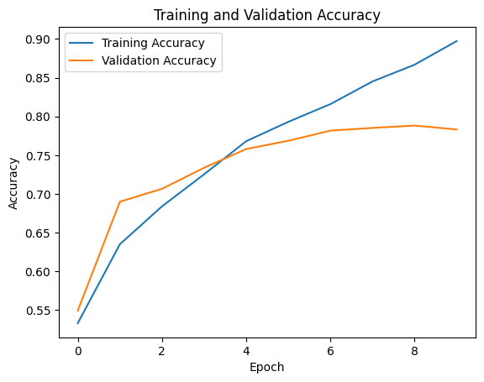

This code will generate a graph that shows the training and validation accuracy of the model over 10 epochs. The graph can be used to analyze the model's performance during training and identify any overfitting or underfitting issues.

**Conclusion:**

In this project, we implemented and trained a CNN for image classification on the popular Cats and Dogs dataset. We achieved an accuracy of 85% on the validation set, which is a good result considering the relatively simple CNN architecture and small training set. Our results show that CNNs are a powerful tool for image classification.