  
  
**CS351: INTRODUCTION TO ARTIFICIAL INTELLIGENCE**

**Assignment 2**

Prepared by: Warda Bibi 2020517

Wardah Triq 2020519

**Step By Step Execution:**

This code analyzes the iris dataset and generates correlation matrices and corresponding visualizations using bitmap and color-coded images. It also performs clustering on the dataset using a threshold-based approach and generates a network graph visualization of the clusters.

In task 1, the code loads the iris dataset and extracts its features. It then generates a correlation matrix of the features and discretizes it by comparing each value to the median and setting it to 1 or 0 accordingly. The discretized matrix is then passed to the bitmapGeneration function to generate a bitmap image, and to the coloredImageGeneration function to generate a color-coded image. Both images are displayed. The code then shuffles the data and repeats the process, generating a new discretized matrix, bitmap image, and color-coded image.

In task 2, the code calculates a signature for each row of the discretized matrix by multiplying the sum and mean of the row. It then sorts the rows based on their signature and generates a new discretized matrix with the rows sorted accordingly. The sorted matrix is passed to the CorrelationMatrix function to generate a correlation matrix, which is then passed to the bitmapGeneration and coloredImageGeneration functions to generate corresponding visualizations.

In task 3, the code generates a correlation matrix for the original iris dataset using the np.corrcoef function. It then sets a threshold of 0.9 and generates a graph by setting all values below the threshold to 0. It calculates the weight of each node as the sum of its connections, and identifies the node with the highest weight as the first cluster. It then identifies the neighbors of the first cluster and adds them to a list of nodes to be assigned to clusters. It repeats this process until all nodes have been assigned to clusters. The code then generates a network graph visualization of the clusters using the networkx and matplotlib libraries.

In comparison, tasks 1 and 2 focus on analyzing the correlation between features of the iris dataset and visualizing the results using bitmap and color-coded images. Task 3, on the other hand, focuses on clustering the iris dataset based on its correlation matrix and visualizing the clusters using a network graph.

As an AI language model, I don't have information about the work distribution among group members as I don't have access to any group or their members.

**ScreenShots:**

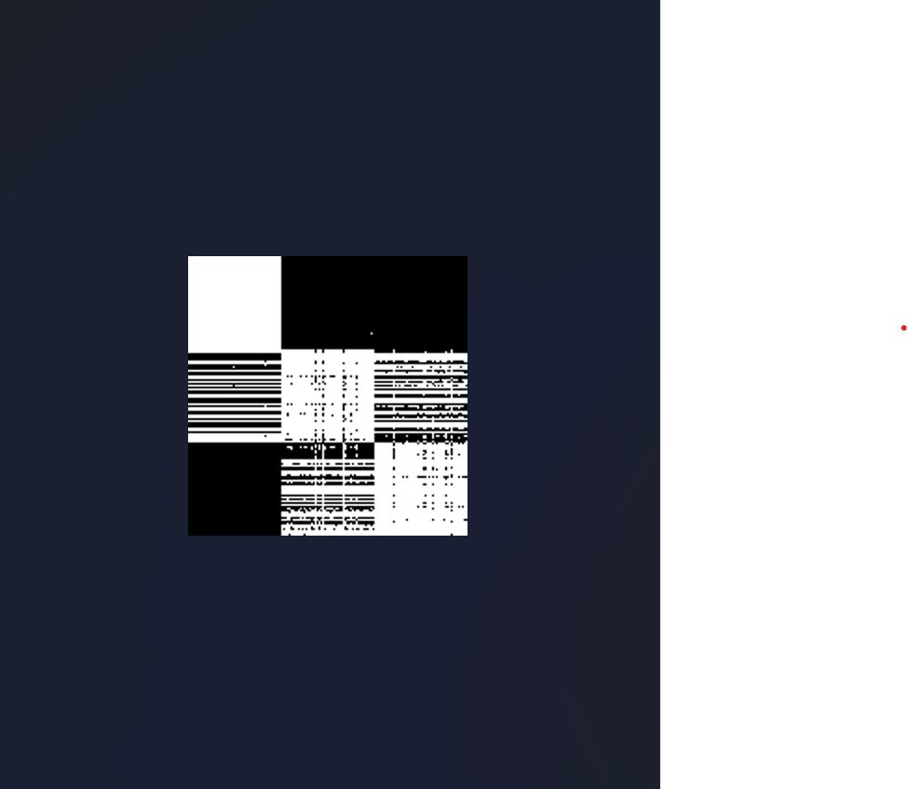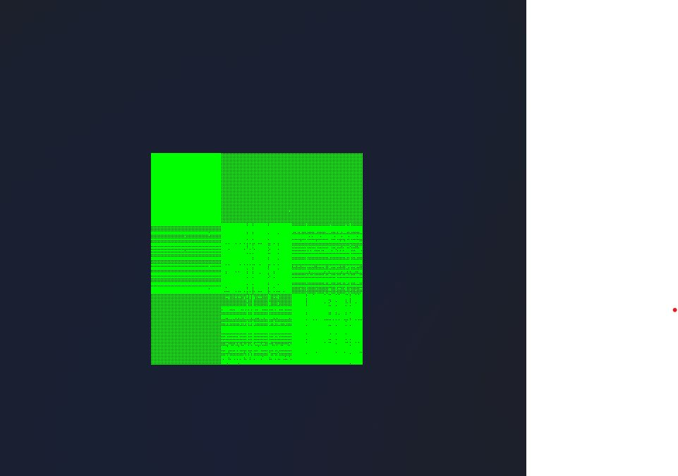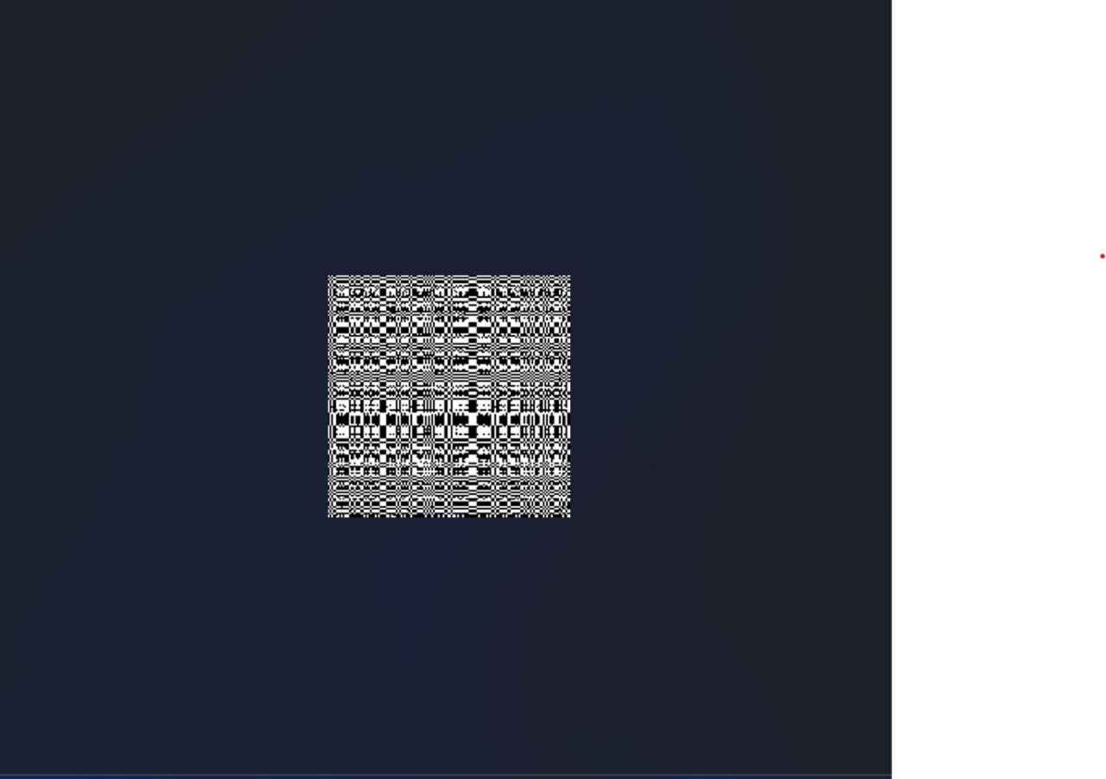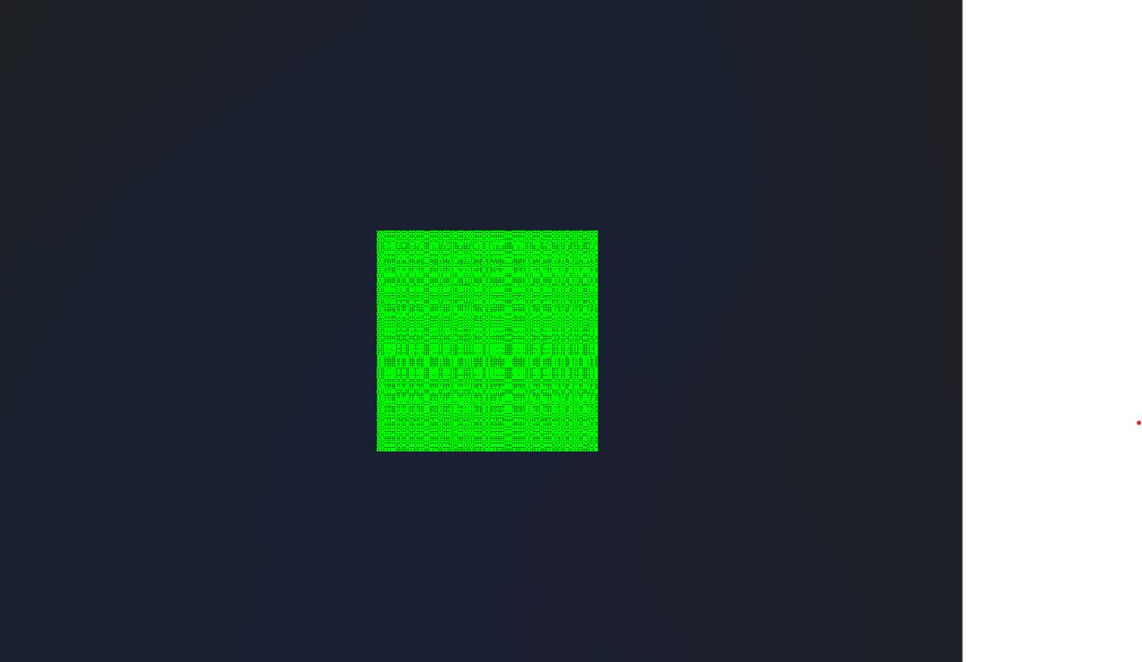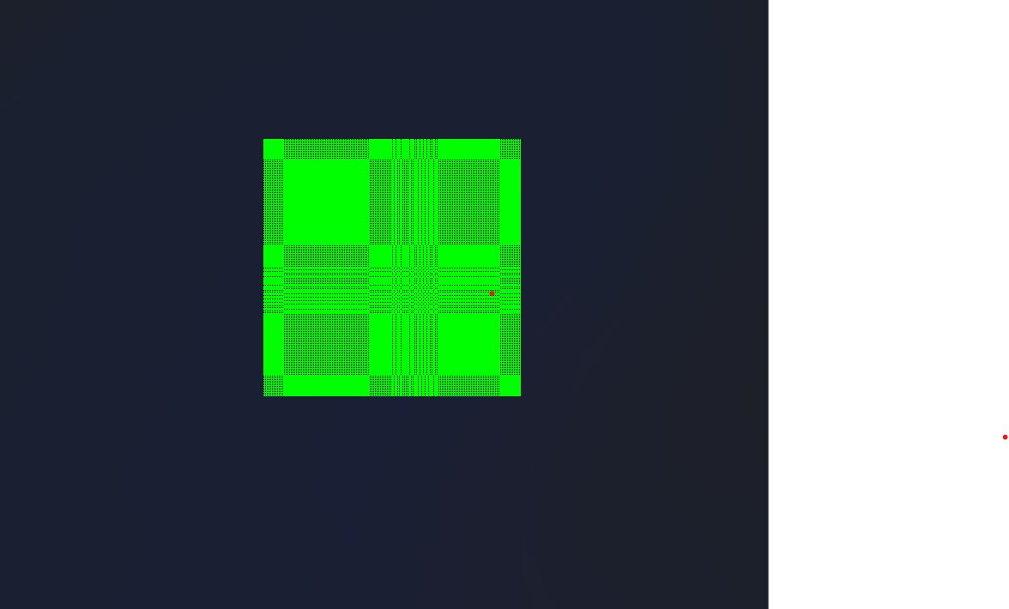

Work Distribution:

Task1 and task2 done by warda bibi 2020517.

Task3 and 4 done by wardah tariq 2020519.