Warda Najam(20K-0310)

Question 2: Change hyper parameters (Kernel size)

Changed filter size from 3x3 to 5x5

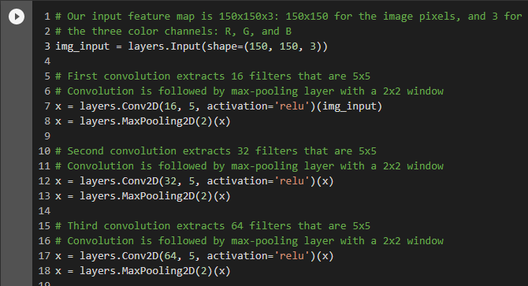

Which gives the following changes in summary:

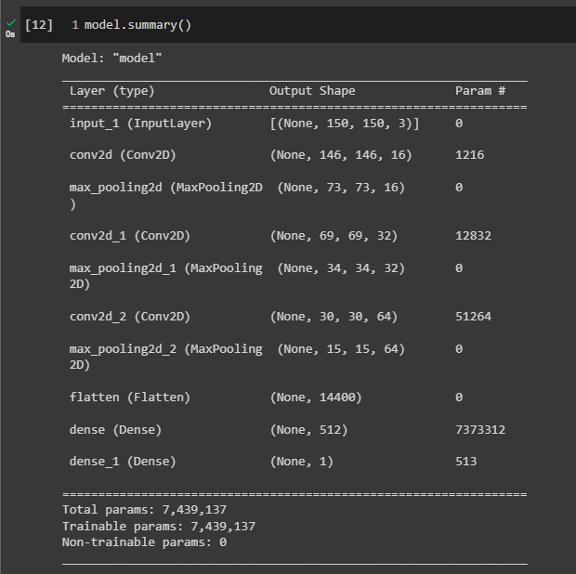

Question 3: Add convolution and pooling

Added a fourth layer and changed pooling size from 2x2 to 3x3:

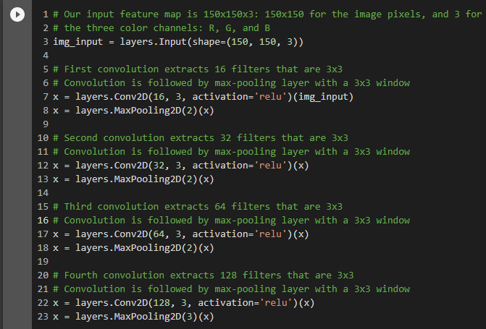

Which gives the following changes in summary:

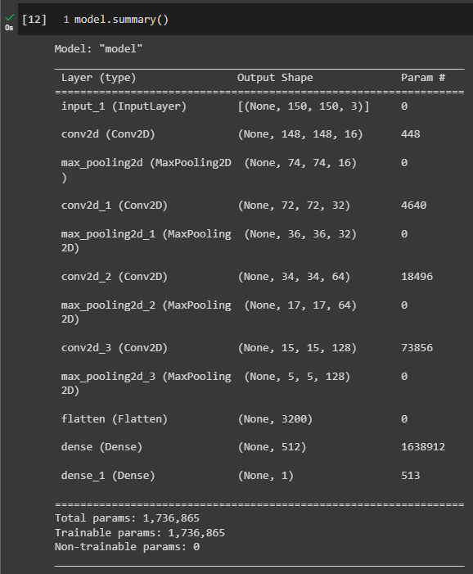

Question 4: Change pooling to observe output

Changed only the pooling size from 2x2 to 3x3:

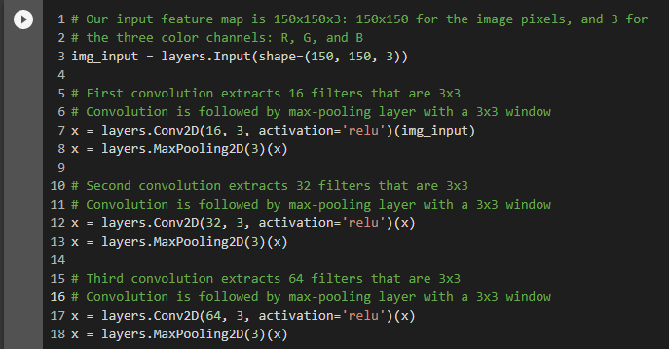

Which gives this output:

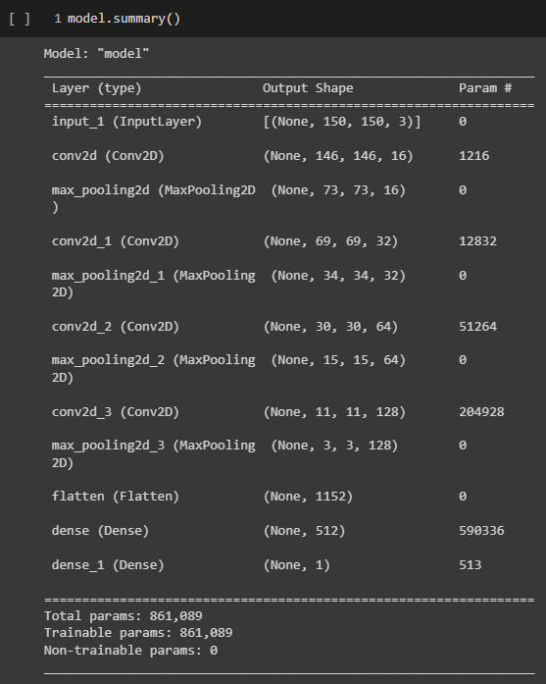

Question 5: Change Dataset

New dataset from Kaggle,

