Warda Najam (20K-0310)

DLP Lab 1

1) Changing number of hidden layers from one to two.

2) Fewer Epoch behaviour.

I choose 1000 values for training data.

Which shows incorrect result. This means that 1000 value training data set is not optimal for this problem because the neural network doesn’t know yet that on test input 1,1 in an AND gate should give 1 as well instead it’s still giving 0 as an answer. This helps us understand that we need to revaluate our number of epochs.

3) Compute error for different:

I considered this target value and error formula:

target=[0,1,0,0]

error=1/2 * ((target-prediction)**2)

1. **Learning Rates:**

* Lower Learning Rate: 0.001

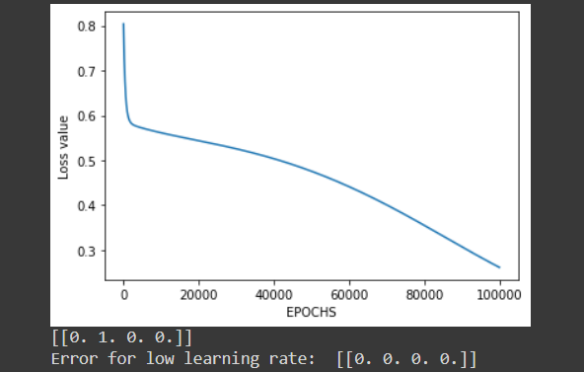

* Higher Learning Rate: 0.1

1. **Epochs:**

* Fewer Epochs: 1000

* Higher Epochs: 200000

1. **Hidden Layers:**

* One Hidden Layer:

* Two Hidden Layers:

4) Repeat for NAND gate and XOR gates:

NAND GATE:

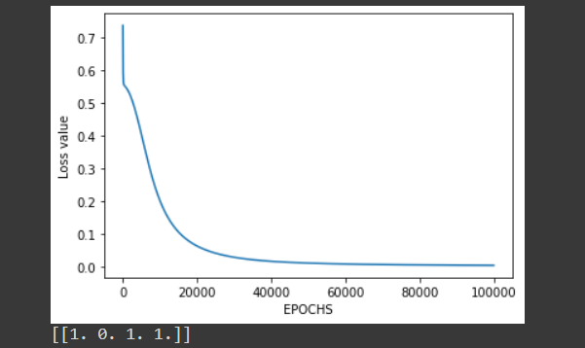

XOR GATE:

