Name: Jay Michael C. Elape Student ID: 231-00116
PART A – SYSTEM INTEGRATION ARCHITECTURE

1. Recommended Architecture
Enterprise Service Bus (ESB).
2. Justification
An ESB fits this university because four independent systems (Student Information System, Learning Management System, Accounting System, and Library System) must exchange data, and these systems were most likely built by different vendors using different data formats and technologies. With a point-to-point design, every system would need its own custom link to every other system. Four systems already require six separate connections, and each new system (for example, a Registrar or HR system) would add several more, making maintenance costly and error-prone.
A hub-and-spoke design reduces the number of links, but it relies on one central hub that mainly forwards messages and offers limited support for varied protocols. An ESB, in contrast, acts as a shared communication layer where each system connects only once. The bus handles message routing, converts data between formats such as XML and JSON, applies security, and exposes each system's functions as reusable services. Service-Oriented Architecture describes the design style of exposing functions as services, while the ESB is the infrastructure that makes it work in practice, so the ESB gives the university both.
In this scenario, a change in one system, such as replacing the Library System, only requires reconnecting that system to the bus, and the other three systems remain untouched. This keeps the integration scalable, easier to manage, and flexible as the university grows.
3. Systems That Need to Communicate
The Student Information System and the Accounting System must communicate so that enrollment and tuition payment stay consistent. The Student Information System and the Learning Management System must also communicate so that enrolled students are linked to their courses and grades. The Library System communicates with the Student Information System to verify student status and to report borrowing clearance.

4. Information Exchanged
From | To | Data Exchanged
Student Information System | Accounting System | Student ID, name, program, enrolled units used to compute tuition and fees
Accounting System | Student Information System | Payment status and balance, used to confirm official enrollment
Student Information System | Learning Management System | Student profile, enrolled subjects, section, enrollment status
Learning Management System | Student Information System | Final grades and course completion records
Library System | Student Information System | Borrowed and unreturned books, fines, clearance status
Student Information System | Library System | Valid student status to issue or renew library access
Architecture Diagram
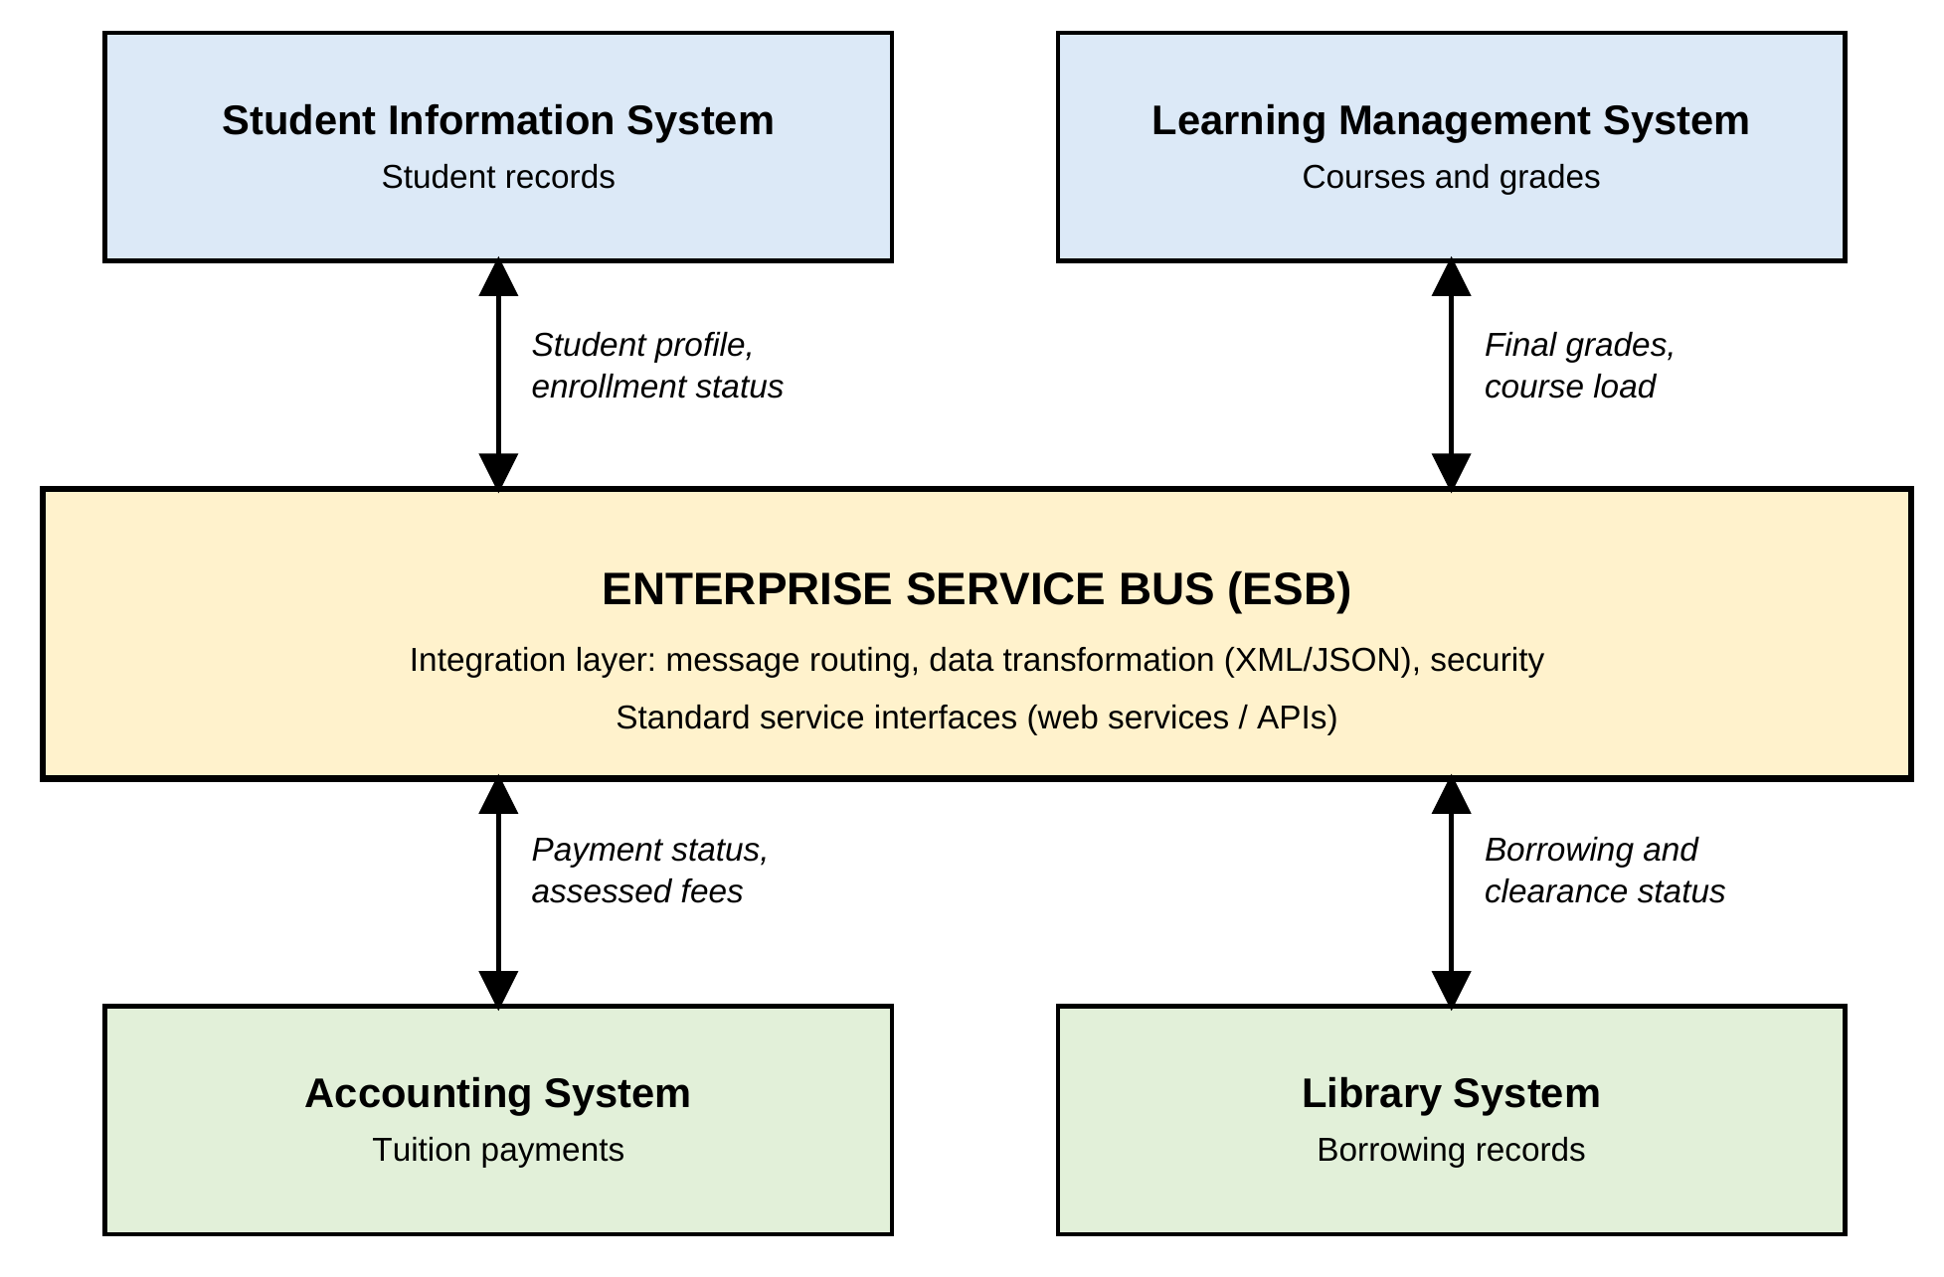
Figure 1. Enterprise Service Bus integrating the university systems

