Login

There isn’t a lot to say about the login page; it is inherently simplistic and serves only one titular function.

We originally intended to have two login pages: one for customer accounts and one for seller accounts. We ultimately decided against this because users preferred a single login page. We found this out from a brief informal survey of sorts.

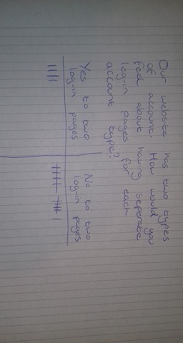

Following this, the creation of a single login page was clear.

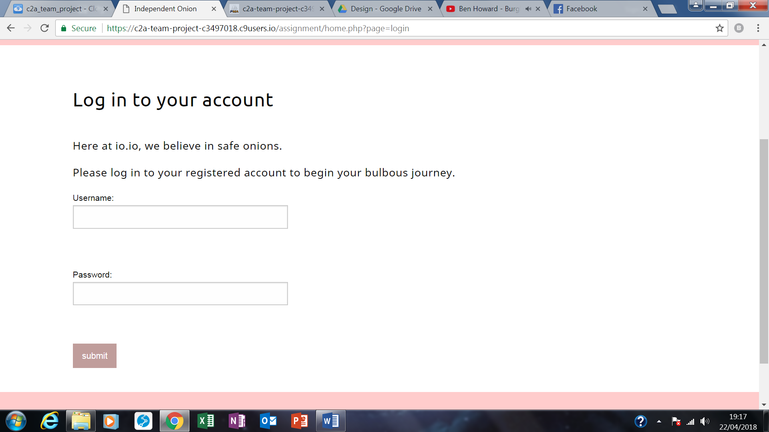

Text was added simply to fill up space; the page looked too empty without it.